
RV COLLEGE OF ENGINEERING
Bengaluru-560 059

REPORT ON
EXPERIENTIAL LEARNING
ACY 2025-26
THEME
SDG 11- Sustainable Cities and Communities
Title of the Project
SnapFix- Democratizing Urban Maintenance through AI-Driven Citizen Reporting
Students Group
SL. No. | USN | Name | Prog.
1
2
3
4

Project Evaluators
SL. No. | Name of the Evaluators (Enter the Names in Capitals)

Name of the Faculty Mentor | Name of the Chief Faculty Mentor
Table of Contents
Chapter 1 INTRODUCTION 3
Chapter 2 PROBLEM DEFINITION 4
2.1 Problem Statement 4
2.2 Background Information 4
Chapter 3 OBJECTIVES 5
3.1 Primary Objectives 5
3.2 Secondary Objectives 5
Chapter 4 METHEDOLOGY 6
4.1 Approach 6
4.2 Procedures 7
Chapter 5 PROJECT EXECUTION 9
5.1 Planning and Design 9
5.2 Implementation 9
Chapter 6 TOOLS AND TECHNIQUES USED 11
6.1 Tools 11
6.2 Techniques 13
Chapter 7 PARTIAL RESULTS 14
7.1 Initial Findings 14
7.2 Iterative Improvements 14
Chapter 8 RESULTS AND DISCUSSION 15
8.1 Final Results 15
8.2 Discussion 16
Chapter 9 PROTOTYPE 17
9.1 Prototype Description 17
9.2 Development Process 17
9.3 Testing and Validation 17
Chapter 10 CONCLUSION 19
10.1 Summary 19
10.2 Personal Reflection 19
Chapter 11 VISUALS 20
Chapter 12 OUTCOME OF THE WORK 23
References 23

INTRODUCTION
Urbanization is increasingly altering the face of cities around the globe with its development, but it is also creating significant strain on the infrastructure. With increasing numbers in cities, basic civic issues like potholes on the roads, solid waste disposal on roadsides, a lack of streetlights, fallen trees on roadsides, and littering on these places is increasing on a day-by-day basis. These basic civic issues significantly impact life with regards to increased issues on the roads with regards to accidents, health issues with regards to pollution, along with issues with regards to increasing crime rates within these cities on a day-by-day basis. Due to increased development in cities with regards to population growth, dealing with these issues is becoming a significant problem for the respective city administration.
Conventional systems adopted for citizen grievance reporting, including telephone grievance systems, paper complaint registration, and basic website grievance portals, have been found inefficient. This is because they lack essential details about grievance locations or proper pictures. This has led to increased time consumption on the part of the municipal corporations to confirm these grievances, resulting in a lack of action. This situation has resulted in a lack of citizen trust in the municipal corporations. Studies reveal that a major portion, including over 75% to 78%, of citizen grievances remain unaddressed, which highlights the deficiency in the current grievance redressal system.
Conventional systems adopted for citizen grievance reporting, including telephone grievance systems, paper complaint registration, and basic website grievance portals, have been found inefficient. This is because they lack essential details about grievance locations or proper pictures. This has led to increased time consumption on the part of the municipal corporations to confirm these grievances, resulting in a lack of action. This situation has resulted in a lack of citizen trust in the municipal corporations. Studies reveal that a major portion, including over 75% to 78%, of citizen grievances remain unaddressed, which highlights the deficiency in the current grievance redressal system.
To address these issues and challenges, there is a need to introduce SnapFix as an intelligent, simple, and effective solution for reporting civic issues. SnapFix is a Telegram bot designed on a Telegram platform and allows citizens to post complaints about issues using a geo-location tagged photo with a brief description of the issues using a simple command /report. The system utilizes a well-trained model called MobileNetV2 and classifies images into nine categories such as damaged concrete and illegal parking with an accuracy rate of 93.36%. The system also analyses the urgency associated with complaints using TF-IDF techniques and spaCy with an accuracy rate of 99.83%, allowing for automatic distribution of 85% of complaints to relevant government agencies. The entire complaint information is stored using a PostgreSQL dashboard and heat maps to indicate problematic areas of the city and contribute to Sustainable Development Goal 11 to create safe and clean cities and communities on a global scale.

PROBLEM DEFINITION

2.1 Problem Statement
Infrastructural problems like potholes in roads, inefficient garbage collection, broken or non-functional street lights, and uprooted or collapsed trees on roads are increasing rapidly across all global cities. These have a direct effect on public security and quality of living standards of citizens. Inefficiencies due to broken roads cause traffic jams and accidents, whereas street lights and trash-related problems cause unhealthy and insecure environments of living. With constantly expanding cities, it has become challenging for civic bodies to effectively address these problems.
The current grievance reporting system in the form of helpline numbers and simple grievance reporting websites is not efficient enough to cope with the requirements of the current urban scenario. These reporting mechanisms generally do not provide the facility to the citizens to report complaints attaching photographs and current location details, which are essential to understand the intensity and actual location of the problem. As a consequence, complaints need to be processed manually, and this results in a huge burden on the administrative staff of the concerned municipalities. This also results in a significant delay in grievance redressal, and the problem becomes a major cause of ineffectiveness. Studies suggest that close to 78% of the complaints registered are not being attended to, hence the gravity of the situation and a sense of distrust among citizens cannot be ignored.

2.2 Background Information
The increase in urbanization in recent years has put enormous pressure on civic infrastructure and made it extremely challenging for civic bodies to manage civic issues effectively. With rapidly developing cities like Bengaluru experiencing a sharp increase in civic-related complaints like road-related issues, waste management, lighting, and other civic infrastructural issues, civic bodies in many cases continue to stick to traditional complaint handling processes like paper complaint registers and calls. The traditional complaint management process misses critical inputs such as exact location details and visual evidence, which makes it even more challenging for civic bodies to understand civic issues effectively in a manner that helps civic bodies take informed decisions. The absence of geospatial inputs also makes it extremely challenging to identify areas in civic infrastructure where issues tend to repeat and plan accordingly for long-term improvements of civic infrastructure.
At the same time, existing research and literature point to participatory sensing-in which active citizens report civic problems-when improvements could be made in urban management. These range from studies using geo-tagging for issues like potholes to smart city feedback tools; these have used location-based data to improve accuracy and response times. But most of these systems adopt complex mobile applications requiring installation, registration, and other multi-step processes. Further, several of the platforms still rely on manual triaging of complaints, thereby enhancing workload and subsequently delaying resolution.
Previous online systems have enhanced citizen reporting of grievances, but issues of scalability and sustainability have derailed them. The development and sustainment costs were high, and there was limited citizen engagement for such systems. The new solution, SnapFix, learns from the strengths of previous systems and incorporates a popular communication platform, Telegram, and technology – artificial intelligence – in order to make civic engagement quicker and scalable.

OBJECTIVES

3.1 Primary Objectives
The primary objective of this project is to design a multi-modal complaint intake framework that will enable citizens to report civic issues in an easy, flexible, and user-friendly way. The system shall support the use of Telegram bot for the reporting modal and a web-based interface as mainstream interface for the admin side modal, which are widely deployed and have familiarity among the general public. With these, it frees the users from learning new applications or following complex procedures; instead, users can interact with them naturally, in chat-based commands. By supporting both structured inputs (using predefined forms with fixed fields) and unstructured input (free-text descriptions and uploaded images), it's well-assured that the citizens can report issues in the way that best suits them. This objective focuses on increasing participation, reducing reporting time, and ensuring that complaint data is captured accurately at source.

3.2 Secondary Objectives
The second important aim of this project is to design an AI complaint classification engine that has the capability to automatically interpret and process incoming complaints on its own without any human intervention. The complaint classification engine makes use of Natural Language Processing (NLP) algorithms to interpret incoming text data from citizens and generate important information such as complaint type, keywords, the department it belongs to and urgency levels from such data. If images are submitted, it make use of Computer Vision algorithms to interpret such data and detect common civic issues such as road damage, garbage collection, and broken infrastructure on such images. The complaint classification process involving text and images will result in accurate classification of complaints into predefined civic categories.
Another significant objective is the development and execution of a robust backend service system framework for processing complaints in a scalable and a reliable manner. This backend system is developed using a RESTful API framework, which would ensure smooth interactions among user interfaces, artificial intelligence components, databases, and administrative interfaces. Additionally, a persistent database system, PostgreSQL is used to retain all information related to the complaints, such as user complaint inputs, image information, geographic information, timestamps, complaint category, level of urgency, and current complaint status. This objective addresses the significant issue of handling a high number of complaints.
The project will also have an administration workflow system in order to enable efficient dealing with complaints at the municipal level. The workflow system will ensure automated allocation of complaints based on types and priority levels to their corresponding departments in the authority. The complaints will have standardized lifecycles in their processing life, starting from the moment of lodging and validation through allocation, processing, and closure of such complaints. The matter is central in addressing challenges allied with inefficient approaches in traditional grievances redressal mechanisms.
Finally the objective with-respect-to normal user is the promotion of community engagement, transparency, and trust within the realm of urban governance. By ensuring fast feedback acknowledgment, real-time status alerts, and swift issue resolution, the project aims to make citizens actively engage with the system and trust the municipal system functions and procedures. It is pertinent to note that the proposed project is also in line with Sustainable Development Goal 11, which aims to make cities safe, resilient, and sustainable.

METHEDOLOGY

4.1 Approach
This method is founded upon a participatory sensing framework whereby citizens are encouraged to participate proactively towards civic issue reporting via their personal devices. This method attempts to integrate civic participation efforts with lightweight artificial intelligence to increase the potential of unstructured data to make it relevant to local government structures. The overall aim of this method revolves around developing civic intelligence to provide quicker and more effective processing of relevant information. This method aims to move away from conventional top-down structures of civic issue reporting.
The system is based on a three-tier architecture with features for complaint intake, intelligent classification, secure storage and usage. The first tier is the intake tier with a conversational frontend based on Telegram. Telegram makes it convenient for individuals to file their complaints using text messages with images which mimic the geo-tagged upload. Using Telegram means that individuals do not need to install anything if they already use the service, thus creating a convenient point for civic engagement.
Upon receiving a complaint, it passes through a hybrid AI pipe. For image inputs, the computer vision algorithm employed uses the MobileNetV2 algorithm with a 93.36% accuracy rate for classifying images belonging to eight different categories of urban infrastructure problems such as damaged concrete structures, electric poles, road signs, fallen trees, garbage dumping, graffiti, illegal parking, potholes and electrical power outage. For complaints that are received in the form of text inputs, Natural Language Processing techniques are employed using TF-IDF along with spaCy for analyzing the complaint description and identifying its urgency level. The F1-score of 99.83% ensures that the complaint is properly prioritized.
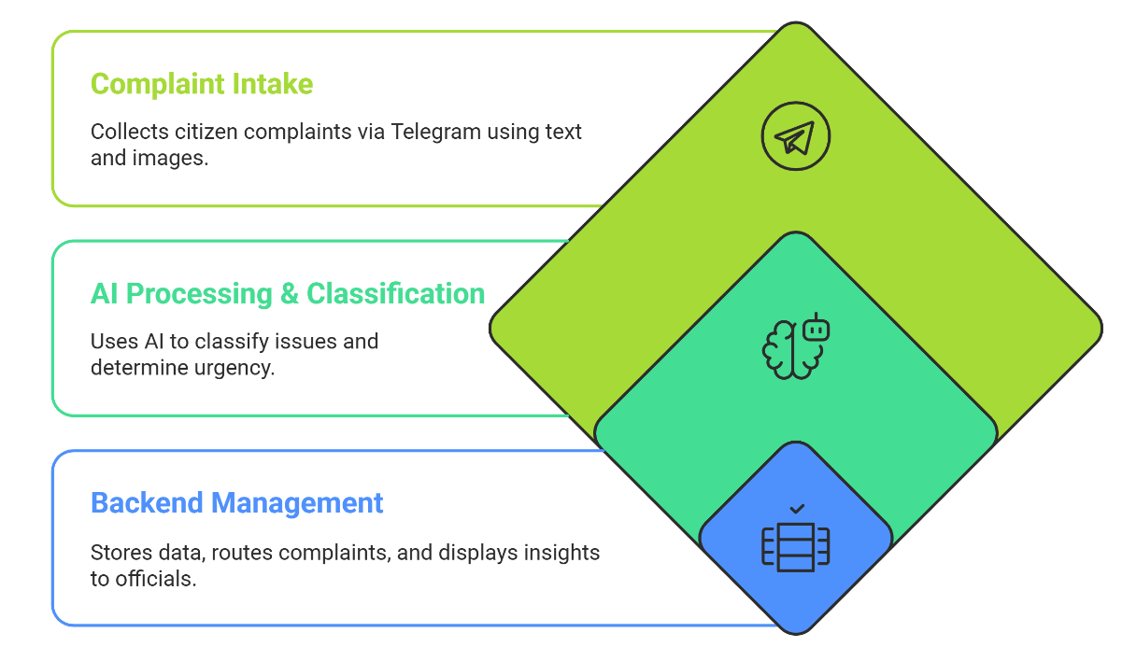
After this categorization and urgency analysis, the complaint is forwarded to the backend layer for further storage and management, achieved through the PostgreSQL database. The back end supports the routing of complaints based on category and urgency to respective municipal departments. It also supports data retrieval and status tracking. The final layer focuses on storage and usage, whereby officials can view complaints through dashboards.

Figure 1: Three-Tier Architecture for AI-Based Urban Issue Classification and Routing

4.2 Procedures
The development process of the proposed system was carried out in a well-planned and systematic manner over a total period of 12 weeks. This timeline was carefully structured to ensure smooth progress from the initial understanding of the problem to the final readiness of the system for deployment. To manage the work efficiently, the entire development cycle was divided into four distinct stages, with each stage focusing on specific objectives and deliverables. This phased approach helped in maintaining clarity, reducing development risks, and ensuring that each component of the system was designed, implemented, and tested properly before moving to the next stage. Together, these stages supported a gradual and logical transition from problem analysis and data collection to model development, system integration, testing, and deployment preparation of the final solution.
Phase 1 (Weeks 1–3): Requirements Gathering and Data Collection
The first phase consisted of problem domain understanding and literature review in order to find the most common civic issues and pains of the existing grievance system. This results indicated that 78% of complaints remain unresolved, hence requiring automation and better reporting mechanisms. This work was executed in tandem with planning the system architecture, selecting the tech stack and AI model, collection of datasets necessary for the model training from open sources that were publicly available and web scrapping. These included over 3,000+ images regarding civic issues and 3,054 text-based complaint descriptions. Such datasets provided the key contribution for achieved accuracy in image classification and text analysis of our model.
Phase 2 (Weeks 4-6): Model Development & Bot Implementation
In the second phase, Machine Learning and NLP models were designed and training. The MobileNetV2 model was then tuned to classify images from input images. The dataset was also divided evenly into 70% training, 15% validation, and 15% test sets to properly measure the performance of each task. In text processing, a pipeline was also designed using the TF-IDF concept, to pick the major features of complaints and measure their urgency. In parallel, a Telegram bot was also designed using the python-telegram-bot library (version 20.7) that allows users to file complaints in text and geo-tagged image formats.
Phase 3 (Weeks 7–9): Backend Integration and Dashboard Development
Third phase, integrate all the system components into one cohesive architecture. Using Flask RESTful APIs, the services for backend development were responsible for complaint submission, complaint processing and routing, and complaint status update. For storing complaint data along with location, we used PostgreSQL database with spatial support. The administrative dashboard was developed with an allowance for role-based authentication, in which only authorized officials could view and manage complaints.
Phase 4 (Weeks 10-12): Testing & Evaluation & Deployment Readiness
The final phase included system testing and evaluation for performance and robustness. Image classification tasks were performed on 500 test samples and resulted in a success rate of 93.36%. Simulations of the system were done by utilizing 3,056 complaint cases in a realistic operating environment. The system used a confidence level of 0.75 to facilitate auto-routing of cases to their respective departments successfully at a rate of 85%. The prototype development process allowed for system monitoring at fortnightly intervals whereby the system was deployable by the end of Week 12 with all its key parts integrated and tested.
The early stages have also played a significant part in understanding the depth of the problem statement and real-time problems and limitations pertaining to grievances being faced by citizens by the grievance systems in present. This awareness has helped define what we should achieve by our project, in terms of ease of use, speed, and communication between citizens and the city authorities and plan our primary and secondary objectives.
The end result of this project illustrates that a more straightforward and citizen-centric strategy can greatly work towards a better reporting and response mechanism for issues in a city. This is achieved through public engagement and quicker complaint resolution mechanisms. The project illustrates immense potential in creating cleaner, safer, and more responsive cities and people contributing for the sustainable development. The focus is on cleaner, safer, and more responsive cities.
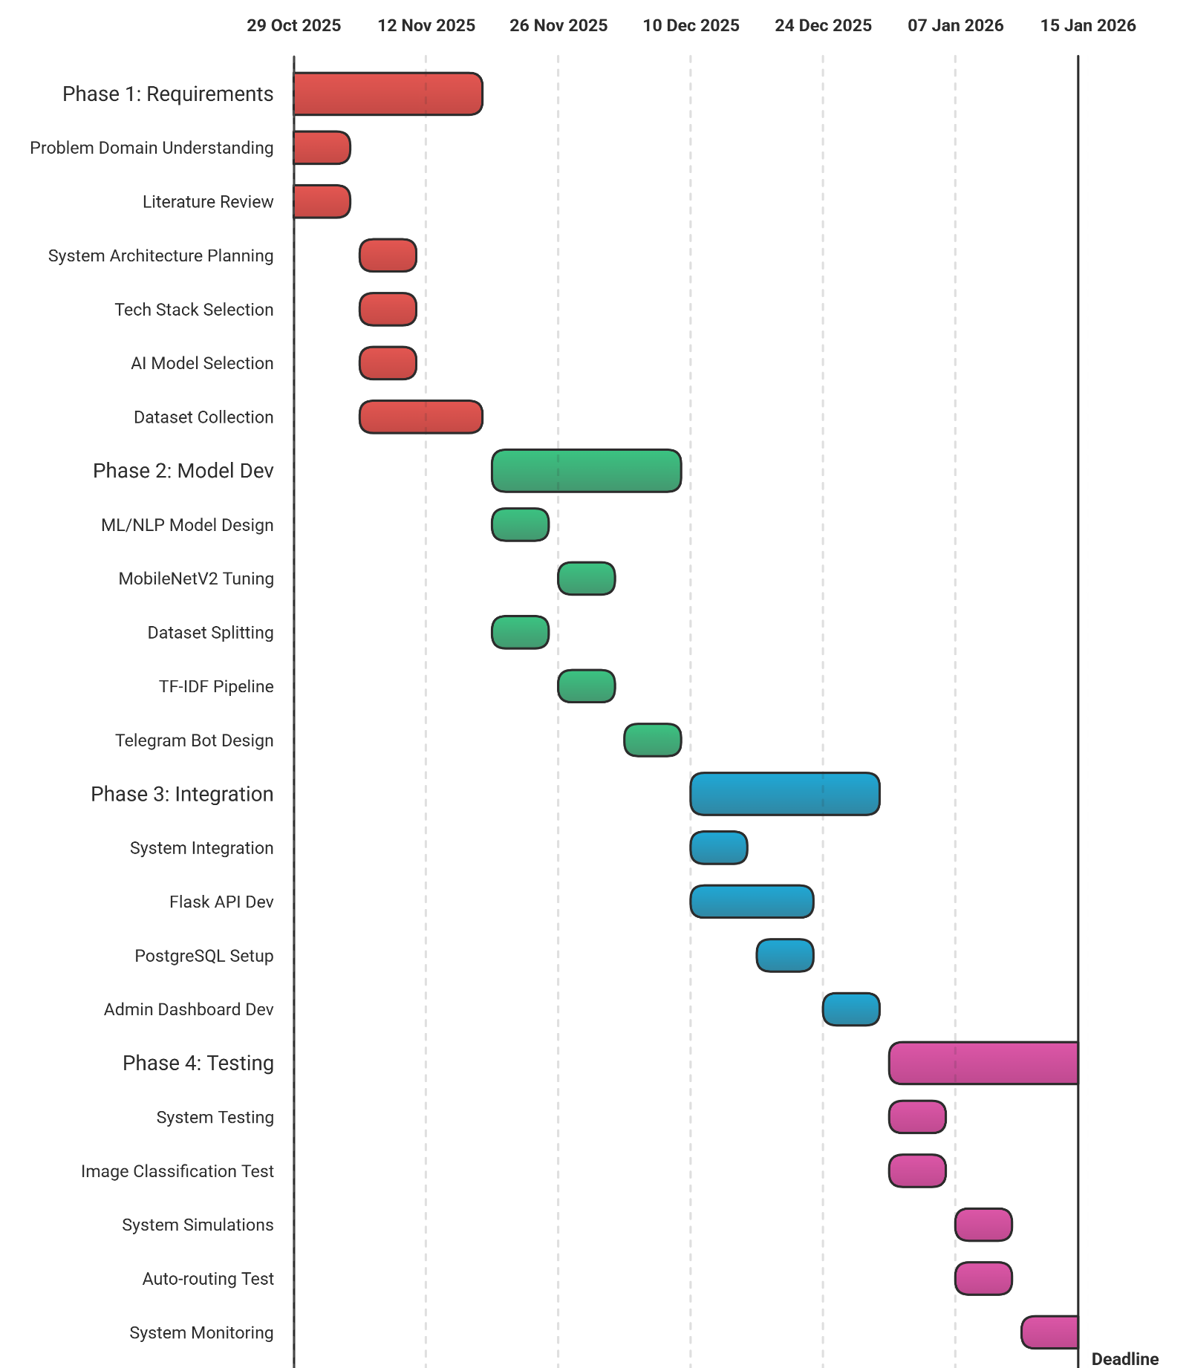
Figure 2: End-to-End Project Timeline

PROJECT EXECUTION

5.1 Planning and Design
The project started with extensive brainstorming sessions with the project team consisting of researchers, developers, and faculty advisors. Here, discussions were held to accurately comprehend the problems faced by a common citizen while reporting issues in an urban infrastructure. The literature survey inputs were analysed in detail, especially the finding that 78% of the complaints reported are unresolved, clearly indicating the gap in existing grievance redressal systems. This phase helped the team to pinpoint the exact problem areas within the lack of proper communication, delay in response, and inaccuracy in the present reporting system about location and visual information.
On the basis of ideas generated in brainstorming sessions, some initial designs were formed in which the overall layout of the system was established. The three-tier structure of the system was proposed by including a conversational interface in front of the system in form of a Telegram bot which allows users to register their complaints in a very easy interface form of a telegram bot by which users can send their complaint by typing commands in a telegram bot interface named "report". There was also a provision of image uploading by which users can attach photographs to register their complaint as evidence by attaching photographs of their complaint in form of a telegram bot interface named "report". The third tier of system structure was a dashboard in which all the reports received by the telegram bot interface named "report" could be analysed by which officials of a particular city can decide which complaint to process first in form of a telegram bot interface named "report".
The process of requirements gathering was highly influenced by the principles of Sustainable Development Goal 11 in regard to inclusive, safe, and sustainable urban development. To make it inclusive, for example, the design process placed a high emphasis on barrier-free access to ensure that citizens were able to rely on familiar tools for their needs instead of being forced to use complicated applications or undergo additional training. Several designs were developed over a two-week timeframe during which feedback from team members and advisors influenced the process. These designs helped enhance multi-modal input support in terms of text, image, and geo-location data inputs as well as improve the routing logic for automatic routing of complaints to authorities.

5.2 Implementation
The development of the proposed system was done by following an agile software development methodology. It is divided into several development sprints, and it is characterized by improvement and feedback on a constant basis with the objective of ensuring each system component was developed step by step and integrated smoothly, reducing risks and improving overall system quality.
The process began with the creation of a MVP, initial functional prototype for the Telegram bot, which turned out to be the primary interface through which complaints were registered. The Telegram bot was created using the python-telegram-bot library (version 20.7), with end-to-end communication capabilities such as the reception of messages, image uploads, and location information. The addition of capabilities such as the use of the inline keyboard interface and commands (such as /report) helped provide a smooth interface for users on how complaints can be registered. At the end of this stage, it was able to receive multi-modal input.
Moving on to the next phase, the artificial intelligence modules were implemented and integrated into the system as a whole. The MobileNetV2 neural network model was fine-tuned using a dataset of civic issues of more than 3,000 images in order to classify them accurately. At the same time, a TF-IDF and spaCy library-based NLP service was also implemented to identify civic issues on the basis of text descriptions, as well as identify their urgency. The AI modules were also integrated into the system by means of Flask REST APIs.
The backend infrastructure was developed in Flask, and PostgreSQL database with spatial indexing enabled efficient storage and retrieval of complaint data along with location information. Throughout the development process, prototypes evolved from a basic intake system to a complete full-stack solution. This included an administrative dashboard complaint status tracking using a unique complaint ID, and confidence-based routing logic. A confidence threshold of 0.75 was applied to the system, which automatically processes and routes approximately 85% of complaints. In the course of implementation, repeated testing was done using simulated complaint data to ensure that all system components worked together seamlessly and that the planned procedures were executed correctly.

TOOLS AND TECHNIQUES USED

6.1 Tools
The Telegram Bot API: Python-Telegram-bot, version 20.7 serves as the major interface of the system, allowing citizens to file complaints in a simple and intuitive chat system. Users are able to file complaints using commands such as "/report" and image and geo-location submission to ensure that complaints are accurate and detailed. The system also uses the Telegram system, thus doing away with the need to develop a mobile app, as the system is easily and readily accessible to a vast number of people, in addition to providing immediate responses to users.
MobileNetV2: Implemented using TensorFlow 2.15, performs image classification of the civic issue photographs uploaded by the user. It is a lightweight deep learning model with about 3.5 million parameters; thus, it perfectly fits fast and efficient processing. After processing, the obtained image falls into one of the eight different categories of urban infrastructure problems such as damaged concrete structures, electric poles, road signs, fallen trees, garbage dumping, graffiti, illegal parking, potholes and electrical power outage and ensures complete accuracy in reliable image-based complaint analysis.
spaCy (version 3.7): Is employed as the natural language process tool for analysing the complaint text provided by the users. It is of great help to the system in making it comprehend the user descriptions conveyed in simplified language. It is capable of efficiently extracting the relevant data necessary for detect urgency and categorization from the complaint text, which is unstructured.
TF-IDF: Developed through scikit-learn, helps to represent complaints in numbers to be easily analysed. This process helps to identify key words and phrases in complaints that display their level of importance regarding the grievances raised. Key features are used in automatic complaint prioritization as well as enhance accuracy in complaints analysed through text.
Flask framework: Is utilized to build RESTful backend APIs that help to integrate the Telegram bot, AI models, database, and visualization dashboard. It also takes care of major operations like the submission of complaints, their processing, routing to respective departments, and updating of status. As a middle stage of communication, it ensures that the system components work seamlessly together.
PostgreSQL Database: Offers a secure and scalable platform for the storage of all types of complaint information, including text, image, timestamps, geo-locations, and the status of a complaint. The PostgreSQL database has the ability to perform spatial indexing thus simplifying organization process of all the complaints. The PostgreSQL database has a scalable architecture that supports organized, secure, and efficient storage for all types of complaints.
HTML: To create an Administrative Dashboard which is an online portal that is used by the local authority to efficiently track and manage the complaints. The complaints are on the Administrative Dashboard, and it is easy to pinpoint areas of complaints. The online portal also provides role-based access to guarantee that the privacy of the data is maintained, and there is also full tracking of complaints from start to completion.
The data flow process of the suggested system starts with the sending of complaints by the citizen through the use of the Telegram bot and the /report command. This allows the citizens to send complaints accompanied by images as well as the citizens’ geo-location through the use of the Telegram geo-location feature, ensuring the complaints are comprehensive. The complaints are then relayed to the backend server through the use of the Telegram bot API and the Flask webhook, where the data is filtered according to the nature of the complaints and directed accordingly. The text complaints are directed to the NLP process by spaCy and TF-IDF, while the images are directed to MobileNetV2 for categorization according to predefined categories of civic complaints, and the resultant complaints from the AI responses are merged and directed either to the respective department depending on the level of certainty.
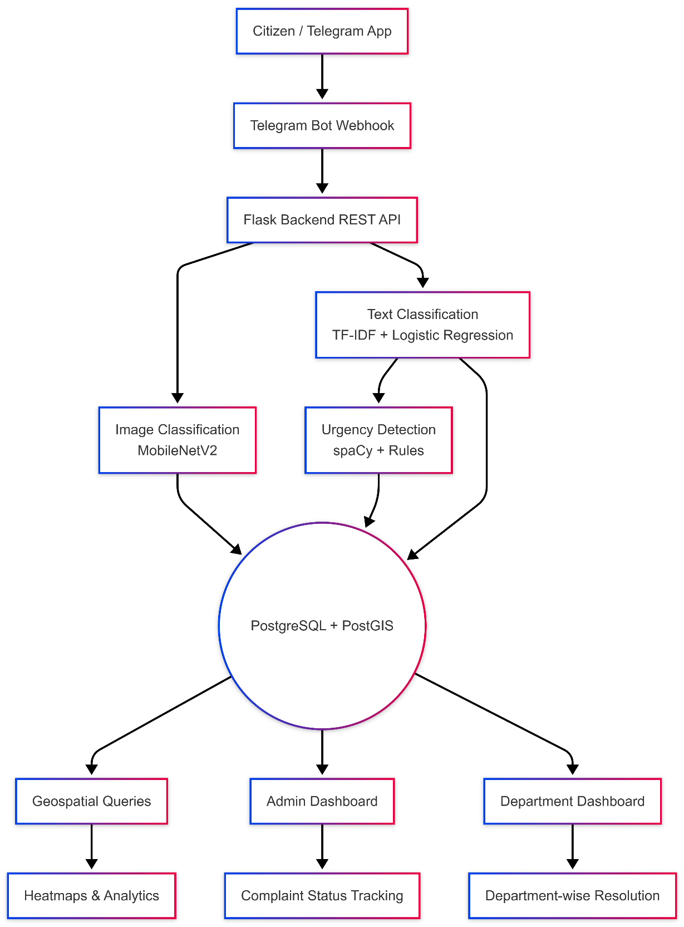
All data from complaints, including text data, images, location information, AI predictions, and status updates, are safely retained in a PostgreSQL database with spatial indexing to efficiently query and display location-based data. Such data can then be displayed on the administrative dashboard for interactive viewing by officials to display complaints for status display and resolution management. All resolutions or update actions by concerned authorities are then reflected back to citizens via the Telegram bot for transparency and immediate update notifications for users.
Figure 3: A workflow diagram illustrating the architecture featuring the dual-pipeline process

6.2 Techniques
The image classification part of the system is developed by fine-tuning the MobileNetV2 model on the dataset of images of civic issues. The images were pre-processed by resizing the images, normalizing the pixel values, and techniques such as rotation, flipping, and brightness adjustment were used. The dataset is divided into test, validation, and train sets, and the training of the model is carried out by standard loss functions and optimizers. MobileNetV2, with depth-wise separable convolutions, is very efficient at extracting the features of urban infrastructure patterns and can be applied in real-time through the Telegram bot due to its lighter nature as compared to other complex models.
In the case of text complaints, the used technology was TF-IDF vectorization with spaCy to handle the user description entered. The process of pre-processing the text entailed lemmatization and stop-word removal, ultimately extracting structured features from unstructured complaints to help the system evaluate complaint categories and urgency levels. The system relied on comparison and rules regarding critical complaints defined by templates and keywords to emphasis critical complaints. The used NLP solution in the system was selected owing to its high speed in handling short complaints.
In this way, a mechanism of confidence thresholding automatically routed high-confidence predictions to the proper municipal departments, while ambiguous cases were flagged for manual review. It ensured efficient processing without sacrificing accuracy in complaint handling. Participatory sensing was also integrated into the system, fusing citizen-submitted geo-tagged data with spatial indexing. This allowed municipal authorities to identify problem areas and plan interventions effectively. By leveraging citizen participation rather than relying on expensive sensors, this approach remains scalable, practical for dense urban environments, and faithful to principles of Sustainable Development Goal 11 on inclusive and sustainable cities.

PARTIAL RESULTS

7.1 Initial Findings
Initial prototype testing was quite informative on the performance and potential for upgrades of the system. The image classification component of the system, which uses MobileNetV2, was able to classify correctly the vast number of civic problems like potholes, waste accumulation, and damaged street lights. Notwithstanding, it was somewhat challenged in identifying issues that may look the same in the image, like uprooted trees and littered waste. This indicated the need to fine-tune the system to enhance the accuracy of classification of the various images.
The text-based urgent issue detection system, which employed both TF-IDF and spaCy, worked effectively in picking urgent issues with priority words such as “emergency” or “danger.” The system was able to detect urgent issues effectively in order to make sure that important issues in complaints were given priority. However, in testing, it has been discovered that the system has limitations in processing informal language, abbreviations, or colloquial expressions used by citizens to complain.
The interface test conducted on the Telegram bot interface proved the intake process to be relatively seamless and user-friendly. Submission of the complaint in text format, image form, or geo-location data was easy and hassle-free for the citizens. There was, however, a small percentage of users who faced some issues in the usage of the inline keyboards or the command flow, causing some of them to drop out. The test on the prototype interface indicated the system to be functional and quite promising while pointing to areas of refinement in the AI technology to make the system complete.

7.2 Iterative Improvements
After the completion of initial prototype testing, some changes were made to improve both the accuracy of the AI algorithm as well as user interface experiences. In the case of image classification, some methods of data augmentation, including image rotation, horizontal flipping, and changes in image brightness, were added to improve the algorithm’s resistance to lighting conditions and angles. Furthermore, fine-tuning, or focusing on specific learning experiences where the appearance of downed trees and garbage might look alike in an image, also reduced instances of improper classifications. Training the algorithm for a longer period also increased its accuracy in properly flagging a broad range of civic problems.
Improvements for text-based urgency detection involved enhancement around informal language. The incorporation of spaCy lemmatization techniques with cosine similarity values for defining danger templates allowed for better urgent complaint detection. The improvements helped optimize critical complaint flagging in an efficient manner such that urgent civic issues received priority regardless of their description being in formally structured formats only. The updates made it possible to have better urgent complaint detection even in text form.
The user interface and system workflow were also improved. The process of submitting a complaint was streamlined into a three-step process: the user types /report, uploads a picture, and submits the complaint. The confidence thresholding technique was used to automatically direct complaints with high confidence to the appropriate city agencies, which greatly reduced the number of complaints that were not fully submitted. The complaint information was also connected to the PostgreSQL database and displayed on the administrative interface, which enabled administrators to preview complaints. All these improvements ensured that the AI models and user interfaces were optimized for the system to be ready for full deployment.

RESULTS AND DISCUSSION

8.1 Final Results
Final testing of the system was carried out on a set of 500 held-out images to evaluate the performance of the MobileNetV2 image classification model. The system achieved a weighted accuracy of 93.36% across the eight different categories of urban infrastructure problems such as damaged concrete structures, electric poles, road signs, fallen trees, garbage dumping, graffiti, illegal parking, potholes and electrical power outage. Among the categories, road signs showed the highest performance, followed by electric poles and potholes, while garbage classification was slightly lower due to visual clutter and overlapping elements in images. These results confirmed that the model was highly effective at recognizing a variety of urban infrastructure issues while highlighting areas that may require further refinement for visually complex cases.
For text-based complaint analysis, TF-IDF and spaCy were used to detect urgency in 500 text samples. The system achieved an F1-score of 99.83%, successfully identifying high-priority complaints for rapid action. Using a confidence threshold of 0.75, approximately 85% of complaints in a simulation of 3,056 reported cases were automatically routed to the correct municipal departments. Among the different types of complaints, fallen trees were the most frequent, making up 11.78% of the total cases, followed by issues such as potholes, garbage accumulation, and damaged streetlights.
The backend and visualization components of the system also proved highly effective. Complaint data was stored securely in PostgreSQL with spatial indexing allowing municipal officials to identify problem hotspots and plan interventions more efficiently. Simulated resolution times using this system were reduced by compared to traditional methods, which often took 24–48 hours. Overall, the final results confirmed that the system was accurate, reliable, and capable of fast, automated, and location-aware complaint handling, supporting both citizens and authorities in managing urban infrastructure issues efficiently.
Table 1: Classification performance metrics on test data over eight categories of urban infrastructure problems by MobileNetV2.
Issue Category | Accuracy | Precision | Recall | F1-Score
Damaged concrete structure | 0.8889 | 0.9302 | 0.8889 | 0.9091
Damaged electric poles | 0.9778 | 0.9167 | 0.9778 | 0.9462
Damaged road sign | 0.9767 | 1.0000 | 0.9769 | 0.9882
Fallen trees | 0.9111 | 0.9318 | 0.9111 | 0.9213
Garbage | 0.9500 | 0.8261 | 0.9500 | 0.8837
Graffiti | 0.9091 | 0.9639 | 0.9091 | 0.9357
Illegal Parking | 0.8953 | 1.0000 | 0.8953 | 0.9448
Pothole Road Crack | 0.9512 | 0.9070 | 0.9512 | 0.9286
Macro Average | 0.9325 | 0.9345 | 0.9325 | 0.9322
Weighted Average | 0.9336 | 0.9377 | 0.9336 | 0.9342
Table 2: Simulated complaint frequency distribution concerning the categories of issues
Issue Category | Count | Percentage (%)
Damaged concrete structure | 297 | 9.72
Damaged electric poles | 299 | 9.78
Damaged road sign | 300 | 9.82
Fallen trees | 360 | 11.78
Garbage | 300 | 9.82
Graffiti | 300 | 9.82
Illegal Parking | 300 | 9.82
No Electricity | 300 | 9.82
Pothole Road Crack | 300 | 9.82
Water logging | 300 | 9.82
Table 3: TF-IDF Vectorization and Urgency Detection Using spaCy Performance on Labelled Complaint Descriptions Showcase High Precision for Automatic Prioritization.
Metric | Value
Accuracy | 0.9983
Precision | 0.9984
Recall | 0.9983
F1-Score | 0.9983

8.2 Discussion
The results of the project show that all the primary and secondary objectives were successfully achieved. The multi-modal complaint reporting framework using Telegram functioned as intended, allowing citizens to submit text, images, and location data with ease. The AI-based classification engine, RESTful backend services dashboard were fully operational and worked together as a complete system. Through iterative improvements and fine-tuning, the system’s performance improved significantly from the initial baseline accuracy of 82%, demonstrating the effectiveness of the chosen design and development approach.
The findings have important implications for Sustainable Development Goal 11, which focuses on building safe, inclusive, and sustainable cities. In fast-growing and resource-constrained cities such as Bengaluru, where studies indicate that 78% of civic complaints remain unresolved, traditional manual systems are no longer sufficient. This project demonstrates how scalable AI-based solutions can reduce dependency on manual processing while increasing citizen participation. By using a familiar and widely used platform like Telegram, the system lowers the barrier to reporting civic issues and encourages broader public involvement in urban maintenance.
An important observation from the results was the strong performance of the text-based urgency detection system, which helped compensate for limitations in image classification for visually ambiguous categories. This highlights the value of a hybrid approach that combines computer vision and natural language processing for real-world deployments. The use of confidence thresholding also proved effective, enabling automated handling of a large portion of complaints while ensuring that uncertain cases were reviewed by humans. This balance between automation and oversight makes the system practical, reliable, and suitable for deployment in real municipal environments.

PROTOTYPE

9.1 Prototype Description
The SnapFix prototype is a fully functional end-to-end software system designed to support efficient civic complaint reporting and management. The system consists of three main components: a Telegram bot frontend for citizens, an AI-powered backend for processing complaints, and a web-based administrative dashboard for municipal authorities. The prototype is flexible in deployment and can run on standard cloud servers or local machines, requiring only minimal hardware resources such as 4GB RAM and a standard CPU or GPU, making it practical for use by resource-constrained municipalities.
From the citizen’s perspective, the prototype offers a simple and user-friendly reporting process. Complaints can be submitted in three clear steps using the Telegram bot: first, the user initiates reporting with the /report command; second, a geo-tagged image of the issue is uploaded; and third, a short text description is provided. This multi-modal input ensures that each complaint contains sufficient context for quick understanding and action. Once submitted, the system automatically analyzes the complaint, classifies it into one of eight predefined civic categories and evaluates its urgency level.
On the administrative side, the prototype provides a web-based dashboard designed for efficient grievance management. The dashboard supports role-based access, ensuring that only authorized officials can view or act on specific complaints. Complaints are displayed allowing authorities to identify problem hotspots across different wards or regions. Department-wise queues, real-time status updates, and full complaint lifecycle management—from submission to resolution—are supported within the interface. All complaint data is securely stored and managed using PostgreSQL with spatial indexing and reliable data handling. Overall, the SnapFix prototype demonstrates a scalable, low-cost, and practical solution for improving urban grievance redressal systems.

9.2 Development Process
The SnapFix system was developed over a 12-week agile cycle with phased and iterative progress. In the initial weeks, the Telegram bot was implemented using python-telegram-bot v20.7 and datasets containing 3,000+ civic issue images were collected. This was followed by the development of AI components, where the MobileNetV2 image classification model and a TF-IDF-based text analysis pipeline were built. Early testing revealed confusion between visually similar categories such as garbage and fallen trees, with initial accuracy around 82%, which was improved through targeted data augmentation and extended training. In the later stages, Flask REST APIs were integrated with a PostgreSQL database to support complaint storage, routing, and visualization, while the administrative dashboard was refined and tested. Performance challenges such as Telegram webhook latency were resolved using asynchronous processing, and user interface issues related to inline keyboards were addressed by simplifying the workflow into a three-step process, improving user completion rates from 85% to 97%. By the end of the development cycle, the system was fully integrated, stable, and ready for deployment.

9.3 Testing and Validation
The SnapFix prototype was thoroughly tested and validated using 500 held-out images and 3,056 simulated complaint cases to evaluate its accuracy, reliability, and usability. The image classification model achieved 93.36% accuracy, while the system successfully auto-routed 85% of complaints using a confidence threshold greater than 0.75, significantly reducing the need for manual intervention. Compared to traditional grievance handling systems, the prototype demonstrated a reduction in resolution time, highlighting its efficiency. Confusion matrix analysis identified 6.4% edge-case errors, mainly between garbage and fallen tree categories, which were effectively managed using a hybrid human–AI routing approach. Overall, the testing and validation results confirmed that the prototype is stable, practical, and ready for real-world municipal deployment.

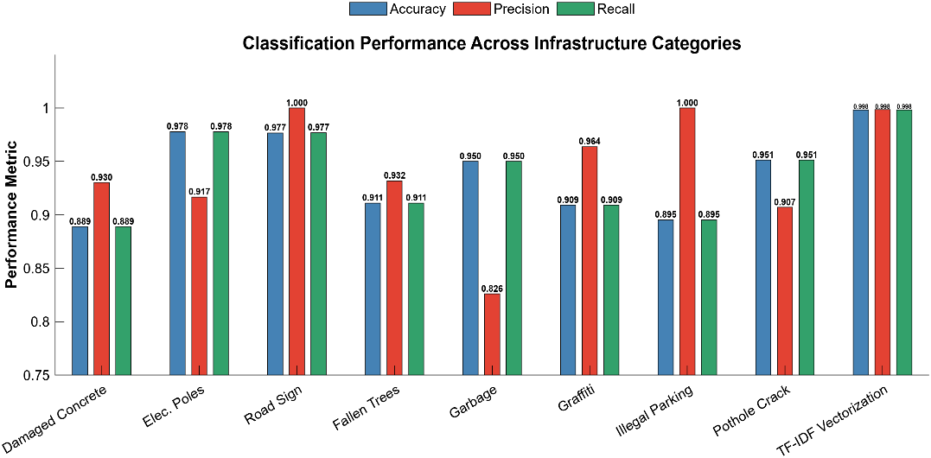
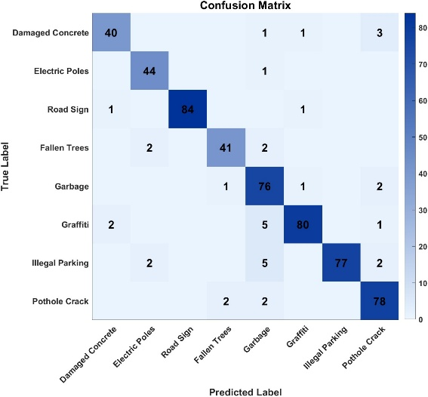
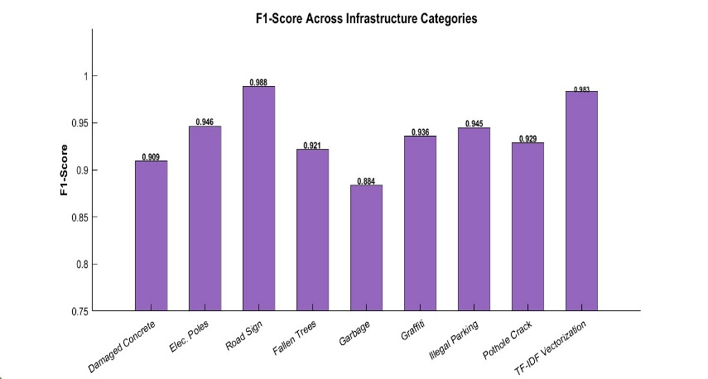
Figure 5: Multi-metric classification performance (accuracy, precision, recall) across infrastructure categories and NLP tasks

0.988

0.988

Figure 6: Confusion matrix for MobileNetV2 classification across eight urban infrastructure categories

Figure 4: F1-score performance across infrastructure categories

0.909

0.909
0.946

0.946
0.988

0.988
0.921

0.921
0.884

0.884
0.936

0.936
0.945

0.945
0.929

0.929
0.983

0.983

CONCLUSION

10.1 Summary
SnapFix successfully addresses the inefficiencies in urban infrastructure complaint handling by introducing a Telegram-based AI system that simplifies civic reporting through photo and text inputs. The system directly responds to the problem of 78% unresolved civic complaints by offering a fast, user-friendly, and automated solution. All project objectives were fully achieved, including the development of a multi-modal complaint intake framework, accurate AI-based classification with 93.36% image accuracy and 99.83% urgency detection, a RESTful backend supported by PostgreSQL, and real-time administrative dashboards. These components enabled 85% automatic routing of complaints and resulted in faster resolution times compared to traditional systems. The SnapFix prototype demonstrates strong alignment with Sustainable Development Goal 11 by promoting participatory urban maintenance, particularly in dense cities like Bengaluru, where citizen smartphones are transformed into scalable and effective tools for urban governance.

10.2 Personal Reflection
Working on the SnapFix project provided extensive hands-on experience in designing and deploying practical, resource-efficient AI systems for real-world urban challenges. The development process highlighted the importance of iterative refinement and continuous improvement, showing that model performance can be significantly enhanced through careful tuning and real-world testing rather than relying only on ideal or perfectly labelled datasets. The project deepened understanding of lightweight computer vision models for image-based civic issue detection and natural language processing techniques for handling informal, unstructured complaint text commonly used by citizens.
The project also strengthened skills in end-to-end system integration, connecting conversational user interfaces with AI pipelines and backend services. Working with Telegram-based reporting and Flask-backed APIs demonstrated how familiar platforms can be transformed into powerful civic engagement tools. Simplifying the complaint submission process reinforced the importance of user-centred design, showing how small interface changes can greatly improve participation and completion rates.
Beyond technical development, the project encouraged deeper reflection on the ethical and social aspects of AI deployment in public systems. It demonstrated how participatory sensing can empower citizens and improve transparency while supporting Sustainable Development Goal 11 by promoting safer, more inclusive, and responsive cities. Overall, SnapFix successfully bridged academic theory with real-world application, equipping the team with production-ready skills and a stronger appreciation of how technology can create meaningful and scalable social impact in smart city and governance initiatives.

VISUALS
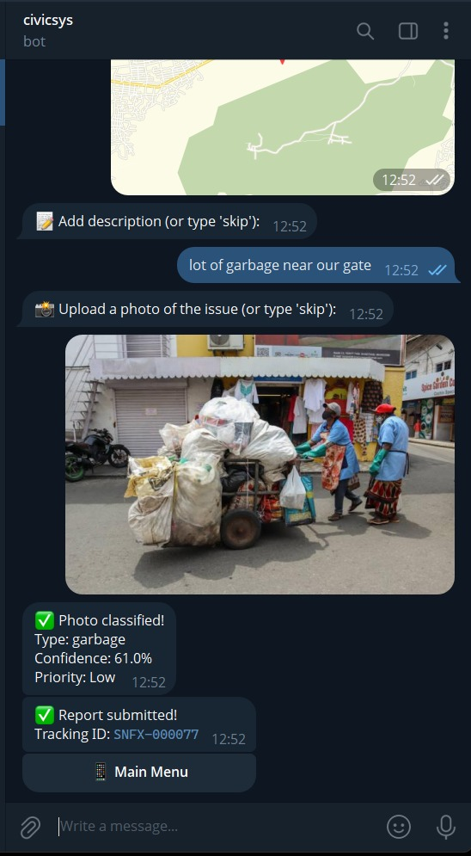

Figure 7: User interaction with the 'civics' Telegram bot. The interface demonstrates the complaint submission flow, where a citizen provides geo-location, a text description and a photo. The system responds with real-time classification results (Type: ; Confidence: ) and issues a unique Tracking ID.
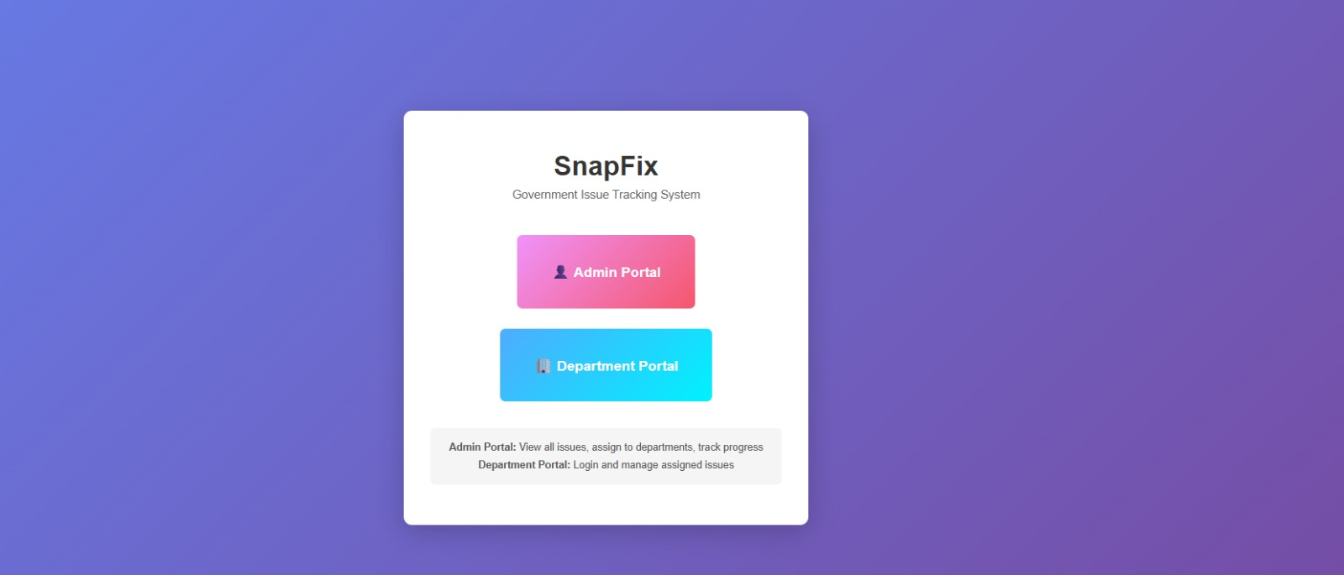
Figure 8: SnapFix Web Portal Entry. The landing page provides role-based access to the system, featuring distinct portals for Administrators
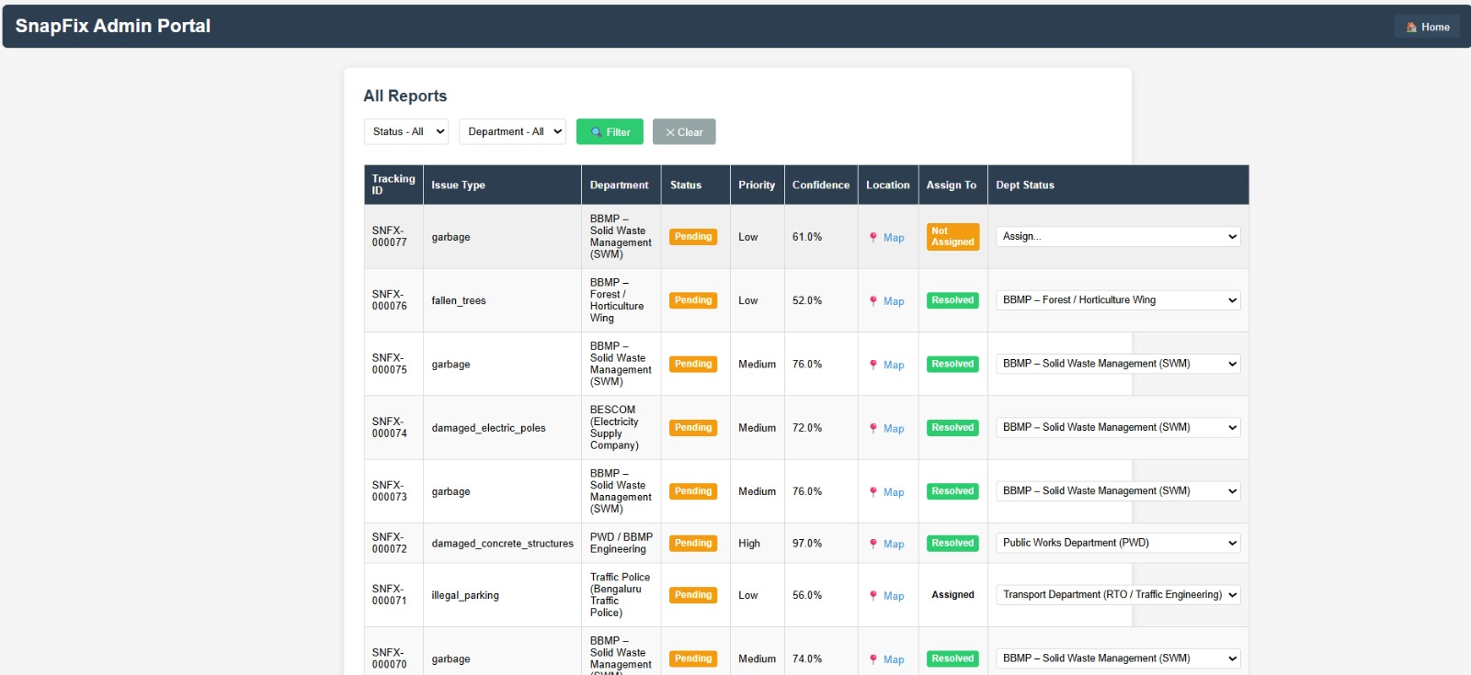
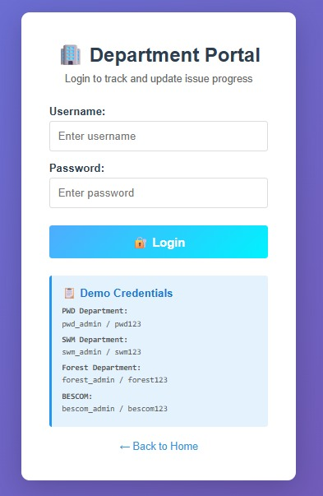
Figure 9: Admin Dashboard view of submitted reports. This interface aggregates citizen complaints

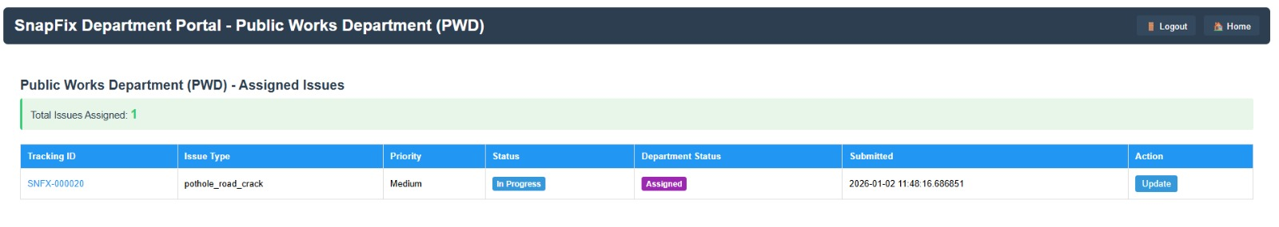
Figure 10: Departmental Task Resolution. This view enables specific officials to manage their respective complaints.
Figure 11: Department Portal Authentication. This secure login interface allows role-based access

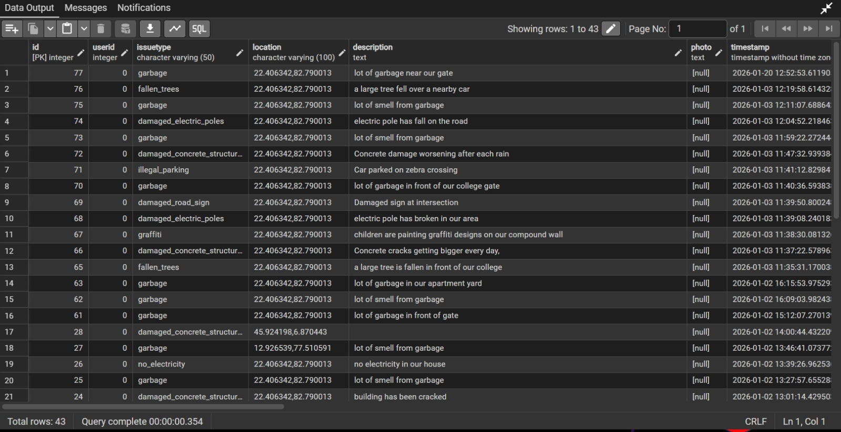
Figure 12: Backend Data Ingestion. A snapshot of the database records showing the variety of issues reported

OUTCOME OF THE WORK
The outcome of this work is oriented toward academic publication. The SnapFix system is being prepared for submission to npj Urban Sustainability, a Springer Nature Portfolio journal that focuses on sustainable urbanization, smart cities, digital technologies, urban data analytics, and inclusive governance. The proposed solution aligns closely with the journal’s scope by demonstrating the use of lightweight AI models integrated with a widely adopted messaging platform to enable participatory urban sensing and efficient civic issue management. Through automated complaint classification, urgency detection, spatial data analysis using PostgreSQL to reduced resolution times compared to traditional systems, the work contributes directly to Sustainable Development Goal 11, particularly in rapidly urbanizing regions such as Bengaluru. The prototype has been validated through extensive testing and simulation, making it suitable for interdisciplinary urban sustainability research, while also serving as a scalable, open-source foundation for future municipal adoption and product-level deployment, supported by complete technical documentation and evaluation results.

References
[1] IJCCT, “Digital grievance redressal for cleaner, smarter India: NLP-powered civic management system,” International Journal of Computer Communication Technology, vol. 12, no. 1, pp. 34–48, 2025.
[2] M. Katageri et al., “Automated management of pothole-related disasters using image processing and geotagging,” arXiv preprint, 2016.
[3] C. Caparrós Hernández, “The role of citizens in smart cities and urban infrastructures,” in Smart Cities and Construction Technologies, 2021.
[4] R. Low Cheng Young, F. Meskaran, and U. Eaganathan, “Public facilities feedback application: A location-based solution for Malaysian public facilities issues,” in Proceedings of the 2022 IEEE Conference on Computer Applications (ICCA), pp. 1–6, IEEE, 2022.
[5] M. Yaghi et al., “AI-powered collaborative geo-tagging and visualization of touristic and social activities on smartphones,” in Proceedings of the 2021 IEEE 3rd International Conference on Information and Communication Technologies (3ICT), IEEE, 2021.
[6] J. J. Yebes, D. Montero, and I. Arriola, “Learning to automatically catch potholes in worldwide road scene images using deep learning,” IEEE Intelligent Transportation Systems Magazine, vol. 13, no. 3, pp. 192–205, 2021.
[7] Y. Chen et al., “DeepLabV3+ for semantic segmentation in civic infrastructure monitoring,” Pattern Recognition Letters, vol. 165, pp. 89–97, 2023.
[8] A. Smalec, “Smart cities, smart governance: The role of citizen engagement in urban digital transformation,” Management Papers of Silesian University of Technology, vol. 15, no. 2, pp. 227–245, 2025.
[9] F. Maheen, “Development of smart complaint portal based on geotagging and proximity search for urban infrastructure management,” International Research Journal of Engineering and Technology (IRJET), vol. 5, no. 7, pp. 201–208, 2018.

