**ABAP Unit Testing**

**Top-Down Approach**

Execute transaction code **SE24** and Enter global class name ‘**ZCL_CALCULATOR’** and click on create button as below screen

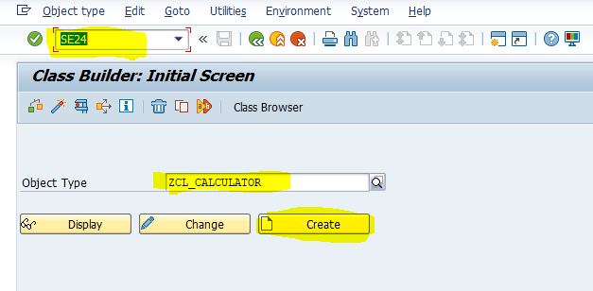

Enter description and click on save button

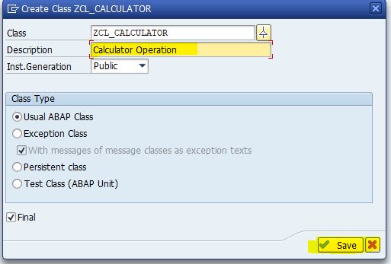

Then class look like as below screen

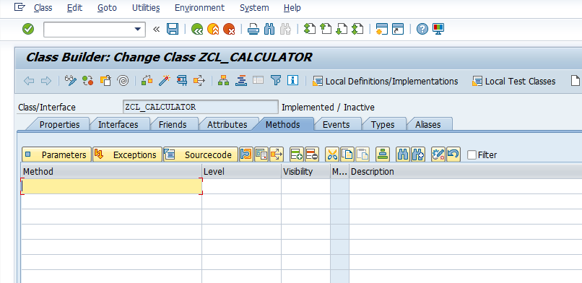

Enter Method ‘ADD’ as below

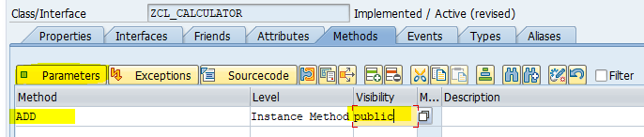

Click on parameter tab to enter importing and exporting parameter to method as below

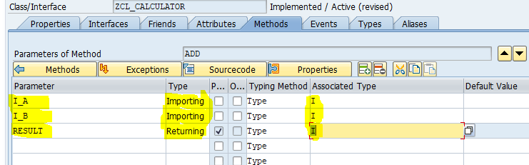

Click on active to activate class

Click on display object list button as below screen

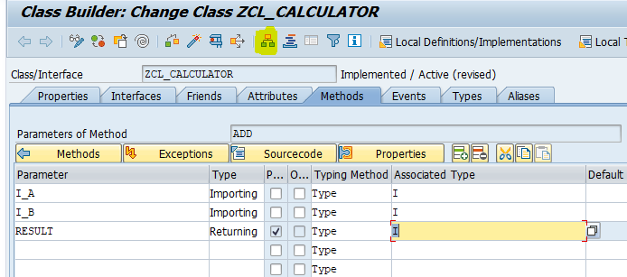

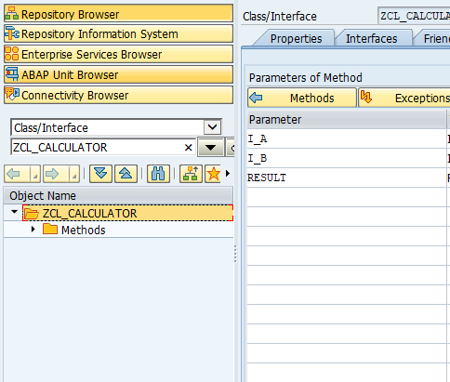

Right click on class ‘**ZCL_CALCULATOR’** and choose path Create->Generate Test class to create test class then below screen will appear

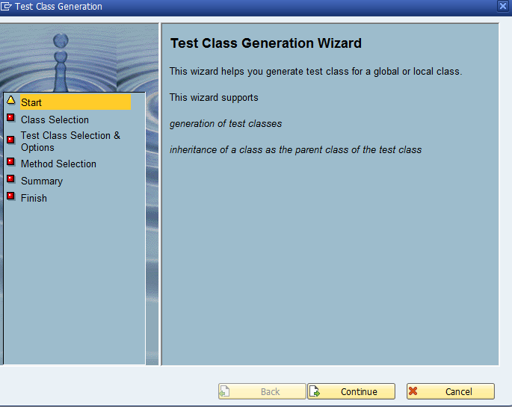

Click on continue button

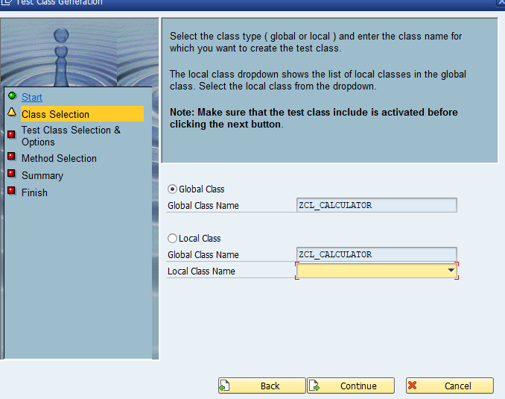

Don’t change anything and click on continue button

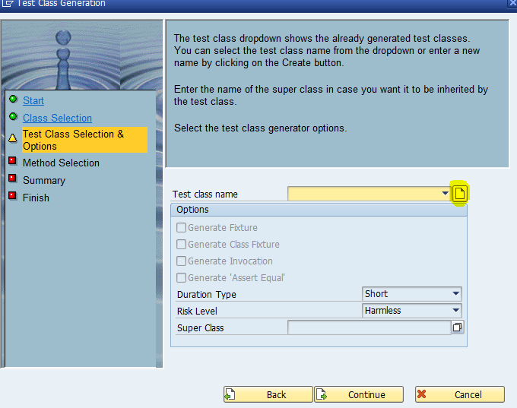

Click on create button to enter local test class name

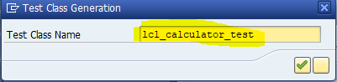

Click on continue button

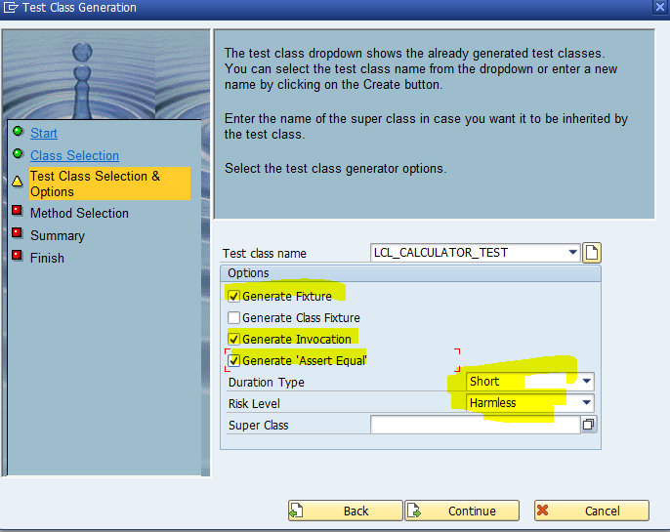

Select Generate Fixture, innovation and ‘**Assert_Equal’** checkbox and choose ‘**short**’ as duration type and ‘**Harmless**’ as Risk level and click on continue button

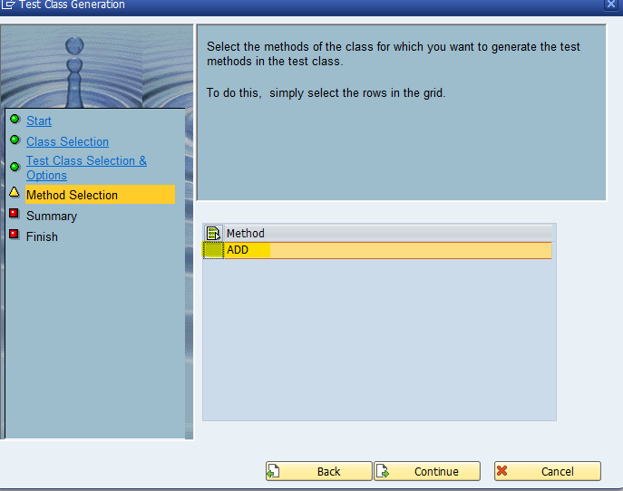

Select method ‘**ADD**’ and click on continue button then next screen will show as below with Global class, Local class, fixture method, duration and risk level and click on continue button

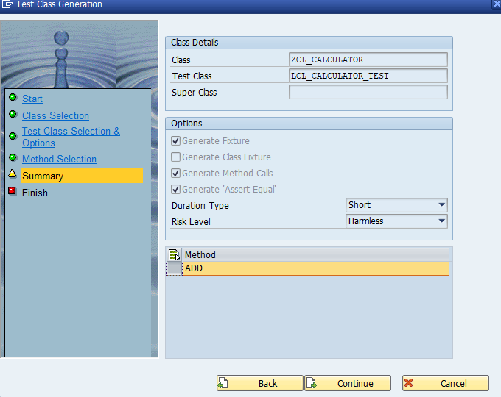

Click on complete button

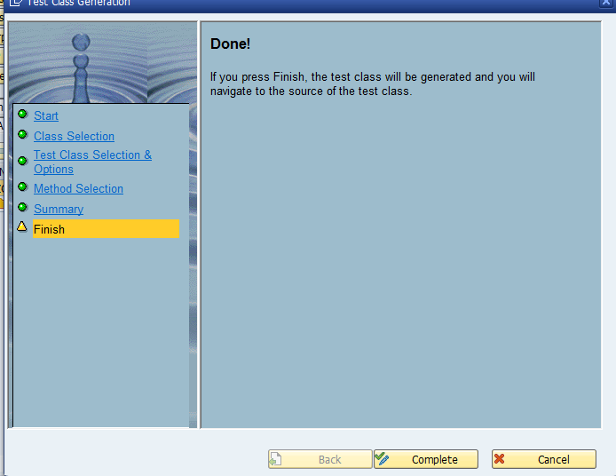

Then local test class will generate with required method as below screen

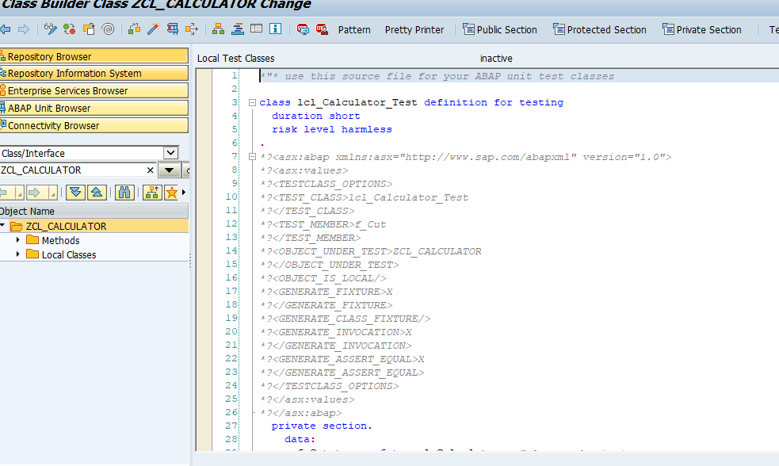

System generated test method ‘**ADD**’ in test class as below screenshot

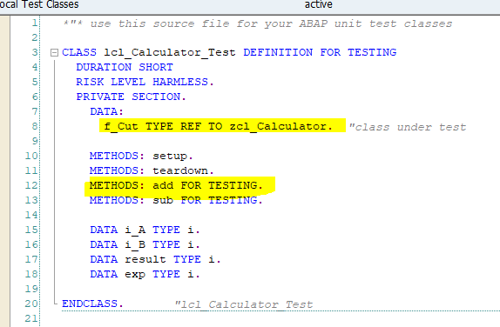

Object “**F_Cut**” is used to access method of product code

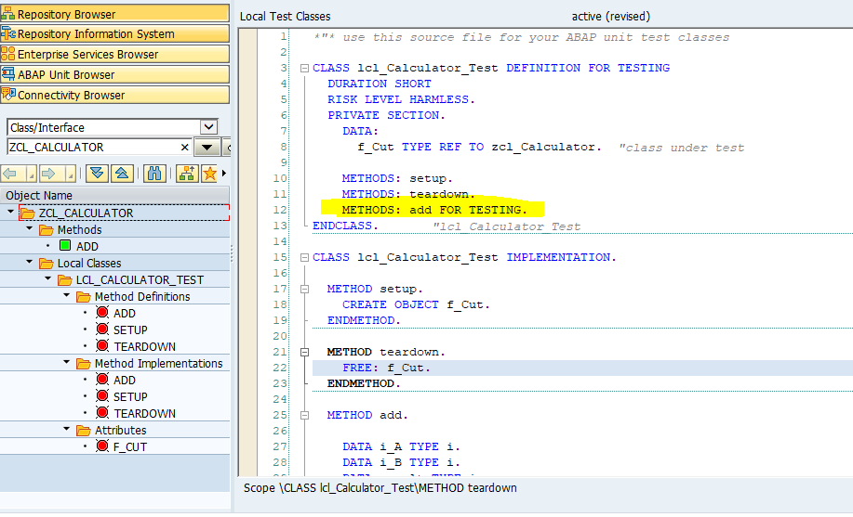

Pass the Given value as

I_A = 5, I_B = 2

Expected Result = 7

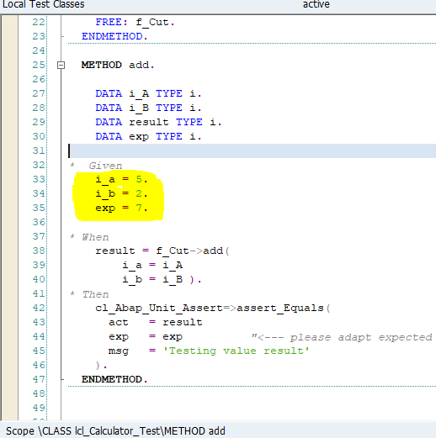

Execute test by shortcut ‘**Ctrl+Shift+F10**’ or Menu path ‘**Local test class->Execute->Unit Tests’**

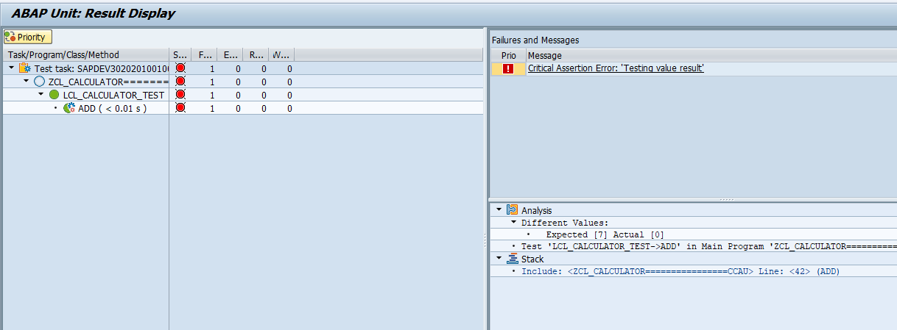

Unit test is fail because no logic inside the product method ‘**ADD**’

Refactor product method code to Pass test case as below

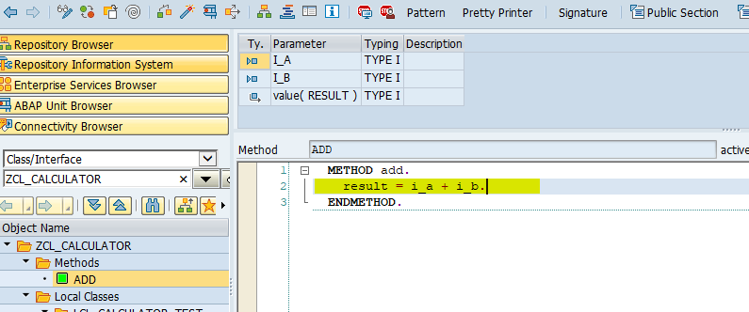

Activate class and run unit test then unit test case will pass

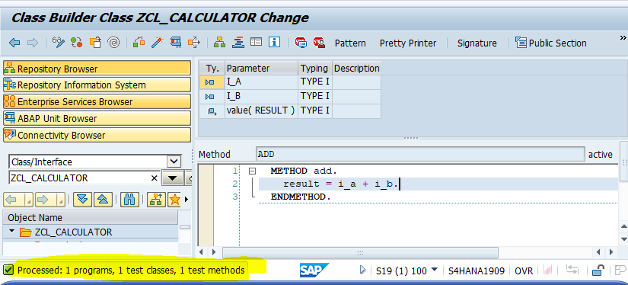

Add method ‘**SUB**’ for subtraction in product code class as below

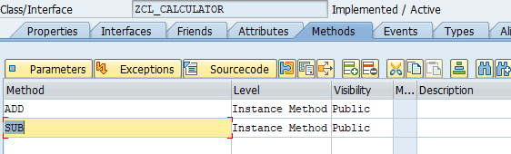

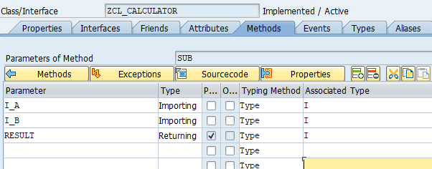

Click on ‘Local test class’ menu button to goes to test class

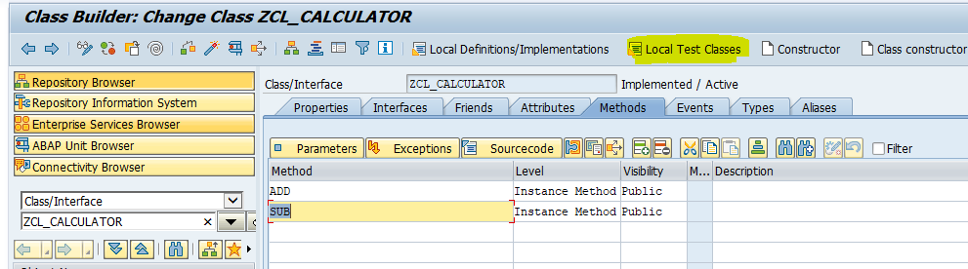

Add “**SUB**” test method in test class definition as below

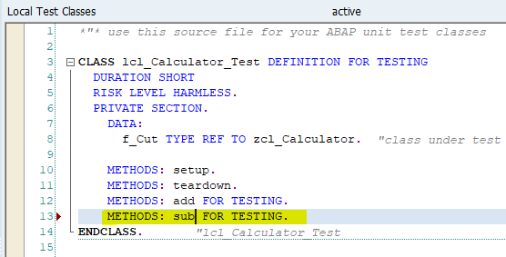

Implement ‘SUB’ method as below and pass Given value

I_A = 5, I_B = 2

Expected Result = 3

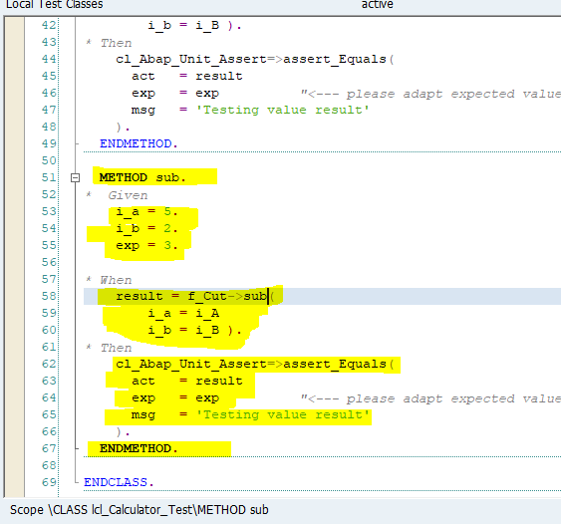

Execute test by shortcut ‘**Ctrl+Shift+F10’** or Menu path ‘**Local test class->Execute->Unit Tests’**

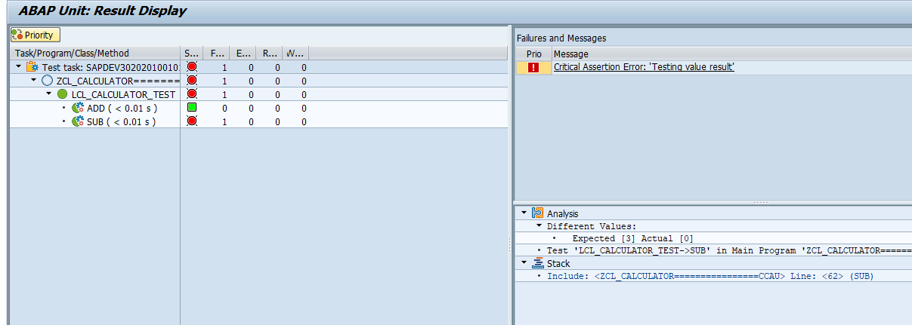

Test method ‘**SUB**’ fail because no product code written inside product method ‘**SUB**’

Refactor product method ‘**SUB**’ code to pass test case as below

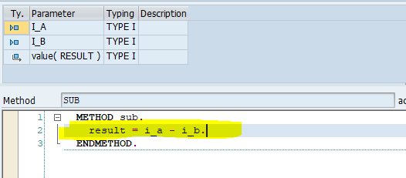

Execute unit test once again

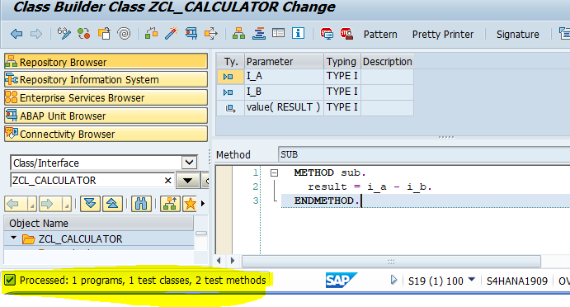

Now two test methods passed

Add method ‘**MULT**’ in product code for multiplication operation as below

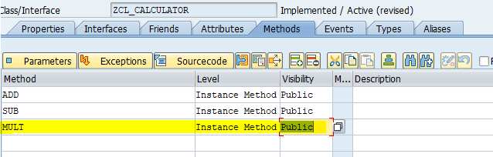

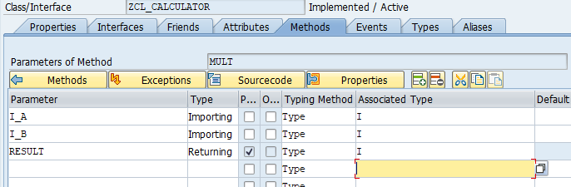

And activate class

Go to local test class and add ‘**MULT**’ test method in test class definition as below

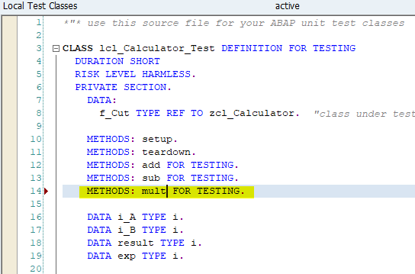

Implement test method ‘**MULT**’ as below

pass Given value

I_A = 5, I_B = 2

Expected Result = 10

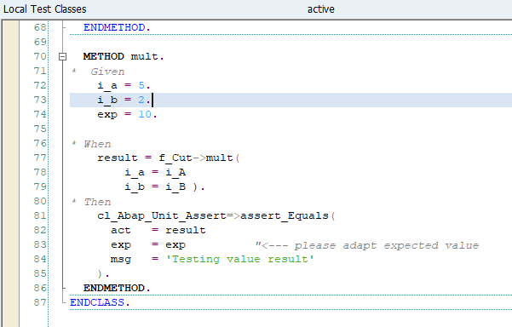

Execute test by shortcut ‘Ctrl+Shift+F10’ or Menu path ‘Local test class->Execute->Unit Tests’

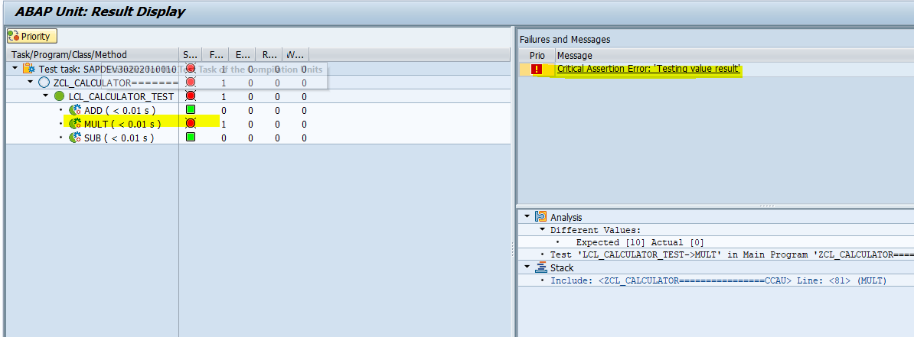

Test method **‘MULT’** is fail because no product code exist. Refactor product code method to pass test method **‘MULT’** as below

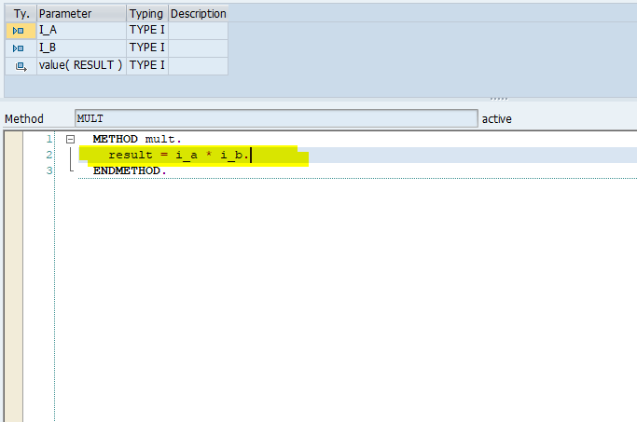

Execute unit test once again

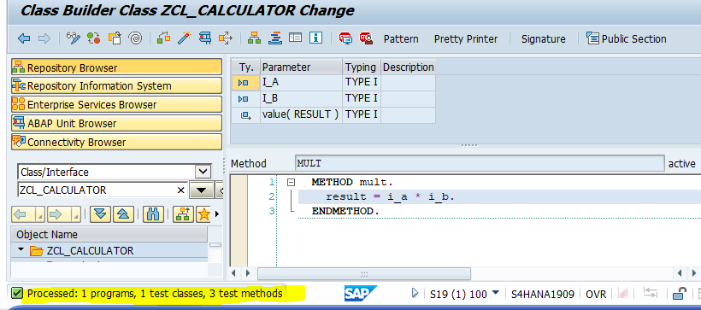

Now test method ‘MULT’ is passed

Add method **‘DIV’** in product code for multiplication operation as below

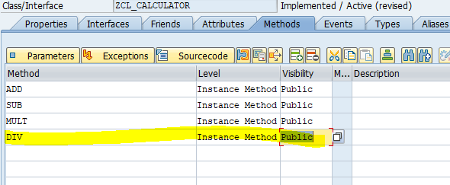

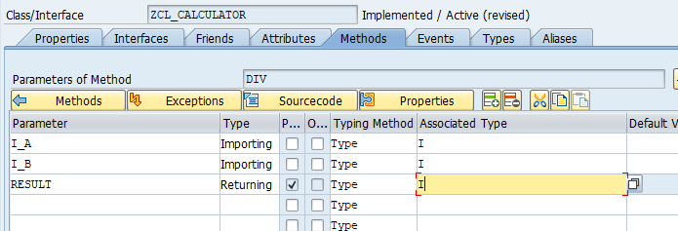

And activate class

Go to local test class and add ‘DIV’ test method in test class definition as below

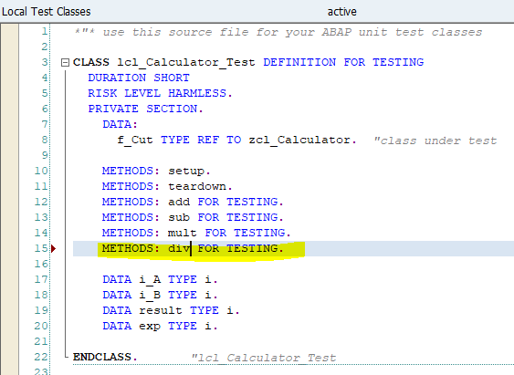

Implement test method ‘**DIV**’ as below

pass Given value

I_A = 6, I_B = 2

Expected Result = 3

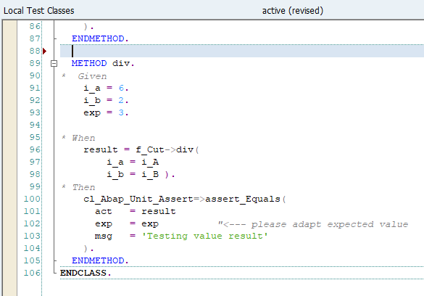

Execute test by shortcut ‘**Ctrl+Shift+F10’** or Menu path ‘**Local test class->Execute->Unit Tests’**

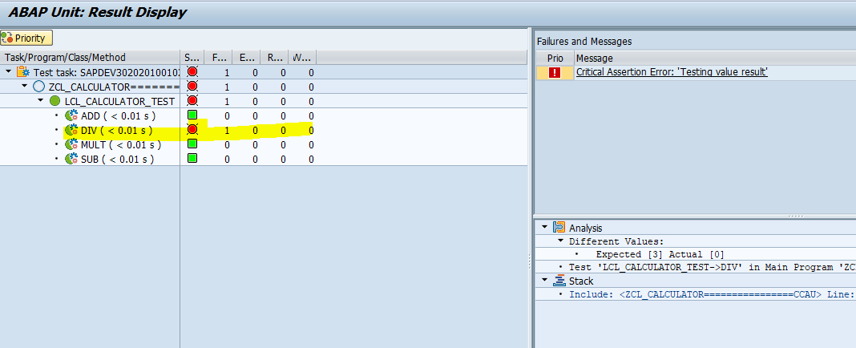

Test method ‘**DIV’** is fail because no product code exist. Refactor product code method to pass test method ‘**DIV**’ as below

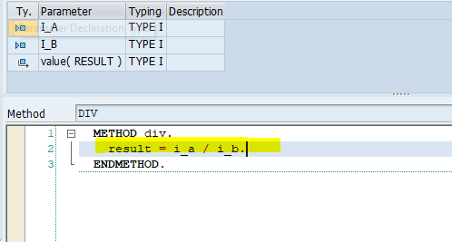

Execute unit test once again

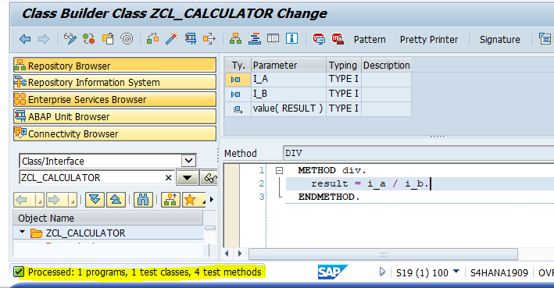

Now test method ‘**DIV**’ is passed

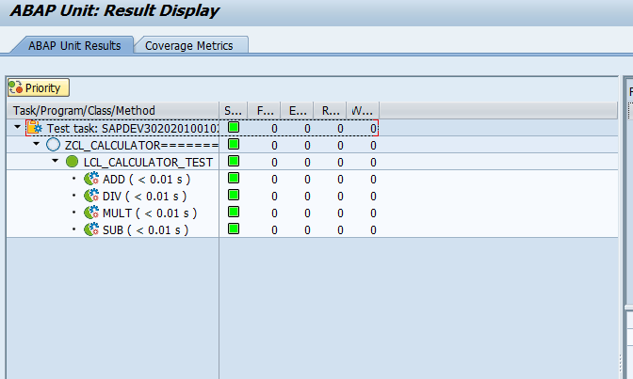

**Bottom-up Approach**

Execute transaction code SE24 and Enter class name ‘**ZCL_CALCULATOR1**’ and click on create button to create global class

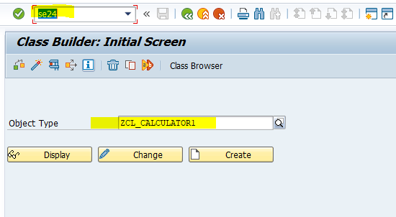

Enter class description and click on save button

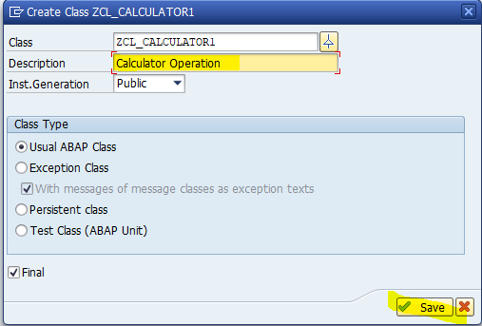

Then class look like as below

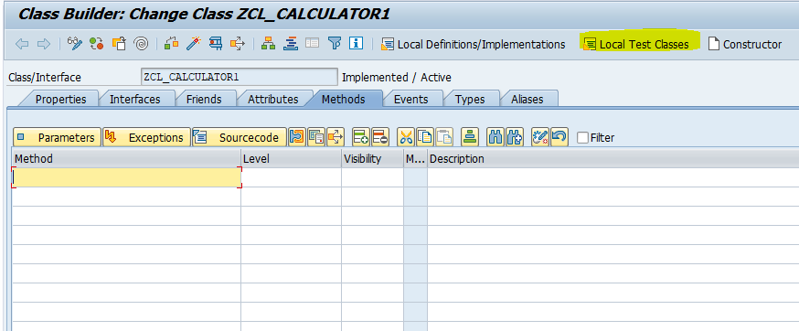

Click on Local Test Classes Menu button to write local test class

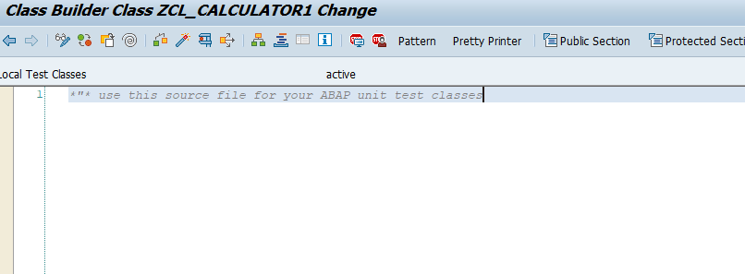

Write Local test class definition and implementation with fixture method as below

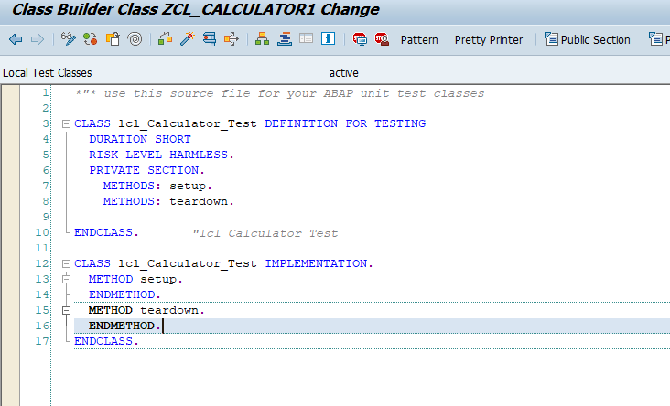

Add Test method ‘**ADD**’ in test class definition, implementation and pass Given data

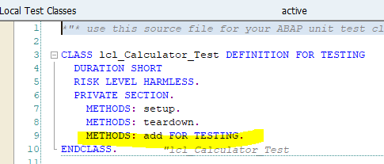

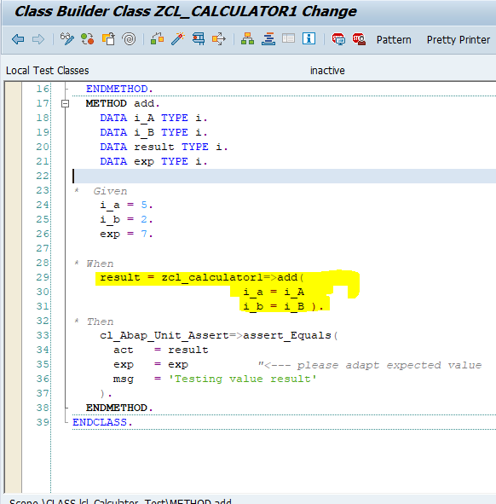

Double click on **ADD** method to create this method in product class

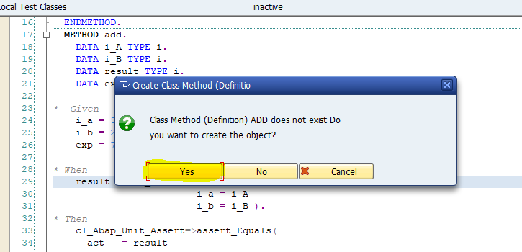

Click on Yes button

Enter Method description, Visibility as public and method as static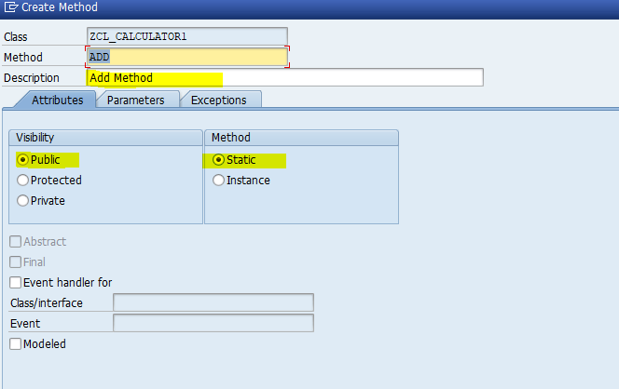

Enter parameter in parameter tab

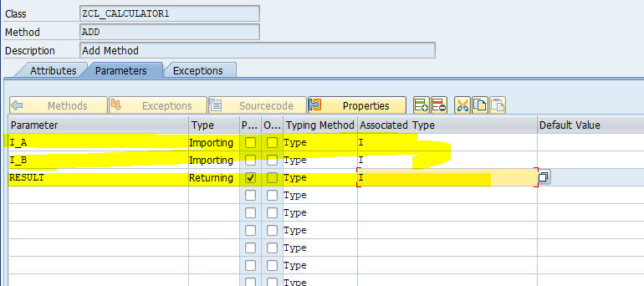

And click on create button

Now method “**ADD**” is added in product class

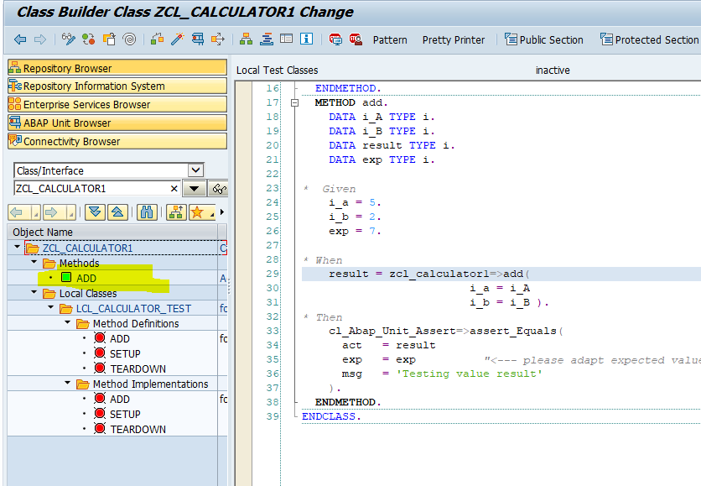

Activate class and Execute test by shortcut ‘**Ctrl+Shift+F10’** or Menu path ‘**Local test class->Execute->Unit Tests’**

Unit testing fail for **ADD** method because no product code exist in product method in product class

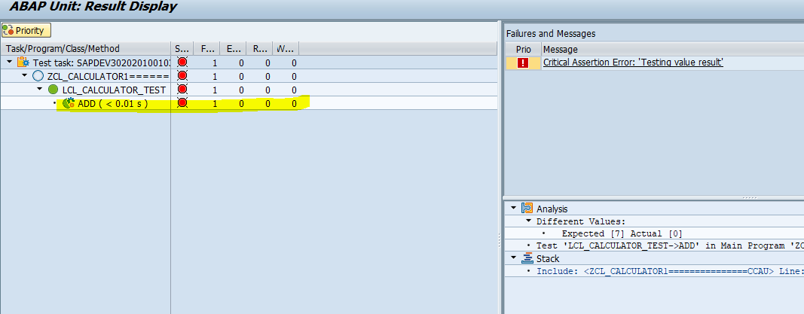

Refactor product method code to pass test case as below

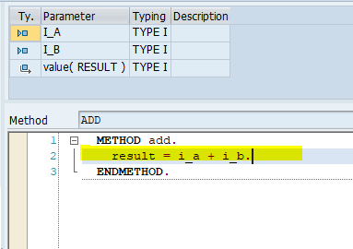

Execute unit test once again

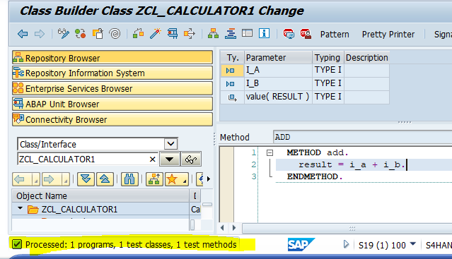

Now test case is passed

**Subtraction Operation**

Add Test method **‘SUB’** in test class definition, implementation and pass Given data

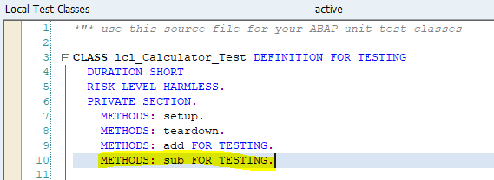

Add input and export into test class definition as below

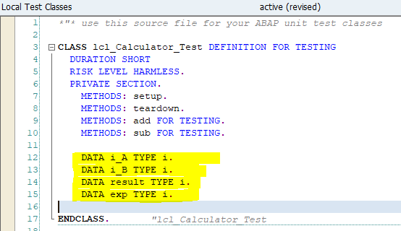

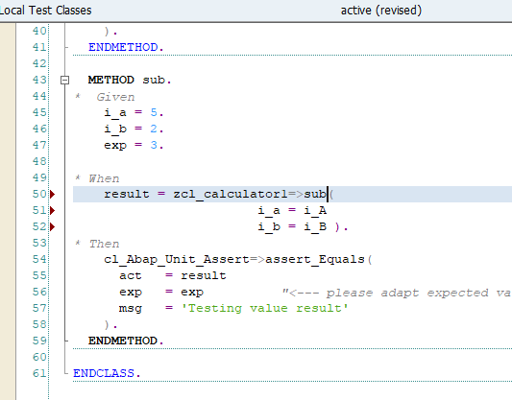

Double click on **SUB** method to create this method in product class

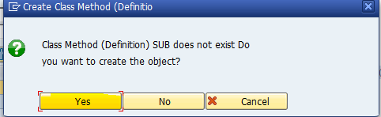

Click on Yes button

Enter Method description, Visibility as public and method as static 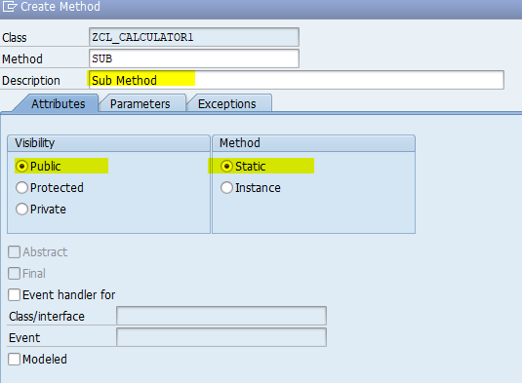

Enter parameter in parameter tab

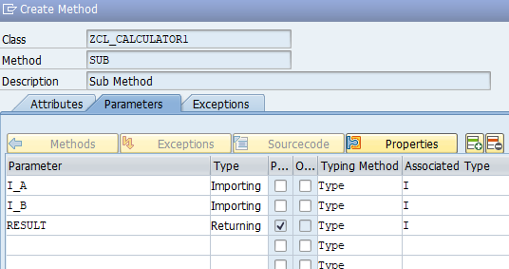

And click on create button

Now **SUB** method is added in product class

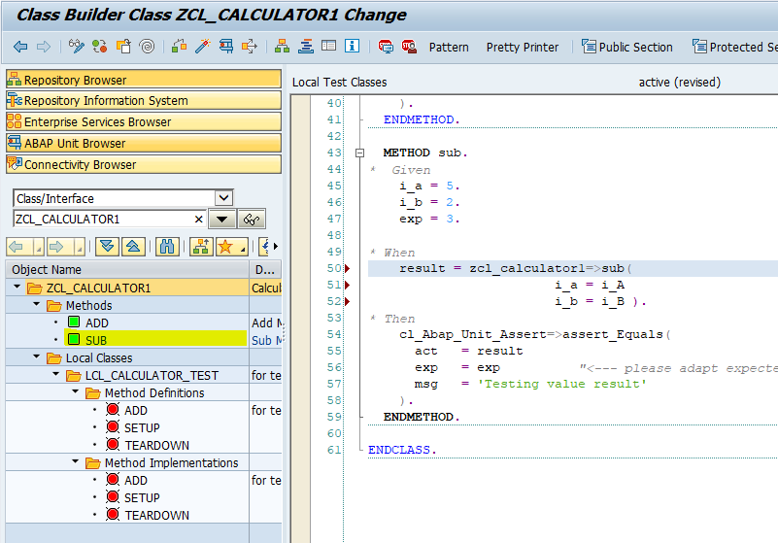

Activate class and Execute test by shortcut ‘**Ctrl+Shift+F10’** or Menu path ‘**Local test class->Execute->Unit Tests’**

Unit testing fail for **SUB** method because no product code exist in product method in product class

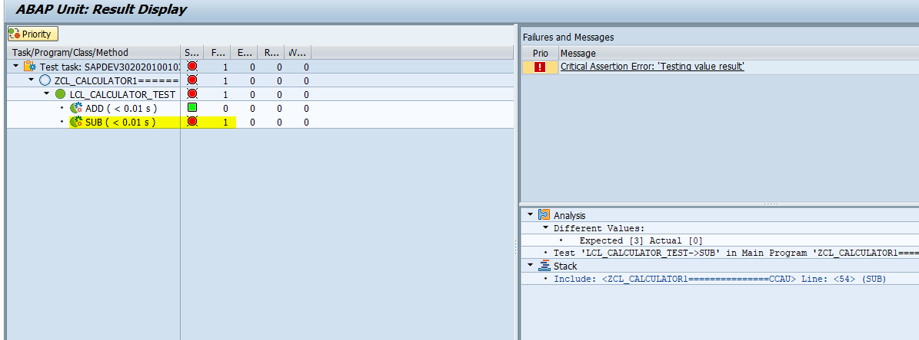

Refactor product method code to pass test case as below

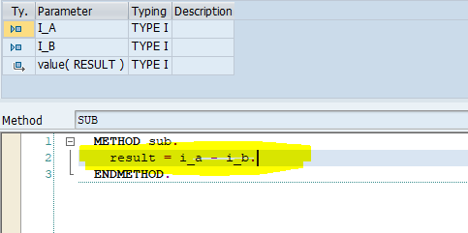

Execute unit test once again

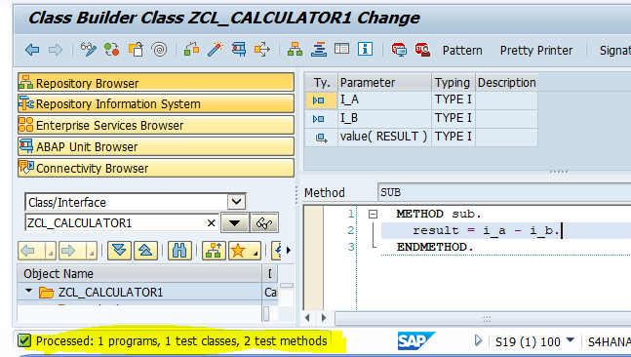

Now test case is passed

**Multiplication Operation**

Add Test method ‘**MULT**’ in test class definition, implementation and pass Given data

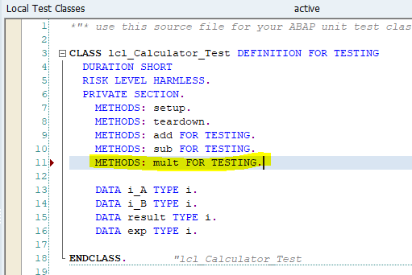

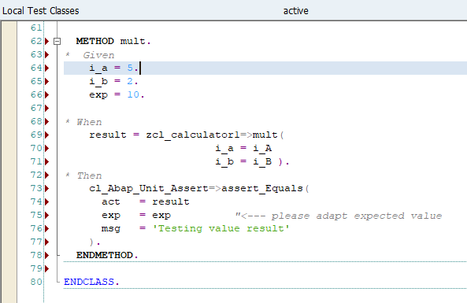

Double click on **MULT** method to create this method in product class

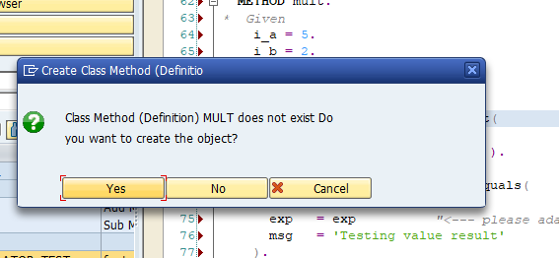

Click on Yes button

Enter Method description, Visibility as public and method as static 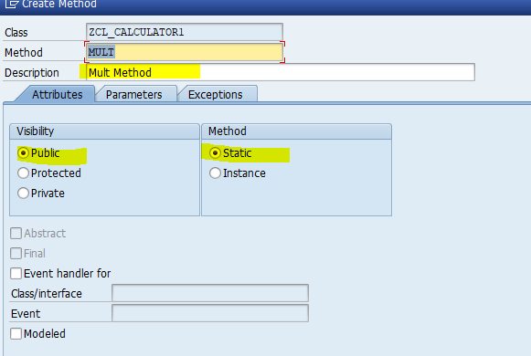

Enter parameter in parameter tab

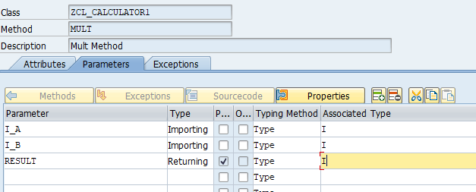

And click on create button

Now MULT method is added in product class

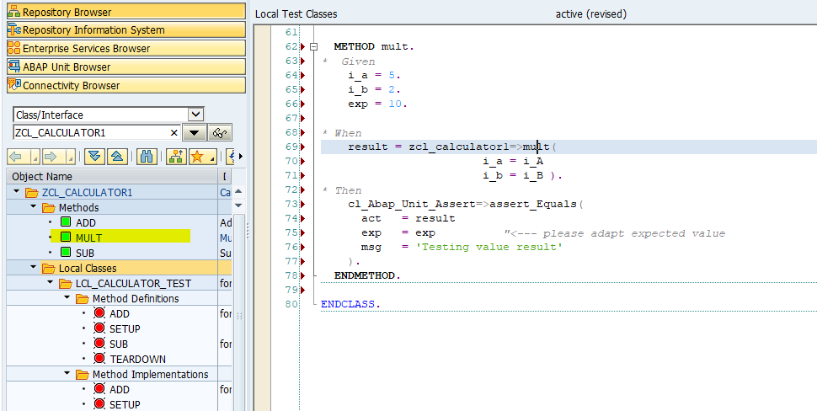

Activate class and Execute test by shortcut ‘**Ctrl+Shift+F10’** or Menu path ‘**Local test class->Execute->Unit Tests**’

Unit testing fail for **MULT** method because no product code exist in product method in product class

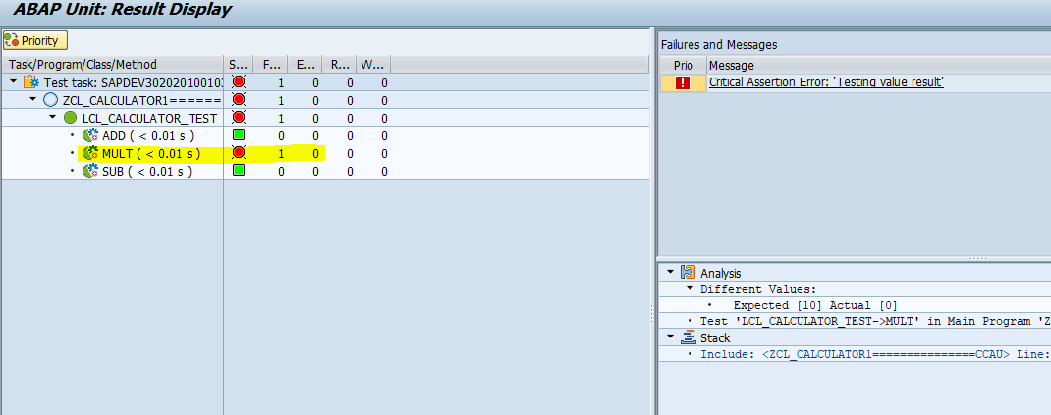

Refactor product method code to pass test case as below

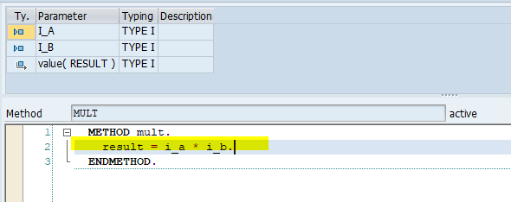

Execute unit test once again

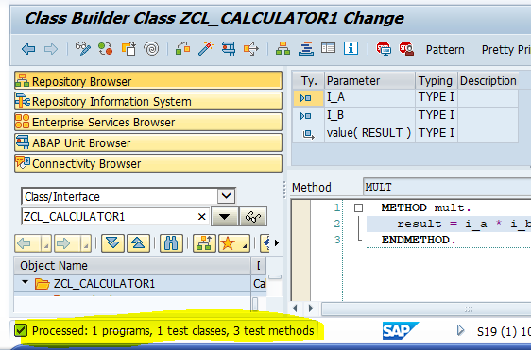

Now test case is passed

**Division Operation**

Add Test method ‘DIV’ in test class definition, implementation and pass Given data

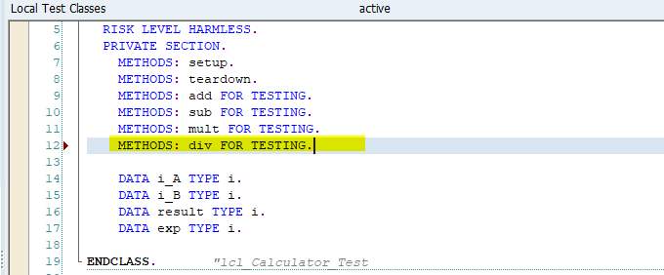

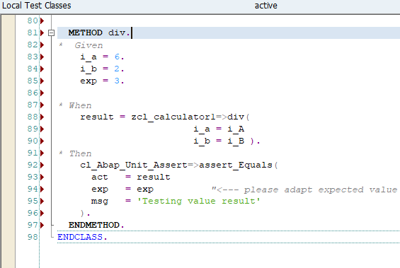

Double click on **DIV** method to create this method in product class

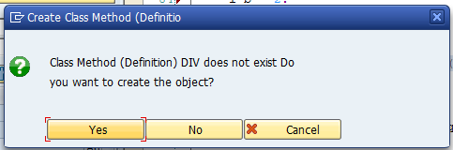

Click on Yes button

Enter Method description, Visibility as public and method as static 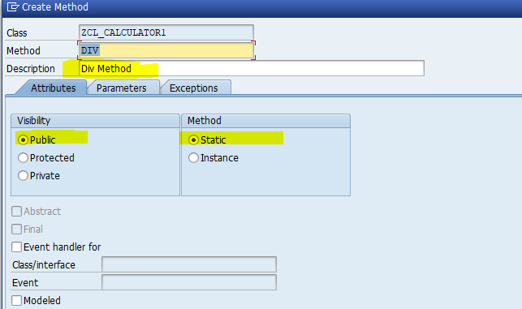

Enter parameter in parameter tab

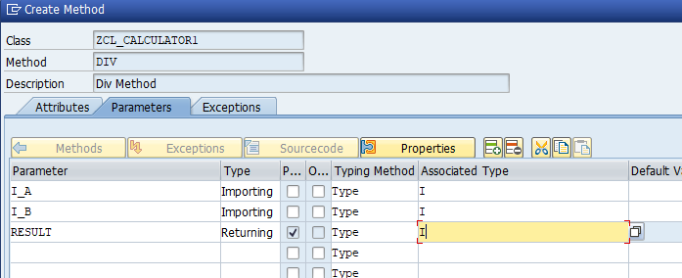

And click on create button

Now **DIV** method is added in product class

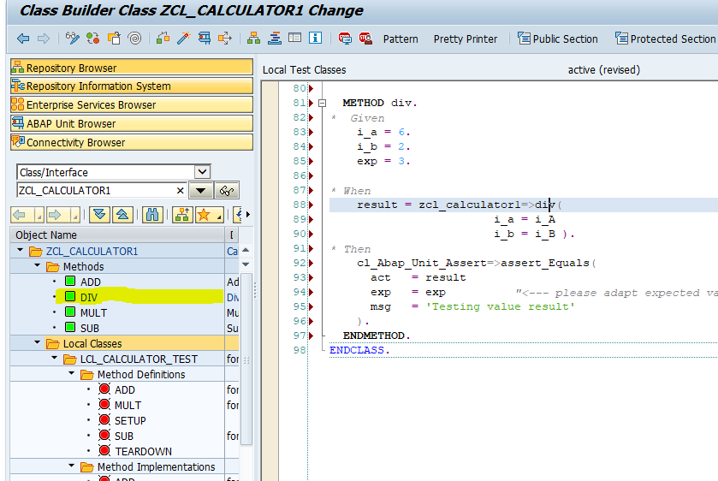

Activate class and Execute test by shortcut ‘**Ctrl+Shift+F10’** or Menu path ‘**Local test class->Execute->Unit Tests**’

Unit testing fail for **DIV** method because no product code exist in product method in product class

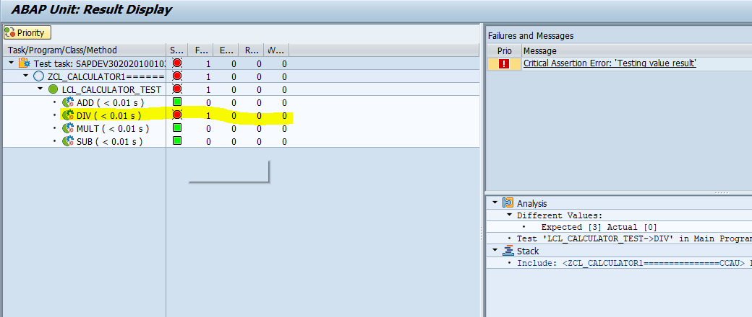

Refactor product method code to pass test case as below

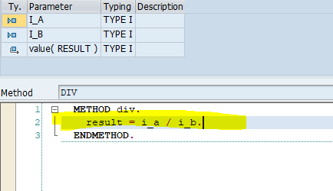

Execute unit test once again

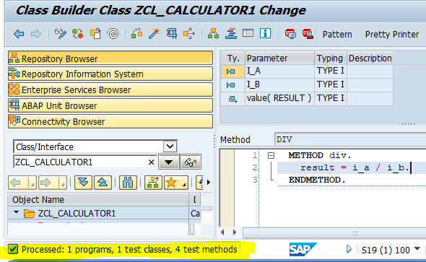

Now test case is passed

