1. BFGS using analytical derivative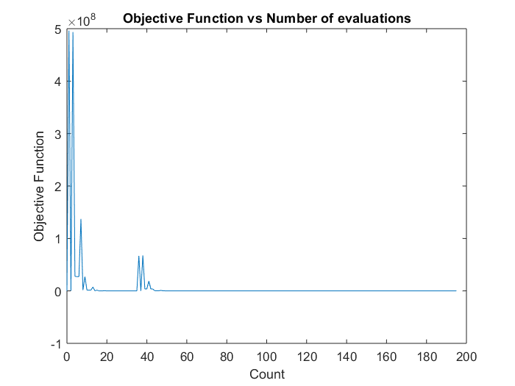
2. BFGS using central difference approach: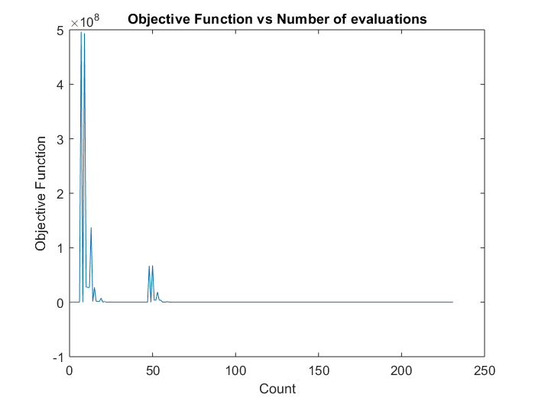
3. Fletcher Reeves using Analytical Derivative :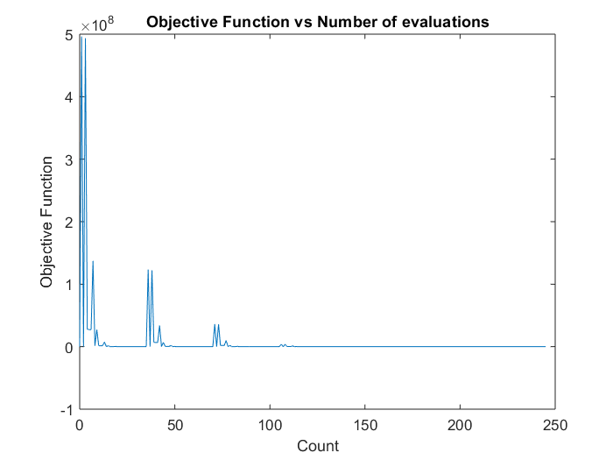
4. Fletcher Reeves using the central difference approach:

