DATA SCIENCE INTERNSHIP PROJECT | RESEARCH PAPER
Factory-to-Customer Shipping Route Efficiency Analysis
A route-, region- and state-level study for Nassau Candy Distributor
Scope
10,194 shipments • 5 factories • 196 factory-to-state routes • 59 states and provinces
Deliverables
Research paper • Streamlit dashboard • Analysis pipeline and KPI tables
Date
September 2026

Abstract
Nassau Candy Distributor ships confectionery from five factories to customers across the United States and Canada, but has lacked route-level visibility into where shipping performs well and where it does not. This paper analyzes 10,194 shipment records (orders placed January 2024 to December 2025), joins them to factory-location and product-origin reference data, and builds a route-level efficiency framework covering 196 Factory→State routes, 20 Factory→Region routes and 59 states and provinces.
The source Order Date and Ship Date fields come from non-overlapping periods, so the computed lead times (mean 1,320.8 days) are not literal shipping durations. Every lead-time, delay and efficiency measure in this paper is therefore defined relative to the dataset’s own distribution; the results support comparison and prioritization, not absolute service-level claims.
Under this framework, 21.1% of shipments are classed as relatively delayed; Tennessee and Washington are the only two states flagged as bottlenecks (high shipment volume combined with high mean lead time), with Indiana a near-miss that looks almost identical; shipment volume explains very little of the variation in state lead times (R² = 0.04), so these delays are not simply a scale effect; and two factories, Lot’s O’ Nuts and Wicked Choccy’s, account for 96.6% of shipment volume. Among the eight lanes with at least 500 shipments, efficiency scores are tightly grouped (44.1 to 48.8), with Wicked Choccy’s→Pacific and Lot’s O’ Nuts→Atlantic at the low end. The principal recommendation is to correct date capture at the source before literal delivery targets are set.
Keywords: shipping route efficiency; logistics analytics; lead time; bottleneck analysis; ship mode; Streamlit dashboard

1. Introduction

1.1 Background and context
Nassau Candy Distributor operates as a national distributor, shipping products from factories to customers across multiple US regions and into Canada. In operations of this kind, shipping efficiency directly affects customer satisfaction, delays increase operational cost, and inefficient routes reduce the ability to scale as order volume grows. Despite holding rich order and shipment data, the organization has historically made logistics decisions without route-level efficiency intelligence, so slow or inconsistent routes are not systematically identified.

1.2 Problem statement
The organization lacks clarity on four questions:
- Which factory-to-customer routes are consistently efficient.
- Which routes experience frequent delays.
- How shipping performance varies by region, state and ship mode.
- Where operational bottlenecks exist geographically.
Without this visibility, logistics optimization remains reactive rather than data-driven.

1.3 Objectives
This study (i) derives route-level shipping KPIs from order and shipment records, (ii) ranks routes and regions by relative efficiency, (iii) compares performance across ship modes, (iv) screens states and provinces for geographic bottlenecks, and (v) delivers the results as an interactive Streamlit dashboard for ongoing use.

2. Data

2.1 Source data and reference tables
The source dataset contains 10,194 shipment records with 18 fields: order and shipment identifiers, order and ship dates, ship mode, customer identity and location (city, state or province, postal code, country, region), product division, product identity, and financial fields (sales, units, gross profit, cost). Two reference tables were added: geographic coordinates for the five factories, and a 15-product mapping from product name to originating factory (Appendix B). The mapping matched every product; no shipment was left without a factory.

2.2 Dataset composition
Table 1. Dataset summary
Attribute | Value
Shipment records | 10,194 (no rows removed during cleaning)
Order date range | 2 January 2024 to 31 December 2025
Unique customers | 5,044
Country split | United States 9,994 (98.0%); Canada 200 (2.0%, 10 provinces)
Division split | Chocolate 9,844 (96.6%); Other 310 (3.0%); Sugar 40 (0.4%)
Factory volume | Lot’s O’ Nuts 5,692 (55.8%); Wicked Choccy’s 4,152 (40.7%); Secret Factory 217 (2.1%); The Other Factory 100 (1.0%); Sugar Shack 33 (0.3%)
Total sales / gross profit | $141,783.63 / $93,442.80
Customer regions | Interior, Atlantic, Gulf, Pacific (these labels also cover Canadian provinces)

Volume is highly concentrated: the two chocolate factories ship 96.6% of all records. Findings for the other three factories rest on far smaller samples and carry proportionally less confidence.

2.3 Data quality finding: non-corresponding date ranges
Order Date values fall between January 2024 and December 2025, while Ship Date values run from mid-2026 to about 2030. Subtracting one from the other gives a “shipping lead time” with a minimum of 904 days, a median of 1,274 days, a mean of 1,320.8 days and a maximum of 1,642 days. These are not physically plausible shipment durations.
The distribution has a distinctive shape (Figure 1): lead times fall into three tight clusters, near 910, 1,275 and 1,640 days, with almost nothing in between. A real shipping process would produce a continuous distribution starting close to zero. This pattern is consistent with Ship Date having been generated or assigned separately from Order Date, and is treated here as a data-generation artifact rather than an operational signal.
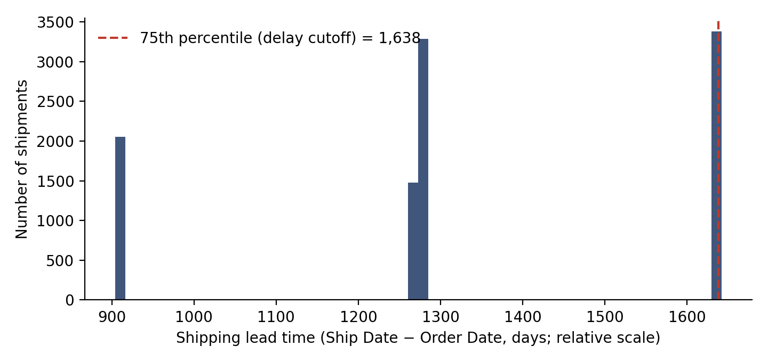
Figure 1. Distribution of computed shipping lead time. Three tight clusters indicate an artifact of the source dates; the dashed line marks the 75th percentile used as the delay cutoff.
Two consequences follow, and they are carried through every result in this paper. First, lead-time measures are used only as relative quantities, so comparisons between routes, regions, states and ship modes remain meaningful while no statement such as “the average shipment takes N days” can be made. Second, because lead times cluster, a route’s mean lead time largely reflects which mix of the three clusters its shipments happen to fall into. That makes rankings sensitive to sample size, and it is the reason low-volume routes are treated cautiously in Section 5.

3. Methodology
- Cleaning and validation. Dates were parsed day-first; records with unparseable dates or with Ship Date earlier than Order Date were to be removed (none were found); exact duplicates were checked (none); state, city and region text was trimmed and standardized.
- Reference joins. Product name was joined to originating factory, and factory to latitude and longitude, so each shipment carries its origin factory and coordinates.
- Feature engineering. Shipping Lead Time = Ship Date − Order Date (days). Route = Factory → State or Province; Route_Region = Factory → Region.
- Relative delay and bucket logic. A shipment is Delayed if its lead time exceeds the 75th percentile of the full dataset (1,638 days), giving a 21.1% delay rate. Lead_Time_Bucket assigns each shipment to a Fast, Medium or Slow tercile of the same distribution (3,531 / 3,266 / 3,397 shipments). Fixed day thresholds were rejected because they would classify 100% of shipments as delayed.
- Route aggregation. For each of 196 Factory→State routes and 20 Factory→Region lanes: shipment count, mean, median and standard deviation of lead time, and delay frequency.
- Efficiency score. Mean lead time is min-max normalized and inverted: Score = 100 × (1 − (x − min) / (max − min)), so 100 is the fastest and 0 the slowest relative to the other entities at the same level. Scores are not comparable across levels (route, lane, state).
- Ship mode comparison. The same metrics grouped by ship mode, with average cost, sales and gross profit.
- Bottleneck screening. A state or province is flagged when both its shipment volume and its mean lead time exceed the 75th percentile across all 59 states and provinces (165.5 shipments and 1,345.4 relative days). This is a screening rule, not a statistical test.
- Trend analysis. Mean lead time was regressed on the base-10 logarithm of shipment volume across all 59 states and provinces. The fit is used descriptively: its R² shows how much of the variation in lead time volume explains, and each state’s gap above or below the line shows how it performs relative to a state of similar size.
- Visualization and delivery. A US choropleth with factory locations overlaid (Canadian provinces are kept in all tables but cannot be drawn on a US map), and a Streamlit dashboard with date, region, state, ship-mode and delay-percentile filters.

4. Exploratory Data Analysis
Beyond the three-cluster lead-time structure shown in Figure 1, the numeric fields behave as expected. Gross profit correlates 0.98 with sales and 0.88 with cost, which follows from its definition (sales minus cost) and is not a separate finding. Shipping lead time has essentially no correlation with sales, units, cost or gross profit (all within ±0.01): order size and value do not predict whether a shipment falls in a relatively fast or slow cluster.
The relative tercile buckets are roughly balanced (Fast 34.6%, Medium 32.0%, Slow 33.3%), as expected from their construction. Orders are spread across the full two-year window, and the top five states by volume are California (2,001), New York (1,128), Texas (985), Pennsylvania (587) and Washington (506).

5. Route Efficiency Findings

5.1 Factory → State routes
Efficiency scores across the 196 Factory→State routes span the full 0 to 100 range. Tables 2 and 3 show the five highest- and lowest-scoring routes.
Table 2. Most efficient Factory→State routes (relative)
Route | Shipments | Mean lead time | Delay rate | Efficiency score
Secret Factory → Nebraska | 1 | 906.0 | 0.0% | 100.0
Secret Factory → New Mexico | 2 | 906.0 | 0.0% | 100.0
The Other Factory → Louisiana | 1 | 907.0 | 0.0% | 99.9
The Other Factory → Connecticut | 2 | 907.5 | 0.0% | 99.8
Wicked Choccy’s → Maine | 2 | 908.0 | 0.0% | 99.7
Table 3. Least efficient Factory→State routes (relative)
Route | Shipments | Mean lead time | Delay rate | Efficiency score
Sugar Shack → New Jersey | 1 | 1,642.0 | 100.0% | 0.0
Secret Factory → New Hampshire | 1 | 1,641.0 | 100.0% | 0.1
Sugar Shack → Connecticut | 1 | 1,641.0 | 100.0% | 0.1
Wicked Choccy’s → West Virginia | 2 | 1,639.0 | 100.0% | 0.4
Lot’s O’ Nuts → North Dakota | 5 | 1,638.2 | 40.0% | 0.5

These extremes should be read as leads, not conclusions. All ten routes above have five or fewer shipments, and 83 of the 196 routes have five or fewer. With lead times clustered into three groups, one order landing in a different cluster can move a small route from best to worst. Route-level rankings become reliable only as volume accumulates.

5.2 Factory → Region lanes
Aggregating to Factory→Region gives 20 lanes with much larger samples. The eight lanes with at least 500 shipments (both chocolate factories across all four regions) carry 9,844 shipments, 96.6% of the network. Table 4 and Figure 2 show them ordered from lowest to highest score.
Table 4. High-volume lanes (500 or more shipments), lowest score first
Lane | Shipments | Mean lead time | Delay rate | Efficiency score
Wicked Choccy’s → Pacific | 1,342 | 1,329.1 | 22.3% | 44.1
Lot’s O’ Nuts → Atlantic | 1,661 | 1,326.8 | 20.7% | 44.6
Wicked Choccy’s → Interior | 950 | 1,324.6 | 22.5% | 45.2
Lot’s O’ Nuts → Interior | 1,321 | 1,324.2 | 21.0% | 45.2
Lot’s O’ Nuts → Pacific | 1,813 | 1,317.5 | 20.7% | 46.8
Wicked Choccy’s → Atlantic | 1,197 | 1,316.0 | 20.7% | 47.2
Lot’s O’ Nuts → Gulf | 897 | 1,314.0 | 20.3% | 47.6
Wicked Choccy’s → Gulf | 663 | 1,309.1 | 20.4% | 48.8

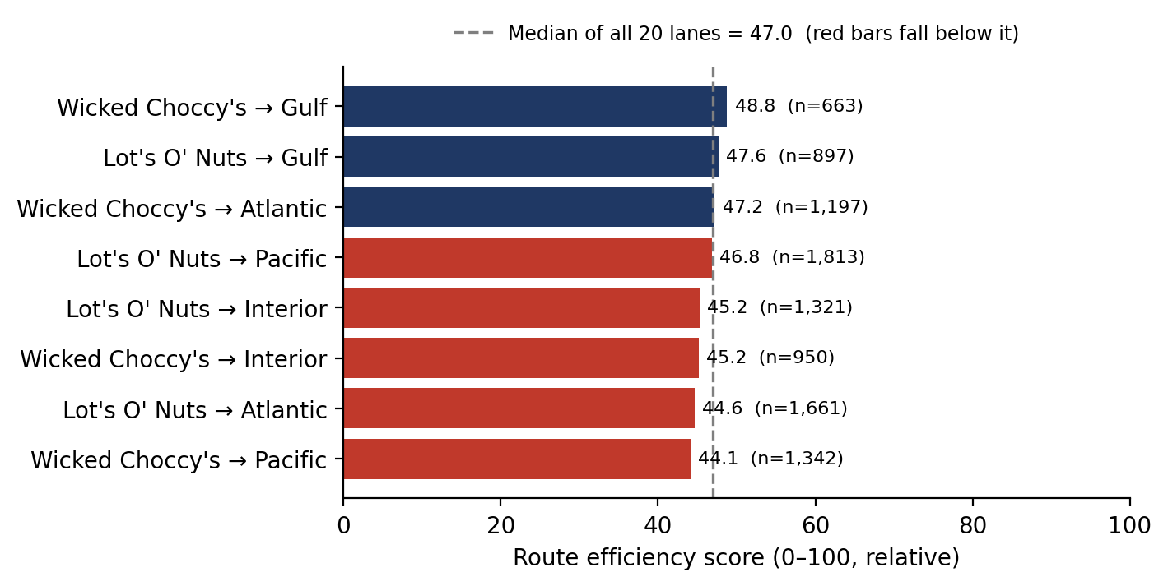
Figure 2. Efficiency score of the eight high-volume lanes. Red bars fall below the median score of all 20 lanes.
The main result is how close together these lanes are. Scores range only from 44.1 to 48.8, and delay rates from 20.3% to 22.5%. The lowest-scoring high-volume lanes are Wicked Choccy’s→Pacific (44.1; 1,342 shipments) and Lot’s O’ Nuts→Atlantic (44.6; 1,661 shipments), followed by the two Interior lanes, which tie at 45.2. The largest lane, Lot’s O’ Nuts→Pacific (1,813 shipments), scores 46.8. No high-volume lane is a dramatic outlier, so the evidence supports monitoring these lanes rather than declaring any of them a failure.
Among the small lanes, Sugar Shack→Pacific (0.0; 3 shipments), Sugar Shack→Atlantic (33.2; 18) and Secret Factory→Atlantic (39.4; 72) score lowest, while Sugar Shack→Gulf (100.0; 4) and The Other Factory→Interior (72.9; 11) score highest. Because scores are normalized across all 20 lanes, these tiny lanes stretch the scale and compress the high-volume lanes into a narrow band.

6. Ship Mode Comparison
Table 5. Ship mode performance (lead time and delay on the relative scale)
Ship mode | Shipments | Mean lead time | Delay rate | Avg cost | Avg sales | Avg gross profit
Standard Class | 6,120 | 1,314.3 | 30.9% | $4.75 | $13.97 | $9.22
Second Class | 1,979 | 1,323.8 | 12.9% | $4.83 | $14.08 | $9.25
First Class | 1,548 | 1,338.3 | 0.0% | $4.72 | $13.77 | $9.05
Same Day | 547 | 1,333.4 | 0.0% | $4.41 | $13.00 | $8.59

Standard Class carries 60.0% of shipments, Second Class 19.4%, First Class 15.2% and Same Day 5.4%. Two patterns stand out.
Delays are confined to two modes. Same Day and First Class have a 0% relative delay rate: none of their shipments falls in the slowest quartile of the whole dataset. Standard Class (30.9%) and Second Class (12.9%) account for every relatively delayed shipment, with Standard Class alone contributing 1,891 of the 2,147 (88%). This is consistent with the intended service levels of the faster modes.
Mean lead time and delay rate disagree. Standard Class has the lowest mean lead time (1,314.3) yet the highest delay rate, while Same Day and First Class have the highest means but no delays. This is a consequence of the clustered distribution described in Section 2.3, and it shows that mean lead time alone is not a reliable ranking of ship modes in this dataset. The delay rate is the more informative measure, and the source dates would need correcting before the reason could be established.
Cost caveat. In the dataset dictionary, Cost is the cost to manufacture, and there is no freight or shipping-charge field. The average cost, sales and profit columns therefore describe the product mix shipped under each mode (a spread of only $4.41 to $4.83 in average cost) and cannot be used to judge the cost-time tradeoff of the shipping modes themselves.

7. Geographic Bottleneck Analysis

7.1 Screening result
A state or province is flagged as a bottleneck when its shipment volume exceeds 165.5 shipments and its mean lead time exceeds 1,345.4 relative days, the 75th percentiles across all 59 states and provinces. Two qualify.
Table 6. States flagged as bottlenecks
State | Shipments | Mean lead time | Delay rate
Tennessee | 183 | 1,391.5 | 31.7%
Washington | 506 | 1,360.7 | 23.9%

Together Tennessee and Washington account for 689 shipments, 6.8% of network volume. None of the ten Canadian provinces was flagged; they contribute to the percentile thresholds but cannot be drawn on the US map.

7.2 Does volume explain lead time? Reading the trend line
Figure 3 plots every state and province by shipment volume (horizontal axis, log scale) and mean lead time (vertical axis). The navy line is the best-fitting straight line through all 59 points, and the dotted lines mark the 75th-percentile thresholds used for flagging; a state must sit in the upper-right quadrant to be flagged.
What the chart shows. The points form a loose, shapeless cloud and the trend line is almost flat, drifting slightly downward from left to right (r = −0.19, R² = 0.04). Volume therefore explains only about 4% of the variation in state lead times. If anything, busier states are marginally faster: the fitted line implies roughly 23 fewer relative days for every tenfold increase in volume. The scatter is also widest on the left, where states with a handful of shipments swing from 1,137 to 1,638 days on a few orders, and narrows to the right, where large samples settle close to the line (the standard deviation of the gap to the line is 83 days across all states but 34 days among the 22 states with 100 or more shipments).
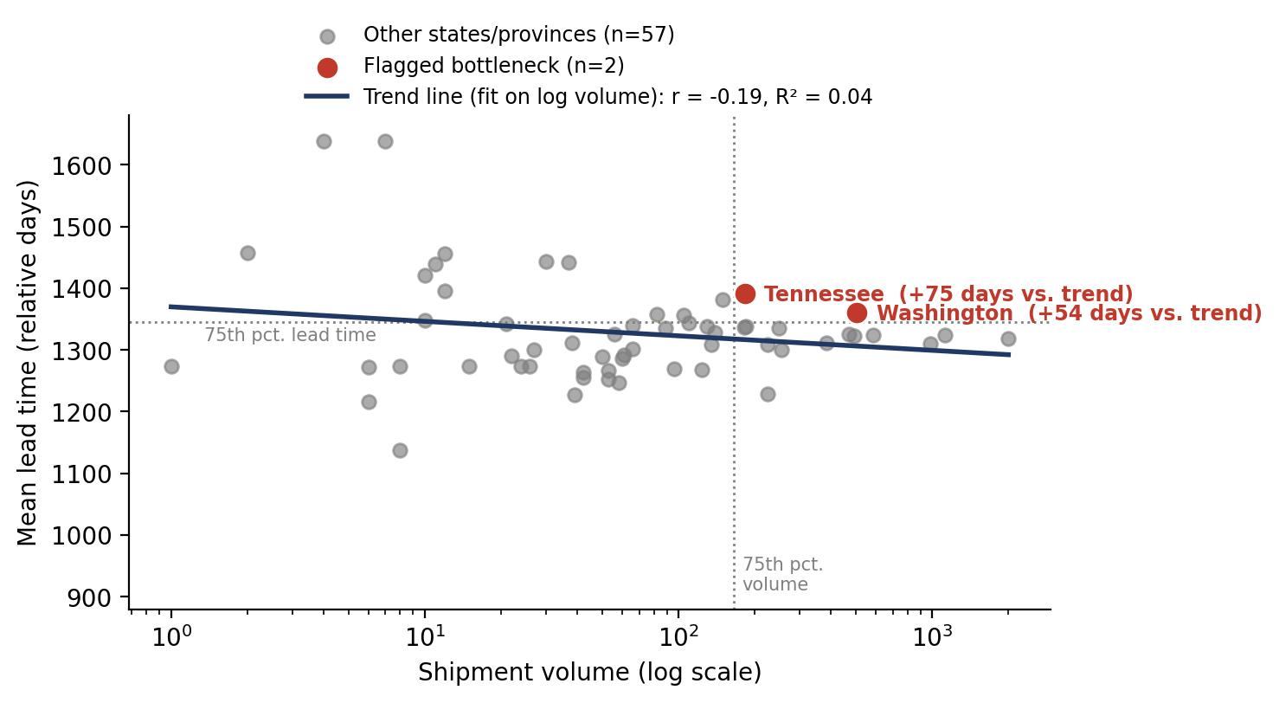
Figure 3. Shipment volume against mean lead time for all 59 states and provinces, with fitted trend line. Tennessee and Washington sit above the line, meaning they are slower than states of similar volume.
What it means strategically. First, bottlenecks in this network are not a scale problem. Handling more shipments does not make a state slower, so adding generic capacity is unlikely to be the fix; the cause is more likely specific to the lanes, ship modes or carriers serving a state. Second, the line gives a fairer yardstick than a raw threshold. Tennessee sits 75 relative days above the line and Washington 54 days above, so both are slower than a state of their size would normally be. Third, the far-left outliers at the very top of the chart (West Virginia with 4 shipments, North Dakota with 7, both near 1,638) look alarming but rest on a handful of orders and should be ignored for planning until their volume grows.
A third state the screening rule misses. Ranking the 22 states with at least 100 shipments by their gap to the trend line puts Tennessee first (+74.9), Indiana second (+62.8) and Washington third (+54.5). Indiana has a delay rate of 30.9%, almost identical to Tennessee’s 31.7%, but it is not flagged because its volume of 149 falls just under the 165.5 threshold. It is the clearest example of a near-miss created by a hard cut-off, and it belongs on the watch list alongside the two flagged states. Maryland also exceeds the lead-time threshold but its delay rate (16.2%) is below the network rate, which suggests a milder, different pattern.
Table 7. Large states (100 or more shipments) above the lead-time threshold
State | Shipments | Mean lead time | Gap to trend line | Delay rate | Flagged as bottleneck
Tennessee | 183 | 1,391.5 | +74.9 | 31.7% | Yes
Indiana | 149 | 1,381.5 | +62.8 | 30.9% | No (volume 149 < 165.5)
Washington | 506 | 1,360.7 | +54.5 | 23.9% | Yes
Maryland | 105 | 1,356.8 | +34.5 | 16.2% | No (volume 105 < 165.5)

Priority. Washington remains the most consequential of the group because of its scale: it ranks fifth in volume (506 shipments) and its delay rate of 23.9% is the highest of the five largest states, whose other four range from 19.9% to 22.3%. Tennessee (14th in volume) and Indiana (16th) have smaller volumes but higher delay rates. Because the trend line is weak, it should be read as a descriptive benchmark rather than a predictive model.

8. Key Findings
- The source dates cannot support literal lead-time reporting. Lead times form three artificial clusters (Section 2.3); all findings here are relative comparisons.
- Volume is concentrated. Lot’s O’ Nuts and Wicked Choccy’s ship 96.6% of records, so conclusions about the other three factories rest on thin samples.
- High-volume lanes perform almost alike. The eight lanes carrying 96.6% of shipments score between 44.1 and 48.8; the lowest are Wicked Choccy’s→Pacific and Lot’s O’ Nuts→Atlantic, but no lane is a clear outlier.
- Washington and Tennessee are the two flagged bottlenecks, with Washington the more consequential because of its volume. Indiana narrowly misses the volume threshold but has a near-identical delay profile.
- Volume does not explain lead time across states (R² = 0.04, slightly negative slope), so bottlenecks are not a scale effect and point to lane-, mode- or carrier-specific causes.
- Relative delays sit entirely in Standard and Second Class, with Standard Class contributing 88% of relatively delayed shipments.
- Lead time is unrelated to order value, size or profit (all correlations within ±0.01).
- Route-level extremes are unreliable. 83 of 196 routes have five or fewer shipments, and every route in the top and bottom five is among them.

9. Recommendations
- Correct date capture at the source (critical). Confirm how Ship Date is recorded and re-extract clean Order and Ship Dates. Literal lead-time targets and service levels should not be set until this is done; the remaining recommendations are otherwise screening-level.
- Review service into Washington, Tennessee and Indiana. Establish which factories and ship modes serve each state and whether the delay pattern follows a particular factory or mode, rather than adding general capacity, since volume does not explain lead time. Washington’s volume makes it the highest-value target; Indiana should be included even though the screening rule did not flag it.
- Place Wicked Choccy’s→Pacific and Lot’s O’ Nuts→Atlantic on a watch list. They are the lowest-scoring high-volume lanes, but the gaps are small; re-test them on corrected dates before committing operational changes.
- Make decisions at the lane or state level, not the single-route level. Use Factory→Region lanes and states for operational decisions, and keep low-volume routes as a watch list until their samples grow.
- Investigate why relative delays occur only in Standard and Second Class. With 1,891 relatively delayed Standard Class shipments, even a modest improvement in that mode would move the network-wide delay rate.
- Capture shipping cost. Adding freight charges per shipment would allow the cost-time tradeoff between ship modes to be evaluated properly.
- Adopt the dashboard for ongoing monitoring and refresh it with corrected data, extending bottleneck screening to Canadian provinces once their volume justifies it.

10. Limitations
- All lead-time, delay and efficiency figures are relative to this dataset’s own distribution, not literal days, because of the date artifact in Section 2.3.
- Lead times cluster into three groups, so route means depend heavily on cluster mix, and rankings are unstable for small routes.
- Results for Sugar Shack (33 shipments), The Other Factory (100) and Secret Factory (217) rest on small samples.
- The bottleneck rule (75th percentile on both volume and lead time) is one reasonable definition; a different threshold or a weighted score could flag different states.
- The trend line is a weak descriptive fit (R² = 0.04) that includes very small states; it is a benchmark for comparison, not a predictive model, and a hard 75th-percentile cut-off can miss near-misses such as Indiana.
- The dataset has no shipping-cost, carrier or delivery-date field, so cost-time tradeoffs and actual on-time delivery cannot be assessed.
- The four Region labels span both countries, so regional results are not US-only.

11. Conclusion
This project converts raw order and shipment records into route-, lane- and state-level intelligence for Nassau Candy Distributor and delivers it as an interactive dashboard. Within the limits set by the date artifact, it identifies Washington and Tennessee as geographic bottlenecks, shows that the two high-volume chocolate factories perform very similarly across regions, and locates relative delays in the Standard and Second Class modes. The most valuable next step is not more analysis but better data: once Order and Ship Dates are captured correctly, the same pipeline and dashboard can be re-run to turn these relative rankings into literal, actionable delivery-time targets.

Appendix A. KPI definitions
KPI | Definition
Shipping Lead Time | Ship Date − Order Date, in days (relative scale; see Section 2.3).
Average / median lead time | Mean and median lead time per route, lane or state.
Route volume | Number of shipment records on the route, lane or state.
Is_Delayed | True when lead time exceeds the 75th percentile of the full dataset (1,638 days).
Delay frequency | Percentage of shipments on an entity that are delayed.
Lead_Time_Bucket | Fast, Medium or Slow tercile of the full lead-time distribution.
Route efficiency score | 100 × (1 − (mean lead time − min) / (max − min)), computed within each level; 100 is the fastest.
Is_Bottleneck | True when a state’s volume and mean lead time both exceed the 75th percentile across all states and provinces.

Appendix B. Reference tables
Table B1. Factory coordinates
Factory | Latitude | Longitude
Lot’s O’ Nuts | 32.881893 | -111.768036
Wicked Choccy’s | 32.076176 | -81.088371
Sugar Shack | 48.119140 | -96.181150
Secret Factory | 41.446333 | -90.565487
The Other Factory | 35.117500 | -89.971107
Table B2. Product-to-factory mapping
Division | Product | Factory
Chocolate | Wonka Bar – Nutty Crunch Surprise | Lot’s O’ Nuts
Chocolate | Wonka Bar – Fudge Mallows | Lot’s O’ Nuts
Chocolate | Wonka Bar – Scrumdiddlyumptious | Lot’s O’ Nuts
Chocolate | Wonka Bar – Milk Chocolate | Wicked Choccy’s
Chocolate | Wonka Bar – Triple Dazzle Caramel | Wicked Choccy’s
Sugar | Laffy Taffy | Sugar Shack
Sugar | SweeTARTS | Sugar Shack
Sugar | Nerds | Sugar Shack
Sugar | Fun Dip | Sugar Shack
Other | Fizzy Lifting Drinks | Sugar Shack
Sugar | Everlasting Gobstopper | Secret Factory
Other | Lickable Wallpaper | Secret Factory
Other | Wonka Gum | Secret Factory
Sugar | Hair Toffee | The Other Factory
Other | Kazookles | The Other Factory

Appendix C. Deliverables and reproducibility
The analysis is fully reproducible from the raw file. Running the pipeline script regenerates every table in this paper; the dashboard reads its outputs.
- 01_analysis_pipeline.py: cleaning, joins, feature engineering, route/lane/state aggregation, KPI export.
- 02_streamlit_app.py: interactive dashboard (KPI overview, route efficiency, geographic map, ship-mode comparison, route drill-down).
- cleaned_shipments.csv, route_summary.csv, route_region_summary.csv, state_summary.csv, kpi_summary.csv, ship_mode_summary.csv: analysis outputs.
- requirements.txt and README.md: pinned package versions and run instructions.

