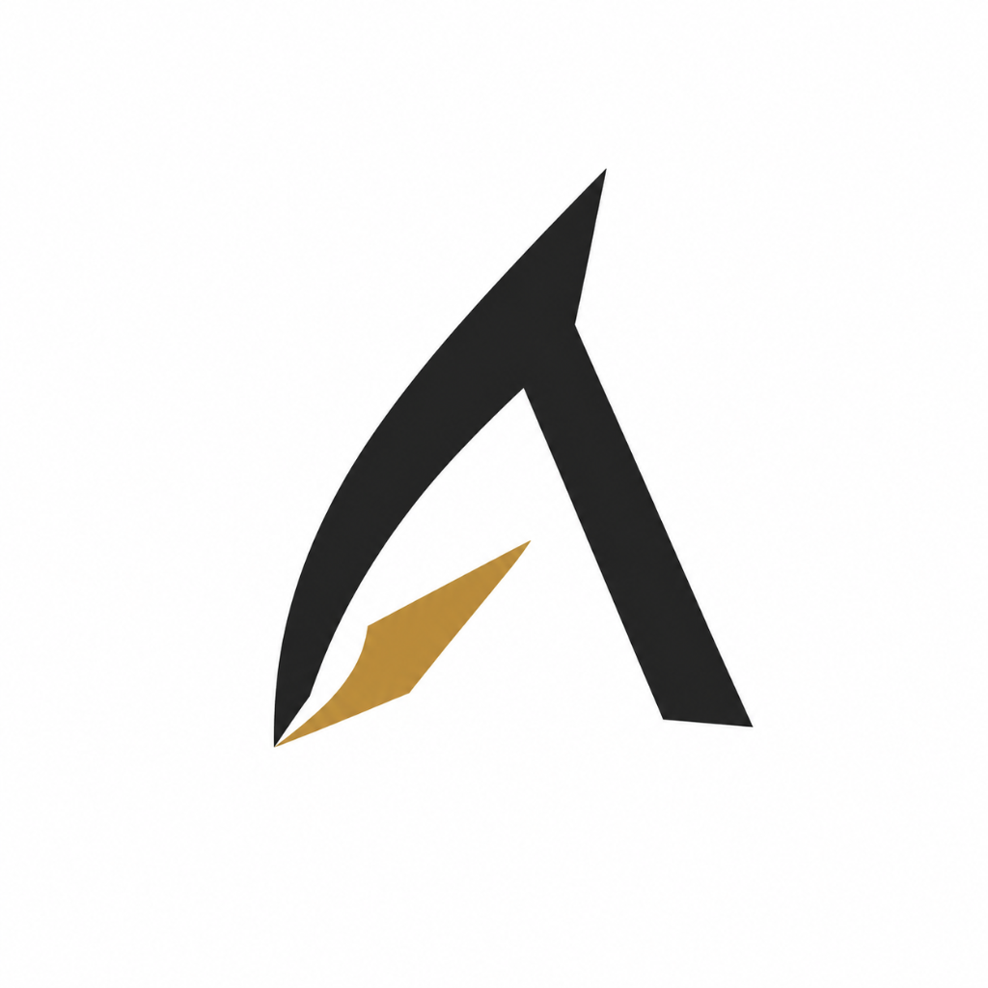

Aravanta Cloud OS
Product Overview, Vision & Strategy
A product by Aravanta Tech

____________________________________________________________

Document Version | v1.0 GA
Date | September 11, 2026
Classification | Internal / Investor Use
Prepared By | Aravanta Tech - Product & Strategy

_____________________________________________________________________________________

Table of Contents
1. | Executive Summary | 3
2. | About Aravanta Tech (Parent Company) | 4
3. | Why Aravanta Cloud OS | 5
4. | Unique Services & Differentiators | 6
5. | Market Gap Analysis | 8
6. | Vision | 9
7. | Mission | 10
8. | Product Architecture Overview | 11
9. | Roadmap & Next Steps | 12
10. | Why Invest / Why Partner | 13
11. | Appendix | 14
Note: Page numbers are approximate. Please update the Table of Contents field after opening in Microsoft Word (right-click > Update Field).

_____________________________________________________________________________________

Executive Summary
Aravanta Cloud OS is a unified, Kubernetes-native multi-cloud operating system built by Aravanta Tech to eliminate the fragmentation, vendor lock-in, and operational complexity that define today's cloud infrastructure landscape.
Modern engineering teams are forced to juggle 15+ disconnected dashboards, proprietary APIs, and siloed observability tools across hyperscaler platforms. The result: spiraling costs, security blind spots, and an estimated 70% of engineering time wasted on infrastructure plumbing rather than product innovation.
Aravanta Cloud OS solves this by providing a single, unified control plane that abstracts and orchestrates compute instances, Kubernetes clusters, managed databases, S3-compatible object storage, GitOps CI/CD pipelines, and real-time observability -- across Amazon Web Services, Google Cloud Platform, Microsoft Azure, and bare-metal on-premise infrastructure.
The platform delivers sub-10ms eBPF-powered telemetry streaming, automated canary deployment gates with 1.2-second rollback, 4-tier zero-trust RBAC with TOTP multi-factor authentication, and predictable per-second billing in both INR and USD. Every action is recorded in an immutable 365-day audit trail, ensuring SOC 2 Type II and DPDPA 2023 compliance out of the box.
With its v1.0 General Availability release, Aravanta Cloud OS serves cloud-native engineering teams, DevOps/SRE organizations, regulated enterprises, and government bodies across 4 production regions (Mumbai, Chennai, Singapore, Frankfurt). The platform's open-standards-first architecture (upstream CNCF Kubernetes, OpenTelemetry, Prometheus, Terraform) guarantees true zero vendor lock-in -- engineers retain full portability of their workloads at all times.
Aravanta Cloud OS is not just another cloud dashboard. It is the operating system layer that the multi-cloud era has been missing.

_____________________________________________________________________________________

About Aravanta Tech

Company Background
Aravanta Tech is a deep-tech infrastructure company founded by ex-hyperscaler engineers who have collectively built, scaled, and operated cloud platforms serving millions of production workloads across AWS, Google Cloud, and Microsoft Azure.
The founding thesis emerged from a shared conviction: the cloud industry's dominant paradigm -- walled-garden hyperscaler consoles with proprietary APIs and aggressive lock-in pricing -- is fundamentally misaligned with the needs of modern engineering teams. Developers deserve an open, unified operating system that respects their autonomy, eliminates context-switching overhead, and delivers enterprise-grade reliability without the enterprise-grade complexity tax.
Headquartered in Bengaluru, India, Aravanta Tech operates with an engineer-first culture that prioritizes open-source contribution, transparent SLAs, and a principled refusal to build proprietary lock-in into any product surface.

Core Belief
"Infrastructure should be invisible. Engineers should spend their time building products that matter, not wrestling with cloud plumbing, IAM sprawl, and billing surprises. We believe the operating system for multi-cloud infrastructure must be open, unified, and relentlessly simple."

Leadership
Name | Title | Background
[Founder Name] | CEO & Co-Founder | Ex-Principal Engineer, AWS / Google Cloud Infrastructure
[Co-Founder Name] | CTO & Co-Founder | Ex-Staff SRE, Kubernetes Core Contributor
[Name] | VP Engineering | 15+ years distributed systems, ex-Azure Compute
[Name] | Head of Product | Enterprise SaaS product leadership, ex-Datadog

_____________________________________________________________________________________

Why Aravanta Cloud OS

The Problem Statement
- Fragmented Toolchain: Teams operate 15+ disconnected consoles (AWS Console, GCP Console, Terraform, Datadog, PagerDuty, ArgoCD, Vault, etc.) with no unified view.
- Vendor Lock-In: Proprietary APIs and data formats create massive migration costs and strategic dependency on a single hyperscaler.
- Cost Opacity: Complex, opaque billing structures with hidden egress fees, cross-AZ transfer charges, and reserved instance accounting.
- Security Sprawl: Disconnected IAM systems, inconsistent RBAC policies, and fragmented audit trails across cloud accounts.
- Observability Silos: Metrics, logs, and traces scattered across vendor-specific tools with no correlated incident timeline.
- Engineering Productivity Loss: Surveys indicate 60-70% of platform engineering time is spent on integration glue code and operational toil, not product development.

Problem-to-Solution Transformation
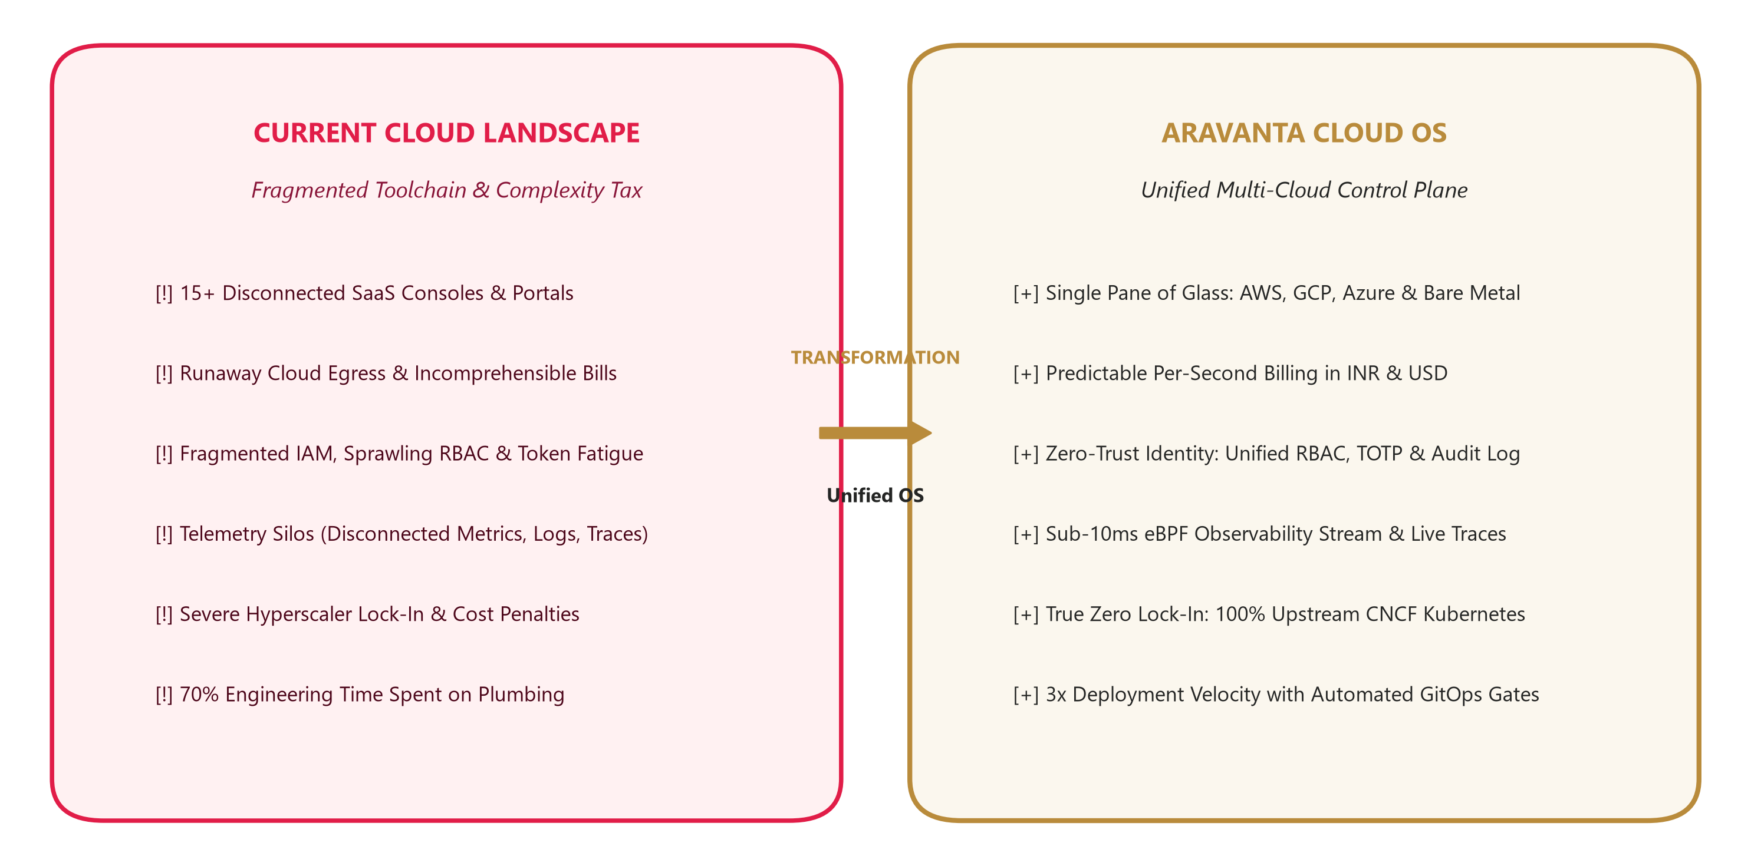

_____________________________________________________________________________________

Unique Services & Differentiators

Core Platform Services
Service Module | Description | Key Differentiator
ArvCompute Engine | Elastic high-performance VMs with NVMe SSD block storage | Live resize without downtime, per-second billing
ArvKube Orchestrator | Managed Kubernetes 1.27-1.30 clusters | Auto-draining, HPA, multi-tenant namespace isolation
ArvStore Fabric | Distributed S3-compatible object storage | AES-256 encryption, lifecycle policies, data residency controls
ArvDB Cluster Manager | Managed Postgres, Redis, MySQL engines | Automated PITR backups, Patroni HA failover
GitOps Delivery Engine | Automated CI/CD with canary deployment gates | 25% canary traffic gating, 1.2s instant rollback
Observability Hub | eBPF-powered telemetry and tracing | Sub-10ms metrics latency, Prometheus + Loki native
War-Room Console | SRE incident command center | Commander assignment, timeline recording, RCA generation
Security & RBAC Vault | Zero-trust identity and access management | 4-tier RBAC matrix, TOTP MFA, 365-day immutable audit trails

Competitive Comparison
Capability | Aravanta Cloud OS | AWS / Azure / GCP Native | DIY Open Source Stack
Unified Multi-Cloud Dashboard | Yes (Single Pane) | No (Per-Cloud Only) | Manual Integration
Per-Second Billing (INR + USD) | Native | Hourly/Monthly Only | N/A
Sub-10ms eBPF Observability | Built-In | 3rd Party Required | Complex Setup
Automated Canary + Rollback | 1.2s Rollback | Manual Configuration | ArgoCD Setup Required
Zero Vendor Lock-In | 100% CNCF Standards | Proprietary APIs | Partially Open
4-Tier RBAC + TOTP MFA | Native | Varies Per Service | Self-Managed
SOC 2 Type II Compliance | Out of Box | Separate Certification | Self-Managed
Indian Data Residency (DPDPA) | Native Compliance | Limited Regions | Self-Managed

_____________________________________________________________________________________

Market Gap Analysis

The Gap
The cloud infrastructure market is dominated by three hyperscalers (AWS, Azure, GCP) that collectively control ~65% of global cloud spend. While these platforms offer powerful individual services, they are architecturally designed to maximize lock-in and create switching costs.
On the opposite end, open-source DIY stacks (Terraform + ArgoCD + Prometheus + Vault + Datadog) offer portability but impose a crushing operational burden: teams report spending 6-12 months to assemble, integrate, secure, and maintain a comparable platform stack -- and then must continuously patch, upgrade, and troubleshoot the integration seams.
The market gap is clear: there is no production-grade, unified operating system that combines the simplicity and managed reliability of a hyperscaler console with the portability, openness, and zero lock-in of CNCF-native open standards. Aravanta Cloud OS occupies precisely this whitespace.

Market Positioning Matrix
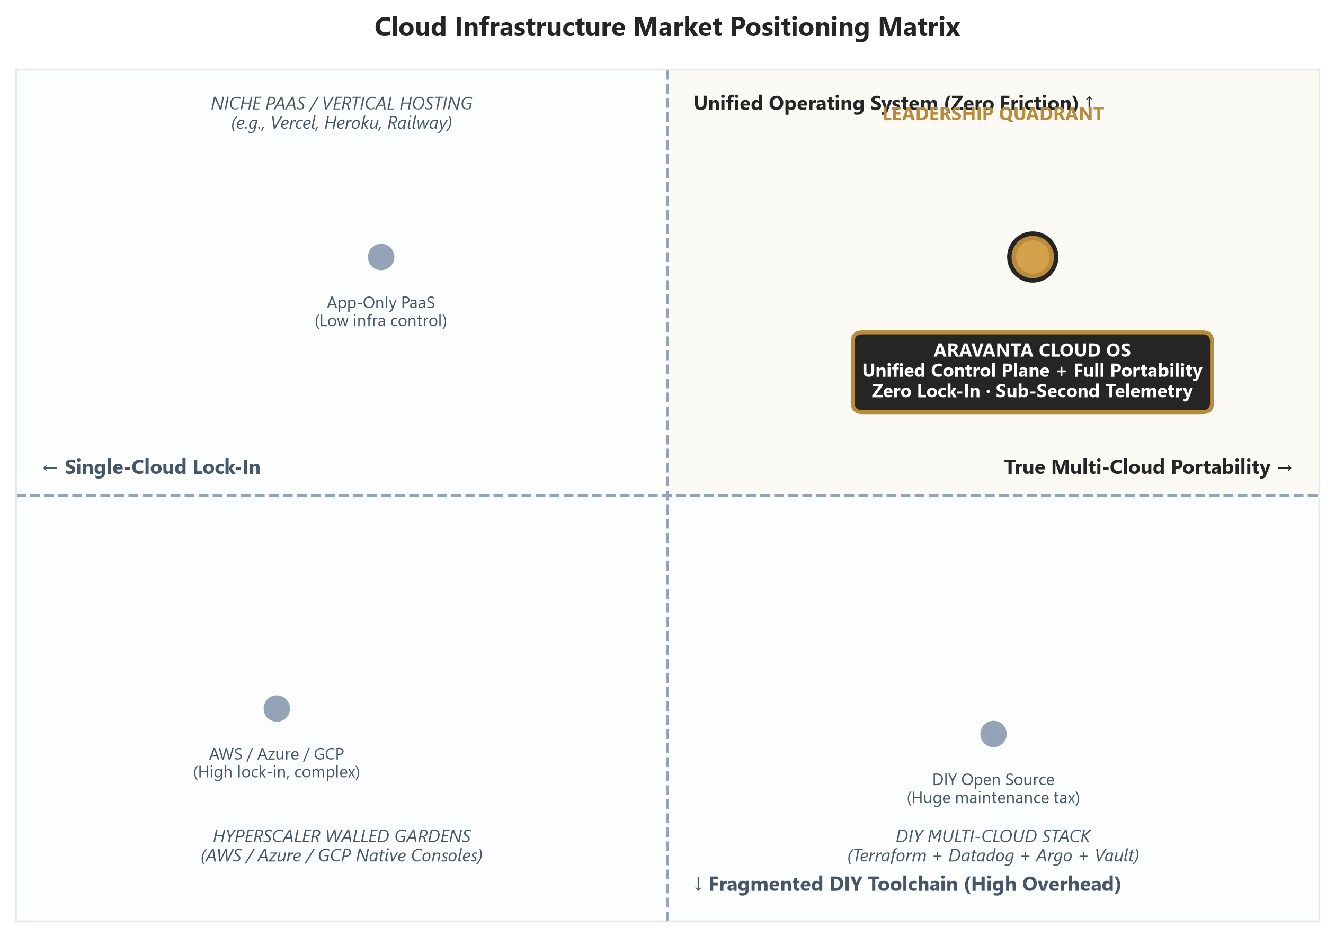

Target Segments
Segment | Pain Point Addressed | Aravanta Value
Cloud-Native Startups & SMBs | Cannot afford dedicated platform engineering teams | Turnkey managed infrastructure with startup-friendly pricing
Enterprise IT / DevOps Teams | Multi-cloud sprawl, compliance overhead | Unified governance, SOC 2, DPDPA compliance out of box
Government & PSU Organizations | Data sovereignty, air-gapped deployment needs | Indian data residency, on-prem BYOK Kubernetes distribution
SRE & Platform Engineering | Toolchain integration fatigue, incident management | Integrated observability, war-room console, automated runbooks
Regulated Industries (BFSI, Healthcare) | Strict audit, compliance, and encryption requirements | Immutable audit trails, AES-256 encryption, RBAC vault

_____________________________________________________________________________________

Vision
Our 3-5 Year Strategic Vision
"By 2030, Aravanta Cloud OS will be the default operating system for multi-cloud infrastructure -- enabling every engineering team on the planet to provision, deploy, observe, and recover production workloads across any cloud provider or bare-metal datacenter through a single, open, and elegantly simple control plane. We envision a world where cloud infrastructure is truly invisible: engineers think in applications and outcomes, not in provider consoles and API quirks."

Universal Cloud Abstraction: Complete provider-agnostic infrastructure management across all major clouds and bare metal, with zero proprietary APIs.
Autonomous Self-Healing Infrastructure: AI-powered anomaly detection and automated remediation that eliminates manual incident response for 80%+ of production issues.
Global Sovereign Compliance: Native compliance engines for every major regulatory framework (SOC 2, ISO 27001, GDPR, DPDPA, FedRAMP, HIPAA) with one-click audit reporting.
Developer Velocity Multiplier: Reduce infrastructure provisioning and deployment cycles from hours to seconds, freeing engineering teams to focus on product innovation.

_____________________________________________________________________________________

Mission
"To build the most reliable, open, and unified cloud operating system that empowers engineering teams to ship faster, observe deeper, and operate with confidence -- without ever being locked into a single vendor, a proprietary API, or an opaque billing model."

Core Pillars
Pillar | Principle | Commitment
Open Standards First | Every API, protocol, and data format is CNCF-native and upstream-compatible | Zero proprietary lock-in at any layer
Relentless Simplicity | Complex infrastructure, simple interface. One dashboard, one CLI, one billing page | < 5 minute time-to-first-workload
Enterprise-Grade Security | Zero-trust by default. Every action authenticated, authorized, and audited | SOC 2 Type II certified, 365-day audit retention
Transparent Economics | Per-second billing, no hidden egress fees, real-time cost dashboards | INR + USD pricing with GST-compliant invoicing

_____________________________________________________________________________________

Product Architecture Overview
Aravanta Cloud OS is architected as a three-layer Kubernetes-native control plane that cleanly separates developer access surfaces, core platform services, and underlying infrastructure backends. This layered design ensures that any cloud provider or bare-metal fabric can be plugged in without affecting the developer experience or control plane logic.
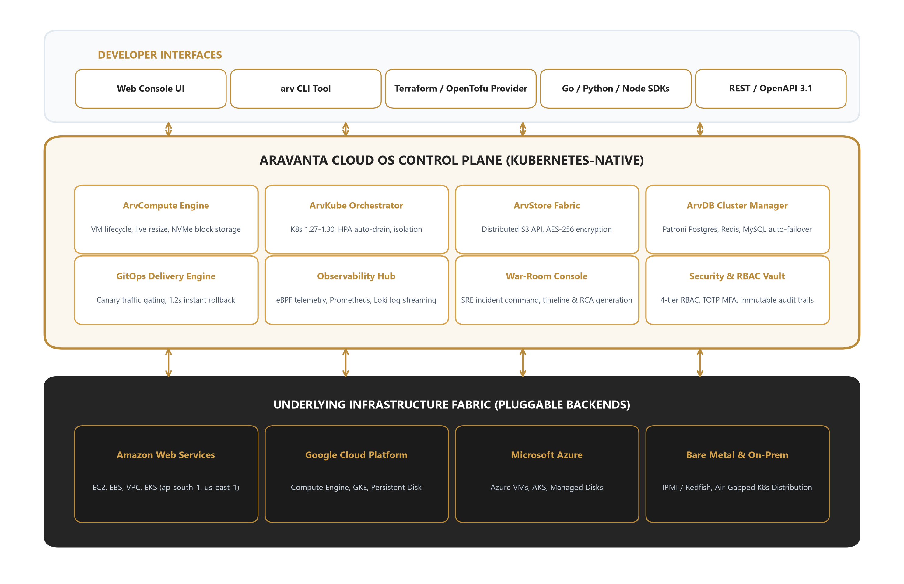

Layer Descriptions
Layer 1 -- Developer Interfaces
Web Console UI, arv CLI, Terraform/OpenTofu Provider, Go/Python/Node SDKs, and REST/OpenAPI 3.1 endpoints. All interfaces are generated from a single API schema ensuring 100% parity.
Layer 2 -- Aravanta Control Plane
The core Kubernetes-native control plane comprising 8 specialized service modules: ArvCompute, ArvKube, ArvStore, ArvDB, GitOps Engine, Observability Hub, War-Room Console, and Security & RBAC Vault. Each module runs as a set of Kubernetes operators with declarative CRD-driven state management.
Layer 3 -- Infrastructure Backends
Pluggable provider adapters for AWS (EC2, EBS, VPC, EKS), GCP (Compute Engine, GKE, Persistent Disk), Azure (VMs, AKS, Managed Disks), and bare-metal/on-prem (IPMI/Redfish, air-gapped K8s distribution). New backends can be added without modifying the control plane.

_____________________________________________________________________________________

Roadmap & Next Steps

Strategic Product Roadmap
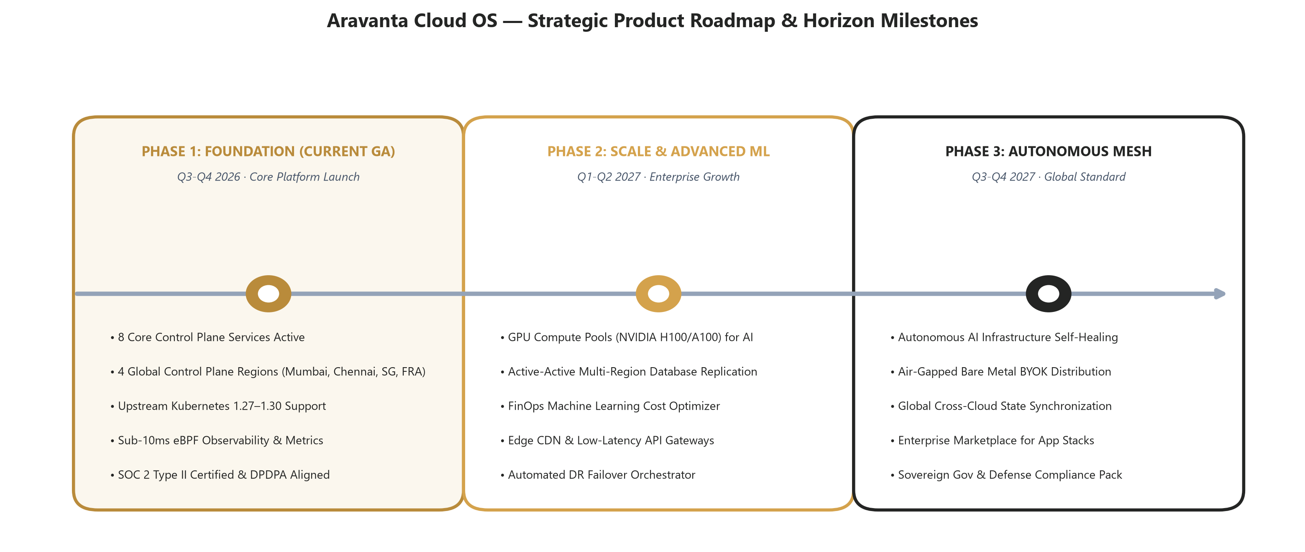

Next Steps to Target
Initiative | Timeline | Description | Success Metric
Enterprise Pilot Program | Q4 2026 | Onboard 5-8 enterprise design partners for 90-day production pilot | 3+ conversions to annual contracts
Channel Partner Program | Q1 2027 | Establish partnerships with top-tier SI/consulting firms (Infosys, TCS, Wipro) | 2+ signed channel agreements
Government Cloud Certification | Q1-Q2 2027 | Obtain MeitY empanelment and deploy sovereign air-gapped distribution | MeitY certification approval
Series A Fundraise | Q4 2026 - Q1 2027 | Raise growth capital to scale engineering, GTM, and regional expansion | Target: $8-12M at $40-60M valuation
APAC Expansion | Q2-Q3 2027 | Launch Singapore and Tokyo production regions with local compliance | 2 new regions operational

_____________________________________________________________________________________

Why Invest / Why Partner

Key Metrics & Traction
Metric | Current (GA) | 12-Month Target | 24-Month Target
Monthly Recurring Revenue (MRR) | [Placeholder] | [Target] | [Target]
Active Workspaces / Tenants | [Placeholder] | 50+ | 200+
Managed Kubernetes Clusters | [Placeholder] | 150+ | 800+
Compute Instances Under Management | [Placeholder] | 2,000+ | 15,000+
Production Uptime SLA | 99.95% | 99.99% | 99.995%
Net Promoter Score (NPS) | [Placeholder] | 60+ | 70+
Engineering Team Size | [Current] | [Target] | [Target]
Production Regions | 4 | 6 | 10

Investment Thesis
- Massive TAM: The global cloud infrastructure market exceeds $250B annually and is growing at 20%+ CAGR. Multi-cloud management is the fastest-growing sub-segment.
- Defensible Moat: Deep Kubernetes-native control plane with 8 integrated service modules creates significant technical barriers to entry. Open-standards-first approach drives organic community adoption and trust.
- Capital-Efficient Model: SaaS recurring revenue with per-second usage billing. Infrastructure costs scale linearly with customer workloads, maintaining healthy gross margins.
- India-First, Global-Ready: Uniquely positioned to serve India's rapidly growing cloud market ($10B+ by 2027) with native INR billing, GST compliance, and DPDPA data residency -- while maintaining full global portability.
- Proven Team: Founded by ex-hyperscaler engineers with deep expertise in distributed systems, Kubernetes, and cloud platform architecture at scale.

Call to Action
We are actively seeking strategic investors, enterprise design partners, and channel partners who share our vision of an open, unified cloud operating system.
Contact: partnerships@aravanta.cloud
Investor Relations: investors@aravanta.cloud
Schedule a Demo: demo.aravanta.cloud

_____________________________________________________________________________________

Appendix

Glossary of Terms
Term | Definition
Control Plane | The central management layer that orchestrates and coordinates infrastructure resources across multiple cloud providers
CNCF | Cloud Native Computing Foundation -- the open-source foundation governing Kubernetes, Prometheus, OpenTelemetry, and related projects
eBPF | Extended Berkeley Packet Filter -- a kernel-level technology enabling sub-millisecond observability without application code changes
GitOps | An operational framework that uses Git repositories as the single source of truth for declarative infrastructure and application configuration
RBAC | Role-Based Access Control -- a method of regulating access to resources based on the roles of individual users within an organization
TOTP | Time-based One-Time Password -- a standard (RFC 6238) for generating short-lived authentication codes for multi-factor authentication
SRE | Site Reliability Engineering -- a discipline that applies software engineering practices to infrastructure and operations problems
PITR | Point-in-Time Recovery -- the ability to restore a database to any specific moment in time within the retention window
SOC 2 Type II | A compliance framework that evaluates an organization's controls over security, availability, processing integrity, confidentiality, and privacy over a sustained period
DPDPA 2023 | Digital Personal Data Protection Act, 2023 -- India's comprehensive data protection legislation governing personal data processing

Contact Information
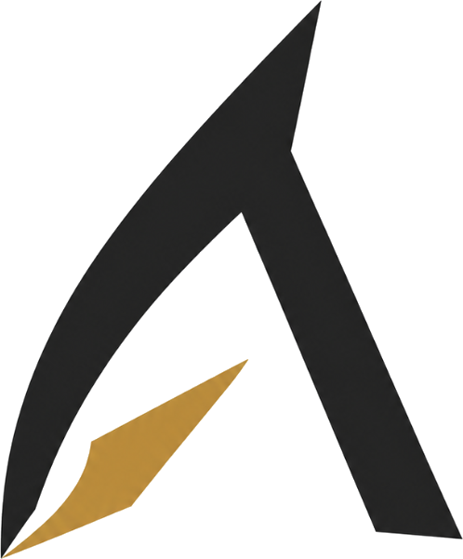  Aravanta Cloud OS  A product by Aravanta Tech | Website: https://aravanta.cloud  Email: hello@aravanta.cloud  Investor Relations: investors@aravanta.cloud  Sales & Partnerships: partnerships@aravanta.cloud  Technical Support: support@aravanta.cloud  Status Page: https://status.aravanta.cloud  GitHub: https://github.com/aravanta  LinkedIn: https://linkedin.com/company/aravanta-tech  Twitter / X: https://x.com/aravantacloud  Headquarters: Bengaluru, Karnataka, India

Aravanta Cloud OS 2026 Aravanta Tech. All rights reserved.
This document is confidential and intended for Internal / Investor use only.

