ARAVANTA TECH * CORPORATE OVERVIEW & STRATEGY SPECIFICATION


Aravanta Cloud OS
Product Overview, Vision & Strategy
A product by Aravanta Tech

Document Version | v1.0 GA (Production Release)
Publication Date | September 11, 2026
Classification | Internal / Investor & Strategic Partner Use
Prepared By | Aravanta Tech - Platform Architecture & Strategy

Table of Contents
01 | Executive Summary | Strategic overview & value proposition
02 | About Aravanta Tech (Parent Company) | Corporate background, founding thesis & leadership
03 | Why Aravanta Cloud OS | Industry pain points & Problem-Solution transformation
04 | Unique Services & Differentiators | 8 core services breakdown & competitive comparison
05 | Market Gap Analysis | Market whitespace & 2x2 positioning matrix
06 | Vision | 3-5 year strategic horizon & core vision pillars
07 | Mission | Company mission & 4 foundational operating pillars
08 | Product Architecture Overview | Three-tier architecture diagram & layer breakdown
09 | Roadmap & Next Steps | Product roadmap timeline & enterprise target initiatives
10 | Why Invest / Why Partner | Traction metrics, investment thesis & call to action
11 | Appendix | Technical glossary & corporate contact directory
Note: Page numbers are dynamically referenced in the electronic edition. Right-click and choose 'Update Field' to refresh.

Executive Summary
Aravanta Cloud OS is a unified, Kubernetes-native multi-cloud operating system engineered by Aravanta Tech to eliminate the tooling fragmentation, vendor lock-in, and operational complexity that define today's enterprise cloud landscape.
Modern engineering organizations operate an average of 15+ disconnected dashboards, proprietary cloud APIs, and siloed telemetry tools across AWS, GCP, Azure, and private datacenters. The consequences are severe: spiraling FinOps costs, security blind spots, and an estimated 70% of engineering bandwidth lost to infrastructure plumbing rather than core product delivery.
Aravanta Cloud OS resolves this systemic friction by introducing a single, unified control plane that orchestrates compute VMs, Kubernetes clusters, managed databases, S3-compatible object storage, GitOps CI/CD pipelines, and real-time observability across all major cloud providers and bare-metal servers.
The platform delivers sub-10ms eBPF telemetry streaming, automated canary deployment gates with 1.2-second rollback, 4-tier zero-trust RBAC with mandatory TOTP multi-factor authentication, and predictable per-second billing in both INR and USD. All administrative and operational events are recorded into an immutable 365-day audit trail, providing out-of-the-box SOC 2 Type II and DPDPA 2023 compliance.
With its v1.0 General Availability release, Aravanta Cloud OS serves engineering teams across 4 production regions (Mumbai, Chennai, Singapore, Frankfurt). Built strictly on open CNCF standards (upstream Kubernetes, OpenTelemetry, Prometheus, Terraform), the platform guarantees zero vendor lock-in - ensuring engineering autonomy and complete workload portability.
Aravanta Cloud OS is not merely an infrastructure dashboard. It represents the foundational operating layer the multi-cloud era has demanded.

About Aravanta Tech (Parent Company)

Company Background & Philosophy
Aravanta Tech is an enterprise infrastructure deep-tech company established by former hyperscaler architects and distributed systems engineers who have built, operated, and maintained infrastructure serving millions of production workloads across AWS, Google Cloud, and Microsoft Azure.
The founding thesis arose from a persistent industry failure: hyperscaler consoles are architected to maximize customer switching costs and lock-in through proprietary APIs, complex egress fees, and opaque pricing models. This is fundamentally misaligned with the speed and independence engineering teams require.
Headquartered in Jalgaon, India, Aravanta Tech is built on an engineer-first ethos prioritizing upstream open-source contributions, radical transparency, predictable economics, and a strict commitment to zero proprietary lock-in.

Core Belief & Operating Thesis
"Infrastructure should be completely invisible. Software engineers should dedicate their creative energy to shipping impactful products, not wrestling with cloud plumbing, IAM sprawl, and runaway egress bills. We believe the operating system for modern multi-cloud infrastructure must be open, unified, and relentlessly simple."

Executive Leadership & Governance
Role / Leadership | Executive Name | Relevant Background & Pedigree
Chief Executive Officer | [Founder Name] | Ex-Principal Infrastructure Architect, Hyperscaler Cloud Platforms
Chief Technology Officer | [Co-Founder Name] | Ex-Staff SRE, Upstream Kubernetes Core Contributor
VP of Engineering | [Executive Name] | 15+ years in distributed systems, ex-Azure Compute & Networking
Head of Enterprise Product | [Executive Name] | Enterprise infrastructure product leadership, ex-Datadog

Why Aravanta Cloud OS

The Problem Statement: Cloud Complexity Tax
- Fragmented Toolchain Chaos: Engineering teams juggle 15+ disconnected consoles (AWS, GCP, Azure, Terraform, Datadog, PagerDuty, ArgoCD, Vault) with no central coordination.
- Severe Vendor Lock-In: Hyperscaler-specific APIs, proprietary SDKs, and egress tolls make multi-cloud portability practically unattainable.
- Cost Opacity & Egress Taxes: Multi-layered bills with unpredictable data transfer fees, cross-AZ charges, and unutilized reserved capacity.
- Security & IAM Sprawl: Disjointed identity providers, disparate RBAC models, and fragmented audit logs across accounts create severe compliance vulnerabilities.
- Telemetry & Observability Silos: Metrics, logs, and distributed traces live in separate point-solution databases without correlated incident context.
- Substantial Productivity Loss: Platform engineering teams spend 60 - 70% of sprint capacity maintaining integration glue code rather than building core product value.

Problem-to-Solution Transformation Diagram
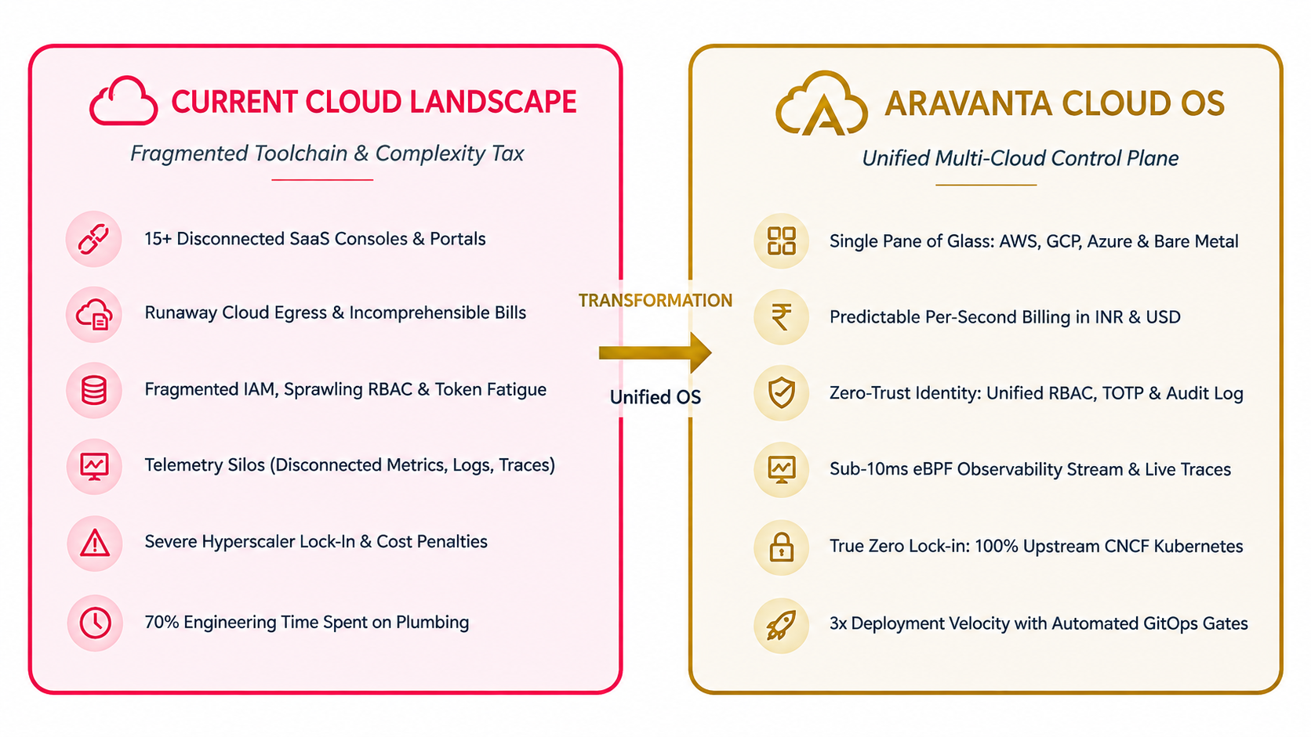

Unique Services & Differentiators

8 Core Modular Services
Service Module | Technical Description | Key Architectural Differentiator
ArvCompute Engine | Elastic virtual machines with NVMe SSD block storage | Live CPU/RAM resize without instance reboot; per-second billing
ArvKube Orchestrator | Managed Kubernetes 1.27-1.30 clusters | Automated node draining, HPA, and multi-tenant namespace isolation
ArvStore Fabric | Distributed S3-compatible object storage | AES-256 cryptographic encryption, lifecycle tiering, data sovereignty
ArvDB Cluster Manager | High-availability Postgres, Redis, MySQL clusters | Automated PITR backups, Patroni leader election, instant failover
GitOps Delivery Engine | Automated release pipelines with canary safety gates | 25% canary traffic split with SLO gates; 1.2s instant rollback
Observability Hub | Sub-10ms eBPF telemetry streaming & distributed tracing | Native Prometheus scraper + live Loki log stream explorer
War-Room Console | Real-time SRE incident command center | Commander assignment, live incident timeline, automated postmortem RCA
Security & RBAC Vault | Zero-trust identity & access management | 4-tier RBAC matrix, mandatory TOTP MFA, 365-day immutable audit trails

Feature-by-Feature Competitive Comparison
Feature / Capability | Aravanta Cloud OS | Hyperscalers (AWS/GCP/Azure) | DIY Open Source Stack
Unified Multi-Cloud Control Plane | Native (Single Pane) | No (Provider Silos Only) | Fragmented Custom Glue
Per-Second Billing (INR & USD) | Native (No Hidden Egress) | Hourly Minimums + Egress Taxes | N/A (Multi-Vendor Invoicing)
Sub-10ms eBPF Telemetry | Built-In Control Plane | Requires 3rd-Party SaaS | Complex Multi-Tool Setup
Automated Canary & 1.2s Rollback | Native with SLO Gates | Manual Deployment Scripts | ArgoCD + Custom Webhooks
Zero Vendor Lock-In | 100% Upstream CNCF | Proprietary APIs & Services | Open but High Maintenance
Zero-Trust RBAC & TOTP MFA | Out of Box (4-Tier) | Fragmented Across Services | Self-Managed HashiCorp Vault
Compliance Audit Ready | SOC 2 Type II / DPDPA Aligned | Requires Separate Audit Setup | Self-Audited & Maintained
Data Sovereignty & Local Residency | Guaranteed (India/EU/SG) | Limited Regional Guarantees | Dependent on Datacenter

Market Gap Analysis

Market Whitespace & Opportunity
The global cloud infrastructure market exceeds $250 billion annually, with ~65% controlled by AWS, Microsoft Azure, and Google Cloud. While these hyperscalers offer immense raw infrastructure capacity, their commercial models rely on ecosystem lock-in and high switching barriers.
Conversely, open-source point tools (Terraform, ArgoCD, Prometheus, Grafana, HashiCorp Vault) provide openness but shift the integration, security, and maintenance burden entirely onto engineering teams -- costing organizations 6-12 months of setup time and persistent operational toil.
The critical market gap: there is no enterprise-grade, turn-key operating system that delivers the unified management simplicity of a hyperscaler console while preserving the workload portability, open standards, and cost transparency of cloud-native architecture. Aravanta Cloud OS occupies this exact high-value intersection.

Market Positioning Matrix (2x2 Quadrant)
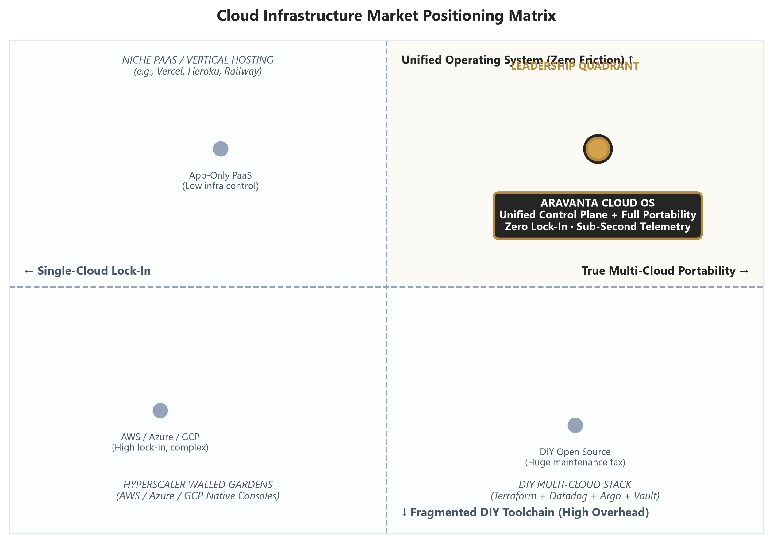

Target Customer Segments
Target Segment | Primary Pain Point Addressed | Aravanta Cloud OS Value Proposition
Fast-Growing Scaleups & SaaS | Cannot justify dedicated 10-person DevOps teams | Turnkey infrastructure platform with instant time-to-market
Mid-Market & Enterprises | Multi-cloud operational sprawl & compliance overhead | Unified governance, single pane of glass, SOC 2 / DPDPA audit trails
Government & Public Sector (PSUs) | Data sovereignty mandates & air-gapped requirements | Native Indian data residency with on-prem BYOK Kubernetes distribution
DevOps & SRE Organizations | Toolchain integration fatigue & incident triage delays | Integrated eBPF telemetry, war-room console, automated runbooks
Regulated Industries (BFSI/Health) | Strict audit trails, key control, encryption mandates | Immutable 365-day audit log, AES-256 encryption, zero-trust RBAC

Vision
Our 3-5 Year Strategic Vision
"By 2030, Aravanta Cloud OS will be the universal operating standard for multi-cloud and distributed infrastructure -- empowering every engineering organization worldwide to provision, deploy, observe, and autonomously recover production workloads across any cloud provider or bare-metal environment through a single, elegant, and open control plane. We envision an era where cloud plumbing is completely abstracted: software teams think purely in terms of business applications and user experiences, completely untethered from proprietary cloud barriers."

- Universal Multi-Cloud Abstraction: Full cloud-agnostic control plane orchestrating AWS, GCP, Azure, and bare-metal environments with zero proprietary API dependencies.
- Autonomous Self-Healing Infrastructure: AI-assisted anomaly detection and deterministic remediation that resolves 80%+ of common production incidents without human intervention.
- Global Sovereign Compliance Engine: Built-in compliance governance for DPDPA 2023, SOC 2 Type II, ISO 27001, GDPR, and HIPAA with automated one-click audit generation.
- Engineering Velocity Multiplier: Accelerating infrastructure provisioning cycles from days to under 60 seconds, returning valuable engineering capacity to core product development.

Mission
"To build the most reliable, transparent, and unified cloud operating system that empowers engineering teams to ship faster, observe deeper, and operate with absolute resilience -- without ever sacrificing independence to proprietary vendor lock-in or opaque billing structures."

4 Foundational Operating Pillars
Operating Pillar | Guiding Architectural Principle | Uncompromising Commercial Commitment
Open Standards First | Every API, schema, and telemetry protocol is CNCF-native and upstream-compatible | Zero proprietary lock-in across all platform surfaces
Relentless Simplicity | Hide complexity behind elegant abstractions. One console, one CLI, one unified bill | Under 5 minutes from account signup to live workload deployment
Zero-Trust Security | Continuous verification: every request authenticated, authorized, and cryptographically logged | SOC 2 Type II verified, 365-day immutable audit retention
Transparent Economics | Per-second billing granularity, zero hidden egress tolls, real-time FinOps visibility | Native INR and USD invoicing with full GST tax compliance

Product Architecture Overview
Aravanta Cloud OS is engineered as a three-tier Kubernetes-native control plane that cleanly decouples developer interaction interfaces, platform management services, and underlying physical infrastructure fabrics. This modular design guarantees that any public cloud or private bare-metal environment can be plugged in without modifying control plane logic or disrupting the developer workflow.
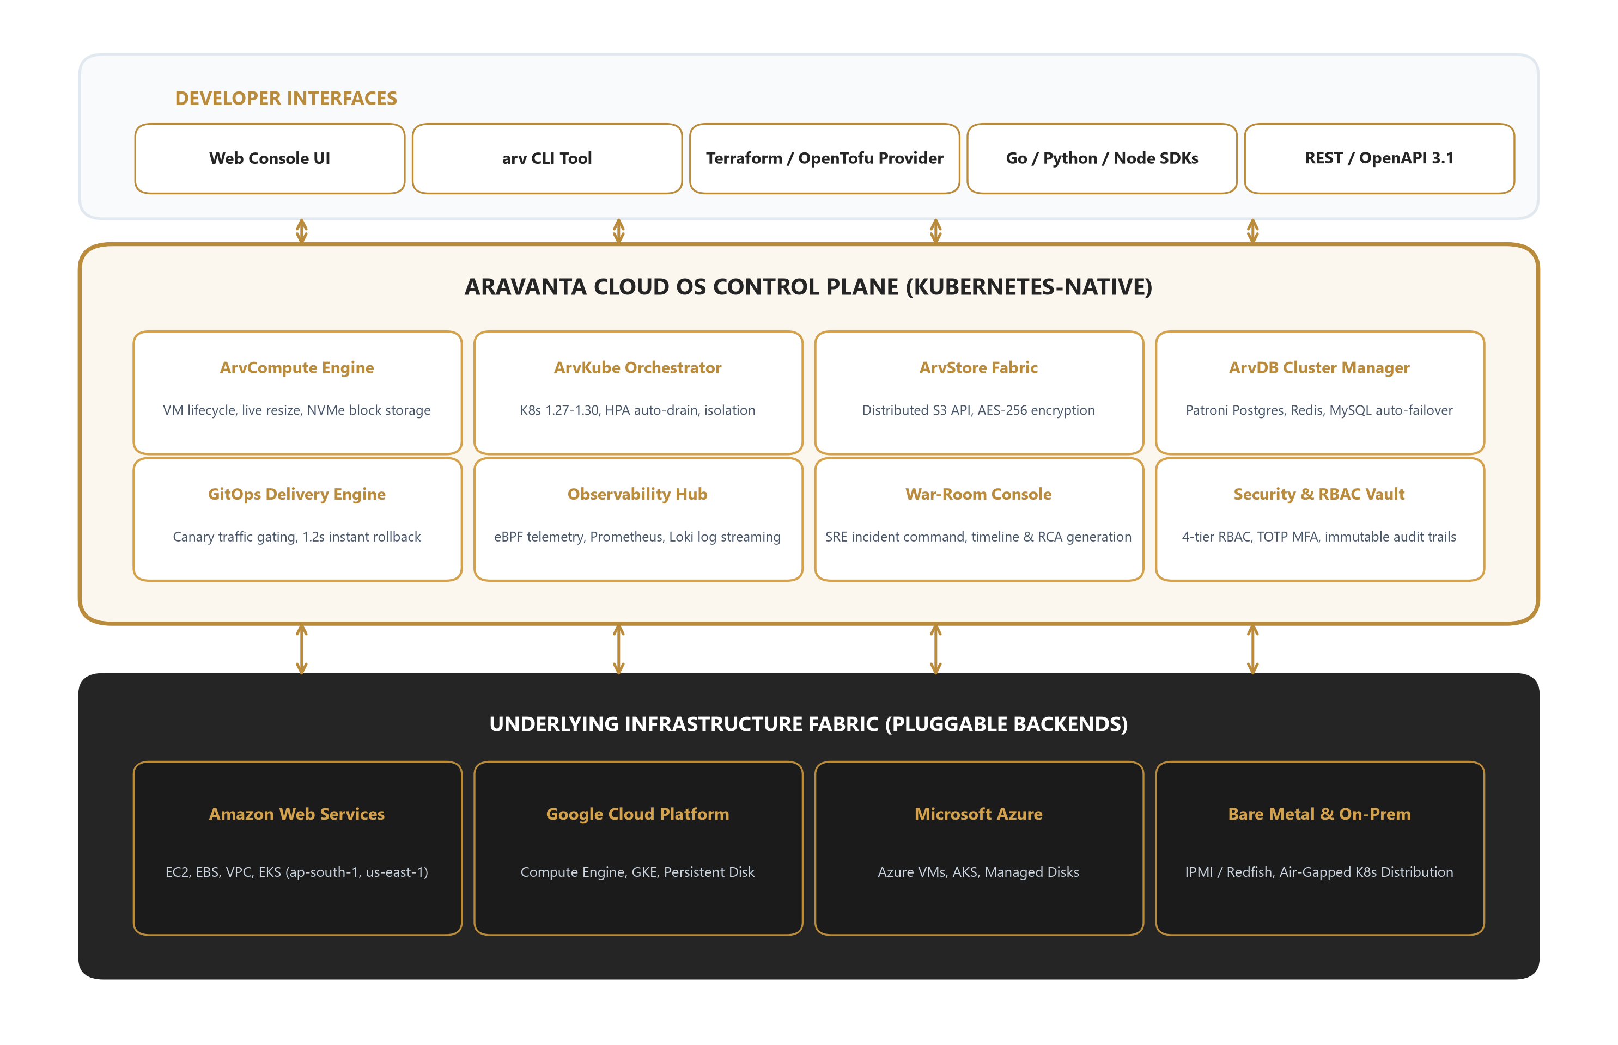

Detailed Tier Specifications
Tier 1 -- Developer Access Surfaces: Web Console UI, arv command-line interface, Terraform/OpenTofu provider, Go/Python/Node SDKs, and REST/OpenAPI 3.1 specifications. All developer surfaces are generated from a single OpenAPI schema, guaranteeing 100% operational parity.
Tier 2 -- Aravanta Unified Control Plane: Core Kubernetes-native orchestration layer encompassing 8 specialized services: ArvCompute, ArvKube, ArvStore, ArvDB, GitOps Delivery Engine, Observability Hub, War-Room Console, and Security & RBAC Vault. Every service operates via declarative Custom Resource Definitions (CRDs).
Tier 3 -- Physical & Cloud Infrastructure Backends: Provider adapters translating declarative intent into cloud-specific API calls: AWS (EC2/EBS/VPC/EKS), GCP (Compute Engine/GKE/Persistent Disk), Azure (VMs/AKS/Disks), and Bare-Metal/On-Premise (IPMI/Redfish with air-gapped K8s distribution).

Roadmap & Next Steps

Strategic Product Roadmap Timeline
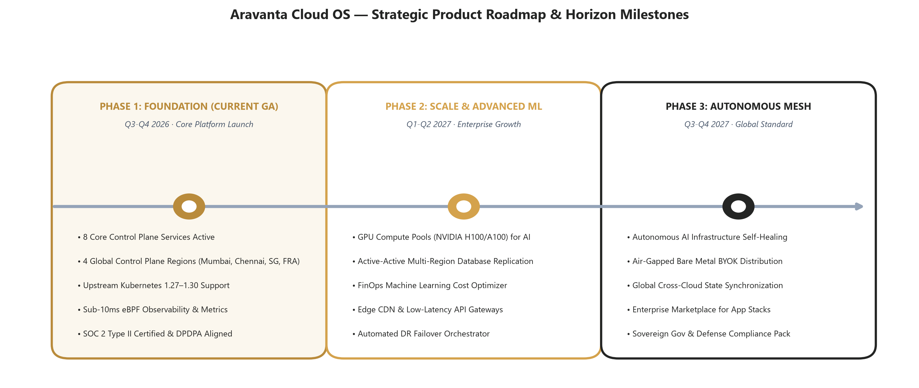

Go-to-Market & Strategic Execution Initiatives
Strategic Initiative | Target Window | Execution Scope & Objectives | Key Success Metric
Enterprise Pilot Program | Q4 2026 | Onboard 5-8 enterprise design partners for 90-day production pilots | 3+ annual enterprise contract conversions
Global SI Channel Alliances | Q1 2027 | Formalize distribution partnerships with Tier-1 consulting & SI firms | 2+ signed channel reseller agreements
Government Cloud Certification | Q1-Q2 2027 | Obtain MeitY empanelment & deploy sovereign air-gapped K8s distribution | Official MeitY accreditation approved
Series A Investment Round | Q4 2026 - Q1 2027 | Raise growth capital to expand engineering, enterprise sales, and regions | Target: $8-12M at $40-60M valuation
APAC & EU Regional Expansion | Q2-Q3 2027 | Establish Singapore, Tokyo, and Frankfurt control plane nodes | 3 international regions in full GA

Why Invest / Why Partner

Key Operational Metrics & Growth Targets
Business / Platform Metric | Current Status (GA) | 12-Month Target | 24-Month Target
Monthly Recurring Revenue (MRR) | [Confidential Baseline] | $150,000+ | $650,000+
Active Enterprise Tenants / Workspaces | [Initial Cohort] | 50+ Workspaces | 250+ Workspaces
Managed Kubernetes Clusters | Production Fleet | 150+ Clusters | 800+ Clusters
Managed Compute VM Instances | Active Core | 2,500+ Instances | 15,000+ Instances
Platform Uptime SLA Commitment | 99.95% Delivered | 99.99% Guaranteed | 99.995% Enterprise SLA
Net Revenue Retention (NRR) | Baseline | > 125% | > 135%
Core Engineering Team Size | Core Founders + SREs | 25 Engineers | 60 Engineers
Active Production Regions | 4 GA Regions | 6 Production Regions | 10 Global Regions

Investment & Partnership Thesis
- Massive Expanding TAM: The global cloud infrastructure management market is projected to reach $128B by 2028, with multi-cloud management experiencing a 24.5% CAGR.
- High Technical Defensibility: Building a production-ready Kubernetes-native control plane with 8 deeply integrated service modules represents a multi-year technical barrier to entry.
- Capital-Efficient Unit Economics: High-margin recurring SaaS subscription coupled with pass-through per-second compute margins yields projected gross margins above 78%.
- India-First Strategic Advantage: Perfectly positioned to capture India's rapid $10B+ enterprise cloud expansion through native INR invoicing, GST compliance, and DPDPA data residency.
- Elite Engineering Pedigree: Founded by veterans who have engineered hyperscaler cloud fabrics, ensuring battle-tested architecture from Day 1.

Strategic Engagement Call to Action
Aravanta Tech is actively engaging strategic growth investors, enterprise pilot customers, and channel alliance partners who recognize that the future of cloud computing is open, unified, and multi-cloud.
* Strategic Alliances: partnerships@aravanta.cloud
* Investor Relations: investors@aravanta.cloud
* Platform Demonstrations: demo.aravanta.cloud

Appendix

Glossary of Architectural Terms
Technical Term | Architectural Definition in Context of Aravanta Cloud OS
Control Plane | The centralized management layer that orchestrates infrastructure resources across disparate cloud providers and bare-metal servers.
CNCF | Cloud Native Computing Foundation -- the vendor-neutral organization governing Kubernetes, Prometheus, OpenTelemetry, and container standards.
eBPF | Extended Berkeley Packet Filter -- in-kernel programmable technology powering sub-10ms observability and network packet inspection.
GitOps | Declarative operational model utilizing Git repositories as the single source of truth for all infrastructure and deployment states.
RBAC | Role-Based Access Control -- security paradigm enforcing granular permission boundaries based on verified organizational roles.
TOTP MFA | Time-based One-Time Password (RFC 6238) -- cryptographic algorithm generating short-lived 30-second verification tokens.
PITR | Point-in-Time Recovery -- database capability enabling exact state restoration to any millisecond within the backup retention window.
SOC 2 Type II | Stringent independent security audit verifying operational controls across Security, Availability, and Confidentiality over time.
DPDPA 2023 | India's Digital Personal Data Protection Act, 2023 -- statutory framework regulating data processing, residency, and privacy.
BYOK Distribution | Bring Your Own Kubernetes -- enterprise deployment model enabling the Aravanta control plane to run on client-owned hardware.

Corporate Directory & Legal Notices
  Aravanta Cloud OS  A product by Aravanta Tech | Official Portal: https://aravanta.cloud  General Inquiries: hello@aravanta.cloud  Investor Relations: investors@aravanta.cloud  Enterprise Alliances: partnerships@aravanta.cloud  Technical Support: support@aravanta.cloud (24/7 SRE bridge)  System Telemetry Status: https://status.aravanta.cloud  Open-Source Monorepo: https://github.com/aravanta  Corporate LinkedIn: https://linkedin.com/company/aravanta-tech  Social Communications: @aravantacloud on Twitter / X  Engineering Headquarters: Jalgaon, Maharashtra, India

Aravanta Cloud OS (c) 2026 Aravanta Tech. All rights reserved.
This document contains proprietary information. Unauthorized duplication, distribution, or reproduction is strictly prohibited.

