
Aravanta CloudOS
CLOUD OPERATING PLATFORM
An open, self-service cloud platform for deploying, managing, and monitoring
cloud-native applications and modern infrastructure from a unified command center.
Version 1.0 — Technical & Architectural Documentation
July 2026 | Prepared by Aravanta Engineering Team

Table of Contents
Chapter 01 — Executive Summary
• Vision & Mission
• Value Proposition
Chapter 02 — Platform Architecture
• High-Level Architecture
• Architectural Layers
• Design Principles
Chapter 03 — Aravanta Service Catalog
• ArvCompute
• ArvKube
• ArvStore
• ArvDB
• ArvRegistry
• ArvEdge
• ArvWatch
• ArvGate
Chapter 04 — Core Modules
• Identity Module
• Dashboard Overview
• Infrastructure as Code
• CI/CD Pipeline
• Security Module
• Billing Engine
Chapter 05 — Technology Stack
• Frontend Stack
• Backend Architecture
• DevOps & Infrastructure
Chapter 06 — API Reference
• Authentication API
• Resource Management APIs
Chapter 07 — Deployment & Operations
• Repository Structure
• Environment Promotion Pipeline
• Local Development
Chapter 08 — Monitoring & Observability
• Metrics, Logs, and Traces
• Alerting Thresholds
Chapter 09 — Security Architecture
• Defense-in-Depth
• Compliance & Governance
Chapter 10 — Roadmap & Portfolio Overview
• Implementation Milestones
• Resume Project Summary

Chapter 01 — Executive Summary
VISION STATEMENT
Aravanta CloudOS is a production-grade cloud operating platform designed to unify every aspect of modern cloud infrastructure into a single, intuitive experience. It empowers engineering teams to provision resources, deploy applications, manage Kubernetes workloads, automate infrastructure, and gain deep operational visibility — without switching between dozens of disconnected tools.

1.1 Vision & Mission
The modern cloud ecosystem is fragmented. Engineers juggle separate consoles for compute, storage, databases, container orchestration, monitoring, and CI/CD. Each tool has its own learning curve, authentication mechanisms, and operational model. Aravanta CloudOS eliminates this fragmentation by acting as the operating system for cloud resources.
1.2 Value Proposition
- For Developers: One-click application deployments with zero-downtime rollouts.
- For Developers: Built-in CI/CD pipelines connected directly to Git repositories.
- For Developers: Real-time log streaming and distributed tracing out of the box.
- For Organizations: Centralized governance, audit logs, and granular RBAC across all services.
- For Organizations: Cost optimization through real-time usage analytics and budget alerts.

Chapter 02 — Platform Architecture
Aravanta CloudOS follows a microservices-oriented, layered architecture. Each layer has clear responsibilities and communicates via well-defined RESTful and gRPC interfaces.
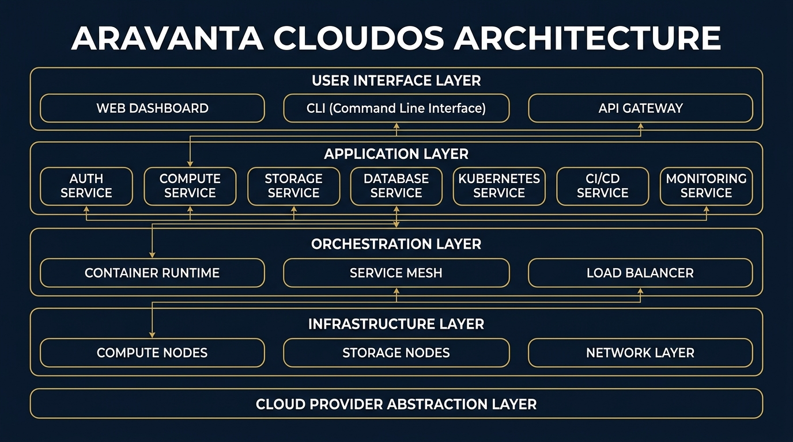
Figure 2.1 — Aravanta CloudOS High-Level Architecture Diagram
2.1 Architectural Layers
Layer | Components | Responsibility
Presentation Layer | Web Dashboard, CLI, Mobile App | User-facing interfaces providing graphical and command-line interactions.
API Gateway | ArvGateway (Nginx + Middleware) | Single entry point handling Auth, Rate Limiting, CORS, and TLS termination.
Application Services | Auth, Compute, Kube, Storage, DB, CICD | Domain-specific microservices implementing business logic and data persistence.
Orchestration Layer | Container Runtime, Service Mesh | Manages container lifecycles, service discovery, and inter-service mTLS.
Provider Abstraction | Cloud Adapters Layer | Translates Aravanta service requests to underlying cloud/bare-metal APIs.
Chapter 03 — Aravanta Service Catalog
Instead of copying cloud provider branding, Aravanta CloudOS introduces its own native, cloud-agnostic service abstractions:
Service Name | Category | Core Capabilities
ArvCompute | Compute Engine | Virtual machines, auto-scaling groups, spot instances, instance templates, and SSH key management.
ArvKube | Kubernetes Engine | Fully managed Kubernetes clusters, node pools, rolling updates, pod inspection, and Helm charts.
ArvStore | Object Storage | High-durability object storage, bucket access policies, object versioning, and CDN integration.
ArvDB | Managed Database | Managed PostgreSQL & MySQL databases with automated HA failover, point-in-time recovery, and read replicas.
ArvRegistry | Container Registry | Private Docker image registry with automatic CVE scanning, image signing, and lifecycle rules.
ArvEdge | Load Balancer & WAF | L7 application load balancing, SSL/TLS termination, rate limiting, and edge DDoS protection.
ArvWatch | Monitoring & Logs | Prometheus metrics, Loki log aggregation, Jaeger tracing, Grafana dashboards, and Alertmanager alerts.
ArvGate | Identity & Access | JWT authentication, MFA (TOTP/FIDO2), RBAC policies, service accounts, and immutable audit logs.
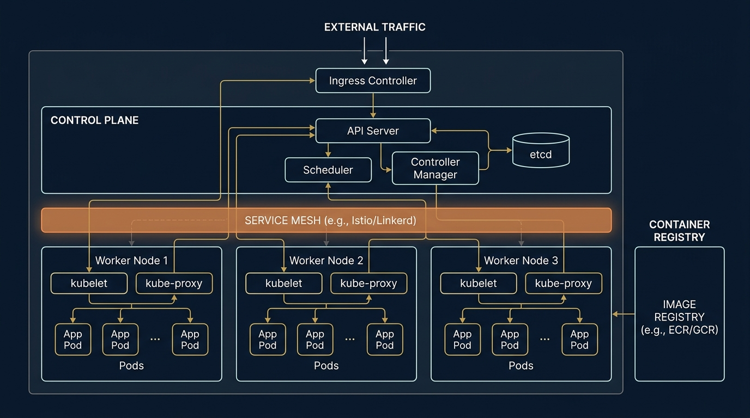
Figure 3.1 — ArvKube Managed Kubernetes Architecture

Chapter 04 — Core Modules & Features
4.1 Dashboard Command Center
The unified dashboard provides real-time operational visibility into infrastructure health, active deployments, and resource utilization.
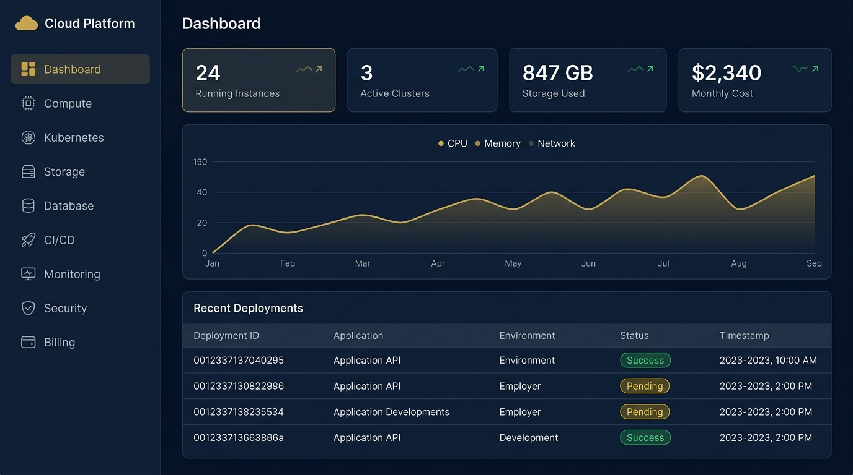
Figure 4.1 — Aravanta CloudOS Unified Web Dashboard Mockup

4.2 Continuous Integration & Deployment (CI/CD)
Automated deployment pipelines connect Git commits directly to staging and production Kubernetes environments.
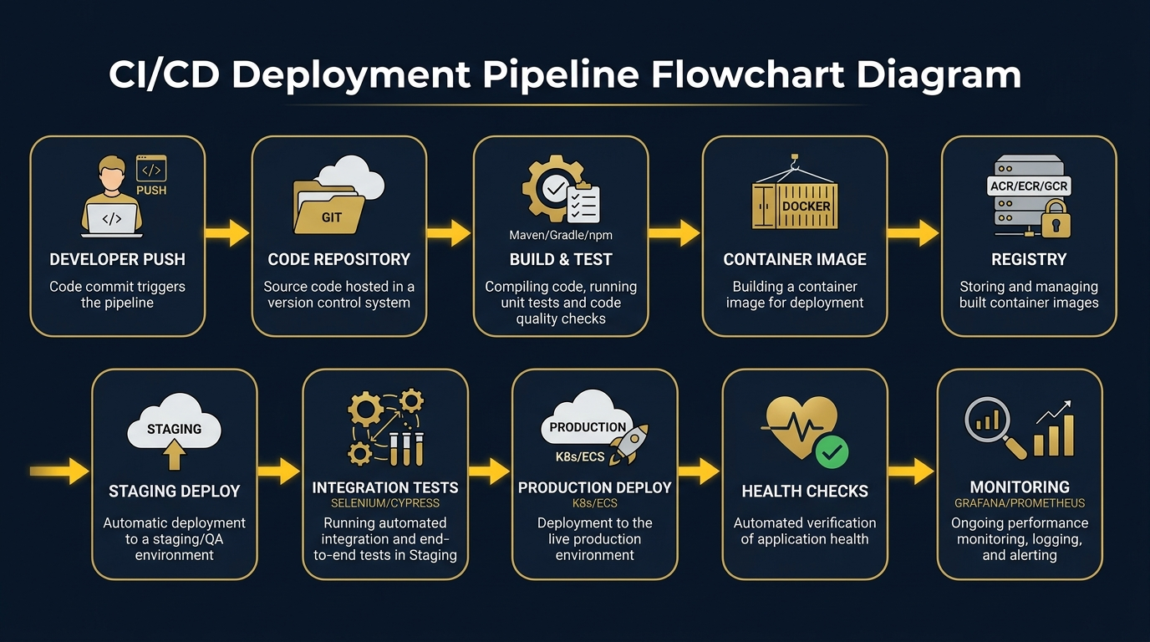
Figure 4.2 — Continuous Integration & Continuous Deployment (CI/CD) Workflow
4.3 Infrastructure as Code (IaC) Engine
Native integration with Terraform allows users to define infrastructure declaratively, review plan outputs, apply changes safely, and detect configuration drift automatically.

Chapter 05 — Technology Stack
Tier | Technology | Role & Rationale
Frontend | React 18 + TypeScript + Tailwind CSS | Modern, type-safe, responsive user interface with component reuse.
Backend API | Python 3.11 + FastAPI | High-performance async REST APIs with auto-generated OpenAPI documentation.
Database | PostgreSQL 15 + Redis 7 | ACID transactional relational storage combined with fast in-memory caching.
Orchestration | Docker + Kubernetes + Helm | Standard container execution, cluster orchestration, and package management.
Infrastructure | Terraform + AWS/Cloud SDKs | Declarative IaC for multi-environment cloud resource management.
Monitoring | Prometheus + Grafana + Loki | Complete observability pillar stack for metrics, logs, and alerting.

Chapter 06 — API Reference
Aravanta CloudOS exposes RESTful endpoints secured via JWT bearer tokens.
6.1 Authentication Endpoints
POST /api/v1/auth/login
POST /api/v1/auth/register
POST /api/v1/auth/mfa/verify

6.2 Compute & Cluster Provisioning Endpoints
GET /api/v1/compute/instances
POST /api/v1/compute/instances
DELETE /api/v1/compute/instances/{id}
GET /api/v1/kubernetes/clusters
POST /api/v1/kubernetes/clusters
GET /api/v1/kubernetes/clusters/{id}/pods

Chapter 07 — Deployment & Monorepo Structure
aravanta-cloudos/
├── frontend/ # React + TypeScript Web Application
├── backend/ # FastAPI Python Microservices
├── terraform/ # Infrastructure Provisioning Modules
├── kubernetes/ # K8s Manifests & Helm Charts
├── docker/ # Docker Compose for Local Development
├── monitoring/ # Prometheus, Grafana, Loki Configs
├── nginx/ # API Gateway Reverse Proxy Rules
├── scripts/ # Automated Setup & Seed Scripts
└── .github/workflows/ # CI/CD Pipeline Definitions

Chapter 08 — Monitoring & Observability
Observability is built directly into every layer of Aravanta CloudOS using Prometheus metrics, Loki log streams, and Jaeger distributed traces.
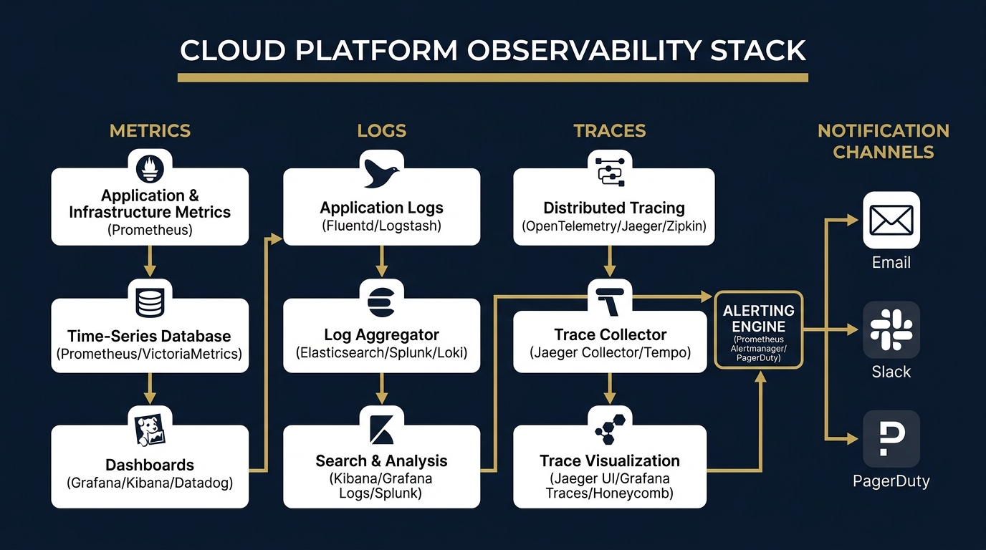
Figure 8.1 — ArvWatch Observability & Alerting Stack

Chapter 09 — Security Architecture
The platform enforces a defense-in-depth model across network, application, and data layers.
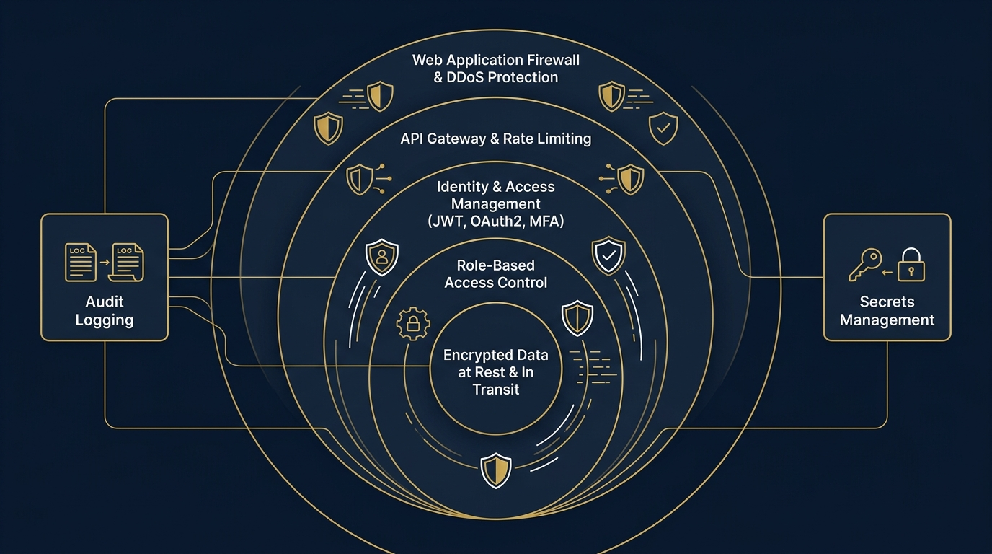
Figure 9.1 — Defense-in-Depth Security Layers

Chapter 10 — Roadmap & Resume Overview
💼 PORTFOLIO & RESUME SUMMARY
Aravanta CloudOS — A production-style cloud operating platform built with Python, React, Docker, Kubernetes, Terraform, and AWS/Cloud infrastructure. Provides secure authentication (JWT/MFA/RBAC), infrastructure provisioning (ArvCompute), managed Kubernetes orchestration (ArvKube), private container registry (ArvRegistry), object storage (ArvStore), database management (ArvDB), observability (ArvWatch), and CI/CD automation through a unified web interface.

