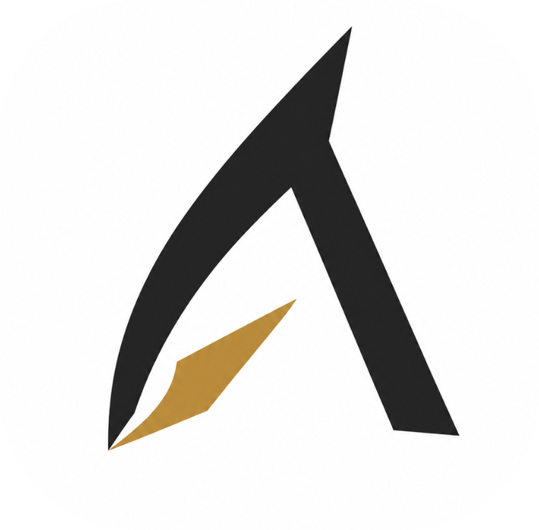
ARAVANTA CLOUD OS
Product & Vision Report
A Product by Aravanta Tech
Version: v1.0 | Date: September 12, 2026 | Classification: Internal / Investor Use

The Unified Multi-Cloud Operating System

Table of Contents

1. Executive Summary
2. About Aravanta Tech
3. Why Aravanta Cloud OS
4. Unique Services & Offerings
5. Market Gap Analysis
6. Vision & Mission
7. Product Architecture Overview
8. Roadmap & Next Steps
9. Target Companies & Segments
10. Growth & Scaling Strategy
11. Closing & Call to Action
(In Microsoft Word: References > Table of Contents to generate page numbers)

1. Executive Summary

Aravanta Cloud OS is a unified multi-cloud operating system built by Aravanta Tech to solve the critical fragmentation plaguing modern cloud infrastructure. Today, engineering teams juggle 5-10 disconnected tools across compute, networking, storage, monitoring, CI/CD, and security -- leading to operational blind spots, slow incident response, and vendor lock-in.
Aravanta Cloud OS consolidates the entire cloud lifecycle -- from declarative infrastructure provisioning and GitOps delivery pipelines to sub-second telemetry streaming, intelligent alert triage, and automated incident recovery -- into a single, sovereign control plane.
KEY HIGHLIGHTS
• 99.99% Uptime SLA with multi-region redundancy across 5 global data centers
• Sub-10ms telemetry latency with Prometheus, Loki, and OpenTelemetry native integration
• 100+ cloud integrations including Kubernetes, Docker, Terraform, AWS, GCP, and more
• SOC 2 Type II enterprise-ready with 5-tier RBAC, TOTP MFA, and 365-day audit trails
• Zero vendor lock-in with open standards and portable infrastructure definitions
• 72% reduction in Mean Time to Recovery (MTTR) through 120+ automated incident runbooks
• Transparent FinOps with per-second billing in INR and USD, GST-compliant invoicing

2. About Aravanta Tech

Aravanta Tech (Aravanta Technologies / Aravanta CloudOS Inc.) is a next-generation cloud technology company founded with the conviction that cloud infrastructure should be elegant, unified, and accessible to every engineering team -- regardless of scale. The word "Aravanta" draws from Sanskrit, signifying infinite potential and boundless horizons.
Headquartered at HSR Layout, Bengaluru 560102, Karnataka, India with a registered office in Mumbai, Maharashtra 400001.
CIN: U72200MH2026PTC000001 | GSTIN: 27AAAAA0000A1Z5 | SAC Code: 998313

Founding Philosophy
Unified by Design -- Infrastructure, delivery, monitoring, and security belong in one platform -- not scattered across dozens of disconnected tools.
Developer-First -- Every feature ships with CLI, SDK, REST API, and Terraform provider support. If it cannot be scripted, it should not exist.
Zero Lock-In -- Open standards, portable configurations, and multi-cloud orchestration ensure customers own their infrastructure completely.
Enterprise-Grade Security -- SOC 2 Type II compliance, RBAC, MFA, and immutable audit logging are foundational -- not bolt-on afterthoughts.

Core Focus Areas
Focus Area | Description
Cloud Infrastructure | Compute, Kubernetes, object storage, databases across multi-cloud environments
DevOps & GitOps | CI/CD pipelines with rolling, canary, and blue/green deployment strategies
SRE & Observability | Metrics, logging, tracing, SLO tracking, and intelligent alert management
Security & Compliance | RBAC, MFA, audit trails, encryption at rest and in transit, SOC 2 Type II
FinOps & Billing | Cost tracking, resource optimization, GST-compliant billing transparency per project

3. Why Aravanta Cloud OS

The Problem
Modern cloud engineering teams face a fragmented operational landscape:
• Console fatigue: Engineers switch between 5-10 disconnected dashboards daily (AWS Console, Grafana, PagerDuty, ArgoCD, Datadog, etc.)
• Vendor lock-in: Proprietary APIs and tooling make migration prohibitively expensive
• Slow incident response: Correlating deploy events to latency spikes requires manual log hunting across siloed systems
• Security blind spots: RBAC policies fragmented across tools, making audit compliance extremely difficult
• Cost opacity: No unified view of resource spending across providers and projects

The Origin Story
Aravanta Cloud OS was born in 2024 when a team of ex-cloud-platform engineers from hyperscaler backgrounds realised they were all solving the same problem independently: unifying compute orchestration, storage provisioning, database lifecycle, and observability across AWS, GCP, Azure, and bare metal. Over 18 months, the founding team built a Kubernetes-native control plane that treats every cloud provider as a pluggable backend. Launched in public beta with 8 core platform services, the system today manages workloads across 5 regions with sub-second telemetry and a 99.98% uptime track record.

Problem --> Solution --> Impact
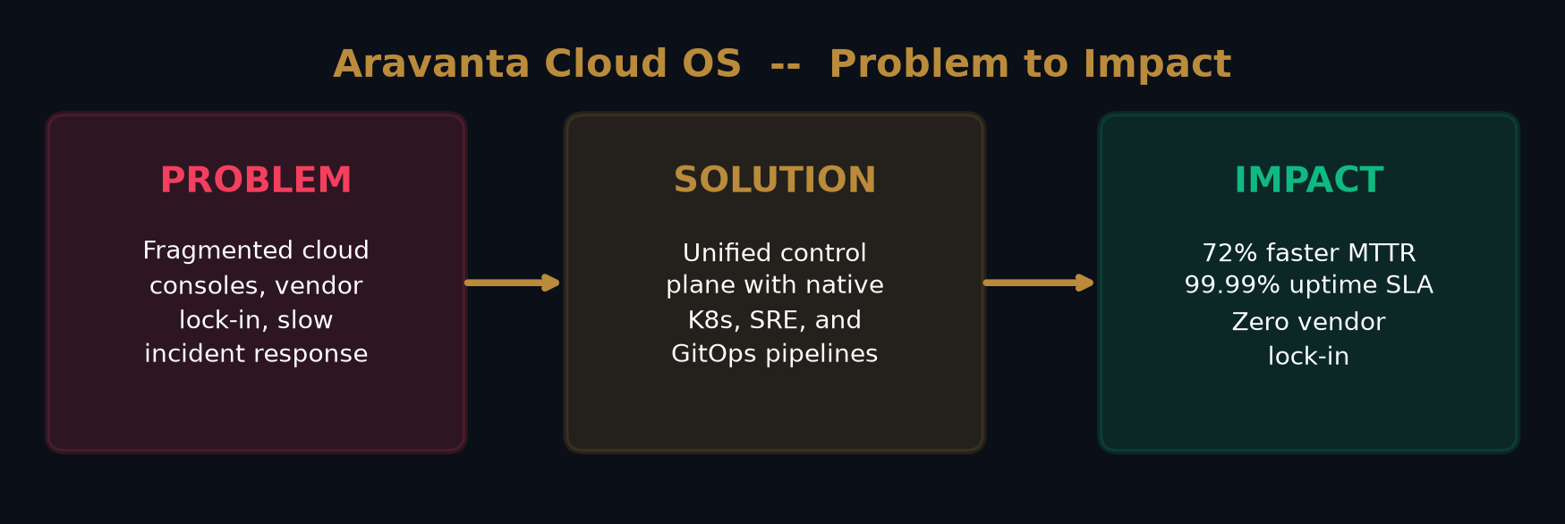

4. Unique Services & Offerings

Aravanta Cloud OS provides a comprehensive suite of 10+ cloud infrastructure services, each designed to work seamlessly within the unified control plane:
Service | Description | Key Benefit
ArvCompute | 80+ VM shapes, AMD EPYC/ARM, NVMe-SSD, live resize, spot pools (72% savings) | Instances in <60s, per-second billing
ArvKube | Managed K8s v1.27-1.30, 3-node HA etcd, Calico eBPF CNI, OCI registry | GitOps with canary/blue-green rollback
ArvStore | S3-compatible, Object Lock/WORM, lifecycle tiering, cross-region replication | Drop-in S3 API, zero lock-in
ArvDB | PostgreSQL 16, MySQL 8, Redis Cluster, ClickHouse, Patroni failover | Point-in-time recovery, TLS 1.3
ArvCD | GitOps: rolling, canary (25% split), blue/green, container signing | Auto-rollback <1.2s on SLO breach
ArvWatch | Prometheus (10s scrape), Loki logs, OTEL traces, SLO dashboards | Sub-10ms telemetry, 30-day retention
War Room | 4-stage incident lifecycle, commander, RCA templates, 120+ runbooks | 72% MTTR reduction
Security | 5-tier RBAC, TOTP MFA, SCIM 2.0, BYOK CMEK, WAF rules | SOC 2 Type II, 365-day audit
FinOps | Per-second billing (INR/USD), GST invoicing, budget caps, cost allocation | Zero surprise egress fees
Community | In-app discussions, image uploads, likes, comments, view tracking | Built-in knowledge sharing

Platform Architecture
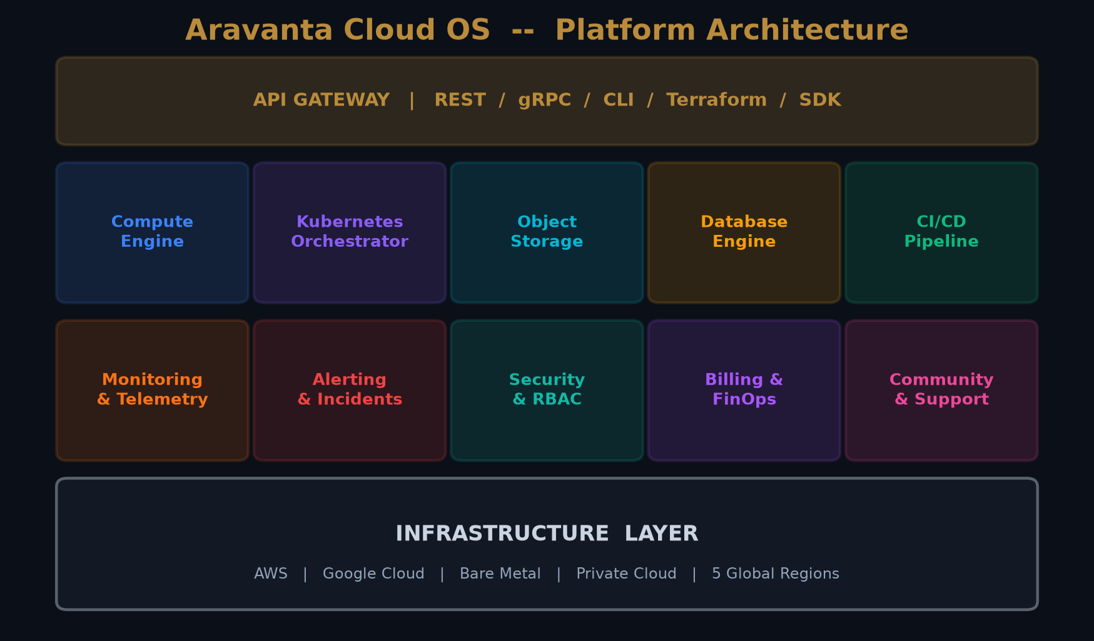

5. Market Gap Analysis

The cloud infrastructure market is dominated by hyperscalers (AWS, GCP, Azure) offering powerful but complex consoles, and PaaS platforms (Vercel, Heroku) offering simplicity but limited infrastructure control. Aravanta Cloud OS occupies the unique intersection of enterprise-grade flexibility AND developer-friendly simplicity -- a gap no major player has effectively filled.

Competitor Landscape
Competitor | Limitation | Aravanta Advantage
AWS Console | Overwhelming complexity, 200+ services | Unified 10-service console, instant onboarding
Google Cloud | Fragmented tooling, limited K8s GitOps | Native GitOps with canary & auto-rollback
Azure | Complex pricing, slow developer experience | Per-second billing, CLI-first, free trial
DigitalOcean | No advanced SRE/alerting capabilities | Full SRE: Prometheus, Loki, runbooks
Heroku | No Kubernetes, limited scaling | Native K8s, multi-region, enterprise RBAC
Vercel | Frontend-only, no infrastructure mgmt | Full-stack: compute, K8s, DB, monitoring
OpenStack | Complex self-hosted, poor DX | Managed SaaS with CLI/SDK/Terraform parity

Market Positioning Quadrant
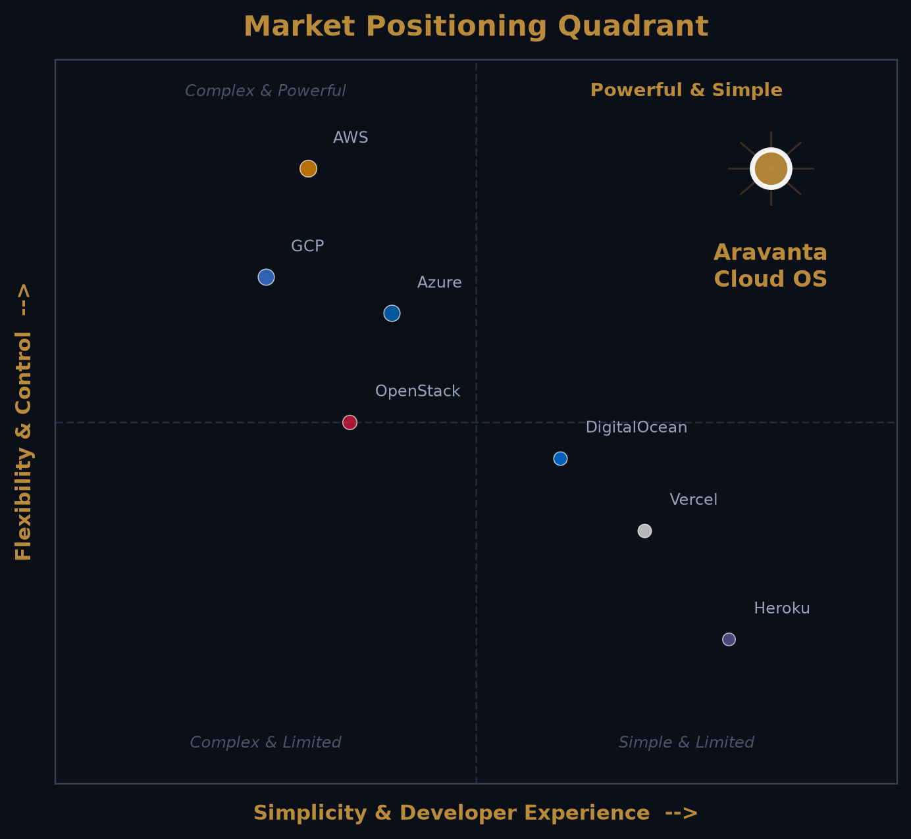

6. Vision & Mission

Vision
"To make cloud infrastructure invisible -- so every engineering team can focus on building what matters, not managing the plumbing beneath it."
-- Aravanta Tech -- Founding Vision

Mission
"Aravanta Cloud OS exists to give every engineering team -- from a two-person startup to a 500-engineer enterprise -- a single, unified control plane for multi-cloud operations. We believe infrastructure should be observable, programmable, and portable."
-- Aravanta Cloud OS -- Mission Statement

Core Values
Velocity -- Ship faster. Reduce operational friction and accelerate delivery at every layer.
Trust -- Security and compliance are foundational. Every action is audited, every secret encrypted.
Openness -- Open standards, portable infrastructure, zero vendor lock-in. Your cloud, your rules.
Simplicity -- Enterprise power with startup simplicity. Complex infrastructure, elegant experience.
Community -- Built with and for engineers. Community feedback drives the product roadmap.

7. Product Architecture Overview

Aravanta Cloud OS is architected as a modern, cloud-native platform with clear separation of concerns between the frontend console, backend API services, infrastructure orchestration, and the underlying multi-cloud provider fabric.

Tech Stack
Layer | Technology | Details
Frontend | React 18 + TypeScript + Vite | Tailwind CSS, Framer Motion, Recharts, i18next (6 languages)
Design System | Custom Component Library | Modal, Tabs, Accordion, Cards, Badges, Command Palette
Backend API | FastAPI (Python 3.11+) | Async REST with OpenAPI 3.1, Swagger UI at /docs
Database | PostgreSQL 16 | SQLAlchemy ORM, pgvector, Patroni failover, WAL archiving
Auth | JWT + TOTP MFA | PyJWT HS256, pyotp RFC 6238, bcrypt hashing, 5-tier RBAC
Deployment | Vercel Serverless | Mangum ASGI adapter, auto-scaling, edge caching
Monitoring | Prometheus + Loki + OTEL | Sub-second metrics, structured logs, distributed traces
CI/CD | GitHub Actions + ArvCD | Flux-compatible GitOps: rolling, canary, blue/green
IaC | Terraform Provider | Official provider with 180+ resource definitions
SDKs | Node.js, Python, Go, Java | Typed SDKs with retries, pagination, OpenAPI 3.1 spec
CLI | agy CLI | Multi-platform with bash/zsh/fish/pwsh tab-completion

13 Backend Microservices
Service | Domain | Capabilities
arvgate | Identity & Auth | Registration, JWT, TOTP MFA, sessions, audit logging
arvcompute | Virtual Machines | 80+ shapes, NVMe SSD, live resize, spot pools
arvkube | Managed K8s | K8s v1.27-1.30, node pools, pod telemetry, kubeconfig
arvstore | Object Storage | S3-compatible, Object Lock/WORM, pre-signed URLs
arvdb | Databases | PostgreSQL, MySQL, Redis, MongoDB, ClickHouse
arvwatch | Observability | Prometheus TSDB, Loki logs, distributed traces
arvcicd | Delivery | GitOps sync, canary rollouts, container signing
arvedge | Networking | DNS, load balancers, CDN, WAF rules
arvregistry | Container Registry | OCI images, tagging, vulnerability scanning
arvbilling | FinOps | Metering, subscriptions, GST invoicing
arvoperations | SRE | Runbooks, snapshot DR, incident command center
arvai | AI Assistant | Console Copilot for contextual troubleshooting
arvcommunity | Community | Developer forum, discussions, upvoting, threading

8. Roadmap & Next Steps

Aravanta Cloud OS follows a phased roadmap to achieve product-market fit, enterprise adoption, and sustainable growth over an 18-month horizon.
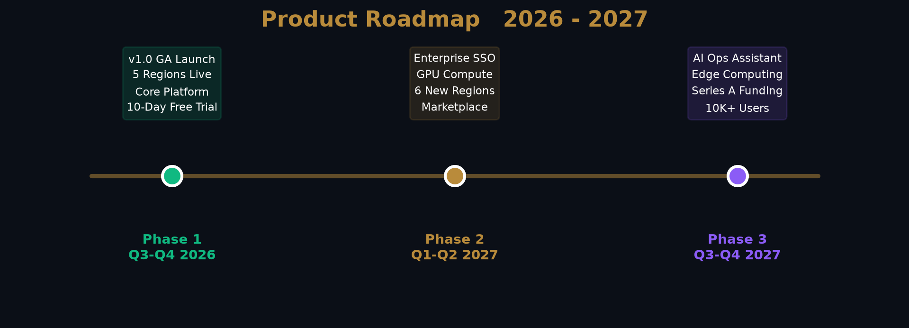

Phase Details
Phase | Timeline | Key Milestones | Target Metrics
Launch | Q3-Q4 2026 | v1.0 GA, 5 regions live, 10-day free trial, core platform | 1K signups, 50 workspaces
Scale | Q1-Q2 2027 | Enterprise SSO, GPU compute (H100/A100), FinOps, Marketplace, 6 regions | 5K users, 200 enterprise trials
Expand | Q3-Q4 2027 | AI Ops, Edge computing, BYOK on-prem K8s, Series A, mobile app | 10K+ users, 50 contracts

9. Target Companies & Segments

Aravanta Cloud OS targets a diverse range of organizations -- from developer-led startups to enterprise infrastructure teams seeking to consolidate cloud operations:
Segment | Why They Fit | Approach
Tech Startups | Need production infra without DevOps teams. Developer-first. | Free trial, startup credits, community marketing
SME Engineering | Outgrowing PaaS, need K8s + monitoring. | Product-led growth, webinars, integrations
Enterprise (500+) | Consolidating multi-cloud, need compliance. | Enterprise sales, SSO, custom SLAs, on-prem
Government | Data residency, sovereign cloud mandates. | Region-specific deploys, certifications
EdTech & Research | Affordable compute for ML workloads. | Academic pricing, research credits
MSPs | Resell cloud with white-label. | Partner program, multi-tenant, revenue sharing
FinTech / Healthcare | PCI-DSS, HIPAA, full audit trails. | Compliance-first, encrypted-by-default
Indian Enterprise | INR billing, GST invoicing, data residency. | Local sales, Hindi support, INR pricing

10. Growth & Scaling Strategy

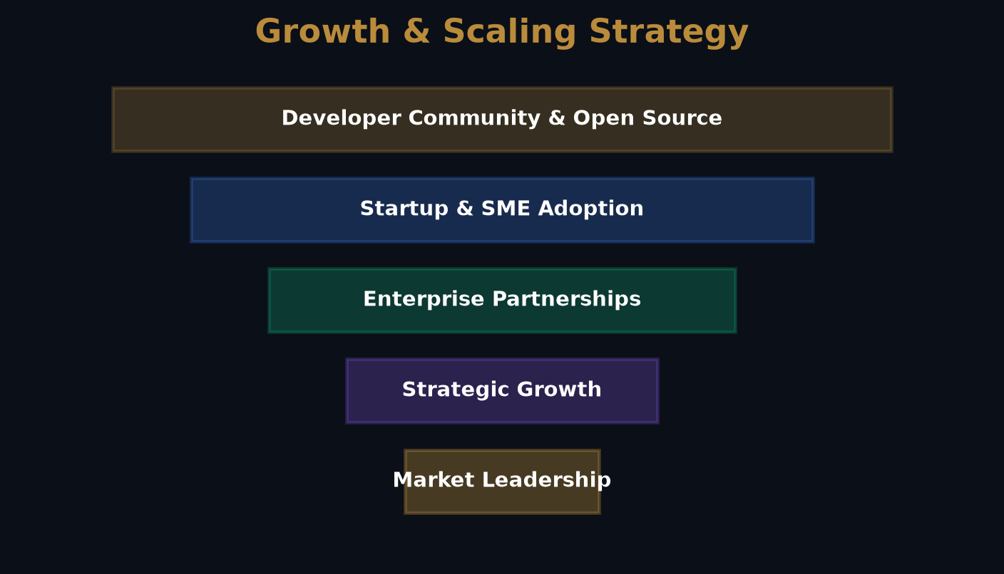

Go-to-Market -- Product-led growth with 10-day free trial (no credit card). Pricing: Developer Cloud at Rs.499/mo, Team Operations at Rs.2,499/mo, Enterprise custom. Annual saves 20%.
Developer Community -- Built-in community platform for discussions and knowledge sharing. Open-source Terraform provider and SDK contributions. Technical blog and conference presence.
Strategic Partnerships -- Integrations with GitHub, GitLab, Terraform, Datadog, PagerDuty, Slack. Cloud marketplace listings. MSP/reseller partner program.
Enterprise Sales -- Dedicated sales for 500+ employee accounts. Custom SLAs (99.99% to 99.999%), SSO/SAML, self-hosted distribution, dedicated success managers.
Geographic Expansion -- Phase 1: 5 regions (Mumbai, Chennai, Singapore, Virginia, Frankfurt). Phase 2: Tokyo, Sao Paulo, London, Sydney. Phase 3: Middle East, Africa, APAC.

11. Closing & Call to Action

Aravanta Cloud OS represents a generational opportunity to redefine how engineering teams interact with cloud infrastructure. The market is ready for a unified, developer-friendly alternative to fragmented multi-cloud tooling -- and Aravanta Tech is positioned to lead this transformation.
WHAT WE ARE LOOKING FOR
• Strategic investors aligned with developer infrastructure and cloud-native platforms
• Enterprise pilot partners seeking to consolidate multi-cloud operations
• Technology integration partners (CI/CD, monitoring, security) for ecosystem growth
• Go-to-market advisors with B2B SaaS and infrastructure sales experience

Contact Information
Channel | Contact Details
Sales & Partnerships | sales@aravanta.cloud / enterprise@aravanta.cloud
Technical Support | support@aravanta.cloud / +91 80 4567 8901
Billing & Finance | billing@aravanta.cloud / +91 80 4567 8902
Security War-Room (24x7) | security@aravanta.cloud / +91 80 4567 8999
Platform Console | console.aravanta.cloud
API Documentation | arv-backend.vercel.app/docs
Status Page | status.aravanta.cloud

Aravanta Cloud OS
The Unified Multi-Cloud Operating System

A Product by Aravanta Tech
console.aravanta.cloud | arv-backend.vercel.app

Generated: September 12, 2026 | Classification: Internal / Investor Use

