G E O P U L S E I N T E L L I G E N C E

Global Events, Commodities
and Currency Markets
Applied Data Analytics and Market Research — Business Report
Brent Oil · Gold · Silver · SWIFT Global Currency Tracker
Report Date: July 13, 2026
Prepared By: GeoPulse Intelligence Team
Department: Data & Business Analytics, SS 2026
Organization: GeoPulse Intelligence
Supervised By: Prof. Dr. Talha Ali Khan & Mr. E. George

“A six-member analytics team connecting 80+ years of commodity price history with
SWIFT currency data and the geopolitical events of 2025–2026.”

The Team
GeoPulse Intelligence
Vaibhav Malhotra  Market Research  Team Lead | Kaushik Reddy Regalla  Data Engineering  Core Team Lead
Surya Koushik Palla  Data Analytics  Member | Raj Ravindra Singh  Market Research  Member
Prashant Pinniboyina  Presentation  Member | Yash David Bedekar  Reporting  Member

A six-member analytics team connecting 80+ years of commodity price history with SWIFT currency data and the geopolitical events of 2025–2026.

Executive Summary

Purpose
This report analyses the behaviour of three key global commodities — Brent Crude Oil, Gold, and Silver — alongside SWIFT international payment currency flows from December 2025 to April 2026. It documents what the data shows, then assesses whether major 2025–2026 geopolitical events — principally the Iran–Hormuz crisis and the broader BRICS de-dollarisation push — plausibly help explain the price and currency movements observed.

Key Insights
+52%  BRENT OIL, ONE MONTH  Feb → Mar 2026, Hormuz disruption | $5,278  GOLD MONTHLY PEAK  Feb 2026 (USD/oz) | $113.95  SILVER ALL-TIME HIGH  Jan 2026 — a month before gold
51.14%  USD PAYMENT SHARE  Mar 2026 — rose into the crisis | #2 · 8.04%  CNY IN TRADE FINANCE  vs. rank #5 in global payments | 75.23%  OFFSHORE RMB IN HK  Concentration in one hub

- Gold reached a monthly-average all-time high of $5,277.89/oz in February 2026, driven by BRICS central-bank accumulation and Iran-crisis flight-to-safety demand.
- Silver hit its own all-time high of $113.95/oz a month earlier (January 2026), on industrial demand from solar, EVs, and defence electronics — before the war began.
- Brent Crude spiked 52% in a single month (Feb–Mar 2026, $67.66 → $102.86/bbl) following the Strait of Hormuz disruption.
- The US Dollar's SWIFT payment share dipped to 49.25% in February 2026 — its first sub-50% reading in the dataset — before recovering to 51.14% in March, a classic flight-to-safety pattern.
- CNY ranks #2 in global trade finance (8.04%) despite ranking only #5 in general payments (3.10%), and 75.23% of all offshore RMB activity runs through Hong Kong — a notable concentration.

Recommendations
- Diversify energy exposure away from Hormuz-dependent oil supply chains; a single choke point halted roughly 20% of seaborne oil within a week.
- Treat gold as a strategic reserve rather than a speculative trade — central-bank and BRICS accumulation provide a structural, not purely event-driven, demand floor.
- Monitor the SWIFT Currency Tracker monthly as an early-warning indicator; the February CNY trade-finance dip and USD dip both preceded the following month's market moves.

Table of Contents

1. Title Page 1
2. The Team 2
3. Executive Summary 3
4. Table of Contents 4
5. Introduction 5
6. Data and Methodology 6
Data Sources 6
Data Preprocessing 6
Tools Used 6
Methodology 6
Assumptions 6
7. Analysis and Insights 7
7.1 Brent Crude Oil 8
7.2 Gold 10
7.3 Silver 11
7.4 SWIFT Currency Tracker 13
7.5 Bonus Analytics (B1–B6) 15
7.6 Market Research — Geopolitical Impact 20
7.7 Comparisons and Manager Insights 24
8. Recommendations 26
9. Conclusion 27
10. Appendices 28
Appendix A — Team Members 28
Appendix B — Dataset Summary 28
Appendix C — Full Annual Average Tables 29
Appendix D — Glossary 33
Appendix E — Limitations and Methodological Notes 33
11. References 34

Introduction

Background
GeoPulse Intelligence is a six-member analytics team formed for the Data & Business Analytics course (SS 2026) under the joint supervision of Prof. Dr. Talha Ali Khan and Mr. E. George. The team was assembled to investigate a practical question in financial markets: how do geopolitical events translate into measurable movements in commodity prices and global currency flows? The period from late 2025 through mid-2026 provides an unusually rich test case — the escalating US–Iran confrontation, the disruption of the Strait of Hormuz, and BRICS-led efforts to reduce dependence on the US dollar together produced sharp, traceable movements across oil, precious metals, and currency data.
The team approaches this as a junior analyst desk would for a financial research manager: describe what the data shows first, then assess — carefully, and without overstating certainty — whether documented events plausibly explain it. The intended reader is a non-technical manager who needs a clear, evidence-based view of risk and opportunity, not a technical audience.

Objective
- Document and explain the price behaviour of Brent Crude Oil, Gold, and Silver across the full available history (1915/1946 through April 2026).
- Analyse SWIFT global payment currency flows from December 2025 to March 2026, with particular focus on the USD–CNY dynamic.
- Identify and, where the evidence supports it, quantify the relationship between specific geopolitical events and these asset classes.
- Deliver clear, appropriately hedged recommendations for market participants and stakeholders.

Scope
The report covers four primary datasets: Brent Crude Oil monthly prices (January 1946 – March 2026, 963 observations); Gold monthly prices (January 1915 – April 2026, 1,336 observations); Silver monthly prices (January 1915 – April 2026, 1,336 observations); and SWIFT Global Currency Tracker data (330 rows spanning the December 2025 – March 2026 reporting months). The geopolitical narrative draws on three course-supplied qualitative sources: the Wall Street Ledger Special Report (April 2026), the Critical New Context: 2026 Iran War & GCC Crisis briefing, and the Reserve Storm financial wargaming document — these are the assignment's evidence base and are treated as given inputs, not independently verified primary sources (see Appendix E).

Data and Methodology

Data Sources
- Brent_Oil.csv — 963 monthly price rows, January 1946 – March 2026.
- Gold_100years.csv — 1,336 monthly price rows, January 1915 – April 2026.
- silver_100_years.csv — 1,336 monthly price rows, January 1915 – April 2026.
- swift_currency_tracker_all_reports.csv — 330 rows covering the December 2025 – March 2026 data months, compiled from SWIFT's monthly Global Currency Tracker reports.
- globalcurrencytrackerapril2026.pdf — the official 9-page SWIFT report (data as of March 2026), cross-checked against the CSV extract.
- Supplementary qualitative sources: Wall Street Ledger Special Report (Apr 2026), Critical New Context: The 2026 Iran War & GCC Crisis, Reserve Storm Financial Wargaming Document.

Data Preprocessing
- Encoding fix: source CSVs carried a UTF-8 BOM prefix that broke the “Date” header; resolved with encoding=“utf-8-sig”.
- Date normalisation: date columns were parsed from MM/DD/YYYY text into proper datetime type, with Month and Year columns derived for the three commodity series.
- Missing values and duplicates: none were found in any of the four datasets — no rows were dropped.
- Currency normalisation: all commodity prices are already denominated in USD; no further conversion was required.

Tools Used
- Python (pandas, NumPy) — data loading, cleaning, annual/percentage-change calculations, and Pearson correlation.
- Matplotlib — all trend charts, bar charts, scatter plots, and the summary dashboard.
- pdfplumber — extraction and cross-checking of the SWIFT Global Currency Tracker PDF.
- openpyxl / Microsoft Excel — the four-sheet cleaned dataset workbook (DSB_Cleaned_Datasets.xlsx).

Methodology
- Trend analysis: visual inspection plus annual percentage changes and period-over-period growth rates.
- Pearson correlation: computed on annual average prices across all three commodities (Gold–Silver r = 0.9538; Brent–Gold r = 0.4577; Brent–Silver r = 0.5148).
- Moving averages: 12-month and 60-month (5-year) rolling means applied to Brent Oil to separate cyclical noise from the structural trend.
- Regression forecasting: a simple linear regression fitted to Gold prices from January 2010 onward, extrapolated 12 months — explicitly presented as a naive baseline, not a prediction (§7.5, Appendix E).
- SWIFT share analysis: month-over-month percentage-point changes tracked for USD, EUR, GBP, JPY, CNY, CAD, AUD, CHF, HKD and SGD.

Assumptions
- Stable exchange rates: commodity prices are USD-denominated and not adjusted for cross-currency effects.
- Reported gold and currency data (central bank disclosures, IMF COFER, World Gold Council) are assumed complete and accurate.
- Commodity prices represent monthly averages, which may differ from intraday highs and lows cited from external news sources.
- SWIFT payment shares reflect messaging volumes, which may not exactly mirror underlying settlement values.

Analysis and Insights
This section presents the core data-analytics findings (Part I), the bonus analytics extensions (B1–B6), and the market-research linkage to 2025–2026 geopolitical events (Part II) in a single integrated narrative, organised by asset class and then by theme.

7.1 Brent Crude Oil
Brent Crude Oil is the global benchmark for crude pricing, influencing energy costs, inflation, and trade balances worldwide. The dataset spans January 1946 through March 2026 — an 80-year record of 963 monthly observations.
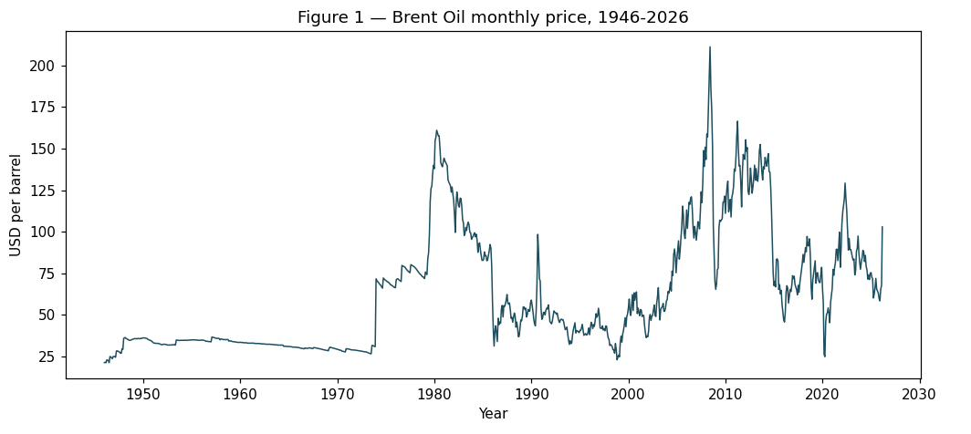
Figure 1 — Brent Oil monthly price, 1946–2026 (USD per barrel)
The chart reveals four distinct eras: a low and stable period from the late 1940s through the 1960s; the first major surge through the 1970s oil shocks into the early 1980s; a volatile climb through the 2000s that peaked in 2008 before a sharp collapse; and further slumps in 2015–2016 and 2020, followed by a renewed spike into 2026.
Commodity | Highest (USD) | Year | Lowest (USD) | Year
Brent Oil (USD/bbl) | 211.21 | 2008 | 21.11 | 1946
Long-run average across all 963 observations: $62.71/bbl. Latest value (March 2026): $102.86/bbl — above the long-run average.
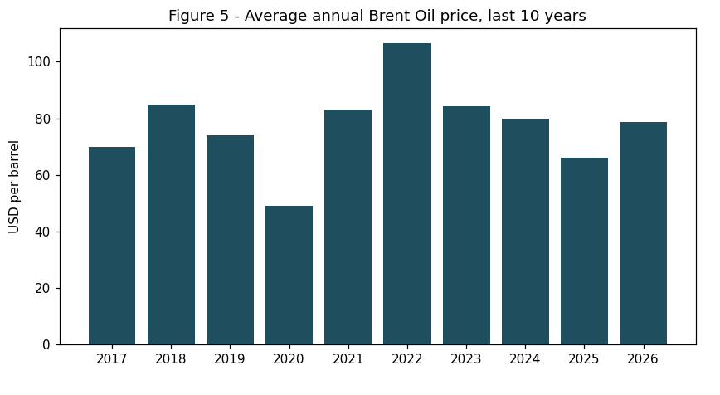
Figure 5 — Average annual Brent Oil price, last 10 years (USD per barrel)
The annual average bottomed near $49 in 2020 (COVID-19 demand collapse), rebounded to about $106 in 2022 (Ukraine-war premium), then eased through 2023–2025 before rising sharply again at the latest reading. The five highest-average years span three separate supply-shock eras (2008, 1980, 2011, 2013, 2012) — see the combined ranking table in §7.7.

7.2 Gold
Gold has historically functioned as both a monetary instrument and a geopolitical hedge. The dataset covers 111 years — January 1915 to April 2026 — with 1,336 monthly observations.
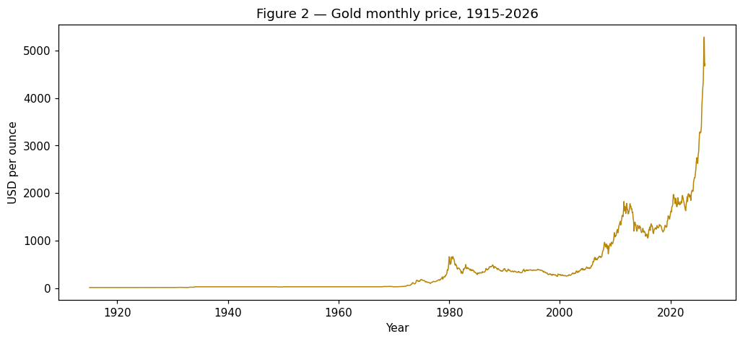
Figure 2 — Gold monthly price, 1915–2026 (USD per ounce)
Gold was flat for decades under the fixed gold-standard era, then stepped up after the price was allowed to float in the 1970s. Appreciation accelerated after 2000 and turned sharply steeper during 2024–2026, reaching the highest monthly average in the series.
Commodity | Highest (USD) | Year | Lowest (USD) | Year
Gold (USD/oz) | 5,277.89 | 2026 | 19.25 | 1915
Long-run average across all 1,336 observations: $397.55/oz. Latest value (April 2026): $4,712.89/oz — well above the long-run average, though that average spans the pre-1971 fixed-price era and is not inflation-adjusted, so the comparison is descriptive rather than a valuation signal (see Appendix E).

7.3 Silver
Silver occupies a dual role as both a monetary metal and an industrial commodity (solar panels, EVs, electronics), which makes its 2025–2026 performance instructive to examine on its own terms.
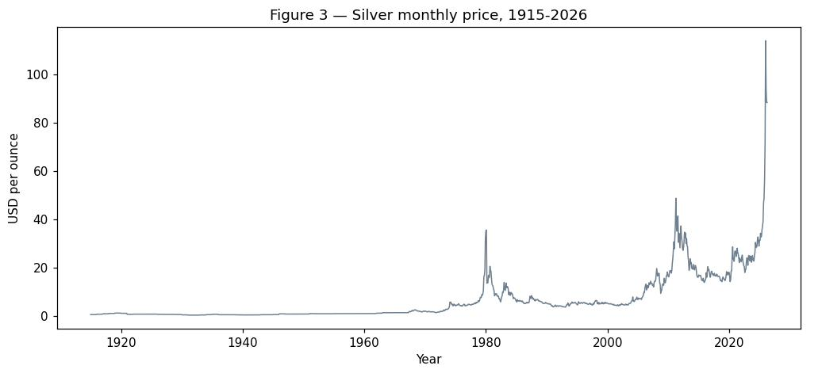
Figure 3 — Silver monthly price, 1915–2026 (USD per ounce)
Silver was very low and stable for the first half of the century, spiked sharply around 1980 (the Hunt brothers' attempted market corner), rose again in 2011, and then broke out to a new all-time high in 2025–2026.
Commodity | Highest (USD) | Year | Lowest (USD) | Year
Silver (USD/oz) | 113.95 | 2026 | 0.28 | 1932
Long-run average across all 1,336 observations: $6.42/oz. Latest value (April 2026): $88.36/oz.
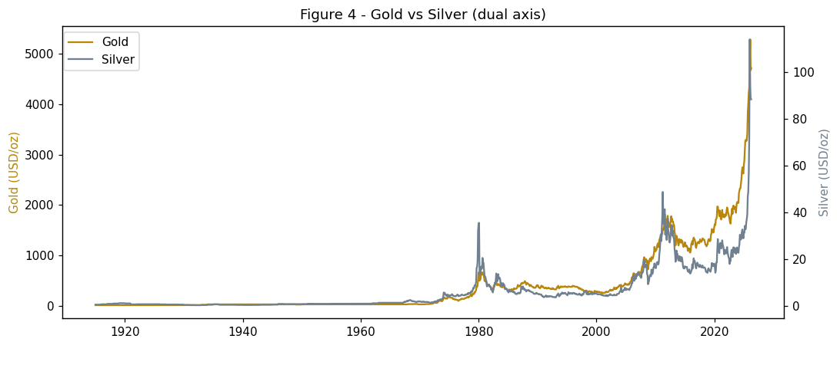
Figure 4 — Gold vs Silver, dual axis (1915–2026)
The dual-axis chart shows both metals broadly moving together — sharing the 1980 peak and the 2025–2026 rally — but silver is far more volatile and trades at a small fraction of gold's price, which is why a shared axis would obscure the comparison. The Pearson correlation across all 1,336 monthly observations is r = 0.9538.
Commodity | Latest date | Latest value
Brent Oil | Mar 2026 | 102.86 USD/bbl
Gold | Apr 2026 | 4,712.89 USD/oz
Silver | Apr 2026 | 88.36 USD/oz

7.4 SWIFT Currency Tracker
SWIFT processes the majority of international financial messages, making its monthly currency-share data the most reliable real-time window into global currency usage. The dataset covers the December 2025 – March 2026 reporting months.
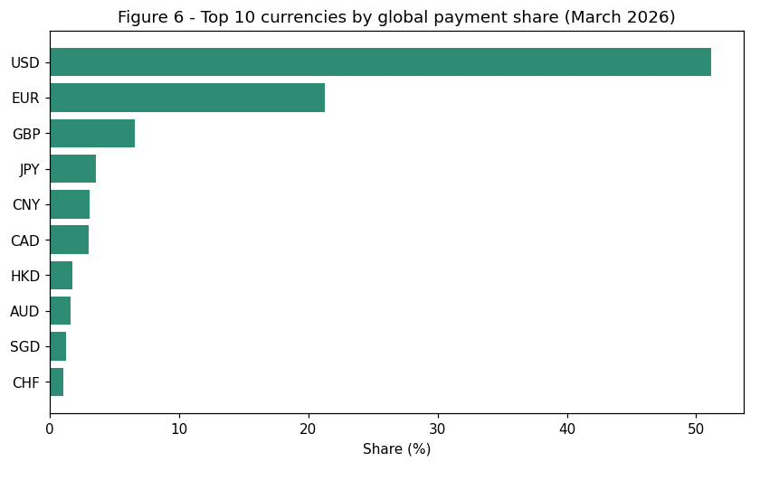
Figure 6 — Top 10 currencies by global payment share, March 2026
Rank | Currency | Global payment share
1 | US Dollar (USD) | 51.14%
2 | Euro (EUR) | 21.30%
3 | British Pound (GBP) | 6.54%
4 | Japanese Yen (JPY) | 3.53%
5 | Chinese Yuan (CNY) | 3.10%
6 | Canadian Dollar (CAD) | 3.03%
7 | Hong Kong Dollar (HKD) | 1.76%
8 | Australian Dollar (AUD) | 1.61%
9 | Singapore Dollar (SGD) | 1.23%
10 | Swiss Franc (CHF) | 1.07%
USD dominates at just over 51%, the Euro is a distant second at 21.30%, and shares fall away steeply from third place onward. CNY ranks 5th at 3.10% in general payments — but this understates its role in trade finance, where it ranks #2 at 8.04% (§7.6).
Data month | USD global payment share
Dec 2025 | 50.49%
Jan 2026 | 49.68%
Feb 2026 | 49.25%
Mar 2026 | 51.14%
The most notable reading is February 2026, when USD dipped to 49.25% — the first sub-50% figure in the dataset — before recovering to 51.14% in March as the Iran crisis intensified. This is discussed further in §7.6 as a possible flight-to-safety signal.
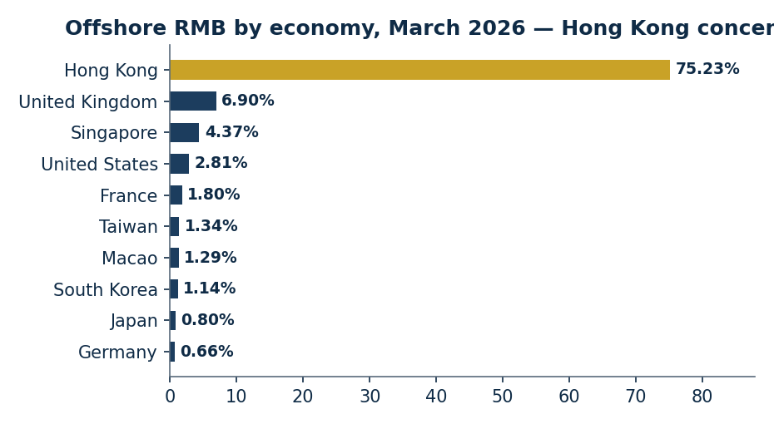
Figure 6b — Offshore RMB activity by economy, March 2026
Economy | Share of offshore RMB volume
Hong Kong | 75.23%
United Kingdom | 6.90%
Singapore | 4.37%
United States | 2.81%
France | 1.80%
Hong Kong alone processed 75.23% of offshore RMB activity in March 2026 — a striking concentration in a single financial hub, discussed further in §7.6.

7.5 Bonus Analytics (B1–B6)

B1 — Annual and Monthly Percentage Change
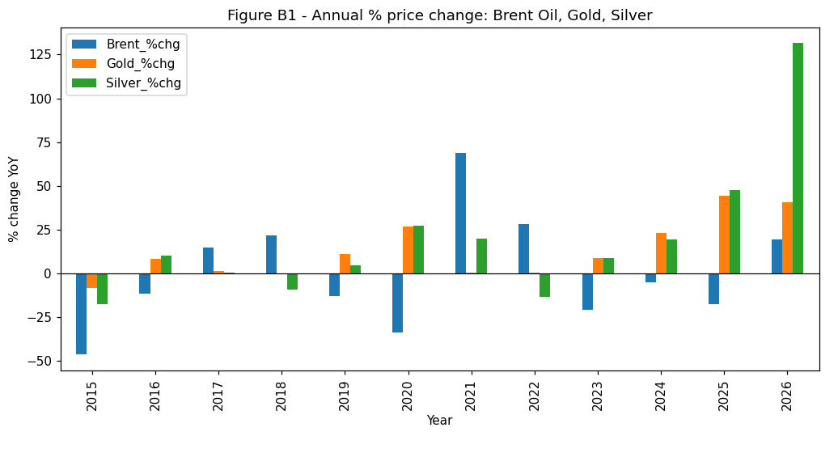
Figure B1 — Annual % change: Brent Oil, Gold, and Silver (2015–2026)
Series (monthly) | Avg change | Std deviation | Range
Brent Oil | +0.52% | 9.05% | −54.2% to +132.5%
Gold | +0.50% | 4.30% | −21.4% to +32.2%
Silver | +0.68% | 7.69% | −62.0% to +69.5%
Brent shows the deepest single-year drawdowns (−46% in 2015, −34% in 2020) and the largest rebound (+69% in 2021), making it the highest annual-risk commodity of the three. Silver's +131.5% move in 2026 is the largest single-year jump anywhere in the dataset.

B2–B3 — Correlation and Heat Map
 | Brent Oil | Gold | Silver
Brent Oil | 1.0000 | 0.4577 | 0.5148
Gold | 0.4577 | 1.0000 | 0.9538
Silver | 0.5148 | 0.9538 | 1.0000
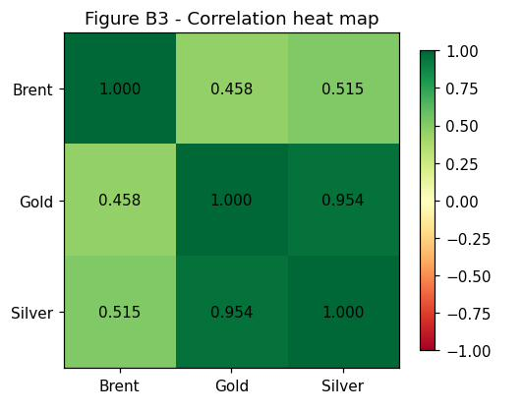
Figure B3 — Correlation heat map (annual average prices)
Gold and Silver are very strongly correlated (r = 0.9538), confirming a shared safe-haven / monetary driver. Brent correlates only moderately with both metals (r = 0.4577 and 0.5148), reflecting some shared macro exposure but distinct supply-side drivers. No pair is negative, so diversification benefit across these three commodities alone is limited. These coefficients are computed on annual averages; monthly-frequency correlations may differ (Appendix E).

B4 — Gold vs Silver Scatter
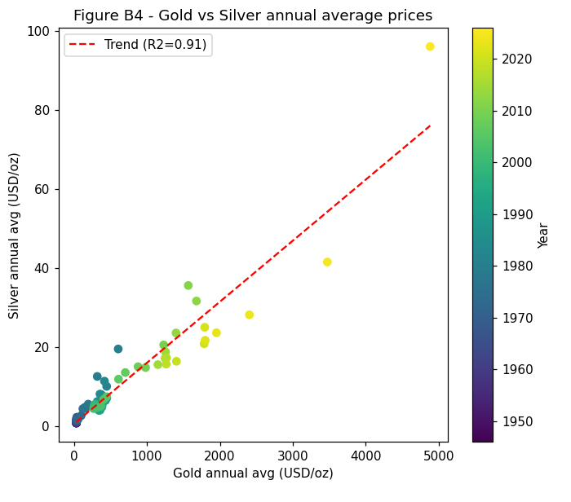
Figure B4 — Gold vs Silver annual average prices, with linear trendline (R² ≈ 0.91)
Annual averages trace a near-linear path from the low prices of the early 2000s to the 2025–2026 records. The 2026 point sits above the trendline, consistent with silver's outsized late-cycle move relative to its historical relationship with gold.

B5 — Brent Oil Moving Averages
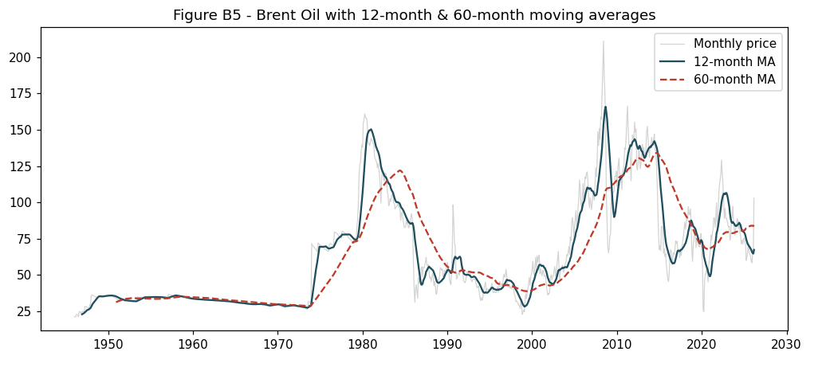
Figure B5 — Brent Oil with 12-month and 60-month moving averages
The 12-month moving average smooths month-to-month noise and clearly shows the key trend phases (the 2000s boom, the 2008 crash, the 2014–2016 collapse, the 2020 slump, and the recent recovery). The 60-month average marks the structural level. The March 2026 price ($102.86) sits sharply above both (12-month MA ≈ $67.3; 60-month MA ≈ $84.2), consistent with a short-term breakout — a single-month reading that should be read cautiously.

B6 — Simple Linear Gold Forecast
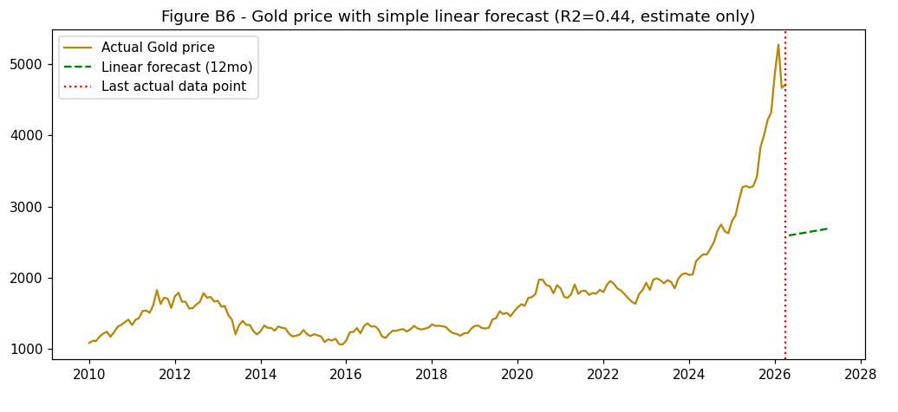
Figure B6 — Gold 12-month linear forecast, May 2026 – April 2027 (R² = 0.44)
⚠ This forecast is a naive statistical estimate, not a prediction. It is fitted on monthly Gold prices from January 2010 onward and does not, and cannot, capture geopolitics, central-bank policy, or investor sentiment.
Month | Forecast (USD/oz) | Month | Forecast (USD/oz)
May 2026 | 2,593 | Nov 2026 | 2,646
Jun 2026 | 2,602 | Dec 2026 | 2,655
Jul 2026 | 2,611 | Jan 2027 | 2,663
Aug 2026 | 2,620 | Feb 2027 | 2,672
Sep 2026 | 2,628 | Mar 2027 | 2,681
Oct 2026 | 2,637 | Apr 2027 | 2,689
The model projects a gentle drift of roughly $8.70/oz per month, reaching $2,593–$2,689/oz by April 2027 — far below the actual April 2026 price of $4,712.89. This gap illustrates that the current price regime is driven by factors a straight-line historical model cannot represent; the forecast is included to satisfy the exercise, not as guidance.

7.6 Market Research — Geopolitical Impact Analysis
This section traces the documented connection between 2025–2026 geopolitical events and the market movements shown above. Event linkages here rest on timing and are treated as association, not proven causation — monthly data cannot isolate causal effects or rule out positioning, seasonality, or policy responses running in parallel (Appendix E).

Three Major Events
- Iran–Hormuz crisis (28 Feb 2026): US–Israel strikes on Iranian nuclear facilities, followed by Iran's disruption of the Strait of Hormuz — the route for roughly 20% of the world's seaborne oil. Brent moved from $67.66 to $102.86/bbl in one month.
- BRICS gold accumulation: 710 tonnes purchased in Q3 2025 alone, with roughly 900 tonnes projected for full-year 2026; associated in the source reports with a $4,300 gold price floor and the February 2026 peak of $5,277.89.
- Tariffs, sanctions and BRICS payment rails: a 20% BRICS tariff from 21 January 2026, a proposed 40% “war tariff” (H.R. 890), BRICS Pay processing roughly $4bn/month, and an April 2026 gold+oil+yuan stablecoin pilot.
Date | Event | Market impact
Oct 2025 | Gold intraday ATH $4,379.60; Silver breaches $50 (first since 1980) | Safe-haven demand building
Oct 2025 | Saudi Aramco invoices China in non-dollar currencies | Petrodollar framework challenged
Oct 2025 | BRICS Kazan Summit — multipolar financial order discussed | CNY / BRICS currency push
21 Jan 2026 | New GOP House majority; 20% BRICS tariff introduced Day 1 | Trade-war escalation
Jan 2026 | Silver ATH $113.95; Gold reaches $4,865 | Industrial + safe-haven demand peak
28 Feb 2026 | US–Israel strikes on Iran begin; Hormuz Strait disrupted | Brent Oil: $67.66 → $102.86 in one month
7–12 Apr 2026 | Ceasefire, Petroline pipeline strike, talks collapse, naval blockade | Escalation confirmed; GCC growth forecast cut 4.4% → 1.3%
Apr 2026 | BRICS emergency stablecoin launched (gold + oil + yuan) | Alternative payment rails accelerate

The Events Behind Oil, Gold and Silver
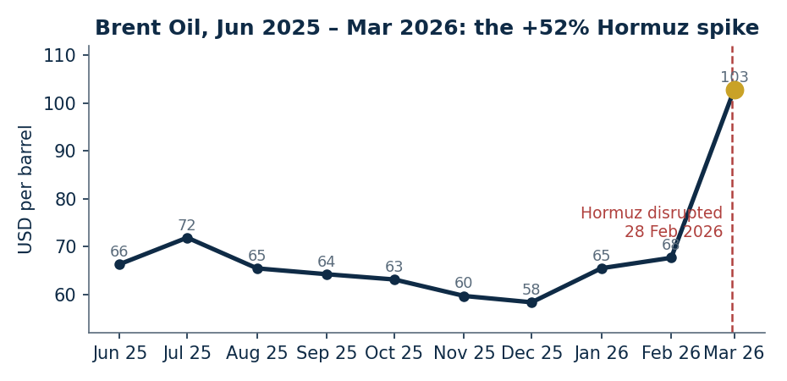
Figure 8 — Brent Oil, June 2025 – March 2026: drifting down through late 2025, then +52% in the Hormuz month
Brent drifted down through late 2025 ($63.12 in October, $58.35 in December) before the February 2026 strikes triggered the sharpest one-month move in the recent series. The reported mechanism combines a physical shortage — loss of a route carrying roughly 20% of seaborne oil — with a fear premium that market commentary put at $10–$30/bbl on top of the fundamental price.
Silver and gold, by contrast, peaked in different months. Silver reached its all-time high of $113.95 in January 2026 — before the war — after roughly tripling from $32.99 in May 2025, a move source reports attribute mainly to industrial demand (solar, EVs, defence electronics). Gold peaked a month later, at $5,277.89 in February 2026, coinciding with the war's start and consistent with a safe-haven interpretation, alongside a falling dollar reserve share (56.92% versus roughly 72% two decades ago per IMF COFER data) and continued BRICS buying. After the war began, silver fell back while gold spiked further — a sequencing consistent with “industry first, geopolitics second,” though it remains a single episode rather than a repeated pattern.

One Crisis, Three Reactions
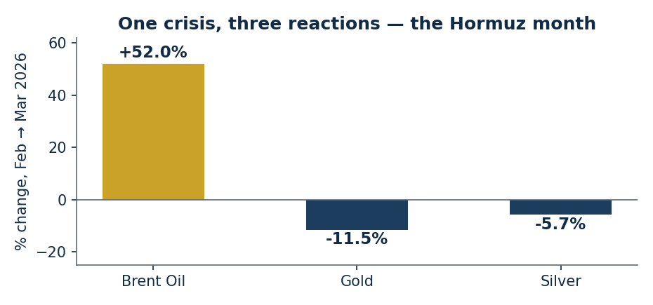
Figure 9 — February → March 2026: Brent surges while the metals pull back from their peaks
Asset | Feb 2026 | Mar 2026 | Change | Behaviour
Brent Oil | $67.66 | $102.86 | +52.0% | Explosive surge — direct supply shock
Gold | $5,277.89 (ATH) | $4,670.35 | −11.5% | Peaked at war start, then partial pullback
Silver | $93.66 | $88.36 | −5.7% | Already falling from its January peak
Oil reacted most sharply, consistent with a direct supply shock with no readily available substitute route. Gold peaked at the moment of maximum uncertainty and then partially retraced. Silver was already declining from its January peak by the time the war began, reinforcing the earlier read that its rally was industrial-demand-led rather than purely fear-driven.

Currencies Under Stress
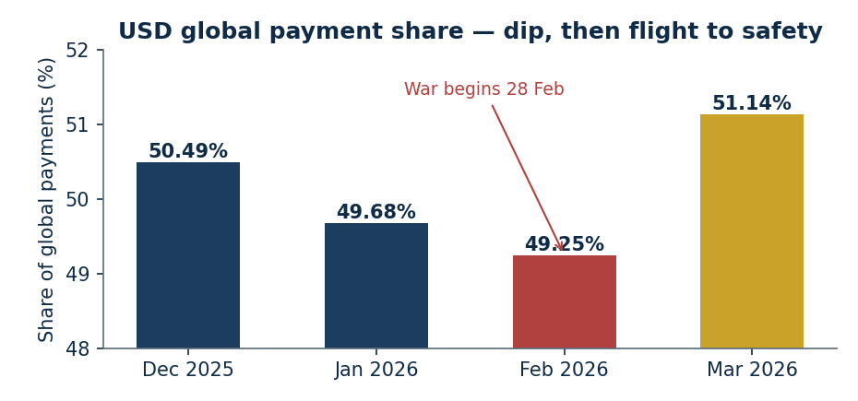
Figure 10 — USD SWIFT share dipped to 49.25% in February, then rose to 51.14% in March
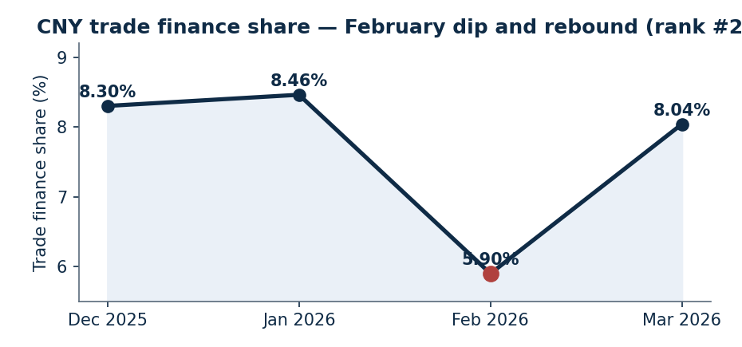
Figure 11 — CNY trade-finance share fell to 5.90% in February, then rebounded to 8.04%
Data month | CNY trade finance share
Dec 2025 | 8.30%
Jan 2026 | 8.46%
Feb 2026 | 5.90%
Mar 2026 | 8.04%
The February dip in CNY trade finance (8.46% → 5.90%) is a genuinely open question: it could reflect a real demand contraction, disrupted SWIFT messaging around the conflict, or settlement activity moving onto alternative rails such as BRICS Pay — the tracker alone cannot distinguish between these, and SWIFT itself notes that its statistics can fluctuate for reasons unrelated to currency use (Appendix E). What is clearer is that sanctions and alternative settlement systems matter for currency analysis generally: losing SWIFT access can sideline a currency (as happened to the ruble after 2022), and the Reserve Storm report documents a real-world example — a 1.05-million-barrel Russian oil cargo settled in offshore RMB plus crypto via Hong Kong — showing that alternative rails already function in practice.
The offshore RMB system itself leans heavily on one hub: Hong Kong handled 75.23% of volume in March 2026 (Figure 6b), which is both a sign of Hong Kong's continued indispensability under “one country, two systems” and a concentration risk if conditions in that hub were to change. RMB FX spot trading is more geographically spread, concentrated mainly in Switzerland (27.37%) and Singapore (18.84%) rather than in China itself.

7.7 Comparisons and Manager Insights
Comparison | Latest | Full-series average | Position
Gold (USD/oz) | 4,712.89 | 397.55 | Above — average spans the pre-1971 fixed-price era; descriptive, not a valuation benchmark
Brent Oil (USD/bbl) | 102.86 | 62.71 | Above

Which Commodity Swings Most?
Commodity | Long-run variation (CoV %) | Monthly volatility (%) | Reading
Brent Oil | 55.6 | 9.1 | Sharpest short-term swings
Gold | 173.4 | 4.3 | Largest long-run range, calmest month-to-month
Silver | 171.4 | 7.7 | Long-run range near gold, monthly volatility near oil
The answer depends on the horizon: gold and silver dominate the long-run range (highest coefficient of variation), while Brent dominates month-to-month swings — consistent with oil reacting fastest to discrete events and the metals reflecting a slower-moving structural repricing.

Top Five Years by Average Price
Rank | Brent Oil | Gold | Silver
1 | 2008 — 150.96 | 2026 — 4,881.62 | 2026 — 96.08
2 | 1980 — 149.86 | 2025 — 3,472.54 | 2025 — 41.50
3 | 2011 — 142.12 | 2024 — 2,404.58 | 2011 — 35.56
4 | 2013 — 138.30 | 2023 — 1,953.69 | 2012 — 31.63
5 | 2012 — 135.27 | 2022 — 1,798.96 | 2024 — 28.13
Gold's five highest years are the five most recent (2022–2026); Brent's record years span three separate supply-shock eras four decades apart.

2008: A Shared Shock, Different Magnitudes
Year | Brent (avg) | Gold (avg) | Silver (avg)
2007 | 119.10 | 704.68 | 13.51
2008 | 150.96 | 880.21 | 14.98
2009 | 98.01 | 982.65 | 14.77
During oil's 2008 spike, gold rose roughly 25% and silver roughly 11% on an annual-average basis. When oil fell back in 2009, gold kept climbing — a reminder that gold's drivers are not identical to oil's, even when they move together during a single shared shock.

Which Market Is Most Sensitive to Events?
Oil reacts fastest and most sharply to discrete events — a mechanical consequence of losing a physical supply route with no easy substitute. Gold shows the largest structural, cumulative sensitivity — its premium over the long-run average reflects years of accumulated central-bank buying and reserve diversification, not one event. Silver sits between the two, moving on industrial cycles first and safe-haven sentiment second. Currencies are the most composite of all, reflecting safety flows, BRICS-driven structural shifts, and monetary-policy cycles simultaneously — which is why the USD dipped and then rose within the same crisis month.

Three Insights for a Non-Technical Manager
- Precious metals are at record highs: gold and silver both reached all-time peaks in 2025–2026, for related but distinct reasons.
- Oil is the most event-sensitive commodity of the three, with by far the largest short-term price swings.
- The US Dollar still dominates global payments at roughly 51%, while the Renminbi holds 5th place at roughly 3% in payments but a stronger #2 position in trade finance.

Recommendations
Based on the analysis above, the following recommendations are directed at stakeholders — investors, businesses, and portfolio managers — assessing how to think about exposure to these markets. They are analytical observations grounded in historical data and the cited event reports, not personalised financial advice; readers should consult a licensed financial advisor before acting on them.

1. Diversify energy exposure away from Hormuz-dependent supply chains
A single choke point halted roughly 20% of the world's seaborne oil within a week. Organisations whose cost base or logistics depend on uninterrupted Gulf transit carry an unhedged tail risk. Diversifying energy sources (renewables, nuclear, non-Gulf LNG) and suppliers reduces exposure to a repeat event.

2. Treat gold as a strategic reserve, not a speculative trade
Central banks bought 710 tonnes in Q3 2025 alone, and BRICS accumulation targets point to continued structural demand. For balance-sheet planning, gold at current levels functions more as insurance against currency debasement and geopolitical surprise than as a short-term trading opportunity — though buyers should recognise that entry at record prices carries its own drawdown risk.

3. Monitor the SWIFT Currency Tracker monthly as an early-warning system
The February 2026 CNY trade-finance dip (8.46% → 5.90%) and the USD's dip below 50% both preceded the following month's larger market moves. Tracking these monthly shares — alongside the caveat that the tracker cannot by itself explain why a share moved — gives treasury and policy teams a leading, low-cost indicator of building stress.

4. Evaluate CNY exposure for trade finance gradually, without abandoning USD
CNY's #2 ranking in trade finance (8.04%) despite a modest 3.10% general payments share suggests a genuine, if narrow, opening for businesses trading with China, the Middle East, or Africa to evaluate CNY invoicing. Hong Kong's offshore RMB infrastructure is mature enough for serious consideration, but its 75.23% share of all offshore RMB volume is itself a concentration risk worth weighing against any cost savings.

Conclusion
The 2025–2026 period captured in this dataset spans one of the more consequential windows in recent commodity and currency market history. The combination of an active geopolitical conflict (US–Iran), a structural de-dollarisation push (BRICS), and an extraordinary precious-metals run produced market behaviour that departs from simple assumptions of stable dollar dominance and uninterrupted energy supply chains.
Read together, the four datasets tell a reasonably consistent story: Brent Oil reacted fastest and most sharply to the discrete Hormuz shock; Gold's premium over its long-run average reflects a slower, structural accumulation of demand rather than any single event; Silver's early-2026 peak points to industrial rather than purely geopolitical drivers; and the SWIFT data shows the US Dollar's payment share dipping and then recovering within the same crisis window — a pattern consistent with, though not proof of, a flight-to-safety response. None of these linkages should be read as strict causation; they are associations grounded in timing and in the course-supplied event reports, and are presented with that caveat throughout (Appendix E).
The key uncertainty going forward is resolution speed. A durable ceasefire or a Hormuz reopening agreement could unwind a meaningful share of the oil war-premium and the gold fear-premium relatively quickly; continued escalation would likely extend and deepen the trends documented here. GeoPulse Intelligence would recommend revisiting this analysis as new SWIFT data, commodity prices, and geopolitical developments become available.

Appendices

Appendix A — Team Members
Name | Role / Domain | Position
Vaibhav Malhotra | Market Research | Team Lead
Kaushik Reddy Regalla | Data Engineering | Core Team Lead
Surya Koushik Palla | Data Analytics | Member
Raj Ravindra Singh | Market Research | Member
Prashant Pinniboyina | Presentation | Member
Yash David Bedekar | Reporting | Member

Appendix B — Dataset Summary
Dataset | Rows | Date Range | Key Metric
Brent_Oil.csv | 963 | Jan 1946 – Mar 2026 | All-time high $211.21 (Jun 2008)
Gold_100years.csv | 1,336 | Jan 1915 – Apr 2026 | All-time high $5,277.89 monthly avg (Feb 2026)
silver_100_years.csv | 1,336 | Jan 1915 – Apr 2026 | All-time high $113.95 (Jan 2026)
swift_currency_tracker_all_reports.csv | 330 | Dec 2025 – Mar 2026 (data months) | USD share low of 49.25% (Feb 2026)

Appendix C — Full Annual Average Tables
Complete year-by-year average prices (USD) for Brent Oil (1946–2026), Gold and Silver (1915–2026). Source: Brent_Oil.csv, Gold_100years.csv, silver_100_years.csv.
Year | Brent | Gold | Silver
1915 | — | 19.25 | 0.51
1916 | — | 19.47 | 0.67
1917 | — | 19.66 | 0.84
1918 | — | 19.84 | 0.98
1919 | — | 20.03 | 1.13
1920 | — | 20.63 | 1.03
1921 | — | 20.69 | 0.63
1922 | — | 20.84 | 0.68
1923 | — | 20.75 | 0.65
1924 | — | 20.78 | 0.67
1925 | — | 20.75 | 0.69
1926 | — | 20.72 | 0.62
1927 | — | 20.75 | 0.57
1928 | — | 20.78 | 0.58
1929 | — | 20.72 | 0.53
1930 | — | 20.69 | 0.38
1931 | — | 22.59 | 0.29
1932 | — | 20.78 | 0.28
1933 | — | 26.47 | 0.35
1934 | — | 35.00 | 0.48
1935 | — | 35.00 | 0.64
1936 | — | 35.00 | 0.45
1937 | — | 35.00 | 0.45
1938 | — | 35.00 | 0.43
1939 | — | 34.69 | 0.39
1940 | — | 34.06 | 0.35
1941 | — | 34.06 | 0.35
1942 | — | 34.06 | 0.38
1943 | — | 34.06 | 0.45
1944 | — | 34.06 | 0.45
1945 | — | 35.00 | 0.52
1946 | 22.90 | 35.00 | 0.80
1947 | 27.20 | 35.00 | 0.72
1948 | 35.31 | 35.00 | 0.74
1949 | 35.65 | 31.88 | 0.72
1950 | 35.28 | 35.00 | 0.74
1951 | 32.70 | 35.00 | 0.89
1952 | 31.96 | 34.69 | 0.85
1953 | 33.50 | 35.00 | 0.85
1954 | 34.68 | 35.31 | 0.85
1955 | 34.78 | 35.31 | 0.89
1956 | 34.26 | 35.31 | 0.92
1957 | 35.78 | 35.00 | 0.92
1958 | 35.00 | 35.31 | 0.89
1959 | 33.70 | 35.31 | 0.92
1960 | 33.16 | 35.31 | 0.92
1961 | 32.81 | 35.31 | 0.93
1962 | 32.42 | 35.31 | 1.09
1963 | 32.03 | 35.31 | 1.29
1964 | 31.35 | 35.31 | 1.30
1965 | 30.60 | 35.31 | 1.30
1966 | 29.88 | 35.31 | 1.30
1967 | 29.96 | 35.31 | 1.66
1968 | 29.15 | 40.20 | 2.19
1969 | 29.66 | 40.84 | 1.80
1970 | 28.50 | 35.99 | 1.75

Year | Brent | Gold | Silver
1971 | 29.03 | 40.97 | 1.52
1972 | 28.12 | 59.10 | 1.70
1973 | 28.76 | 99.95 | 2.59
1974 | 69.47 | 161.68 | 4.75
1975 | 68.50 | 160.41 | 4.42
1976 | 73.32 | 123.79 | 4.34
1977 | 77.88 | 148.95 | 4.65
1978 | 75.22 | 196.80 | 5.50
1979 | 101.05 | 320.97 | 12.52
1980 | 149.86 | 607.76 | 19.48
1981 | 133.35 | 449.58 | 10.01
1982 | 115.07 | 376.11 | 7.93
1983 | 100.81 | 419.40 | 11.33
1984 | 93.00 | 358.12 | 8.06
1985 | 85.56 | 320.83 | 6.16
1986 | 43.40 | 368.22 | 5.40
1987 | 55.30 | 451.09 | 7.05
1988 | 44.68 | 432.21 | 6.42
1989 | 52.14 | 380.12 | 5.42
1990 | 62.56 | 383.90 | 4.76
1991 | 51.25 | 358.94 | 3.99
1992 | 48.47 | 343.23 | 3.92
1993 | 42.33 | 363.95 | 4.41
1994 | 38.85 | 384.64 | 5.30
1995 | 39.97 | 383.76 | 5.20
1996 | 45.61 | 386.25 | 5.15
1997 | 41.95 | 329.33 | 5.00
1998 | 29.59 | 294.19 | 5.50
1999 | 38.97 | 280.60 | 5.28
2000 | 57.00 | 276.68 | 4.90
2001 | 47.10 | 271.13 | 4.39
2002 | 48.77 | 312.86 | 4.60
2003 | 55.48 | 367.62 | 4.95
2004 | 72.61 | 409.81 | 6.69
2005 | 96.72 | 448.98 | 7.39
2006 | 109.59 | 611.54 | 11.83
2007 | 119.10 | 704.68 | 13.51
2008 | 150.96 | 880.21 | 14.98
2009 | 98.01 | 982.65 | 14.77
2010 | 121.06 | 1230.75 | 20.51
2011 | 142.12 | 1567.96 | 35.56
2012 | 135.27 | 1679.83 | 31.63
2013 | 138.30 | 1399.56 | 23.53
2014 | 127.67 | 1256.25 | 18.76
2015 | 68.52 | 1151.95 | 15.51
2016 | 60.79 | 1249.98 | 17.13
2017 | 69.85 | 1269.34 | 17.24
2018 | 84.91 | 1265.60 | 15.64
2019 | 74.03 | 1405.32 | 16.36
2020 | 49.19 | 1784.66 | 20.80
2021 | 83.02 | 1792.73 | 24.97
2022 | 106.45 | 1798.96 | 21.67
2023 | 84.19 | 1953.69 | 23.58
2024 | 79.83 | 2404.58 | 28.13
2025 | 65.93 | 3472.54 | 41.50
2026 | 78.67 | 4881.62 | 96.08

Appendix D — Glossary
SWIFT — Society for Worldwide Interbank Financial Telecommunication — the global messaging network for international financial transactions.
DXY (US Dollar Index) — A measure of the USD relative to a basket of six major currencies (EUR, JPY, GBP, CAD, SEK, CHF).
COFER — IMF Currency Composition of Official Foreign Exchange Reserves — tracks the currency breakdown of global central bank reserves.
CNY / RMB — Chinese Yuan / Renminbi. CNY is the code used for offshore transactions.
Petrodollar — The convention of pricing and settling global oil trades in USD, established in the 1970s.
Pearson Correlation (r) — A statistical measure of linear relationship strength between two variables; r = 1 is perfect positive correlation.
Strait of Hormuz — A narrow waterway between Iran and Oman through which roughly 20% of the world's oil passes.
BRICS — Intergovernmental organisation comprising Brazil, Russia, India, China, South Africa and expanded members — a central actor in de-dollarisation discussions.
Offshore RMB — Chinese yuan transacted outside mainland China, primarily through Hong Kong.
Gold–Silver Ratio — The number of silver ounces needed to buy one ounce of gold; historical average roughly 70–80x.

Appendix E — Limitations and Methodological Notes
- Annual-frequency correlations: the B2/B3 correlation coefficients use annual averages; monthly-frequency correlations may differ. r = 0.9538 describes a long-run relationship, not a trading signal.
- Long-run gold average: the comparison to the $397.55 average spans the pre-1971 fixed-price era and is not inflation-adjusted — it is descriptive context, not a valuation benchmark.
- Association, not causation: the event linkages in §7.6 rest on timing. Monthly data cannot isolate causal effects or control for policy responses, investor positioning, or seasonality occurring in parallel.
- Source quality: the geopolitical narrative relies on course-supplied reports (Wall Street Ledger, Reserve Storm, Critical New Context) — the assignment's evidence base, not independently verified primary sources.
- The CNY trade-finance dip in February 2026 is unexplained by the tracker alone: it could reflect a genuine demand contraction, disrupted SWIFT messaging, or settlement volume moving to alternative rails such as BRICS Pay. SWIFT itself notes that its statistics can fluctuate for reasons unrelated to currency use.
- SWIFT coverage: the tracker reflects only SWIFT-messaged transactions (MT 103/202, pacs.008/009, MT 300, MT 400/700) — a blind spot that grows as alternative payment rails expand.
- Forecast caveat: the B6 linear projection (R² = 0.44) materially underestimates the current price regime and is included only to satisfy the exercise — it is explicitly not a prediction.

References
[1] SWIFT Global Payments Innovation. (April 2026). Global Currency Tracker — April 2026 Report (Data: March 2026). SWIFT SCRL, Brussels.
[2] Wall Street Ledger. (April 13, 2026). A New Financial Order II — Special Report. Wall Street Ledger Publications.
[3] GeoPulse Intelligence Internal Briefing. (April 2026). Critical New Context: The 2026 Iran War & GCC Crisis. GeoPulse Intelligence.
[4] Reserve Storm Financial Wargaming Document. (October 2025 – December 2026). USD Alliance vs BRICS Scenario Analysis. GeoPulse Intelligence.
[5] International Monetary Fund. (Q3 2025). Currency Composition of Official Foreign Exchange Reserves (COFER). IMF, Washington D.C.
[6] Macrotrends / EIA Historical Data. (2026). Brent Crude Oil Price History: 1946–2026. Energy Information Administration.
[7] World Gold Council / Macrotrends. (2026). Gold Price History: 1915–2026. World Gold Council, London.
[8] Silver Institute / Macrotrends. (2026). Silver Price History: 1915–2026. The Silver Institute, Washington D.C.
[9] CBS News. (2026). Highest Gold Price in History — How It's Changed from 2025 to 2026. cbsnews.com.
[10] Investing News Network. (2026). Highest Price for Gold. investingnews.com.
[11] University of Europe for Applied Sciences & Avron Global Ltd. (2024). DSB 2024 Project: US/EU/UK/BRICS Trade Dynamics. Supervised by Prof. Dr. Talha Ali Khan and Mr. E. George.
— End of Report —
© 2026 GeoPulse Intelligence. All rights reserved.

