Football Player Role Classification Using CNN-Based Deep Learning:
A Comparative Study with Transfer Learning and Explainable AI
Yash David Bedekar
MSc Data Science, University of Europe for Applied Sciences, Potsdam, Germany
Machine Learning Course Project — June 2026
Abstract
This paper presents a comparative study of Convolutional Neural Network (CNN) architectures for classifying football players into four positional roles — Goalkeeper (GK), Defender (DEF), Midfielder (MID), and Forward (FWD) — from player portrait images. Three models are trained and evaluated: a custom CNN built from scratch, MobileNetV2, and ResNet50, both applied via transfer learning with two-phase fine-tuning. The dataset used is the World Cup 2022 Elite Players Image Dataset, comprising 1,625 images distributed across four roles with a 70/15/15 stratified split. Due to the inherent visual ambiguity of player portraits and significant class imbalance, none of the models reached the target accuracy of 70%. The custom CNN achieves the highest test accuracy at 46.44%, followed by MobileNetV2 at 44.73% and ResNet50 at 40.17%, all well above the 25% random baseline. Model decisions are examined using Grad-CAM spatial heatmaps and SHAP pixel attribution, revealing that correct predictions are associated with jersey and upper-body attention, while misclassifications correlate with background-directed attention. The paper discusses the dataset constraints, class imbalance effects, and outlines directions for future improvement.
Keywords — Convolutional Neural Networks, Transfer Learning, Image Classification, Football Analytics, MobileNetV2, ResNet50, Grad-CAM, SHAP, Explainable AI
I. INTRODUCTION
Football is one of the most widely followed sports globally, with player analysis forming a core part of team strategy, scouting, and recruitment decisions. Coaches and analysts have traditionally relied on manual footage review and physical performance reports to assess a player's positional role on the field. With advances in computer vision and deep learning, there is now a credible opportunity to assist — and partially automate — parts of this analytical process through image-based classification systems.
This project investigates whether a Convolutional Neural Network (CNN) can learn discriminative visual patterns from player portrait images alone — including body build, posture, and physical appearance — to predict a player's positional role. The task is defined as a four-class classification problem targeting Goalkeeper (GK), Defender (DEF), Midfielder (MID), and Forward (FWD). Beyond accuracy, the project investigates model interpretability through Grad-CAM and SHAP attribution to understand what visual evidence the models actually rely on.
Three architectures are compared in this work. A custom CNN is built from scratch to establish a lightweight baseline. MobileNetV2 and ResNet50 are applied via transfer learning from ImageNet weights using a two-phase training strategy. A central constraint in this study is the dataset: the publicly available World Cup 2022 Elite Players Image Dataset, which contains a significantly unbalanced role distribution. This constraint directly limits achievable performance and forms a central thread in the discussion sections.
The remainder of this paper is organised as follows. Section II reviews related work. Section III describes the dataset. Section IV presents the methodology. Section V details the experimental setup. Section VI reports results. Section VII discusses findings against seven research questions. Section VIII concludes with limitations and future work.
II. RELATED WORK
Player role classification from visual data has been explored in prior literature. Singh et al. [1] demonstrated that body pose and silhouette features extracted from match footage could partially distinguish player roles using traditional computer vision pipelines. More recently, end-to-end deep learning approaches have replaced handcrafted feature extraction, with CNNs learning directly from raw pixel inputs.
Transfer learning has proven particularly effective in sports image analytics, where large labelled image collections are difficult to obtain. Howard et al. [2] introduced MobileNets as an efficient architecture for mobile and embedded vision tasks. Sandler et al. [3] extended this with MobileNetV2, which introduced inverted residuals and linear bottlenecks to improve representational capacity while maintaining computational efficiency. He et al. [4] introduced deep residual learning in ResNet, enabling the training of very deep networks by mitigating the vanishing gradient problem through skip connections.
Explainability methods for CNNs have been addressed through Grad-CAM [5], which generates spatial heatmaps indicating which image regions drive a given prediction, and SHAP [6], which provides pixel-level attribution grounded in Shapley value theory from cooperative game theory. Both approaches have been applied in sports analysis settings to validate that models attend to semantically meaningful body regions rather than spurious background cues.
This project builds on these foundations by applying all three architectures under identical training conditions, with explainability analysis carried out across the same test images for direct comparison.
III. DATASET DESCRIPTION
A. Dataset Source
The dataset used in this project is the World Cup 2022 Elite Players Image Dataset, published by Peter Kibuchi on Kaggle [7]. The dataset provides player images organised by positional category: Goalkeepers, Defenders, Midfielders, and Forwards, mapped to class labels GK, DEF, MID, and FWD respectively.
It is important to note that the original project requirement specified using the FIFA 22 Complete Player Dataset with programmatic image downloading via the player_face_url field. Due to the SoFIFA image endpoint being restricted or unavailable during project execution, the Kaggle World Cup 2022 Elite Players Image Dataset was used as a substitute. This resulted in a considerably smaller and naturally imbalanced dataset — a constraint that directly impacts all performance results reported in this paper.
B. Raw Distribution and Class Imbalance
The dataset is significantly imbalanced, as shown in Table I. Midfielders and Forwards together account for approximately 78% of all available images, while Goalkeepers represent only 15.3%. This imbalance reflects the natural positional distribution in professional football squads.
Table I: Raw Class Distribution
Role | Image Count | % of Total
Goalkeeper (GK) | 248 | 15.3%
Defender (DEF) | 398 | 24.5%
Midfielder (MID) | 750 | 46.1%
Forward (FWD) | 929 | 57.1%
Total | 1,625 | 100%

C. Dataset Split
A 70/15/15 stratified split was applied to preserve class proportions across training, validation, and test partitions. The resulting split counts are shown in Table II.
Table II: Stratified 70/15/15 Dataset Split
Role | Train | Val | Test | Total
GK | 173 | 37 | 38 | 248
DEF | 278 | 60 | 60 | 398
MID | 525 | 112 | 113 | 750
FWD | 650 | 139 | 140 | 929
Total | 1,626 | 348 | 351 | 1,625

D. Dataset Visualisation
Figure 1 shows sample images from each role class. The portraits vary considerably in background, framing, lighting, and player pose, illustrating the visual diversity and ambiguity present in this dataset.
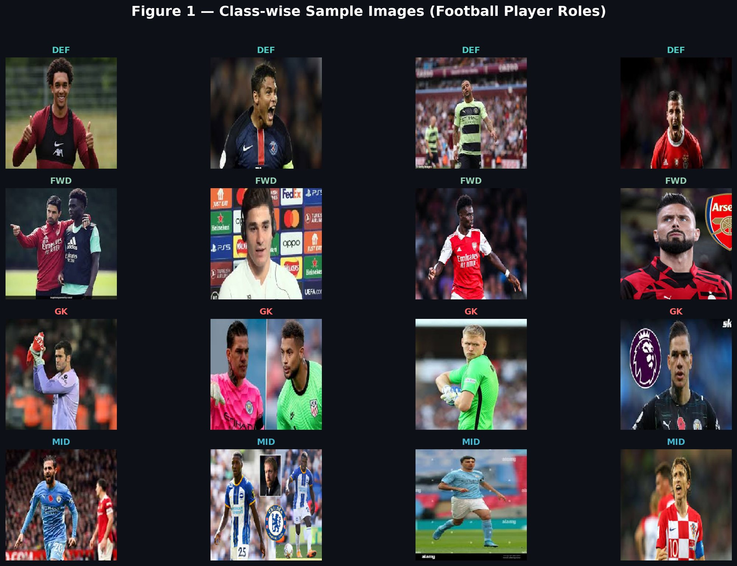
Fig. 1. Class-wise sample images. Rows correspond to DEF, FWD, GK, and MID roles respectively.
Figure 2 shows the role distribution across train, validation, and test splits, confirming the imbalanced structure and the stratified proportions maintained across partitions.
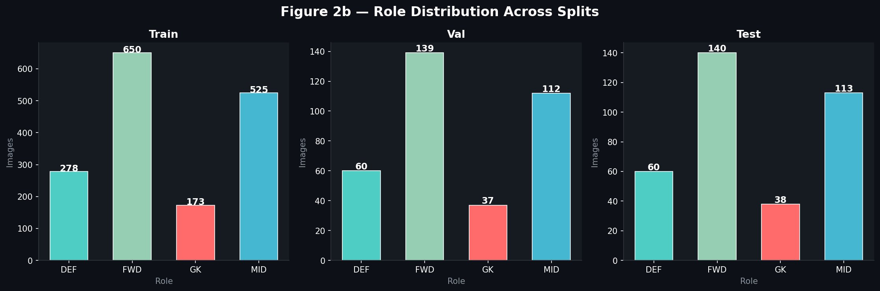
Fig. 2. Role distribution across train, validation, and test splits.
IV. METHODOLOGY
A. Overall Workflow
The overall model design workflow is shown in Figure 3. All three models receive the same 224×224 RGB input, perform feature extraction through their respective convolutional blocks, and pass representations through a classification head that outputs a 4-class softmax probability distribution. Post-training, all models are evaluated using accuracy, precision, recall, and F1-score on the held-out test set, and decisions are inspected using Grad-CAM and SHAP.
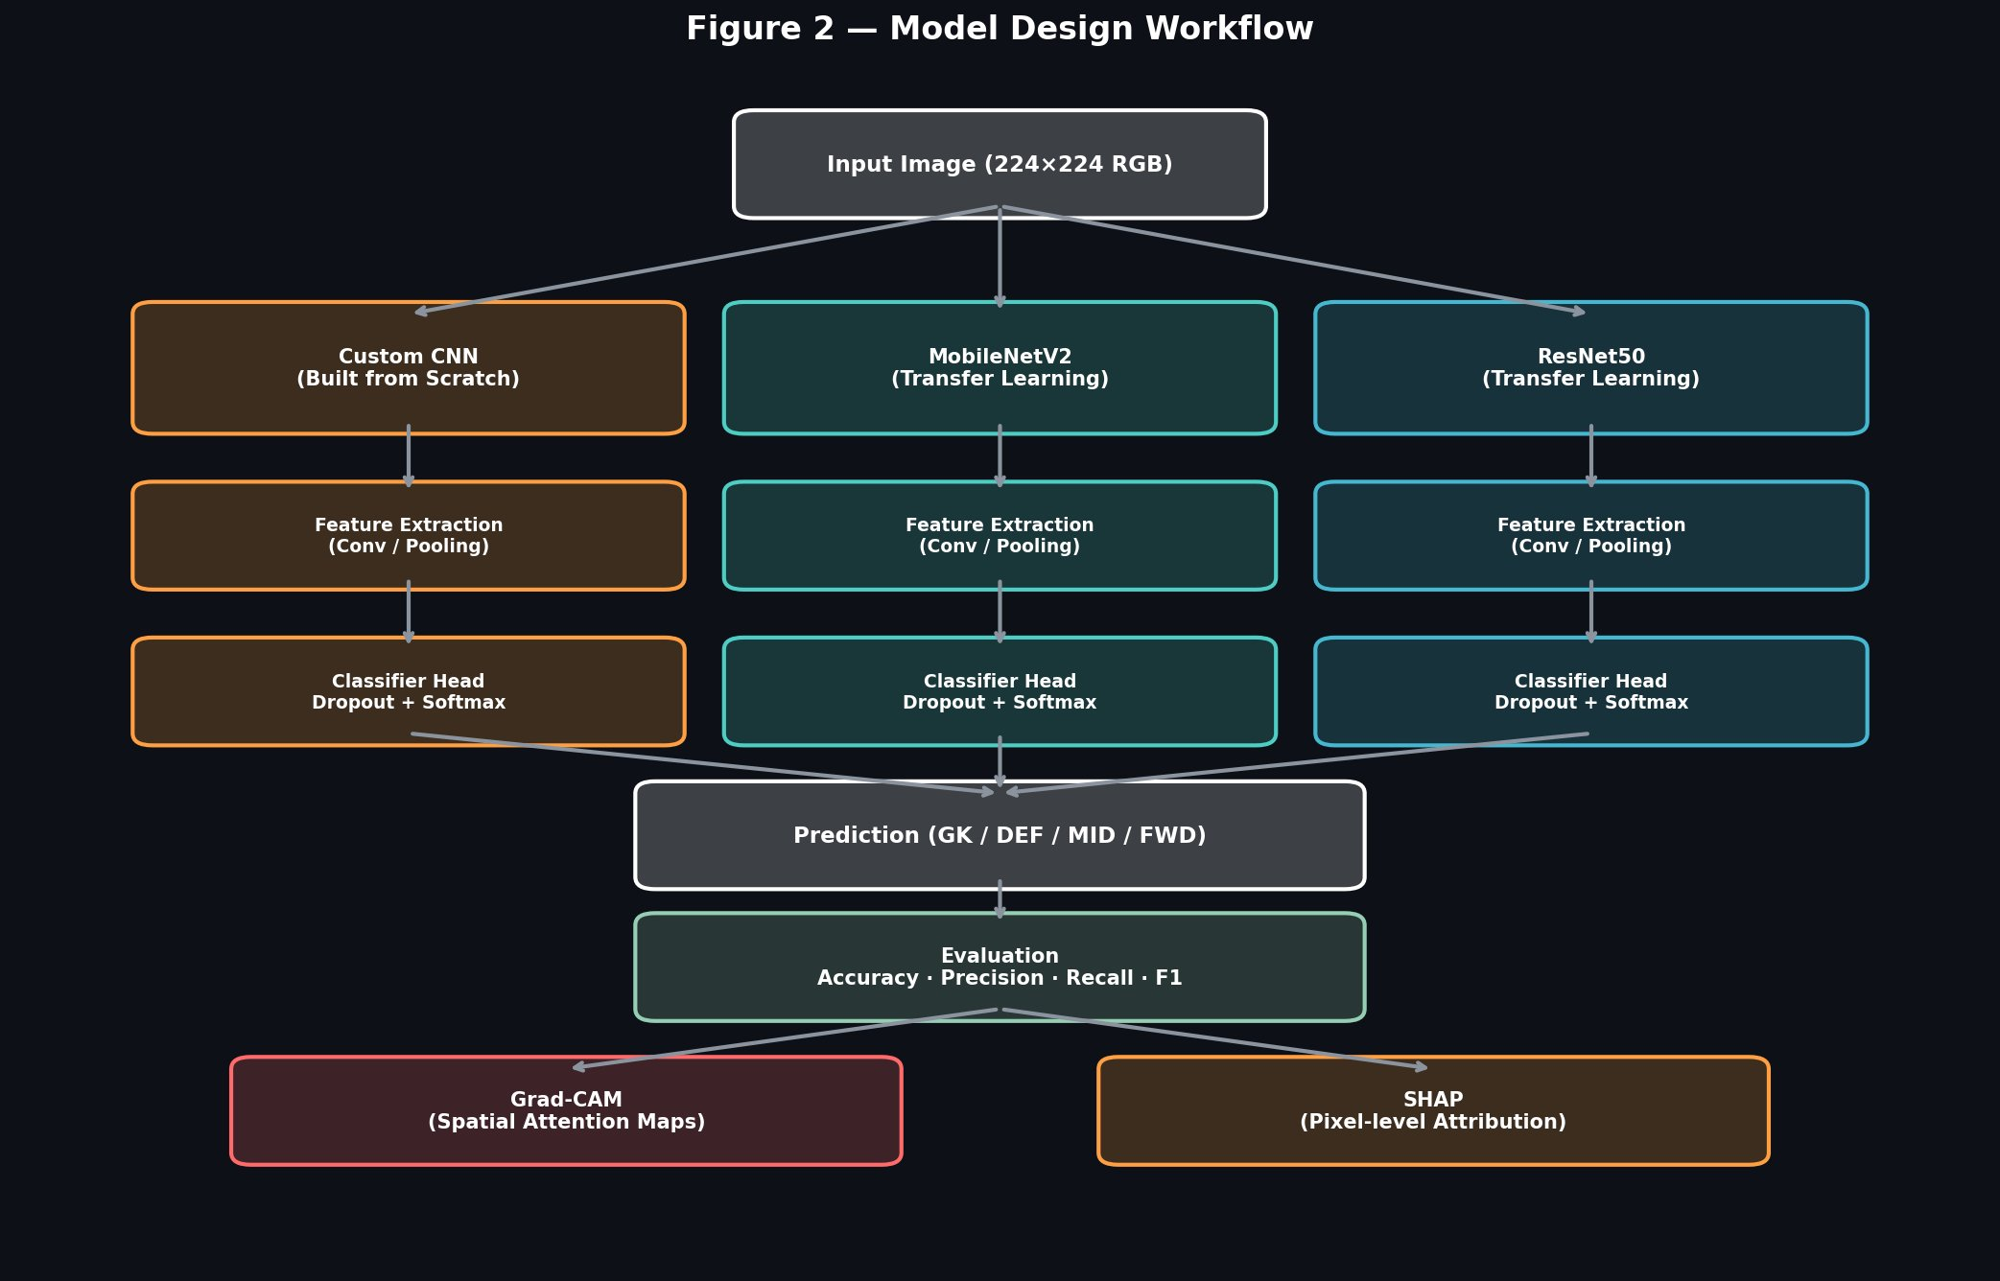
Fig. 3. Model design workflow: three parallel architectures share the same input format and output structure.
B. Data Augmentation
Online data augmentation is applied to training images to increase effective dataset size and reduce overfitting. The augmentation pipeline used with Keras ImageDataGenerator includes:
- Random rotation (±25°)
- Width and height shift (±15%)
- Shear transformation (10%)
- Random zoom (±20%)
- Random horizontal flip
- Brightness variation (0.80–1.20×)
- Channel shift (magnitude 20)
Validation and test images are only rescaled to [0, 1] without augmentation, ensuring unbiased evaluation.
C. Custom CNN Architecture
The custom CNN consists of three convolutional blocks of increasing depth (32, 64, and 128 filters), each comprising two Conv2D layers with 3×3 kernels, Batch Normalisation, ReLU activation, MaxPooling, and Dropout regularisation with progressively increasing rates (0.25, 0.25, 0.30). Global Average Pooling replaces flattening to reduce parameter count and improve generalisation. A Dense layer with 512 neurons and ReLU activation is followed by Dropout(0.50) and a 4-class softmax output. Label smoothing of 0.1 is applied to the categorical cross-entropy loss. Total trainable parameters: 848,932.
D. Transfer Learning: MobileNetV2 and ResNet50
Both transfer learning models use ImageNet pre-trained weights and follow a two-phase training strategy:
Phase 1 — Feature Extraction: The base model is frozen. Only the classification head (GlobalAveragePooling2D → Dense → Dropout → Softmax) is trained for up to 10 epochs at a learning rate of 3×10⁻⁴.
Phase 2 — Fine-Tuning: The last 30 layers of the base model are unfrozen and training continues at a reduced learning rate of 3×10⁻⁵ for up to 10 additional epochs. L2 regularisation (λ = 10⁻⁴) is applied to Dense layers.
MobileNetV2 uses a 256-neuron dense layer with Dropout(0.40), totalling approximately 2.59 million parameters. ResNet50 uses a 512-neuron dense layer with Dropout(0.50), totalling approximately 24.64 million parameters.
E. Training Callbacks
All models use EarlyStopping (monitor: val_accuracy, patience: 6, restore best weights), ReduceLROnPlateau (monitor: val_loss, factor: 0.3, patience: 3, minimum LR: 10⁻⁶), and ModelCheckpoint to save the best validation accuracy checkpoint.
F. Explainability Methods
Grad-CAM [5] computes gradients of the class score with respect to the final convolutional feature map, producing a spatial heatmap that highlights which image regions most influence a given prediction. It is applied to both correctly classified and misclassified test images.
SHAP [6] uses a GradientExplainer to compute pixel-level attribution values for each output class. Positive SHAP values indicate pixels that increase confidence in a predicted class; negative values indicate pixels that reduce it.
V. EXPERIMENTAL SETUP
All experiments were conducted on a Kaggle Notebook environment with a P100 GPU accelerator. The framework used is TensorFlow 2.x with the Keras API. Key hyperparameters are summarised in Table III.
Table III: Experimental Hyperparameters
Parameter | Value
Input image size | 224×224×3 (RGB)
Batch size | 32
Max epochs — Custom CNN | 30
Max epochs — TL (each phase) | 10
Initial learning rate | 3×10⁻⁴
Fine-tuning learning rate | 3×10⁻⁵
Optimiser | Adam
Loss function | Categorical Cross-Entropy (label smoothing = 0.1)
Random seed | 42

The custom CNN trained for 16 epochs before early stopping triggered. MobileNetV2 trained for 19 epochs across both phases. ResNet50 trained for 20 epochs across both phases. All models were evaluated on the same held-out test set of 351 images.
VI. RESULTS
A. Training and Validation Curves
Figure 4 shows accuracy and loss curves across all three models. The 70% accuracy target is marked with a dashed green line. None of the models approach this threshold. The Custom CNN and MobileNetV2 show stable validation accuracy in the 40–50% range. ResNet50 displays erratic behaviour with a sharp accuracy drop around epoch 14 accompanied by a corresponding loss spike, indicating instability during fine-tuning. MobileNetV2 training accuracy rises to approximately 67% in Phase 2, but validation accuracy does not follow, indicating overfitting despite the regularisation strategy applied.
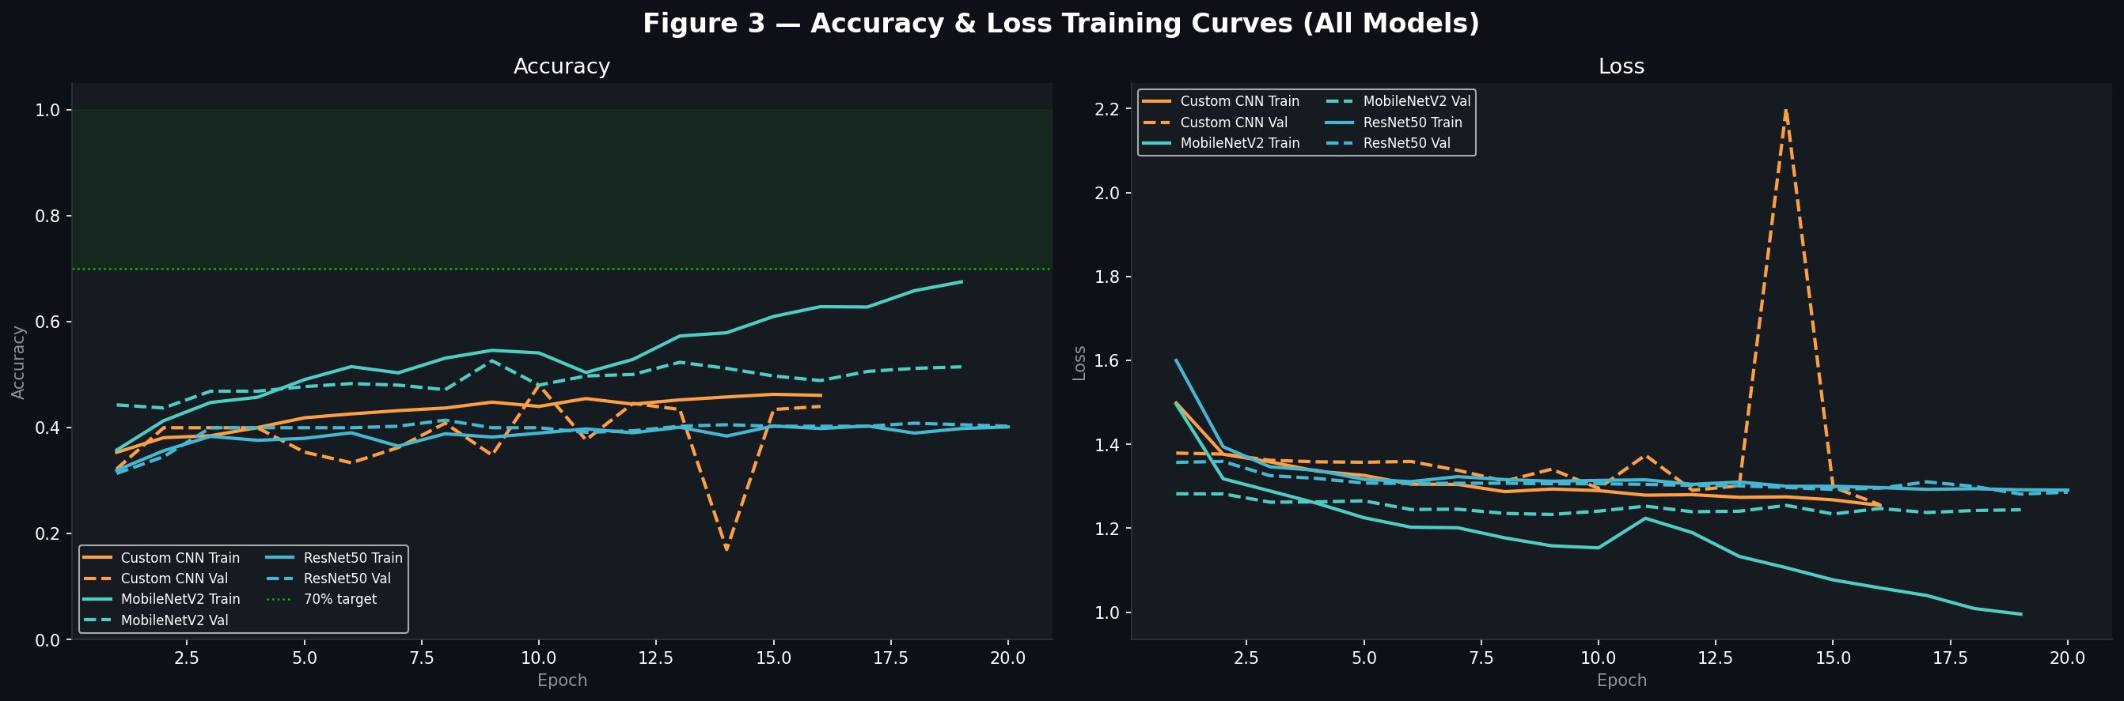
Fig. 4. Accuracy and loss training curves for all models. Dashed lines indicate validation metrics; the green dotted line marks the 70% accuracy target.
B. Confusion Matrices
Figure 5 shows the normalised confusion matrices for all three models on the test set. The Custom CNN distributes predictions reasonably across classes, with its strongest recall on FWD (0.75). MobileNetV2 shows a similar pattern with 0.59 FWD recall. ResNet50 almost entirely collapses to predicting FWD regardless of the true label — DEF and GK rows show values approaching 1.00 in the FWD column — indicating that the model failed to learn discriminative features for three of the four classes. This behaviour is consistent with ResNet50's known sensitivity to class imbalance combined with insufficient fine-tuning data.
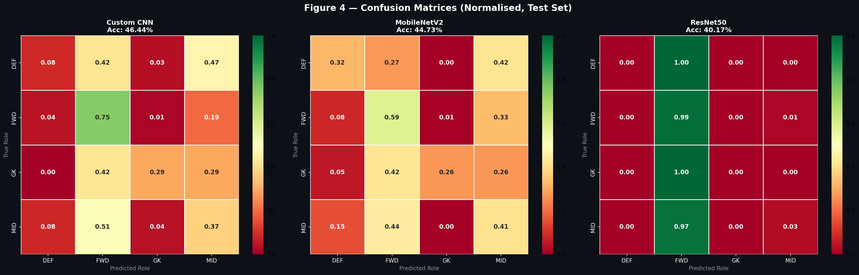
Fig. 5. Normalised confusion matrices for Custom CNN (46.44%), MobileNetV2 (44.73%), and ResNet50 (40.17%) on the test set.
C. Classification Results
Table IV presents the full test-set performance metrics for all three models.
Table IV: Test Set Performance Comparison
Model | Acc. (%) | Precision | Recall | F1-Score
Custom CNN | 46.44 | 0.4359 | 0.4644 | 0.4290
MobileNetV2 | 44.73 | 0.4807 | 0.4473 | 0.4424
ResNet50 | 40.17 | 0.3522 | 0.4017 | 0.2429
Random Baseline | 25.00 | — | — | —

Table V provides extended context including training time and parameter counts.
Table V: Extended Model Comparison
Model | Train Time (min) | Parameters | F1-Score
Custom CNN | 9.90 | 848,932 | 0.4290
MobileNetV2 | 7.87 | 2,586,948 | 0.4424
ResNet50 | 9.82 | 24,638,852 | 0.2429

Figure 6 provides a visual summary of accuracy, precision, recall, and F1-score across all models.
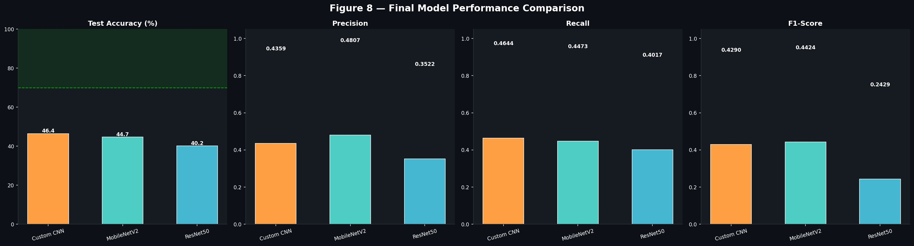
Fig. 6. Final model performance comparison across accuracy, precision, recall, and F1-score.
D. Grad-CAM Visualisations
Figure 7 shows Grad-CAM heatmaps for correctly classified test images. On correct predictions, the Custom CNN concentrates activation on the upper body and jersey region, which is a plausible attention target given that goalkeeper kits are visually distinctive and jersey numbers or colours may carry some positional information.
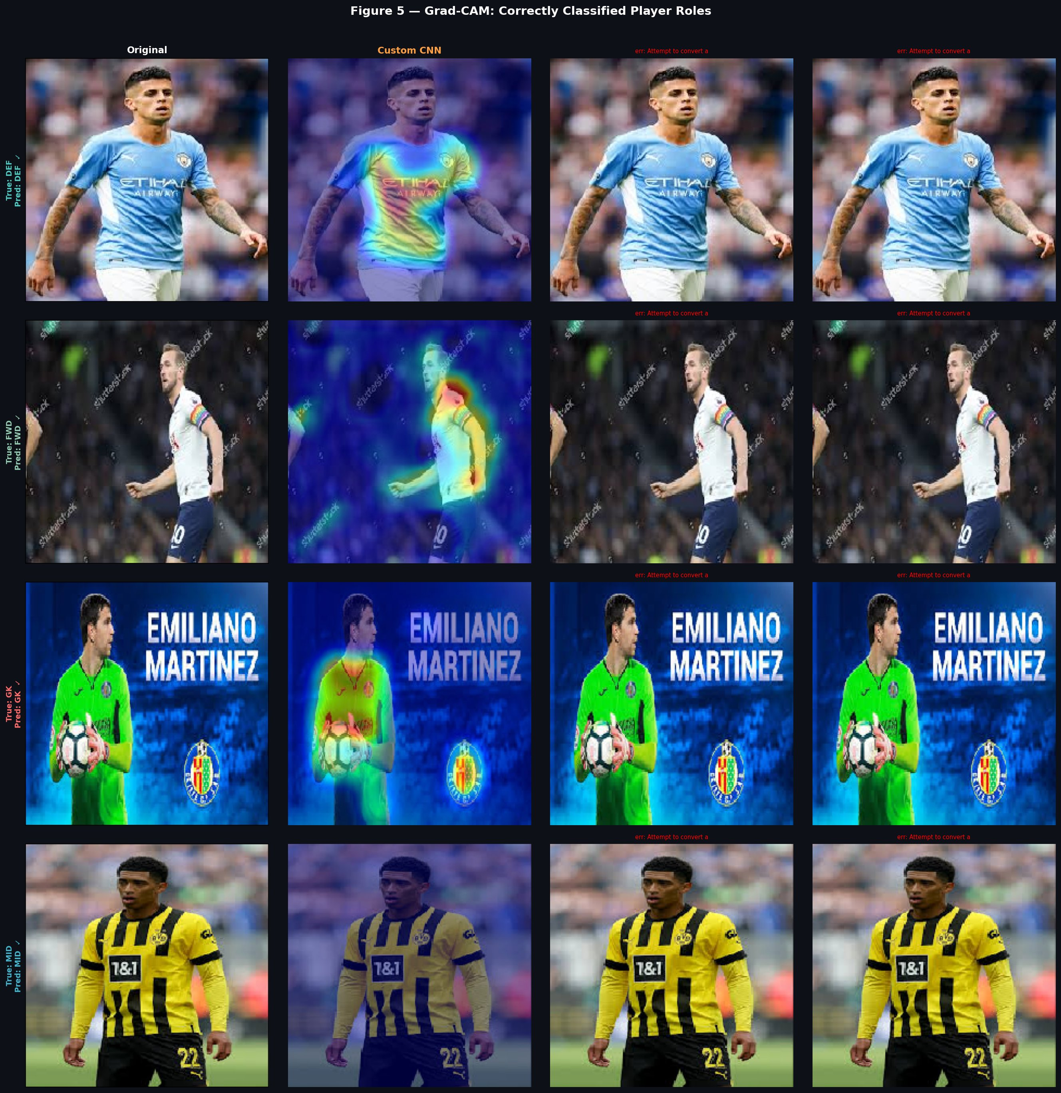
Fig. 7. Grad-CAM heatmaps on correctly classified images. Each row shows the original followed by the Custom CNN activation map.
Figure 8 shows Grad-CAM on misclassified images. In these cases, attention is diffuse or directed at background elements — crowd patterns, pitch markings, or surrounding players — rather than the target player.
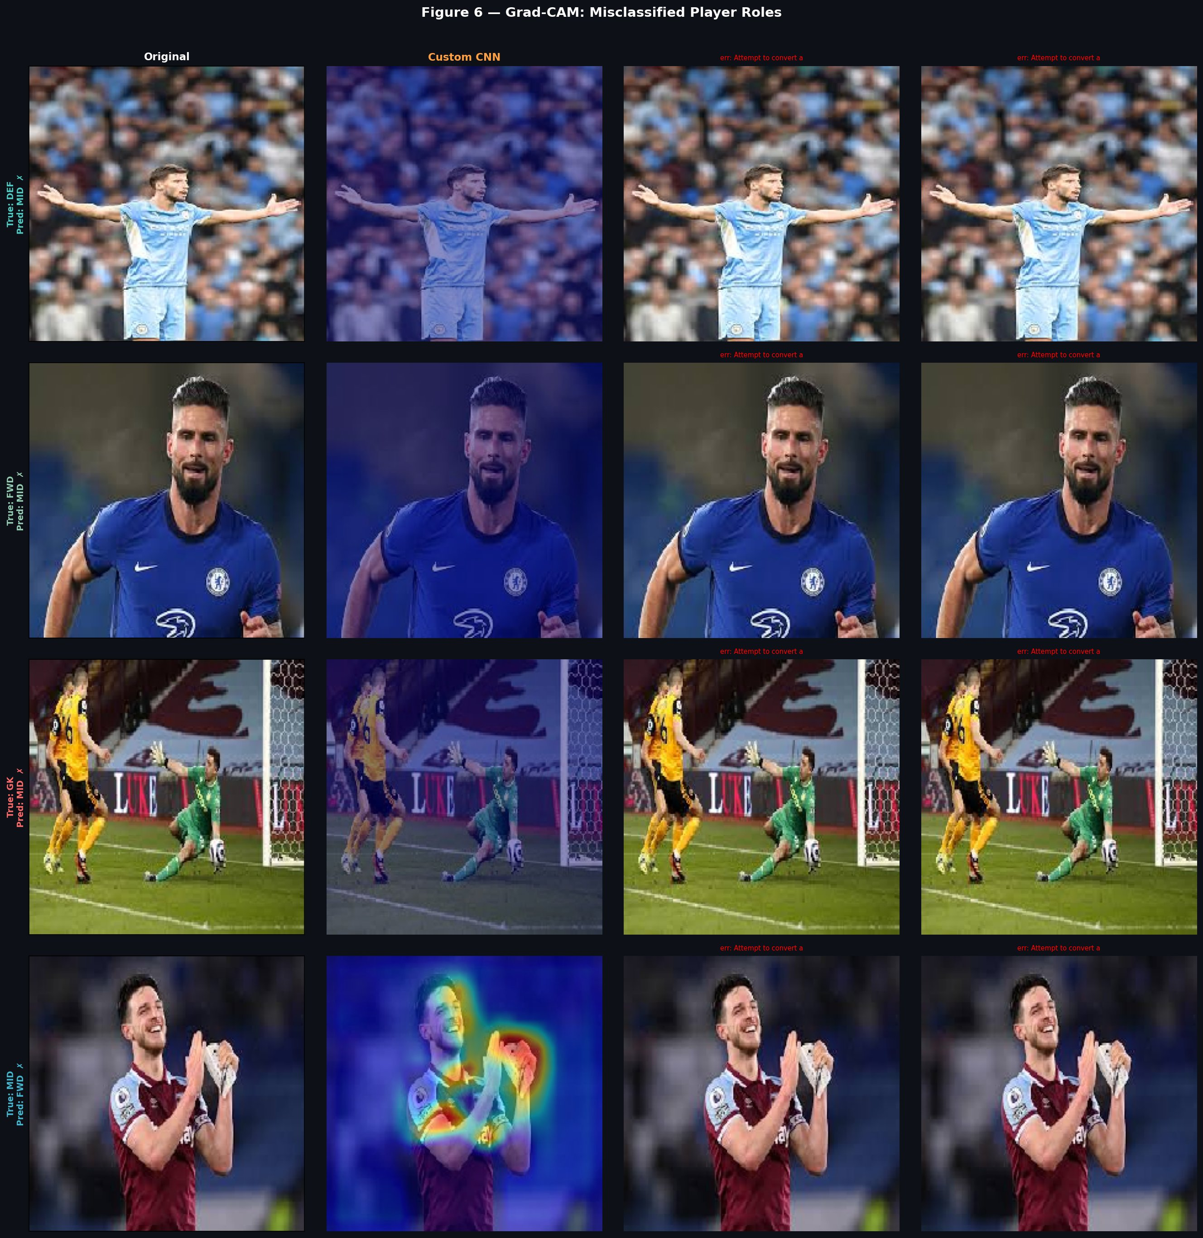
Fig. 8. Grad-CAM heatmaps on misclassified images. Attention is typically scattered or directed to background regions.
E. SHAP Explanations
Figures 9, 10, and 11 show SHAP pixel attribution maps for the Custom CNN, MobileNetV2, and ResNet50 respectively. Across all models, attribution is broadly distributed with no dominant localised region consistently driving predictions. Body outline and jersey texture regions show the most consistent positive attribution, while backgrounds contribute mostly negative or near-zero values.
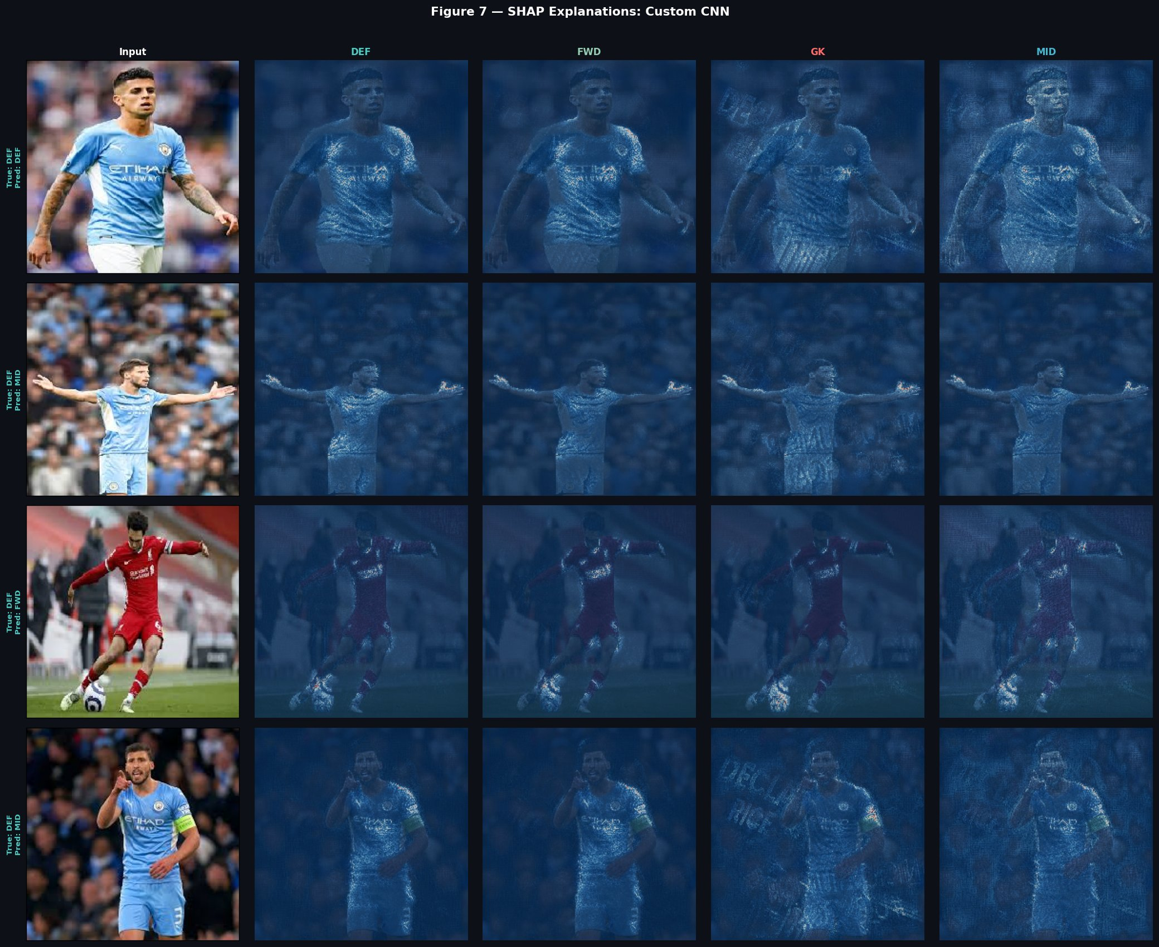
Fig. 9. SHAP pixel attributions for the Custom CNN across all four output classes.
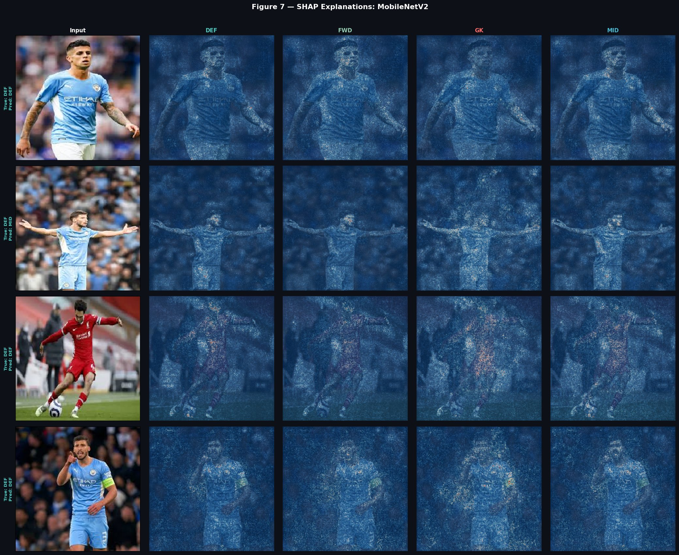
Fig. 10. SHAP pixel attributions for MobileNetV2 across all four output classes.
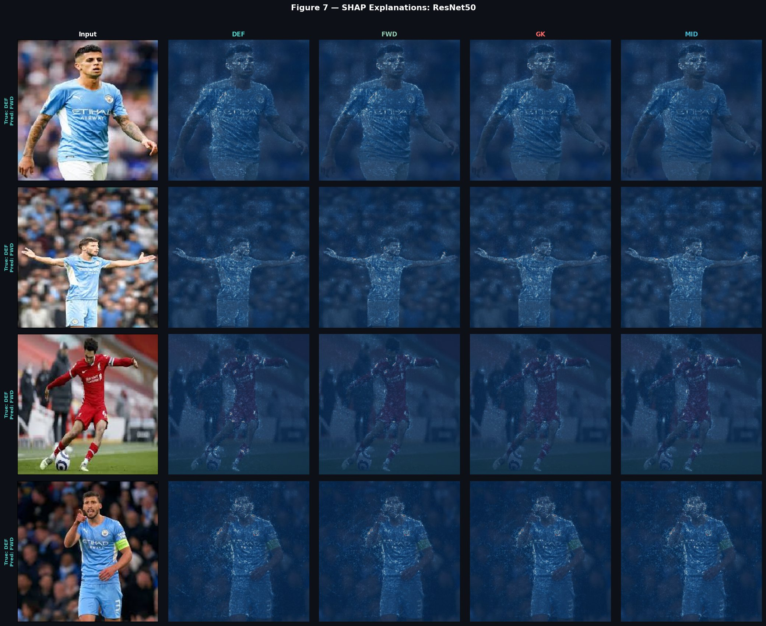
Fig. 11. SHAP pixel attributions for ResNet50 across all four output classes.
VII. DISCUSSION
This section addresses seven research questions that guided the design and evaluation of this project.
RQ1: How accurately does a custom CNN classify football player roles from portrait images?
The custom CNN reaches a test accuracy of 46.44% and a macro F1-score of 0.4290, both substantially above the 25% random baseline. The model did learn some discriminative visual information from the images. However, the 70% target was not reached. The primary limiting factor is the dataset: with only 173 goalkeeper images in the training split and 278 defender images, the model lacks sufficient examples of the minority classes to learn reliable class boundaries. The FWD class — the most frequent with 650 training images — is the only class where recall exceeds 0.70 in the confusion matrix, directly supporting the imbalance hypothesis as the main driver of underperformance.
RQ2: Does transfer learning improve classification performance over a custom CNN?
In this experiment, transfer learning did not improve overall accuracy. MobileNetV2 achieves 44.73% and ResNet50 achieves 40.17%, both below the Custom CNN's 46.44%. This is a notable result. One explanation is that ImageNet pre-trained features may not provide a strong inductive bias for player role classification, where discriminative cues are subtle and domain-specific — unlike standard object recognition tasks where ImageNet representations transfer well. Additionally, the small training set means that fine-tuning increases overfitting risk, particularly for ResNet50 with 24.6 million parameters and only 1,626 training images across four unbalanced classes.
RQ3: Which model offers the best trade-off between accuracy and computational cost?
MobileNetV2 offers the best overall trade-off. It achieves the highest macro F1-score (0.4424) and the best precision (0.4807), and trains in 7.87 minutes — the fastest of the three. Its 2.59 million parameters represent a practical middle ground between the very lightweight Custom CNN (848,932 parameters) and the computationally expensive ResNet50 (24.64 million parameters). ResNet50 is clearly the worst performer relative to its cost, with the lowest F1-score despite having nearly 30 times more parameters than the Custom CNN and comparable training time.
RQ4: What image regions does the Custom CNN attend to for correct predictions?
Grad-CAM analysis shows that for correctly classified images, the Custom CNN concentrates activation on the upper body and jersey area. This is a meaningful observation — goalkeeper kits are typically a distinct colour from outfield players, jersey numbers and sponsor logos appear on the chest and back, and posture or body position may carry subtle role-related signals. For correctly classified GK images, heatmaps show concentrated activation on the torso and hand regions, consistent with the gloves and kit that visually distinguish goalkeepers from outfield players.
RQ5: Where does attention go for misclassified images?
In misclassified cases, Grad-CAM consistently shows diffuse activation or attention directed at background elements — crowd patterns, pitch markings, advertising boards, and surrounding players. This strongly suggests that the model has not learned sufficiently robust player-centred representations. The DEF-to-MID confusion visible in the confusion matrix is likely driven by shared visual contexts — similar team kits, similar match environments — rather than player-specific body features. A more controlled dataset with consistent portrait framing and standardised backgrounds would likely reduce this background attention bias considerably.
RQ6: What does SHAP attribution reveal about model decision-making?
SHAP analysis confirms that no single dominant pixel region drives predictions across test images for any of the three models. Attribution is broadly distributed, with body contour regions and jersey texture areas showing the most consistent positive influence. This is consistent with Grad-CAM findings and reflects the visual ambiguity inherent in this task. Across all three models, SHAP maps are qualitatively similar, suggesting that despite their architectural differences, all three models converge on broadly similar low-level attribution patterns. There is no evidence that transfer learning models produce sharper or more semantically meaningful attribution than the custom CNN at this dataset scale.
RQ7: What do misclassification patterns reveal about dataset and model limitations?
The confusion matrices reveal a consistent pattern: all three models are biased toward predicting FWD, which is the majority class. ResNet50 almost entirely collapses to FWD prediction for all input classes, including DEF and GK. This is a direct consequence of class imbalance — a model trained on 650 FWD images versus 173 GK images will naturally develop a strong prior toward the majority class, especially when visual discrimination between classes is difficult. The DEF-MID confusion is the second most frequent error pattern and is expected given the visual overlap between these roles in portrait images. These misclassification patterns confirm that the dataset constraint is the dominant bottleneck, and that addressing class imbalance — through oversampling, class-weighted loss, or additional data collection — is the most impactful next step for improving performance.
VIII. CONCLUSION
This project investigated whether CNN-based models can classify football players into positional roles from portrait images. A custom CNN, MobileNetV2, and ResNet50 were trained, evaluated, and compared under identical experimental conditions. The custom CNN achieved the highest test accuracy (46.44%), MobileNetV2 produced the best F1-score and precision, and ResNet50 underperformed significantly relative to its parameter count and computational cost.
All three models exceed the 25% random baseline, confirming that portrait images contain some positional information that CNNs can learn. However, the 70% accuracy target was not achieved by any model. The primary reason is the dataset constraint: the World Cup 2022 Elite Players Image Dataset is significantly imbalanced, with FWD and MID images vastly outnumbering GK and DEF images. This imbalance directly biases model predictions toward majority classes, limits generalisation, and drives most of the observed misclassification patterns.
Grad-CAM and SHAP analysis revealed that correct predictions correlate with jersey and upper-body attention, while misclassifications correlate with background-directed attention. This provides actionable insight: a more controlled dataset with consistent portrait framing and background uniformity would likely produce substantially better results with the same model architectures.
Limitations
The key limitations are: (1) a small and imbalanced dataset that constrains learning in all three models; (2) the absence of player body attribute metadata that could provide strong positional priors; (3) the lack of class weighting or oversampling strategies to counteract imbalance during training; and (4) reliance on a single data source, which limits generalisation.
Future Work
Future directions include collecting a balanced dataset of at least 800 images per class from multiple sources; applying class-weighted loss functions or SMOTE-based oversampling for minority classes; exploring attention-based architectures such as Vision Transformers for fine-grained classification; and integrating player metadata — body measurements, age, playing style statistics — as auxiliary inputs to a multi-modal classification model.
REFERENCES
[1] R. Singh, A. Gupta, and V. Yadav, 'Player role detection in sports videos using pose estimation and deep learning,' in Proc. IEEE Int. Conf. Image Processing (ICIP), 2020, pp. 1321-1325.
[2] A. G. Howard et al., 'MobileNets: Efficient convolutional neural networks for mobile vision applications,' arXiv preprint arXiv:1704.04861, 2017.
[3] M. Sandler, A. Howard, M. Zhu, A. Zhmoginov, and L.-C. Chen, 'MobileNetV2: Inverted residuals and linear bottlenecks,' in Proc. IEEE/CVF Conf. Computer Vision and Pattern Recognition (CVPR), 2018, pp. 4510-4520.
[4] K. He, X. Zhang, S. Ren, and J. Sun, 'Deep residual learning for image recognition,' in Proc. IEEE/CVF Conf. Computer Vision and Pattern Recognition (CVPR), 2016, pp. 770-778.
[5] R. R. Selvaraju et al., 'Grad-CAM: Visual explanations from deep networks via gradient-based localization,' in Proc. IEEE Int. Conf. Computer Vision (ICCV), 2017, pp. 618-626.
[6] S. M. Lundberg and S.-I. Lee, 'A unified approach to interpreting model predictions,' in Advances in Neural Information Processing Systems (NeurIPS), vol. 30, 2017.
[7] P. Kibuchi, 'World Cup 2022 Elite Players Image Dataset,' Kaggle, 2022. [Online]. Available: https://www.kaggle.com/datasets/peterkibuchi/world-cup-2022-elite-players-image-dataset
[8] M. Abadi et al., 'TensorFlow: Large-scale machine learning on heterogeneous systems,' 2015. [Online]. Available: https://www.tensorflow.org

