Submission 1: Proposal, Code, and GitHub Repository
Supervised Learning for WHOOP Fitness Recovery Score Prediction

Project and Dataset Summary
Table A. Project and dataset summary
Item | Value
Dataset | WHOOP Fitness Dataset
Dataset link | https://www.kaggle.com/datasets/likithagedipudi/whoop-fitness-dataset
Rows | 100,000
Columns | 41.000
Target variable | recovery_score
Task type | Regression

Metric Note
This is a regression task. The project reports MAE, RMSE, R2, residuals, actual-vs-predicted plots, cross-validation, and robustness outputs.

Methodology Summary
- Load and inspect the WHOOP Fitness dataset.
- Use recovery_score as the target variable.
- Preprocess numerical and categorical features with pipelines.
- Train baseline, regularized, tree-based, and ensemble regression models.
- Save tabular outputs and visual outputs for RQ1-RQ7.

RQ1. Baseline Performance

Research Question
How effectively can baseline supervised learning models predict WHOOP recovery score?

Actual Results
Table RQ1. Actual output table for Baseline Performance
Model | MAE | RMSE | R2 | Expected R2 Range | Matches Expected Range
Linear Regression | 10.540 | 13.175 | 0.4420 | 0.45-0.75 | No
Decision Tree | 12.754 | 15.907 | 0.1870 | 0.45-0.75 | No
k-NN | 13.043 | 16.093 | 0.1680 | 0.45-0.75 | No

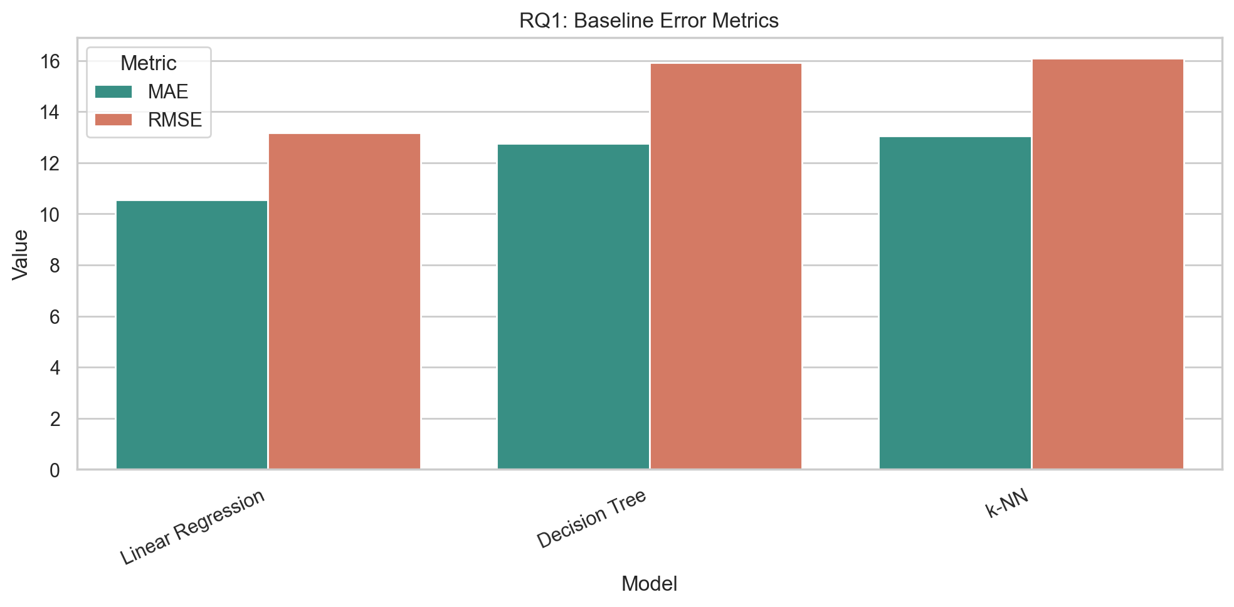
Figure 1. Baseline model error metrics.

RQ2. Model Comparison

Research Question
Which supervised learning model achieves the best predictive performance for recovery score?

Actual Results
Table RQ2. Actual output table for Model Comparison
Model | Model Type | MAE | RMSE | R2 | Rank by R2 | Best Model
Linear Regression | Simple/regularized baseline | 10.540 | 13.175 | 0.4420 | 1.0000 | Yes
Ridge Regression | Simple/regularized baseline | 10.748 | 13.426 | 0.4210 | 2.0000 | No
Elastic Net | Simple/regularized baseline | 11.085 | 13.803 | 0.3880 | 4.0000 | No
Decision Tree | Simple/regularized baseline | 12.602 | 15.762 | 0.2010 | 7.0000 | No
Random Forest | Ensemble | 11.307 | 14.066 | 0.3640 | 5.0000 | No
Gradient Boosting | Ensemble | 11.374 | 14.102 | 0.3610 | 6.0000 | No
XGBoost | Ensemble | 11.087 | 13.782 | 0.3900 | 3.0000 | No

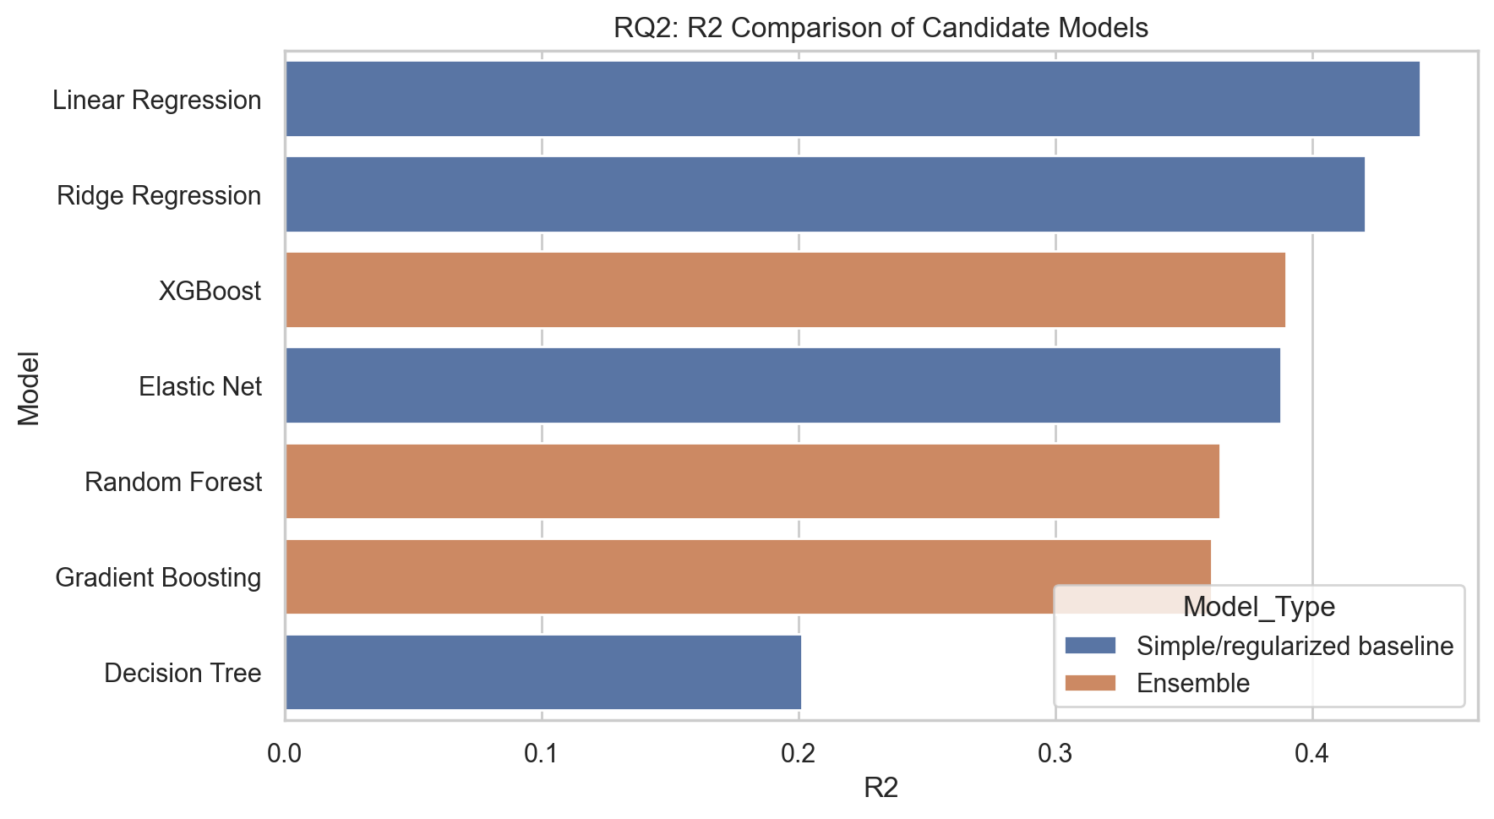
Figure 2. Candidate model R2 comparison.

RQ3. Effect of Preprocessing

Research Question
How do preprocessing strategies affect supervised learning performance?

Actual Results
Table RQ3. Actual output table for Effect of Preprocessing
Preprocessing Strategy | MAE | RMSE | R2
Numeric only + imputation | 10.562 | 13.206 | 0.4394
Numeric + imputation + scaling | 10.784 | 13.463 | 0.4174
Full pipeline: scaling + encoding | 10.748 | 13.426 | 0.4206
Full pipeline + Random Forest | 11.307 | 14.066 | 0.3641

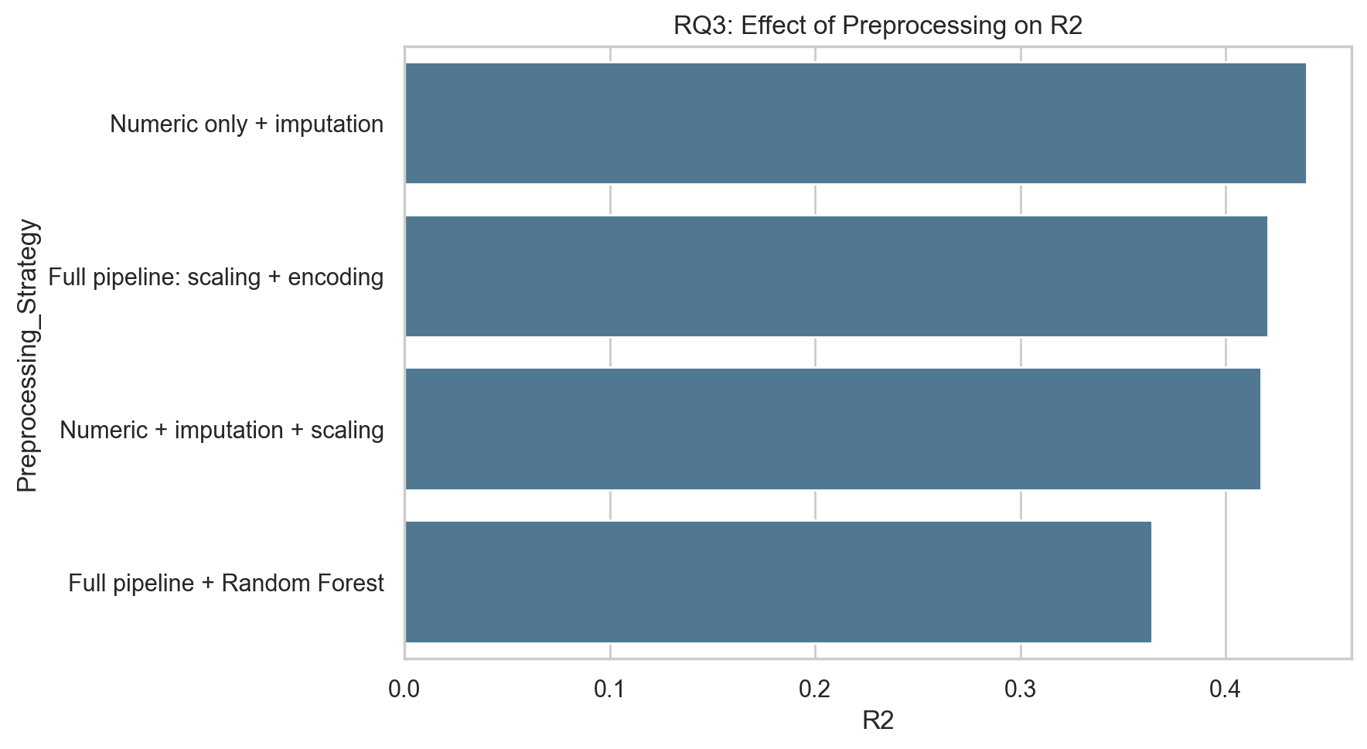
Figure 3. Preprocessing strategy comparison.

RQ4. Feature Importance and Interpretability

Research Question
Which features contribute most to recovery score prediction?

Actual Results
Table RQ4. Actual output table for Feature Importance and Interpretability
Rank | Original Feature | Importance | Importance Percent
1.0000 | resting_heart_rate | 0.1835 | 18.348
2.0000 | hrv | 0.1598 | 15.980
3.0000 | rhr_baseline | 0.1283 | 12.829
4.0000 | day_strain | 0.0999 | 9.9890
5.0000 | hrv_baseline | 0.0866 | 8.6579
6.0000 | calories_burned | 0.0472 | 4.7224
7.0000 | date_dayofyear | 0.0461 | 4.6141
8.0000 | height_cm | 0.0324 | 3.2441
9.0000 | age | 0.0296 | 2.9622
10.000 | activity_strain | 0.0275 | 2.7517

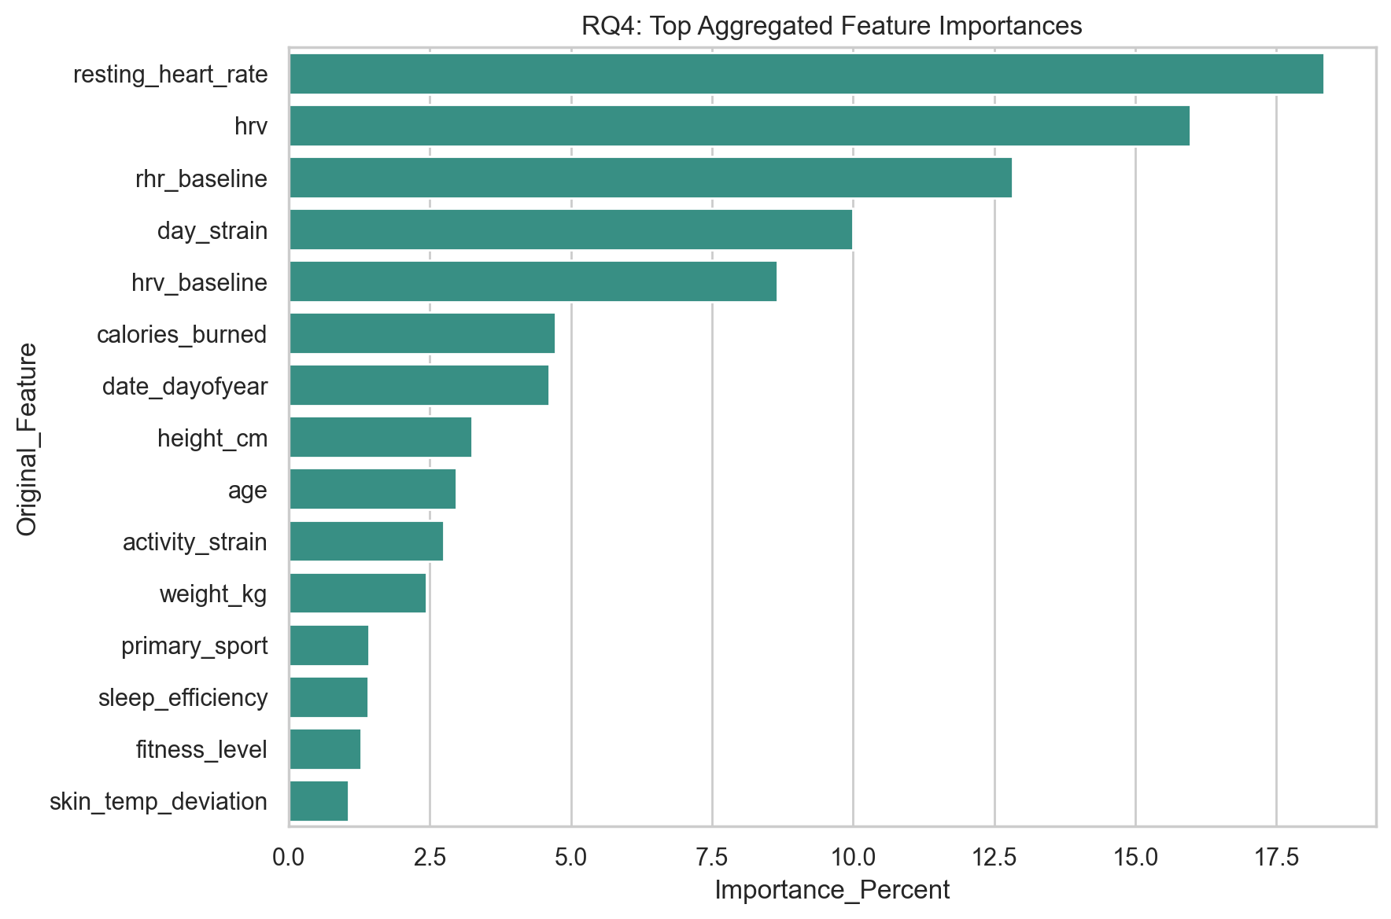
Figure 4. Top aggregated feature importance.

RQ5. Sensitivity to Evaluation Metrics

Research Question
How does model ranking change across MAE, RMSE, and R2?

Actual Results
Table RQ5. Actual output table for Sensitivity to Evaluation Metrics
Model | MAE | RMSE | R2 | MAE Rank | RMSE Rank | R2 Rank | Average Rank
Linear Regression | 10.532 | 13.140 | 0.4464 | 1.0000 | 1.0000 | 1.0000 | 1.0000
Ridge Regression | 10.809 | 13.466 | 0.4185 | 2.0000 | 2.0000 | 2.0000 | 2.0000
Elastic Net | 11.106 | 13.788 | 0.3904 | 3.0000 | 3.0000 | 3.0000 | 3.0000
XGBoost | 11.154 | 13.791 | 0.3901 | 4.0000 | 4.0000 | 4.0000 | 4.0000
Gradient Boosting | 11.434 | 14.109 | 0.3617 | 5.0000 | 5.0000 | 5.0000 | 5.0000
Random Forest | 11.510 | 14.219 | 0.3516 | 6.0000 | 6.0000 | 6.0000 | 6.0000
Decision Tree | 12.863 | 16.020 | 0.1770 | 7.0000 | 7.0000 | 7.0000 | 7.0000
Baseline Mean | 14.415 | 17.661 | -0.0001 | 8.0000 | 8.0000 | 8.0000 | 8.0000

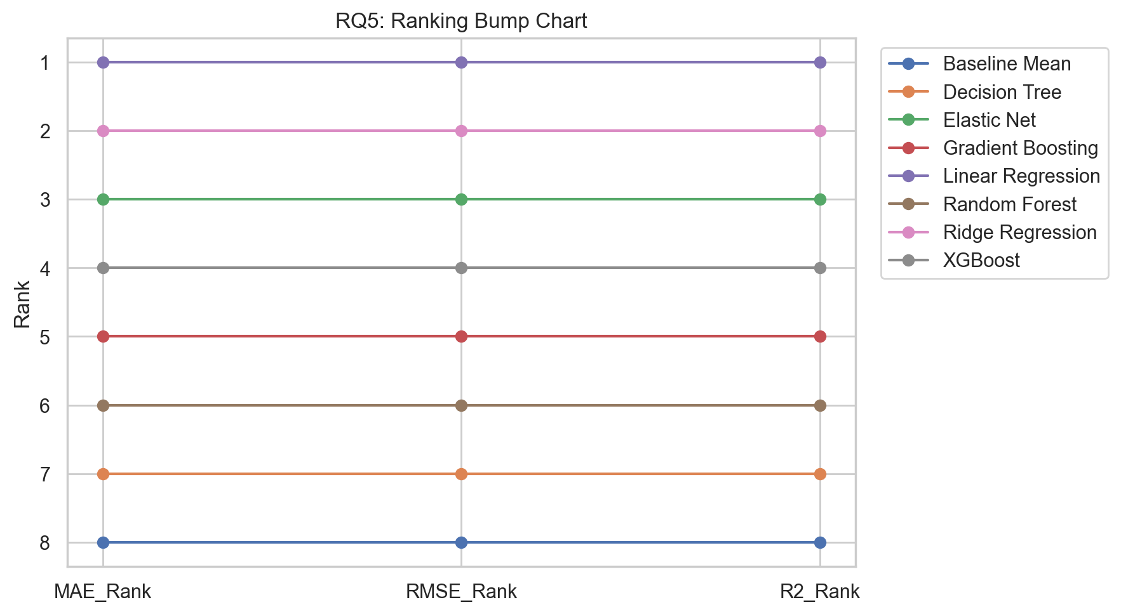
Figure 5. Ranking bump chart.

RQ6. Robustness and Generalization

Research Question
How robust is the best model under validation, noise, and missingness?

Actual Results
Table RQ6. Actual output table for Robustness and Generalization
Condition | Mean R2 | Min R2 | Max R2 | Mean RMSE | Mean MAE
Baseline CV | 0.4479 | 0.4416 | 0.4567 | 13.152 | 10.537
Added numeric noise | 0.3852 | 0.3825 | 0.3877 | 13.879 | 11.139
Simulated missingness | 0.1973 | 0.1821 | 0.2115 | 15.858 | 12.815

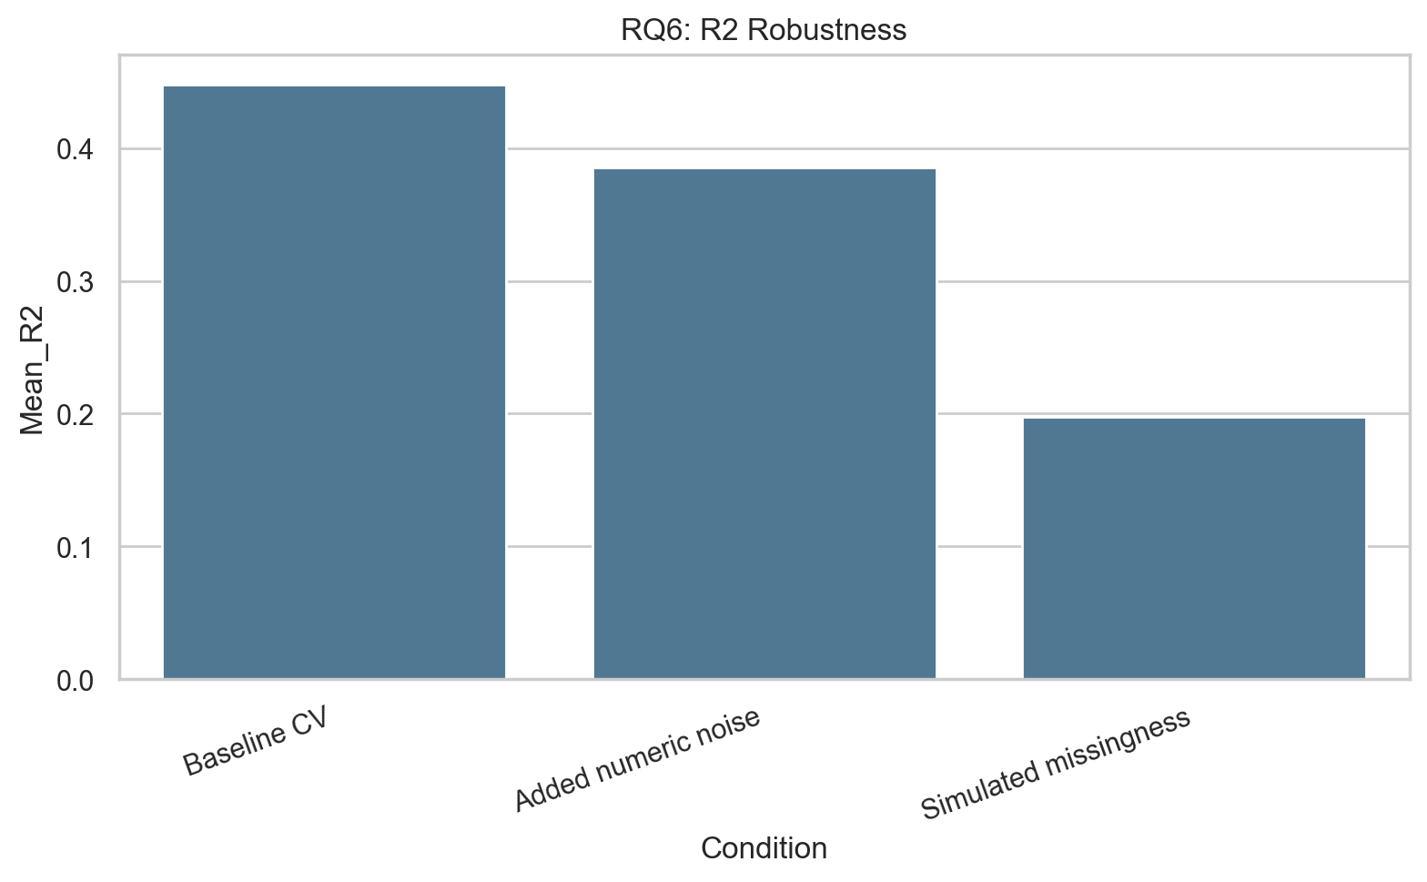
Figure 6. R2 robustness comparison.

RQ7. Practical Usefulness and Final Recommendation

Research Question
Which model provides the best practical balance for recovery decision support?

Actual Results
Table RQ7. Actual output table for Practical Usefulness and Final Recommendation
Model | CV R2 | Holdout R2 | Interpretability Score | Deployment Suitability Score | Weighted Decision Score | Final Rank
Linear Regression | 0.4464 | 0.4420 | 5.0000 | 5.0000 | 4.3555 | 1.0000
Ridge Regression | 0.4185 | 0.4206 | 5.0000 | 5.0000 | 4.1722 | 2.0000
Elastic Net | 0.3904 | 0.3876 | 5.0000 | 5.0000 | 3.6580 | 3.0000
Random Forest | 0.3516 | 0.3641 | 3.5000 | 4.0000 | 3.4153 | 4.0000
XGBoost | 0.3901 | 0.3895 | 2.5000 | 3.0000 | 3.4097 | 5.0000
Decision Tree | 0.1770 | 0.2015 | 4.0000 | 4.0000 | 3.1254 | 6.0000
Gradient Boosting | 0.3617 | 0.3608 | 3.0000 | 3.0000 | 2.9054 | 7.0000
Baseline Mean | -0.0001 | -0.0004 | 1.0000 | 2.0000 | 2.3493 | 8.0000

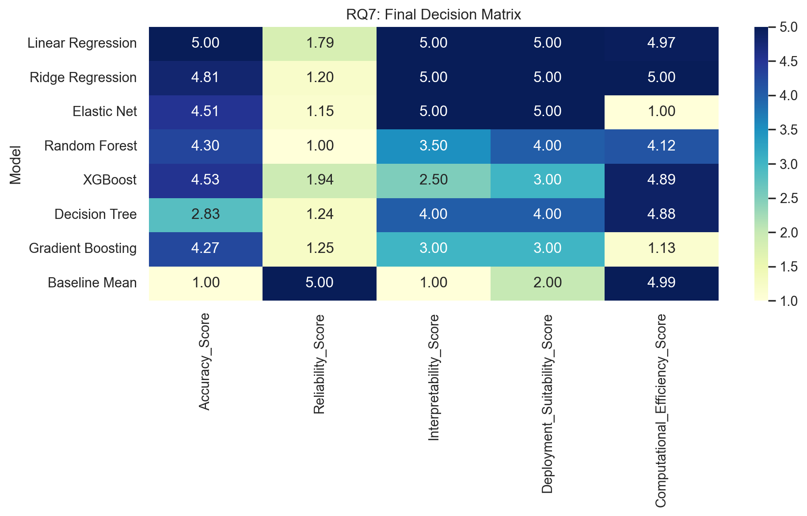
Figure 7. Final decision matrix heatmap.

Final Recommendation
Table B. Final recommendation
Item | Value
Recommended Model | Linear Regression
Highest Holdout Accuracy Model | Linear Regression
Recommendation | Use the recommended model for planning because it balances accuracy, reliability, interpretability, runtime, and deployment suitability.

Submission Checklist
Table C. Submission checklist
Item | Status
Proposal file | Submission_1_Proposal.docx
README | README.md
Code | whoop_assignment_pipeline.py and RQ1-RQ7 notebooks
Dataset | data/whoop_fitness_dataset_100k.csv
Dataset link | https://www.kaggle.com/datasets/likithagedipudi/whoop-fitness-dataset
Outputs | outputs/tables and outputs/figures

