DATA ANALYTICS PROJECT REPORT
DA 120B · Academic Year 2025–2026

Air Quality Index (AQI) Analysis
India · 2015–2020

Temporal Trends · Pollutant Relationships · Urban Air Quality Exposure
29,531  City-Day Records | 26  Cities Monitored | 24,850  Valid AQI Records | 26.0%  Unhealthy Days

PROJECT TEAM
Yash David Bedekar — Project Lead & Data Engineer
Data pipeline, cleaning, feature engineering, Kaggle integration, project coordination
Surya Koushik Palla — Data Analyst & Visualisation Lead
All 14 EDA charts, RQ1 temporal analysis, chart design, interpretation
Aryaman Negi — Statistical Analyst
Pollutant correlations, outlier detection, AQI_capped methodology, descriptive statistics
Arda Onhun — Insights & Reporting Lead
RQ3 city exposure, COVID-19 analysis, key findings, report writing

Dataset: Air Quality Data in India (2015–2020) · CPCB via Kaggle (rohanrao) · CC0 Public Domain
Kaggle: kaggle.com/code/yashbedekar07/air-quality-index-aqi-analysis · GitHub: github.com/yashbedekar07/air-quality-index-project

1. Executive Summary
This report presents a comprehensive data analytics investigation of India's Air Quality Index (AQI) across 26 major cities from January 2015 to July 2020. Using 29,531 daily observations (24,850 after cleaning) compiled by India's Central Pollution Control Board (CPCB), the project addresses three research questions: temporal AQI trends, pollutant–AQI relationships, and geographic exposure to unhealthy air.

Research Question | Core Finding
RQ1 — Temporal Trends | Strong seasonal cycle: Winter avg AQI ≈ 221, Monsoon ≈ 116. COVID-19 lockdown reduced AQI in 25 of 26 cities. Day-of-week effects are negligible (158–164 range).
RQ2 — Pollutant Relationships | PM10 is the dominant AQI driver (r = 0.80), followed by CO (r = 0.69) and PM2.5 (r = 0.67). Ozone is weakly correlated (r ≈ 0.20).
RQ3 — Urban Exposure | 26.0% of city-days are unhealthy (AQI > 200). Delhi (65.1%) and Ahmedabad (81.9%) are worst affected. Bengaluru (2.1%) is the cleanest major city.

Air pollution in India is a systemic, year-round public health challenge concentrated in northern cities, with particulate matter as the primary driver. The COVID-19 lockdown provides rare quantitative evidence of the human contribution to urban air quality.

2. Introduction

2.1 Background & Motivation
India is home to several of the world’s most polluted cities. The Air Quality Index (AQI) is the primary metric used by India’s Central Pollution Control Board (CPCB) to communicate daily air quality to the public and policymakers. Understanding how AQI varies across cities, seasons, and years — and which pollutants drive it — is critical for designing effective public health interventions.

2.2 Research Questions
- RQ1 — Temporal Trends: How does AQI change over time? Are there clear daily, monthly, seasonal, or year-on-year patterns?
- RQ2 — Pollutant Relationships: Is there a measurable relationship between specific pollutants (PM2.5, PM10, NO₂, SO₂, CO, O₃) and the overall AQI category?
- RQ3 — Urban Exposure: How often does air quality reach unhealthy or hazardous levels, and which cities are most affected?

2.3 Objectives
- Profile air quality trends over time and identify seasonal patterns across 26 Indian cities.
- Quantify the statistical relationship between six core pollutants and the AQI.
- Identify cities with the highest exposure to unhealthy air and the months when risk peaks.
- Analyse the impact of the COVID-19 national lockdown (March 2020) as a natural experiment in pollution reduction.
- Produce 14 publication-quality visualisations embedded in this report.

3. Dataset

3.1 Source & Overview
Attribute | Detail
Dataset name | Air Quality Data in India (2015–2020)
Primary source | Central Pollution Control Board (CPCB), Government of India
Curator | Rohan Rao (Kaggle: rohanrao)
Kaggle dataset | kaggle.com/datasets/rohanrao/air-quality-data-in-india
Kaggle notebook | kaggle.com/code/yashbedekar07/air-quality-index-aqi-analysis
GitHub repository | github.com/yashbedekar07/air-quality-index-project
File used | city_day.csv — one row per city per day
Total records | 29,531 raw observations
After cleaning | 24,850 records (4,681 rows with missing AQI removed)
Cities | 26 major Indian cities
Period | 1 January 2015 – 1 July 2020
Licence | CC0 Public Domain

3.2 CPCB AQI Scale
AQI Range | Category | Health Concern | Unhealthy?
0 – 50 | Good | Minimal impact | No
51 – 100 | Satisfactory | Minor discomfort to sensitive individuals | No
101 – 200 | Moderate | Breathing discomfort for lung/heart patients | No
201 – 300 | Poor | Discomfort for most on prolonged exposure | YES
301 – 400 | Very Poor | Respiratory illness on prolonged exposure | YES
401 – 500 | Severe | Serious impact on healthy people; hazardous for all | YES

3.3 Missing Values Profile
Column | Missing Count | Missing % | Action
Xylene | 18,109 | 61.3% | Dropped — not a core pollutant
PM10 | 11,140 | 37.7% | Retained; pairwise-complete correlations
NH3 | 10,328 | 35.0% | Dropped — not a core pollutant
PM2.5 | 4,598 | 15.6% | Retained; pairwise-complete correlations
AQI | 4,681 | 15.9% | Rows DROPPED — target variable, cannot impute
CO, SO2, NO2, O3 | < 15% | < 15% | Retained; pairwise-complete correlations
City, Date | 0 | 0.0% | Complete — no action needed

4. Methodology

4.1 Tools & Technologies
Tool | Version | Purpose
Python | 3.10+ | Core analysis language
pandas | 1.5+ | Data loading, cleaning, and aggregation
NumPy | 1.23+ | Numerical operations
Matplotlib | 3.6+ | Base charting engine
Seaborn | 0.12+ | Statistical visualisations
Jupyter Notebook | 1.0+ | Interactive analysis environment

4.2 Data Cleaning Pipeline
- Column selection: Retained City, Date, six core pollutants (PM2.5, PM10, NO₂, SO₂, CO, O₃), AQI, and AQI_Bucket. Dropped Xylene, NH3, Benzene, Toluene, NO, NOx due to high missingness or limited AQI relevance.
- AQI row removal: 4,681 rows (15.9%) with missing AQI dropped, leaving 24,850 analysis-ready records.
- Outlier detection & capping: AQI values above the CPCB ceiling of 500 were flagged. An AQI_capped column (clipped at 500) was created for all aggregate statistics. Ahmedabad raw max AQI = 2,049 — clearly a sensor malfunction.
- Feature engineering: Derived Year, Month, DayOfWeek, Season (Winter / Summer / Monsoon / Post-Monsoon), and a boolean Unhealthy flag (AQI > 200).
- Imputation strategy: Remaining per-pollutant NaNs left as-is. All correlation and aggregation functions use pairwise-complete observations, appropriate for exploratory analysis and avoiding bias.

5. Findings — RQ1: Temporal Trends

5.1 Monthly AQI Trend (2015–2020)
The monthly average AQI time series reveals a consistent, repeating annual wave. Delhi and Lucknow exceed the unhealthy threshold (AQI > 200) every winter. Southern cities remain flat year-round, rarely exceeding AQI 150. A visible dip in April–June 2020 marks India’s COVID-19 national lockdown (25 March 2020).
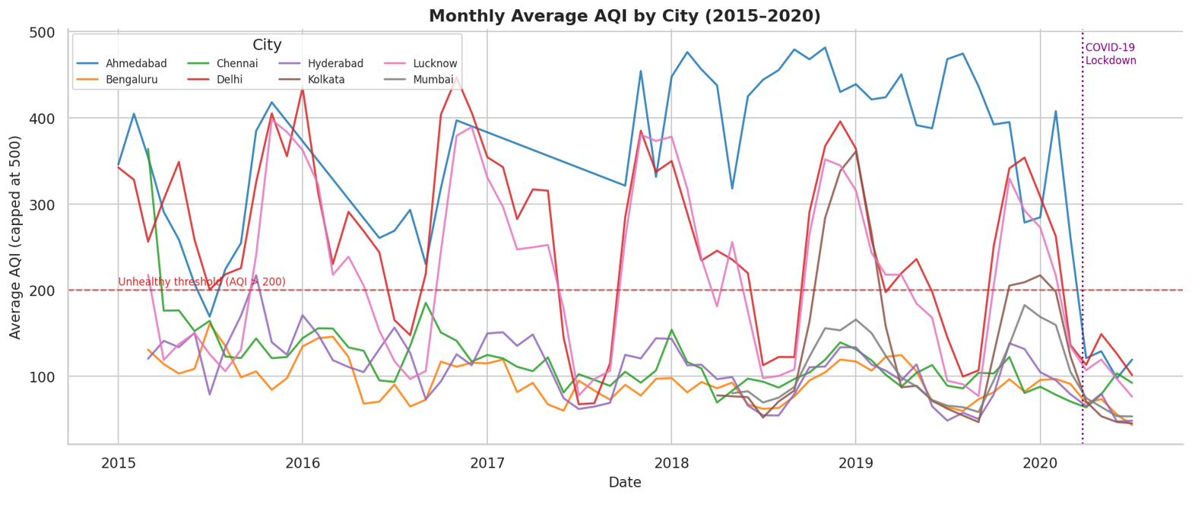
Figure 1: Monthly Average AQI by City (2015–2020)
Northern cities (Delhi, Lucknow) breach the unhealthy threshold every winter. A clear COVID-19 dip is visible in 2020. Southern cities remain consistently low.

5.2 Year-on-Year Average AQI
Delhi’s annual mean AQI fluctuated between ≈230–290 with no clear long-term downward trend. Southern cities remained stable and well below AQI 200. The 2020 figures are partial (January–July only) and are influenced by the lockdown.
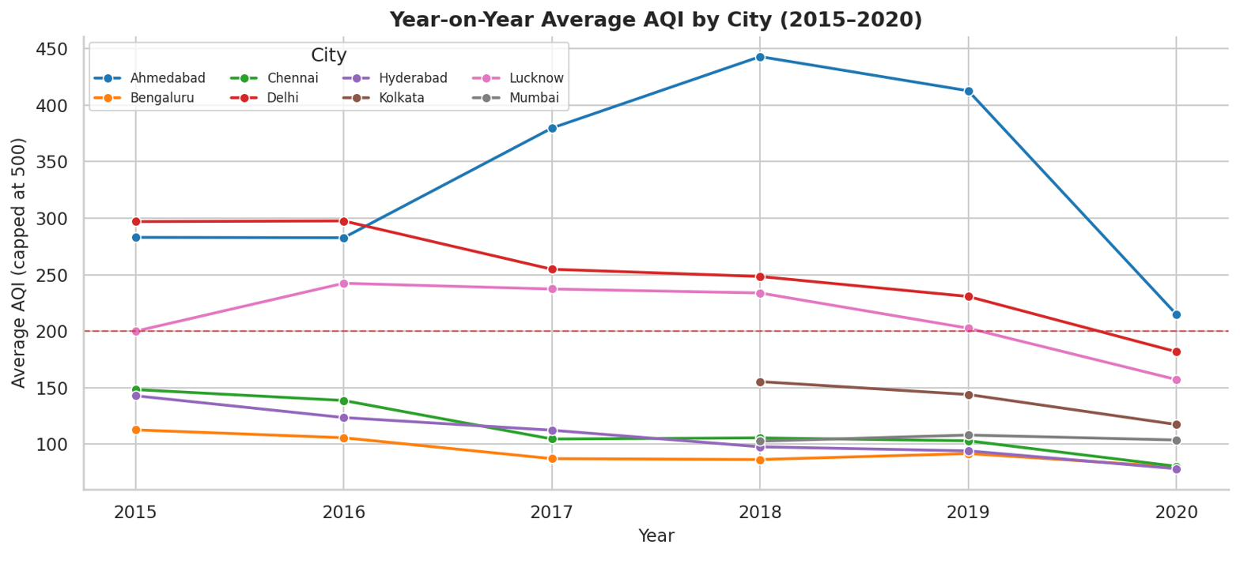
Figure 2: Year-on-Year Average AQI by City (2015–2020)
Delhi and Lucknow are the most volatile. No long-term improvement trend is visible. 2020 shows a lockdown-driven dip.

5.3 AQI Category Distribution
Distribution of all 24,850 valid city-days across CPCB categories. Moderate (35.5%) is the single most common category. The combined unhealthy categories (Poor + Very Poor + Severe) account for 26.0% of all city-days.
AQI Category | City-Days | Percentage | Cumulative Unhealthy %
Good | 1,341 | 5.4% | —
Satisfactory | 8,224 | 33.1% | —
Moderate | 8,829 | 35.5% | —
Poor | 2,781 | 11.2% | 11.2%
Very Poor | 2,337 | 9.4% | 20.6%
Severe | 1,338 | 5.4% | 26.0% total unhealthy

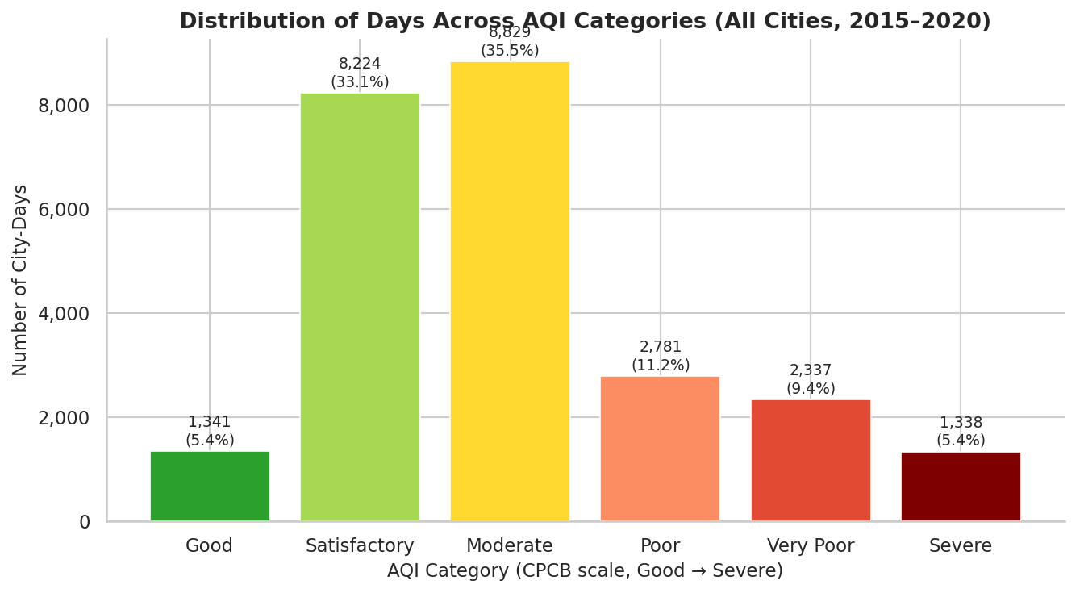
Figure 3: Distribution of Days Across AQI Categories (All Cities, 2015–2020)
Moderate and Satisfactory dominate. 26.0% of city-days are unhealthy (AQI > 200) — confirming that poor air quality is systemic, not exceptional.

5.4 Seasonal Cycle by Calendar Month
All cities follow a U-shaped seasonal curve — AQI peaks in December–January (winter) and reaches its lowest in July–August (monsoon). The seasonal swing is much larger for northern cities.
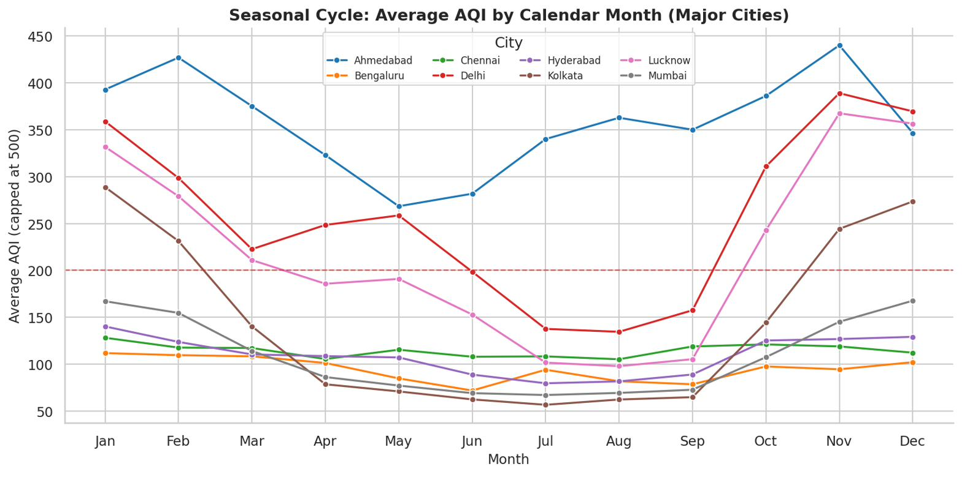
Figure 4: Seasonal Cycle: Average AQI by Calendar Month (Major Cities)
U-shaped curve consistent across all cities. Northern cities show a much steeper winter spike. The monsoon trough (Jul–Aug) is the cleanest period nationwide.

5.5 Average AQI by Meteorological Season
Season | Months | Avg. AQI | Primary Driver
Winter | Dec, Jan, Feb | ≈ 221 | Temperature inversions trap particulates near the surface
Post-Monsoon | Oct, Nov | ≈ 215 | Stubble burning in Punjab/Haryana; Diwali fireworks
Summer | Mar, Apr, May | ≈ 158 | Dry but windy; partial dispersal of pollutants
Monsoon | Jun, Jul, Aug, Sep | ≈ 116 | Rainfall washes out particulates; strong vertical mixing

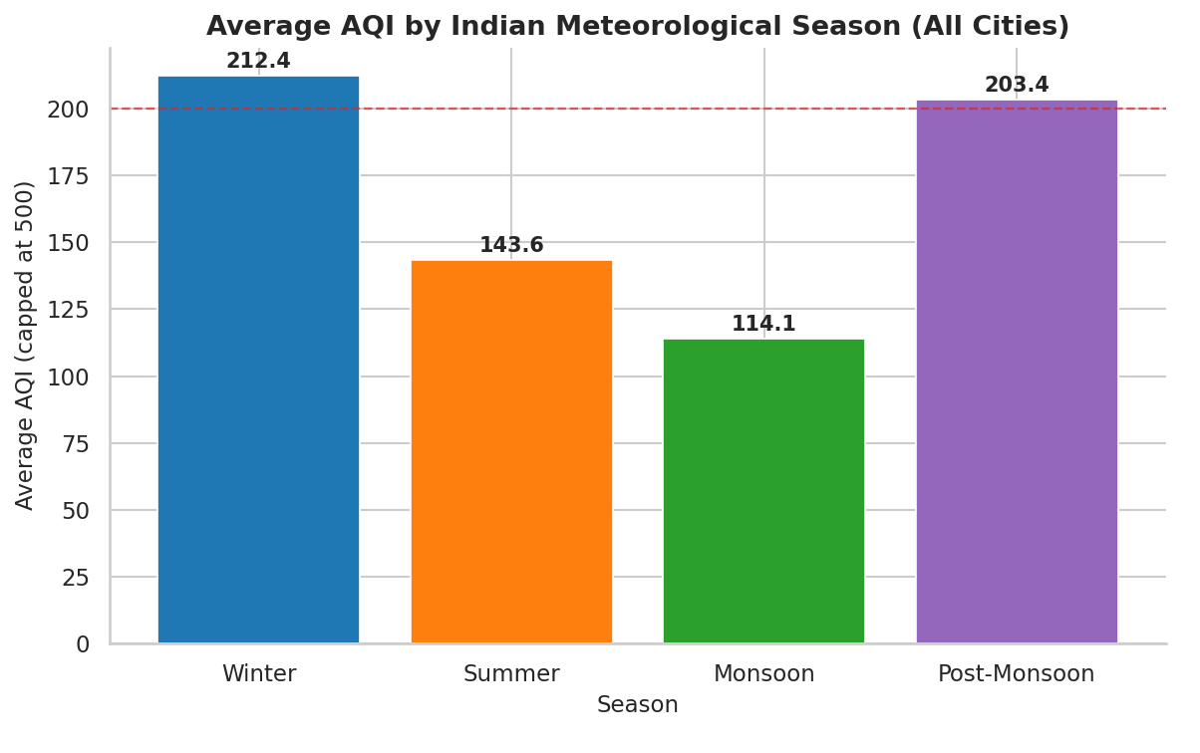
Figure 5: Average AQI by Indian Meteorological Season
Winter is the worst season (≈221 AQI), Monsoon the best (≈116). The 105-point seasonal range spans from Satisfactory to Poor categories.

5.6 Day-of-Week Pattern
All seven days fall within a 6-point AQI range (158–164) with fully overlapping ±1 standard deviation bands. This definitively confirms that seasonal weather — not weekday traffic or industrial scheduling — is the dominant driver of AQI.
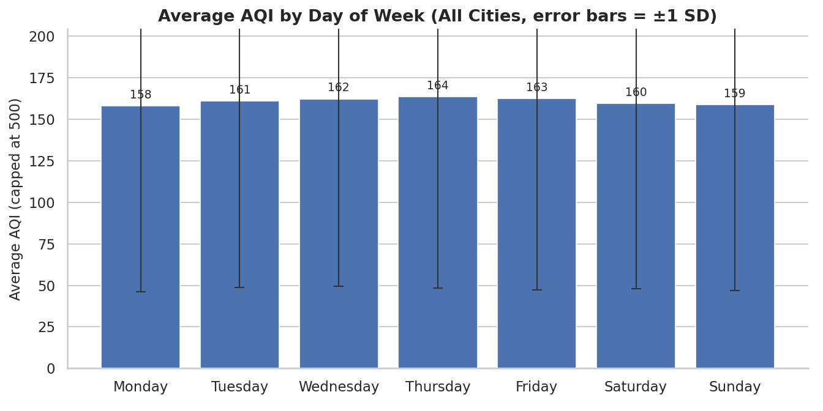
Figure 6: Average AQI by Day of Week (±1 SD error bars, all cities combined)
Negligible variation across all 7 days. Day-of-week is NOT a significant AQI driver. Seasonal meteorology dominates.

5.7 COVID-19 Lockdown Impact
Comparing January–March 2020 (pre-lockdown) to April–June 2020 (lockdown period) reveals AQI improvements in 25 of 26 cities, providing natural-experiment evidence that anthropogenic emissions are a significant and reducible pollution driver.
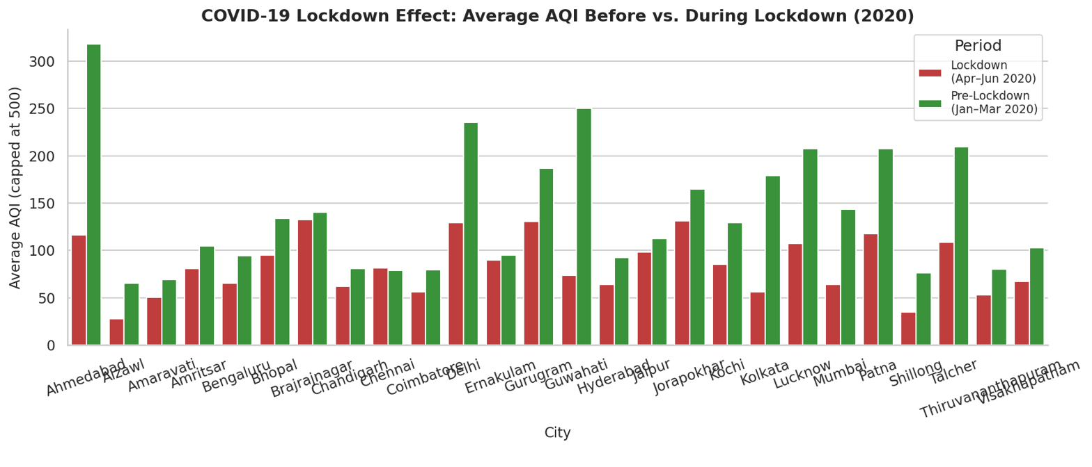
Figure 7: COVID-19 Lockdown Effect: AQI Before vs. During Lockdown (2020)
Every major city recorded lower AQI during the lockdown. Delhi dropped 45.5% (234.9 → 129.3). Mumbai dropped 55.6% (143.8 → 63.9). Kolkata dropped 68.4%.
Key Takeaway — RQ1
Air quality follows a strong seasonal cycle: Winter ≈221, Monsoon ≈116. Day-of-week effects are negligible (158–164). COVID-19 lockdown reduced AQI in 25 of 26 cities, directly quantifying the human contribution to pollution.

6. Findings — RQ2: Pollutant Relationships

6.1 Correlation Heatmap: AQI and Pollutants
Pearson correlation analysis between each pollutant and AQI reveals a clear hierarchy. PM10 (r = 0.80) is the strongest predictor. Ozone (r = 0.20) is the weakest — unlike Western countries where ozone is a primary AQI driver.
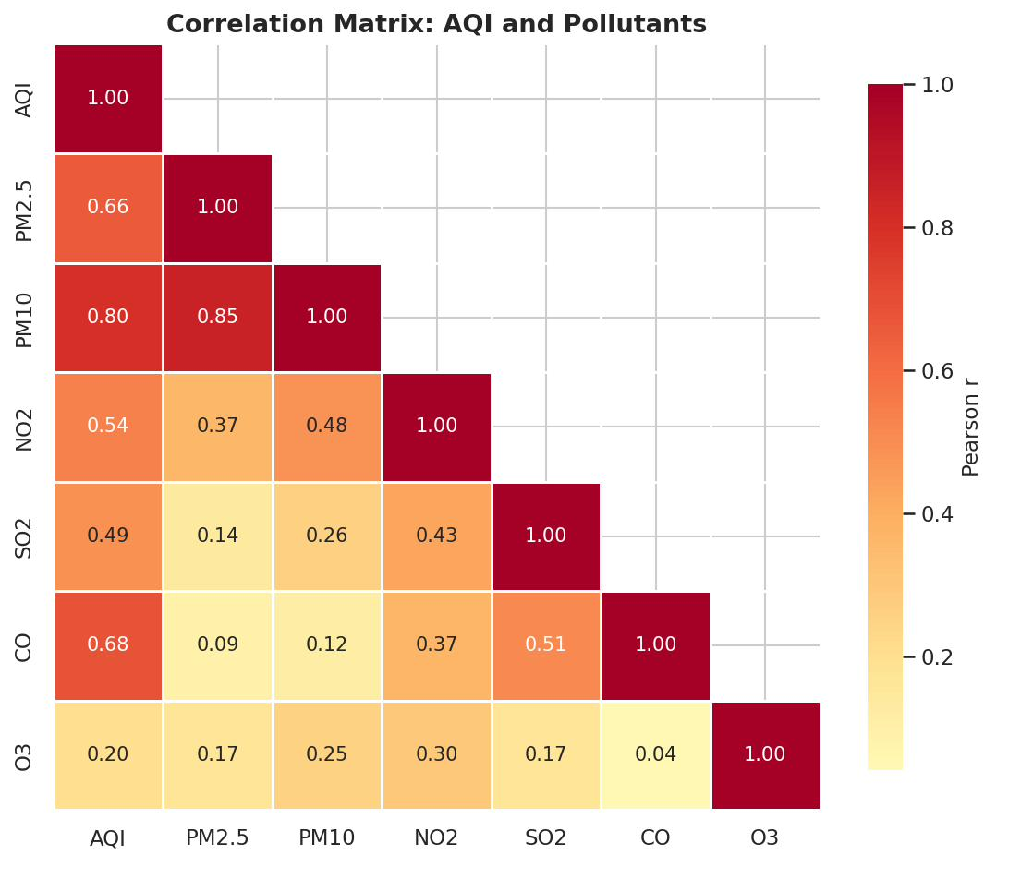
Figure 8: Correlation Matrix: AQI and Six Core Pollutants (Pearson r, lower triangle)
PM10 has the strongest correlation (r = 0.80). CO and PM2.5 follow (≈0.67–0.69). Ozone is weakly correlated (r ≈ 0.20) and is not a primary AQI driver in India.

Pollutant | Pearson r | Strength | Policy Implication
PM10 | 0.800 | Very Strong | Primary target for AQI reduction interventions
CO | 0.690 | Strong | Co-located with PM episodes; traffic-related
PM2.5 | 0.670 | Strong | Key respiratory health risk; vehicle and biomass burning
NO2 | 0.530 | Moderate | Traffic-sourced; secondary target
SO2 | 0.380 | Moderate | Industrial source; lower priority for AQI
O3 | 0.200 | Weak | NOT a primary AQI driver in India

6.2 Mean Pollutant Concentration by AQI Category
PM2.5 and PM10 concentrations rise monotonically from Good to Severe, validating that CPCB categories correspond to genuinely different real-world pollution levels. Ozone peaks at Moderate and declines in Severe, reflecting complex photochemical dynamics.
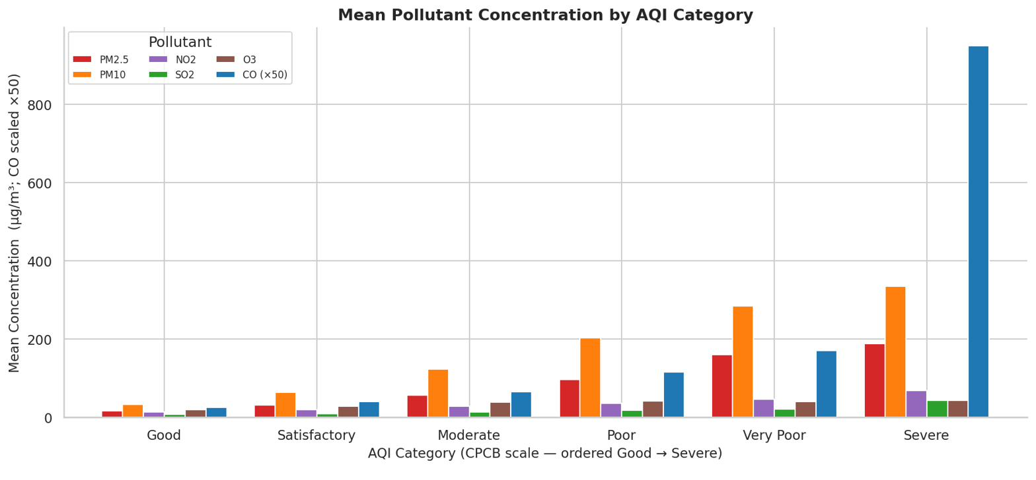
Figure 9: Mean Pollutant Concentration by AQI Category (CO scaled ×50 for visibility)
PM2.5 and PM10 rise steeply and monotonically from Good → Severe. CO shows a sharp spike at Severe. SO₂ and NO₂ rise more modestly.

6.3 PM2.5 and PM10 Distribution by AQI Category
Boxplot medians increase at every step of the CPCB scale for both PM2.5 and PM10. The widening interquartile range in higher categories indicates greater day-to-day variability during severe pollution episodes, consistent with episodic drivers such as stubble burning and dust storms.
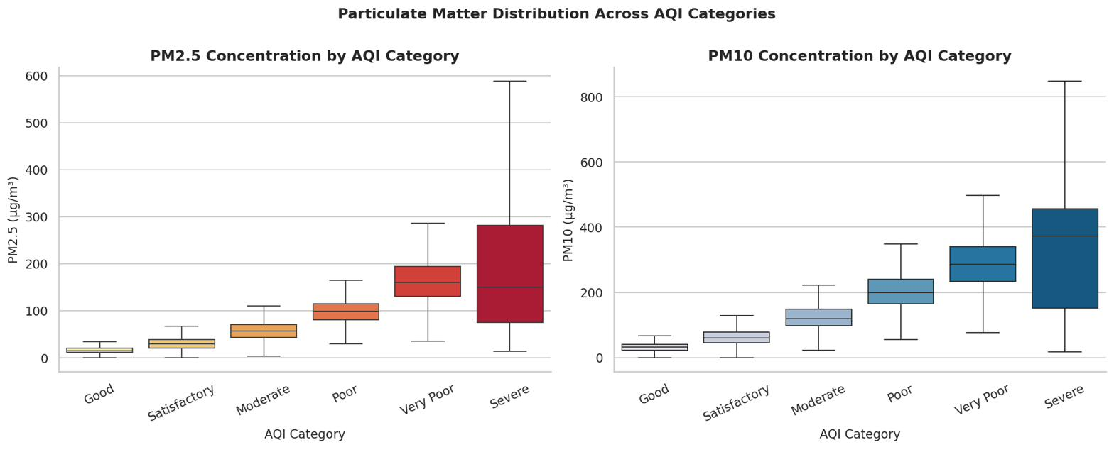
Figure 10: PM2.5 and PM10 Concentration by AQI Category (boxplots, outliers hidden)
Medians increase monotonically at every CPCB level. The widening IQR in Very Poor and Severe categories reflects episodic pollution events (stubble burning, dust storms).

6.4 AQI vs. PM10 Scatter Plot
The scatter plot of AQI against PM10 (n = 5,000 sampled points, colour = AQI category) shows a strong positive trend. Good/Satisfactory days cluster at PM10 < 100 µg/m³. Severe days consistently appear at PM10 > 200 µg/m³.
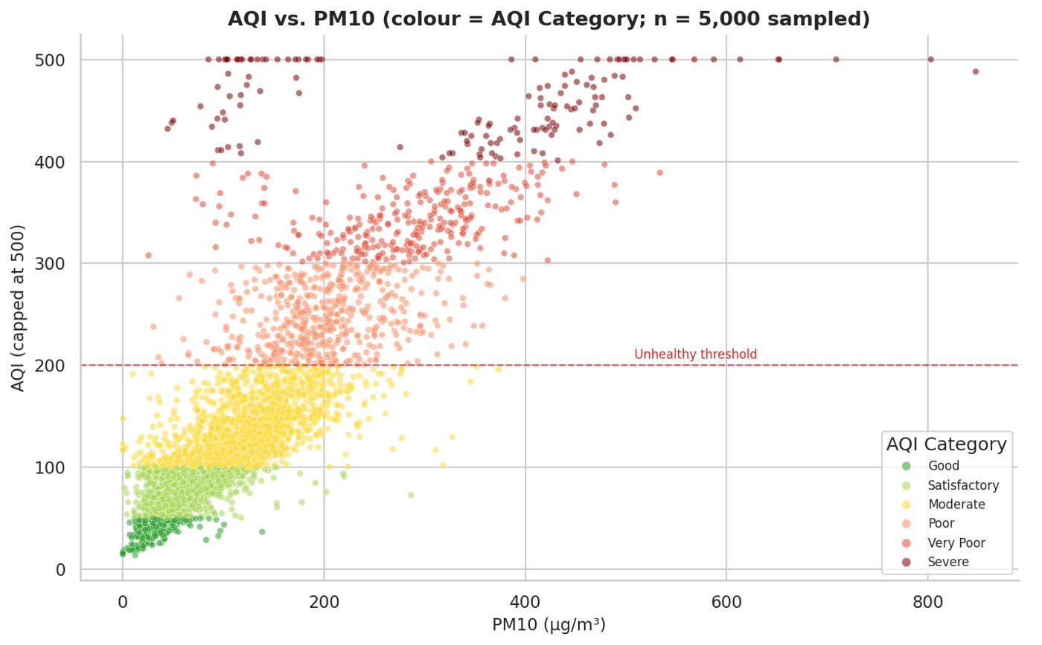
Figure 11: AQI vs. PM10 Concentration (colour = AQI Category; n = 5,000 sampled)
Strong positive trend confirms PM10 as the primary AQI predictor. Good days cluster at PM10 < 100 µg/m³; Severe days at PM10 > 200 µg/m³.
Key Takeaway — RQ2
Particulate matter (PM10 r=0.80, PM2.5 r=0.67) and CO (r=0.69) dominate Indian AQI. Ozone (r≈0.20) is NOT a primary driver. Policy should prioritise particulate emission sources: vehicle exhaust, industrial emissions, stubble burning, and construction dust.

7. Findings — RQ3: Unhealthy Air Quality Exposure

7.1 Overall Exposure Rate
Across all 24,850 valid city-days, 6,456 (26.0%) fall in the unhealthy categories (AQI > 200). Roughly one in four days across Indian cities carries a genuine health risk. This is a persistent baseline condition, not a rare extreme.

7.2 City Ranking by % Unhealthy Days
Ranking all 26 cities by percentage of unhealthy days (AQI > 200) reveals a sharp geographic divide between northern and southern India.
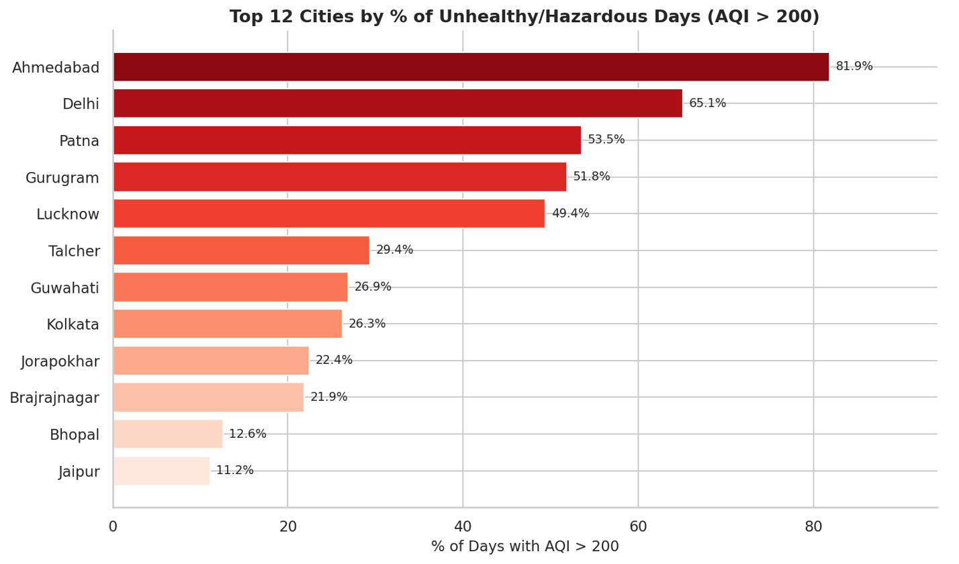
Figure 12: Top 12 Cities by % of Unhealthy/Hazardous Days (AQI > 200)
Ahmedabad and Delhi dominate. Note: Ahmedabad’s 81.9% is partially inflated by sensor data anomalies (raw max AQI = 2,049). Delhi’s 65.1% is a verified public health signal.

City | Total Days | Mean AQI | Median AQI | Max AQI (raw) | Unhealthy Days | Unhealthy %
Ahmedabad * | 1,334 | 356.0 | 384.5 | 2,049 | 1,092 | 81.9%
Delhi | 1,999 | 258.1 | 257.0 | 716 | 1,301 | 65.1%
Lucknow | 1,893 | 217.5 | 198.0 | 707 | 935 | 49.4%
Kolkata | 754 | 140.6 | 94.0 | 475 | 198 | 26.3%
Chennai | 1,884 | 114.5 | 100.0 | 449 | 127 | 6.7%
Mumbai | 775 | 105.4 | 91.0 | 307 | 36 | 4.6%
Hyderabad | 1,880 | 109.0 | 104.0 | 737 | 71 | 3.8%
Bengaluru | 1,910 | 94.3 | 86.0 | 352 | 41 | 2.1%
* Ahmedabad: Raw AQI up to 2,049 indicates sensor malfunctions. Capped mean AQI = 356.0.

7.3 AQI Category Mix per Major City
The stacked bar chart makes the north–south divide visually unambiguous. Bengaluru and Mumbai are dominated by green (Good/Satisfactory) bars. Delhi and Lucknow have large red/dark-red (Very Poor/Severe) segments.
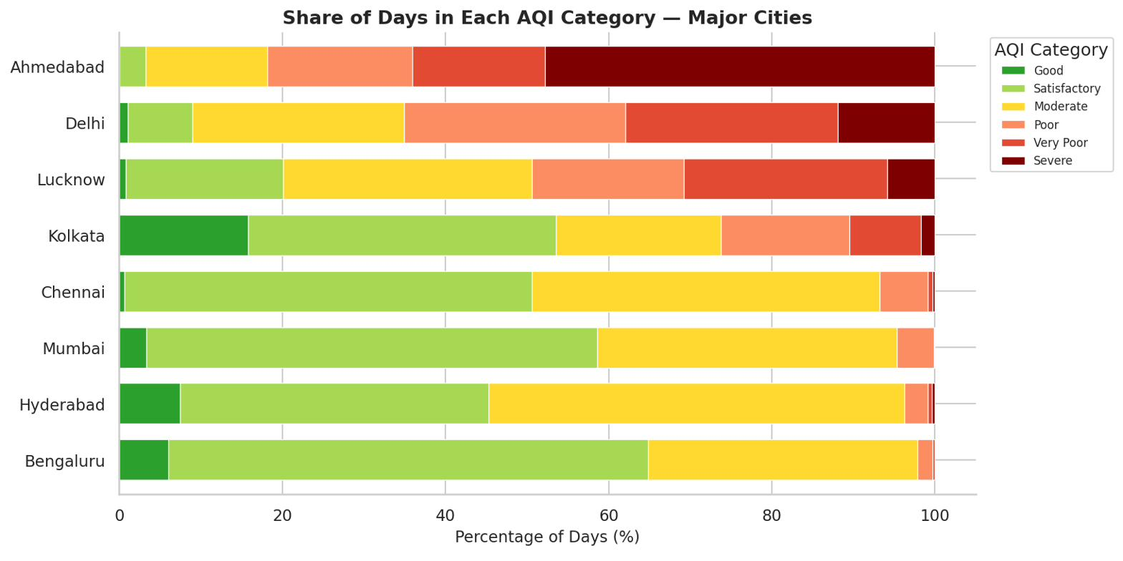
Figure 13: Share of Days in Each AQI Category — Major Cities (stacked, sorted by unhealthy %)
Bengaluru and Mumbai are predominantly green (clean). Delhi and Lucknow have dominant red segments. The chart visually confirms the north–south pollution divide.

7.4 City × Month Heatmap: % Unhealthy Days
The heatmap localises the worst exposure precisely. Northern cities (Delhi, Lucknow) carry near-100% unhealthy day rates in October–January. Southern cities show near-zero unhealthy days year-round.
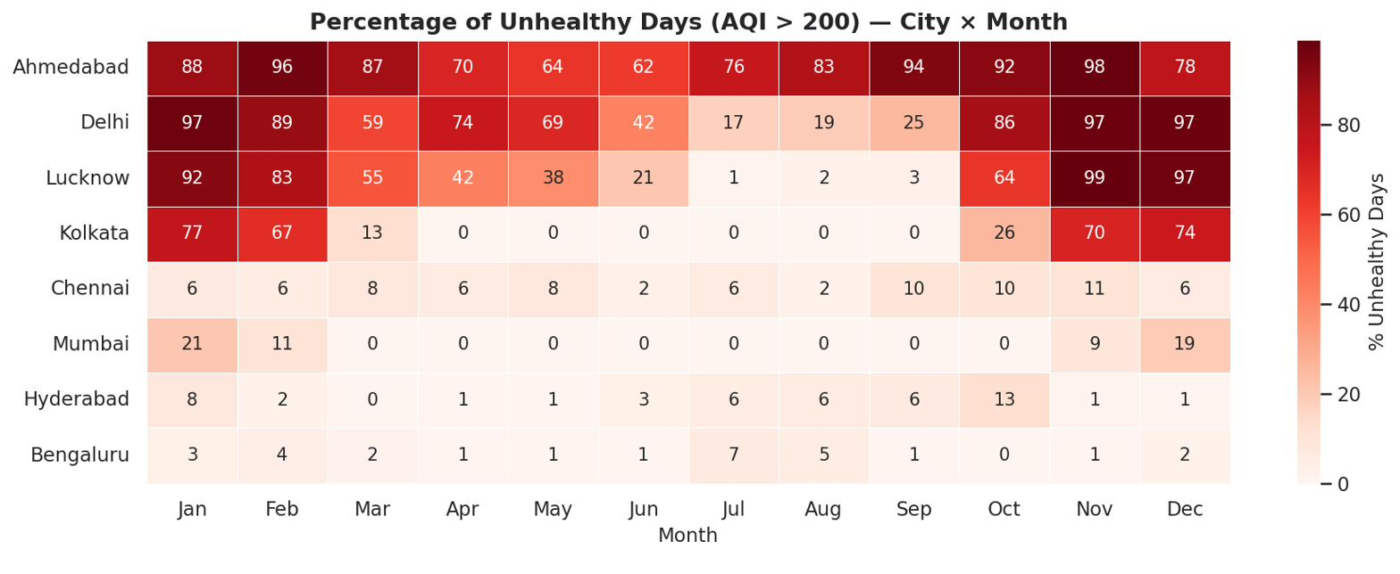
Figure 14: Percentage of Unhealthy Days (AQI > 200) — City × Month Heatmap
Worst exposure: northern cities (Delhi, Lucknow) in October–January. Driven by stubble burning, cold temperature inversions, and Diwali fireworks. Southern cities near-zero year-round.
Key Takeaway — RQ3
26.0% of city-days are unhealthy (AQI > 200) — poor air quality is systemic. Delhi (65.1%) is the worst-affected major city with verified data. The worst exposure window is northern India in October–January. Southern cities (Bengaluru 2.1%, Hyderabad 3.8%) are largely unaffected year-round.

8. Discussion

8.1 North–South Divide
The Indo-Gangetic Plain’s flat terrain and cold winter temperature inversions trap pollutants near the surface for months. Agricultural stubble burning in Punjab and Haryana (October–November) adds a massive seasonal particulate pulse. Southern cities benefit from sea breezes, higher temperatures promoting vertical mixing, and lower industrial and vehicular density.

8.2 Particulate Matter as the Priority Pollutant
The dominance of PM10 (r = 0.80) and PM2.5 (r = 0.67) has direct policy implications. Interventions targeting particulate emission sources will have the greatest leverage on AQI: tighter vehicle exhaust standards, industrial emission controls, enforced stubble burning bans, construction dust suppression, and transition to cleaner cooking fuels.

8.3 COVID-19 as a Natural Experiment
The lockdown-period AQI drops — Mumbai −55.6%, Kolkata −68.4%, Delhi −45.5%, Guwahati −70.4% — suggest that targeted short-term interventions (odd-even vehicle schemes, industrial shutdown days during inversion episodes) can produce rapid, measurable air quality improvements.

8.4 Limitations
- Dataset ends July 2020; post-lockdown recovery and long-term post-2020 trends cannot be assessed.
- Ahmedabad data quality issues (raw max AQI = 2,049) must be interpreted with caution.
- Analysis is at city level; within-city neighbourhood variation is not accessible with this dataset.
- Correlation identifies association, not causation. Meteorological confounders (wind, humidity, temperature) are not controlled.
- Unequal city record counts (Kolkata: 754 vs Delhi: 1,999 days) create unequal statistical power.

9. Conclusion
This project delivered a comprehensive, reproducible data analytics study of air quality in India using 24,850 valid daily observations across 26 cities from 2015 to 2020, producing 14 publication-quality visualisations and 7 summary tables.

- Air quality is governed primarily by seasonal meteorology. Winter temperature inversions and post-monsoon stubble burning produce the worst episodes (≈221, ≈215 AQI). The monsoon provides natural cleansing (≈116 AQI). Day-of-week patterns are negligible.
- Particulate matter is the priority pollutant. PM10 (r=0.80), PM2.5 (r=0.67), and CO (r=0.69) dominate AQI. Ozone (r=0.20) is not a primary driver in India. Policy should prioritise particulate emission sources.
- 26% of city-days are unhealthy; the problem is geographic and seasonal. Delhi (65.1%) and Lucknow (49.4%) dominate exposure in October–January. Southern cities (Bengaluru 2.1%, Hyderabad 3.8%) are largely unaffected. COVID-19 lockdown confirmed that anthropogenic emissions are significant and reducible.
Future work could incorporate meteorological covariates as statistical controls, apply time-series forecasting to predict city-level AQI, and use the station-level dataset (230 stations across 26 cities) for within-city neighbourhood-level analysis.

10. Team Contributions
Team Member | Role | Primary Responsibilities
Yash David Bedekar | Project Lead & Data Engineer | Overall coordination; Kaggle notebook (kaggle.com/code/yashbedekar07/air-quality-index-aqi-analysis); data ingestion pipeline; full cleaning pipeline (missing value profiling, column selection, AQI row removal, outlier capping, AQI_capped); feature engineering (Year, Month, Season, DayOfWeek, Unhealthy); GitHub repository management
Surya Koushik Palla | Data Analyst & Visualisation Lead | All 14 publication-quality charts (Figs. 1–14); RQ1 temporal analysis; chart theme and CAT_COLORS palette; interpretation print statements; ZIP export cell (21 files, 1.62 MB)
Aryaman Negi | Statistical Analyst | RQ2 pollutant analysis — Pearson correlation (PM10 r=0.80), by-category charts, PM boxplots, PM10 scatter; outlier detection and AQI_capped methodology; descriptive stats Tables 2 and 3 (all 26 cities)
Arda Onhun | Insights & Reporting Lead | RQ3 city exposure analysis; COVID-19 lockdown comparison; key findings narrative; this project report; README

11. References
- Central Pollution Control Board (CPCB). National Air Quality Index. Government of India. https://cpcb.nic.in
- Rao, R. (2020). Air Quality Data in India (2015–2020) [Dataset]. Kaggle. kaggle.com/datasets/rohanrao/air-quality-data-in-india
- Bedekar, Y. D. et al. (2026). Air Quality Index (AQI) Analysis — India (2015–2020) [Kaggle Notebook]. kaggle.com/code/yashbedekar07/air-quality-index-aqi-analysis
- McKinney, W. (2010). Data Structures for Statistical Computing in Python. Proceedings of the 9th Python in Science Conference.
- Hunter, J. D. (2007). Matplotlib: A 2D Graphics Environment. Computing in Science & Engineering, 9(3), 90–95.
- Waskom, M. (2021). Seaborn: Statistical Data Visualization. Journal of Open Source Software, 6(60), 3021.
- WHO (2021). WHO Global Air Quality Guidelines: Particulate matter, ozone, nitrogen dioxide, sulfur dioxide and carbon monoxide. World Health Organization.

