**LAB ASSIGNMENT -01**

Q1 An array is a bitonic array if all integers from index 0 to index i are sorted in

ascending order, and all subsequent integers from index i+1 to n-1 are sorted in

descending order. Given a bitonic array of n distinct integers, write a C/C++ program to

find the maximum integer in the array in O(log(n)) time.

Example:

Input: n = 6 , A[] ={1 2 4 8 7 6}Output: 8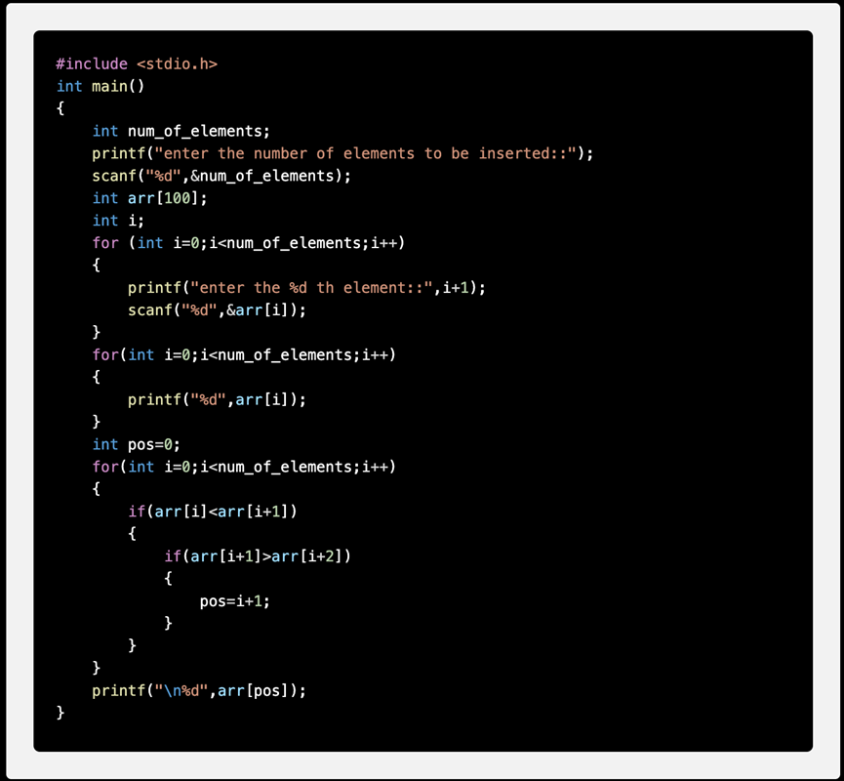

**O/P:**

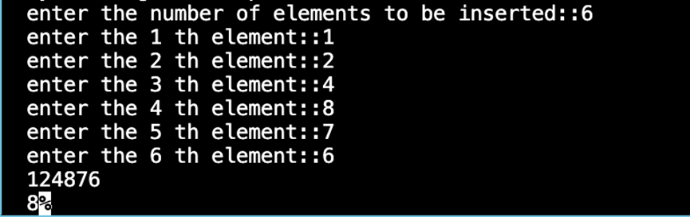

Q2 Let A[n] be an array of n distinct integers. If i < j and A[i] > A[j], then the pair is called an inversion of A. Write a C/C++ program that determines the number of

inversions in any permutation on n elements.

Example: A = {4, 1, 3, 2} output is 4

**O/P:**

#include <stdio.h>

int main(){

int n; //number of elements in the list

int inversion_occurence = 0;//initially inversion_occurence is zero

printf("Enter the number of numbers you want to enter: ");

scanf("%d", &n);//input from the user for n

int array_1[n];//

for (int i = 0; i < n; i++) {

printf("Enter a number: ");

scanf("%d", &array_1[i]); //enter the numbers for the array

}

for (int i = 0; i < n; i++){

for (int j = i+1;j<n;j++){

if (array_1[i]>array_1[j]){ // it just checks if the element i is bigger than element j as the loop ensures the number i is bigger than number j

inversion_occurence+=1;

}

}

}

printf("Inversion occurence: %d",inversion_occurence);

}

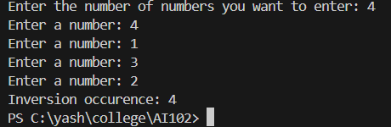

Q3 Write a C program to manage the details of students using an array of structures.

The program should:

1. Accept the number of students (n) from the user.

2. For each student, input the following details:

• Roll number (integer)

• Name (string)

• Marks (floating-point value)

3. Store the details of all students in an array of structures.

4. Display the details of all students in a formatted way.

#include <stdio.h>

#include <string.h>

struct records {

int roll;

char name[100];

float marks;

};

int main() {

int n;

printf("Enter the number of student records you want to enter: ");

scanf("%d", &n);

getchar();

struct records students[n];

for (int i = 0; i < n; i++) {

printf("Enter the record of the student %d\n", i + 1);

printf("Enter the name: ");

fgets(students[i].name, sizeof(students[i].name), stdin);

students[i].name[strcspn(students[i].name, "\n")] = '\0';

printf("Enter the roll number: ");

scanf("%d", &students[i].roll);

getchar();

printf("Enter the marks: ");

scanf("%f", &students[i].marks);

getchar();

printf("\n");

}

printf("These are the student records:\n");

for (int i = 0; i < n; i++) {

printf("Name of the student: %s\n", students[i].name);

printf("Roll number of the student: %d\n", students[i].roll);

printf("Marks of the student: %.2f\n\n", students[i].marks);

}

return 0;

}

