**ASSIGNMENT-02**

**Q1** Write a C program to multiply two matrices using dynamic memory allocation. Each two dimensional array should be processed as an array of pointers to a set of 1 dimensional integer arrays. Read, access and display the matrix elements using pointers instead of subscript notation. Use three functions i) To read input matrix ii) To compute the product and iii) To display the resultant matrix

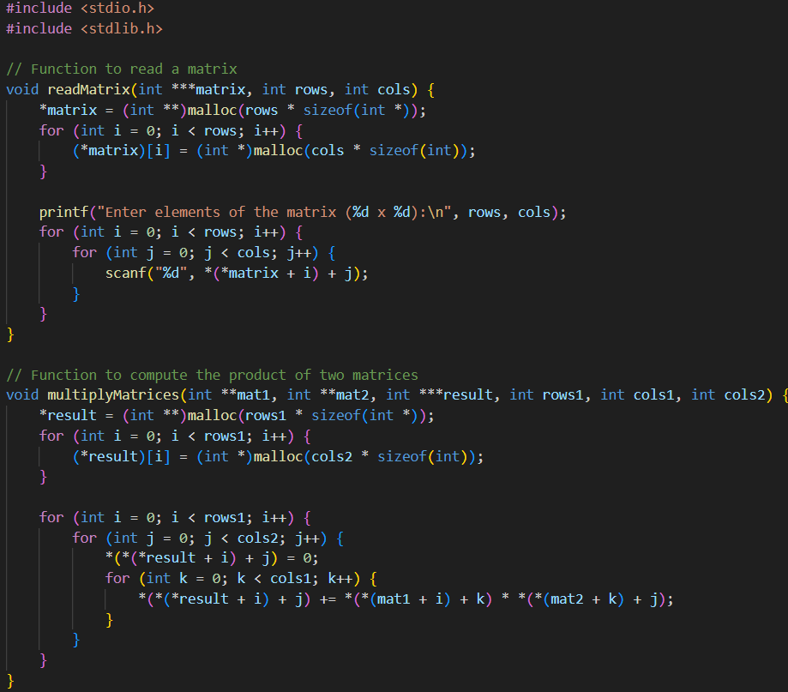

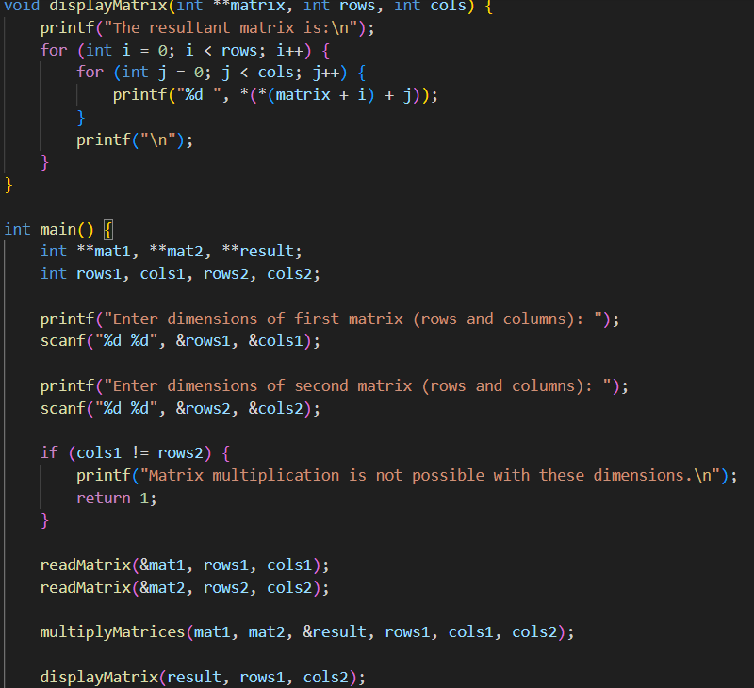

**OUTPUT:**

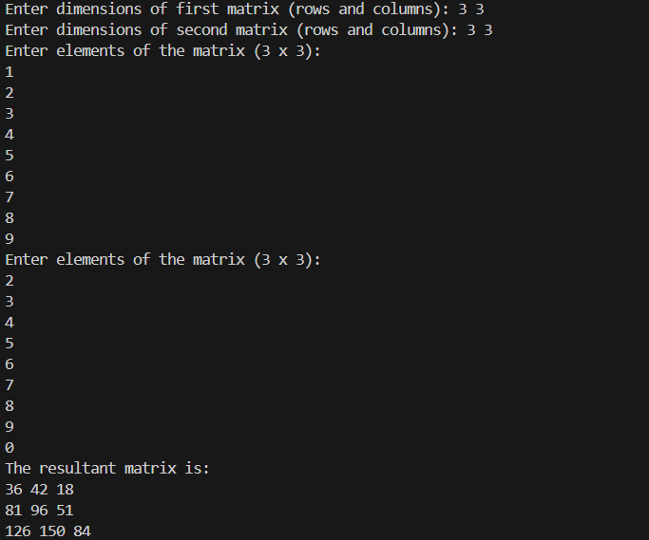

Q2 Write a C program to hold two integer pointers as structure members. Allocate space for the structure and its data members during runtime. Get one array as input. In the second array copy the elements of the first array and replace the odd positioned elements by the product of its adjacent elements. Access the array elements and structures using pointers instead of subscript notation.

**CODE**:

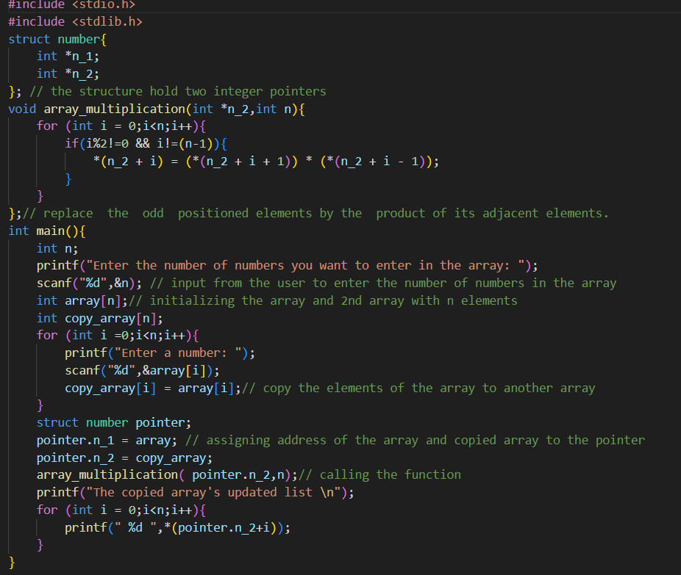

**OUTPUT**:

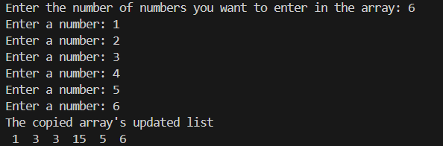

Q3 Create a Structure called BankMgmt with AccNumber, CustName,AvlBalance, AccType as members. Implement a Bank management Application as menu driven program for the above said Structure scenario.

Menu Option:

1.Withdrawal

2. Deposit

3. Display Balance

4. Exit If option 1 is chosen Amount can be withdrawn from the account (Withdrawn amount should be given as input). For withdrawal the condition is the AvlBalance must be greater than withdrawn amount).2 is chosen Amount can be deposited to the account (the deposited amount should be given as input). The deposited amount should be reflected in AvlBalance of the account. 3 is chosen Current available balance (AvlBalance) of the AccNumber should be Displayed with other details 4 is chosen Exit from the application

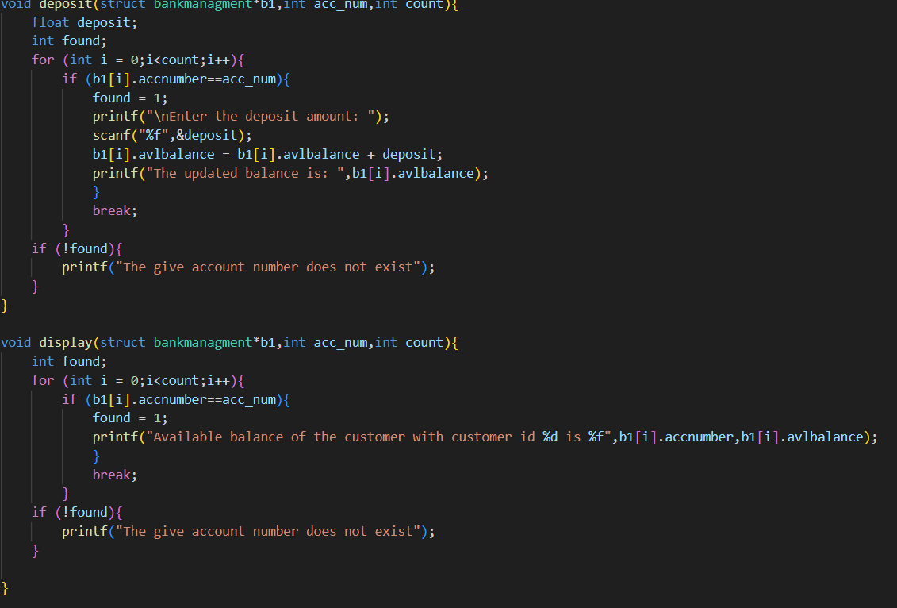

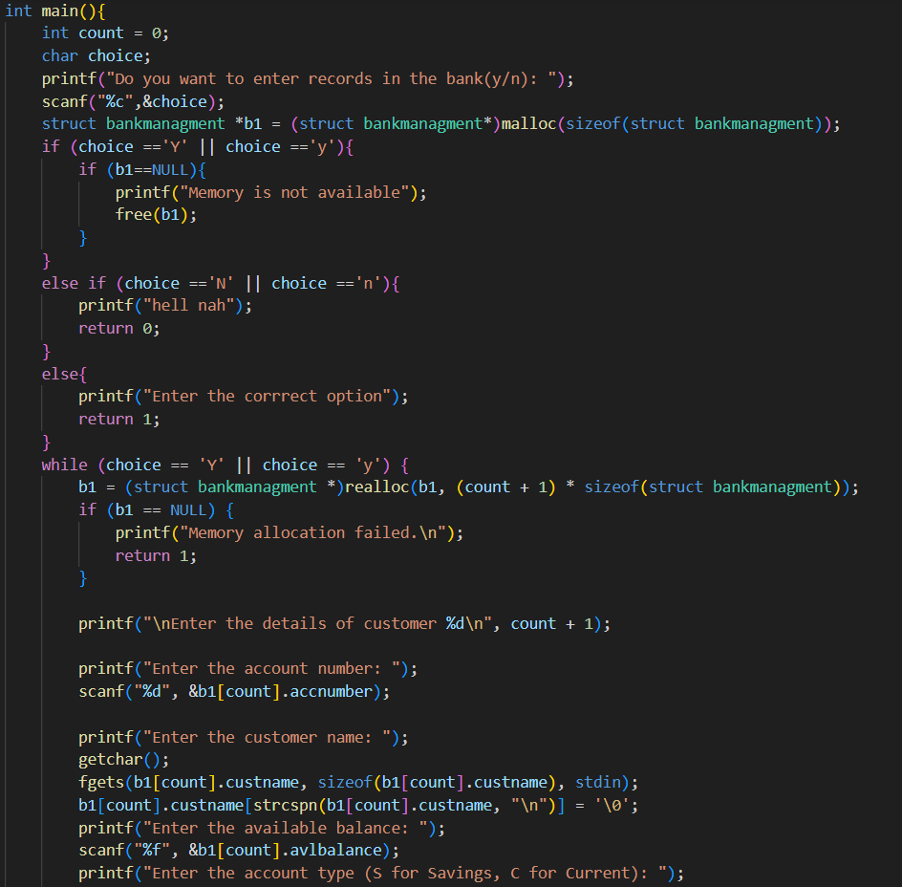

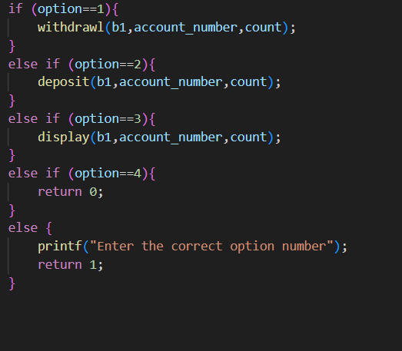

**OUTPUT:**

