**ASSIGNMENT-03**

**Q1** Write a program in C to create and display a single linked list.

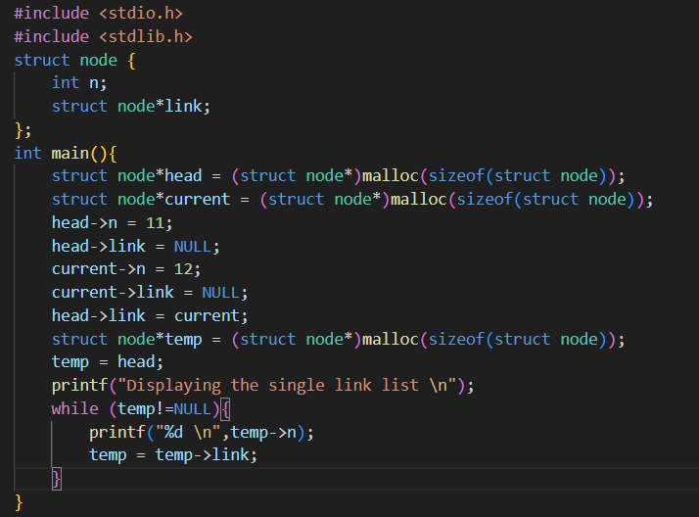

**OUTPUT**:



**Q2** Write a C program to insert a new node at the beginning of a singly linked list.

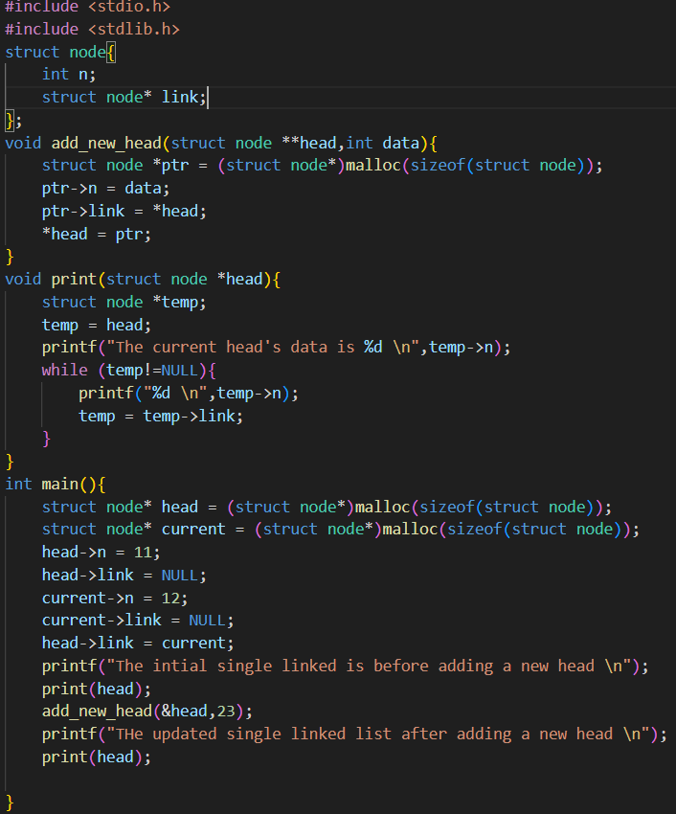

**OUTPUT**:

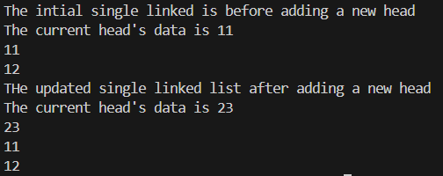

**Q3** Write a program in C to traverse in a single linked list.

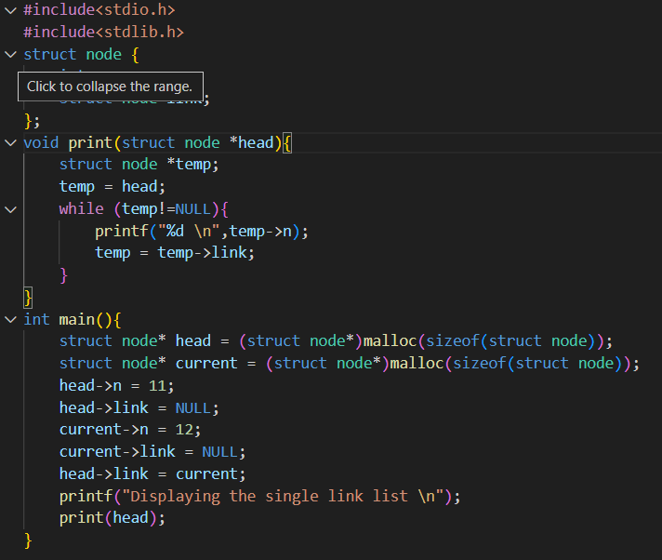

**OUTPUT:**

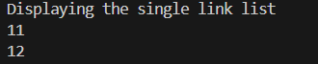

**Q4** Write a program in C to copy the elements of the array to a singly linked list.

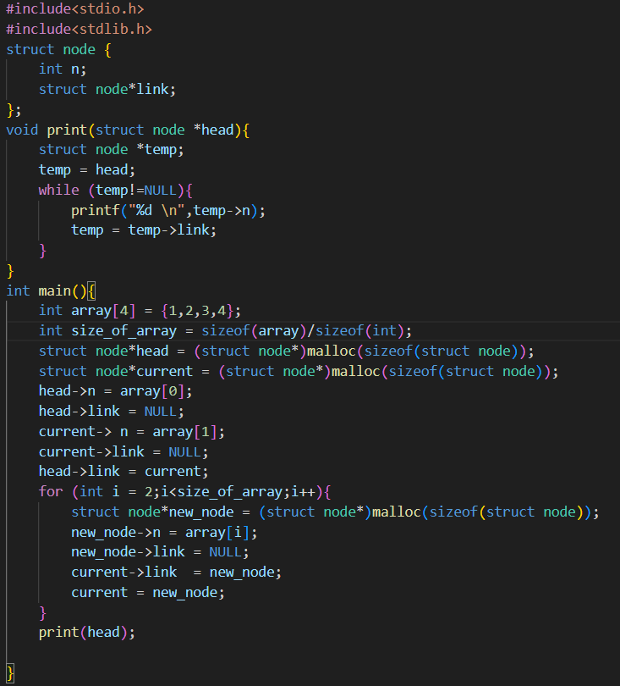

**OUTPUT**:



**Q5** Write a C program that converts a single linked list into an array and returns it.

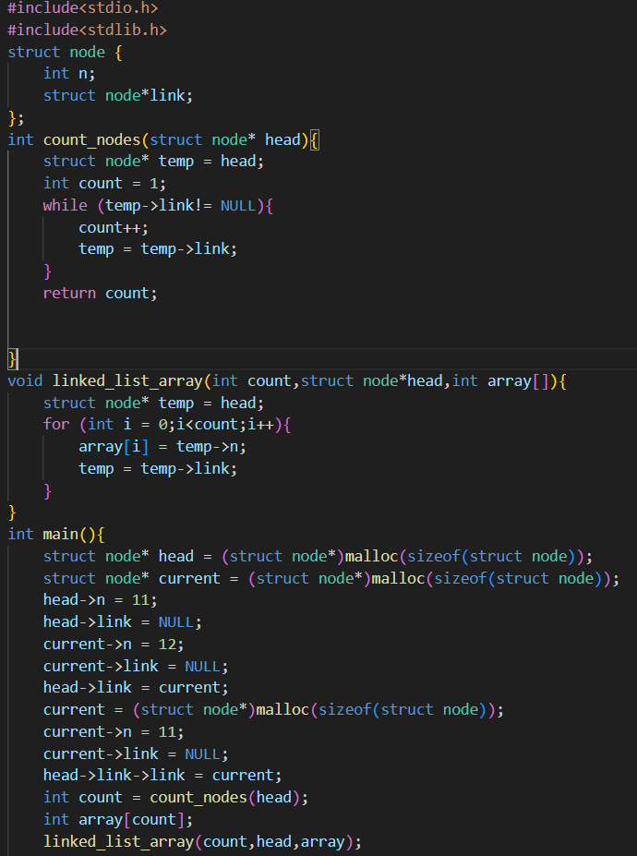

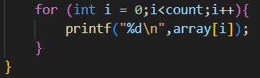

**OUTPUT:**

