{
"full_name": "Test User",
"username": "testuser123",
"email": "test123@gmail.com",
"password": "123456"
}
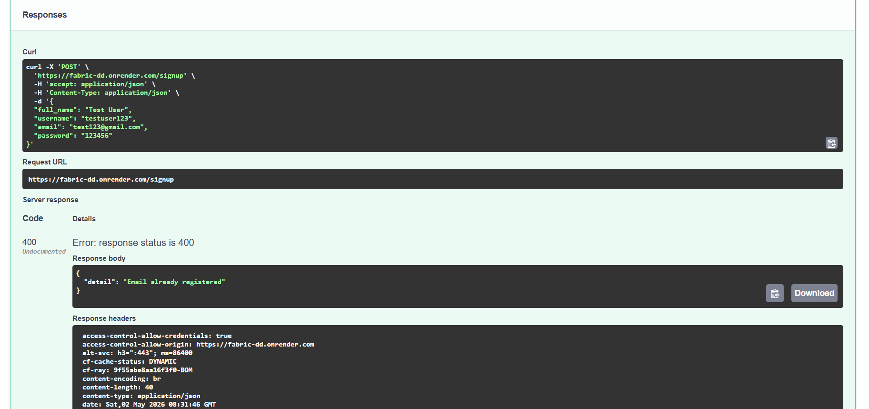
test123@gmail.com
123456
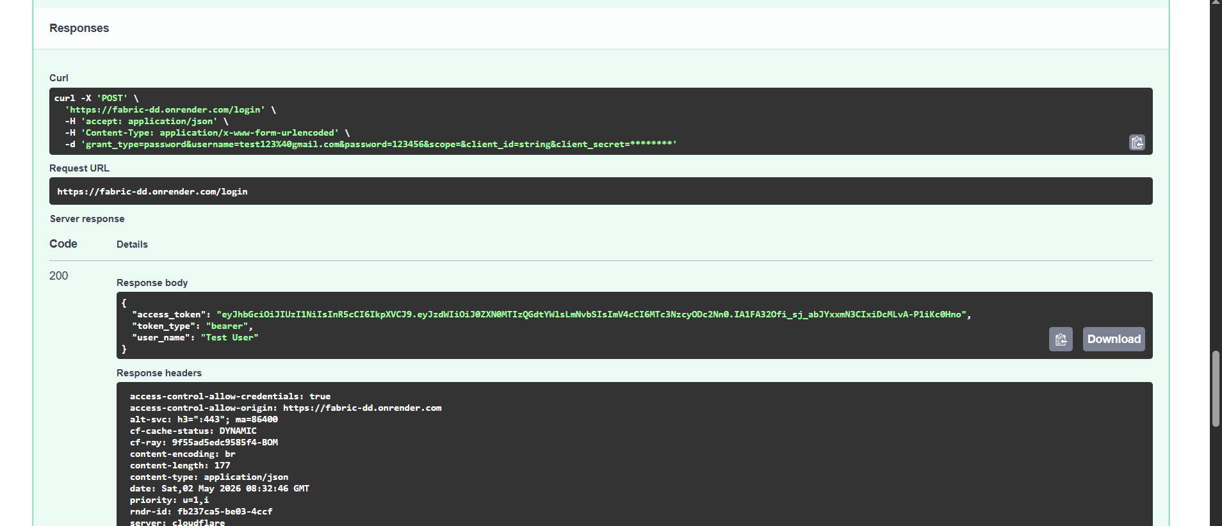
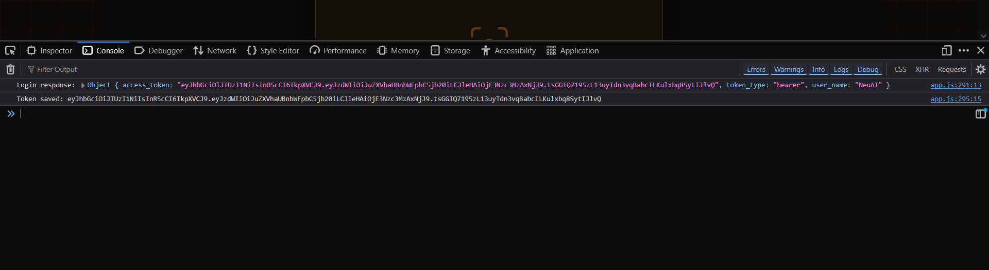
Then login over here with the email id
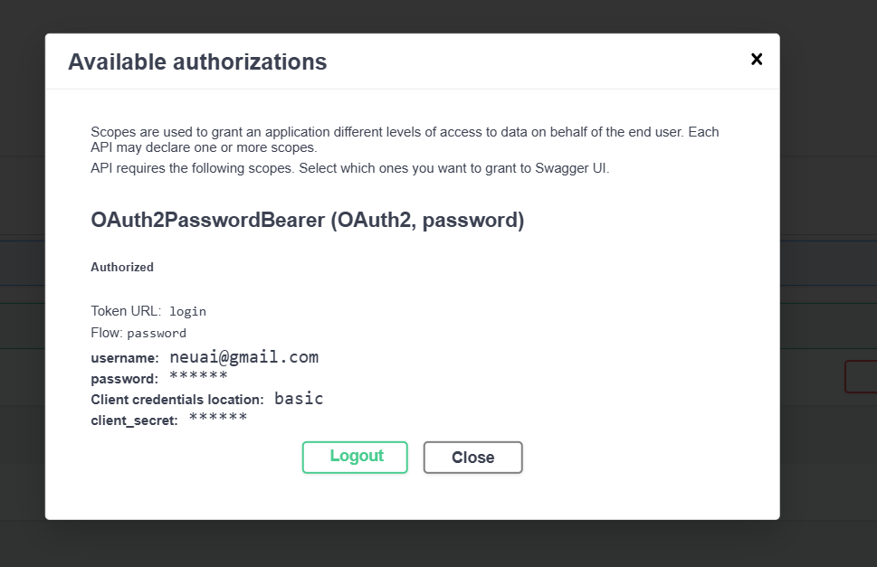
🔴 ERROR
502 Bad Gateway
👉 This means:
❌ Your backend crashed while processing /predict
NOT a frontend issue
NOT auth issue
👉 It’s a model/backend runtime issue

🧠 Why 502 is happening
Most common causes in your case:
1️⃣ Model loading / memory issue (VERY LIKELY)
- You’re using YOLO (Ultralytics + PyTorch)
- Render free tier = 512MB RAM
- Model loading → 💥 crash

2️⃣ File path issue
- best.pt not found
- Wrong path in Render

3️⃣ Code error inside /predict
- Image processing crash
- Pandas / Excel read issue
- 🔴 CURRENT ERROR
- 401 Unauthorized
"Could not validate credentials"
- 👉 This means:
- ❌ Your token is being rejected by backend

New email.id
