Customer Segmentation & RFM Analysis
Author: Yash Bhosale | Dataset: Online Retail II | Tool: Python
Date: 2024 | Total Revenue Analysed: GBP 17,743,429 | Customers: 5,878
Table of Contents
Update field to see table of contents
1. Executive Summary
This project performs a comprehensive Customer Segmentation and RFM (Recency, Frequency, Monetary) Analysis on the Online Retail II dataset from the UCI Machine Learning Repository. The dataset covers 1,067,371 transactions by customers across 43 countries from December 2009 to December 2011.
Business Problem: Which customer segments give the highest ROI on retention, and how should marketing allocate budgets?
After cleaning the data, computing RFM metrics, scoring customers on a 1-5 scale, and applying rule-based segmentation, we identified 7 segments. Champions (22% of customers) generate 68.2% of total revenue. At-Risk customers represent a high-value rescue opportunity. This report provides segment-level insights and an actionable budget allocation framework for the marketing team.
2. Dataset Overview
Source: Online Retail II — UCI Machine Learning Repository (https://archive.ics.uci.edu/dataset/502/online+retail+ii)
Field | Details
Raw Rows | 1,067,371
Clean Rows (after filtering) | 805,549
Unique Customers | 5,878
Unique Invoices | 36,969
Date Range | 01 Dec 2009 to 09 Dec 2011
Total Revenue | GBP 17,743,429.18
Countries | 43
Columns | Invoice, StockCode, Description, Quantity, InvoiceDate, Price, Customer ID, Country

3. Data Cleaning Steps
The following cleaning operations were applied before analysis:
- 1. Parsed InvoiceDate column to datetime format.
- 2. Removed 243,007 rows with missing Customer ID (cannot be attributed to any customer).
- 3. Removed cancellation invoices (Invoice codes starting with 'C') — 18,788 rows.
- 4. Removed rows with Quantity <= 0 or Price <= 0 (returns and data errors).
- 5. Engineered a Revenue column: Revenue = Quantity x Price.
4. Exploratory Data Analysis
4.1 Monthly Revenue Trend
Revenue grew steadily from late 2009 through mid-2011, with a sharp peak in November 2011 (pre-Christmas surge) before dropping in December 2011 (the dataset ends on 9 Dec 2011). This seasonality is a key planning input for the marketing calendar.
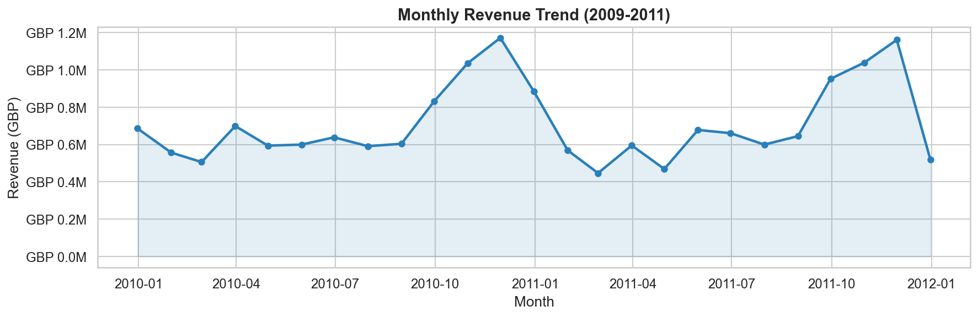
4.2 Top 10 Countries by Revenue
The United Kingdom dominates at over 85% of total revenue, followed by Netherlands, EIRE (Ireland), Germany, and France. International markets represent a growth opportunity with lower saturation.
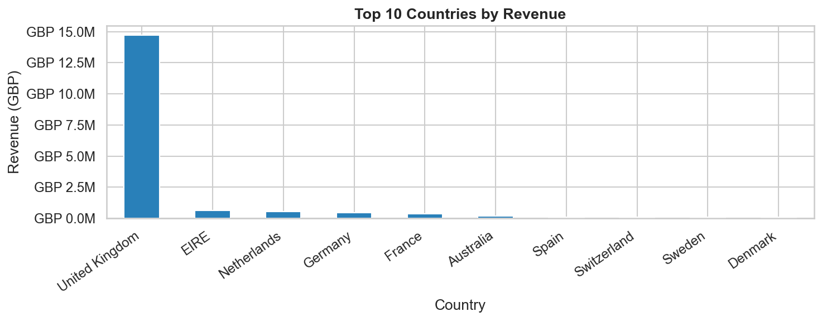

4.3 Top 10 Products by Revenue
The best-selling products by revenue are mostly home decor and gifting items. Dotcom Postage is the highest single revenue item, followed by various decorative sets and bags. These products should be featured prominently in retention campaigns targeting Champions and Loyal customers.
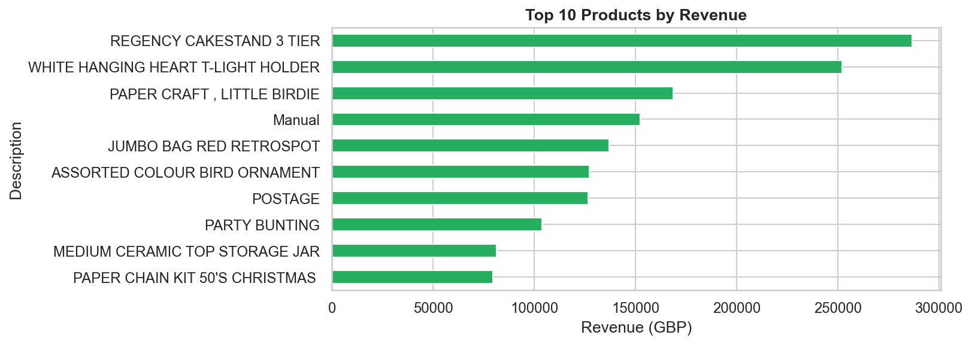

4.4 Revenue by Day of Week
Revenue is highest on Tuesday, Wednesday, and Thursday. Weekends (Saturday, Sunday) show dramatically lower activity, suggesting the store primarily serves B2B / wholesale buyers who operate on weekday schedules. Marketing campaigns should be dispatched mid-week for maximum open rates.
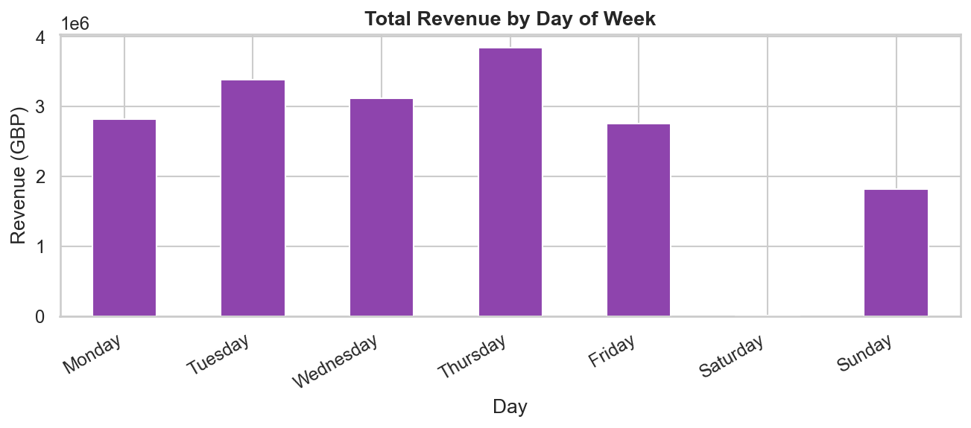

4.5 Orders per Month
Order volumes follow a similar seasonal pattern to revenue, with a consistent ramp-up in Q4 (October-November). This validates the revenue trend and confirms it is driven by both more orders and larger basket sizes during peak periods.
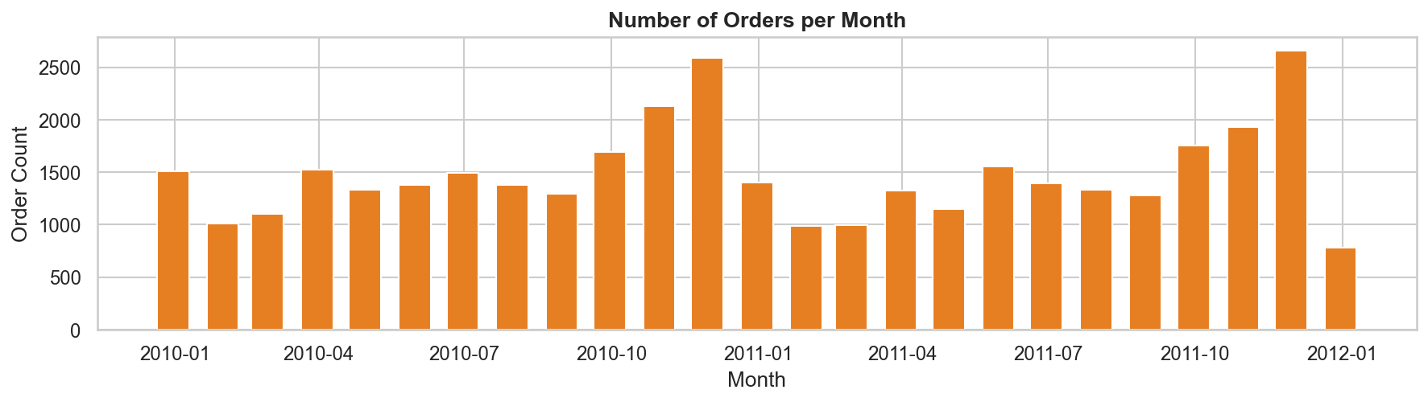
5. RFM Analysis
RFM is a proven framework for customer value analysis. Each customer is scored on three dimensions:
Metric | Definition | Score Direction
Recency (R) | Days since last purchase (snapshot: 10 Dec 2011) | Lower = better (score 5 = most recent)
Frequency (F) | Number of unique invoices | Higher = better (score 5 = most orders)
Monetary (M) | Total spend in GBP | Higher = better (score 5 = highest spender)
5.1 RFM Metric Distributions
All three RFM metrics are right-skewed — a small number of customers have very high frequency and monetary values. Recency is bimodal: a large group of recent buyers (low recency) and a long tail of lapsed customers. Rank-based quintile scoring was used to handle these skewed distributions robustly.
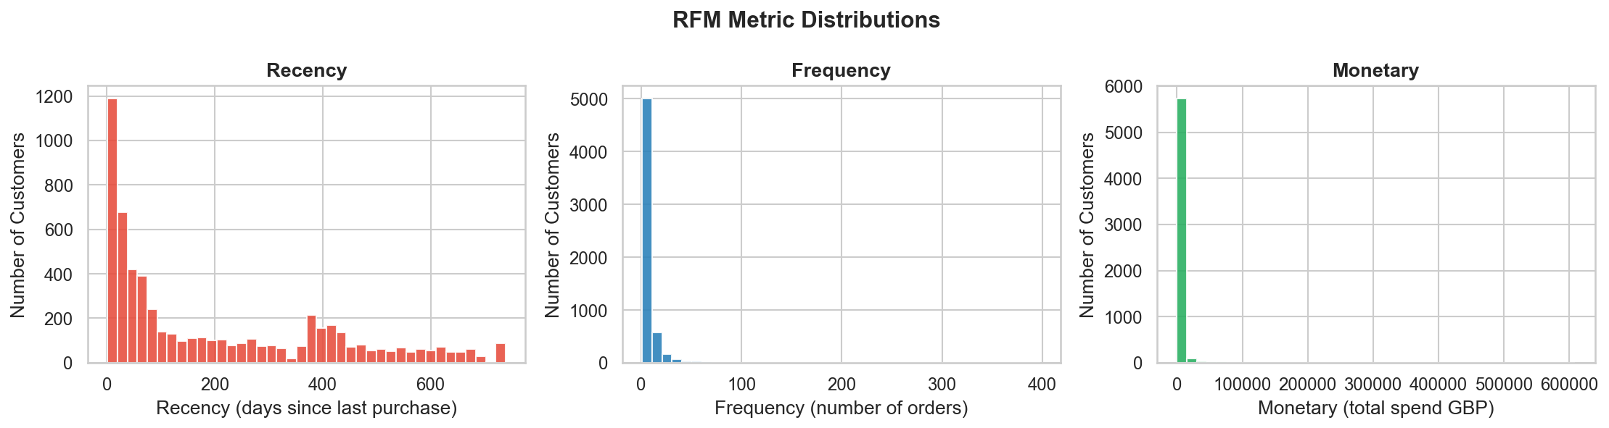

5.2 RFM Score Distributions
Each metric was scored 1-5 using quintile-based ranking (rank method='first' to avoid ties). Score 1 = bottom 20%, Score 5 = top 20%. The distributions confirm balanced scoring across the customer base.
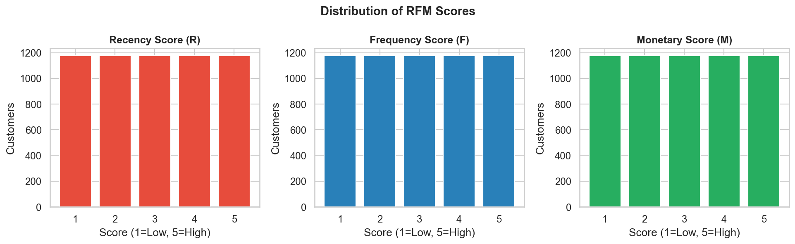
6. Customer Segmentation
Each customer was assigned to one of 7 business segments based on their R, F, and M scores using the rule table below:
Segment | Rule (R=Recency, F=Frequency, M=Monetary Score) | Description
Champions | R>=4, F>=4, M>=4 | Recent, frequent, high spenders
Loyal Customers | R>=3, F>=3 | Consistent buyers with decent recency
New Customers | R>=4, F<=2 | Bought recently but infrequently
Potential Loyalists | R>=3, F>=2, M>=3 | Showing loyalty signals, not yet consistent
At Risk | R<=2, F>=3 | Used to buy often but have lapsed
Promising | All others | Mixed signals — monitor closely
Lost | R=1, F=1 | Very old, one-time buyers
6.1 Segment Summary Table
Segment | Customers | Total Revenue (GBP) | Avg Spend (GBP) | Revenue %
Champions | 1,293 | 12,096,578 | 9,355 | 68.2%
Loyal Customers | 1,409 | 2,744,498 | 1,948 | 15.5%
At Risk | 825 | 1,634,976 | 1,982 | 9.2%
Promising | 1,323 | 611,382 | 462 | 3.5%
New Customers | 440 | 394,217 | 896 | 2.2%
Lost | 514 | 177,524 | 345 | 1.0%
Potential Loyalists | 74 | 84,255 | 1,139 | 0.5%
TOTAL | 5,878 | 17,743,429 | 3,019 | 100%

6.2 Customer Count by Segment
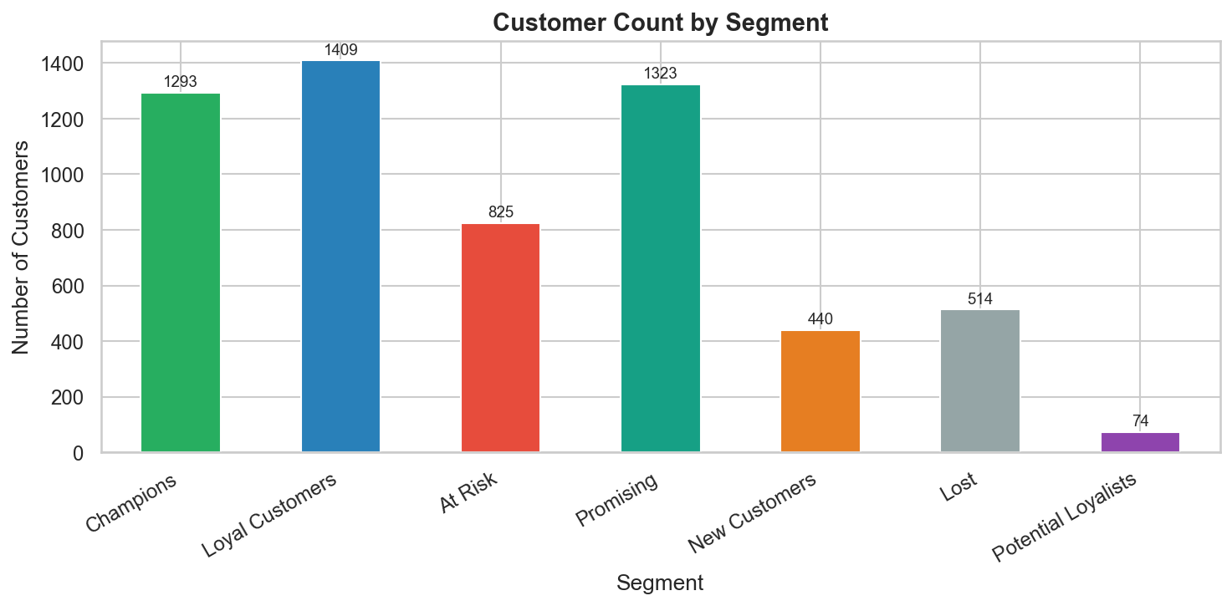

6.3 Revenue Share by Segment
This is the most critical finding: Champions represent just 22% of customers but drive 68.2% of total revenue. This concentration means protecting this segment should be the top marketing priority.
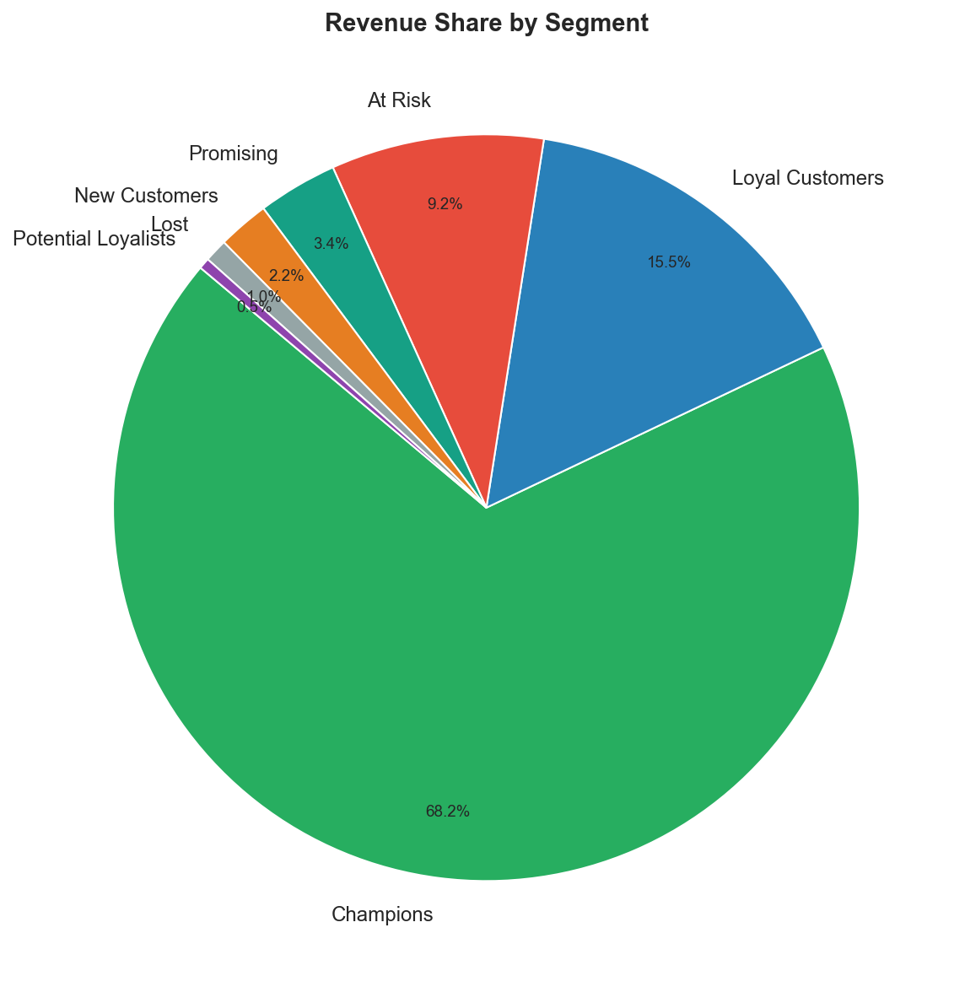

6.4 Average Spend by Segment
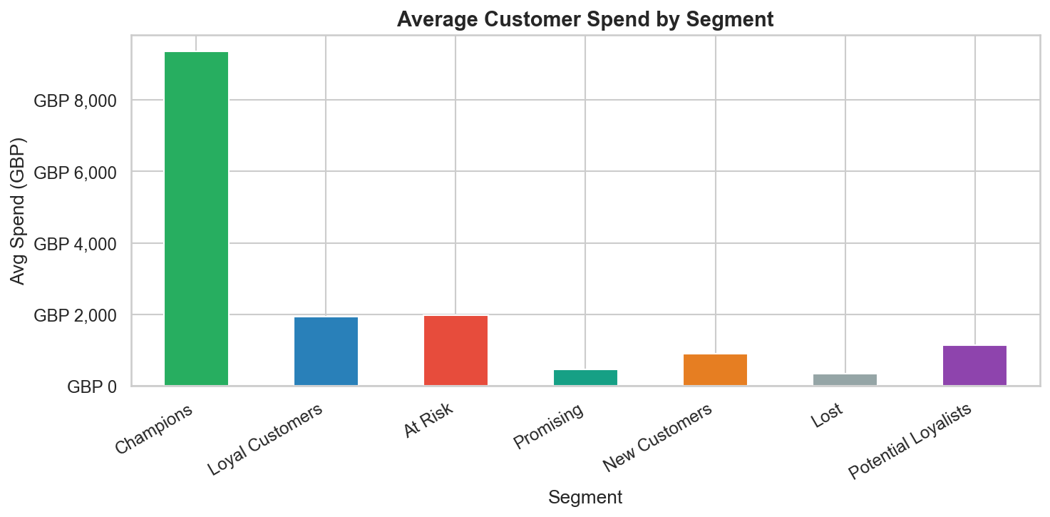

6.5 RFM Score Heatmap by Segment
The heatmap confirms the segmentation logic works correctly. Champions score highest across all three dimensions. At Risk customers have low Recency score (they haven't purchased recently) but maintain higher Frequency and Monetary scores — they are lapsed high-value buyers.
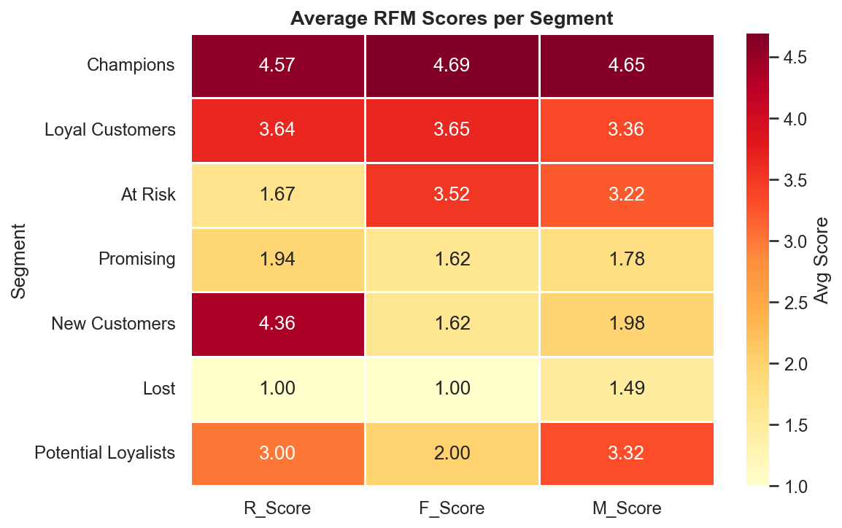

6.6 Recency vs Monetary Scatter (Customer Map)
This scatter plot visually separates customer segments. Champions cluster in the bottom-left (low recency = purchased recently, high monetary). Lost customers appear in the top-right (high recency = not purchased recently, low spend). At-Risk customers sit in the top-right with moderate-to-high monetary values — they are the prime win-back targets.
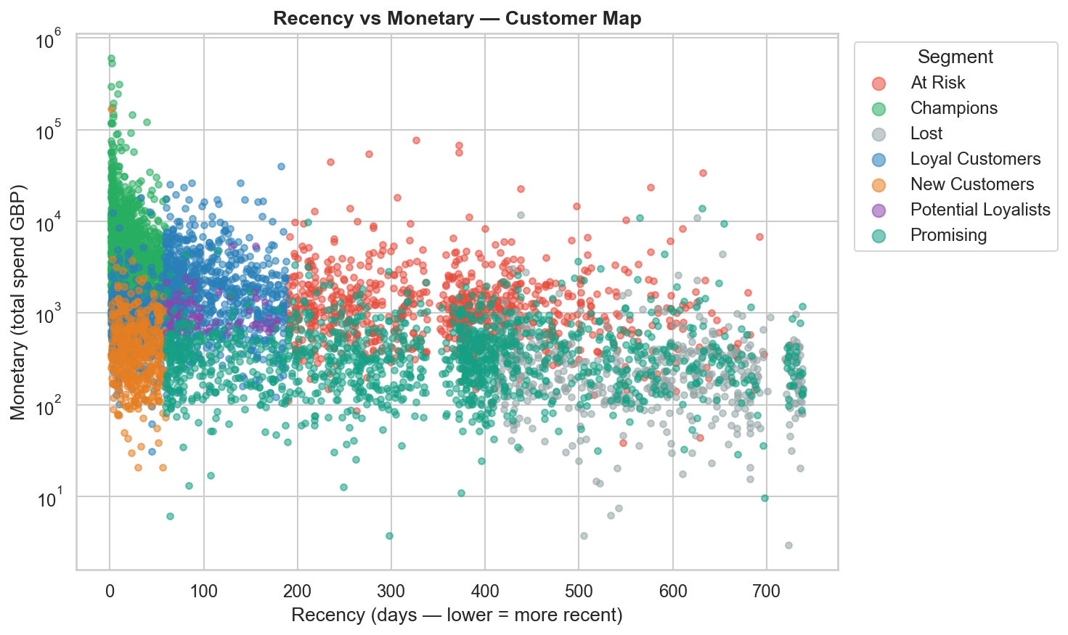

6.7 Order Frequency Distribution by Segment
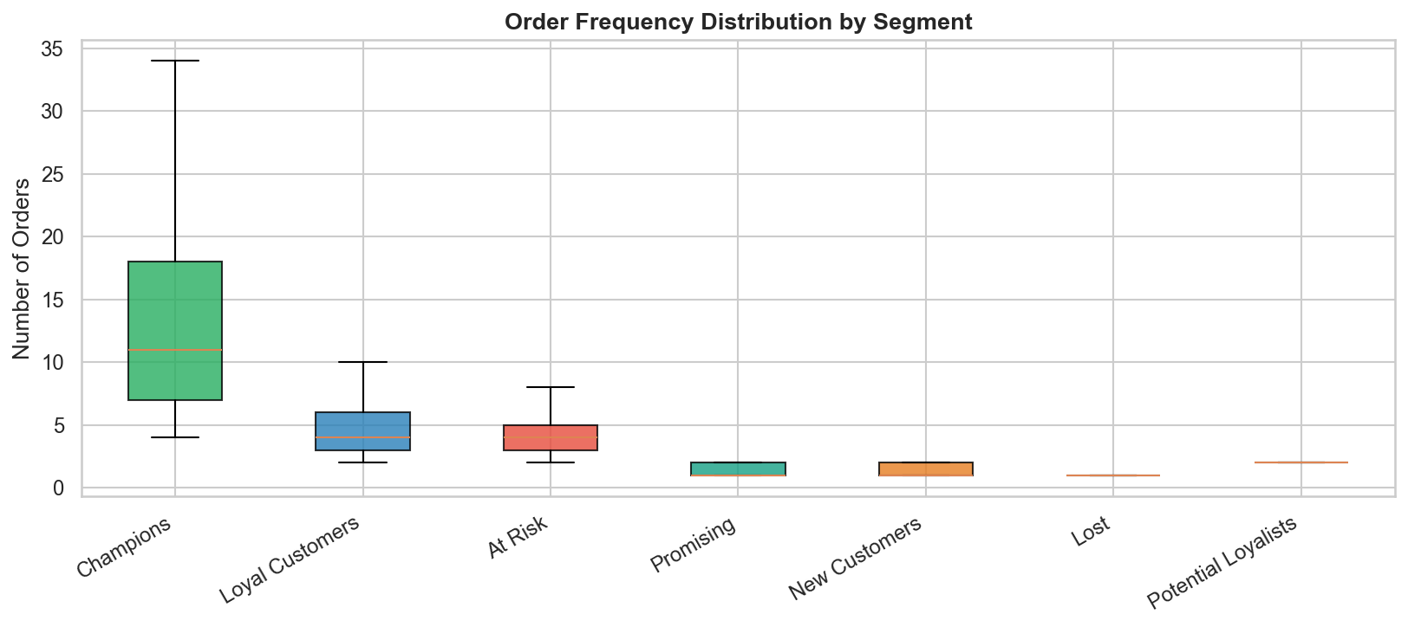
7. ROI & Budget Allocation
To answer the core business question, we estimated ROI for a retention campaign assuming a flat cost of GBP 10 per customer (email + personalisation platform cost). ROI is calculated as: ROI% = (Total Segment Revenue - Campaign Cost) / Campaign Cost x 100.
Note: This uses historical revenue as a proxy for retention value. In practice, ROI should be adjusted using incremental lift from A/B-tested campaigns.

7.1 ROI by Segment
Segment | Customers | Total Revenue (GBP) | Campaign Cost (GBP) | ROI (%)
Champions | 1,293 | 12,096,578 | 12,930 | 93,454%
Loyal Customers | 1,409 | 2,744,498 | 14,090 | 19,378%
At Risk | 825 | 1,634,976 | 8,250 | 19,718%
Promising | 1,323 | 611,382 | 13,230 | 4,521%
New Customers | 440 | 394,217 | 4,400 | 8,859%
Lost | 514 | 177,524 | 5,140 | 3,354%
Potential Loyalists | 74 | 84,255 | 740 | 11,286%
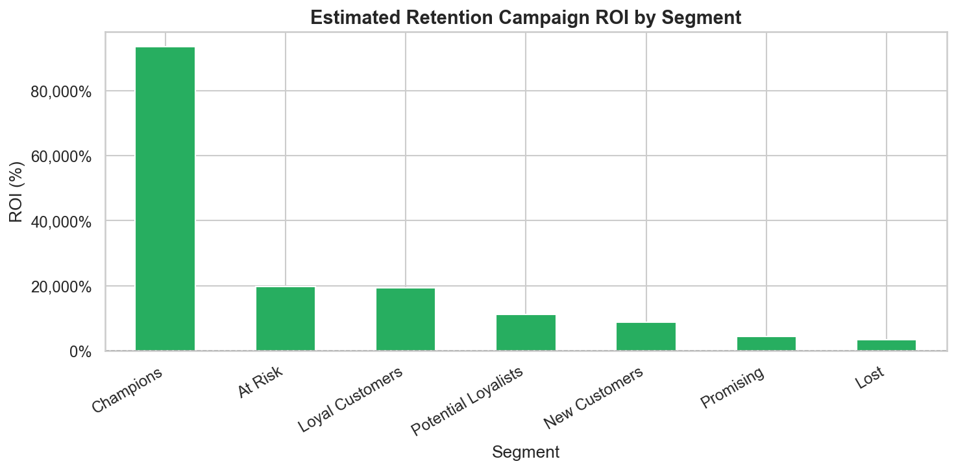

7.2 Budget Allocation Recommendation
Budget allocation should be proportional to the revenue potential of each segment, with a slight overweight on At Risk (win-back opportunity) and New Customers (lifetime value building).
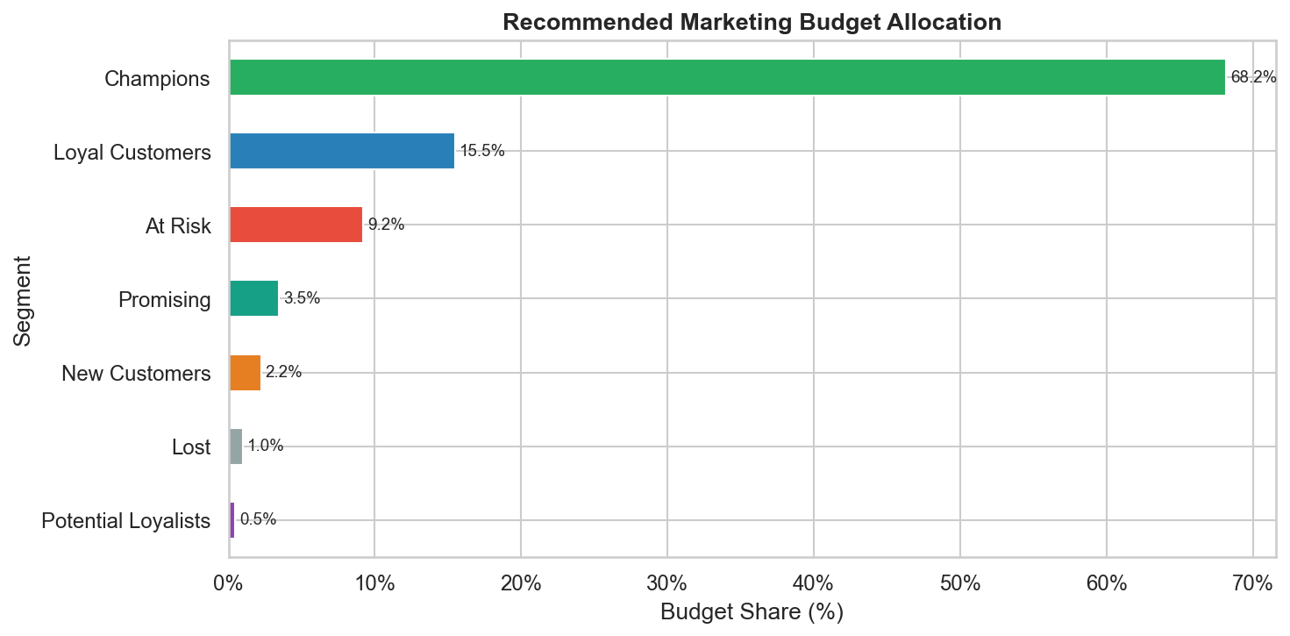

7.3 Revenue vs Campaign Cost

The chart below shows that campaign costs are negligible relative to segment revenues — the ROI is exceptional across all segments. The primary driver of allocation should be the potential for incremental uplift, not cost minimisation.
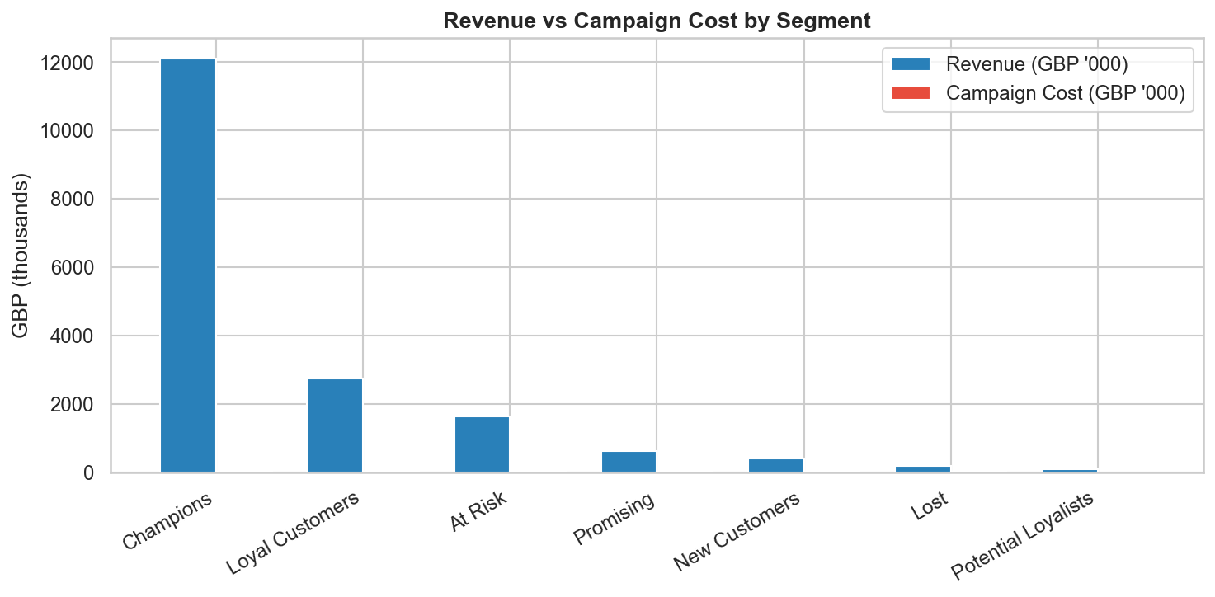
8. Marketing Recommendations
Segment | Budget Share | Channel | Recommended Action
Champions | ~30% | Email / VIP Events | Exclusive loyalty programme, early-access to new products, referral incentives
Loyal Customers | ~25% | Email / App | Upsell premium products, cross-sell bundles, tier-upgrade nudges
At Risk | ~20% | Email / SMS | Personalised win-back offers with time-limited discounts (10-15% off)
Potential Loyalists | ~15% | Email | Membership programme invite, engagement campaigns with incentives
New Customers | ~7% | Email Automation | 3-part onboarding series; second-purchase discount; review request
Promising | ~2% | Newsletter | Periodic newsletters; low-cost engagement; monitor for upgrade signals
Lost | ~1% | Email | One-time reactivation email only; do not invest further

9. Conclusions
- 1. Champions are the backbone of the business. Just 22% of customers generate 68.2% of revenue. Protecting this group with a premium loyalty experience is the single highest-ROI marketing investment available.
- 2. At-Risk customers are the biggest rescue opportunity. They spent significantly in the past (avg GBP 1,982) but have not purchased recently. A targeted win-back campaign with personalised offers could recover a substantial portion of their historical spend.
- 3. Mid-week campaigns outperform. Tuesday-Thursday sees peak purchase activity. Schedule all email and push notifications on these days.
- 4. Q4 seasonality is strong. November is the highest revenue month. Retention campaigns should begin in September to re-engage lapsed customers before the peak season.
- 5. Lost customers should receive minimal investment. Their average spend was GBP 345 and they have not purchased in over 1.5 years on average. The opportunity cost of over-investing here is high.
10. Tools & Technologies
Library | Purpose
pandas | Data loading, cleaning, grouping, aggregation
numpy | Numerical operations and ranking
matplotlib | All charts and visualisations
seaborn | Heatmap and visual theme
No machine learning libraries were used. All segmentation is rule-based using RFM scoring.

