Zentrix Minerals - Supplier Profile

Overview
Zentrix Minerals is a lithium producer headquartered in Perth, Australia. All of its active mines are located in Valdoria. In November 2025 the Valdorian government announced export restrictions on lithium, effective 1 March 2026: exports of lithium carbonate are capped at 50% of each producer's 2025 volume.

Mine Sites
Mine | Region | Annual output (tonnes) | Status
Valdoria North | Valdoria | 18,000 | Active
Valdoria South | Valdoria | 9,000 | Active
Kestrel Ridge | Western Australia | 0 | Commissioning 2027

Customers
The chart below shows the split of 2025 sales by customer.
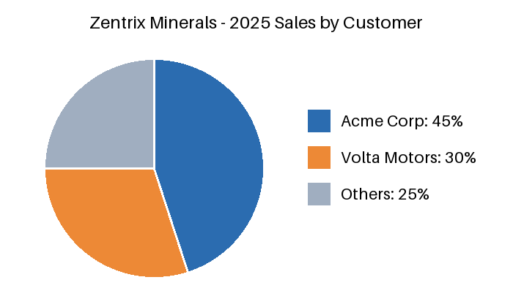

Contacts
Account manager: Daniel Reyes, daniel.reyes@zentrix.example, +1-555-0142.

