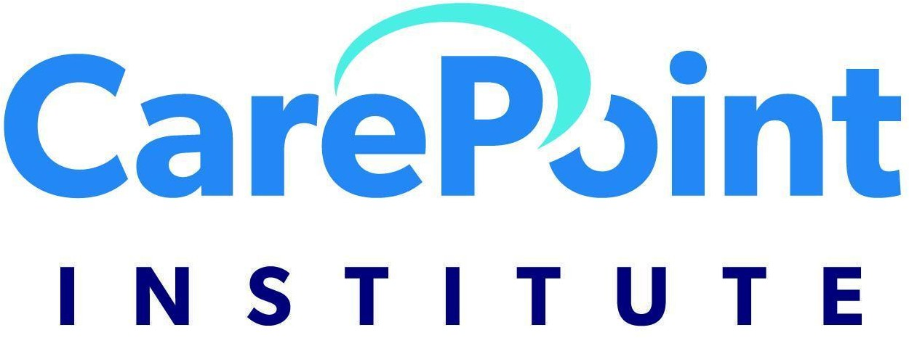

Tabs at top- FRONT END
CPR Courses (Drop Down) More Courses (Drop Down) Acceptance Log In Contact Us Add 1-800 number Espanol (can we
click a button to change the website to Spanish)

Also add AI bot (like on APT’s site)- Need any help? Pops up

CPR Courses Dropdown:
CPR Only First Aid Only
CPR and First Aid Healthcare BLS Instructor/Skill Evaluator

More Courses Dropdown
(still developing what will be on here)

Nationally Recognized CPR Training
CarePoint Institute (CPI) offers training for CPR, AED, First Aid, and advanced programs such as Basic Life Support (BLS). Designed to meet regulatory requirements, CarePoint Institute (CPI) offers a variety of ways for your organization to get full certification in CPR training.
Find out more about our flexible and cost-effective options for full-certification CPR training.
LINK TO CONTACT US

Specialized CPR and First Aid Certification for those Supporting People with Intellectual/Developmental Disabilities, Physical Disabilities, and Aging Adults
At CarePoint Institute, we exist to elevate the standard of care by equipping healthcare professionals, direct support professionals, educators, and the community with
real-world education. We are deeply committed to advancing inclusive, relevant, and high-quality training that meets real-world needs of those supporting individuals with intellectual/developmental disabilities, physical disabilities, and aging adults.

Who Can Take Our CPR or First Aid Classes? (Add stock Photo)
Our CPR and First Aid training is open to anyone who wants to be prepared to respond confidently in an emergency. This includes healthcare and direct support professionals, parents and family caregivers, teachers and childcare providers, coaches and school staff, and workplace teams who need certification or renewal.

Join us as an authorized CarePoint Institute (CPI) Instructor (add stock photo)
As a CPI instructor, you’ll provide CPR training with our distinguished programs. Our programs are known for having engaging videos, detailed skill guides, and comprehensive presentations. Combined with your expertise as an instructor, CPI programs efficiently and effectively deliver classes for increased student retention.
You can become an instructor by attending a CPI Instructor Development Course located online or a city near you. Or, if you are already an instructor with another reputable organization, we offer an easy and quick reciprocity process.

LINK TO CONTACT US PAGE

CPR Training Programs Designed For Learning (add stock photo)
CPI’s video-driven, instructor-facilitated courses provide a consistent way to train employees in lifesaving CPR, AED, and first aid programs while meeting your regulatory requirements.
CPI’s scenario-based programs promote learning and retention because they are designed to engage students, no matter their learning styles.

Training Is About More Than A Card (add stock photo)
Yes, you need a certification card to work. But more importantly, your training could mean the difference between life and death to someone in trouble. That’s why it’s vital that the skills you learn become second-nature and the training is fresh in your mind when you need it most. We will help you stay fresh with unlimited access to our training library so you will always be prepared.

Need CPR Training For Yourself? (add stock photo)
CPI can help you get the CPR training you need. Choose remote training with feedback from a live, on-screen instructor in the comfort of your home or office, or find an CPI approved training center with a location near you.
LINK TO CONTACT US PAGE

UNDER ACCEPTANCE TAB

When earning your CPR certification - especially if it is a requirement of your employment or profession - you want to make sure you’re getting the highest quality and most up-to-date CPR training.

The training requirements in my state indicate that the CPR and First Aid training must equivalent to the American Heart Association. Does this training meet the requirement?
Yes! CarePoint Institute (CPI) meets the standards of the American Heart Association and also includes specialized content for those supporting people with
Intellectual/Developmental Disabilities, Physical Disabilities and Aging Adults.

How Are CPR Guidelines Created?
The guidelines for CPR as a life-saving technique are developed through a process of looking at scientific studies that evaluate the likelihood of survival depending on which CPR methods are used. These studies are shared and deliberated at an international conference called International Liaison Committee on Resuscitation (ILCOR), which
meets every 5 years. The United States liaison of ILCOR is the American Heart Association (AHA). After
ILCOR meetings, the AHA publishes updated guidelines on how to best perform CPR, based on what ILCOR decides.

Who Uses ILCOR and AHA Guidelines to Teach CPR?
Using ILCOR guidelines, communicated by the AHA, training companies are able to form their own systems and curricula for teaching. Among these training companies are the two largest – The American Heart Association and the American Red Cross – as
well as several private companies including CarePoint Institute (CPI).
All these organizations develop their programs using the same ILCOR CPR guidelines as the framework of their own training process; however, they may teach them in different ways, at different price points, and using different modalities that students can choose from to find the best match that suits their schedules and needs.
CPR training companies create curriculum based on the recommendations published by the AHA per ILCOR’s deliberations on CPR research. The AHA is not involved in the

curriculum-building process outside of their organization and therefore cannot approve
other CPR training companies’ programs. Choosing CarePoint Insitute (CPI) CPR courses means that you have a training
program that follows the guidelines that ILCOR creates and AHA publishes. Through student feedback and professional experience, CarePoint Institute (CPI) has also exceeded the AHA’s recommendations when building our curriculum.

Where Can I Learn the Best CPR Skills?
At CarePoint Institute (CPI), we follow the latest CPR guidelines, but we also
add recommendations, tips, and real-world skills from active EMTs and other medical professionals. Students often find that our courses are more up-to-date and more robust than other CPR courses out there, especially given that ILCOR guidelines can take
several years to evolve.

Does this accreditation cover Adult, Child, and Infant CPR and AED and First Aid?
Yes! CarePoint Institute (CPI) meets the requirement for most Medicaid programs that require basic CPR and First Aid.

What is CarePoint Institute’s Educational Process?
CarePoint Institute (CPI) CPR courses strictly adhere to ILCOR and the American Heart
Association CPR and ECC/ILCOR guidelines for emergency cardiac care. Our education
process is based on best practices, testing, and improving over time to maximize learning and efficiency.

Does this accreditation offer an online only option for certification?

No, we do not. The skills demonstration must be completed in person with a certified instructor.

How does the Skills Demonstration/Evaluation Work?
Students are provided with a student manual and support materials. If students have questions, they are able to re-watch videos, use our chat or phone support to get answers from our highly educated staff and instructors.
Students are also engaged throughout the training with shorter video segments and section pre-test questions that ensures comprehension of the material.
Upon completion of the training, students take the multiple choice test, which they must pass with an 80% or better.
The test is remedial, meaning that students are given a helpful explanation when they answer a question incorrectly. In addition, the questions on the final test are randomly chosen from a group of relevant questions developed by our education team, so no test is completely the same. They are also adaptive to each student and identify the areas where a student struggled the most.
At the end of the test – regardless of pass or fail – students are able to re-watch the videos related to the questions they answered incorrectly. When the student passes the written test, they are able to print out verification.
Next, the student will meet with a certified
skill-evaluator/instructor to perform the hands-on practice. Upon successful completion, the student is awarded a certification card.

Meet our Education Review Board

Need to get pictures of Brittany Buchanan and her husband (the EMT’s who are filming And add the others

Director of Medical Education

Physician Medical Director

LEGAL (be able to click on each of these)- working on these
Privacy Policy Data Protection Security Policy Refund Policy
Terms and Conditions
CE Privacy Policy and Conflict of Interest Disclosures

