

1. Write a command to get the Python version you are using.

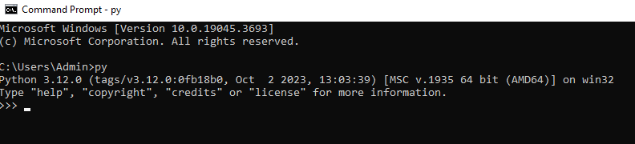

2. Write a python script to print Hello Python on the screen directly in the command

line.

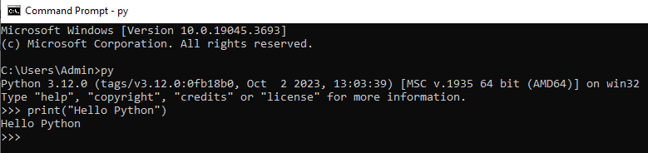

3. Write a python script and store it in a file and execute the file from the command line.

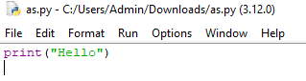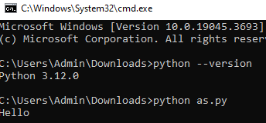

4. Write a python script to print Hello Python on the screen using visual studio code.

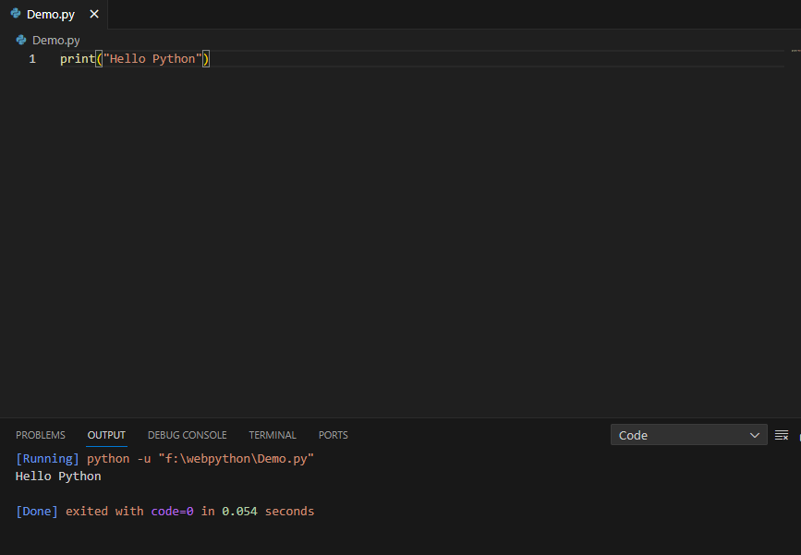

5. Write a python script to print Hello on the first line and Python on the second line

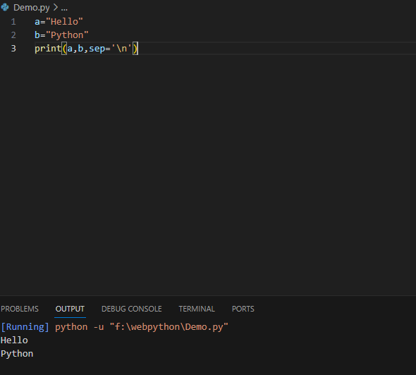

6. Write a python script to print “MySirG” on the screen

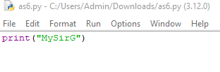

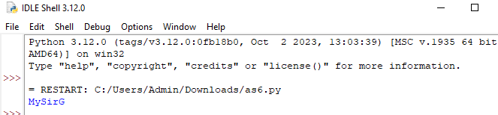

7. Write a python script to print “Teacher’s Day” on the screen

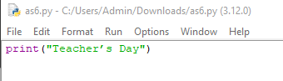

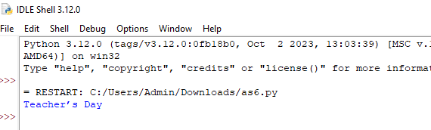

8. Write a python script to print the value of a variable. Variable contains your name as

data.

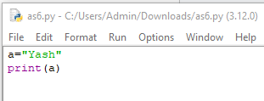

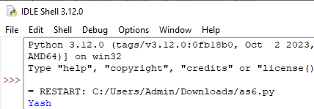

9. Write a python script to create variables to store your name, age, qualification, years

of experience and print it.

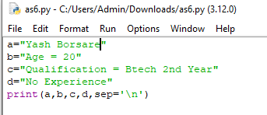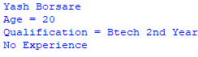

10. Write a python script to print values of three variables, each in a new line. Variable

contains integer values

