1. Write a python script to add comments and print “Learning Python” on screen.

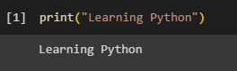

2. Write a python script to add multi line comments and print values of four variables,

each in a new line. Variable contains any values.

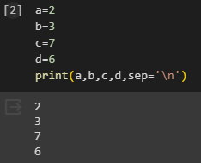

3. Write a python script to print types of variables. Create 5 variables each of them

containing different types of data. (like 35, True, “MySirG”,5.46, 3+4j, etc)

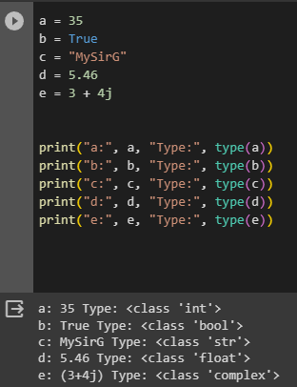

4. Write a python script to print the id of two variables containing the same integer

Values

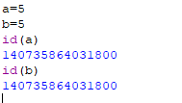

5. Create four variables in a Python script and assign values of different data types to

them. Write a Python script to print value, its type and id of each variable

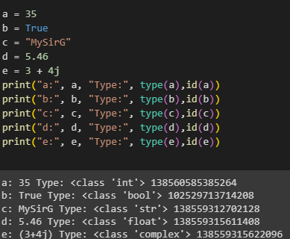

6. Write a python script to print all the keywords

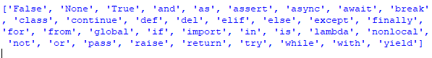

7. On Python shell use help() function and display the list of keywords

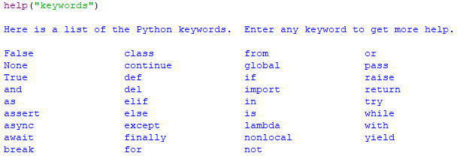

8. Create two Python files A0.py and A1.py. Create a variable in A1.py and assign some

value to it. Write a python script to import A1 module in A0 and print value of the

variable created in A0.py

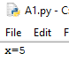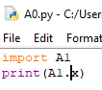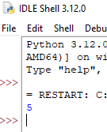

9. Name the keywords, used as data in the Python script.

Integer

Floating-point

Complex

String

Boolean

10. Write a python script to display the current date and time. First create variables to

store date and time, then display date and time in proper format (like: 13-8-2022 and

9:00 PM)

