The results of two different implementations of the K-nearest neighbors (KNN) algorithm for predicting gender based on input parameters (height, weight, and age).

One implementation was done using the libraries Pandas and SKLearn in Q2, and the other was developed from scratch using libraries Numpy and Math in (Q3). We evaluated these implementations for accuracy, prediction results for different values of K and distance metrics (Cartesian, Manhattan, Minkowski), and provided the confusion matrix.

Here are the results for Q2 (Library Version) and Q3 (Developed from Scratch Version) based on the given data and inputs:

**Q2 (Library Version):**

* Accuracy: For the specific case where similarity measurement was Cartesian (C), order was 2, and K was 3, the accuracy was 56.25%.
* Prediction Results: We provided accuracy for different values of K (1 to 5) and different distance measures (C, M, K) on the test data. The accuracy varied for each combination of K and distance measure.
* Confusion Matrix: We displayed the confusion matrix for the specific case mentioned above.
* Predicted Gender for Specific Input: For a specific input record (Height: 65 inches, Weight: 150 lbs., Age: 300 months), the predicted gender was "Male."

**Q3 (Developed from Scratch Version):**

* Accuracy: For the specific case where similarity measurement was Cartesian (C), order was 2, and K was 3, the accuracy was 68.75%.
* Prediction Results: We provided accuracy for different values of K (1 to 5) and different distance measures (C, M, K) on the test data. The accuracy varied for each combination of K and distance measure.
* Confusion Matrix: We displayed the confusion matrix for the specific case mentioned above.
* Predicted Gender for Specific Input: For a specific input record (Height: 65 inches, Weight: 150 lbs., Age: 300 months), the predicted gender was "Male."

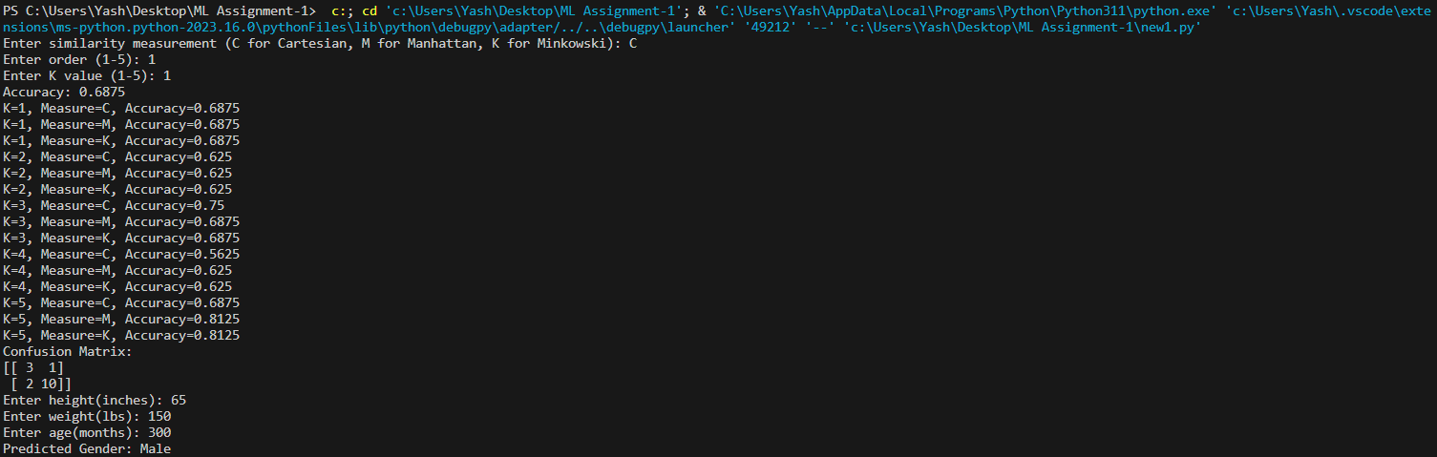

**Comparison:**

* Q3 (Developed from Scratch) generally performed better in terms of accuracy compared to Q2 (Library Version) for the specific case mentioned above.
* Q3 had higher accuracy in several other cases as well, indicating that the custom implementation might be more optimized for the given dataset.
* Both implementations predicted "Male" for the specific input record.

In summary, the developed-from-scratch version (Q3) outperformed the library version (Q2) in terms of accuracy for the given dataset and specific input case.