Computer Networks (CN)
“Network Analysis using Wireshark”

Objective: Capture the following traffic types and Interpret/ Analyze the corresponding header and payload:
IP and ICMP

Solution - Wireshark Lab: ICMP and IP

Select the first ICMP Echo Request message sent by your computer, expand the Internet Protocol part of the packet in the packet details window, and print this.

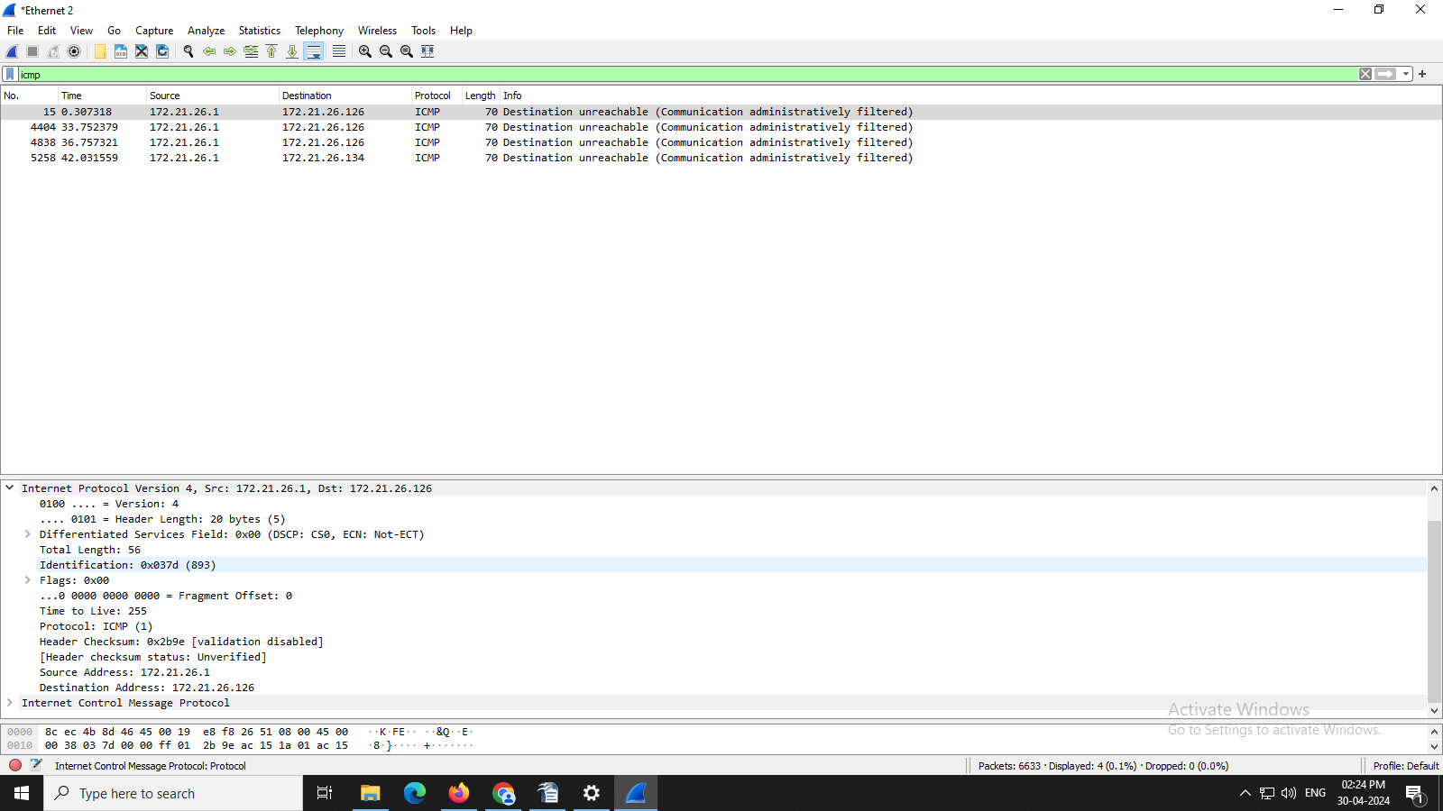

1. What is the IP address of your computer?
Ans: 172.21.26.112

2. Within the IP packet header, what is the value in the upper layer protocol field?
Ans: ICMP

3. How many bytes are in the IP header? How many bytes are in the payload of the IP datagram?
Explain how you determined the number of payload bytes.
Ans:
Header bytes: 20 (as seen in screenshot)

Payload bytes: 36 (total length 56 minus the 20 header bytes = 36)

4. Which fields in the IP datagram always change from one datagram to the next within this series of ICMP messages sent by your computer?

Ans: Identification field is incrementing. Time to live is also incrementing.

5. Which of the fields must stay constant? Which fields must change? Why?

Ans: The following fields remain constant:

• version (IPv4 always used)

• header length (doesn’t change since we are always using IPv4)

• source IP (my computer’s IP address doesn’t change)

• destination IP (usc.edu’s IP address doesn’t change)

• differentiated services (same protocol every time)

• upper layer protocol (same protocol every time)

• header checksum (verification disabled in my tests) The following fields change:
• Identification field is incrementing (each IP datagram has a different ID)

• Time to live is also incrementing (this is how trace route works, as discussed in the assignment)

6. Describe the pattern you see in the values in the Identification field of the IP datagram.

Ans: They are incrementing with each datagram.

