DMW FA 01

Name : Yash Anil Chavan
PRN : 123B1B105
Batch : B2
Branch : Computer Engineering

Problem Statement :
Q3. Relationship Modeling & Courses

Table : Student and Courses
- Create a relationship using coursesID
- Build a bar chart showing the number of students per course, with slicers for semester.

Dataset table for courses

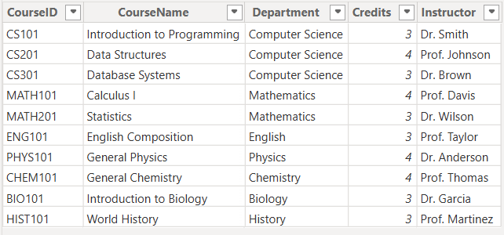

Dataset table for students

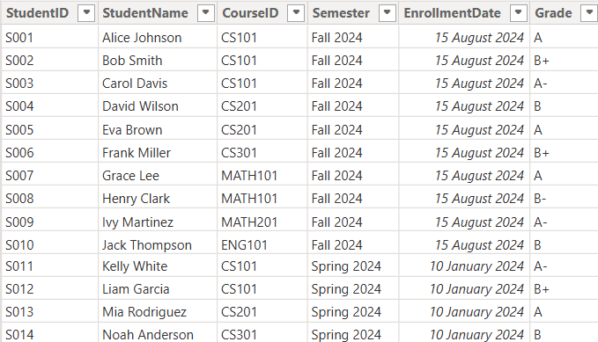

Work for subquestion 01 (a) : Create a relationship using coursesID

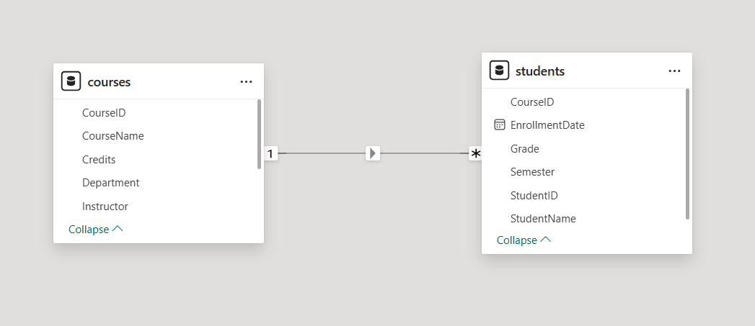

Work for subquestion 02 (b) : Build a bar chart showing the number of students per course, with slicers for semester.

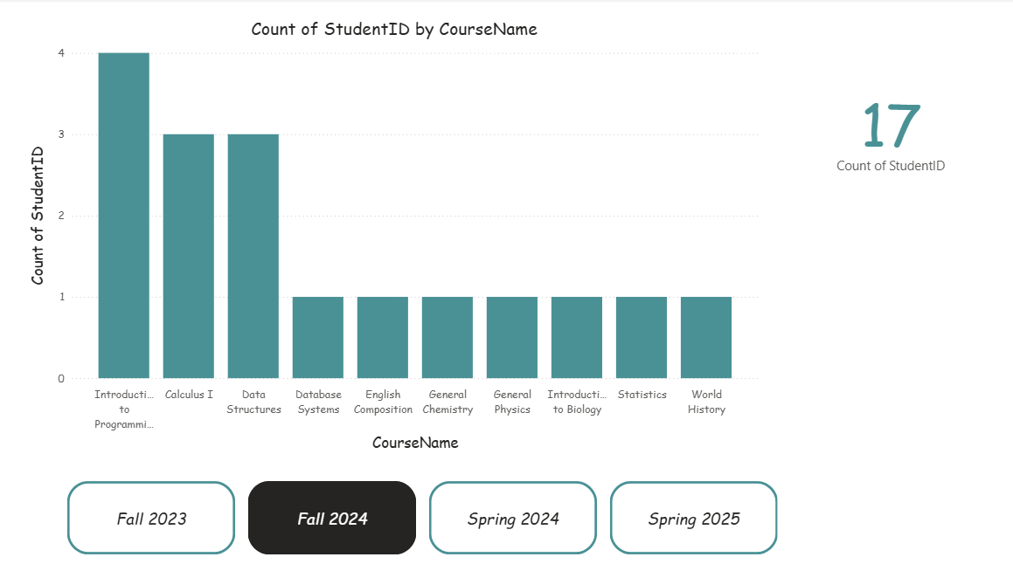

Extra work : Count of studentID by semester and department

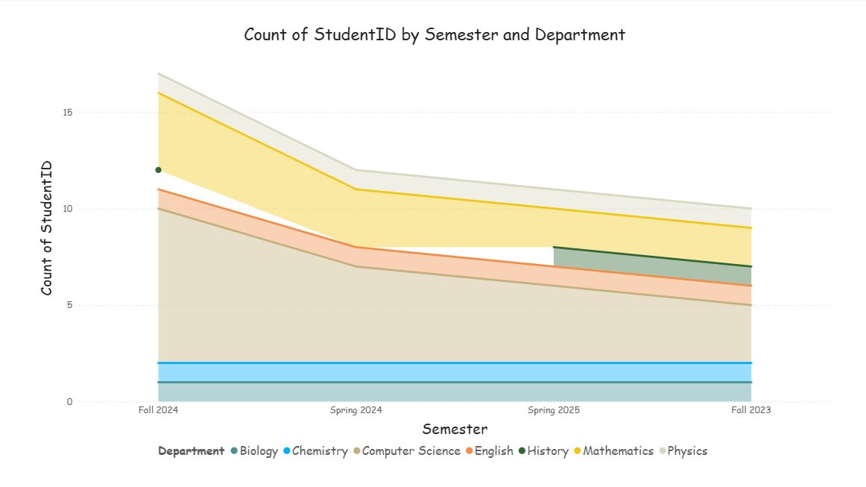

Extra work : Count of studentID by semester and department
