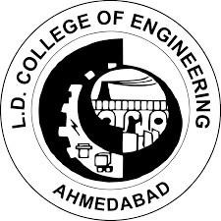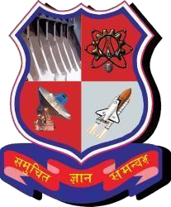**L. D. College of Engineering**

**120, Circular Road, University Area, Ahmedabad, Gujarat 380015**

**Summer Internship Report**

**(3170001)**

*Submitted by*

**Vhanesa Arth Bhikhabhai**

**200280116029**

*In partial fulfillment for the award of the degree*

**BACHELOR OF ENGINEERING**

*In*

**Information Technology Engineering**

1. **D. College of Engineering**

**GUJARAT TECHNOLOGICAL UNIVERSITY**

**Chandkheda, Ahmedabad**

**INTERNAL GUIDE NAME:** DR. HITEISHI DIWANJI

**HEAD OF THE DEPARTMENT:** DR. HITEISHI DIWANJI

Academic Year (2023-24)

**L. D. College of Engineering**

**120, Circular Road, University Area Ahmedabad, Gujarat 380015**

# CERTIFICATE

This is to certify that the internship report submitted along with the project entitled **Summer Internship –** **LDCE Student Portal**has been carried out by **Vhanesa Arth Bhikhabhai - 200280116029**under my guidance in partial fulfilment for the degree of Bachelor of Engineering in Information Technology Engineering, 7th Semester of Gujarat Technological University, Ahmadabad during the academic year 2023-24.

|  |  |  |  |
| --- | --- | --- | --- |
|  | |  | |
| Internal Guide | | Head of the Department | |
| Dr. Hiteishi Diwanji | | Dr. Hiteishi Diwanji | |
| Sign | | Sign | |

**L. D. College of Engineering**

**120, Circular Road, University Area, Ahmedabad, Gujarat 380015**

**DECLARATION**

I hereby declare that the summer internship report along with the Summer Internship entitled “**LDCE Student Portal”**submitted towards the completion of the summer internship in the 7th semester of Bachelor of Information Technology Engineering in L. D. College of Engineering, Ahmedabad is an authenticated record of mine work carried out at **LDCE**under the supervision of **Prof. Hiteishi Diwanji**.

I further declare that to the best of my knowledge the report of I.T. 7th semester.

|  |  |
| --- | --- |
| **Candidate’s Name**:  Arth Vhanesa | **Sign**: |

**L. D. College of Engineering**

**120, Circular Road, University Area, Ahmedabad, Gujarat 380015**

**ACKNOWLEDGEMENT**

This report is by far the most significant accomplishment in our life and it would be impossible without people who supported us and believed in us. We would like to extend our gratitude and our sincere thanks to our honorable, esteemed supervisor: **PROF. HITEISHI DIWANJI.**

She is not only a great professor with deep vision but also most importantly a kind person. We sincerely thank her for her exemplary guidance and encouragement. Her trust and support inspired us in the most important moments of making the right decisions and we are glad to work with her. Our special thanks go to **Dr. Hiteishi Diwanji**Head of the Department of Information Technology Engineering, **L. D. COLLEGE OF ENGINEERING**, for providing us with the best facilities in the Department and for his timely suggestions.

We want to thank all our teachers for providing a solid background for our studies and research thereafter. They have been great sources of inspiration to us and we thank them from the bottom of our hearts.

Last but not least we would like to mention here that we are greatly indebted to each and everybody who has been associated with our project at any stage but whose name does not find a place in this acknowledgement.

Yours Sincerely,

Arth Vhanesa

**L. D. College of Engineering**

**120, Circular Road, University Area, Ahmedabad, Gujarat 380015**

**3170001 - SUMMER INTERNSHIP REPORT**

**Summer 2023**

**INTERNSHIP TITLE:** LDCE Student Portal

**INTERN NAME:** Vhanesa Arth Bhikhabhai

**ENROLLMENT NO:** 200280116029

**MAIL ID:** arthbvhanesa2853@gmail.com

**MOBILE NUMBER:** 9316358558

**INTERNSHIP COMPANY:** LDCE

**DURATION:** 15 Days

**DATES OF INTERNSHIP:** 27th July, 2023 to 10th August, 2023

**TOOLS AND TECHNOLOGY:** React.js, Node.js, Express.js, MySQL

**NATURE OF INTERNSHIP:** Mini Project (Online)

**STIPEND RECEIVED: YES/NO AMOUNT (IF ANY):** No

**L. D. College of Engineering**

**120, Circular Road, University Area, Ahmedabad, Gujarat 380015**

**Confirmation Letter**

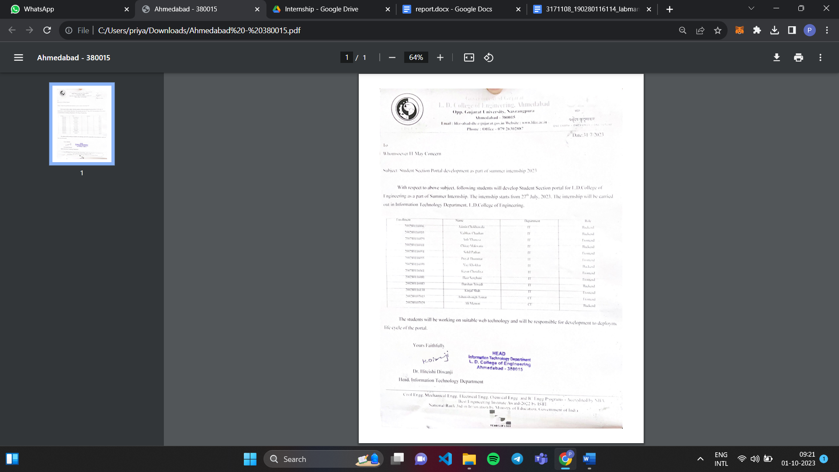

**Completion Certificate**

**L. D. College of Engineering**

**120, Circular Road, University Area, Ahmedabad, Gujarat 380015**

**SUMMER INTERNSHIP Weekly Report**

**Week No:** 1 **From:** 27th July, 2023 **To:** 2nd Aug, 2023

**Task Planned:**

* Student login integration
* Student dashboard
  + Display student data
  + Request to update student data

**Task Completed:**

* All the tasks were completed as planned.

**Objective**:

During my initial week at LDCE (L.D. College of Engineering) for my internship, my main focus was to kickstart the development of the student module. As part of this initiative, I also worked on integrating student login functionality and designing the student dashboard. The student dashboard was designed to display student data and allow requests for updating their information.

**Outcome:**

Login Page: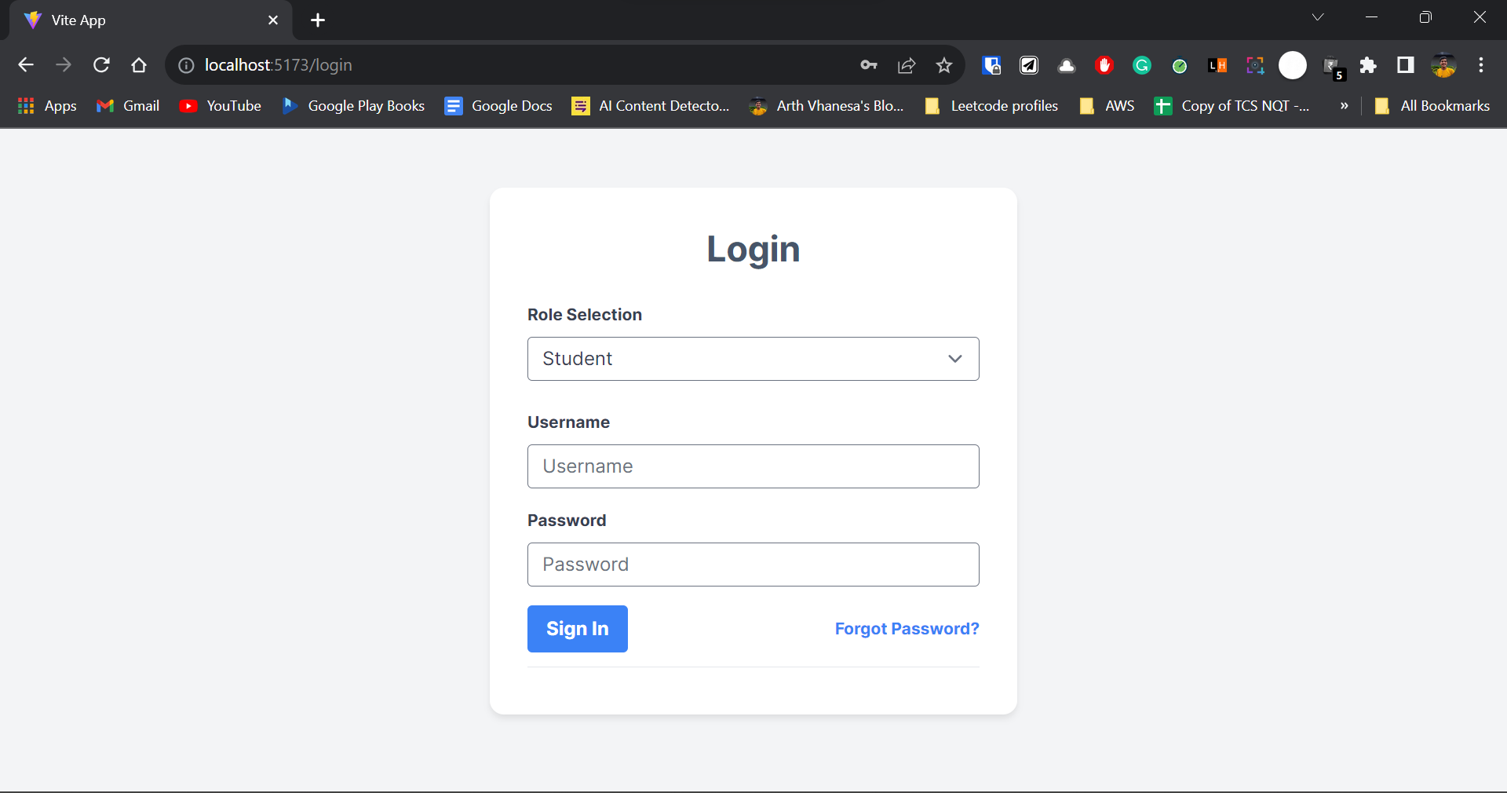

Student dashboard:

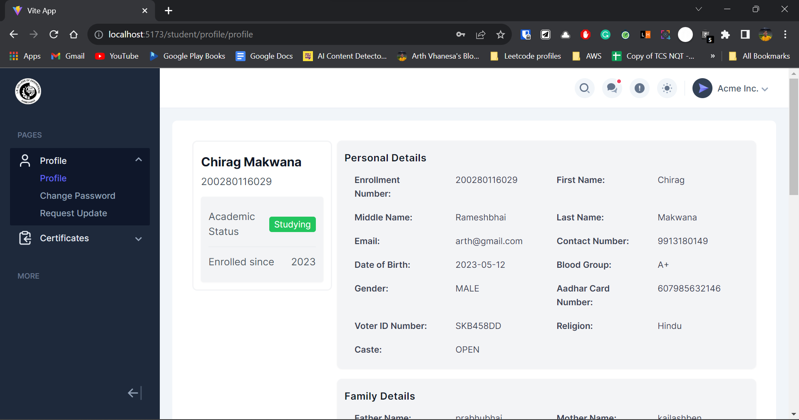

Student data update:

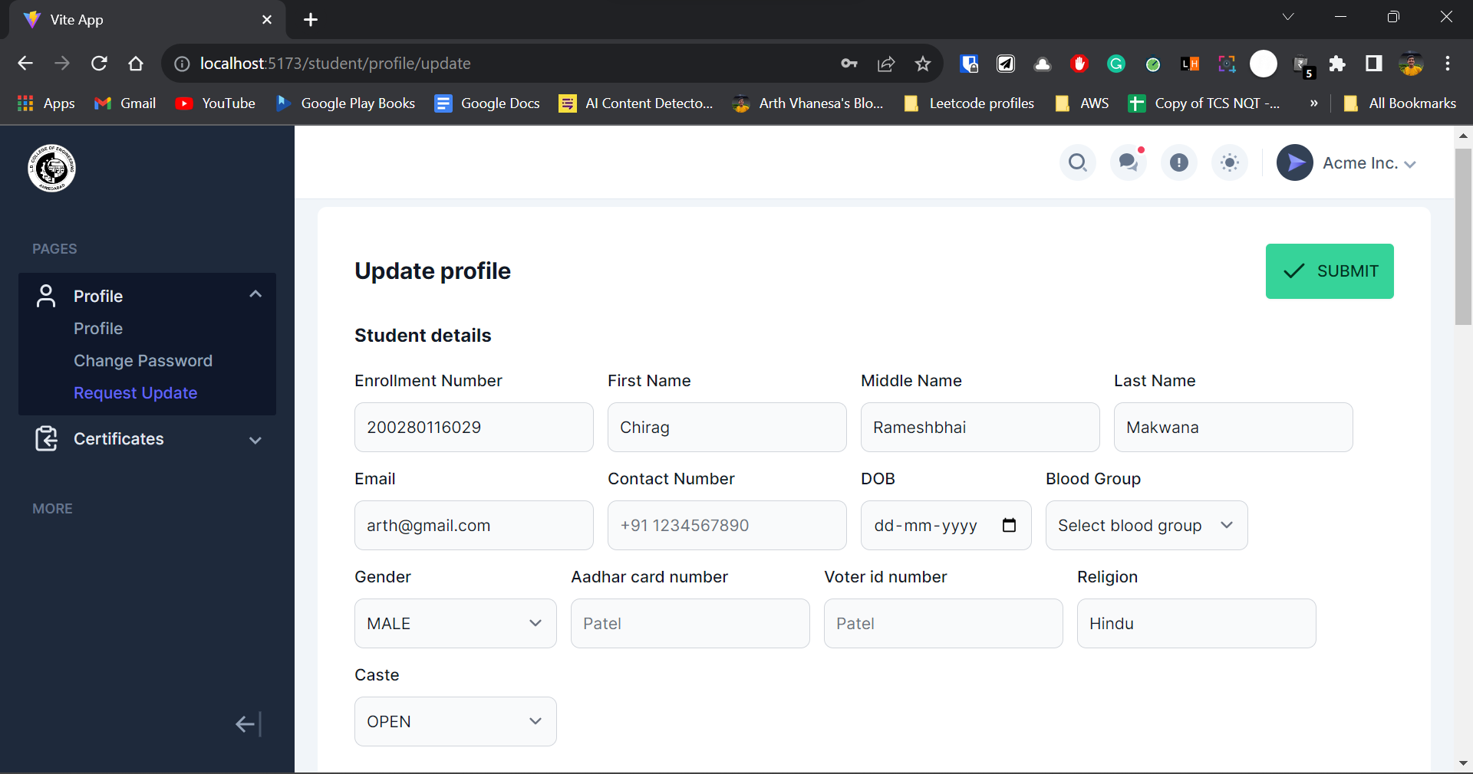

**L. D. College of Engineering**

**120, Circular Road, University Area, Ahmedabad, Gujarat 380015**

**SUMMER INTERNSHIP Weekly Report**

**Week No:** 2 **From:** 3rd Aug, 2023 **To:** 10th Aug, 2023

**Task Planned:**

* Integrate endpoints for student certificate requests to the front end.
* Integration for managing student certificate functionality that has endpoints for certificate request status, download and delete certificate requests in the student dashboard.

**Task Completed:**

* All the tasks were completed as planned.

**Objective**:

During the second week of my internship at LDCE (L.D. College of Engineering), my primary objective was to expand the functionality of the LDCE student portal by developing the various student certificate modules that have functionality of **certificateRequest, deleteCertificate, downloadCertificate** etc. I successfully integrated the backend with the frontend part of the student certificate and developed **a Certificate Status Page** that allows students to check the status of their certificate requests and download certificates once they are ready. These pages are integral to streamlining the certificate issuance process and enhancing the overall user experience for students.

**Outcome:**

**Request certificate (Student dashboard):**

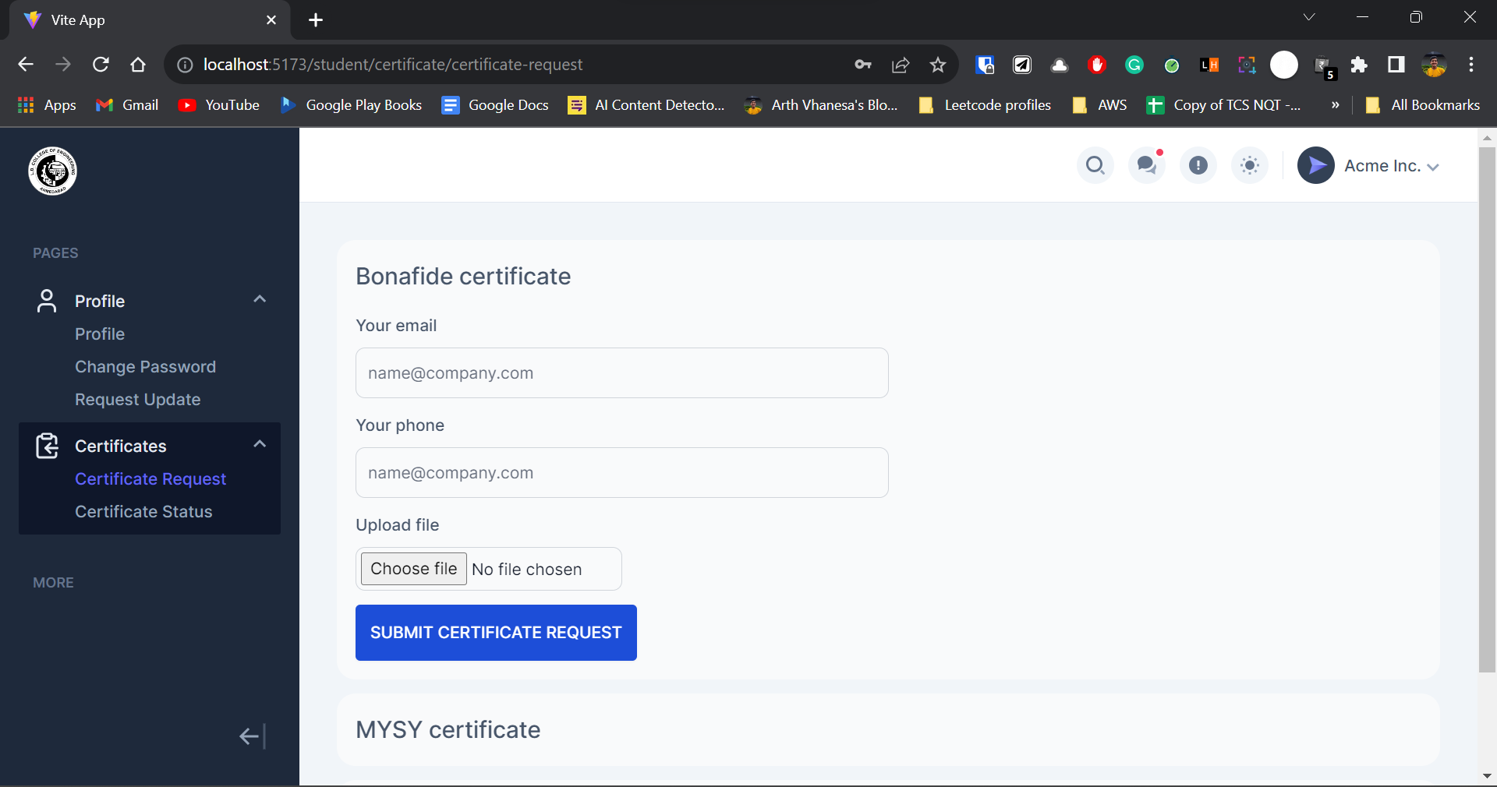

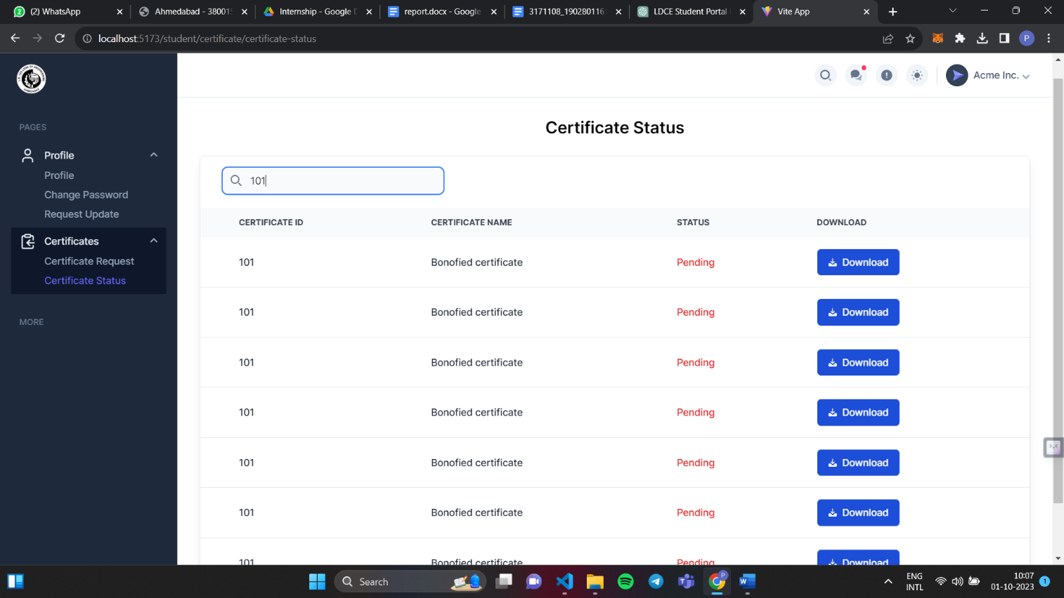**Manage certificate request (Student dashboard):**

**SUMMER INTERNSHIP/TRAINING FEEDBACK FORM**

**(Information Technology department, LDCE)**

**Student name:** Vhanesa Arth Bhikhabhai

**Address:** E-901 Shukan Rivera, Surat - 395004

**Mail id:** arthbvhanesa2853@gmail.com **Mobile number:** 9316358558

**Internship Company:** LDCE

**Dates of internship:** 27th July, 2023 to 10th Aug, 2023

**Grade From 1 To 5 1-Not Sure, 2-Strongly Disagree, 3- Disagree, 4- Agree, 5- Strongly Agree**

|  |  |
| --- | --- |
| **Sr. No.** | **Grade** |
| 1 Internship helped improve the subject knowledge? |  |
| 2 It helped you get some insight into the project work to be carried out/ the project you want to pursue. |  |
| 3 Various tasks/Assignments given to you helped you with the learning experience. |  |
| 4 Did the internship involve the use of modern Engineering tools/IT tools? |  |
| 5 Did it help you to acquire skills like writing skills, communication and presentation skills, interpersonal skills, analytic skills etc.. |  |
| 6 Have you made presentation of what you learnt, in front of your faculty mentor and other students? |  |
| 7 Did it help you in any way to inculcate work place /professional ethics? |  |
| 8 Did it develop in you the spirit of working in a team? |  |
| 9 Will this internship be relevant and meaningful to your short/ long-term career interests? |  |
| 10 Any other points you want to share. |  |

**Sign of student**