**L. D. College of Engineering**

**120, Circular Road, University Area, Ahmedabad, Gujarat 380015**

**Summer Internship Report**

**(3170001)**

*Submitted by*

**Vhanesa Arth Bhikhabhai**

**200280116029**

*In partial fulfillment for the award of the degree*

**BACHELOR OF ENGINEERING**

*In*

**Information Technology Engineering**

1. **D. College of Engineering**

**GUJARAT TECHNOLOGICAL UNIVERSITY**

**Chandkheda, Ahmedabad**

**INTERNAL GUIDE NAME:** DR. HITEISHI DIWANJI

**HEAD OF THE DEPARTMENT:** DR. HITEISHI DIWANJI

Academic Year (2023-24)

**L. D. College of Engineering**

**120, Circular Road, University Area Ahmedabad, Gujarat 380015**

# CERTIFICATE

This is to certify that the internship report submitted along with the project entitled **Summer Internship –** **LDCE Student Portal**has been carried out by **Vhanesa Arth Bhikhabhai - 200280116029**under my guidance in partial fulfilment for the degree of Bachelor of Engineering in Information Technology Engineering, 7th Semester of Gujarat Technological University, Ahmadabad during the academic year 2023-24.

|  |  |  |  |
| --- | --- | --- | --- |
|  | |  | |
| Internal Guide | | Head of the Department | |
| Dr. Hiteishi Diwanji | | Dr. Hiteishi Diwanji | |
| Sign | | Sign | |

**L. D. College of Engineering**

**120, Circular Road, University Area Ahmedabad, Gujarat 380015**

**INDEX**

|  |  |  |
| --- | --- | --- |
| **No.** | **Description** | **Page no.** |
| **1** | **Declaration** |  |
| **2** | **Acknowledgement** |  |
| **3** | **Confirmation letter** |  |
| **4** | **Completion certificate** |  |
| **5** | **Weekly Report – Week 1** |  |
| **6** | **Weekly report – Week 2** |  |
| **7** | **Summer Internship Feedback Form** |  |

**L. D. College of Engineering**

**120, Circular Road, University Area, Ahmedabad, Gujarat 380015**

**DECLARATION**

I hereby declare that the summer internship report along with the Summer Internship entitled “**LDCE Student Portal”**submitted towards the completion of the summer internship in the 7th semester of Bachelor of Information Technology Engineering in L. D. College of Engineering, Ahmedabad is an authenticated record of mine work carried out at **LDCE**under the supervision of **Prof. Hiteishi Diwanji**.

I further declare that to the best of my knowledge the report of I.T. 7th semester.

|  |  |
| --- | --- |
| **Candidate’s Name**:  Arth Vhanesa | **Sign**: |

**L. D. College of Engineering**

**120, Circular Road, University Area, Ahmedabad, Gujarat 380015**

**ACKNOWLEDGEMENT**

This report is by far the most significant accomplishment in our life and it would be impossible without people who supported us and believed in us. We would like to extend our gratitude and our sincere thanks to our honorable, esteemed supervisor: **PROF. HITEISHI DIWANJI.**

She is not only a great professor with deep vision but also most importantly a kind person. We sincerely thank her for her exemplary guidance and encouragement. Her trust and support inspired us in the most important moments of making the right decisions and we are glad to work with her. Our special thanks go to **Dr. Hiteishi Diwanji**Head of the Department of Information Technology Engineering, **L. D. COLLEGE OF ENGINEERING**, for providing us with the best facilities in the Department and for his timely suggestions.

We want to thank all our teachers for providing a solid background for our studies and research thereafter. They have been great sources of inspiration to us and we thank them from the bottom of our hearts.

Last but not least we would like to mention here that we are greatly indebted to each and everybody who has been associated with our project at any stage but whose name does not find a place in this acknowledgement.

Yours Sincerely,

Arth Vhanesa

**L. D. College of Engineering**

**120, Circular Road, University Area, Ahmedabad, Gujarat 380015**

**3170001 - SUMMER INTERNSHIP REPORT**

**Summer 2023**

**INTERNSHIP TITLE:** LDCE Student Portal

**INTERN NAME:** Vhanesa Arth Bhikhabhai

**ENROLLMENT NO:** 200280116029

**MAIL ID:** arthbvhanesa2853@gmail.com

**MOBILE NUMBER:** 9316358558

**INTERNSHIP COMPANY:** LDCE

**DURATION:** 15 Days

**DATES OF INTERNSHIP:** 27th July, 2023 to 10th August, 2023

**TOOLS AND TECHNOLOGY:** React.js, Node.js, Express.js, MySQL

**NATURE OF INTERNSHIP:** Mini Project (Online)

**STIPEND RECEIVED: YES/NO AMOUNT (IF ANY):** No

**L. D. College of Engineering**

**120, Circular Road, University Area, Ahmedabad, Gujarat 380015**

**Confirmation Letter**

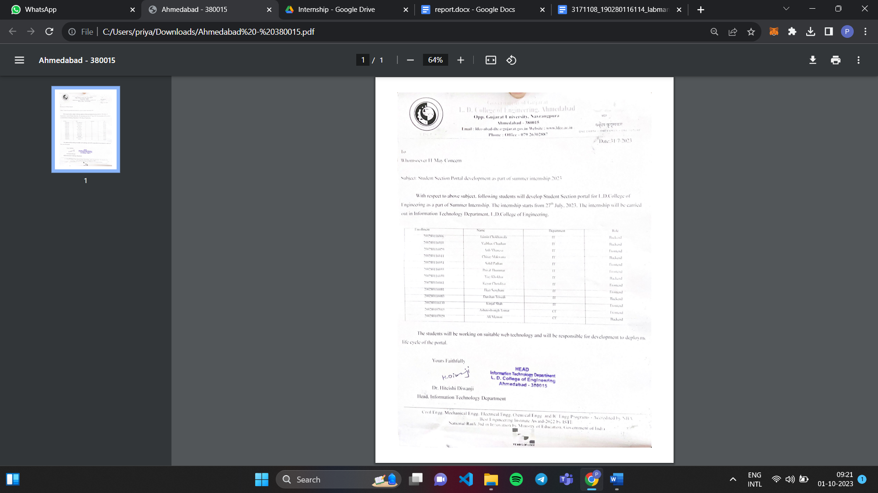

**Completion Certificate**

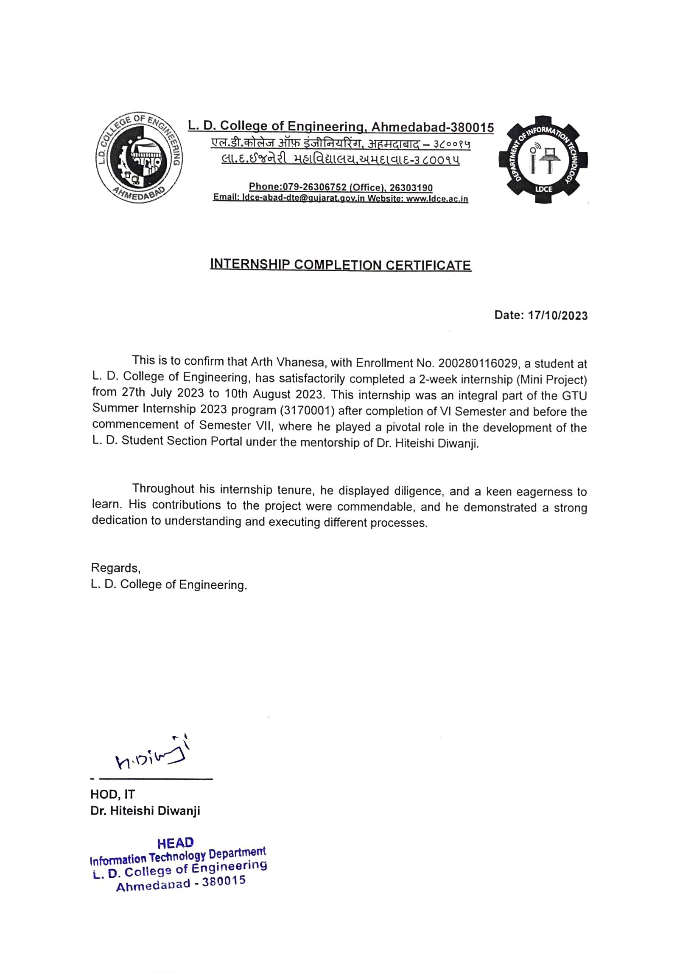

**L. D. College of Engineering**

**120, Circular Road, University Area, Ahmedabad, Gujarat 380015**

**SUMMER INTERNSHIP Weekly Report**

**Week No:** 1 **From:** 27th July, 2023 **To:** 2nd Aug, 2023

**Task Planned:**

In a collaborative team meeting, we examined the previously gathered project requirements, engaging in a comprehensive discussion concerning the strategic course for both the front-end and back-end development phases. During this discussion, important information was meticulously processed.

I took the responsibility of creating the project's folder structure and architecting the comprehensive set of routes for the front end. Moreover, I proactively undertook the task of crafting the login functionality, catering to students, department members, and administrators. Additionally, my mandate encompasses the creation of a dedicated student data dashboard, ensuring seamless data presentation to students. This initiative is slated for completion over the upcoming weekend.

**Task Completed:**

I successfully executed the designated tasks within the timeframe. The project's folder structure was thoughtfully organized and implemented, providing a robust foundation for seamless development and efficient collaboration among team members. The comprehensive set of routes for the front end was skillfully defined, ensuring a smooth and intuitive user experience.

Moreover, the login functionality was expertly crafted, catering to the unique authentication needs of students, department members, and administrators. This feature was thoroughly tested and integrated into the project, guaranteeing secure access and tailored privileges for each user category. Additionally, the student data dashboard was meticulously developed, presenting vital information.

Overall, each task was executed with precision and attention to detail, adhering to the established timeline and showcasing our team's dedication to achieving project objectives.

**Outcome:**

* 1. **Folder Structure and Route Set-up**

In the process of crafting an efficient and optimized project structure, I opted for React JS coupled with Vite to enhance development speed and overall performance. The initial step involved establishing a foundational folder structure based on Vite for React. Subsequently, careful attention was directed towards designing specialized folders to house essential components fundamental to the software, such as buttons and selection options. This segregation facilitated systematic organization and streamlined accessibility during the development phase.

|  |  |
| --- | --- |
| **CSS:** Contains fundamental styles. | **Partials:** Encapsulate specific sections of the pages. |
| **Components:** Components such as buttons, selection options etc. | **package.json** : managing project dependencies |

**Folder structure of the project:**

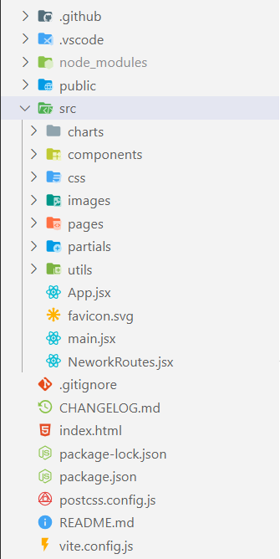 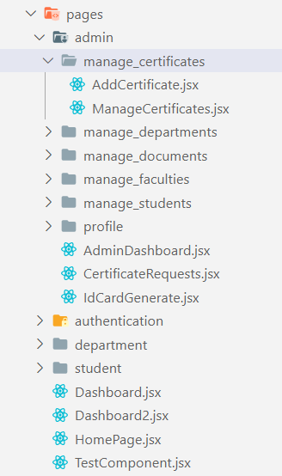

**Fig. 1.1 Root folder of project Fig. 1.2 Pages folder of project**

Within the project structure, a pivotal component is the "pages" directory, strategically organized to encapsulate the project's major functional modules: "admin" "department" and "student". These directories serve as a fundamental means of segregating and categorizing the distinct components associated with each module. Furthermore, within each of these principal folders, subdirectories have been established to delineate and organize the various options and functionalities available within their respective modules. This hierarchical structuring facilitates efficient development, maintenance, and navigation through the software, ensuring a streamlined and intuitive workflow for the project team.

**Pages folder structure:**

* Pages
  + Admin
    - manage_certificates
    - manage_departments
    - manage_faculties
    - manage_students
    - manage_documents
    - profile
  + Department
    - manage_requests
    - manage_students
    - profile
  + Student
    - profile
  + Authentication

All in all, this thoughtfully designed folder structure optimally served the project's development needs, contributing to an effective and systematic development process.

* 1. **Login Page**

The login page serves as the gateway to the system, ensuring secure and personalized access based on user credentials. For administrators, it provides exclusive access to administrative functionalities and empowers them to manage the platform efficiently. Departmental users can seamlessly log in to access specific departmental tools and resources tailored to their respective needs. Additionally, students are granted access to their academic profiles and related features, enhancing their overall user experience and engagement with the system. The implementation of this login page reflects a user-centric approach, facilitating a streamlined and intuitive login process for all stakeholders involved.

**Technical Details:**

This crucial feature encompasses a user interface elegantly designed to accommodate login actions for three distinct roles: "department", "student" and "admin". The login process commences with an intuitive interface where the user can select their role via a dropdown menu. Additionally, the interface prompts the user to input their credentials, namely, the username and password.

**Three roles for login:**

* Admin
* Student
* Department

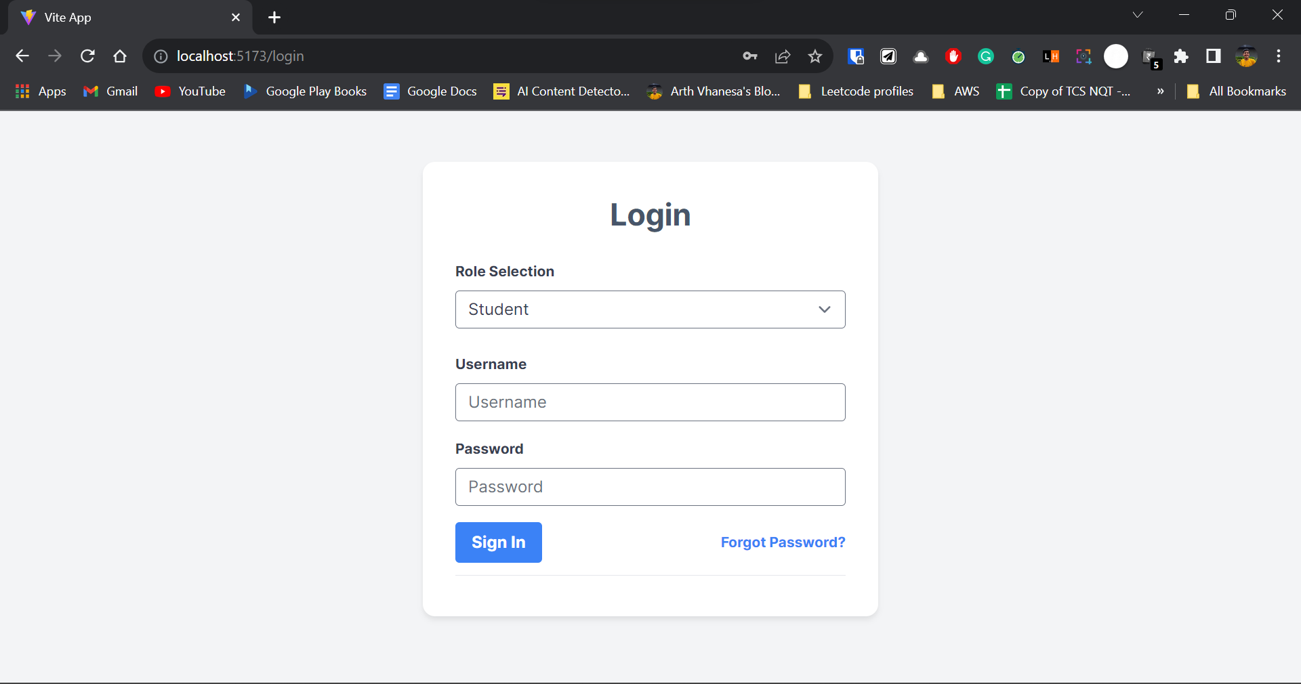

**Fig. 1.2 Login Page**

**How successful login is handled:**

Upon submission, a POST request is generated, transmitting the entered credentials to the backend for authentication and validation. The backend processes the data and verifies the provided username and password for legitimacy. In the event of valid credentials, the backend responds by issuing a JSON Web Token (JWT), a cryptographic token serving as an authorization mechanism. This JWT token is instrumental in enabling seamless access to the portal upon subsequent visits by the user. Notably, the token is securely stored in the local storage of the user's browser.

**How error is handled:**

Conversely, if an error is detected during the authentication process, the backend conveys an appropriate error message. This message is then elegantly displayed to the user on the front end, utilizing a toast message mechanism. The toast message presents a clear and unobtrusive manner of communicating errors, enhancing user experience by providing informative and timely feedback.

Overall, this login functionality serves as a cornerstone in enabling secure and tailored access to the portal, incorporating a user-centric approach to authentication.

* 1. **Student Dashboard**

The dashboard elegantly presents data such as contact information, course enrollment, certificates and more. The development of this student-centric dashboard underscores the project's commitment to enhancing the student experience by centralizing key information in a user-friendly and easily accessible manner.

**Feature:**

A significant aspect of our system is the student dashboard—a user-friendly feature designed to provide students with easy access to their essential information. Once students log in with their designated credentials, they are presented with a dashboard displaying a comprehensive array of personal and academic details.

**Details are shown to students:**

|  |  |  |  |
| --- | --- | --- | --- |
| **Personal Details** | **Family Details** | **Address** | **Education Details** |
| Enrollment Number  First Name  Middle Name  Last Name  Email  Contact Number  Date of Birth  Blood Group  Gender  Aadhar Card Number  Voter ID Number  Religion  Caste | Father Name  Mother Name  Father Occupation  Father Contact-Number  Office Address 1  Office Address 2  Office City  Office State  Office Country  Office Pin code  Mother Occupation  Family Income | Residential Address  Residential City  Residential State  Residential Country  Residential Pin code  Permanent Address  Permanent City  Permanent State  Permanent Country  Permanent Pin code | HSC Year  HSC Percentage  SSC Year  SSC Percentage  **Admission Details**  Course  Branch  Semester  Admission Year  Admission Category |

**Table 1.1 Details of the students**

This consolidated dashboard serves as a central hub, simplifying data retrieval and enhancing the overall user experience. Our aim is to ensure that this feature remains a valuable tool for students, providing them with quick and convenient access to their vital information, ultimately supporting their academic journey.

**Technical details:**

**How we get data from the database:**

From a technical perspective, the student dashboard feature leverages the GET method to request specific student data from the backend. When a student logs in using their credentials, a GET request is sent to the backend API, including the appropriate endpoint for student data retrieval. Notably, this request is authorized using a JSON Web Token (JWT) extracted from the local storage during login. The JWT token is included in the request header to ensure authentication and authorization for accessing the student's personalized data.

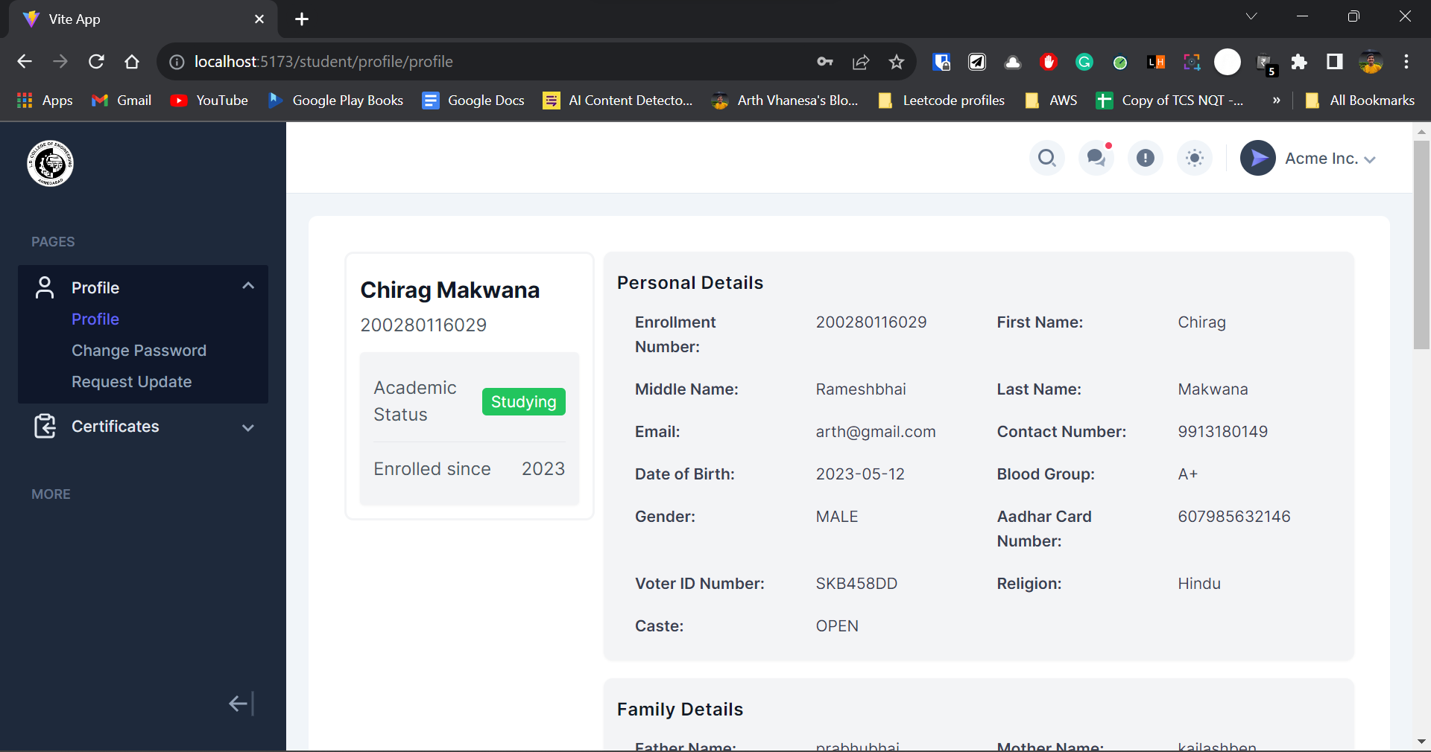

**Fig. 1.4 Student Dashboard Page**

**How we manage the data and API response on the front end:**

Upon receiving the response from the backend, the frontend utilizes React to handle the data. The retrieved data is parsed and the relevant states within the React application are set accordingly. In instances where specific details are not available in the response, the front end gracefully handles this scenario by displaying default blank or placeholder information for those particular data points.

**Access control and authorization:**

It is important to highlight that access to these details is conditional upon successful authorization; unauthorized access attempts are effectively denied. This security measure ensures that only authenticated users with the appropriate permissions can view and interact with the displayed information on the dashboard. By adhering to this authorization protocol, we maintain data privacy and uphold the security of the system while providing a seamless and informative user experience.

**L. D. College of Engineering**

**120, Circular Road, University Area, Ahmedabad, Gujarat 380015**

**SUMMER INTERNSHIP Weekly Report**

**Week No:** 2 **From:** 3rd Aug, 2023 **To:** 10th Aug, 2023

**Task Planned:**

During the second week of our internship, we initiated a team meeting to review the progress from the previous week. We were pleased to find that most of the tasks from the previous week had been completed, and we collaborated to finish any remaining work. Following this, we delved into planning to drive the project towards completion during the second week. To efficiently manage the workload, we analyzed the pending tasks and divided them accordingly.

I took on three significant tasks:

* Enhancing the student profile update functionality to allow students to request corrections to their information
* Incorporating a feature enabling students to request certificates.
* Certificate status page that allows students to track the progress of their certificate requests and download them once approved.

**Task Completed:**

In line with the task assignments from our planning session, I successfully completed the designated tasks during the second week of our internship. The enhancement of the student profile update functionality now enables students to request corrections to any inaccuracies in their information, enhancing data accuracy and completeness.

The implementation of the certificate request feature empowers students to seamlessly request certificates through the system, streamlining administrative processes. The creation of the certificate status page offers students a clear view of their certificate request progress, facilitating transparency and efficiency. These accomplishments align with our goal of advancing the project towards its successful completion.

**Outcome:**

**2.1 Student data update page**

**Feature:**

The student data update page is a crucial feature designed to empower students to actively manage and update their personal profiles. Students can review their existing information, including contact details, and other relevant data. Moreover, this page facilitates a seamless process for students to request updates or modifications to their records. Through a user-friendly interface, students can submit requests for changes, such as updated contact information, and recent achievements.

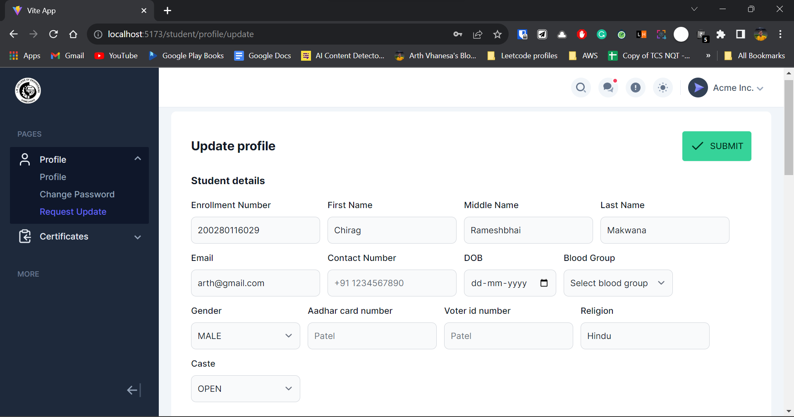

**Fig. 2.1 Student data update page**

**Technical details:**

From a technical standpoint, this feature operates with three distinct status categories: "request update" "update request approved" and "submitted details". When a student identifies a need for changes in their data, they initiate a request for an update. This request undergoes a validation process, where it can be approved by the department.

**Three statuses of the request:**

* Request update
* Update request approved
* Submitted details

Post-approval, the student is granted a 24-hour window to effectuate the necessary updates. During this time, the status of the request is designated as "request approved". Once the student successfully updates the data and submits it, the changes are reflected in the database.

All data from the student profile is not allowed to be updated by the student considering the integrity of the student portal. Here are the fields that can be updated by students:

**Data allowed to be updated by students:**

|  |  |  |
| --- | --- | --- |
| **Personal Details** | **Family Details** | **Address** |
| Email  Contact Number  Blood Group  Gender  Voter ID Number  Religion  Caste | Father Name  Mother Name  Father Occupation  Father Contact-Number  Office Address 1  Office Address 2  Office City  Office State  Office Country  Office Pin code  Mother Occupation  Family Income | Residential Address  Residential City  Residential State  Residential Country  Residential Pin code  Permanent Address  Permanent City  Permanent State  Permanent Country  Permanent Pin code |

**Table 2.1 Details of the students**

**How is the 24-hour update window managed:**

Crucially, the update process is facilitated through a POST request, ensuring secure and authenticated data transmission. To manage the 24-hour update window, the system records the approval time and calculates the endpoint for the 24-hour period from that moment. This approach prevents unnecessary and unauthorized alterations to student data, emphasizing data accuracy and integrity.

**2.2 Request certificate (Student dashboard):**

**Feature:**

This feature allows students to efficiently request various certificates they may require. This seamless functionality enhances administrative efficiency by automating the certificate request process, reducing paperwork, and providing students with a convenient and centralized platform to request and track their certificate requests.

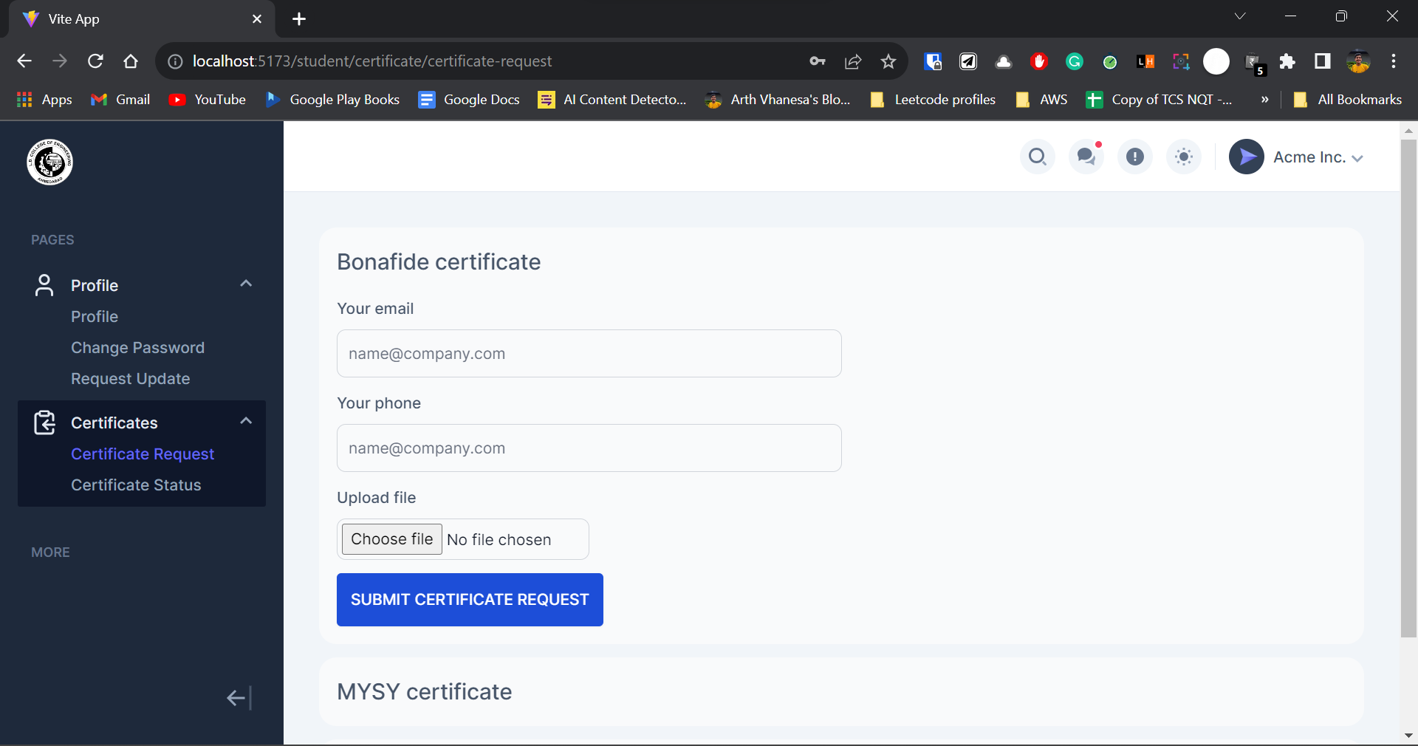

**Fig. 2.2 Request certificate page (Student dashboard)**

**Technical details:**

**Where to get certificate types:**

From a technical perspective, the feature capitalizes on pre-stored certificate types created and saved by administrators. Each certificate type is associated with specific approval criteria, including email, phone, and required documents for validation.

On the user interface, all available certificate types are dynamically retrieved from the database and presented on the request page. Students can then select the desired certificate and input necessary details such as email, phone, enrollment information, and relevant files through the user-friendly dashboard.

**How we manage to request a certificate:**

The certificate request submission utilizes a POST request, transmitting the gathered data to the designated endpoint for database storage upon clicking the submit button. Once submitted, the request is displayed on the certificate management page with a "pending" status.

**Status of request:**

* Pending
* Approved

**When we change status of request:**

Certificates have two primary statuses: "pending" and "approved". Upon approval by the department, the status transitions to "approved", allowing the student to download the requested certificate, and complete the request process seamlessly.

In summary, this feature optimizes administrative processes, offering students an efficient way to request certificates and track their progress. The technical implementation involves utilizing predefined certificate types, employing a POST request for data submission, and managing request statuses for a seamless user experience.

**2.3 Manage certificate requests (Student dashboard):**

I have developed a dedicated page where students can access and manage all their requested and approved certificates. Once a certificate request is approved, students can easily download the respective certificates from this page.

**Benefit:**

This feature saves students time and effort by providing a centralized location to view and retrieve their certificates. It enhances the user experience by offering a one-stop platform for managing and obtaining important certificates, contributing to a smoother administrative process for both students and staff.

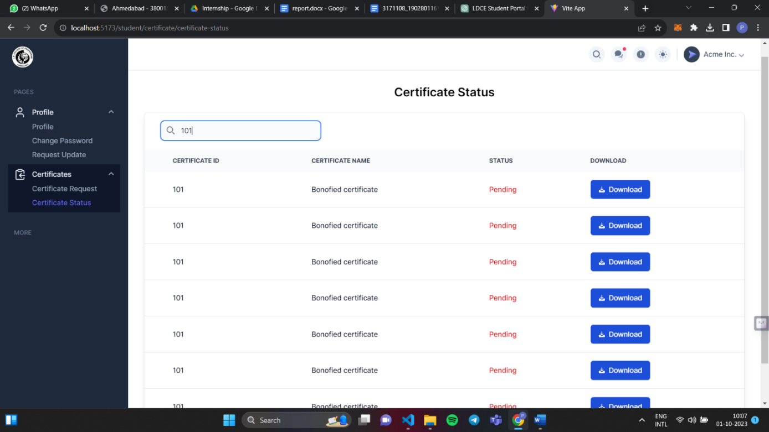

**Fig. 2.3 Manage certificate requests page (Student dashboard)**

**Technical details:**

**How we get details of the request:**

In the technical aspect of this feature, a dedicated dashboard displays essential certificate details like certificate ID, certificate name, status, and a download button for each certificate. To populate this information, a GET request is made to the database using the student's JSON Web Token (JWT). This request fetches all certificate requests associated with the logged-in student and presents them on the dashboard.

**Details shown to student: (View Fig. 2.3)**

* Certificate ID
* Certificate name
* Status
* Download button

**How we change the status on the request page:**

The status of each certificate request is automatically updated with every page refresh through requests sent to the server. When an admin approves a certificate request, the status changes to "approved" and the response from this request includes the document, which is the certificate file.

**How students can download certificates:**

This certificate file is made accessible to the student for download through the "download" button. Importantly, this functionality is exclusively available to logged-in students to ensure authenticity and data security.

**Summary of Technical Details:**

This feature enables students to view and manage their certificate requests through a dashboard displaying the Certificate ID, name, status, and a download button. Data is populated by making a GET request to the database using the student's JWT. The status updates automatically on page refresh through server requests. Upon approval by an admin, the status changes to "approved," and the associated certificate file becomes downloadable for the respective student, promoting a secure and convenient user experience.

**SUMMER INTERNSHIP/TRAINING FEEDBACK FORM**

**(Information Technology department, LDCE)**

**Student name:** Vhanesa Arth Bhikhabhai

**Address:** E-901 Shukan Rivera, Surat - 395004

**Mail id:** arthbvhanesa2853@gmail.com **Mobile number:** 9316358558

**Internship Company:** LDCE

**Dates of internship:** 27th July, 2023 to 10th Aug, 2023

**Grade From 1 To 5 1-Not Sure, 2-Strongly Disagree, 3- Disagree, 4- Agree, 5- Strongly Agree**

|  |  |
| --- | --- |
| **Sr. No.** | **Grade** |
| 1 Internship helped improve the subject knowledge? |  |
| 2 It helped you get some insight into the project work to be carried out/ the project you want to pursue. |  |
| 3 Various tasks/Assignments given to you helped you with the learning experience. |  |
| 4 Did the internship involve the use of modern Engineering tools/IT tools? |  |
| 5 Did it help you to acquire skills like writing skills, communication and presentation skills, interpersonal skills, analytic skills etc.. |  |
| 6 Have you made presentation of what you learnt, in front of your faculty mentor and other students? |  |
| 7 Did it help you in any way to inculcate work place /professional ethics? |  |
| 8 Did it develop in you the spirit of working in a team? |  |
| 9 Will this internship be relevant and meaningful to your short/ long-term career interests? |  |
| 10 Any other points you want to share. |  |

**Sign of student**