Team ID :- 254037

# WEHEAR WEB DEVELOPER INTERNSHIP

## AN INTERNSHIP REPORT

***Submitted by***

# SOHAM PANKAJKUMAR PATEL

## 190280116118

***In partial fulfillment for the award of the degree of***

# BACHELOR OF ENGINEERING

***In***

***INFORMATION TECHNOLOGY L.D.COLLEGE OF ENGINEERING, AHMEDABAD***



# Gujarat Technological University, Ahmedabad

## [JULY, 2022]

 

# LD COLLEGE OF ENGINEERING, AHMEDABAD

Opp. Gujarat University, Navrangpura, Ahmedabad - 380015

# CERTIFICATE

This is to certify that the project report submitted along with the project entitled **WeHear Web Developer Internship** has been carried out by **Soham pankajkumar patel** under my guidance in partial fulfillment for the degree of Bachelor of Engineering in Information Technology, 7th Semester of Gujarat Technological University, Ahmedabad during the academic year 2022-23.

Prof. Mital Panchal Dr. Hiteishi Diwanji

**Internal Guide Head of Department**

**JOINING LETTER**

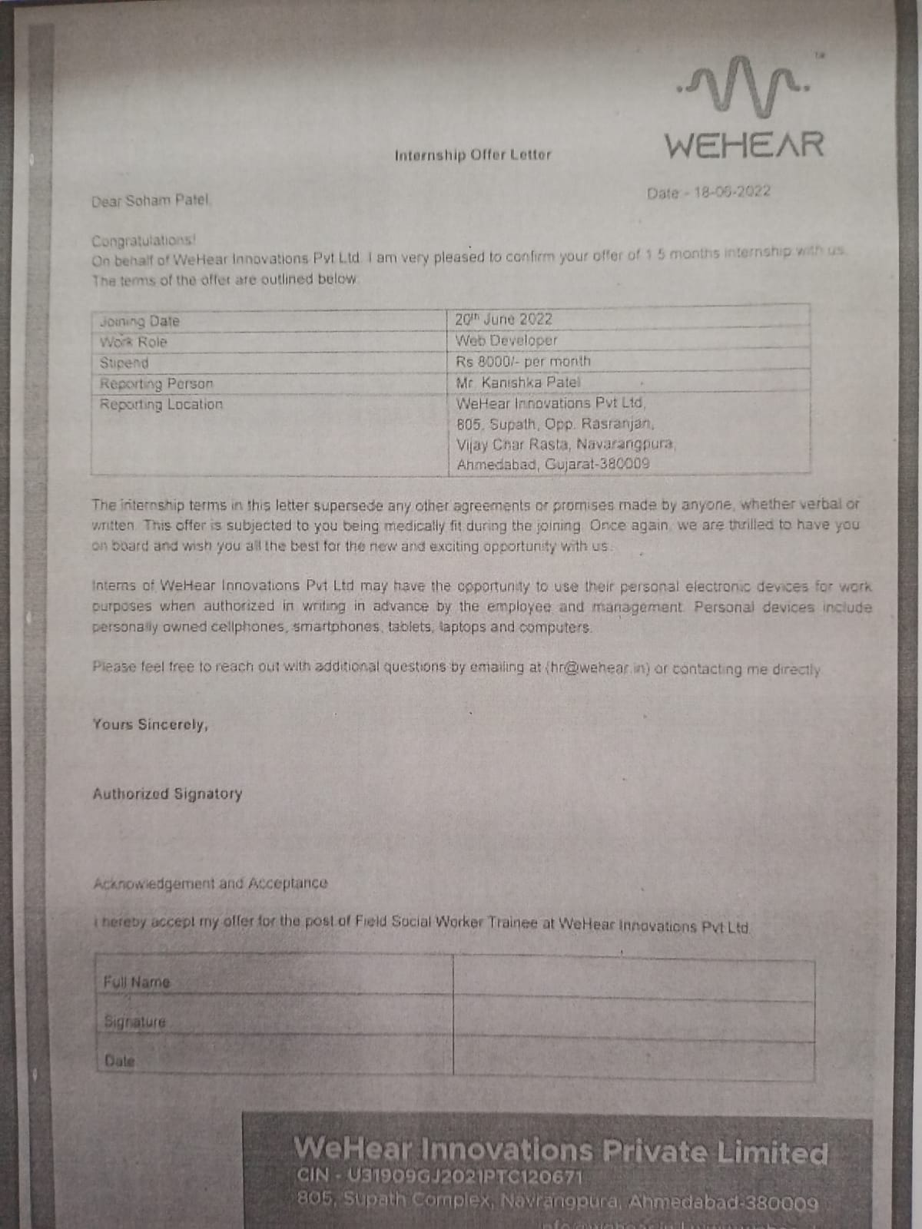

**COMPLETION CERTIFICATE**

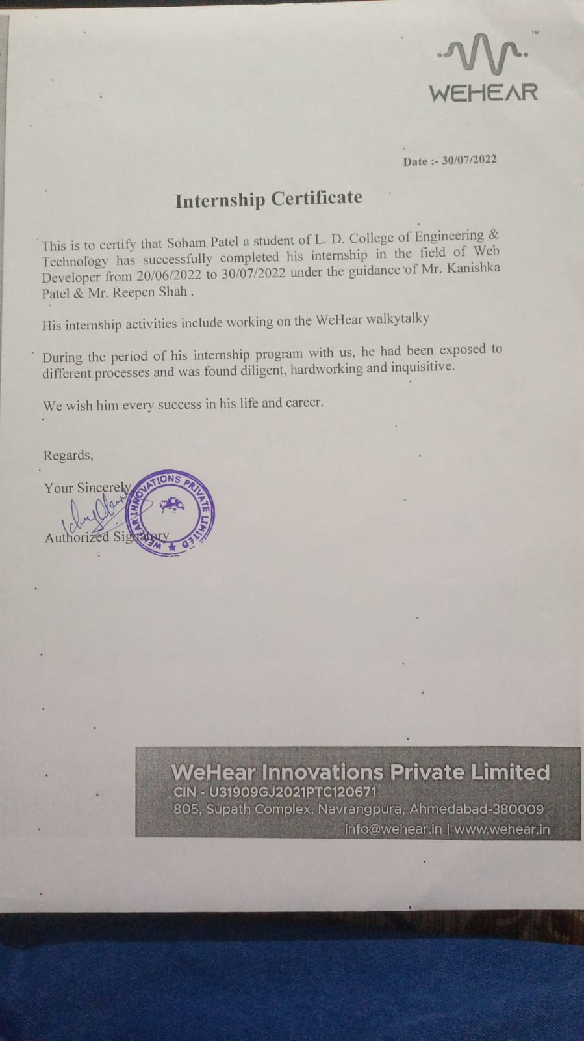

 

# LD COLLEGE OF ENGINEERING, AHMEDABAD

Opp. Gujarat University, Navrangpura, Ahmedabad - 380015

# DECLARATION

We hereby declare that the Internship report submitted along with the Internship entitled **WeHear Web Developer Internship** submitted in partial fulfillment for the degree of Bachelor of Engineering in Information Technology to Gujarat Technological University, Ahmedabad, is a bonafide record of original project work carried out by me at WeHear Innovations Pvt. Ltd. underthe supervision of **Kanishka Patel (C.E.O)** and that no part of this report has been directly copiedfrom any students reports or taken from any other source, without providing due reference.

Name of The Student Sign of Student

1 Soham P. Patel

**Acknowledgement**

To begin, I would like to express my gratitude to my respected professor, **Prof. Mital Panchal**, for providing me with the required advice and knowledge to finish this internship report. Is appreciate encouragement, understanding, and insightful support provided throughout the semester.

**Dr. Hiteishi Diwanji**, Head of Information Technology Department, LD College of Engineering, Ahmedabad, has been a constant source of inspiration and motivation for us.

Also, I'd like to express my gratitude to **Kanishka Patel (C.E.O)** for patiently teaching me the fundamentals of my job and mentoring me during my internship.

Your Sincerely,

**Soham Patel (190280116118)**

# ABSTRACT

With a constant rise in unsafe listening practices, it has been predicted by WHO that over 1 billion young adults are at risk of permanent or avoidable hearing loss. Amidst the absence of awareness regarding audio care and markets being flooded with audio devices which are bound to cause hearing loss. These devices also come with an app aa the companion but, these apps do not really enhance the experience of their device.

WeHear OX is a device which is based on the bone-conduction technology and it come with an app which totally changes the user experience of the device. WeHear Ox is an app which comes with some exceptional feature like OX Translator, Learn a Language, Multilingual Chat, Hearing aid etc.

There is no platform that allows to communicate with people in multiple languages. If you are doing business on a global level then you need to have communication with people from different countries with different languages, sometimes it is difficult to communicate everything in the common language but if both parties communicate through their preferred language, then it is easy to expand the business.

A Chat application is the best way to create communication between clients and customers and keep them updated about the offers, deals of your business. WeConverse is a real-time multilingual chat app that enables realtime communications, generally in the form of text and audio messages between two or more users. Unlike other chat apps, this application allows the users to chat in their preferred language.

**Table of Contents**

|  |  |  |  |  |
| --- | --- | --- | --- | --- |
|  | **Title** | | | **Page**  **No.** |
|  | Cover page | | |  |
|  | First page | | | i |
|  | College certificate | | | ii |
|  | Joining Letter | | | iii |
|  | Completion certificate | | | iv |
|  | Candidate’s declaration | | | v |
|  | Acknowledgement | | | vi |
|  | Abstract | | | vii |
|  | Table of contents | | | viii |
|  |  | | |  |
| **1** | Overview of the company | | | 1 |
|  | 1.1 | History | | 1 |
|  |  | | |  |
| **2** | Overview of different process being carried out in the  Company | | | 2 |
|  | 2.1 | Schematic layout | | 2 |
|  | 2.2 | Detail of stages in production | | 3 |
|  |  | | |  |
| **3** | Introduction to internship and internship management | | | 4 |
|  | 3.1 | Objective | | 4 |
|  | 3.2 | Technology and literature review | | 4 |
|  |  | 3.2.1 | NODE JS | 4 |
|  |  | 3.2.2 | React JS | 4 |
|  |  | 3.2.3 | Firebase & mongoDB | 4 |

|  |  |  |  |
| --- | --- | --- | --- |
| **5.0** |  | Weekly Reports | 5 |
|  |  | |  |
| **6.0** |  | Feedback Form | 17 |
|  |  | |  |
| **7.0** |  | References | 18 |

# OVERVIEW OF COMPANY

## 1.1 About

WeHear is India’s first hearing care company developing the products to make your day to day hearing habits more ear-health friendly.

Our main goal is to be the pioneer of hearing care community & provide ear-health friendly hearing solutions powered by our technologies.

# OVERVIEW OF DIFFERENT DEPARTMENT OF THE ORGANIZATION

## PREPARE SCHEMATIC LAYOUT WHICH SHOWS THE SEQUENCE OF OPERATION FOR MANUFACTURING OF END PROJECT

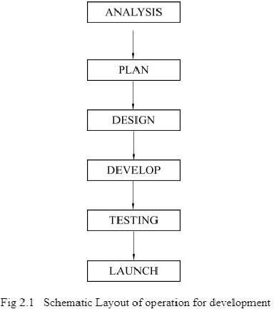

* 1. **EXPLAIN IN DETAILS ABOUT EACH STAGE OF PRODUCTION**

### ANALYSIS

They analyze, refine, and scrutinize the gathered requirements to make consistent and unambiguous requirements. This activity reviews all requirements and may provide a graphical view of the entire system.

### PLAN

In this stage team perform size and cost estimation, development time, resources requirement and project scheduling.

### DESIGN

Software design is the process by which an agent generates a specification for a software artifact that is meant to achieve goals and is based on a set of primitive components and restrictions.

### DEVELOP

They apply engineering principles to the process of building software. Using programming

languages like javascript and markup languages like HTML,CSS ete. they design software

for Web apps..

### TESTING

Check the developed product to ensure that the desired functionality is being provided by it. It involves manual testing of all functionality of software. Assesses the software for errors and bugs if there any.

### LAUNCH

In this phase deploy the created products in real world and give it to the users after perform testing of all modules.

# INTRODUCTION TO INTERNSHIP

## OBJECTIVE

* + - To add more features to existing app.
    - To optimize the code base.
    - To make the code more modular in terms of cohesion and coupling.
    - To help people with hearing disability and let them hear the world with the company’s device.

## TECHNOLOGY AND LITERATURE REVIEW

### Node js (Express JS)

* + - * Node js is open source javascript development kit, which provide server side

development using javascript, it gives non blocking functionality though it is

single threaded.

* + - * Express js is framework of node js which gives perbuild function and middleware

### React Js

* + - * React js is front-end library use to create SPA(single page application).It is light

weight and efficient coding stratergies.

### FIREBASE

* + - * Google Firebase is a Google-backed application development software that enables developers to develop iOS, Android and Web apps. Firebase provides tools for tracking analytics, reporting and fixing app crashes, creating marketing and product experiment.

# INTERNSHIP DETAILS

|  |  |
| --- | --- |
| INTERNSHIP TITLE: | Web Developer Intern |
| INTERN NAME: | Soham Patel |
| ENROLLMENT NO: | 190280116118 |
| MAIL ID: | [sohampatel9403@gmail.com](mailto:sohampatel9403@gmail.com) |
| MOBILE NUMBER: | +91 8320911631 |
| INTERNSHIP COMPANY NAME: | WeHear Innovations Pvt Ltd |
| DURATION: | 1.5 MONTHS |
| DATES OF INTERNSHIP: | 20 June2022 TO 30 July 2022 |
| CONTACT DETAILS (COMPANY): | Kanishka Patel (CEO) -> +91 7600105991 |
| TOOLS AND TECHNOLOGY: | MERN , firebase |
| NATURE OF INTERNSHIP: | Online |
| STIPEND RECEIVED: | YES |
| STIPEND AMOUNT: | 7000 |

### Guide Sign:

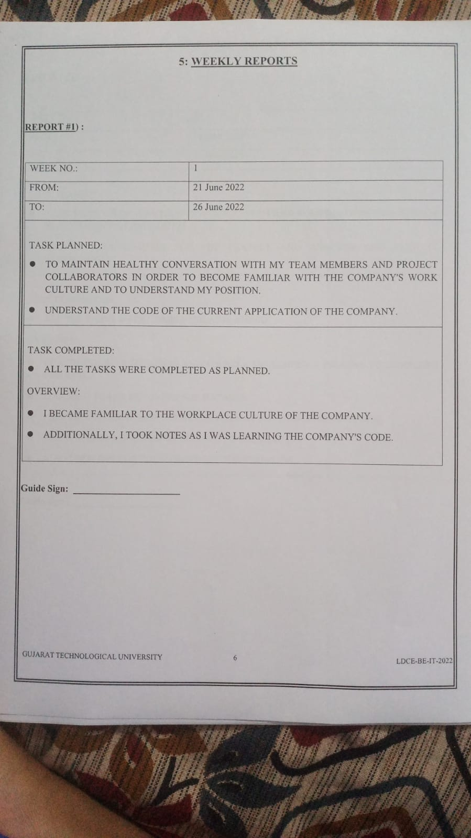

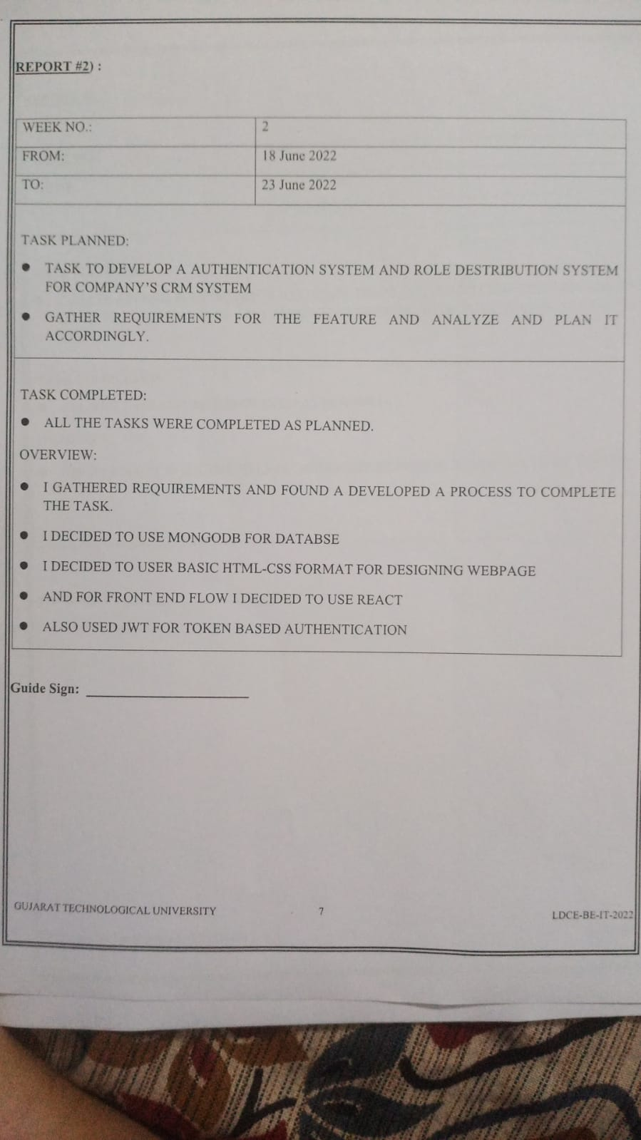

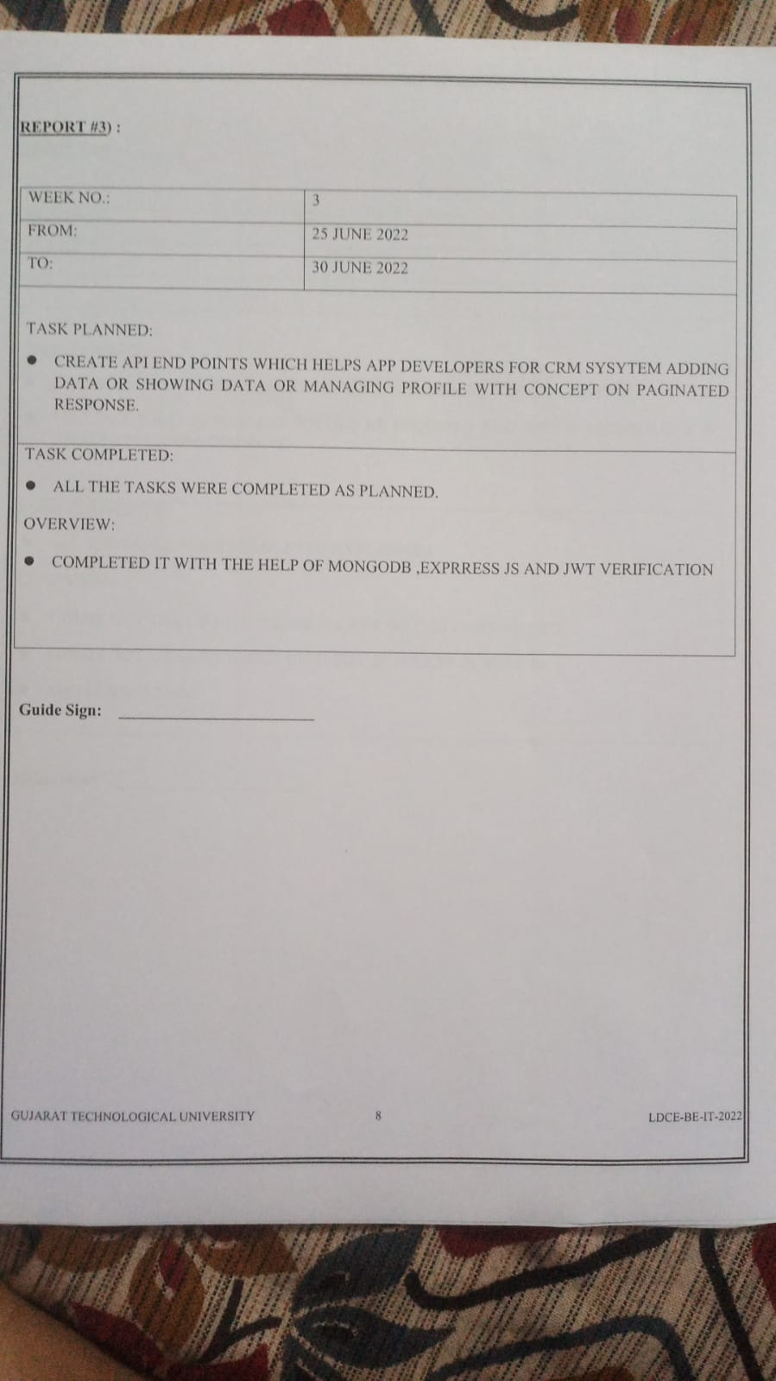

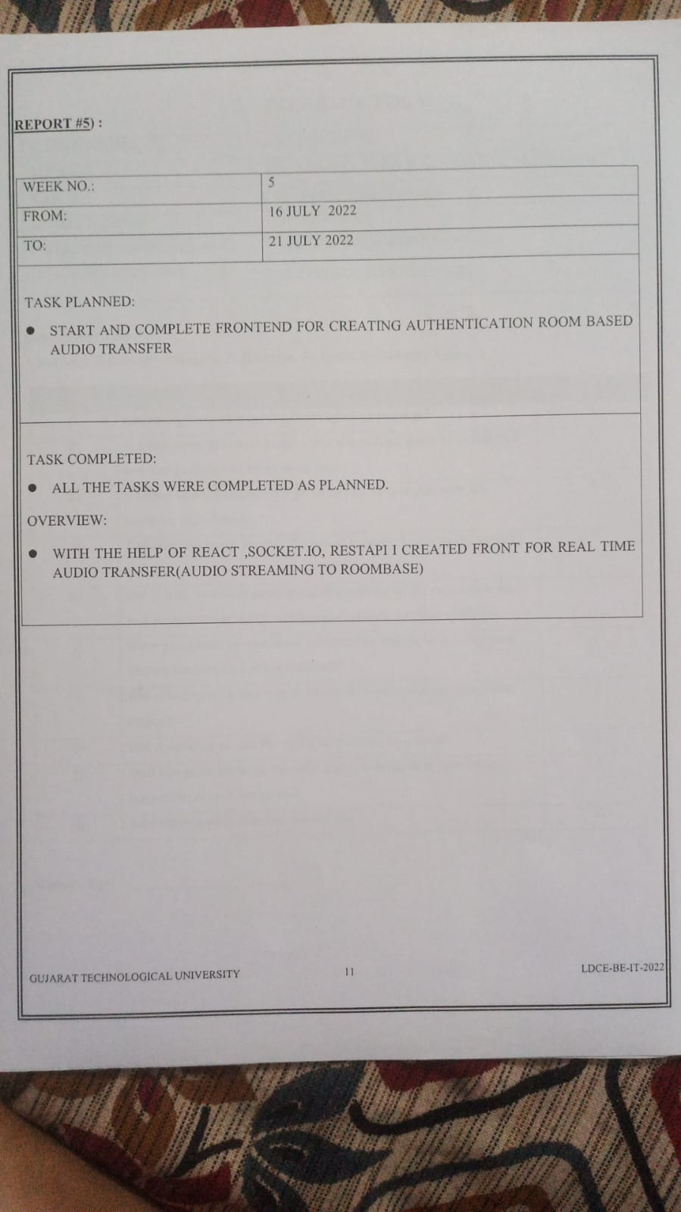

# FEEDBACK FORM

|  |  |
| --- | --- |
| STUDENT NAME: | Soham Patel |
| ADDRESS: | A-19 Tridev Park soc.,vastral road ahemdaabd |
| MAIL ID: | [sohapatel9403@gmail.com](mailto:sohapatel9403@gmail.com) |
| MOBILE NUMBER: | +91 8320911631 |
| INTERNSHIP COMPANY NAME: | WEHEAR INNOVATIONS PVT LTD |
| DATES OF INTERNSHIP: | 20 June2022 TO 30 July 2022 |

### Grade From 1 To 5 : -

**1-Not Sure, 2-Strongly Disagree, 3- Disagree, 4- Agree, 5- Strongly Agree.**

|  |  |  |
| --- | --- | --- |
| **Sr.No.** | **TITLE** | **Grade** |
| **1)** | **Internship helped improve the subject knowledge?** | **5** |
| **2)** | **It helped you get some insight into the project work to be carried**  **out/ the project you want to pursue.** | **5** |
| **3)** | **Various tasks/Assignments given to you helped you with the**  **learning experience.** | **5** |
| **4)** | **Did the internship involve the use of modern Engineering tools/IT**  **tools?** | **5** |
| **5)** | **Did it help you to acquire skills like writing skills, communication**  **and presentation skills, interpersonal skills, analytic skills etc.** | **4** |
| **6)** | **Have you made presentation of what you learnt, in front of your**  **faculty mentor and other students?** | **2** |
| **7)** | **Did it help you in any way to inculcate work place /professional**  **ethics ?** | **5** |
| **8)** | **Did it develop in you the spirit of working in a team?** | **5** |
| **9)** | **Will this internship be relevant and meaningful to your short/**  **long-term career interests ?** | **5** |
| **10)** | **Any other points you want to share?** | **2** |

### Student Sign:

**7 . References**

**Recat:**- <https://reactjs.org/>

**Vs Code:-** https://code.visualstudio.com/docs **Firebase :-** <https://firebase.google.com/docs>

**Node JS:-** <https://nodejs.org/docs>