Pimpri Chinchwad Education Trust’s

**Pimpri Chinchwad College of Engineering**



**Department of Computer Engineering**

**Project Report**

on

**“*TRIP BILL GENERATOR*”**

under

**Project Based Learning – I**

Academic year 2021-22

by

|  |  |
| --- | --- |
| Roll numbers | Name of the student |
| SYCOA37 | YASH CHINCHOLE |
| SYCOA26 | SAHIL BOBMLE |
| SYCOA25 | ATHARVA BOKADE |
| SYCOA35 | VIJAY CHAURE |

**Index**

1. Problem Statement
2. Details of object oriented programming features used
3. Pseudo-code of the project
4. Output screen shots
5. References (Books/ Notes/ Web Links )

**Problem statement**

You want to plan a trip to a new destination, and you want to make the most of your time there. You have a budget in mind and a list of places you want to visit, but you're not sure how to plan the logistics of the trip. You need to figure out the best way to get to your destination, where to stay, and how to get around once you're there. You also want to make sure you have enough time to see everything you want to see and leave some time for relaxation or unexpected events.

"Given a set of destinations, available modes of transportation, and constraints on time and budget, find an itinerary that maximizes enjoyment while minimizing cost and time."

This problem can be broken down into several subproblems, such as finding the cheapest flights or determining the most efficient route to take. It may also involve making decisions about where to stay and what activities to do at each destination.

**Details of OOP features used**

**Class Objects:**

We used class to make three different classes:

* Bill class
* Hotel Class
* Travel class

Containing attributes like total bill, Travel destination and package information

**Constructor:**

We have used constructor and destructor to initialise variables and function that needed to be called on object creation and set the values accordingly as required by our program

**Inheritance:**

In this Program we have used a type of inheritance called multilevel inheritance

In this, we transfer the required class properties from one to another maintaining a “level” like structure

travel

bill

hotel

**File handling:**

In our program we need to have a file for bill generation and this file will generate bill and travel generation.

For this purpose we used fstream (file handling) to open and generate a file.

**Exception handling:**

To avoid exceptions and unexpected errors that could have happened in our project we used “try” to find the exception

And then in “catch” statement we handled the error accordingly

Corresponding image shows try and catch demonstration in our project

**PSEUDO-CODE**

START :

Step 1 :

get user info

Step 2 :

get info about travel destination

Step 3 :

select characteristics of trip

Step 4 :

get required info about travel

Step 5 :

calculate bill according to selected options

Step 6 :

create a new file and add bill data into it

Step 7 :

prints the calculated bill

EXIT

**OUTPUT**

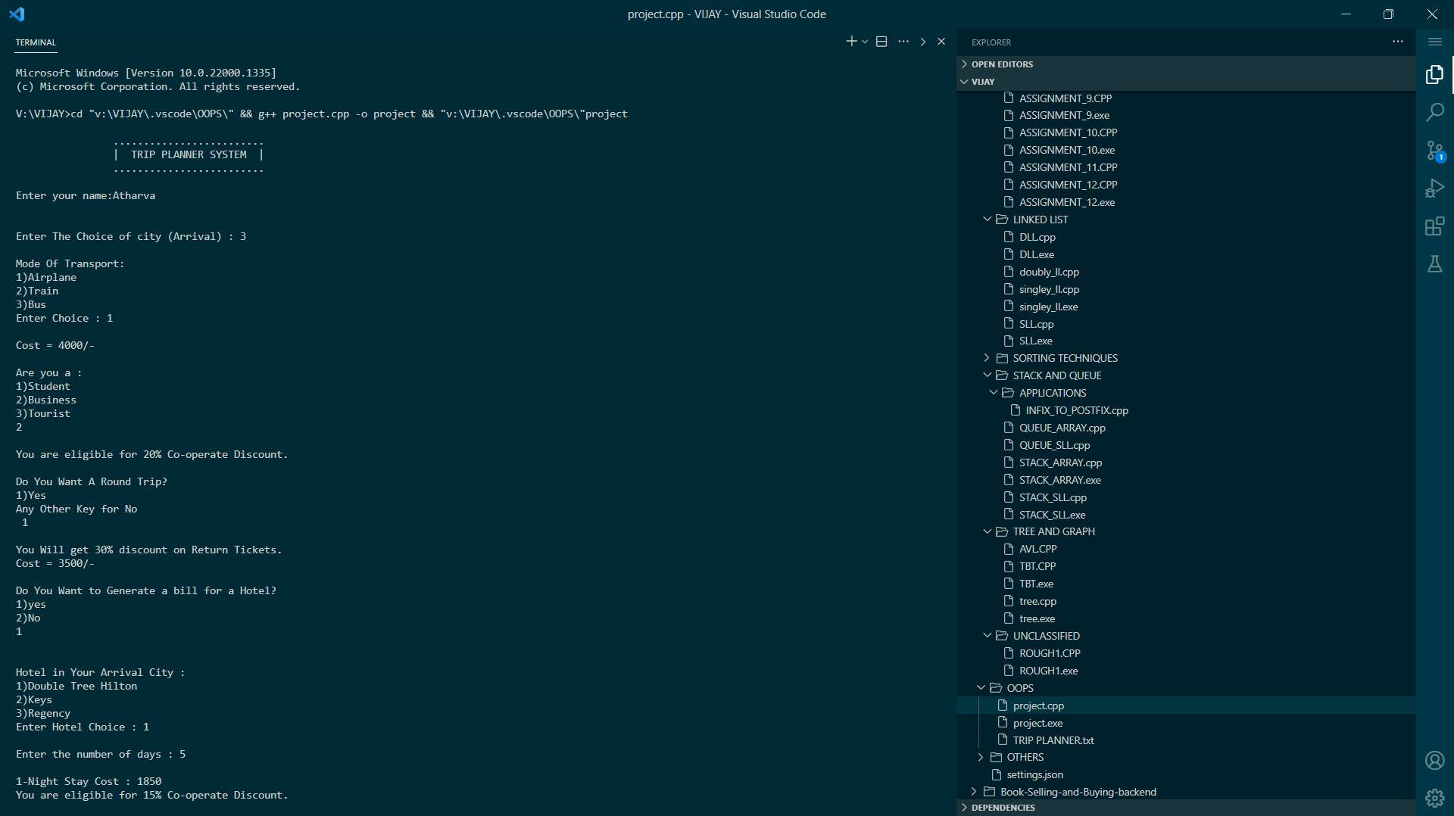 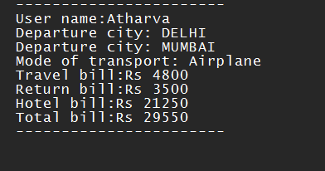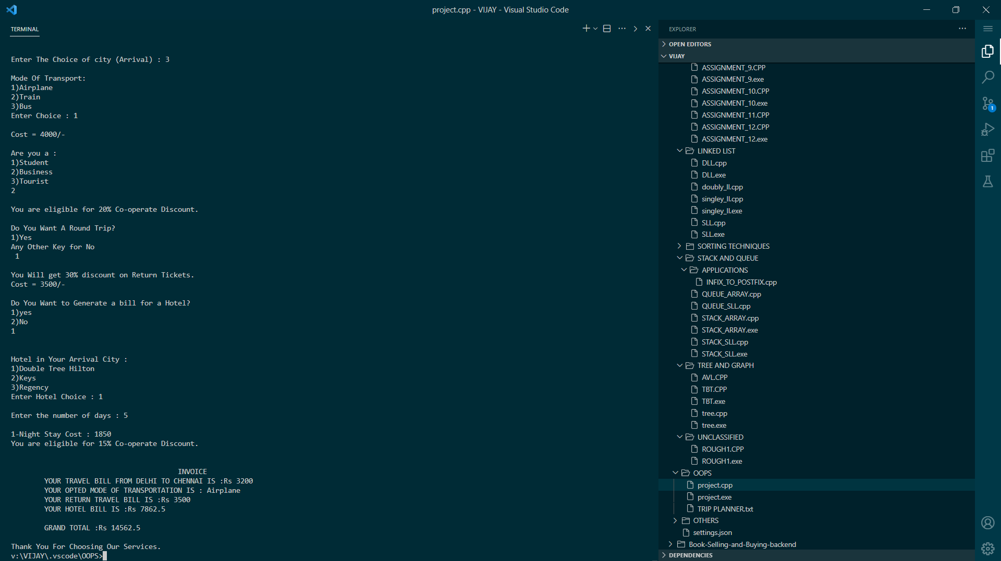

**References (Books/ Notes/ Web Links )**

Book - Balaguruswami for OOP

Links :

<https://geeksforgeeks.org/>

https://cplusplus.com/