Report on terrorism in India
Yash Choubey

Plotting of data on maps:

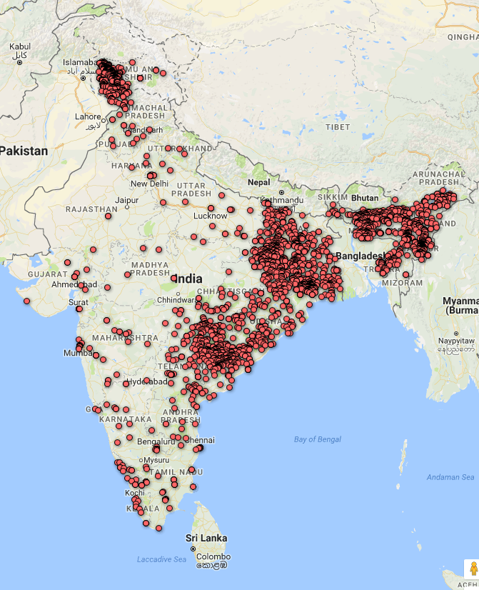

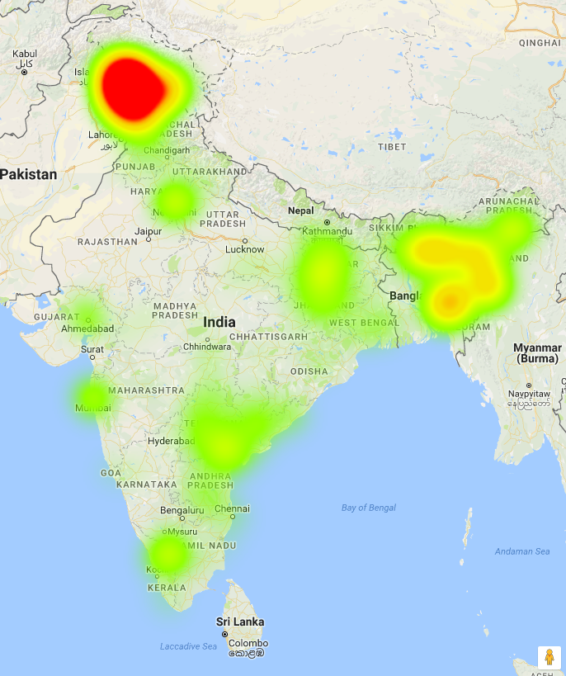Illustration 1: Heat map of data points

I analysed the given data and came to the following conslusions:

1) Terrorism is increasing at the alarming rate :

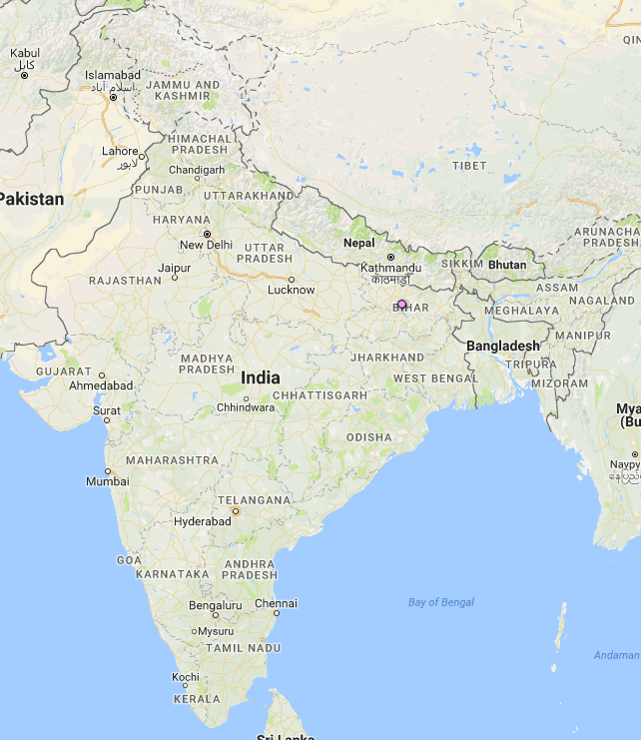Illustration 2: Terrorist attacks between 1975-95

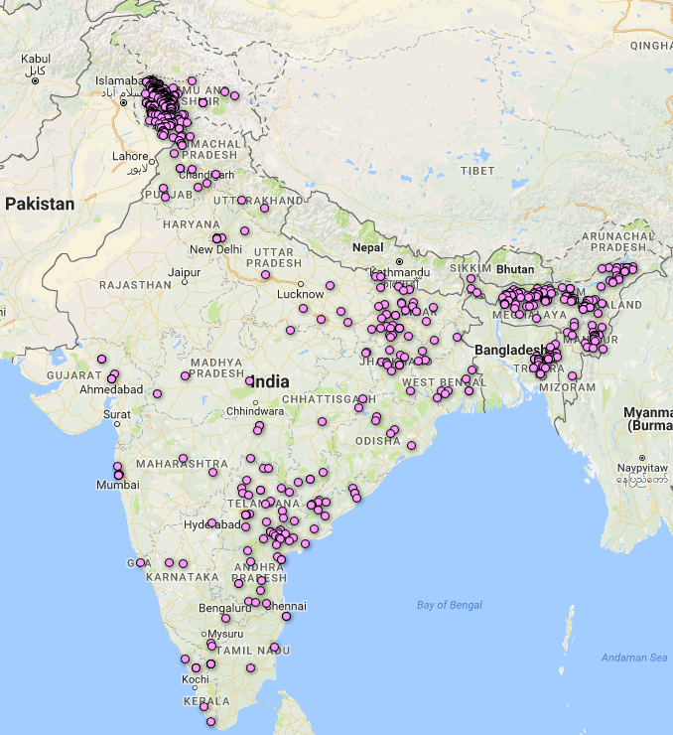Illustration 3: Terrorist attacks between 1995-2005

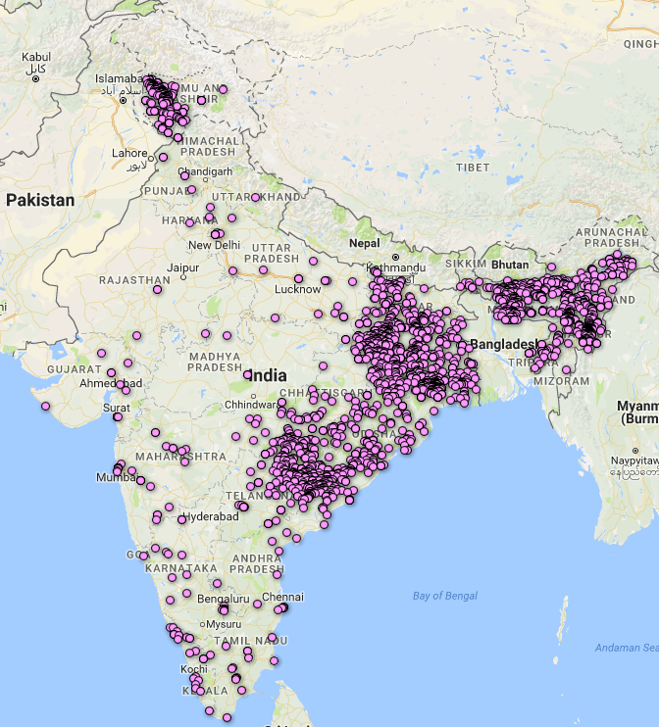Illustration 4: Terrorist attacks between 2005-15

2) Terrorist groups are region specific:
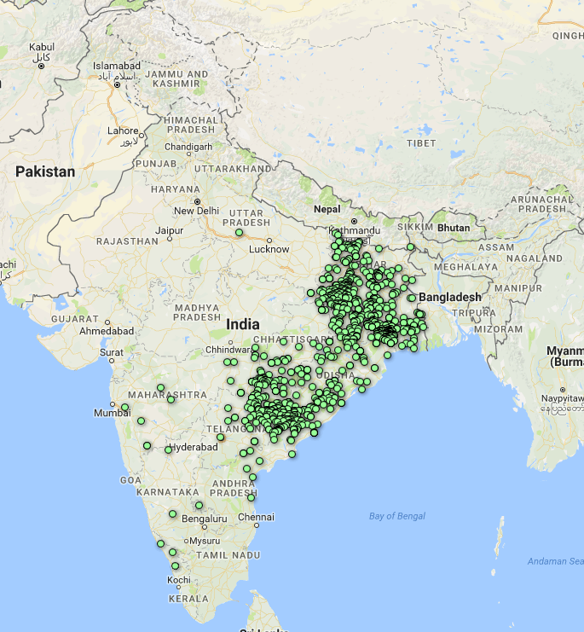Illustration 5: Attacks by CPI-M

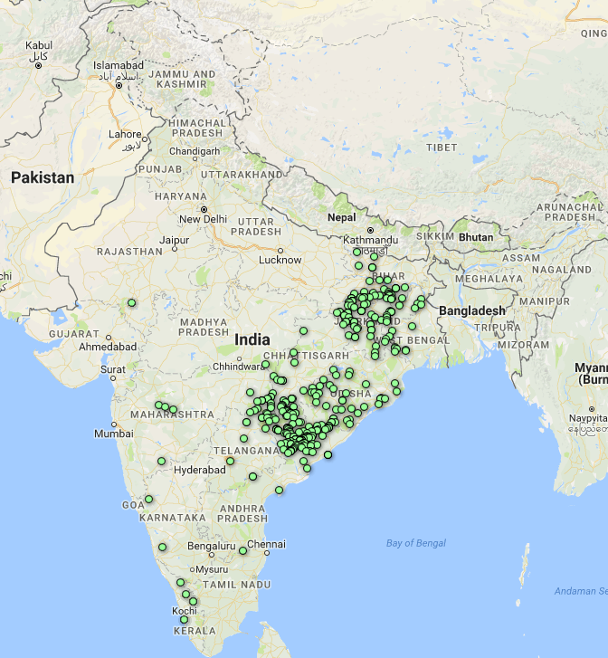Illustration 6: Attacks Maoist

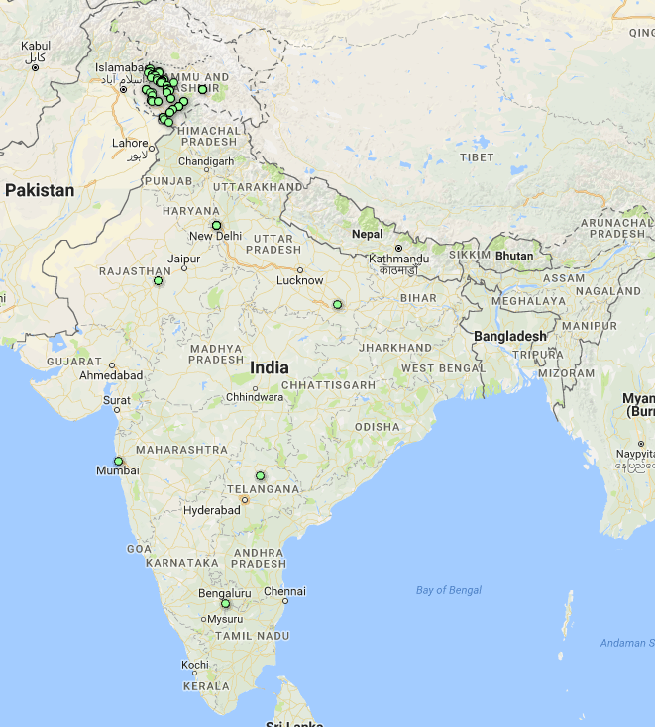Illustration 7: Attacks by Let and HM

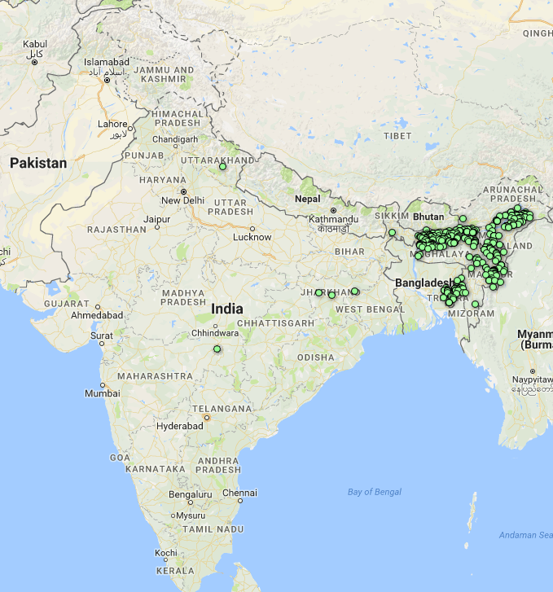Illustration 8: Attacks by NDFB/ULFA/PLA/NLFT

3) We cannot segregate region on basis of type of attack:
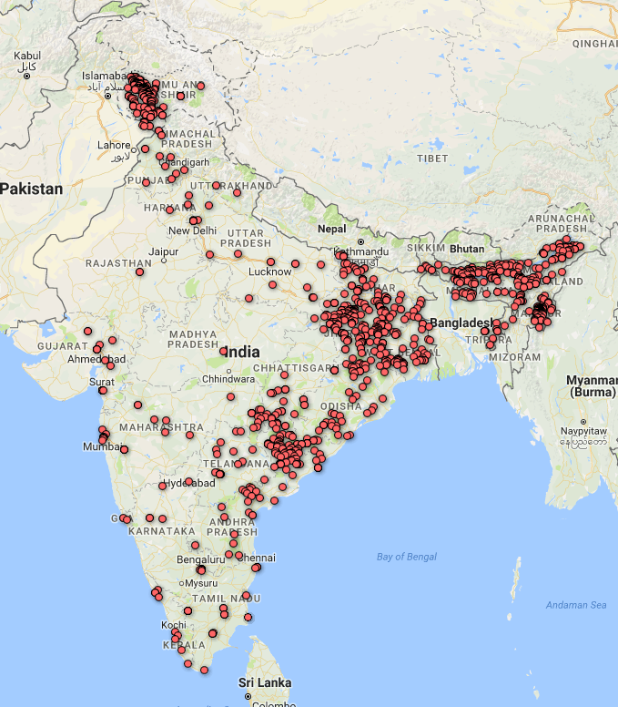Illustration 9: Use of bombs+explosives

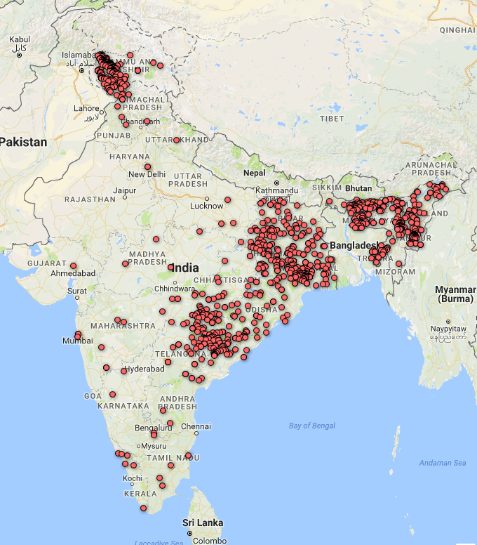Illustration 10: Use of firearms

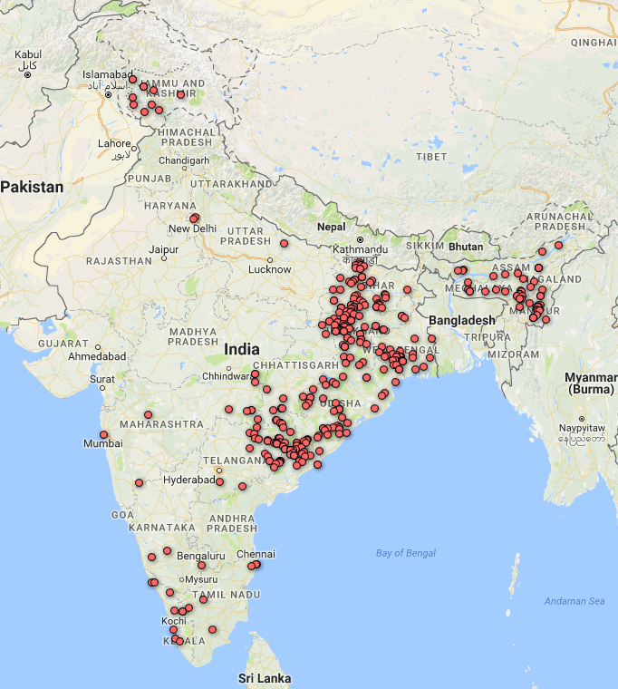Illustration 11: Facility and infrastructure attack

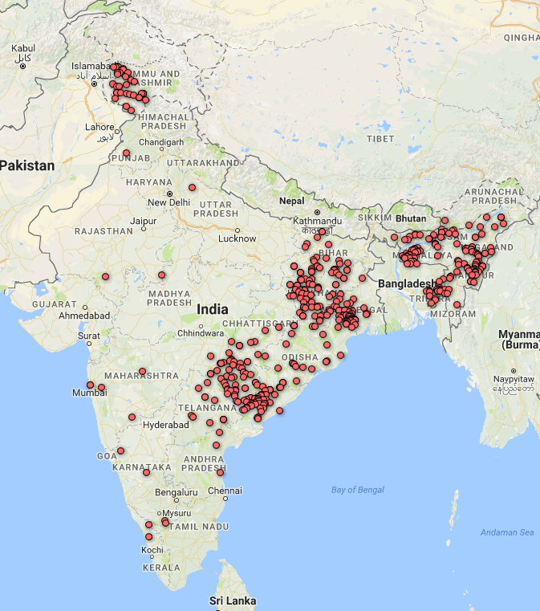Illustration 12: Hostage Taking

