PayWatch · XElevate homework · Yash Saini, Founder · 20 October 2026
Value Proposition & Competition
Value Proposition Canvas · Competitor Grid · Blue Ocean Strategy Canvas (with scoring rationale)
1. Value Proposition Canvas
Customer segment: “Daisy” — 22–30 year-old first earners in small-town and metro India; phone-first, no financial advisor, big dreams and quiet money worries. Value proposition: one money brain that turns every dream into a plan — quietly handling tax, insurance and investing in the background.
What changed in iteration #2: after mentor feedback we moved from “a finance app / CFO in your pocket” to a dreams-first view. Customers don’t want to manage money; they want experiences (a trip, a café of their own, looking after parents). Money, insurance and investments are the enablers, not the goal.
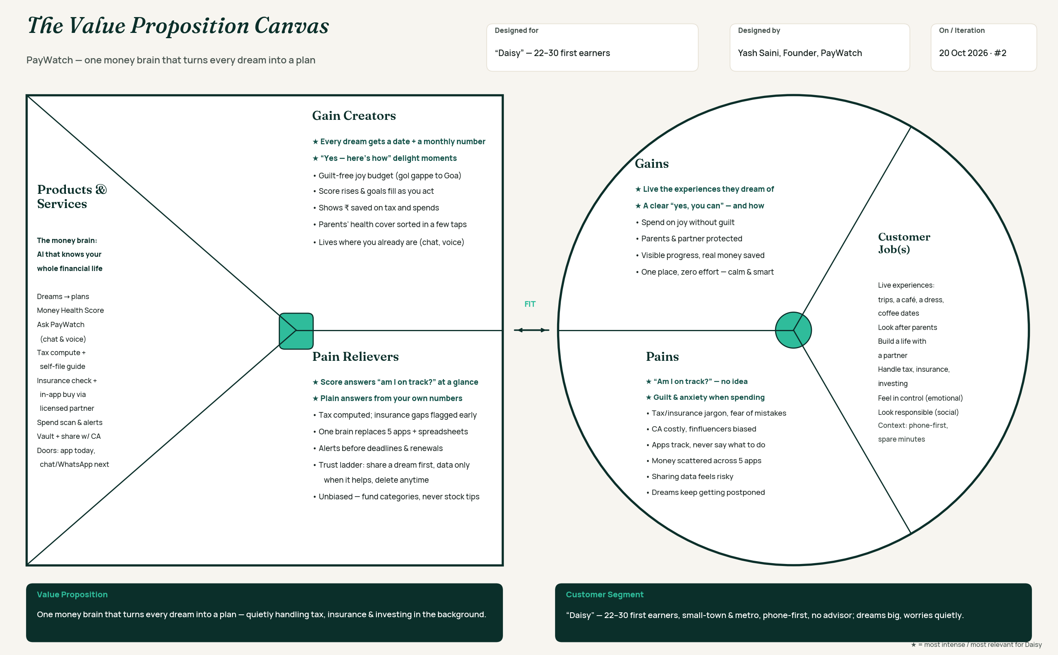
WHERE THE FIT IS STRONGEST
- “Am I on track?” (most intense pain) → Money Health Score answers it at a glance; the score moves when the user acts.
- Guilt & anxiety when spending → dreams get a date and a monthly number, plus a guilt-free “joy budget” — spending on joy becomes part of the plan.
- Jargon & fear of mistakes → plain-language answers grounded in the user’s own numbers; tax computed, insurance gaps flagged before they hurt.
- “Sharing data feels risky” → a trust ladder: share a dream first, data only when it clearly helps, delete anytime.
- Honest gap: execution — actually investing/insuring/filing in-app needs licences or licensed partners; insurance is routed via a licensed partner first.
2. Competitor Grid
Direct = same job for the same user; indirect = solves one slice of the job; substitute = what the user does instead of any app.
Competitor | Type / target | Core offering | How they earn | Strength | Weakness for Daisy | Score fit*
INDmoney | Direct · investors, young urban professionals | Net-worth tracking + investing in Indian & US stocks/MFs | Broking, investing & distribution revenue | Strong aggregation and investing rails | Investing-first; little help with dreams, tax depth or “what do I do next?” | Medium
FOLO | Direct · Indian families tracking net worth | Real-time net-worth app: banks, MFs, insurance, retirals, loans + physical assets via Account Aggregator; “Lync” family sharing; Account Health Score (nominees, records) | Not public | Strongest whole-picture view + family sharing; ₹10 Cr pre-seed | Tracks and organises — doesn’t plan dreams, compute tax or say what to do next | Medium
Jumpp (Finvasia × YES Bank) | Direct · Tier 2–3 users, financial inclusion | AI “super app”: YES Bank savings account, payments & bills, NSE cash trading, MFs, loans (in testing); conversational AI in English & Hindi, voice | Banking, broking & lending revenue | Bank + broker rails; Hindi voice AI for low-literacy users | Transaction-first (bank/trade/borrow); no tax, insurance planning or dreams-first guidance | Medium
PowerUp Money | Indirect · MF investors wanting advice | Registered mutual-fund advisory, annual subscription | Subscription (≈₹999/yr per our research) | Regulated advice; people do pay for it | Investing only — no tax, insurance or life goals | Low–Med
ClearTax | Indirect · tax filers | Income-tax filing, expert-assisted plans | Filing / assisted-filing fees | Best-in-class tax filing & brand trust | Seasonal (once a year); no year-round guidance or dreams | Low
CA / financial advisor | Substitute · anyone who can afford one | Human tax filing and advice | Fees per filing / per year / % of assets | Trusted, personal, handles complex cases | Expensive, seasonal, not available 24×7, can be product-biased | Medium
Spreadsheets, YouTube, family, “doing nothing” | Substitute · everyone | Free, informal help | — | Free and familiar | Generic, unverified, not based on the user’s own numbers | Low
PayWatch | Daisy, 22–30 first earners | One money brain: dreams → plans, score, AI answers, tax, insurance (via licensed partner) | Free → ₹199/₹499 subscription + insurance distribution via partner | Whole picture + next step + dreams-first + works with your CA | Pre-launch; no live users yet; execution needs licences/partners | —
*How well the competitor serves Daisy’s core job (“live my dreams without money stress”). FOLO and Jumpp details from 2025–26 press coverage (YourStory, Business Today, APAC News Network); other descriptions high-level from public info and our research — to be re-verified.
3. Blue Ocean Strategy Canvas
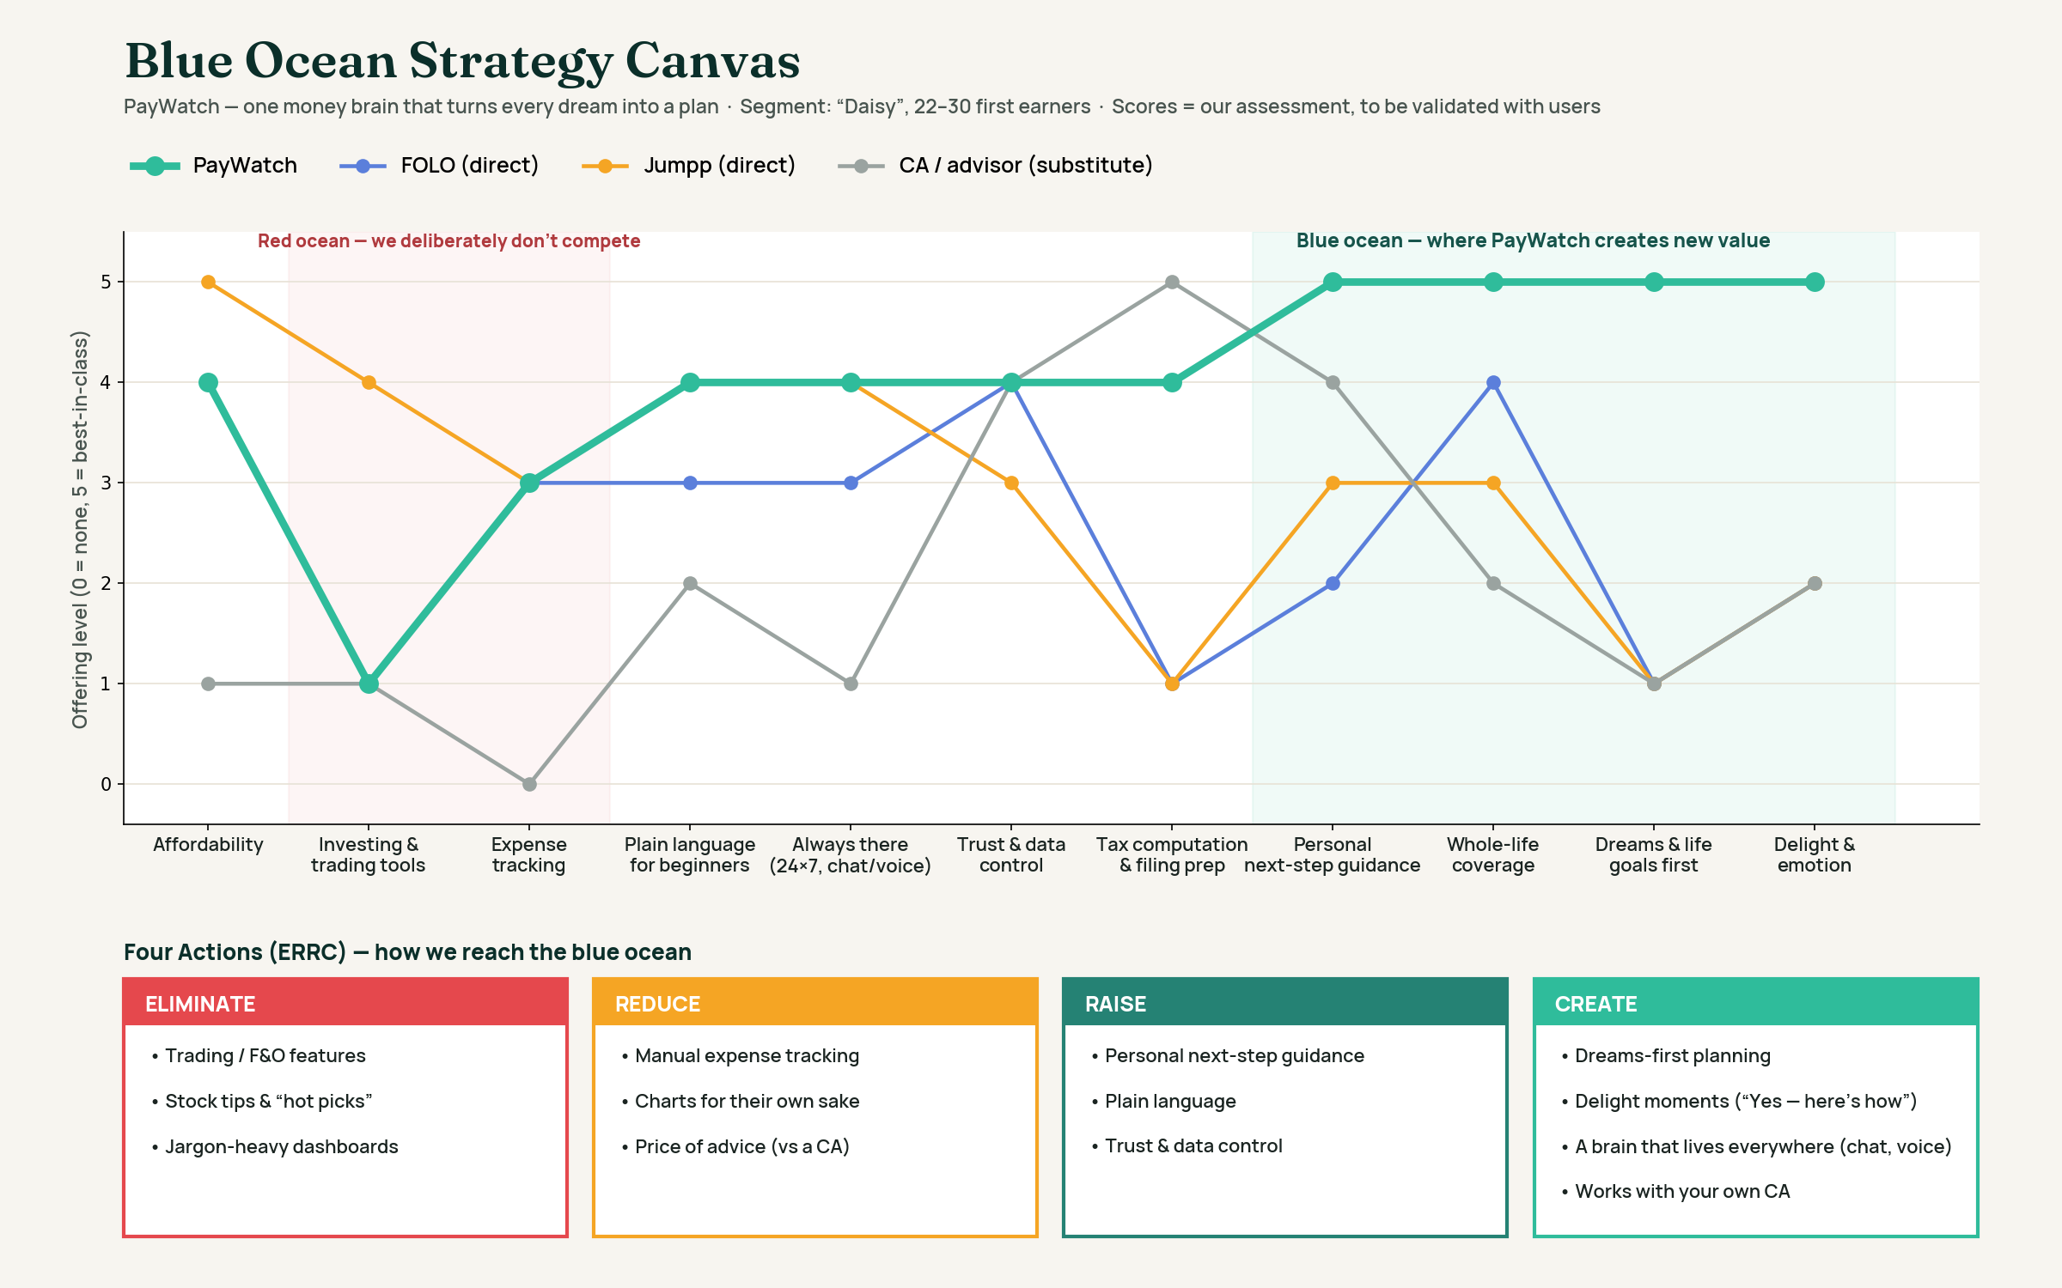
HOW WE SCORED
- Scale: 0 = not offered at all · 1 = barely · 2 = basic · 3 = good · 4 = strong · 5 = best-in-class for Daisy.
- Basis: public product information, our competitor research, 56 user interviews + 49 survey responses (willingness to pay, trust, pains), and our own product. We compared what each player offers to Daisy specifically — not to a trader or a large business.
- Honesty rule: PayWatch scores describe what is built today; where a score depends on something still being built we say so. Scores are our assessment and will be re-tested with users.

SCORING RATIONALE — ATTRIBUTE BY ATTRIBUTE
Attribute | What a 5 means | PayWatch | FOLO | Jumpp | CA / advisor
Affordability | Free or near-free for a first earner | 4 — free tier; full plan ₹199–499/mo: far cheaper than a CA, but not free | 4 — free to start (pricing not public) | 5 — free app + zero-balance bank account | 1 — ₹2.5k–10k+ per filing per our interviews; ongoing advice costs more
Investing & trading tools | Buy/sell stocks & funds in-app | 1 — deliberately not a broker; fund-category guidance only (SEBI lane) | 1 — tracks investments, no trading | 4 — NSE cash-segment trading + mutual funds | 1 — may advise, doesn’t execute
Expense tracking | Automatic, detailed spend tracking | 3 — statement scan + “where you could’ve saved”; no live bank sync yet (needs AA licence) | 3 — live balances & holdings via AA; net worth, not spend coaching | 3 — transaction history, bills & AA-linked accounts | 0 — not offered
Plain language for beginners | A first earner understands every screen | 4 — written for beginners, AI explains simply; English only today (Hindi on roadmap) | 3 — clean, but finance-literate users | 4 — Hindi + English conversational AI and voice | 2 — depends on the person; often jargon
Always there (24×7, chat/voice) | Available anytime, wherever you are | 4 today — app + AI 24×7 with voice input; WhatsApp/chat door in build (target 5) | 3 — app 24×7 | 4 — conversational AI with voice | 1 — office hours, by appointment
Trust & data control | User controls what’s shared; clear privacy | 4 — trust ladder, delete anytime, data never sold; brand still young | 4 — consent-based AA data, family-sharing controls | 3 — YES Bank brand helps; broad data needs (bank + broker) | 4 — personal relationship of trust
Tax computation & filing prep | Accurate return across all income heads | 4 — full computation, both regimes, ITR form, self-file guide; no one-click e-filing yet (needs ERI) | 1 — not a tax product (net-worth certificates only) | 1 — not offered | 5 — files and signs for you
Personal next-step guidance | Tells you exactly what to do next, for you | 5 — ranked action plan with ₹ impact; score moves when you act | 2 — Account Health Score flags admin issues (nominees, records), not financial moves | 3 — AI answers questions, but transaction-first | 4 — personal, but only when you book and pay
Whole-life coverage | Tax + insurance + investing + spending + goals in one place | 5 — all in one money brain, incl. tax & insurance | 4 — broadest asset/liability view (incl. insurance, retirals) | 3 — bank, pay, invest, borrow; no tax/insurance planning | 2 — usually tax and some investing
Dreams & life goals first | Starts from what you want in life, not from products | 5 — dreams → plans with dates & monthly numbers (core of the new vision) | 1 — starts from assets you already have | 1 — starts from banking/transactions | 1 — rarely starts from goals
Delight & emotion | Makes users feel good and in control | 5 — “Yes — here’s how” moments, joy budget, rising score | 2 — clarity, but functional | 2 — convenient, functional | 2 — reassuring but transactional
4. HOW WE REACH THE BLUE OCEAN (ERRC)
Eliminate trading/F&O, stock tips and jargon dashboards · Reduce manual tracking and the price of advice · Raise next-step guidance, plain language and trust · Create dreams-first planning, delight moments, a brain that lives everywhere, and working with your own CA (see the grid on the canvas).
Strategy in one line: competitors fight over investing tools and dashboards (red ocean). PayWatch doesn’t compete there — it owns the space nobody serves: turning a young earner’s dreams into a plan, in plain language, with trust earned step by step. Next: validate these scores and the Daisy persona through deep user interviews (in progress), then test with our first tester cohort.

