# BASIC se BASIC
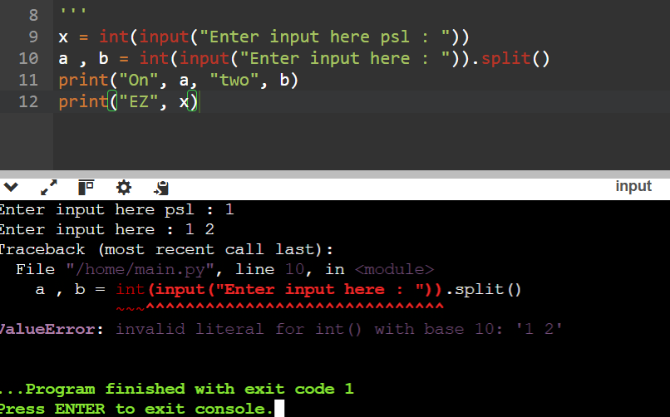
- Cannot use the .split() with multiple input shit

- Use type(input(“//statement”)) for the specific definatioon and boundary? For the input variable

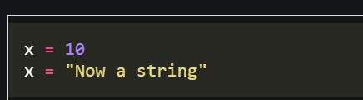
- Python vars are dynamically typed cause “x naam ke multiple chize rehe skti hai diff data type ki…”

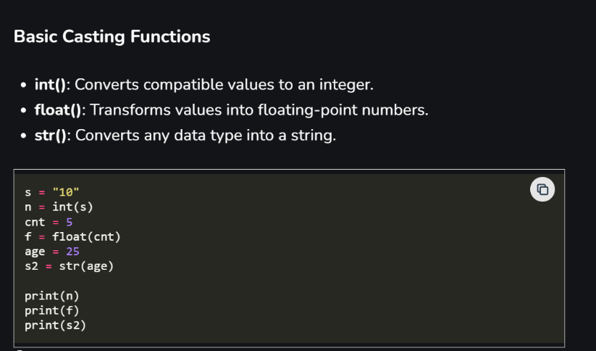
- Typecasting in Python:

- A variables name is the reference to the object referencing whatever the data is inside the object…
Eg :
x = 10
then x[variable or reference] => object[data == 10]

if did
x=y
both now points at the object data

>>> def example(a, b, *args):
... print(type(args))
...
... example(1, 2, 3, 4, 5)
<class 'tuple'> args gets packed into a tuple …

213. zip() in python -> lets you traverse multiple shit at once
Also remember it returns a iterator and not a list.

- Python has a build in garbage collector : just like java…
How it works?

A] Normal Garbage collector :->
Maintains a reference count or refcount
- Every object keeps a count of how many references point to it.
- When refcount hits 0, memory is freed immediately.
a = []
b = a # refcount = 2
del a # refcount = 1
del b # refcount = 0 → object destroyed by the GC

B] Cyclic garbage collector :->
Helps when theres self refences and cyclic references in the python code
a = []
b = []
a.append(b)
b.append(a)

a references b and b references a
pythons GC can even detect the Reference cycles….

Garbage collector can be enabled and disabled…
gc.disable()
# when performance-critical code
gc.enable()

Final verdict : Python uses reference counting for immediate memory cleanup and a generational cyclic garbage collector to detect and clean reference cycles. This hybrid approach provides deterministic destruction with safety against circular references.

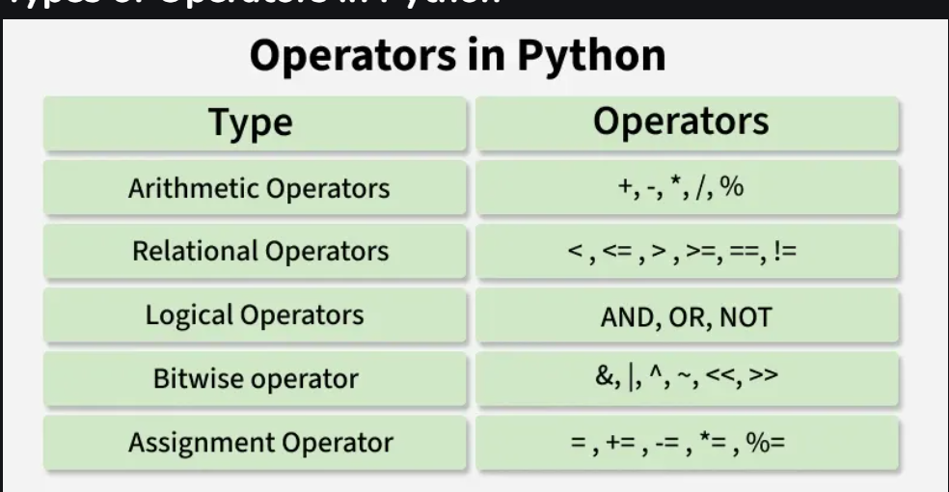
- Python Operators

AND is true iff ; a*b multiplication
OR is true if ; a=1 or b=1 addition operation
XOR is true if ; a != b not equal else false
Eg. 10 == (1010)

- Python Keywords
The list of keywords are:
['False', 'None', 'True', 'and', 'as', 'assert', 'async', 'await', 'break', 'class', 'continue', 'def', 'del', 'elif', 'else', 'except', 'finally', 'for', 'from', 'global', 'if', 'import', 'in', 'is', 'lambda', 'nonlocal', 'not', 'or', 'pass', 'raise', 'return', 'try', 'while', 'with', 'yield']

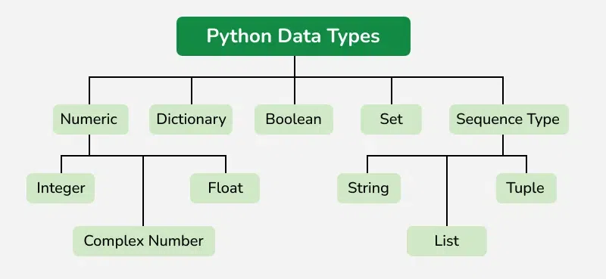
- Python Datatype

- List [], tuple() and dict {}

List are ordered list of items .
Tuples are immutable list of items.
Dictionary are just key values pair of data. Dictionary are just like HashMap and Hashset are just like sets in python….

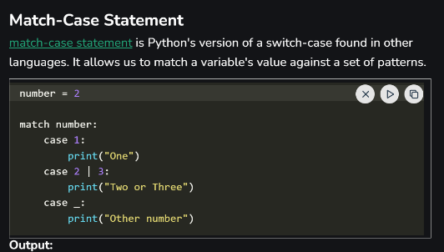
- Switch Case in python is just called as Match case

- Python Functions

Definations :
- Normal : def() :
- Normal : def(a, b, c) : // with args
- With default arguments : def(a, b, c=2): // if c not mentioned it will be declared as 2 always.
- There are also arbitrary arguments present
Where we specify the keyword and not specify the keyword.
- Args : used when we don’t know the number of values passed into the function.
- Kwargs : just dictionary of the args world.
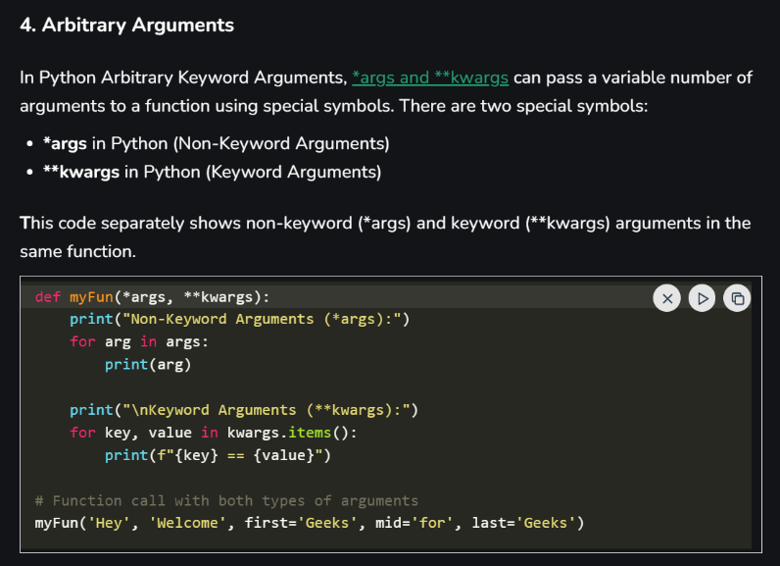

- Inner Functions.
In Python we can write Function within the function

- In python we can do both pass by value and pass by reference

Is the copy to the data object is passed or original object is passes?
Pass by value or pass by reference….
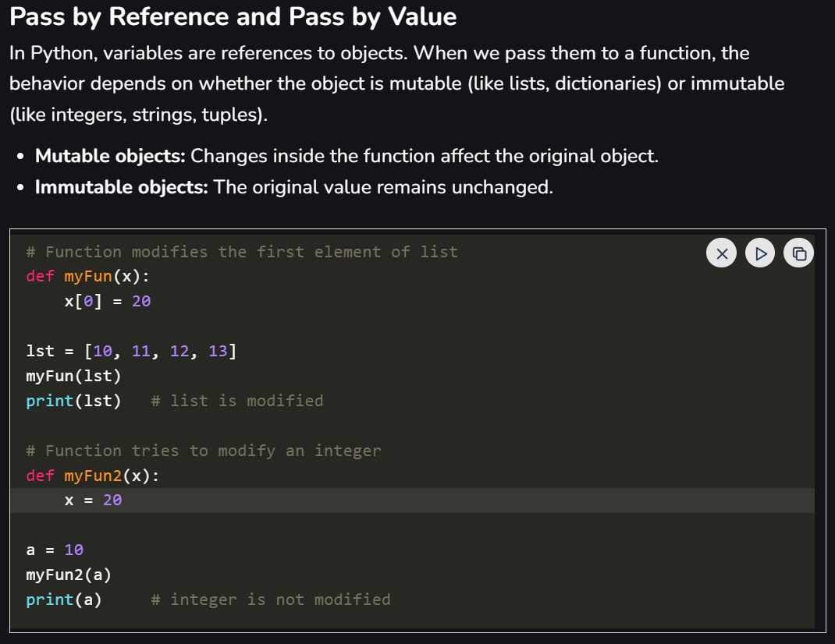

Mutable shit behave like pass by pass by reference. You change the memory itself.
Immutable shit behave like pass by value. You don’t change shit.

***SO, PYTHON IS PASS-BY-OBJECT-REFERENCE
Mutable objects behave like pass by reference, while immutable objects behave like pass by value.***
Python has mutable and immutable at object level shit….
# remember tho both the times the reference of the object is passed….

- Immutable : int, float, string, tuple etc….
When passed into an object a copy is passed and if any chages are made a new object is created and processed.

- Mutable : list, dict, set etc….
When passed into an object a reference is passed and the changes apperes in the original object.

- DUCK TYPING IN PYTHON

Method is giving more importance rather than the class level definition of the object.
“If it quacks, it’s a duck”
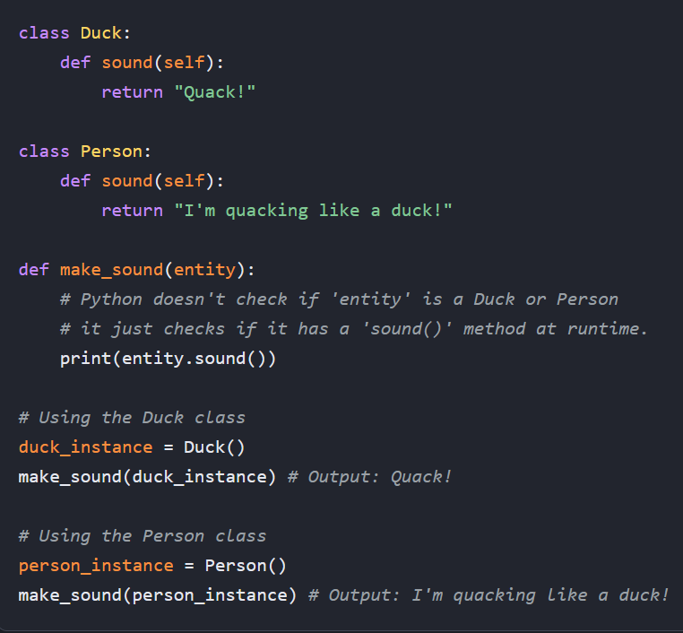

- Inner functions and Closers

- Inner functions or closers, remembers the access that the outer function has without creating global variables.
- function object that remembers and has access to variables from its enclosing (outer) function's scope, even after the outer function has finished executing. This allows the inner function to maintain a state associated with the environment in which it was created, without using global variables or classes.

How Closures Work A closure is created in Python when the following conditions are met:
- A nested function exists: There must be a function defined inside another function.
- The inner function references a variable from the outer (non-local) scope: The inner function uses a variable that is not in its local scope or the global scope.
- The outer function returns the inner function: The inner function object is returned from the outer function, rather than being called within i.
- Python store these attributes in the __closure__ attribute in the inner tab. Once inner function have been created.

- def make_multiplier_of(n):
- # 'n' is a variable in the outer function's scope
- def multiplier(x):
- # 'multiplier' is the inner (nested) function
- # it accesses 'n' from the outer scope
- return x * n
- # The outer function returns the inner function object
- return multiplier

By default, the inner function can read variables from the outer scope, but not modify them. To change the value of an outer function's variable from within the inner function, you must use the nonlocal keyword
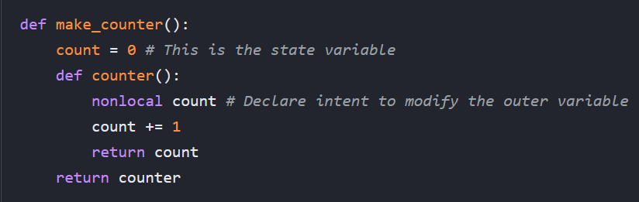

LAMBDA shit :- single line anonymous functions

- Simpler usage for the custom definition of the function: (this is function that customly doubles or triple a number)
def myfunc(n):
return lambda a : a * n
mydoubler = myfunc(2)
mytripler = myfunc(3)
print(mydoubler(11)) // ans = 22
print(mydoubler(11)) // ans = 33

- With map() : to map every element in the iterable to the lambda
numbers = [1, 2, 3, 4, 5]
doubled = list(map(lambda x: x * 2, numbers))

- With filter() : to filter elements from the iterable that satisfy the conditions:
numbers = [1, 2, 3, 4, 5, 6, 7, 8]
odd_numbers = list(filter(lambda x: x % 2 != 0, numbers))

- With sorting() custom sorting functions
students = [("Emil", 25), ("Tobias", 22), ("Linus", 28)]
sorted_students = sorted(students, key=lambda x: x[1])

Decorators: letS you add extra functionality to code without changing the functions code. Take function as a input and return new function as a output. A decorator must return a functionality (function) not val.

def changecase(func):
def myinner():
return func().upper() # inner function takes whaterver the outer func returned and just .upper it
return myinner # returns a function
@changecase # DECORATOR
def myfunction():
return "Hello Sally"
print(myfunction())

essentially changecase is just :
myfunction = changecase(myfunction) # wrapping myfucn with changecase

- PYTHON CODE CRUX AND MACHINE LEVEL WORKING

https://www.geeksforgeeks.org/python/internal-working-of-python/

- ERROR And Exception
Error : Serious problems in the program logic that cannot be handled. Examples include syntax errors or memory errors.
Exception : less serious. Invalid file error, misinpu etc. Less severe problems that occur at runtime and can be managed using exception handling (e.g., invalid input, missing files).

