INBUILD_MAIN DATA STRUCTURES IN PYTHONS

- Python has no character type even single character is treated like a string….
“…” and ‘…’ are single lined string
“””…””” are multi line strings

- Fun operation in string
print(s[::-1]) # reverse string

- Python strings are immutable only few operations are possible to change the strings and changing operation always creates a new string like concatenation, slicing, formatting or Replace. [all of these operations creates a new String]
- Len(), upper(), lower(), strip() -> basic ops
- Membership testing
s = "GeeksforGeeks"
print("Geeks" in s) // True
print("GfG" in s) // false

- LIST
List “[a, b, c…]” are mutable and Tuple “(a, b, c…)” are immutable

Convert list to tuple using -> tup = tuple([1, 2, 2]) and vica verca

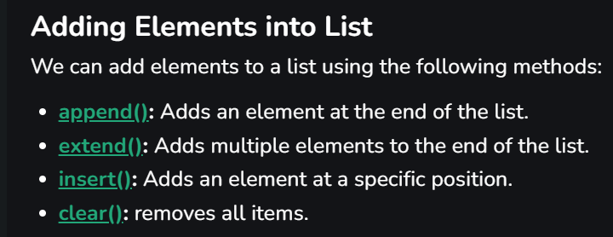

- Deletion operation in the string
- List.remove(//param) -> removes the first occurrence in the string
- List.pop(//if_param) -> remove the top elemet else remove the element at specific index if shits not provided.
- Del list[//index] -> deletes the specific index
- List comprehension
To create the list in short and concise way
squares = [x**2 for x in range(1, 6)] // put sq(x) at each place
print(squares)
- In python list does not stores the val at the index directly it stores the reference to the val at each index….
Which means a single list can store every type of data structure….. even fucking functions…

- Tuple
Tuples are immutable and rest of tuple is exactly like the list. Element access and shit is absoloutly same…..
- Concatenation:
tup1 = (0, 1, 2, 3)
tup2 = ('Geeks', 'For', 'Geeks')
tup3 = tup1 + tup2 // this is a new tuple created….
print(tup3)
- Slicing => syntax = tuple[start:stop:step].
Note tuple reverse -> print(tup[::-1])

- Dictionary
Keys: Keys must be immutable in python ie keys can be string, numbers or even tuples.
Python 3.7 Version onward, Python dictionary are Ordered.

Valid Syntaxex :->
d1 = {1: 'Geeks', 2: 'For', 3: 'Geeks'}
d2 = dict(a = "Geeks", b = "for", c = "Geeks")
- dict add -> dict[“key”] = val;
- dict replace -> dict[“already avaible key”] = val;

- pop(“key”) -> remove the key from the dictionary and returns the value.
- popItem(“key”) -> remove the last key value pair from ordered dictionary.
- Del dict[“key”] -> remove the key value pair from the dictionary completely.
- Dict.Clear() -> deletes the dictionary.
- Iterators in Dict?
For key in dict:
For val in dict.values():
For key, val in dict.items():
- Python also supports the nested dictionary.

- SETS
Unordered, mutable, unindexed and no duplicats. Sets are implemented using hashtabels internally. But not thread safe internally …

S1 = {1,2,3,4} // both of em creates a set
S2 = set([1,2,3,4])

- .add() -> add elements in the set one at a time.
- .update([list]) -> add multiple elements in the set.
- In -> Check presence using print(“val” in setName) using the in keyword.
- .remove() -> remove the elemet and raises error if not present.
- .discard () -> remove the elemet and raises nothing if not present.
- .pop() -> remove a arbitrary element from the set.

- Frozensets are just sets with immuatablity as a feature.

