Python OOPS

- Always public attributes in python
- Self is the reference to the current instance of the class in each of the objects. made...
- Constructer name in python is __init__(self, args, kwargs):
Automatically created whenever the new object is created.
- Python Inheritance:
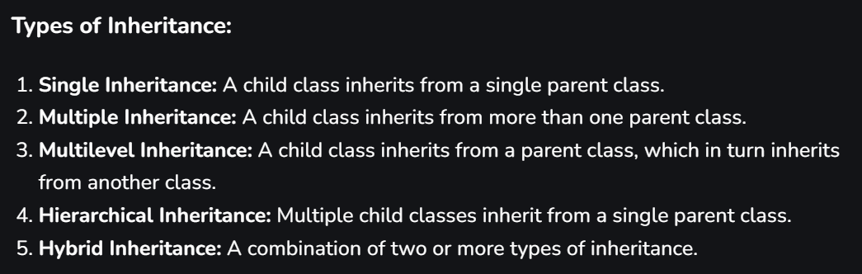

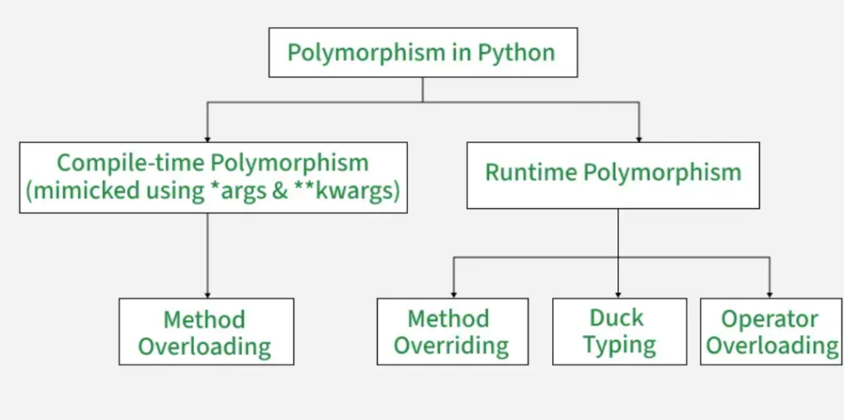
- Polymorphism:

- Common operator overloading methods…
Redefine these method to have your own definition of the oeperator or function….
Operator | Method
+ | __add__
- | __sub__
* | __mul__
/ | __truediv__
== | __eq__
> | __gt__
< | __lt__
len() | __len__
[] | __getitem__
- Public members -> Variable name any

- Protected members -> Vaiable name with single underscore _item, _name and _age.

- Private members -> Variable names double underscore __item, __name and __age [requires getters and setters to setup and get val of]

- Abstraction
- Abstract method = method that are the method that just tell the inherititing class to inherit the method name.
- Concreate method = method that are fully defined and verbose like that…
Focuces on what to do rather than how to do it…

- Partial Abstraction -> contains both the abstracted function and the concreate method.
- Full Abstraction -> just no concreate class is present in the sause.

----------------------------------------------------------------------------------------------

- Exception Handelling :

try:
# Runs the risky code that might cause an error.
except SomeException:
# Catches and handles the error if one occurs.
# You can write multiple except statements for this block to catch
else:
# Executes only if no exception occurs in try.
finally:
# Runs regardless of what happens useful for cleanup tasks like closing files.

- Python File Handelling

- Var = open(‘name.txt’ , mode ) // read the file
- Data = var.read() // read the data in single var
- For line in var: // read line by line
Print(line.stripe())
- Var.write(// Line) // write into the file
Use with keyword to read the file according and autoclose it when needed.

- Filters
To filters iterables and stuff:
You need to
New_it = filter(function, old_list)
This give a new list, and applies the filter onto the original list :
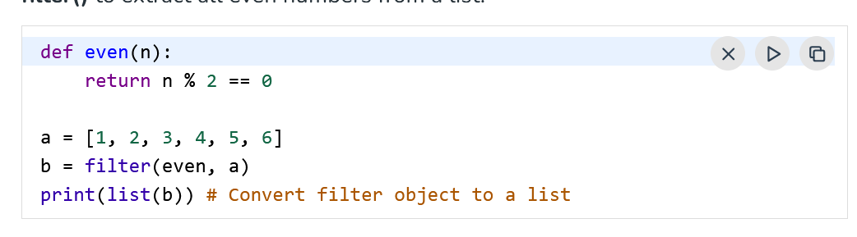
Eg :

- Inbuild shit -> https://www.geeksforgeeks.org/python/python-dsa-libraries/
- Flask shir -> https://www.geeksforgeeks.org/python/flask-tutorial/

- Generators : How to Use Generators and yield in Python – Real Python

- Generator are functions that can pause and resume there execution
- Yield keyword is used to create generator functions — special functions that return values one at a time instead of computing and returning them all at once.
- Generators return a lazy iterator through we can iterate over the sequence of data.
But unlike normal iterators they do not take up any space in RAM.
- The code inside the function is not executed yet, it is only compiled. The function only executes when you iterate over the generator.

Meaning
yield pauses the function, saving its state. When the generator is resumed (e.g., via next () that is in the loop…. ), execution continues right after the last yield. This allows lazy evaluation — values are produced only when needed, saving memory.
Basic Example
def count_up_to(n):
"""Generator that yields numbers from 1 to n."""
num = 1
while num <= n:
yield num # Pause here and return the value , return the value and return right here
num += 1
for number in count_up_to(5):
print(number)
Output:
1 , 2, 3, 4, 5…..
WORKING : First call to the generator function returns a generator object (does not run the code yet). Each call to next() or each loop iteration runs the function until it hits a yield.
The function pauses at yield, returns the value, and remembers where it left off. When resumed, it continues from the saved state.
Practical Usage
- Large datasets: Process data without loading everything into memory.
- Infinite sequences: Generate values on demand.
- Pipelines: Pass data between functions efficiently.
KEY POINTS :
- yield turns a function into a generator.
- Generators are iterators (can be used in for loops).
- They are memory-efficient because they produce values on demand.
- Use return in a generator to stop iteration (raises StopIteration).

OOPS Fast Notes :
- Four tenets of OOP :
  - Abstraction
  - Encapsulation
  - Inheritance
  - Polymorphism
- dunder methods :->
  - __init__ -> constructer.
  - __str__ -> default return for the object called.
  - __hash__ -> defines the hash of the object.

Operator Overloading in Python : Operator Overloading in Python - GeeksforGeeks

- Operators ex : _add__(), __mul__(), __sub__(),, __lt__(), __gt__() and __eq__() to make objects work for operators like +, *, -, <, > and == respectively.
class A:
def __init__(self, a):
self.a = a

# define behavior of +
def __add__(self, o):
return self.a + o.a

ob1 = A(1)
ob2 = A(2)
ob3 = A("Geeks")
ob4 = A("For")

print(ob1 + ob2) # integer addition # 3
print(ob3 + ob4) # string concatenation # GeeksFor

# actual working (internally)
print(A.__add__(ob1, ob2)) # 3
print(ob1.__add__(ob2))# 3
- Operator Overlations in bools :
  - and: __and__(self, other)
  - or: __or__(self, other)
  - not: __not__(self)

why use the operator overloading ? Advantages?
Overloading operators in custom classes provides several benefits:
- Improved readability: code looks natural (e.g., ob1 + ob2 instead of ob1.add(ob2)).
- Consistency with built-in types: custom objects behave like integers, strings, etc.
- Conciseness: less boilerplate code.
- Custom behavior: extend operators to user-defined classes (e.g., vectors, matrices).
- Enhanced functionality: enable operators to work meaningfully with new data types.

MAGIC METHODS AND DUNDER METHODS IN PYTHON :

Magic methods, also known as dunder methods (short for "double underscore"), are special methods in Python that begin and end with double underscores (__). These methods are invoked automatically by Python in response to specific operations, such as arithmetic, comparisons, or object initialization. They allow developers to customize the behavior of objects and enable operator overloading, making classes more intuitive and Pythonic.

Dunder or magic methods in Python - GeeksforGeeks

Polymorhism :

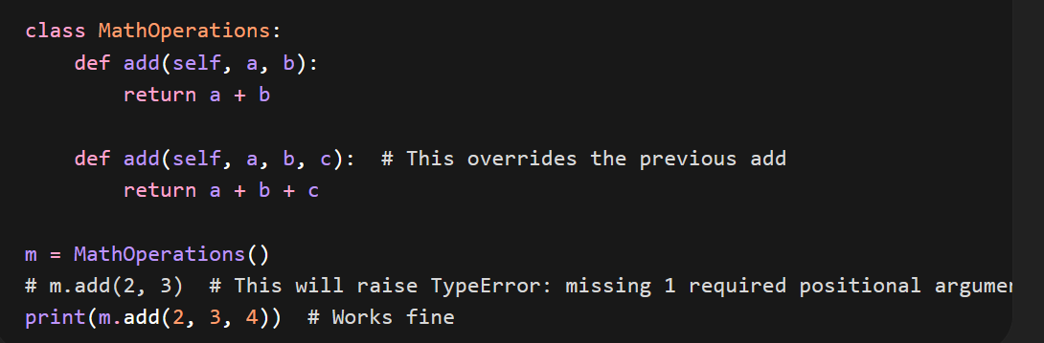
- compile time [not supported by python (method overloading) , operator overloading],
sol? Just use args and kwargs?
- Operator Overloading is also fully supported in this design.
- Polymorphism resolved at runtime (like method overriding in subclasses).
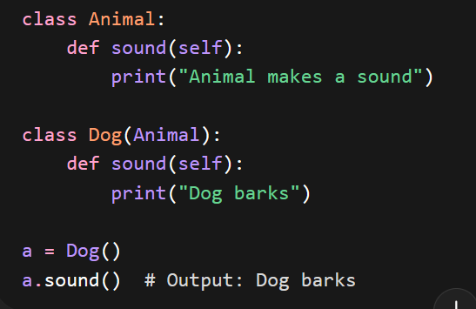

Beyond this even duck typing is supported. So its all great.

runtime []

