Miscellaneous

- any() keyword in python : any(numbers) checks if any element in the list numbers is True (non-zero or non-empty).
numbers = [0, 0, 5, 0]
result = any(numbers)
print(result) # Output: True

# check if any of the row or col element is 0 or not : if then it assigns the element as the TRUE:

any(matrix[0][j] == 0 for j in range(cols))
any(matrix[i][0] == 0 for i in range(rows))

- Python dependencies are global in nature :
  - That’s why the “pip list” works and fetches all the dependencies in the PC.
  - virtual environment in Python is an isolated directory that contains a specific Python interpreter, its own pip (package manager), and a separate library folder for installing third-party packages. This isolation prevents conflicts between different projects that may require different versions of the same library, keeping the system's global Python installation clean

- Python lambdas can be used inplace of comparators and interface substitute.

  - Sort array by just the first element -> arr.sort(key=lambda x: x[0])
This shows the implementation of “key” keyword

- Python random generator :
Import random
Rand = random.randrange(1,100)

- Typecasting in python and stuff :
Change numbers from the other datatypes :
Int(), float() , str()

- .lower(), .upper() , .split() and .strip() -> strips the element of it whitespaces
- Str.replace(“//part”,”//part”) -> replace part of string to other part of string
- String methods : Python - String Methods

- is - Checks if both variables point to the same object in memory
== - Checks if the values of both variables are equal
- List Comprehension prep krneka

- .sort() -> sorts the list in ascending order
.sort(reverse=True) -> sorts the list In desending order

- Copying a list is a trick
If
list1=list2 # this statement just copies the reference to the lists changes made in either are reflected across both the lists
but,
list1 = list2.copy()
or
list1 = list(list2) # copy the values and assigns new space for the list1

- List append and extend

TUPLES

- This is Unpacking a tuple
  - A = [1,2,3]
  - (a, b, c) = A

- Iterable cointainers gets you iterator from of an object.
  - Iterator is an object that implements iterator protocol ie. __iter__() and __next__()
  - next keyword can be used to iterate iterable objects
  - for loop internally actually creates an iterable object and runs next() for each next option

DEBUGGIN AND ITss framework in python

- use print statement
- user assert statement for the conditions that are expected to be true.
- Assert is used for the statements that should never be false
A = 10 , “Optional statement”
Asser A == 10 # this executes as normal
Assert A == 2 # programs execution stops and returns zero
# raises assertion error
- Assert statements can be disabled in the running using the -o flag, helps debug during development and reduces costs during production.
- Using pdb debugger in real programm
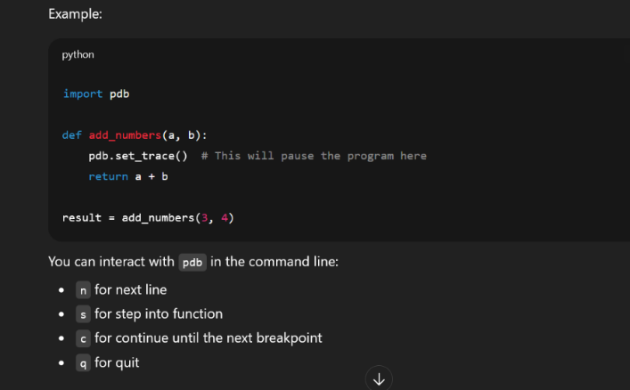

    - Manual testing frameworks can include pytest, unittest etc
    - Ceil division (or ceiling division) is a mathematical operation that divides two numbers and rounds the result up to the nearest integer, specifically toward positive infinity
Q] dict hashtable weird shit….->
- Weird shit about the dict in python is
- Build upon hashtables.
- Still maintains he order of the entries.
High-level idea
A Python dict is a hash table, but:
- It stores entries in a compact array
- New key–value pairs are appended
- Iteration walks this array in insertion order
- Deletions leave markers (“dummy” entries) so order isn’t disturbed

- Python Context management system with -> with statement LINK

- Python’s with statement allows you to manage external resources safely by using objects that support the context manager protocol. These objects automatically handle the setup and cleanup phases of common operations.
- By using the with statement alongside appropriate context managers, you can focus on your core logic while the context managers prevent resource leaks like unclosed files, unreleased memory, or dangling network connections.

// General syntax

write expression as objectName :
// operations

- Write essesntially need to do 2 things :

- Execute expression to obtain a context manager object.
- Call .__enter__() on the context manager and bind its return value to obj if provided.
- Execute the with code block.
- Call .__exit__() on the context manager when the with code block finishes.

Ex ->
with open("hello.txt", mode="w", encoding="utf-8") as file:
file.write("Hello, World!")
  - When you run this with statement, open() returns an io.TextIOBase object. This object supports the context manager protocol, so the with statement calls .__enter__() and assigns its return value to file. Then, you can manipulate the file inside the with code block. When the block ends, Python automatically calls .__exit__(), which closes the file for you, even if an exception occurs in the with code block.
Ex with of custome context manager
class HelloContextManager:
... def __enter__(self):
... print("Entering the context...")
... return "Hello, World!"
...
... def __exit__(self, exc_type, exc_value, exc_tb):
... print("Leaving the context...")
... print(f"{exc_type = }")
... print(f"{exc_value = }")
... print(f"{exc_tb = }")
...
with HelloContextManager() as hello:
... print(hello)

- Entering the context...
- Hello, World!
- Leaving the context...
- exc_type = None
- exc_value = None
- exc_tb = None

https://www.geeksforgeeks.org/python/python-interview-questions/

While : loop has else condition !!!!!!!!!!!!!!!!!!!!!!!
While loop ke saath else conditions lg skte hai…..

Typing module in python : provide additional type hints in the pythonic syntax.
Like typescript does with JavaScript.

Q. Comparing different implementations of python:->
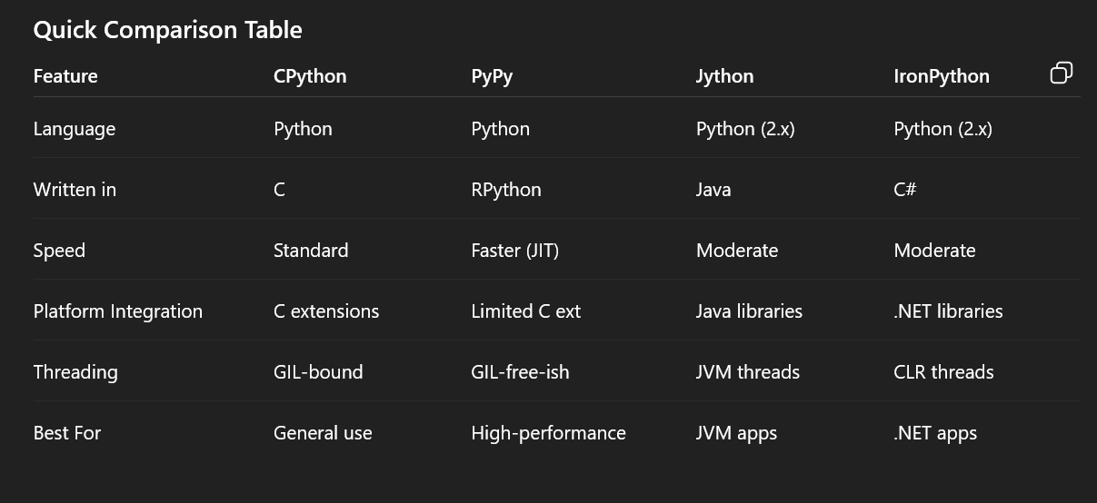

.py → AST → bytecode → .pyc → PVM
Python code :- > lifecycle
.py source code -> basic python code written
↓
Tokenizer (lexing) -> tokeninzes the syntax
↓
Parser -> makes the Abstract Syntax tree….
↓
AST -> AST is the shit that makes a syntactic tree of the python language
↓
Compiler -> The compiler walks the AST and emits bytecode instructions:
↓
Bytecode -> discard the AST from the memory
↓
.pyc file (cached bytecode) __pycache__/*.pyc
↓
Python Virtual Machine (PVM) -> Executes bytecode instruction-by-instruction

yield from x is conceptually just await x

Python interfaces : Two ways to write it:-> when inheriting this class we have to have these methods, we are enforcing it…

Class NAME :
Def some() :
Pass
Class Name :
Def some() : …
range() vs xrange() in Python:->

In Python 2, both range() and xrange() exist, but they behave differently. In Python 3, xrange() was removed, and range() now works like xrange() did — using lazy evaluation for memory efficiency.
Key differences in Python 2:
- range(): Returns a list of numbers. All elements are stored in memory at once.
- xrange(): Returns an xrange object (an immutable sequence type) that generates numbers on demand without storing the entire list in memory.
Python 3 change: range() now returns a range object (immutable, iterable, and memory-efficient), similar to xrange() in Python 2. This means it does not create a full list unless explicitly converted with list().
Example in Python 3
# range() in Python 3
r = range(1, 10, 2)
print(r) # range(1, 10, 2)
print(list(r)) # [1, 3, 5, 7, 9]
print(r[2]) # 5 (supports indexing)
print(r.count(3)) # 1
print(r.index(7)) # 3

Exception hierarchy :

BaseException
├── SystemExit
├── KeyboardInterrupt
├── Exception
├── ArithmeticError
│ ├── ZeroDivisionError
│ ├── OverflowError
│ └── FloatingPointError
├── LookupError
│ ├── IndexError
│ └── KeyError
├── ValueError
├── TypeError
├── NameError
│ └── UnboundLocalError
├── FileNotFoundError
├── IOError / OSError
└── ImportError
└── ModuleNotFoundError

METACLASSES
class MyClass:
pass
print(type(MyClass)) # <class 'type'>
print(type(type)) # <class 'type'>
- MyClass is an instance of type.
- type itself is an instance of type (Python is self-referential here).

Protocol inheritance : defines structural subtyping (static duck typing), allowing type checkers to verify if an object has specific methods or attributes without requiring explicit inheritance.
But Python does not enforce type hints at runtime.
So its fucking useless.
But can be useful in the applications of developers assistance.

- Always use self for the first argument to instance methods.
- Always use cls for the first argument to class methods.

Creating metaclasses and shit ?

# Define a metaclass
class MyMeta(type):
def __new__(cls, name, bases, dct):
print(f"Creating class {name}")
return super().__new__(cls, name, bases, dct)

# Use the metaclass
class MyClass(metaclass=MyMeta):
x = 5

# When MyClass is defined, MyMeta.__new__ is called

----------------------------------------------------------------------------------

__hash__, is, == and id()

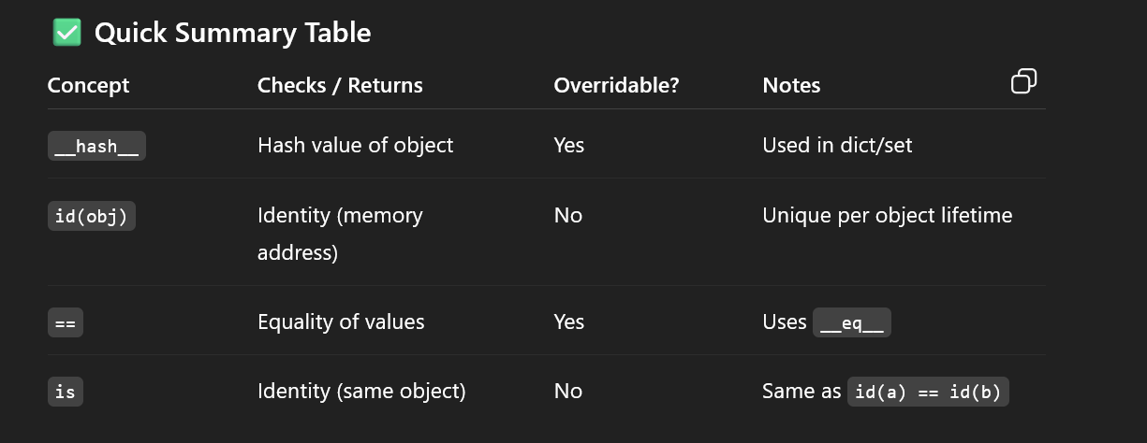
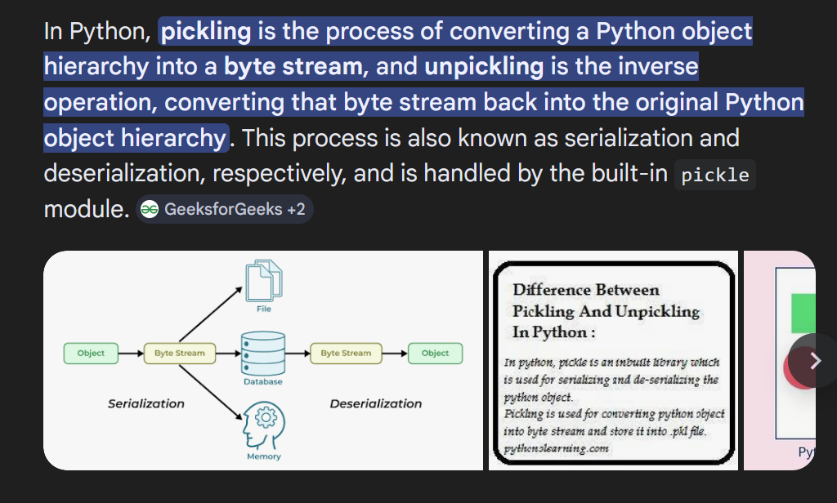

- Deep and Shallow Copy: import copy
- Reference Copy
A = [1 , 2 , 3 , 4]
B = A # this just copies the reference

- Shallow copy | SHARED REFERNCES.
A shallow copy creates a new outer object, but does not copy nested objects — it just copies their references. So the shell of the object are different but essentially its just the same object all together from the inside. a = copy.copy()
- Deep Copy | No SHARED REFERNCES.
A Deep copy creates a new outer object, and copies all the nested objects with new memory allocation. Recursively copies each of the data field and no references are copied. So the shell of the object are different with all the fields in the sause. A = copy.deepcopy(). Creates new objects for mutable types.
Deepcopy does not create new copies of immutable objects because:
- It’s unnecessary
- It’s safe (they can't be modified anyway)
Interning : Reuse immutable objects in python. Its an optimisation strategy. Instead of storing duplicate objects in memory, Python keeps a single shared copy and reuses it.

--------------------------------------------------------------------------
COMPARATOR IN PYTHON :
To use the comparator in python you have,
to use the cmp_to_key from the functools.
--------------------------------------------------------------------------------------------------------------------------------------------------

ERROR DETECTION CYCLE
In Python, errors can be detected at different stages of program execution. Let’s go step by step and in order:

1. AST Formation / Parsing Stage
Before Python even runs your code, it parses the source code and builds an Abstract Syntax Tree (AST). This is like Python “understanding” the structure of your program.
- Errors caught here: Syntax errors
- Example:
if True print("Hello")
- Python will raise:
SyntaxError: invalid syntax
At this stage, Python doesn’t care about variable values yet; it only checks structure.

2. Compile Time / Bytecode Generation
After parsing, Python compiles the AST into bytecode. In standard CPython, this happens automatically before execution.
- Errors caught here:
  - More SyntaxErrors (sometimes caught late, e.g., in nested functions)
  - Some NameErrors if Python can detect them at compile time (rare)
Note: In Python, “compile time” is not like C/C++ where the program is fully compiled to machine code. Compilation here is to bytecode.

3. Runtime / Execution Stage
Finally, Python executes the bytecode. Most errors occur here, because Python is dynamically typed and evaluates expressions on the fly.
- Errors caught here:
  - NameError – variable not defined
  - TypeError – wrong operations on objects
  - IndexError, KeyError, ValueError – invalid data access
  - ZeroDivisionError – dividing by zero
  - AttributeError – invalid attribute access
Example:
x = 10
y = "hello"
print(x + y)
- Raises:
TypeError: unsupported operand type(s) for +: 'int' and 'str'

✅ Summary Table
Stage | What happens | Common errors detected
AST Formation / Parsing | Builds AST from source code | SyntaxError
Compile Time / Bytecode | Compiles AST into bytecode | Rare early NameErrors, SyntaxError
Runtime / Execution | Executes bytecode | NameError, TypeError, IndexError, KeyError, ZeroDivisionError, AttributeError, etc.

In short, the order of error detection in Python is:
1️⃣ AST/Syntax check → 2️⃣ Bytecode compilation → 3️⃣ Runtime execution
If you want, I can make a visual diagram showing exactly when each type of Python error is detected—it makes this way easier to remember. Do you want me to do that?

