What are venvs?
A virtual environment is created on top of an existing Python installation, known as the virtual environment’s “base” Python, and by default is isolated from the packages in the base environment, so that only those explicitly installed in the virtual environment are available.
See Virtual Environments and site’s virtual environments documentation for more information.

Code Quality wali shit :
- Checking the quality of Python code involves using tools like linters and static type checkers to ensure adherence to coding standards and detect potential errors.
- Writing quality code in Python requires following best practices, such as clear naming conventions, modular design, and comprehensive testing.
- Good Python code is characterized by readability, maintainability, efficiency, and adherence to standards like PEP 8.
- Making Python code look good involves using formatters to ensure consistent styling and readability, aligning with established coding styles.
- Making Python code readable means using descriptive names for variables, functions, classes, modules, and packages.

Low quality code -> Does what its supposed to do minimal required characteristics to be functional.

High quality code features:
- Functionality: Works as expected and fulfills its intended purpose. [does thing we excpect it to do]
- Readability: Is easy for humans to understand. [easy to follow along]
- Documentation: Clearly explains its purpose and usage. [clearly and properly exposes it usage]
- Standards Compliance: Adheres to conventions and guidelines, such as PEP 8.
- Reusability: Can be used in different contexts without modification. [ex. DB agnostic]
- Maintainability: Allows for modifications and extensions without introducing bugs. Allows greatest of maintainability.
- Robustness: Handles errors and unexpected inputs effectively.
- Testability: Can be easily verified for correctness.
- Efficiency: Optimizes time and resource usage.
- Scalability: Handles increased data loads or complexity without degradation.
- Security: Protects against vulnerabilities and malicious inputs.

Tradeoffs in the code quality and stuff…

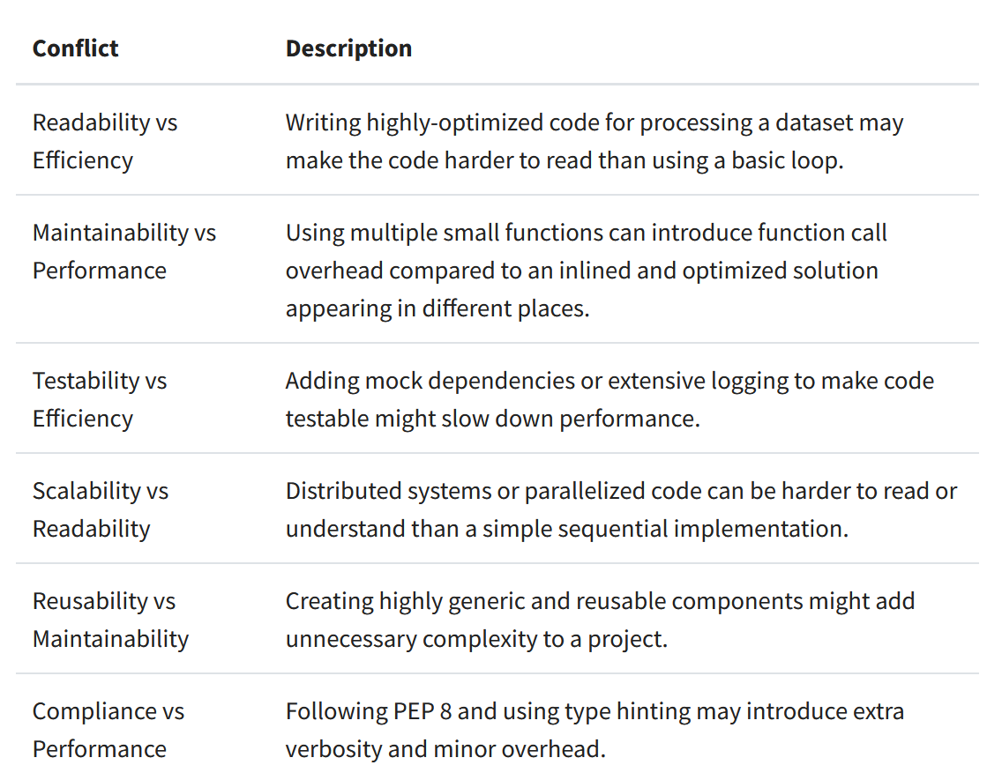

Pylint : Code linters working
- Parses code to AST without running it. No execution happens here. It’s all analysis.
- It applies hundreds of rules :
• Errors (E) – very likely bugs
Example: using a variable before assigning it
• Warnings (W) – suspicious behavior
Example: redefining a built-in name
• Refactor (R) – code structure could be better
Example: function is too complex
• Convention (C) – style issues
Example: variable name doesn’t follow snake_case
• Info (I) – optional suggestions
- At end of it all it scores your code also very confifigarable.
    - • .pylintrc
    - • pyproject.toml
    - • Inline comments like:
PEP 8 ->

Class names -> CamelCase
Function names -> snake-case
Zen of Python? Internal philosophy to write the python code
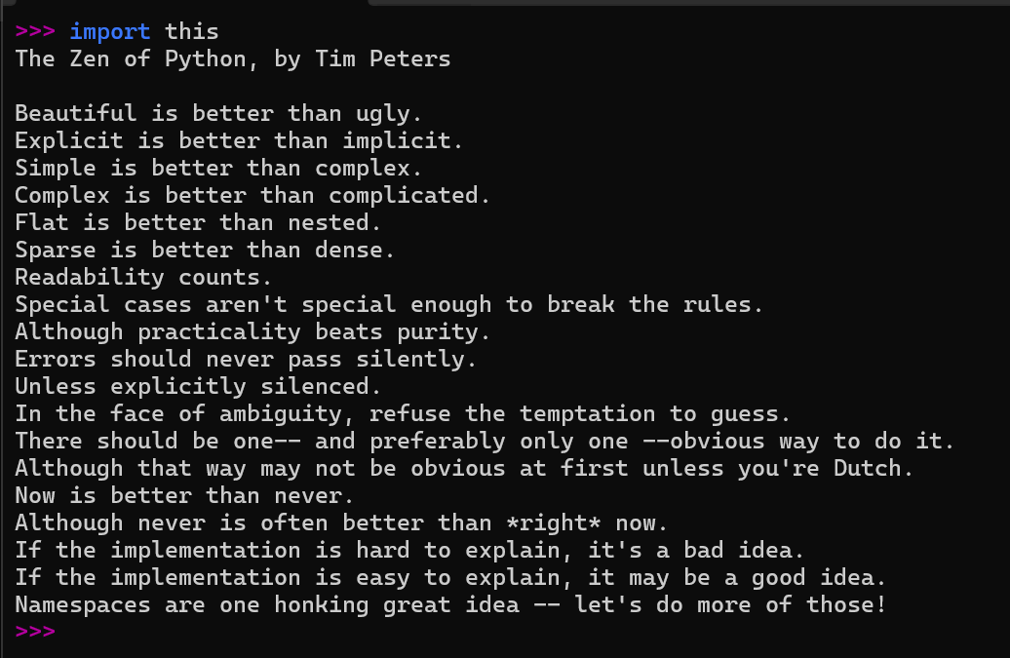

Virtual Enviorments and VENV and UV and poetry:

When py -m venv venv :
When we venv a folder :
Creates a file structure having a copy or syslink for the interpreture, pip and sitepackages…

Venv is not a virtual machine, its just clever…

✅ Dependency isolation
✅ Interpreter-level isolation
✅ Path-based isolation

Commands:
uv init -> initializes the uv project. Creates a toml, lock and complete file structure.
Edit toml file with the whaterver dependencies and uv figure out the dependencies graph and the download it according to the proper function for us.
uv add -> adds the parent dependencies in the toml file.
uv sync -> installs everything in a reduced way and downloads the entire dependencies graph wali shit.
uv run // file name-> runs the main base python code.

Its simple and effective……

