Image Forgery Detection using Error Level Analysis
and Generative Adversarial Networks

1. Introduction
Purpose: The purpose of this project is to create an image forgery detection system. Emphasize the significance of detecting image forgery in numerous applications (e.g., journalism, law enforcement, social media).
Methodology Overview: Briefly describe the two primary methods employed: Error Level Analysis (ELA) as a feature extraction technique and Generative Adversarial Networks (GANs) as a data augmentation method to enhance the accuracy of a Convolutional Neural Network (CNN) classifier.

2. Project Steps and Methodology
Dataset Information:
The project utilizes the CASIA Image Tampering Detection Evaluation Database (CASIA v2.0), a publicly available dataset widely used in image forgery detection research. The CASIA v2.0 dataset is structured into two primary categories:
- Authentic Images (Au): This category contains original, unmanipulated images. These images serve as the "real" examples for training our detection model. The dataset includes a variety of scenes and subjects within this authentic category.
- Tampered Images (Tp): This category comprises images that have been digitally manipulated or forged. The forgeries in CASIA v2.0 involve various tampering techniques, such as copy-move forgery (where parts of an image are copied and pasted within the same image) and splicing (where parts of different images are seamlessly combined).
- Dataset Link: https://www.kaggle.com/datasets/sophatvathana/casia-dataset

2.1 Methodology:
- Due to computational limitations encountered in the Google Colaboratory environment, particularly memory constraints when attempting to process the entire dataset, a limit was imposed on the number of samples loaded per class using the MAX_SAMPLES_PER_CLASS = 3000 parameter. This was a necessary step to prevent the Colab environment from crashing during the data processing and model training phases, given the specifications of approximately 12.9GB RAM and 110GB storage.
- The load_data function handles the data loading. It initializes two empty lists, X to store the ELA-converted images and Y to store their corresponding labels (1 for real, 0 for fake). The function then processes the authentic images located in the /content/casia-dataset/CASIA2/Au/ directory. For each image file found within this directory, the convert_to_ela_image function is called.
- The convert_to_ela_image function is crucial as it performs the Error Level Analysis. This technique works on the principle that when a JPEG image is saved, it undergoes a lossy compression process. If an image has been tampered with and parts have been re-saved at different quality levels, these inconsistencies in compression artifacts can be highlighted by comparing the original image with a version saved at a specific quality (here, 90). The function saves the input image at a specified lower quality, then calculates the pixel-wise absolute difference between the original and the re-saved image. This difference is then enhanced to make subtle compression differences more visible. The resulting ELA image serves as the input feature for our models.
- After obtaining the ELA image, it is resized to the specified image_size = (128, 128) and normalized by dividing pixel values by 255.0 to scale them to the range [0, 1]. The processed ELA image is appended to the X list, and the label 1 (indicating a real image) is appended to the Y list. This process continues until MAX_SAMPLES_PER_CLASS authentic images have been processed.
- A similar process is then followed for the tampered images located in the /content/casia-dataset/CASIA2/Tp/ directory. The same convert_to_ela_image, resizing, and normalization steps are applied. However, for tampered images, the label 0 is appended to the Y list. Again, the loading is limited to MAX_SAMPLES_PER_CLASS tampered images.
- Finally, the X list (containing the ELA images) is converted to a NumPy array, and the Y list (containing the labels) is converted to a NumPy array of categorical labels using to_categorical for the binary classification task (real or fake). The data is then split into training and validation sets using train_test_split with a test_size of 0.2 and a random_state of 5 for reproducibility.
2.2 Generative Adversarial Network (GAN) for Data Augmentation
To augment the training data with synthetic tampered images, a DCGAN-inspired Generative Adversarial Network (GAN) was implemented. This architecture, known for its effectiveness in image generation, comprises two main components: a Generator and a Discriminator.
The Generator is designed to create synthetic images from a random noise vector. It begins with a dense layer to project the noise into a higher-dimensional space, followed by reshaping into a foundational feature map. Subsequently, a stack of deconvolutional layers (Conv2DTranspose) are used to progressively upsample this feature map, increasing its spatial dimensions and learning to generate image-like structures. Batch normalization is applied after each deconvolutional layer for training stability, and LeakyReLU activation introduces non-linearity. The final layer uses tanh activation to output the synthetic image with pixel values ranging from -1 to 1.
The Discriminator acts as a binary classifier, tasked with distinguishing between real ELA-processed images from the dataset and the synthetic images produced by the Generator. Its architecture consists of a series of convolutional layers (Conv2D) that extract features and downsample the input image using a stride. LeakyReLU activation is applied after each convolutional layer. The extracted features are then flattened, and a final dense layer with a sigmoid activation outputs the probability that the input image is real.
The Generator and Discriminator are trained in an adversarial manner for 40 epochs. The Discriminator is trained to maximize its accuracy in identifying real and fake images, while the Generator is trained to produce images that the Discriminator misclassifies as real. Both networks are optimized using the Adam optimizer with a learning rate of 1e-4 and the binary cross-entropy loss function. After training, the Generator was used to generate 1500 synthetic tampered images, which were then rescaled to the 0-1 range to align with the original image data.

2.3. Convolutional Neural Network (CNN) for Forgery Detection
Convolutional Neural Networks (CNNs) are highly effective for image classification due to their ability to automatically learn hierarchical spatial features through convolutional filters. This makes them particularly well-suited for identifying patterns and anomalies indicative of image tampering, especially when used in conjunction with ELA-processed images that highlight subtle compression differences.
The CNN model architecture (build_forgery_detection_model) is implemented as a sequential model, meaning the layers are stacked linearly. This relatively simple architecture is designed for binary classification (real or fake) and consists of the following components:
- Several convolutional blocks, each containing one or more Conv2D layers with relu activation for feature extraction. These are followed by MaxPooling2D layers, which downsample the spatial dimensions of the feature maps and increase the receptive field of subsequent convolutional layers.
- A Flatten layer that transforms the 2D feature maps from the convolutional blocks into a 1D vector, preparing the data for the fully connected layers.
- A Dense layer with relu activation, followed by a Dropout layer (with a rate of 0.5). Dropout is a regularization technique used to prevent overfitting by randomly setting a fraction of the neurons to zero during training.
- A final Dense layer with softmax activation, which outputs a probability distribution over the two classes: "fake" and "real".
The CNN is trained using the Adam optimizer with a learning rate of 0.0001 and the categorical cross-entropy loss function, appropriate for multi-class classification with one-hot encoded labels. The training is conducted for CNN_EPOCHS = 8 epochs under two distinct scenarios:
- Baseline: The CNN is trained exclusively on the original ELA-converted real and fake images from the CASIA dataset.
- Augmented: The CNN is trained on a combined dataset that includes the original ELA-converted images along with the synthetic tampered images generated by the GAN. The labels for these generated fake images are also one-hot encoded to represent the "fake" class.

3. System Requirements
Running this project effectively on Google Colab with adequate computational resources requires a minimum of 13 GB of RAM (recommended), with more being beneficial for handling larger datasets. Storage-wise, at least 110 GB is needed to accommodate the dataset and intermediate files. A dedicated GPU with sufficient memory is highly advisable to significantly accelerate the training of the deep learning models (GAN and CNN).

4. Results
4.1. Baseline Model (Trained without GAN Augmentation)
The CNN trained on the original ELA-converted data achieved a validation accuracy that plateaued around 88% after a few epochs, as seen in the "Model Accuracy Comparison" graph. When evaluated on separate subsets of the original data, the baseline model demonstrated a significant disparity in performance: 100.00% accuracy on real images but 0.00% accuracy on fake images. This indicates that the model, without exposure to a wider variety of tampered image characteristics, became highly specialized in identifying real images but failed to generalize to unseen forgeries present in the evaluation set.
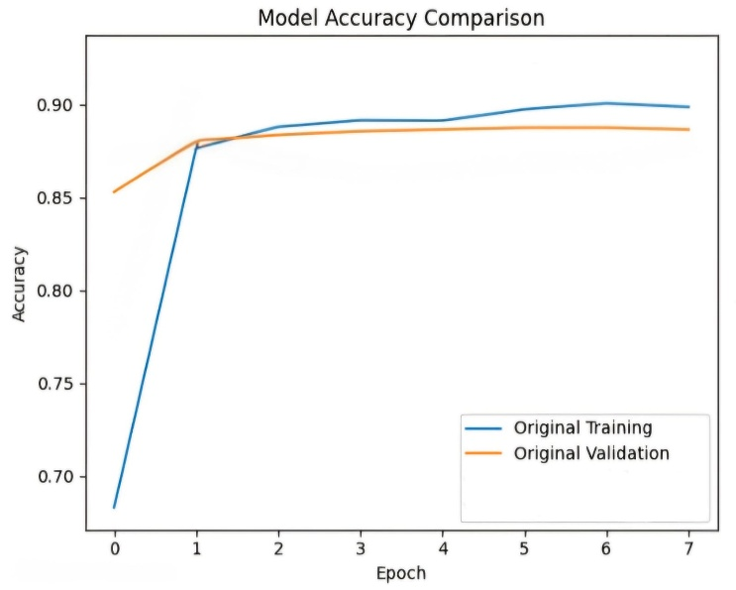
Baseline Model Accuracy Graph

4.2. Augmented Model (Trained with GAN Augmentation)
The CNN trained on the augmented dataset (original ELA images + GAN-generated fake images) showed a different training dynamic. The training accuracy reached a higher peak compared to the baseline. However, the validation accuracy, while starting at a reasonable level, fluctuated and plateaued at a similar overall level to the baseline. The evaluation on unseen original data revealed an improved accuracy of 9.00% on fake images, accompanied by a slight decrease to 94.00% on real images. This suggests that the GAN-generated images provided the model with some additional information about potential forgery characteristics, improving its ability to detect fake images it hadn't seen before, although the improvement was modest.
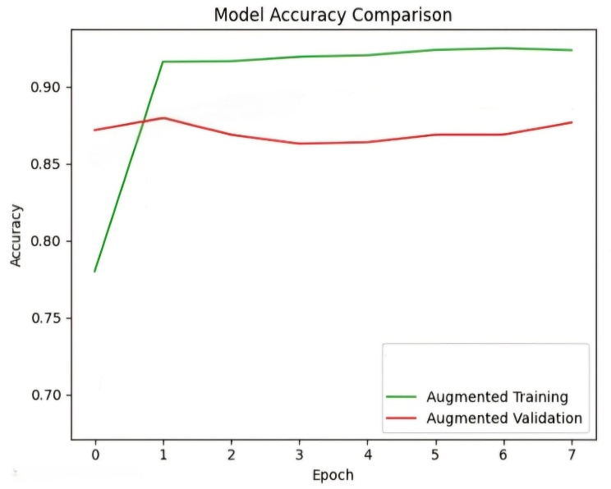
Augmented Model Accuracy Graph

4.3. Comparison
The average accuracy across both real and fake image evaluation sets for the baseline model was (100.00% + 0.00%) / 2 = 50.00%. For the augmented model, the average accuracy was
(94.00% + 9.00%) / 2 = 51.50%. This represents a modest improvement of 1.50% in average accuracy due to the GAN-based data augmentation. While the GAN did contribute to a better detection rate for fake images, the overall impact on the model's generalization ability, as measured by the average accuracy on unseen original data, was limited.

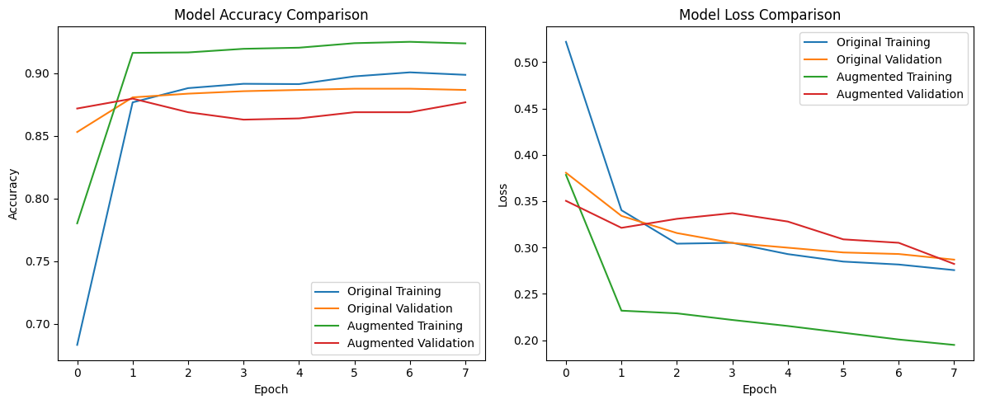
Model Loss Comparison Graph
Model Accuracy Comparison Graph
4.4 Training History Comparison (Model Loss)
The "Model Loss Comparison" graph shows Loss (y-axis) over Epochs (x-axis).
- Original Training Loss (Blue): Starts high, decreases significantly initially, then slows, suggesting approaching learning capacity.
- Original Validation Loss (Orange): Decreases initially, then plateaus and slightly increases, indicating potential overfitting.
- Augmented Training Loss (Green): Starts higher, sharp initial decrease, continues decreasing, ends lower than baseline.
- Augmented Validation Loss (Red): Fluctuates more, decreases initially, then increases and plateaus similarly to baseline, possibly due to GAN image characteristics.
Interpretation: Loss curves indicate GAN augmentation influenced training dynamics. Augmented model training loss was smaller, but validation loss did not improve significantly, supporting evaluation metrics of modest fake image detection improvement without extreme overall generalization gain. Plateauing/slight rise in validation loss indicates there is limited improvement with existing setup and possible overfitting. Lower loss is preferable.

4.5 Training History Comparison (Model Accuracy)
The "Model Accuracy Comparison" graph shows Accuracy (y-axis) over Epochs (x-axis).
- Original Training Accuracy (Blue): Starts low, rapid initial increase, continues improving, reaches high accuracy.
- Original Validation Accuracy (Orange): Increases initially, then plateaus with little further improvement, indicating overfitting.
- Augmented Training Accuracy (Green): Starts lower, very sharp initial increase, surpasses baseline, reaches highest training accuracy.
- Augmented Validation Accuracy (Red): Starts higher, fluctuates more, some initial improvement then plateaus/slight decrease, similar final accuracy to baseline.
Interpretation: Accuracy curves indicate GAN augmentation influenced training. Augmented model's training accuracy was greater but final validation accuracy the same as baseline, which means GAN didn't significantly improve generalization to unseen data, even though it may have assisted in learning more features. Plateauing validation accuracy implies there is little further improvement. Greater accuracy is better.
5. Conclusion
This project investigated the use of GAN-based data augmentation, combined with Error Level Analysis, to enhance a CNN's ability to detect image forgeries. The results indicated a 1.5% improvement in the average accuracy on the evaluation set after augmenting the training data with GAN-generated synthetic tampered images, suggesting a marginal enhancement in the detection of unseen fake images. However, the overall impact on the model's generalization remained modest. A significant factor potentially limiting the effectiveness of the GAN augmentation was the necessity to use only a subset of the CASIA dataset due to computational constraints. This likely restricted the variety and realism of the generated synthetic forgeries, thus limiting their ability to significantly improve the CNN's generalization to a broader range of unseen tampered images. Therefore, further research with more extensive datasets and refined GAN techniques is warranted to fully realize the potential of generative augmentation for image forgery detection.

