InsightPilot AI - Executive Portfolio Report
Report Generated: 2026-07-07 14:07:45
Data Analyst: InsightPilot AI Multi-Agent Coordinator
Executive Overview
The dataset contains 500 records across 19 columns.
The target column 'Delinquent_Account' shows a delinquency rate of 16.0% (80 delinquent accounts).
The average credit score of delinquent accounts is 591.1, compared to 575.2 for non-delinquent accounts.
Portfolio KPI Metrics
KPI Metric | Value
Total Accounts | 500
Average Credit Score | 577.8
Average Income | $108,323.59
Historical Delinquency Rate | 16.0%
Predicted High Risk Accounts | 0 (0.0%)
Average Predicted Risk | 16.5%
Delinquency Trend Analysis
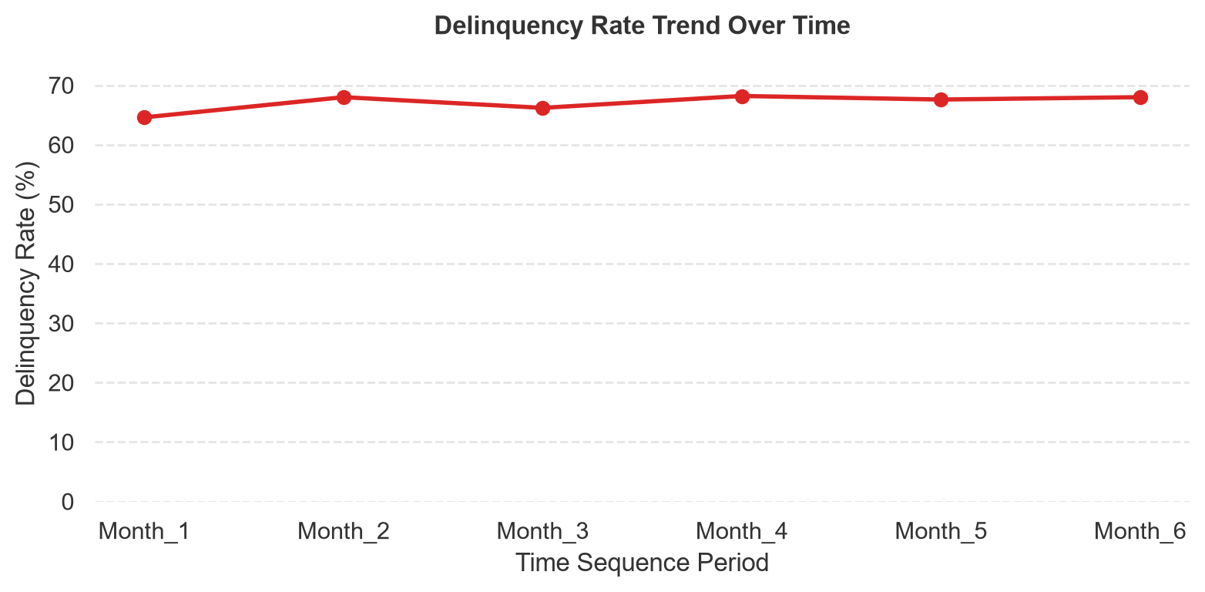
Prediction Model Performance
Model Algorithm: Random Forest
F1-Score: 0.0000 | Accuracy: 0.8400
ROC-AUC: 0.3790 | Precision: 0.0000 | Recall: 0.0000
High Risk Account Action Registry

