**Assignment**

**MODULE-1:** SE- Overview of IT Industry

1. **What is software? What is software engineering?**

* Basically software is a set of instructions programs used to operate computers tasks. It is opposite of hardware, which describes the physical aspects of a computer. Software generic term is used to refer to applications, scripts and programs.
* Software engineering is an engineering-based approach to software development. software engineering is a person who applies the engineering design process to design, develop, test, maintain computer software. Software Engineers bring comprehensive knowledge of programming, design, and engineering principles to build software

2. **Explain types of software.**

* two type of categories software1). Application software and 2). system software.

1. **Application software: -**

* Application software is develop by developer for uses any type of something wanted or needed an application can be self-contained, or it can be a group of programs that run the application for the user.Application is software that fulfills a specific need or performs tasks.

Example of applications software: -MS Word, WhatsApp, Facebook exe….

1. **System software: -**

* System software is a designed to run a computer’s hardware and provides a platform for applications to run on top of. Your system has three basic types of software: application programs, device drivers, and operating systems

Example of system software: -calendar, calculator, clock, notepad exe….

**3.What is SDLC? Explain each phase of SDLC**

* SDLC stands for software development life cycle.

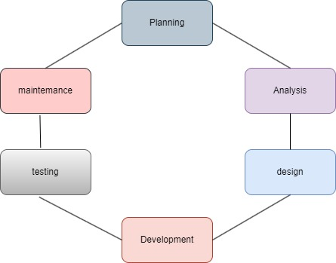

SDLC is the cost-effective and time-efficient process that development teams use to design and build high-quality software.

**Phases of SDLC**

**1)planning :**

* The first phase of the SDLC is the project planning stage where you gathering business requirements from your client or stakeholders. This phase is when you evaluate the feasibility of creating the product, revenue potential, the cost of production, the needs of the end-users, etc.…

**2) analysis:**

* The analysis stage includes gathering all the specific details required for new system as well as determining the first ideas for prototypes. This phase involves gathering information about the software requirements from stakeholders, such as customers, end-users, and business analysts.

**3) Design:**

* The second of the software development life cycle phases is often done concurrently with the first. This phase is necessary for the developers. They will first outline the details for the overall application long side specific aspects, such as; use interface, system interface, network and network requirements and database

**4) Coding:**

* Computer programming or coding is the composition of sequences or instructions, called programs, that computers can follow to perform tasks. It involves designing and implementation algorithms, step-by-step specifications of procedures, by writing code in one or more programming languages.

**5) Testing:**

* Different types of testing occur during this phase, such as a code quality, unit testing, integration testing, performance testing and security testing.

**6) Maintenance:**

* Maintain software functionality, make upgrades to the coding, and ensure any repairs needed to the software are completed. The customer is responsible for maintaining the software by upgrading it when advised.

**4. What is DFD? Create a DFD diagram on Flipkart.**

DFD is the abbreviation for the data flow diagram. The flow of data of a system or a process is represented by DFD.It also gives insight into the inputs and outputs of each entity and the process itself.DFD does not have control flow and no loops or decision rules are present.

**DATA FLOW DIAGRAM ON FLIPKART**

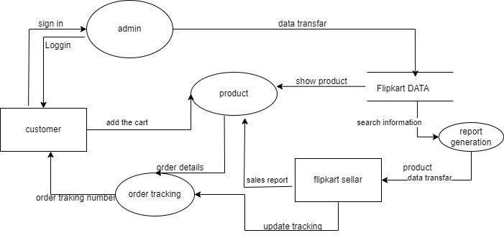

**0 Level DFD**

**5. What is flow chart? Create a flowchart to make addition of two numbers.**

* Flowchart is a type of diagram that represents a workflow or process.
* A flowchart can also be defined as a diagrammatic representation of an algorithm, a step-by-step approach to solving tasks.
* The flowchart shows the steps as boxes of various kinds, and their order by connecting the boxes with arrows.

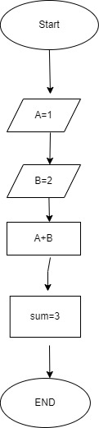

flowchart to make addition of two numbers

**6. What is use case diagram? Create a use case on bill payment on Paytm.**

* Use-case diagrams the high-level functions and scope of a system.
* These diagrams also identify the interactions between the system and its actors.
* The use cases and actors in use-case diagrams describe what the system does and how the actors use it, but now how the system operators internally.

Use case on bill payment on paytm.

