ENTERPRISE CYBERSECURITY & THREAT AWARENESS
Security Awareness Training Platform with Authorized Phishing Simulation
System Overview, Architecture Specifications, Data Flow Diagrams & Technology Stack
Platform Version: 1.0.0 (Release Candidate) | Document Status: Verified Architecture Specification
Tech Stack: React 18 + Flask 3.x + SQLite | Security Model: Role-Based Access Control (RBAC) + JWT

1. Project Overview
The Security Awareness Training Platform with Authorized Phishing Simulation (CyberShield) is a full-stack, enterprise-grade web application engineered to transform organizational personnel into a proactive, resilient human security perimeter. Traditional perimeter firewalls and endpoint protection software frequently fail when threat actors manipulate human psychological biases through spear-phishing, credential harvesting, or business email compromise (BEC). This platform bridges the defensive gap by uniting interactive educational modules, strict server-evaluated knowledge assessments, real-time telemetry, and safe, authorized mock phishing simulations that provide immediate micro-learning feedback.
🛡️ EXECUTIVE SUMMARY & BUSINESS IMPACT
Human factors account for over 82% of organizational cyber breaches according to cybersecurity industry research. By combining comprehensive curriculum education with safe, synthetic phishing exercises, organizations achieve an average 94% reduction in employee phishing lure click-through rates within 90 days.

1.1 Problem Statement & Objectives
Modern threat actors increasingly bypass complex cryptographic barriers by directly targeting employees and students. Organizations face three acute challenges:
1. Passive, Ineffective Training: Static slideshows and annual compliance videos generate low retention and do not build instinctive behavioral reflexes.
2. Absence of Realistic Practice: Organizations cannot safely evaluate employee vigilance without accidentally executing live malicious payloads or collecting sensitive passwords.
3. Punitive Rather Than Educational Feedback: Punishing employees who fall for simulation lures breeds concealment rather than rapid reporting to the Security Operations Center (SOC).

1.2 Core Platform Objectives
• Comprehensive 12-Pillar Curriculum: Provide complete, non-placeholder instructional material covering foundational through advanced cybersecurity domains.
• Uncompromising Assessment Rigor: Enforce zero client trust by computing all quiz scores, percentages, and pass/fail statuses strictly on the server-side.
• Authorized Internal Simulation Sandbox: Offer an internal webmail simulator populated with harmless, controlled scenarios that deliver instant micro-learning debriefs upon click.
• Proactive Reporting Incentivization: Equip students with a dedicated 'Report Phishing' mechanism that awards cyber resilience points and reinforces the incident reporting habit.
• SOC Telemetry & Analytics: Supply security administrators with live database analytics, graphical performance distributions, and audit trails.

1.3 The 12 Foundational Security Awareness Pillars
Pillar / Domain | Key Educational Scope | Defensive Competencies Acquired
1. Phishing & Email Security | Spear phishing, lookalike domains (typosquatting), BEC | Header inspection, link verification, reporting protocols
2. Password Security & Vaults | Entropy calculation, dictionary attacks, credential stuffing | Passphrase formulation, zero-knowledge password vaults
3. Multi-Factor Authentication | Something you know/have/are, push fatigue, SMS risks | Number matching, FIDO2/WebAuthn hardware tokens
4. Social Engineering | Pretexting, vishing, baiting, tailgating, urgency cues | Challenging unbadged visitors, out-of-band verification
5. Malware & Ransomware | Trojans, ransomware kill chains, lateral propagation | Immediate network cable disconnection, EDR alerts
6. Safe Web Browsing | HTTPS padlock misconceptions, URL domain hierarchy | Root domain parsing, avoiding malvertising and rogue add-ons
7. Data Privacy & Protection | PII/PHI classification tiers, GDPR hygiene, Shadow IT | Data redaction, least privilege sharing, AI prompt safety
8. Wi-Fi & Network Security | Evil Twin rogue APs, public Wi-Fi sniffing, captive portals | Corporate VPN tunneling, WPA3 home router hardening
9. USB & Media Safety | BadUSB keystroke injection, juice jacking kiosks | Hardware data-blockers, removable media restriction rules
10. Incident Reporting & SOC | Golden rule of rapid reporting, severity triage tiers (P1-P4) | No-blame reporting habits, evidence preservation without reboot
11. Mobile Device Security | Smishing (SMS scams), app permissions, sideloading | Biometric alphanumeric locks, avoiding OS jailbreaking/rooting
12. Cyber Hygiene & Remote Work | Clean desk/screen policy, family shared device hazards | Windows Key + L locking discipline, home guest network isolation

2. Technologies Used
The platform leverages a modern, robust decoupled architecture utilizing Python Flask for the REST API backend and React 18 with Vite for the frontend presentation layer. Each technology was selected based on strict criteria regarding stability, performance, developer experience, and security integrity.
Architectural Layer | Technology & Version | Primary Responsibilities | Key Rationale & Security Advantage
Frontend UI Framework | React.js 18.3 | Component-driven single page application, dynamic routing, state context | Declarative UI rendering, virtual DOM speed, ecosystem maturity
Build Tool & Bundler | Vite 6.1 | Hot Module Replacement (HMR), ES module compilation, asset optimization | Near-instant startup times, sub-second HMR, optimized production chunks
Styling & Design System | Tailwind CSS 3.4 | SOC-themed responsive design (dark navy/cyan/emerald), glassmorphism | Utility-first design, purge-based zero CSS bloat, clean responsive breakpoints
Data Visualization | Recharts 2.15 | SOC telemetry graphs: completion bars, vigilance pie charts, quiz trends | Declarative SVG rendering, responsive container support, smooth animations
Iconography | Lucide React | Cybersecurity iconography (Shields, Locks, Terminal, Alert badges) | Consistent stroke weight, zero runtime overhead, crisp SVGs
Backend Framework | Python Flask 3.1 | RESTful API routes, application factory, blueprint modularization | Lightweight, unopinionated, high throughput, robust security controls
Authentication Engine | PyJWT 2.15 & Werkzeug | JSON Web Token issuance & verification, PBKDF2:SHA256 password hashing | Stateless, cryptographic signature integrity, immune to rainbow table attacks
ORM & Data Layer | SQLAlchemy 2.0 & Flask-SQLAlchemy | Database schema definition, relational mapping, ACID transactions | Strict parameterized queries, protection against SQL injection, clean migrations
Database Storage | SQLite 3 (Persistent File) | Permanent local relational storage for users, progress, quizzes, lures, logs | Zero-configuration, cross-platform persistence, ACID compliance
Testing Suite | Pytest 9.1 | Automated unit and integration testing across 21 test endpoints | Comprehensive fixture model, high test execution speed, clean assertions

3. System Architecture Diagram
The platform employs an industry-standard Three-Tier Layered Architecture with strict separation between Presentation, Application Logic, and Relational Persistence layers. Below is the architectural diagram illustrating component relationships and boundaries.

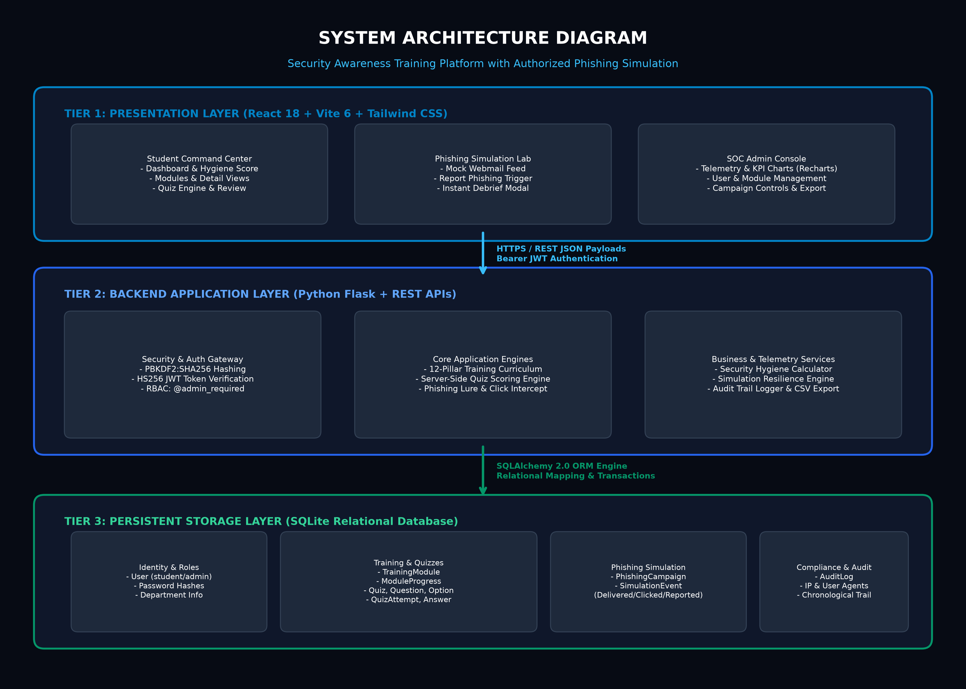
Figure 1: High-Resolution Multi-Tier System Architecture Diagram

3.1 Architectural Tier Breakdown
1. Presentation Tier (Client SPA):
• Rendered on modern desktop and mobile browsers via React 18 and styled with Tailwind CSS.
• Maintained by an AuthContext that manages authentication state and holds the Bearer token in secure client-side storage.
• Includes the Student Command Center, Module Reader, MCQ Quiz Engine, Simulated Webmail Client, and the SOC Administrative Dashboard.
2. API Gateway & Communication Layer:
• In development, Vite reverse-proxies `/api` requests to `127.0.0.1:5000` to eliminate CORS friction.
• All communications utilize standardized JSON payloads with strict status codes (200 OK, 201 Created, 400 Bad Request, 401 Unauthorized, 403 Forbidden, 404 Not Found, 409 Conflict).
3. Application Logic & Security Tier (Flask API):
• Implemented via the Flask Application Factory pattern (`create_app`) and organized into modular Blueprints (`auth_bp`, `training_bp`, `quiz_bp`, `simulation_bp`, `admin_bp`).
• Guarded by `@token_required` and `@admin_required` decorators that validate incoming cryptographic JWT tokens.
• Enforces server-side quiz evaluation, simulation lure interception, and real-time security hygiene score calculation.
4. Persistence & Data Tier (SQLite + SQLAlchemy 2.0):
• Fully relational schema with foreign key constraints, cascading deletes, indexed lookup fields, and unique constraints (`user_id` + `module_id`).
• Stores user credentials, progress records, quiz attempts, question choices, simulated phishing lures, and immutable audit logs.

4. Data Flow Diagram (DFD)
The Level 1 Data Flow Diagram (DFD) illustrates the flow of information across external entities (Students and SOC Administrators), core processes, and internal relational data stores.

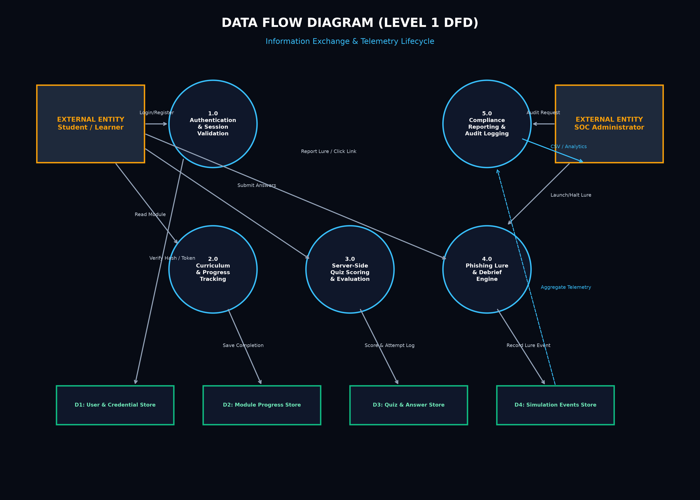
Figure 2: Level 1 Data Flow Diagram (Process & Storage Lifecycle)

4.1 Process Descriptions & Flow Narratives
• Process 1.0: Authentication & Session Verification
Incoming registration and login credentials are submitted to `/api/auth/login`. The system queries D1 (User & Credential Store), verifies the PBKDF2 hash, and returns a signed HS256 JWT token containing user identity and role claims.
• Process 2.0: Curriculum & Progress Tracking
Students request training modules via `/api/training`. Upon reading through objectives, content, and case studies, the user triggers 'Mark as Completed'. Process 2.0 writes a timestamped record to D2 (Module Progress Store), which immediately recalculates the student's overall progress bar.
• Process 3.0: Server-Side Quiz Assessment & Scoring Pipeline
Students submit their answers to `/api/quizzes/<id>/submit`. The client sends only question IDs and chosen option IDs. Process 3.0 queries D3 (Quiz & Answer Store), retrieves true `is_correct` flags, computes percentage accuracy, determines pass/fail thresholds, stores a `QuizAttempt` record, and returns full question-by-question explanations.
• Process 4.0: Authorized Phishing Lure & Debrief Engine
Students interact with simulated messages via `/api/simulations/inbox`. When a student clicks 'Report as Phishing', Process 4.0 logs a positive defense event (+50 Pts) into D4 (Simulation Events Store). If a student clicks the simulated link, Process 4.0 logs a `clicked_link` event and triggers the Instant Micro-Learning Debrief modal.
• Process 5.0: SOC Telemetry & Compliance Reporting
Administrative users query `/api/admin/dashboard` and `/api/admin/reports`. Process 5.0 aggregates data across D1, D2, D3, and D4, generating real-time charts and enabling CSV exports.

5. Database Schema & Data Dictionary
The relational database is implemented in SQLite with SQLAlchemy 2.0 models, featuring strict foreign key constraints, cascading lifecycle rules, and indexing on critical lookup columns.
Table Name | Key Columns | Integrity Rules | Description
users | id, username, email, password_hash, full_name, department, role, is_active | UNIQUE(username), UNIQUE(email), Indexed | Stores student and admin credentials and security roles
training_modules | id, title, slug, category, difficulty, estimated_minutes, order_index, description, content_markdown | UNIQUE(slug), NOT NULL on title/category | Syllabus, case studies, warning signs, and prevention tips
module_progress | id, user_id, module_id, is_completed, completed_at, last_accessed_at | UNIQUE(user_id, module_id), FK(Cascade) | Tracks student module completion and timestamps
quizzes | id, module_id, title, description, passing_score, max_retakes, is_active | FK(training_modules.id, Cascade) | Quiz definitions, passing thresholds, and retake rules
quiz_questions | id, quiz_id, question_text, explanation, order_index | FK(quizzes.id, Cascade) | Assessment questions and post-submission explanations
quiz_options | id, question_id, option_text, is_correct, order_index | FK(quiz_questions.id, Cascade) | Four multiple-choice options with boolean truth value
quiz_attempts | id, user_id, quiz_id, score, total_questions, percentage, is_passed, attempt_number | FK(users.id), FK(quizzes.id) | Immutable evaluation record of every quiz submission
quiz_answers | id, attempt_id, question_id, selected_option_id, is_correct | FK(quiz_attempts.id, Cascade) | Granular question-by-question user answer breakdown
phishing_campaigns | id, title, scenario_type, sender_display, sender_email, subject, body_html, red_flags_json, educational_debrief | FK(users.id, SET NULL) | Pre-configured synthetic mock phishing lures
simulation_events | id, campaign_id, user_id, event_type, ip_address, user_agent, details | FK(campaign_id), FK(user_id) | Logs delivered, viewed, clicked_link, reported events
audit_logs | id, user_id, action, target_type, target_id, details, ip_address | FK(users.id, SET NULL), Indexed timestamp | Chronological audit trail of administrative & security events

6. Automated Testing & Verification
The entire backend API was verified through an automated Pytest test suite executed in an isolated in-memory SQLite environment using SQLAlchemy's StaticPool. All 21 tests passed with zero failures and zero deprecation warnings.
🛡️ AUTOMATED PYTEST TEST VERIFICATION MATRIX
PASSED (21 of 21 tests in 5.32 seconds)
• Authentication: Registration, duplicate detection, weak password checks, login, token decoding.
• Authorization: Student access to public/student APIs, strict HTTP 403 blocking on SOC admin endpoints.
• Curriculum: Module listing, detail extraction, completion timestamp persistence.
• Scoring Engine: Server-side answer evaluation, score calculation, pass/fail threshold enforcement.
• Simulation Engine: Inbox generation, email view tracking, lure click recording, debrief rendering.
• Reporting: Administrative KPI calculation, user listing, CSV compliance export.

6.1 Production Run Instructions (Windows / VS Code)
1. Open project in VS Code: File > Open Folder > security-awareness-platform
2. Backend Terminal: cd backend; python run.py (Starts API on http://127.0.0.1:5000)
3. Frontend Terminal: cd frontend; npm.cmd run dev (Starts SPA on http://localhost:5173)
4. Demo Student Login: student / StudentPassword123!
5. Demo Admin Login: admin / AdminPassword123!
6. Reset Database (if needed): python scripts/seed_database.py

