1.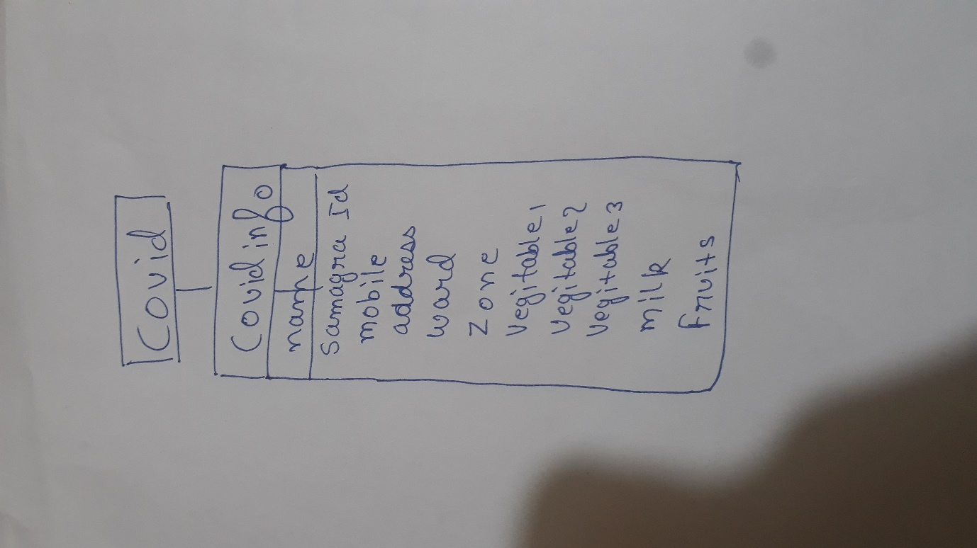

2. Describe all the servlet classes and their functionalities that you need to build this project.

Ans. The very servlet class that I used in this project is” **public** **class** covid_info” .

This class extends the http servlet and provides the functionality to generate the dynamic web content. In this class there are several methods those are :

Public covid_info()

Protected void dopost()

This class takes takes the values from the jsp page and process those values and feed the entered detail into mysql database.

3. NO non servlet class are used .

4. The major challenge that I faced during developing the application was to establish a proper connection between the java file and tomcat server. In my case the NetBeans version was different from the tomcat version, this arouse the compatibility problem then I resolved this problem by using the correct files. The only problem that was faced was this only.

5.

JSP code:

<%@ page language=*"java"* contentType=*"text/html; charset=ISO-8859-1"*

pageEncoding=*"ISO-8859-1"*%>

<!DOCTYPE html>

<html>

<head>

<meta charset=*"ISO-8859-1"*>

<title>Insert title here</title>

</head>

<body>

<div align = *"center"*>

<form method = *"post"* action =*covid_info*>

<h3>Enter your details</h3>

Enter your name : <input type = *"text"* name= *"name"*><br><br>

Samgara ID:<input type =*"text"* name = *"s_ID"*><br><br>

Mobile number:<input type =*"number"* name = *"mobile"*><br><br>

Address:<input type =*"text"* name = *"addre"*><br><br>

Ward number:<input type =*"text"* name = *"ward"*><br><br>

Zone number:<input type =*"number"* name = *"zone"*><br><br>

<h3>Plese Enter your Requirement</h3>

Vegitable 1<input type = *"text"* name = *"vegi1"*><br><br>

Vegitable 2<input type = *"text"* name = *"vegi2"*><br><br>

Vegitable 3<input type = *"text"* name = *"vegi3"*><br><br>

Milk(ltrs)<input type= *" text"* name = *"milk"*><br><br>

Fruits<input type =*"text"* name = *"fruit"*><br><br>

<input type = *"Submit"* >

</form>

</div>

</body>

</html>

Servlet code:

import java.io.IOException;

import java.io.PrintWriter;

import java.sql.DriverManager;

import javax.servlet.ServletException;

import javax.servlet.annotation.WebServlet;

import javax.servlet.http.HttpServlet;

import javax.servlet.http.HttpServletRequest;

import javax.servlet.http.HttpServletResponse;

import java.sql.*;

//import com.mysql.cj.xdevapi.Statement;

import java.sql.Connection;

//import com.mysql.cj.xdevapi.Statement;

/**

* Servlet implementation class covid_info

*/

@WebServlet("/covid_info")

public class covid_info extends HttpServlet {

private static final long serialVersionUID = 1L;

/**

* @see HttpServlet#HttpServlet()

*/

public covid_info() {

super();

// TODO Auto-generated constructor stub

}

/**

* @see HttpServlet#doPost(HttpServletRequest request, HttpServletResponse response)

*/

protected void doPost(HttpServletRequest request, HttpServletResponse response) throws ServletException, IOException {

// TODO Auto-generated method stub

String name = request.getParameter("name");

String s_ID = request.getParameter("s_ID");

String mobile = request.getParameter("mobile");

String addre =request.getParameter("addre");

String ward= request.getParameter("ward");

String zone = request.getParameter("zone");

try

{

Class.forName("com.mysql.cj.jdbc.Driver");

Connection con=DriverManager.getConnection("jdbc:mysql://localhost:3306/covid","Phoenix","Phoenix@2607");

PreparedStatement st = con.prepareStatement( "insert into covidinfo values"+"(?,?,?,?,?,?,?,?,?,?,?)");

String Name = request.getParameter("name");

String SamgraId = request.getParameter("s_ID");

String mob = request.getParameter("mobile");

String address = request.getParameter("addre");

String w = request.getParameter("ward");

String z = request.getParameter("zone");

String v1 = request.getParameter("vegi1");

String v2 = request.getParameter("vegi2");

String v3 = request.getParameter("vegi3");

String milk = request.getParameter("milk");

String fruits = request.getParameter("fruit");

st.setString(1, Name);

st.setString(2, SamgraId);

st.setString(3, mob);

st.setString(4, address);

st.setString(5, w);

st.setString(6, z);

st.setString(7, v1);

st.setString(8, v2);

st.setString(9, v3);

st.setString(10, milk);

st.setString(11, fruits);

int g = st.executeUpdate();

System.out.println("Data inserted");

con.close();

}

catch(Exception e)

{

System.out.println(e.getMessage();

}

}

}