A lot of Linux systems use lilo, the LInux LOader for booting operating systems. We will only discuss GRUB, however, which is easier to use and more flexible.

Bootloader

When a computer is turned off, its software‍—‌including operating systems, application code, and data‍—‌remains stored on non-volatile memory. When the computer is powered on, it typically does not have an operating system or its loader in random-access memory (RAM). The computer first executes a relatively small program stored in read-only memory (ROM) along with a small amount of needed data, to access the nonvolatile device or devices from which the operating system programs and data can be loaded into RAM.
The small program that starts this sequence is known as a bootstrap loader, bootstrap or boot loader. This small program's only job is to load other data and programs which are then executed from RAM. Often, multiple-stage boot loaders are used, during which several programs of increasing complexity load one after the other in a process of chain loading.

When power is first applied to the computer it runs the POST (Power On Self Test) which is part of the BIOS (Basic I/O System).POST is the part of BIOS whose task is to ensure that the computer hardware functioned correctly. If POST fails, the computer may not be usable and so the boot process does not continue.

BIOS POST checks the basic operability of the hardware and then it issues a BIOS interrupt, INT 13H, which locates the boot sectors on any attached bootable devices. The first boot sector it finds that contains a valid boot record is loaded into RAM and control is then transferred to the code that was loaded from the boot sector. (This is MBR)

The BIOS tests the system, looks for and checks peripherals, and then looks for a drive to use to boot the system. Usually it checks the floppy drive (or CD-ROM drive on many newer systems) for bootable media, if present, and then it looks to the hard drive. The order of the drives used for booting is usually controlled by a particular BIOS setting on the system. Once Linux is installed on the hard drive of a system, the BIOS looks for a Master Boot Record (MBR) starting at the first sector on the first hard drive, loads its contents into memory, then passes control to it.

GRUB2 is the program which makes the computer just smart enough to find the operating system kernel and load it into memory. GRUB has been designed to be compatible with the multiboot specification which allows GRUB to boot many versions of Linux and other free operating systems; it can also chain load the boot record of proprietary operating systems.

Intel developed the MBR for their early computer systems. They placed the MBR in the first sector of the drive so that it is the first information found on the disk. This is intended so that the BIOS will not have any trouble in locating it after the initial boot process. Because the partition table is not really very large, it is then placed within the MBR so that it is also easily accessible even without the use of higher level programs.
On the other hand, the partition table is just a few entries that tell the computer how the hard drive is divided or partitioned. This lets you divide your drive and make it look like you have multiple drives even if you just have one.

The primary function of either GRUB is to get the Linux kernel loaded into memory and running.

Stage 1
As mentioned in the BIOS POST section, at the end of POST, BIOS searches the attached disks for a boot record, usually located in the Master Boot Record (MBR), it loads the first one it finds into memory and then starts execution of the boot record. The bootstrap code, i.e., GRUB2 stage 1, is very small because it must fit into the first 512-byte sector on the hard drive along with the partition table. The total amount of space allocated for the actual bootstrap code in a classic generic MBR is 446 bytes. The 446 Byte file for stage 1 is named boot.img and does not contain the partition table which is added to the boot record separately.
Because the boot record must be so small, it is also not very smart and does not understand filesystem structures. Therefore the sole purpose of stage 1 is to locate and load stage 1.5. In order to accomplish this, stage 1.5 of GRUB must be located in the space between the boot record itself and the first partition on the drive. After loading GRUB stage 1.5 into RAM, stage 1 turns control over to stage 1.5.

Stage 1.5
As mentioned above, stage 1.5 of GRUB must be located in the space between the boot record itself and the first partition on the disk drive. This space was left unused historically for technical reasons. The first partition on the hard drive begins at sector 63 and with the MBR in sector 0, that leaves 62 512-byte sectors—31,744 bytes—in which to store the core.img file which is stage 1.5 of GRUB. The core.img file is 25,389 Bytes so there is plenty of space available between the MBR and the first disk partition in which to store it.
Because of the larger amount of code that can be accommodated for stage 1.5, it can have enough code to contain a few common filesystem drivers, such as the standard EXT and other Linux filesystems, FAT, and NTFS. /* The GRUB2 core.img is much more complex and capable than the older GRUB1 stage 1.5. This means that stage 2 of GRUB2 can be located on a standard EXT filesystem but it cannot be located on a logical volume. * / So the standard location for the stage 2 files is in the /boot filesystem, specifically /boot/grub2.
Note that the /boot directory must be located on a filesystem that is supported by GRUB. Not all filesystems are. The function of stage 1.5 is to begin execution with the filesystem drivers necessary to locate the stage 2 files in the /boot filesystem and load the needed drivers.

Stage 2
All of the files for GRUB stage 2 are located in the /boot/grub2 directory and several subdirectories. GRUB2 does not have an image file like stages 1 and 2. Instead, it consists mostly of runtime kernel modules that are loaded as needed from the /boot/grub2/i386-pc directory.
The function of GRUB2 stage 2 is to locate and load a Linux kernel into RAM and turn control of the computer over to the kernel. The kernel and its associated files are located in the /boot directory. The kernel files are identifiable as they are all named starting with vmlinuz. You can list the contents of the /boot directory to see the currently installed kernels on your system.

Kernel
All of the kernels are in a self-extracting, compressed format to save space. The kernels are located in the /boot directory, along with an initial RAM disk image, and device maps of the hard drives.
After the selected kernel is loaded into memory and begins executing, it must first extract itself from the compressed version of the file before it can perform any useful work. Once the kernel has extracted itself, it loads systemd and turns control over to it.
This is the end of the boot process. At this point, the Linux kernel and systemd are running but unable to perform any productive tasks for the end user because nothing else is running.

Systemd (it is replacement of init )
systemd is the mother of all processes and it is responsible for bringing the Linux host up to a state in which productive work can be done. Some of its functions, which are far more extensive than the old init program.

The initrd image contains the necessary executables and system files to support the second-stage boot of a Linux system.

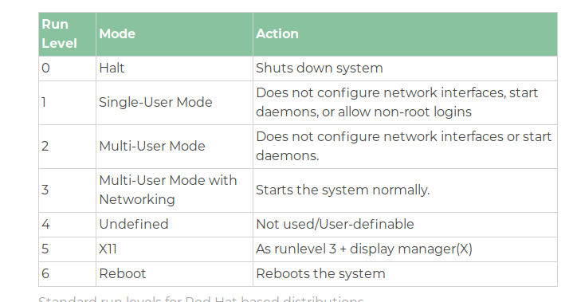

https://www.geeksforgeeks.org/run-levels-linux/
https://www.geeksforgeeks.org/what-happens-when-we-turn-on-computer/
https://www.ibm.com/developerworks/library/l-linuxboot/

