ADAPTIVE CHESS ENGINE

Project Development and Research Report
  - A living technical record from engine foundations to personalized opponent modelling
Project owner Yash Dutt
Repository Adaptive Chess Engine
Report version 1.0 30 September 2026
Repository history reviewed All project commits through 2dbeaf0 plus this learned-selector milestone

This report is the durable context record for the project. It explains what was built, why design choices were made, how claims were measured, what the results mean, and what remains unproven. It is intentionally more complete than a release note and more accessible than the source code.
The project has reached two distinct achievements. First, a correct Python engine was developed and transformed into a measured C++ production engine whose local short-time benchmark improved from an estimated 1871 to 1996 Elo on Stockfish 18's limited-strength scale. Second, a bounded adaptive layer and a reproducible opponent-modelling pipeline were built. The current evidence shows that a nonlinear personalized model predicts future YashDutt7 errors better than a same-class population model, but the project has not yet shown that this predictive advantage produces more wins at equal compute.

How to use this report
Read Part One to understand the conventional engine and the performance foundation that makes adaptive experiments credible. Read Part Two to understand the adaptive selector, personal-game dataset, model comparison, limitations, and next experiment. The final pages provide a milestone ledger and a maintenance rule so future work is not separated from its evidence.

Contents
1. Executive summary
2. Part One Main performance development
3. 1 Foundations and correctness
4. 2 Search and evaluation
5. 3 Performance engineering
6. 4 C++ production migration
7. 5 Measurement and current engine baseline
8. Part Two Adaptive layer and opponent modelling
9. 6 Research question and safety contract
10. 7 Hand-authored adaptive layer
11. 8 Personal-data research pipeline
12. 9 Three-model comparison
13. 10 Player growth, history, and learned deployment
14. 11 What is established
15. 12 Next confirmatory work
16. Appendix Milestone ledger and update protocol

Executive summary
Area | Current result | Interpretation
Production engine | Single-threaded C++20 UCI engine with Python oracle | Playable in standard chess GUIs and independently testable
Engine strength | 1996 estimate; approximate 95% interval 1930 to 2063 | A local Stockfish limited-strength benchmark, not a human-platform rating
Adaptive safety | MultiPV candidates, 35 cp bound, mate protection, neutral fallback | Adaptation is constrained to objectively competitive root moves
Personal corpus | 1,166 usable exact 10-minute games; 36,039 decisions | Large enough for a first player-specific prediction study
Selected model | Histogram gradient boosting | Best held-out probability prediction and only class where personal training beat population training
Open claim | No compute-matched win-rate result yet | Predictive usefulness must still be translated into playing outcomes

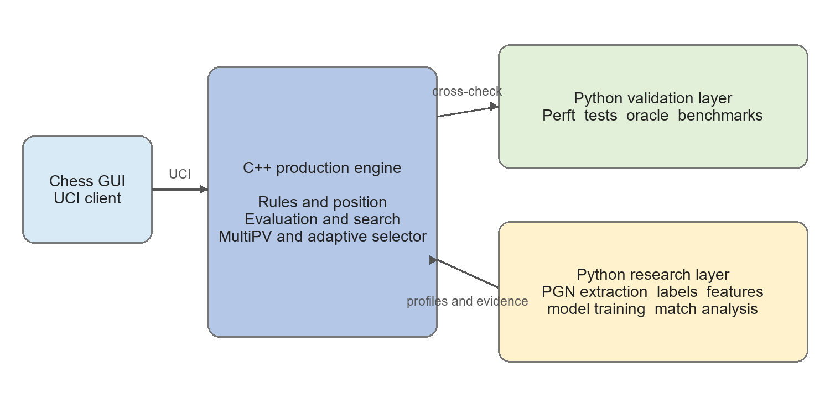
Figure 1 Current hybrid architecture and responsibility boundary

Part One Main performance development
The first phase built a conventional chess engine from first principles, validated it with reference positions and regression tests, then moved performance-critical work into C++. This phase matters to the adaptive research because any claimed adaptive gain is meaningless if the neutral engine is unstable, illegal, or receives less compute than the treatment.

1 Foundations and correctness
The initial Python implementation established the position model: board representation, compact move encoding, FEN parsing, reversible make and unmake, castling, en passant, promotions, undo history, incremental Zobrist hashing, and internal validation. Legal chess behavior then grew through attack maps, pseudo-legal generation, legal filtering, checker and pin handling, draw rules, perft, and divide.
- Perft reference positions verify move counts across special rules and deeper move trees.
- Round-trip tests verify that every move and unmove restores the exact prior position and hash.
- Random-game comparisons preserve a slower correctness path as an oracle for optimized legal generation.
- The Python implementation remains deliberately independent after the C++ migration, allowing the production engine to be checked rather than trusted by construction.

2 Search and evaluation
The playing engine progressed from negamax alpha-beta to iterative deepening, principal-variation search, quiescence, aspiration windows, transposition storage, search ordering, and conservative pruning. Evaluation moved from material and placement toward a tapered middlegame and endgame score with pawn structure, king shelter, rook files, bishop pair, connected and passed pawns, and piece mobility.
Subsystem | Implemented mechanisms | Why it mattered
Search | Iterative deepening, PVS, quiescence, aspiration windows | Improved depth, move stability, and reuse of earlier iterations
Ordering | Hash move, MVV-LVA, SEE, killers, history, countermoves | Raised alpha-beta cutoff efficiency
Pruning | LMR, null move, futility, quiescence delta and SEE pruning | Avoided low-value work with safeguards for tactical and zugzwang cases
Evaluation | Tapered score, structure, shelter, rook files, mobility | Made the neutral engine strategically less shallow
Protocol | UCI, clocks, increments, node limits, asynchronous stop | Enabled repeatable GUI play and experiments

3 Performance engineering
Optimization followed measured hot paths rather than replacing correctness checks. The move core adopted bitboard iteration, precomputed king and knight attacks, direct checker and absolute-pin legality, and occupancy-indexed sliding attacks. Search allocations were reduced through fixed-capacity move lists and principal-variation storage. Material, piece placement, bishop counts, and game phase became incremental; wider geometric terms remain calculated at leaves.
- Pawn structure was cached and evaluation loops became bitboard-driven.
- Undo-state records are reused by ply, reducing recursive allocation pressure.
- Static exchange evaluation improved capture ordering and prevented hopeless losing captures from expanding quiescence.
- Clustered transposition replacement retains several colliding positions and protects deeper current entries.
- Deterministic fixed-node modes made before-and-after comparisons reproducible.
The engineering principle was to preserve a slower reference behavior wherever possible. Speed was accepted only with perft, tactical, search-result, and state-restoration coverage.

4 C++ production migration
The project became a hybrid system rather than a wholesale rewrite. C++ owns the production UCI engine, position core, move generation, evaluation, search, timing, transposition table, and root selection. Python owns the correctness oracle, experiment harnesses, PGN processing, labeling, training, uncertainty analysis, and model research.
C++ production boundary | Python research and validation boundary
Packed moves, bitboards, FEN and Zobrist | Independent legal moves, perft and hash cross-checks
Direct legal generation and lookup attacks | Regression suites and deterministic random comparisons
Tapered evaluation and timed PVS | Dataset construction and reference-engine labeling
UCI, asynchronous stop and self-play | Model fitting, calibration, bootstrap uncertainty
MultiPV, frozen learned inference, and bounded adaptive selection | Profile creation, training, model export, and match analysis

Python is not called at every search node. The intended deployment path is to train and validate outside the engine, export a compact frozen artifact, and perform low-overhead inference in C++ only at the root candidate boundary.

5 Measurement and current engine baseline
The project added deterministic tactical benchmarks, fixed-node self-play, EPD best-move solving, SPRT support, and a Stockfish gauntlet. The current absolute estimate uses Stockfish 18 with UCI_LimitStrength, one thread, 64 MB hash, 30 ms per move, deterministic four-ply openings, color swaps, legal-move verification, and a 140-ply maximum.
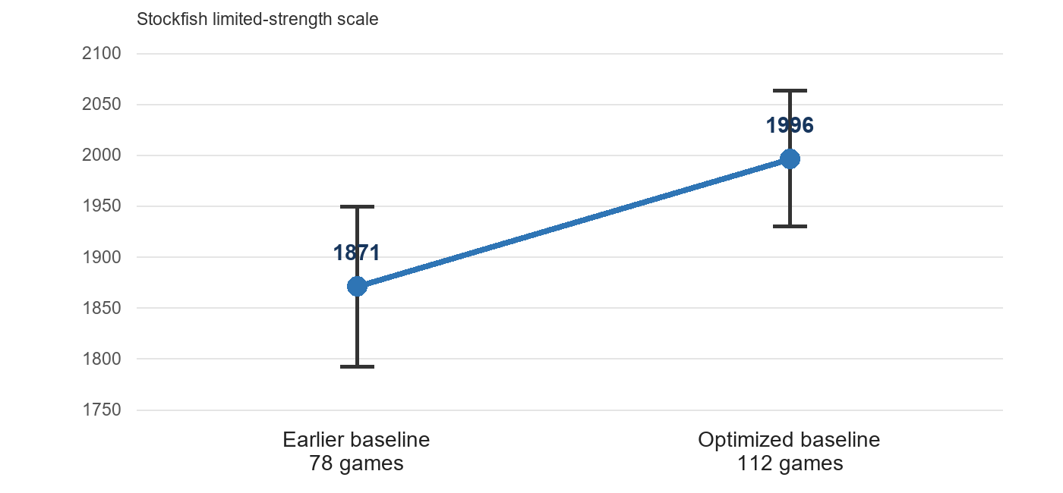
Figure 2 Measured local engine-strength progression with approximate intervals
Opponent setting | Games | W D L | Score | Single-sample estimate
Stockfish 1875 | 64 | 35 14 15 | 65.6% | 1987
Stockfish 2000 | 48 | 20 9 19 | 51.0% | 2007
Combined fit | 112 | 55 23 34 | 59.4% | 1996 interval 1930 to 2063

The earlier 78-game baseline was 1871 with an approximate interval of 1792 to 1949. The newer estimate is about 125 points higher, but it should not be interpreted as FIDE, Chess.com, Lichess, CCRL, or CEGT Elo. It is a local rating within one short-time reference protocol. All 112 latest games completed without a crash or illegal move.
Current verification 117 Python tests passed in the project research environment on 30 September 2026. The C++ implementation also has dedicated suites for position, perft, move generation, search, pruning, timing, MultiPV, adaptive features, model-inference parity, and adaptive selection.

Part Two Adaptive layer and opponent modelling
The adaptive phase changed the central question from making the engine generally stronger to testing a causal claim: can prior information about a recurring opponent improve match score when the personalized and neutral engines receive identical compute and root candidates? The project first built a safe hand-authored selector, then created a data-driven personal error-prediction study.

6 Research question and safety contract
The treatment is not allowed to search more moves or spend more time than the control. Both arms use MultiPV 4 and the same all-root search. Neutral play selects rank one; adaptive play may rerank only completed candidates. Single-PV neutral play is a practical baseline but not the causal control because it performs less root work.
Invariant | Operational rule
Legality | Only moves returned by legal C++ root search can be selected
Objective safety | Alternatives must be no more than 35 centipawns below the neutral best move
Mate safety | Winning mates are preserved and lines allowing forced mate are ineligible
Completeness | Only a fully completed all-root MultiPV iteration can drive adaptation
Fallback | Invalid profiles, interrupted search, terminal positions, or unsupported data fail closed to neutral
Reproducibility | Fixed position, profile, engine version, limits, and seed must reproduce the decision
Fair experiment | Binary, nodes, openings, colors, hardware, and prior-information boundary are matched

7 Hand-authored adaptive layer

7.1 MultiPV root candidates
The C++ engine was extended to return multiple unique, score-sorted root candidates together with completion metadata. Terminal roots are represented as complete zero-candidate results. Interrupted searches can retain diagnostics but cannot become an adaptive decision set.

7.2 Position characteristics
Every completed root candidate is temporarily made on the board and described from the root mover's perspective. The extractor restores the original position. These values measure the position and move; they do not themselves contain preferences.
Feature group | Examples
Forcing play | capture value, promotion gain, check, legal reply count
Material | balance, absolute imbalance, remaining non-pawn material, pawn count
Position shape | open files, mobility, king safety, pawn structure, center control
Commitment | pawn tension, irreversible move, castling

7.3 Versioned profiles and synthetic archetypes
Opponent profiles use a strict JSON schema with a signed weight and confidence for every feature. Unknown fields, duplicates, unsupported versions, missing features, non-integer values, non-finite values, and out-of-range values are rejected. The profile cannot change engine-owned safety limits.
Synthetic profile | Intended pressure
Tactical pressure | Checks, captures, restricted replies, open and imbalanced play
Simplification pressure | Exchanges, reduced material and tension, safer conversion
Complexity pressure | More pieces, choices, tension, imbalance, and commitment
Positional restriction | Mobility, king safety, structure, center control, restricted replies

7.4 Bounded root selector
Candidate zero remains the neutral move. Eligible alternatives are compared with it using normalized feature differences, profile weights, and profile confidence. Only a strictly positive adaptive utility can change the move; ties preserve neutral order. Adaptive Mode is opt-in and the profile is copied into the active search task, preventing mid-search mutation.
This implementation proves that the engine can express controlled behavioral differences. It does not prove that any synthetic style exploits a real person, and it does not yet emit the full candidate-by-candidate decision explanation originally planned.

8 Personal-data research pipeline
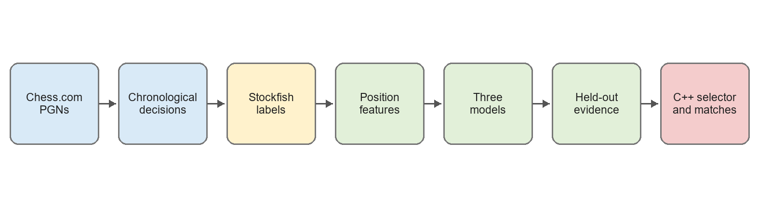
Figure 3 Evidence pipeline from public games to the future playing experiment

8.1 Corpus
The read-only Chess.com archive pipeline downloaded 1,676 public games for YashDutt7. Of these, 1,182 used the exact 600-second time control. The parser produced 36,039 target-player decisions from 1,166 usable games. Raw data and fitted artifacts are ignored by Git; code, schemas, hashes, aggregate results, and protocols are versioned.
Corpus quantity | Value
All public games downloaded | 1,676
Exact 10-minute games | 1,182
Usable parsed games | 1,166
Personal decisions | 36,039
Eligible non-mate labels | 32,988
Large errors at 100 cp | 5,726
Mate-score exclusions | 3,051
Archive PGN SHA-256 | d624add4...e4e2a6f

8.2 Chronological split
Whole games were sorted by date and divided 60 percent training, 20 percent validation, and 20 percent final test. Positions from the same game never cross partitions. This simulates actual deployment: only past information can predict later behavior.
Split | Dates | Games | Decisions | Mean rating | Range
Train | 2022-12-16 to 2024-06-12 | 695 | 20,320 | 772.5 | 370 to 950
Validation | 2024-06-13 to 2025-01-21 | 235 | 7,735 | 985.1 | 897 to 1,095
Test | 2025-01-21 to 2026-06-27 | 236 | 7,984 | 1,186.1 | 1,056 to 1,296

8.3 Labels and stability
For each decision, Stockfish first evaluated the original position and then the child position after the played move. Scores were converted to the player's pre-move perspective. A large error is a loss of at least 100 centipawns; mate-score cases are excluded because mate distance is not a stable centipawn quantity.
The node budget was locked before fitting through a deterministic 500-position stability study. Agreement improved monotonically with more nodes. The chosen 100,000-node budget still contains measurement noise: 12 of 453 jointly eligible labels changed between 50,000 and 100,000 nodes.
Budgets | Agreement | Kappa | Flips | CPL correlation
5k versus 20k | 94.44% | 0.7980 | 26 | 0.9549
20k versus 50k | 96.73% | 0.8859 | 15 | 0.9745
50k versus 100k | 97.35% | 0.9071 | 12 | 0.9827

8.4 Leakage-resistant model features
The model sees only information available before the player's decision: check state, legal moves and captures, material, remaining material, pawns, open files, mobility, king safety, pawn structure, center control, tension, move number, color, player rating, and rating difference. It does not receive Stockfish evaluation, the played move's outcome, centipawn loss, game result, or future information.

9 Three-model comparison
Three model families were compared because they represent increasing flexibility and different assumptions about personalization.
Model | What it assumes | Role in the study
Regularized logistic regression | One mostly additive relationship between features and error probability | Transparent, calibrated linear baseline
Hierarchical Bayesian logistic | Population coefficients plus a cautious player-specific deviation | Partial pooling and uncertainty, implemented with a Laplace approximation
Histogram gradient boosting | Conditional thresholds and interactions among position features | Nonlinear challenger able to represent different regimes

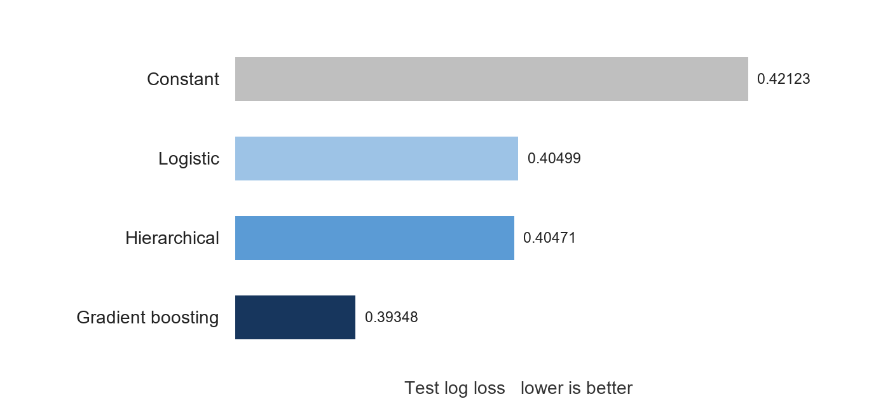
Figure 4 Personalized model test log loss on untouched chronological games
Personalized model | Log loss | Brier | ROC AUC | Avg precision | ECE 10
Logistic | 0.40499 | 0.12157 | 0.62550 | 0.21108 | 0.03020
Hierarchical logistic | 0.40471 | 0.12152 | 0.62584 | 0.21121 | 0.02968
Gradient boosting | 0.39348 | 0.11958 | 0.64934 | 0.22044 | 0.01608

Lower log loss and Brier score mean better probability predictions. ROC AUC measures ranking ability: the boosting value of 0.649 means that, for a randomly selected error and non-error example, the model ranks the error as more likely about 65 percent of the time. Average precision focuses on the rarer positive class, while ECE summarizes calibration error across probability bins.
Model class | Personal | Population | Personal minus population | 95% game-bootstrap interval | Finding
Logistic | 0.40499 | 0.40299 | +0.00200 | +0.00025 to +0.00368 | Population better
Hierarchical | 0.40471 | 0.40291 | +0.00180 | +0.00038 to +0.00313 | Population better
Gradient boosting | 0.39348 | 0.40004 | -0.00656 | -0.01081 to -0.00198 | Personal better

The central result is nuanced. Personal history did not automatically help. Both linear personal models were slightly worse than population versions on the same future Yash positions. Only nonlinear gradient boosting converted the personal history into a statistically supported improvement. A 2,000-replicate paired bootstrap over whole games estimated a 99.9 percent probability that personalized boosting was better than population boosting on this test.
Post-hoc ablations removed rating and time proxies. The personal boosting advantage persisted without player rating and rating difference, and also without rating plus fullmove number. These checks are consistent with nonlinear position-dependent personal tendencies, but they are exploratory because they were run after inspecting the primary result.

10 Player growth and concept drift
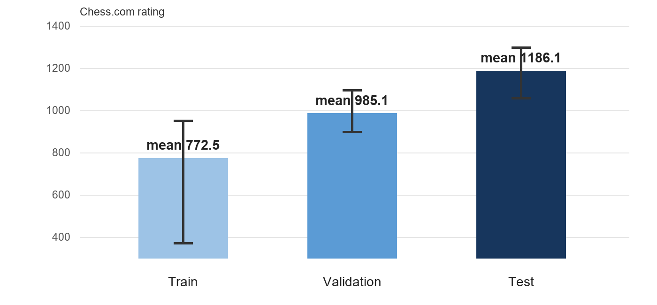
Figure 5 Rating drift across chronological partitions; vertical lines show observed ranges
The training and test periods do not describe a stationary player. Mean rating increased by about 414 points, and the maximum training rating of 950 is below the minimum test rating of 1,056. A lifetime profile therefore combines early, intermediate, and later versions of the player.
Chronological testing was still the correct primary choice because a random split would leak later-strength behavior into training and answer an easier question. The cost is that the experiment tests forward personalization under improvement rather than interpolation within a stable player state.
The nonlinear model did not eliminate growth. It handled the mixture better by learning conditional regimes: a feature can matter differently in a tense middlegame than in a quiet ending, or at different ratings and material structures. Tree models still cannot smoothly extrapolate beyond observed rating thresholds, and the selected model probably retains obsolete information.
The population data are also heterogeneous, but the population model estimates general relationships between position types and human error rather than one fictional combined person. Variation can average into a stable baseline. Personalization must learn tendencies that are specific to the player and remain present in future play, which is a stricter requirement.

10.1 Lifetime, recent, decayed, and online comparison
A follow-up experiment compared five history strategies with the same boosting model. Window sizes and decay rates were selected on validation only. Recent training used the latest 200 games, time decay used a 400-game half-life, and the online arm predicted 20-game batches before adding each completed batch to its history.
History strategy | Log loss | ROC AUC | Meaning
Population | 0.40004 | 0.62223 | General human-position baseline
Lifetime personal | 0.39348 | 0.64934 | Best validation-selected frozen model
Recent 200 games | 0.40185 | 0.64797 | Hard cutoff lost calibration and sample strength
Time-decayed | 0.39768 | 0.64526 | Gentler than a cutoff, but below lifetime
Online 20-game updates | 0.39048 | 0.66229 | Best forward prediction; retrains after completed batches

The data do not support discarding older history for this corpus. Lifetime boosting beat the recent and decayed frozen variants, while online updating was best overall and beat population by -0.00956 log loss with a 95 percent game-bootstrap interval from -0.01343 to -0.00543. The practical interpretation is to retain broad lifetime signal and refresh it as newly labeled games arrive. Because online updating is a process rather than one frozen artifact, lifetime boosting remains the fair fixed model for the causal playing experiment.

10.2 Frozen learned selector and safety experiment
The lifetime personal and population boosting models were exported as deterministic C++ tree data with source hashes, exact feature order, thresholds, missing-value directions, and leaf values. C++ probabilities match sklearn to within 1e-12 on a parity corpus, and a board fixture matches all 17 Python position features. The fixed exploitation adjustment is 100 centipawns per unit probability difference, capped at plus or minus 20 cp; the existing 35 cp eligibility bound and mate protections remain authoritative.
Policy | Changes on 32 identical positions | Mean score loss | Maximum score loss
Neutral rank 1 | 0 (0.0%) | 0.00 cp | 0 cp
Population boosting | 2 (6.25%) | 0.25 cp | 8 cp
Personal lifetime boosting | 1 (3.13%) | 0.03 cp | 1 cp
Deterministic random-safe | 11 (34.38%) | 1.47 cp | 15 cp

All four arms consumed identical candidates and scores at 20,000 nodes, with zero mismatches. The personal policy is operational but conservative: only one of 32 held-out historical opponent-turn positions changed, at a one-centipawn search cost.
Policy | W-D-L versus 1164-limited Stockfish | Score | Difference versus neutral (95% interval)
Neutral | 11-5-0 | 84.38% | reference
Population | 11-4-1 | 81.25% | -3.13 pp (-21.88, +15.63)
Personal | 12-4-0 | 87.50% | +3.13 pp (-12.50, +18.75)
Random-safe | 9-6-1 | 75.00% | -9.38 pp (-28.13, +6.25)

This 64-game safety run found no detectable arm difference; every interval includes zero. It verifies stable, legal, bounded play at equal target nodes. It is not a causal personalization test because limited-strength Stockfish is not Yash and does not express the learned tendencies. Historical replay also cannot reveal how Yash would respond after the engine chooses a counterfactual move.

11 What is established
Established by current evidence | Not yet established
The production engine is legal, testable, GUI-compatible, and locally measured | The 1996 estimate transfers to human or public rating pools
Position features predict future large errors better than a constant rate | The model explains causal psychological weaknesses
Boosting outperforms both linear alternatives on future games | The result transfers to other players or time controls
Personal boosting beats same-class population boosting on Yash test games | Personalized root selection wins more games against Yash at equal compute
Frozen C++ learned selection is parity-tested, bounded, and conservative | Online refresh improves real match outcomes

12 Next confirmatory work
The probability model and playing policy are now frozen and parity-tested. The remaining confirmatory phase must measure their effect against the profiled human without tuning on that final match set.
1. Preregister the prospective match sample size, stopping rule, random arm order, color balance, opening policy, time control, and primary score comparison.
2. Run blinded games in which Yash faces neutral, population, personal, and random-safe arms without knowing the active policy. Preserve identical MultiPV 4 node limits and hardware.
3. Use paired game-level uncertainty or SPRT and report all arms. Do not tune the 100 cp probability scale or 20 cp cap on these games.
4. Treat the human result as the causal endpoint. Retrospective prediction and Stockfish safety matches cannot substitute for it.
5. Only after the frozen causal match, evaluate a deployment process that periodically relabels completed games and refreshes the lifetime model in preregistered 20-game batches.
The strongest research direction is opponent modelling under concept drift: whether an engine can track an evolving human well enough to improve compute-matched playing outcomes. This framing preserves negative findings and makes player growth part of the scientific problem instead of treating it as inconvenient noise.

Appendix Milestone ledger
Date | Milestone | Evidence retained
10 Jul 2026 | Core board representation and move system | Stage 1 implementation and regression tests
28 Jul 2026 | Legal generation, evaluation, alpha-beta, UCI, TT, ordering | Perft, search and protocol tests
4 Aug 2026 | Python performance work and C++ production migration | Benchmarks, cross-checks, self-play and SPRT tools
18 Aug 2026 | C++ direct legality, sliding lookups, preallocation, incremental evaluation | Architecture sync and 1996 Elo baseline
18 Aug to 1 Sep 2026 | Adaptive contract, MultiPV, features, schema, synthetic profiles, selector | Versioned docs, profiles and C++ tests
30 Sep 2026 | Personal PGN pipeline, reference labels, features and three-model comparison | Dataset hashes, stability report, drift report and held-out results
30 Sep 2026 | Living project report established | This Word report and reproducible builder
30 Sep 2026 | Player-history drift strategies compared | Lifetime frozen model retained; online updating produced the best forward prediction
30 Sep 2026 | Boosting models deployed in bounded C++ selector | Inference and feature parity, 32-position identical-candidate replay, and 64-game safety match

Report maintenance rule
This document is a living project artifact. Every future GitHub push that changes architecture, experimental protocol, data, model behavior, measurements, conclusions, or the roadmap should update the corresponding section of this report in the same work cycle. Small refactors that do not change behavior may be recorded in the milestone ledger rather than expanded into a new section.
- Record the commit or milestone, date, purpose, implementation change, validation performed, result, and remaining uncertainty.
- Separate measured facts from interpretations and proposed next steps.
- Preserve negative results and failed hypotheses; do not rewrite history around the winning model.
- Update charts and sample counts when a newer experiment supersedes them, while retaining the older value in the milestone narrative.
- Regenerate this Word file with tools/build_project_report.py, render it, inspect every page, then commit the report with the related project change.

Source record
This version was assembled from the Git history through commit 2dbeaf0 plus the learned-selector milestone documented here, the repository roadmap and architecture notes, the Elo benchmark, the adaptive experiment contract, the profile and feature specifications, the reference-label stability study, the player-drift report, and the YashDutt7 model-results report. Personal raw games remain outside version control; frozen derived tree parameters are checked in with source hashes for reproducibility.

