K-Means Clustering Analysis of Fashion Sales Data
- Executive Summary
This report outlines the process and findings of a k-means clustering analysis performed on a fashion sales dataset. The primary objective was to segment customers based on their purchasing behavior to identify distinct groups. The analysis involved data preprocessing, exploratory data analysis, and the application of k-means clustering. The results identified four unique customer segments, each with specific characteristics related to sales, profit, and discount usage.

- Methodology
The analysis was conducted using Python with libraries such as pandas, numpy, and scikit-learn. The dataset, "Snitch_Fashion_Sales_Uncleaned.csv", was loaded and underwent several preprocessing steps:
Handling Missing Values: Missing data in numerical columns like Units_Sold, Unit_Price, and Sales_Amount were imputed using the mean, while categorical columns like Segment were imputed with the most frequent value.
Feature Engineering: New features, including Total_Cost, Day, Month, and Year, were created to provide a more comprehensive view of customer behavior.
Data Encoding: Categorical variables such as City, Product_Category, and Segment were converted into a numerical format using one-hot encoding for use in the clustering model.
Data Scaling: The selected numerical features were scaled using StandardScaler to ensure that no single feature disproportionately influenced the clustering algorithm. To determine the optimal number of clusters, both the Elbow Method and the Silhouette Score were employed. The Elbow Method plot showed a significant bend at k=3, while the Silhouette Score plot indicated the highest score at k=4. Based on this, four clusters were selected for the final model.

3. Clustering Results & Analysis

The k-means model successfully grouped the data into four distinct clusters. The average values for key features were analyzed to profile each segment:
Cluster 0 (High-Value Customers): This segment represents the most profitable customers, with the highest average sales amount, profit, and total cost. These customers receive the largest discounts, suggesting that high-value purchases may be influenced by promotional offers.
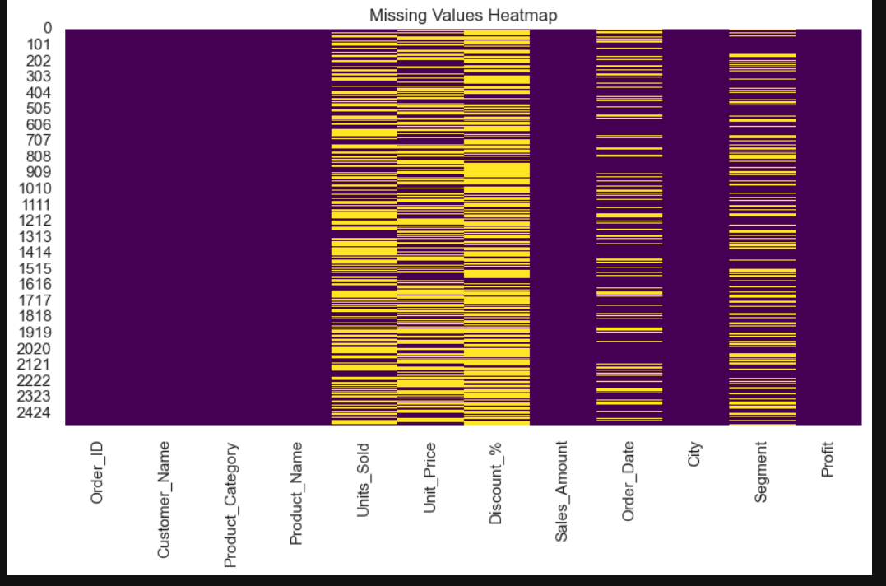

Cluster 1 (Low-Value Customers): This cluster has the lowest average sales, profit, and units sold. They also receive minimal discounts, indicating they are a low-engagement segment that may not be responsive to current promotions.

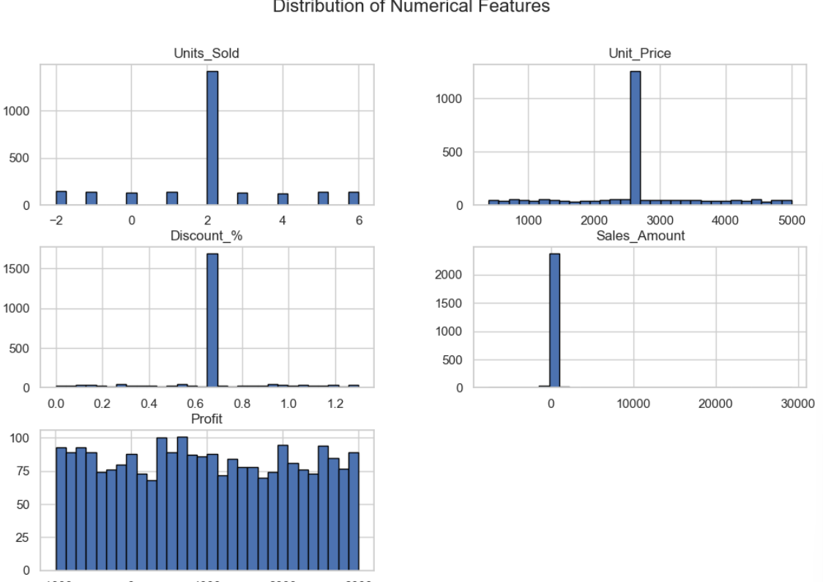

Cluster 2 (Low-to-Moderate Value): Customers in this segment exhibit low to moderate sales, profit, and units sold. They receive low average discounts, similar to the low-value segment.

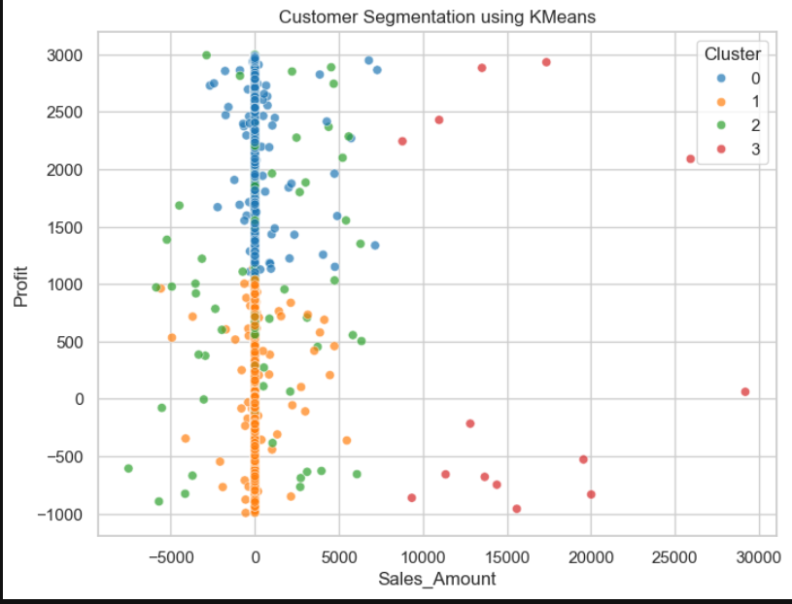

Cluster 3 (Moderate-Value Customers): This group has moderate sales, profit, and units sold. Notably, they receive high average discounts, making them a potential target for personalized offers to increase their profitability.

4. Conclusion & Recommendations
The customer segmentation analysis provides valuable insights into the sales data. The four identified clusters can be used to develop targeted marketing and sales strategies.
High-Value Customers (Cluster 0): To retain this key segment, the company should focus on loyalty programs and exclusive offers.
Low-Value Customers (Cluster 1): This group requires a strategy to boost engagement. Targeted promotions and personalized product recommendations could encourage more frequent purchases.
Moderate-Value Customers (Clusters 2 & 3): These segments represent an opportunity for growth. By leveraging the high discounts that seem to appeal to Cluster 3, and experimenting with new promotions for Cluster 2, the company can aim to move these customers into a higher-value category.

