**Modeling of Electromagnetic Stirring of Liquid Metals**

*A project Second review report submitted for the degree of*

**Bachelors of Technology in Mechanical Engineering**

*By*

**Yash Ganatra**

**(10BME1043)**

**SCHOOL OF MECHANICAL AND BUILDING SCIENCES**



April 2014

1. **INTRODUCTION**

In the first chapter, a detailed description regarding the working and types of electromagnetic stirrer was done. This was accompanied by a discussion of Magnetohydrodynamic phenomena and the governing equations that are used to model electromagnetic stirring.

In this chapter, a detailed discussion regarding the boundary conditions for Maxwell’s equations and potential formulation to simplify Maxwell’s equations will be done. Subsequently, this formulation was used to validate the magnetic field around a current carrying conductor by implementing user defined functions in FLUENT commercial solver. The chapter will conclude with the scope for future work.

1. **EQUATIONS DEFINING ELECTROMAGNETIC PROBLEM**

As discussed in the first chapter, the Maxwell’s equations are described below:

Faraday’s Law: $∇×\vec{E}= - \frac{∂\vec{B}}{∂t}$ (2.1)

Ampere’s Law: $∇×\vec{H}= \vec{j}+\frac{∂\vec{D}}{∂t}$ (2.2)

Gauss Law (electric): $∇∙\vec{D}= ρ_{e}$ (2.3)

Gauss Law (magnetic): $∇∙\vec{B}=0$ (2.4)

The general form of Ohm’s Law is given by:

 (2.5)

where **E** is the electric field (V/m)

**B** is the magnetic flux density (Wb/m2)

**H** is the magnetic field intensity (A/m)

**J** is the current density (A/m2)

is the permeability of the metal (H/m)

is the conductivity (S/m)

**v** is velocity of the fluid ( m/s)

The mechanical forces given by the vector cross products are as follows:

 (2.6)

The constitutive relations are:

 (2.7)

 (2.8)

A typical structure of an eddy-current problem with conducting and non-conducting regions is shown in Fig. 2.1. The boundaries of the conducting region W1 and the non-conducting region W2 are denoted by G1 and G2, respectively. The interface between these two regions is denoted by G12 and is a part of G1 and G2. Coils carrying known source current densities ***J***c are included in the non-conducting region W2. The arrows illustrate the flow of a magnetic field. These arrows are used to distinguish between the two parts G*H* and G*B* of the outer boundary where different conditions apply. Those parts of G1 and G2 which belong to G*H* are denoted by G*H*1 and G*H*2, respectively. Similarly, those parts of G1 and G2 which belong to G*B* are denoted by G*B*1 and G*B*2, respectively. At the interface G12, Maxwell’s equations imply continuity conditions on the normal component of the magnetic flux density and on the tangential component of the magnetic field intensity,

***B*** 1 × ***n***1 + ***B***2 × ***n***2 = 0 (2.9)

***H*** 1 ´ ***n***1 + ***H***2 ´ ***n***2 = **0** (2.10)

where ***n***1 and ***n***2 are the unit normal vectors directed outward from the conducting and the non-conducting regions, respectively.



Figure 2.1: Typical structure of an eddy current problem with conducting and non-conducting regions

On the outer boundary, three conditions are imposed: the tangential component of the magnetic field intensity is zero on G*H*

***H*** x ***n*** = **0** (2.11)

the normal component of the magnetic flux density is zero on G*B*

***B*** . ***n*** = 0 (2.12)

and the normal component of the current density is zero on G1

***J*** . ***n***1 = 0 (2.13)

where ***n*** is the unit normal vector directed outward from the region in question. The boundary and interface conditions are assumed to be homogeneous for the sake of simplicity. A detailed derivation of the boundary conditions is presented in [1].

1. **POTENTIALS DESCRIBING THE ELECTROMAGNETIC FIELD**

The electromagnetic field variables ***H*** and ***E*** can be solved directly, but it is often found to be advantageous to use potentials describing the field. If ***H*** or potentials describing ***H*** are used as unknowns, the formulations are called magnetic formulations.

According to the principles of Vector calculus, $∇∙\left(∇x\vec{A}\right)=0$

Hence, we define, Magnetic vector potential A as

$\vec{B}= ∇ x \vec{A}$ (2.14)

Substituting (2.14) in (2.1),

$∇ x \left(E+\frac{d\vec{A}}{dt} \right)=0$ (2.15)

Defining a electric scalar potential V as,

$∇ V= -\left(E+\frac{d\vec{A}}{dt} \right)$ (2.16)

This formulation is referred as the A-V formulation

The following assumptions are taken due to the nature of the problem:

1. Electro-neutrality

Using the equation for conservation of charge,

$\frac{∂q_{e}}{∂t}+∇ ∙\vec{j}=0$ (2.17)

With the assumption that each volume element is electrically neutral at macroscopic scale (total electric charge is zero), results in,

$∇∙\vec{j}=0$ (2.18)

1. Quasi steady electromagnetic phenomena

Considering Ampere’s Law (2.2), if the dimension of eddy current regions is small compared with the effect of prescribed fields, the displacement current, $\frac{∂D}{∂t}$, can be neglected.

Thus Ampere’s Law reduces to:

$∇×\vec{H}= \vec{j}$ (2.19)

Taking divergence of (2.5), using (2.16) neglecting the induction term 

$∇∙j= ∇∙\left(σE\right)=- ∇∙σ\left(∇ V+ \frac{∂A}{∂t}\right)=0$ (2.20)

For magnetostatic cases [2] or for an axisymmetric AC arc [3], $\frac{∂A}{∂t}$ is neglected. Thus (2.20) essentially states that current is divergence free and charge is conserved.

This leads to $∇∙σ\left(∇ V\right)=0$ (2.21)

When the induction term is included in Ohm’s Law, (2.21) becomes

$∇∙σ\left(∇ V\right)=- ∇∙(σ \vec{v} ×\vec{B})$ (2.22)

which is numerically more tedious to solve.

For the magnetostatic case or when velocities of fluid are low, (2.20) is used. Magnetic Reynolds number (${Re}_{m}= σμ U_{0}L$) is used to determine if the induction term is neglected or not.

Considering (2.19),

$∇×\vec{B}= ∇ ×(∇×\vec{A })= μ \vec{j}$

$∇ ×\left(∇×\vec{A }\right)= ∇∙\left(∇∙\vec{A}\right)- ∇^{2}\vec{A}= μ \vec{j}$

Using Coulomb Gauge Condition [3],[4], $∇∙\vec{A}=0$,

$∇^{2}\vec{A}= - \vec{j}$ (2.23)

1. **SIMPLIFIED EQUATION SET**

$∇∙σ\left(∇ V\right)=0$ (2.24)

$\vec{j}= -σ∇V$ (2.25)

$∇^{2}\vec{A}= - \vec{j}$ (2.26)

$\vec{B}= ∇ x \vec{A}$ (2.27)

1. **IMPLEMENTATION AND VALIDATION**

The system of equations (2.24),(2.25),(2.26),(2.27),supplemented with the constitutional relations (2.7),(2.8) have no general analytical solutions or analytical solutions are available only for simple geometries under a set of assumptions. Thus, a numerical solution is sought.

In this work, FLUENT is used as the solver. By default, it can’t solve equations (2.24),(2.25),(2.26),(2.27) but it provides for solving equations which are not under its scope by default by it’s in-built user defined scalar transport equation (UDS) module described in Chapter 1. These equations are casted in the form required by FLUENT and solved.

The subsequent sections deal with implementation of UDS and their validation for different electromagnetic problems.

1. **Validation of FLUENT simulations on a 2D axisymmetric geometry**
2. Geometric properties for 2D Axisymmetric Geometry

The thesis by Zhe Huang [2] is taken as the reference for validation problems because the thesis validates the result obtained by OpenFoam simulations with that of COMSOL simulations along with then analytical result. Thus a strong agreement with these results would validate the code solved in FLUENT.

The 2D axisymmetric geometry is shown in Figure 2.1. It comprises of a conductor of radius **r** m surrounded by an air box of radius **R** m, both have the same length **L** m. The dimensions are given in Table 2.1.



Figure 2.1: Geometry from 3D to 2D axisymmetric

Table 2.1: Geometric data for 2D Axisymmetric geometry

|  |  |  |
| --- | --- | --- |
| r (inner radius) m | R (outer radius) m | L (Length ) m |
| 0.2 | 2 | 6 |

1. Mesh Generation in ANSYS

FLUENT requires that X Axis be the axis of symmetry [4]. The Geometry along with the Named Selections is shown in Figure 2.2. The Mesh comprises of 50 Cells in X direction (axial direction) and 68 Cells in Y direction (radial).

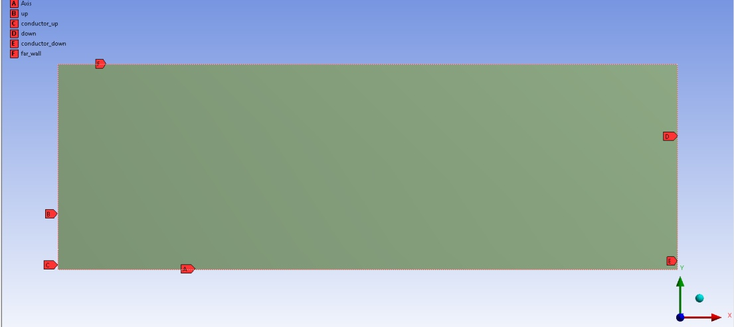

Figure 2.2: 2D Axisymmetric Geometry with Named Selctions

1. Boundary Conditions and Initial Values.

As shown in Table 2.2 and Table 2.3, potential difference between 2 ends is the driving force.

Table 2.2: Material properties for 2D Axisymmetric Geometry

|  |  |  |  |
| --- | --- | --- | --- |
|  | $$μ (H/m)$$ | Electric Potential (V) | Electrical Conductivity (S/m) |
| Copper | 1.26e-6 | High:670 Low:0 | 2700 |
| Air | 1.26e-6 | 0 | 1e-5 |

Table 2.3: Boundary conditions for 2D Axisymmetric Geometry

|  |  |  |
| --- | --- | --- |
|  | A(V.s/m) | V (V) |
| Conductor_up | Zero normal gradient | 670 |
| Conductor_down | Zero normal gradient | 0 |
| Up | Zero normal gradient | Zero normal gradient |
| Down | Zero normal gradient | Zero normal gradient |
| Far_walls | Zero value | Zero normal gradient |
| Axis | Axis | Axis |

Zero normal gradient (normal implies the direction of outward normal vector of the surface under consideration) corresponds to Neumann boundary condition and Zero value corresponds to Dirichlet boundary condition. For Axis no boundary conditions are needed [4].

The Magnetic vector potential has two components – **Az** and **Ar** .  Thus there are 2 UDS for A and 1 for electric scalar potential **V.**

Table 2.4 describes the conversion of the equations corresponding to the **A-V** formulation into user defined scalar transport equations required by FLUENT solver according to (1.13).

Table 2.4: Equations casted into UDS form

|  |  |  |  |
| --- | --- | --- | --- |
| Scalar | Flux term coefficient | Diffusivity | Source Term |
| Az | 0 | 1 | $$μJz$$ |
| Ar | 0 | 1 | $$μJr$$ |
| V | 0 | $$σ$$ | 0 |

1. Results

The resulting magnetic field plot is shown and compared with the analytical solution.

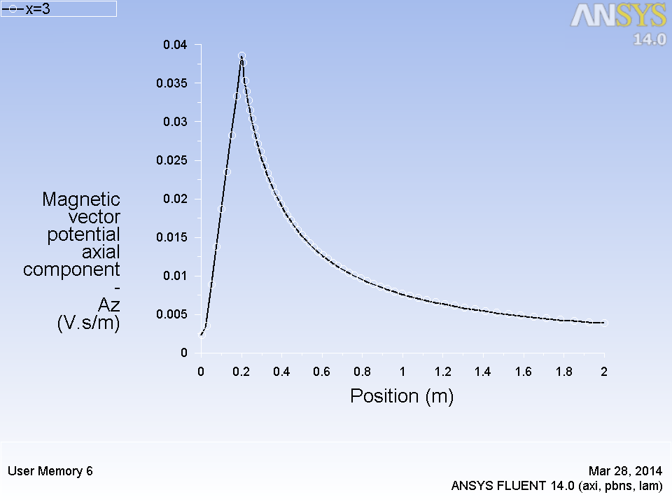

Figure 2.2: Line plot of Magnetic flux density at x=3 with the radial distance

The line plot of magnetic field inside the conductor is shown in Figure 2.3.

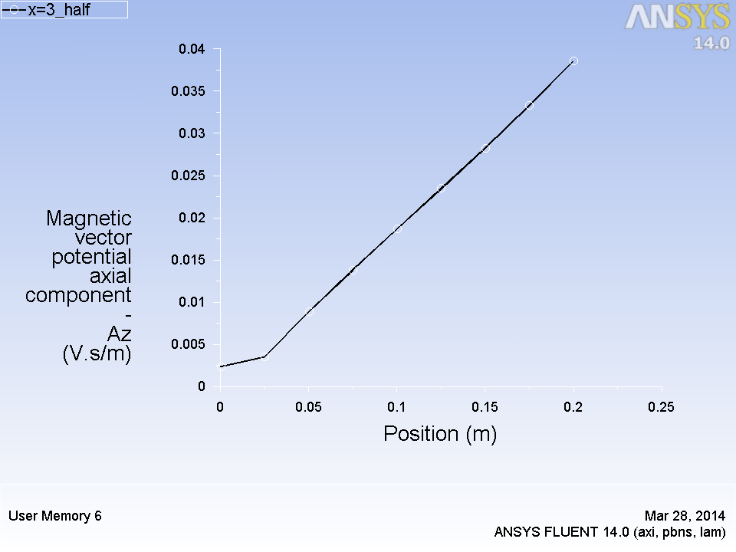

Figure 2.3: Line plot of Magnetic field inside the conductor

The line plot of analytic and numerical solution is shown in Figure 2.4. The maximum error is 1.45% which occurs at the singularity point where conductivity changes at r = 0.2m (highlighted by the data cursor).

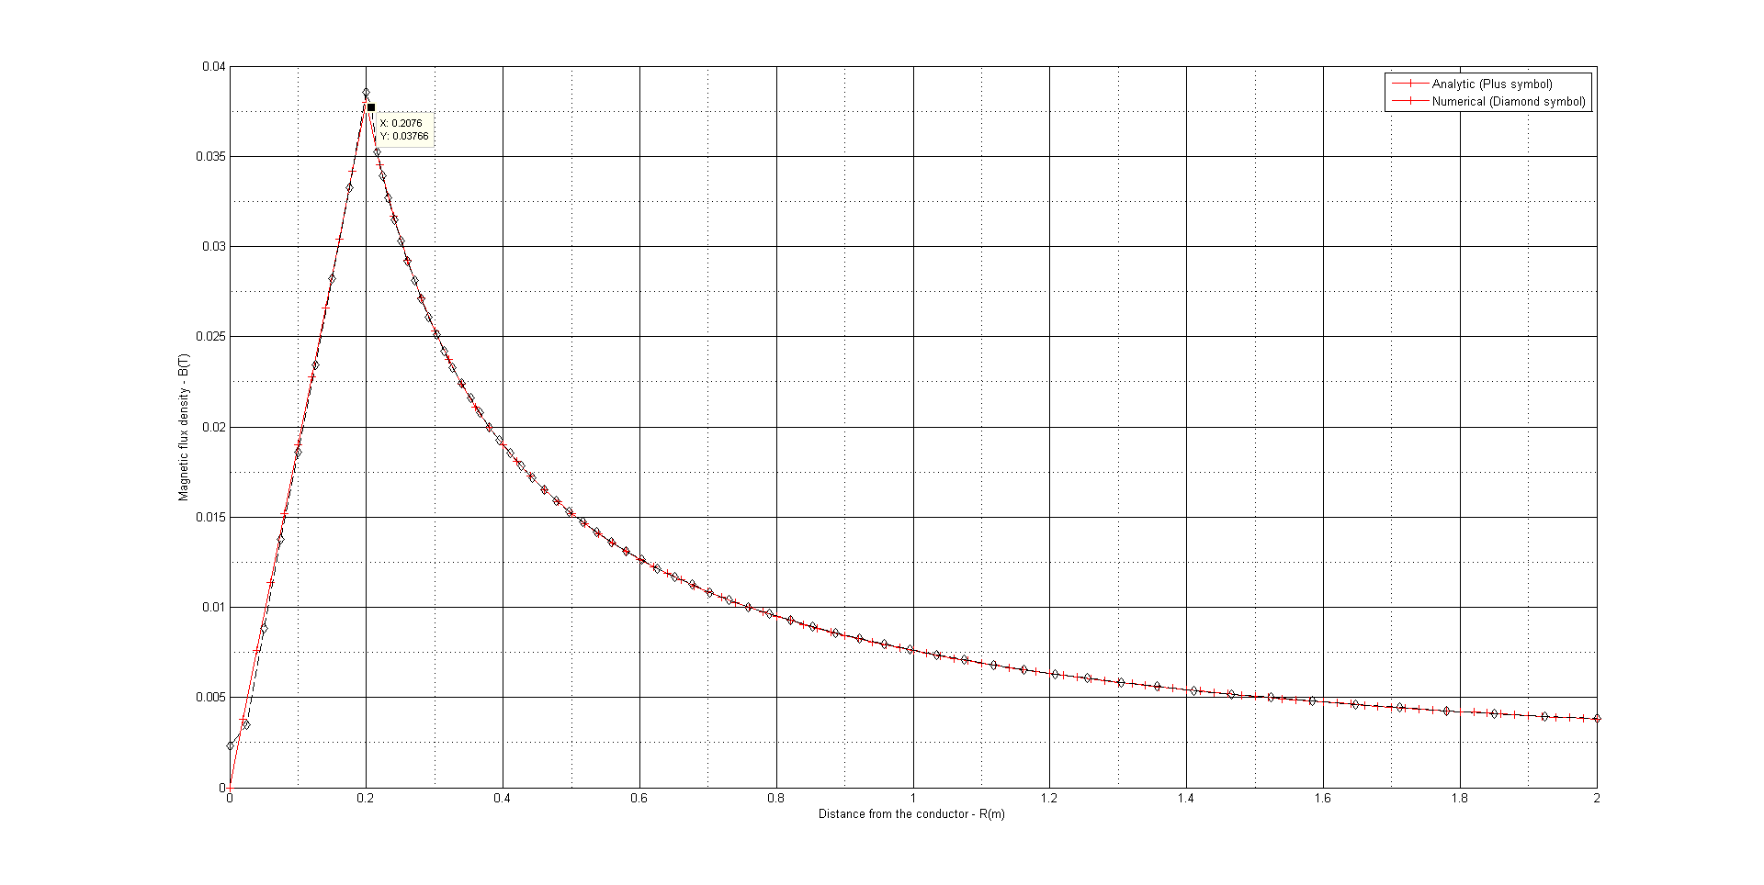

Figure 2.4: Comparison of Line plot of Magnetic flux density with analytical results

The line plot of axial component of magnetic vector potential is shown in Figure 2.5.

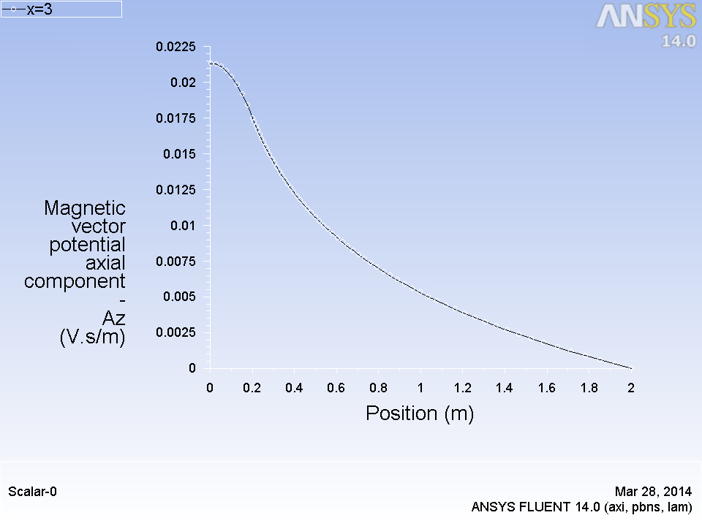

Figure 2.5: Line plot of Az along radius

1. **Validation of FLUENT simulations on a 3D square bar**
2. Geometry properties

The calculated domain is a cuboid copper wire surrounded by a cuboid air box in 3 dimensions. The geometry data in 3D is given in table 2.5 and figure 2.6 shows the problem region. High voltage and low voltage are applied to the two ends of the copper bar separately.

Table 2.5: Geometric properties of bar

|  |  |  |  |
| --- | --- | --- | --- |
|  | x(m) | y(m) | z(m) |
| Conductor | 0.4 | 0.4 | 6 |
| Air box | 44 | 4 | 6 |



Figure 2.6: Geometry of single bar case

1. Mesh Generation and Boundary Conditions

A $20 ×20 ×30$ hex mesh is used initially which is refined gradually to $50 ×50 ×60$

The material properties and boundary conditions are shown in Table 2.6

Table 2.6: Boundary Conditions for Copper bar

|  |  |  |  |  |
| --- | --- | --- | --- | --- |
|  | A (V.s/m) | V (V) | $σ$ (S/m) | $$μair \sim μcopper$$ |
| Conductor up | Zero Normal Gradient | 670 V | 2700 | 1.26e-6 |
| Conductor down | Zero Normal Gradient | 0 V | 2700 | 1.26e-6 |
| Up | Zero Normal Gradient | Zero Normal Gradient | 1e-5 | 1.26e-6 |
| Down | Zero Normal Gradient | Zero Normal Gradient | 1e-5 | 1.26e-6 |
| Front,Back,Left,Right (Far Walls) | Zero value | Zero Normal Gradient | 1e-5 | 1.26e-6 |

1. Results

The line plot of magnetic field at y,z =0 along x is shown in Figure 2.7. The symmetry of the magnetic field can be observed.

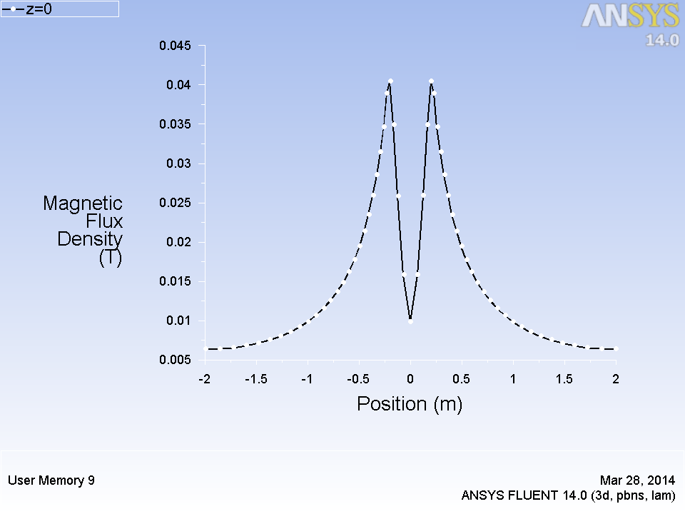

Figure 2.7: Line plot of Magnetic flux density along x (y =0, z=0)

The magnetic field inside the conductor is shown in Figure 2.8. Figure 2.7 and Figure 2.8 are similar to Figure 2.2 and Figure 2.3 respectively. They agree in principle that magnetic flux density is directly proportional to the radius inside the conductor and inversely proportional to the radius outside the conductor.

However, one thing that should be noted is that at r=0 from analytical solution, the magnetic flux density should be zero, however there remains some residual error at r=0 (of the order of 1%). The maximum error between the results computed in OpenFoam from [2] and the computed result of magnetic flux density is 1.45% the interface between conductor and air box.

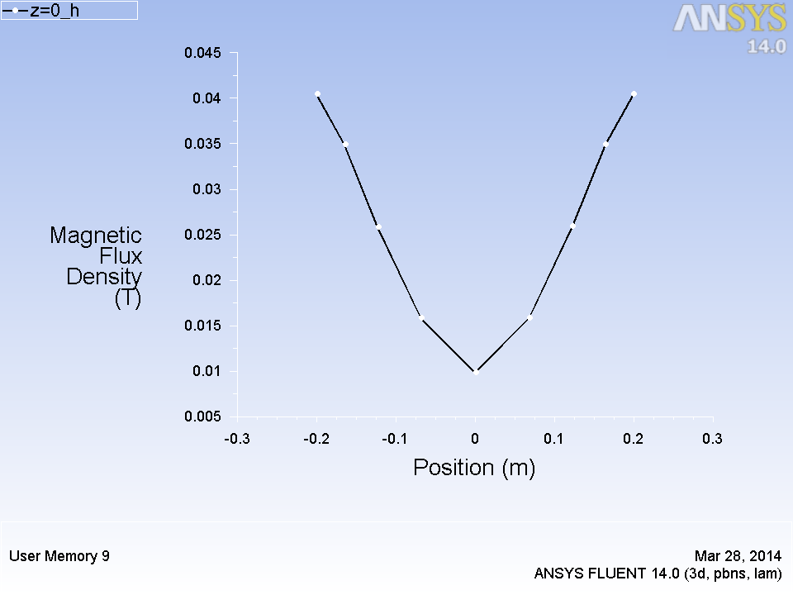

Figure 2.8: Line plot of Magnetic flux density inside the conductor along x (y =0, z=0)

The line plot of current density magnitude is shown in Figure 2.9. It can be observed that there are four points of singularity at the four vertices of the conductor which results in the erroneous jump of current density magnitude. This problem can be alleviated by making giving a fillet to the four vertices so that no sharp edges remain.

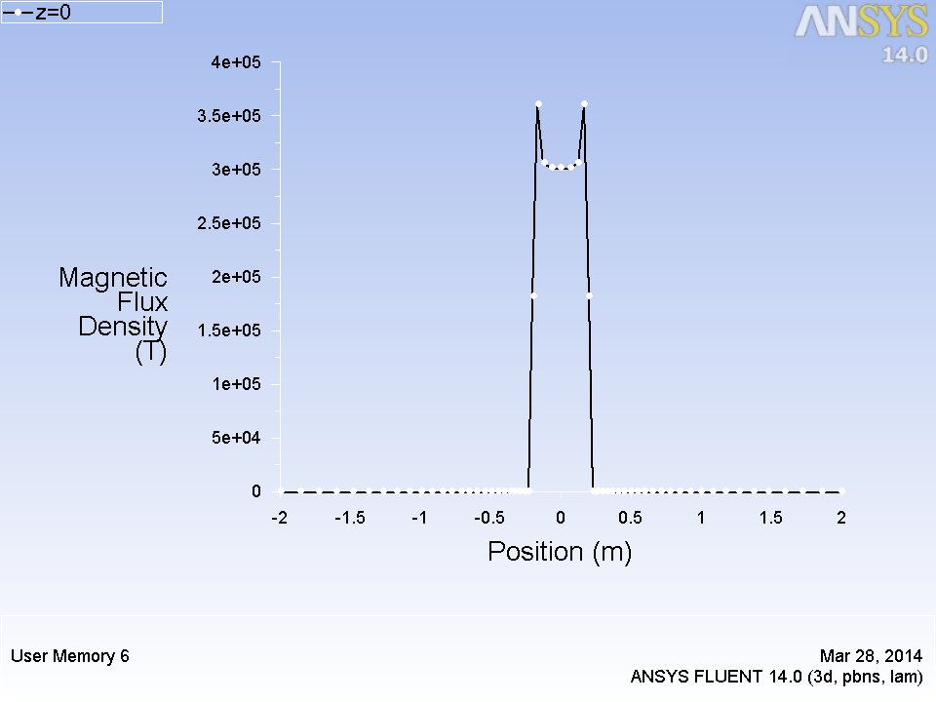

Figure 2.9: Line plot of current density magnitude along x (y =0, z=0)

The contour plot of Magnetic flux density and magnitude of magnetic vector potential are shown in Figure 2.10 and Figure 2.11 respectively.

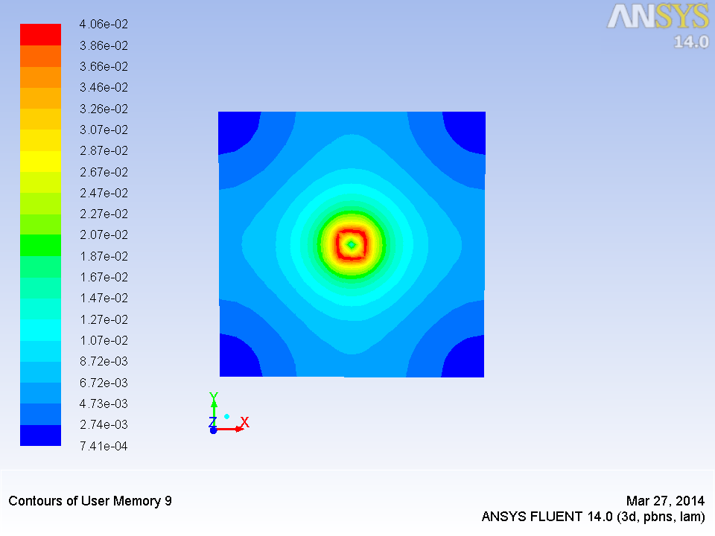

Figure 2.10: Contour plot of Magnetic flux density at z=0

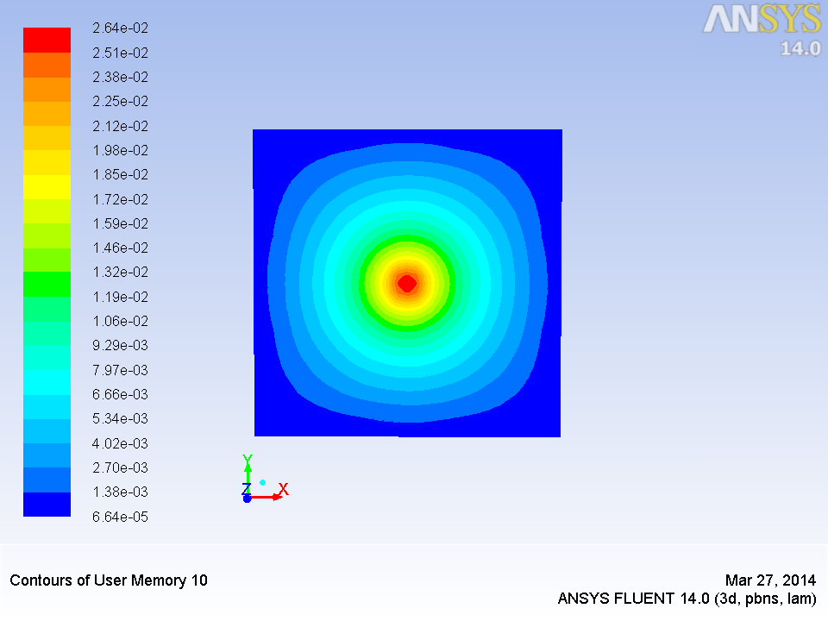

Figure 2.11: Contour plot of magnitude of Magnetic vector potential density at z=0

1. **CONCLUSION AND FUTURE WORK**

In the present chapter, **A-V** formulation using magnetic vector potential and electric scalar potential was discussed. Subsequently, these equations were written as user defined scalar transport equations (UDS) in FLUENT commercial solver. The code was validated by computing the magnetic flux density around a current carrying conductor. In the first case, taking advantage of axi-symmetry the cylinder was modeled as a rectangle. This was validated with analytical results in addition to [2]. In the second case, the field around a square copper bar was computed and validated against [2].

The next logical step is to validate the code against the magnetic field produced by a current flowing through a single turned coil and then with multi-turned coil where the field induced by the last turn of the coil will induce a current in the first coil. Also, the code will be validated against the well-known analytic result of force produced due to two parallel current carrying conductors.

It has been explained in Chapter 1 that a sinusoidal distribution of magneto-motive force (analogous to electromotive force) is needed in any electrical machine. This is produced by three phase displaced coils which are equivalent to a current sheet varying in time and space [5]. Thus after these validations, the equations will be applied to a time and spatially varying current or voltage.

**References:**

[1] Sass-Tisovskaya, Margarita. Plasma arc welding simulation with OpenFOAM. Chalmers University of Technology, 2009.

[2] Huang, Zhe. "OpenFOAM Simulation for Electromagnetic Problems." (2010).

[3] Westermoen, Andreas. "Modelling of dynamic arc behaviour in a plasma reactor." (2007).

[4] Fluent, A. N. S. Y. S. "12.1 User Manual." ANSYS Inc (2010).

[5] [5] Milind, S., & Ramanarayanan, V. (2004, October). Design and analysis of a

linear type electromagnetic stirrer. In Industry Applications Conference, 2004.

39th IAS Annual Meeting. Conference Record of the 2004 IEEE (Vol. 1).

IEEE.