**Infinitely Long Current Carrying Conductor (2D- Axisymmetric)**

|  |  |  |
| --- | --- | --- |
| r (inner radius) m | R (outer radius) m | L (Length ) m |
| 0.2 | 2 | 6 |

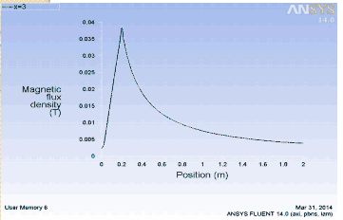

Figure 1: Variation of B along radius of conductor

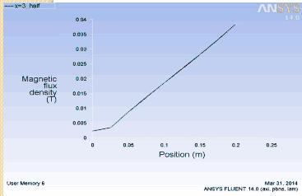

Figure 2: Variation of B inside the conductor along the radius

**Ring:**

**Configuration**

|  |  |  |  |  |  |  |
| --- | --- | --- | --- | --- | --- | --- |
| Current direction | Radius of domain (m) | Length of Domain (m) | Rin | Rout | Ring Thickness(m) | J_magnitude (A/m2) |
| CW | 0.05 | 0.2 | 0.037 | 0.043 | 0.05 | 225000 |

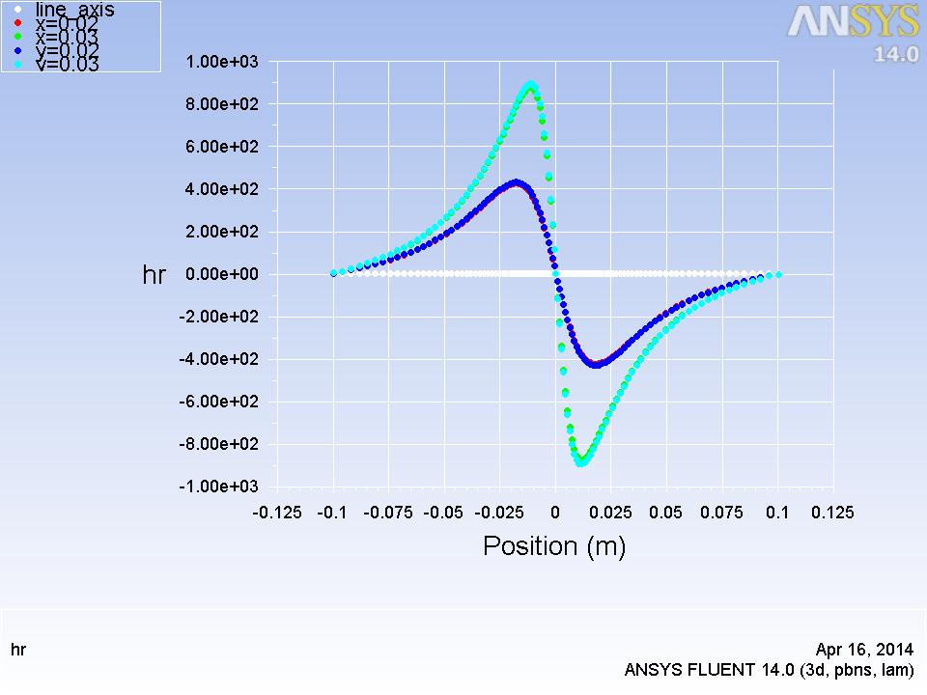

Figure 1: Variation of Hr along axis

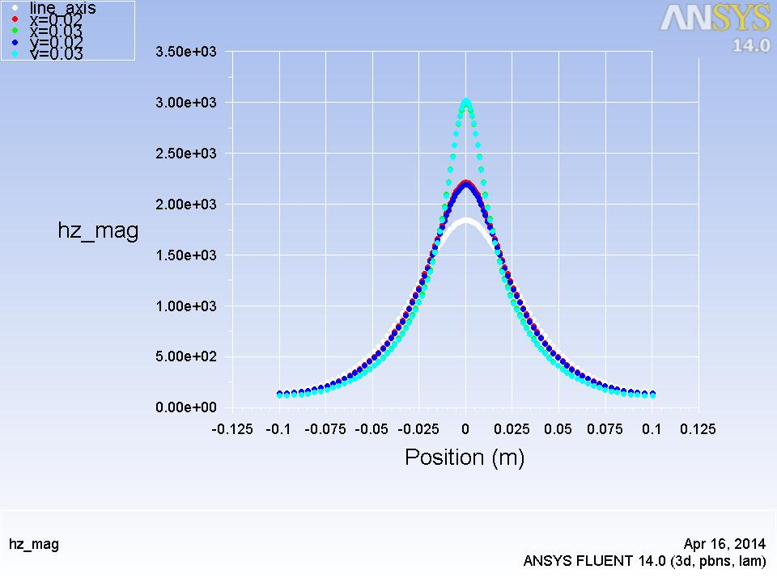

Figure 2: Variation of Hz magnitude along axis

**Solenoid:**

**Configuration**

|  |  |  |  |  |  |  |
| --- | --- | --- | --- | --- | --- | --- |
| Current direction | Radius of domain (m) | Length of Domain (m) | Rin | Rout | Solenoid Length(m) | J_magnitude (A/m2) |
| CW | 0.05 | 0.24 | 0.038 | 0.042 | 0.2 | 225000 |

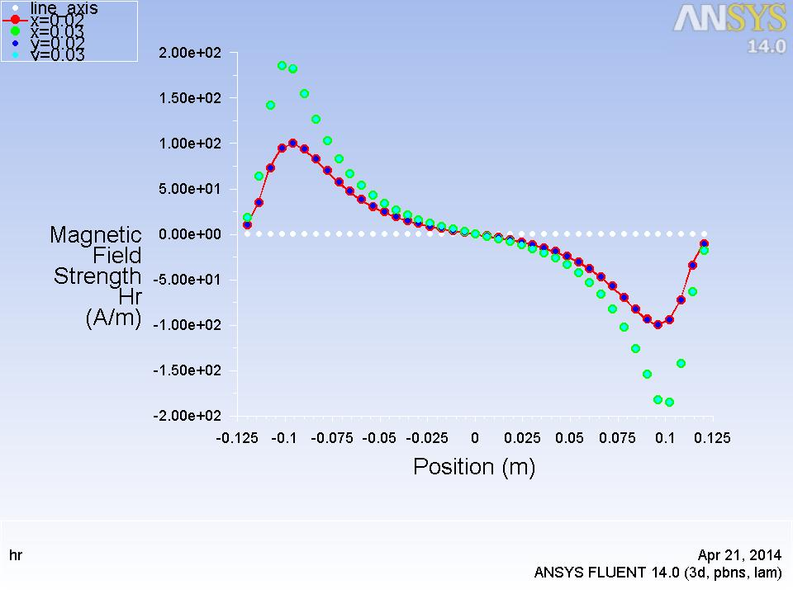

Figure 1: Variation of Hr along axis

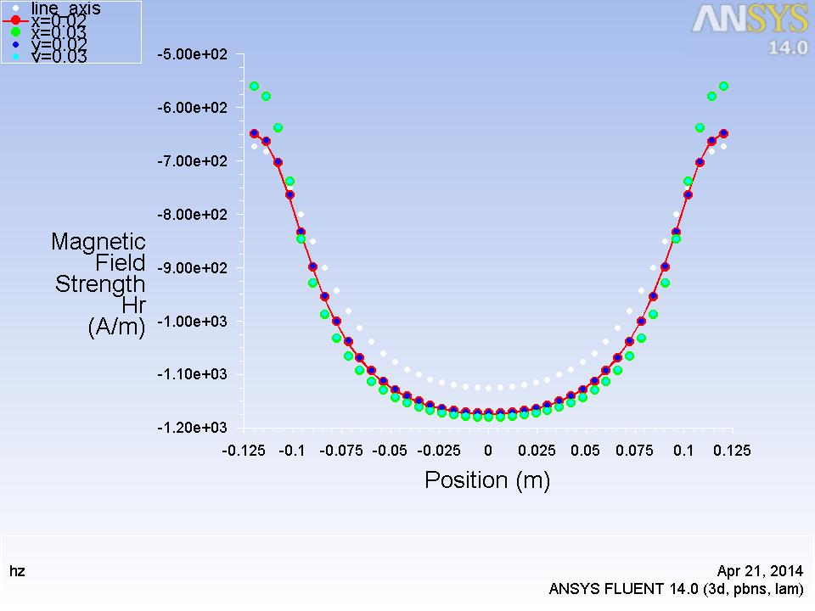

Figure 2: Variation of Hz along axis

**b. Space Varying Current**

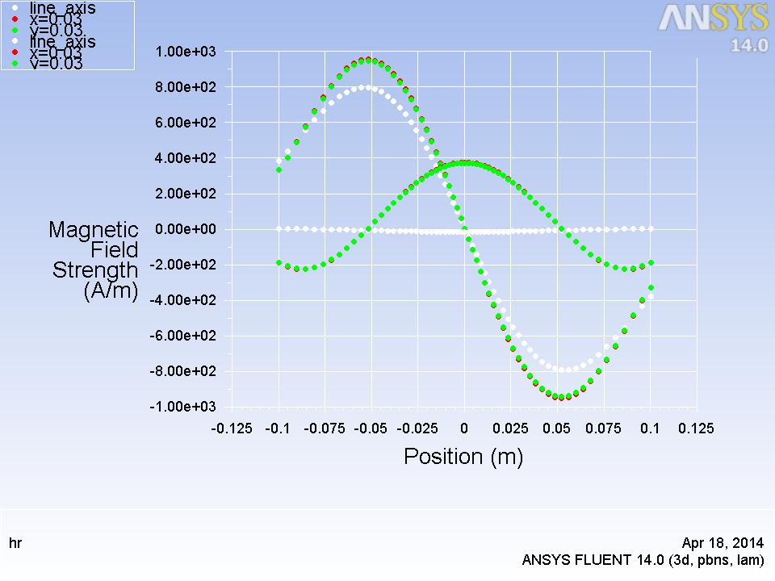

Figure 3: Variation of H along axis at L/R =5

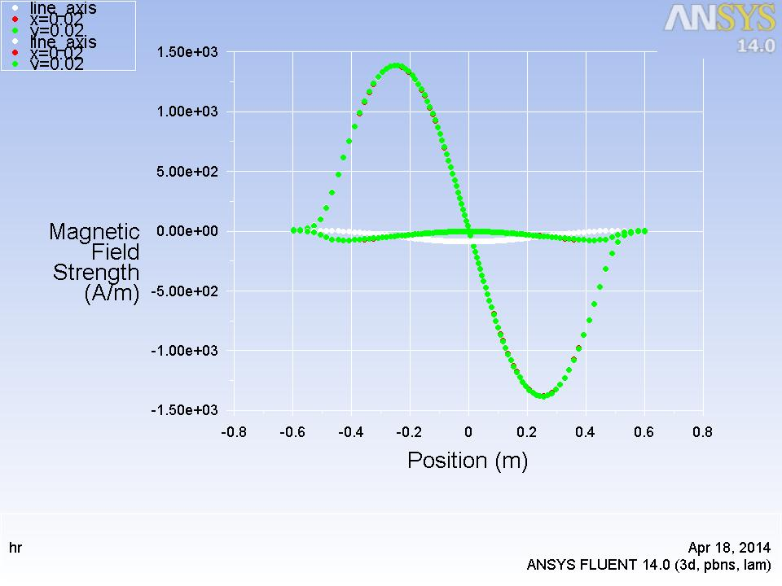

Figure 4: Variation of H along axis at L/R =25

**c. Space and time varying fields**

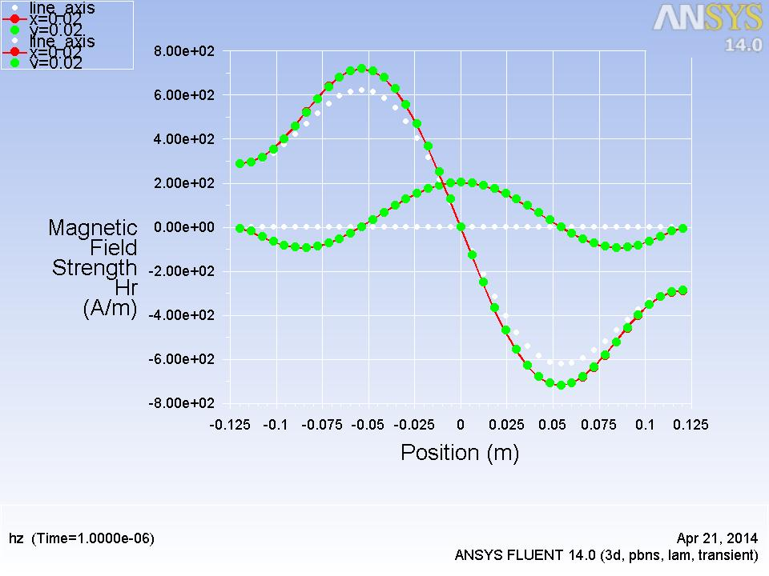

Figure 5: Variation of H along axis at t =1e-6 s

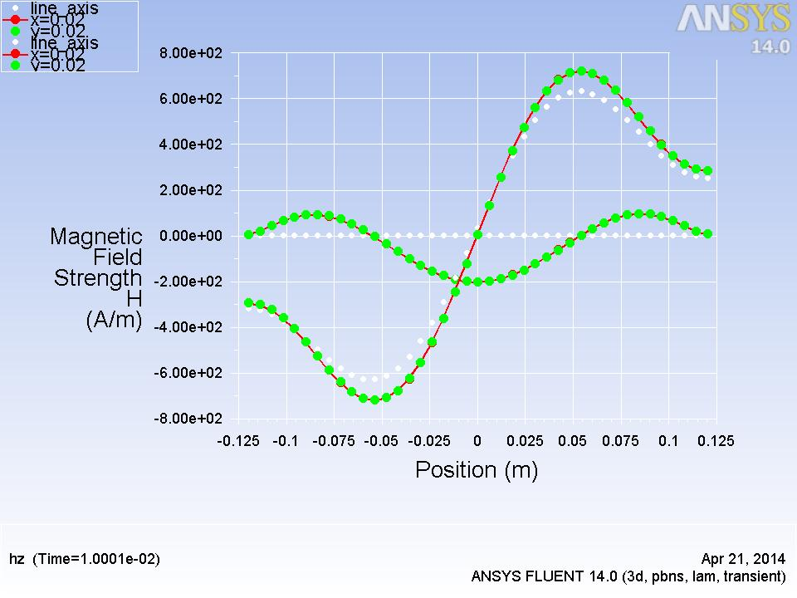

Figure 6: Variation of H along axis at t =1e-2