EE354L Final Project Proposal

Team Members: Yash Gupta, Adhish Chakravorty, Surpreet Kaur

Game Rules: 2048/Tetris Hybrid
• The player moves tiles on a 4×4 grid (using buttons or switches).
• Identical tiles merge into one with double the value.
• A new tile (2 or 4) spawns after each valid move, player has to drop like “tetris”.
• The game ends when no moves remain (Game Over) or when 2048 is reached (Win).
Game Visualization: https://www.youtube.com/watch?v=iQWD9Qo4J4E
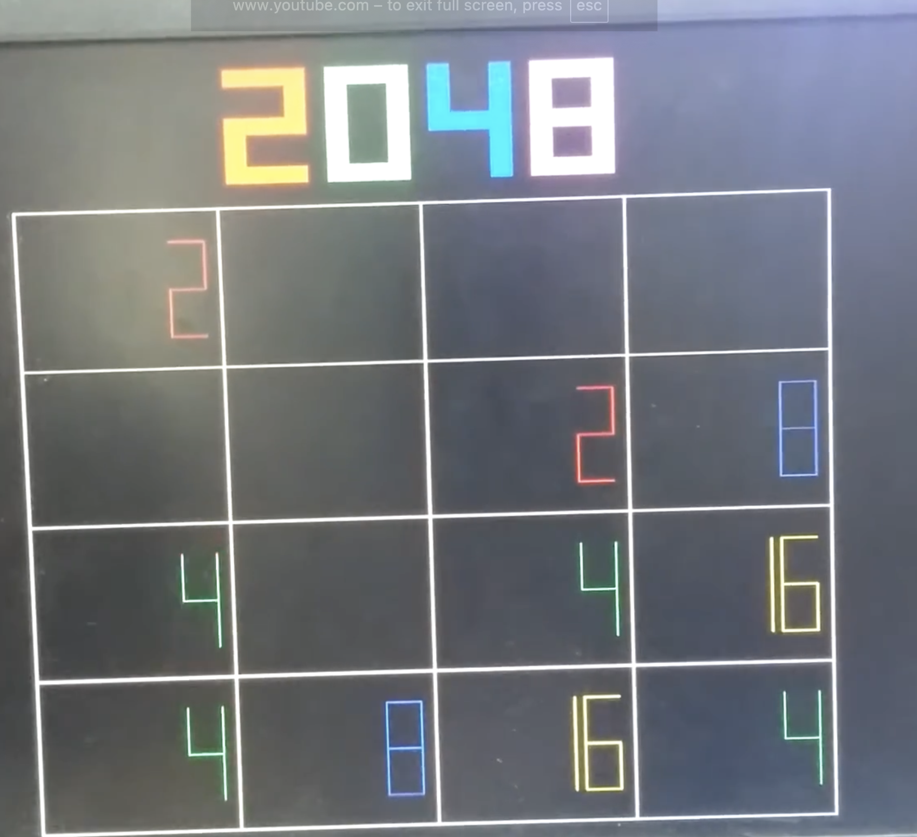
Top Design: Inputs (Switches to ‘shift’ – 2 = 4 directions, PB to place tile + start + reset)
State Machine (Core Design):
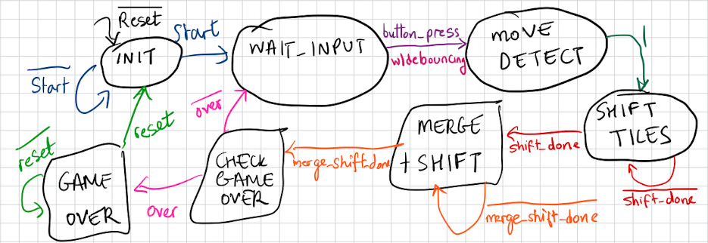
Timeline
- State Machine + Interface w/IO
- Simulations + VGA Display
- VGA + Testing & Debugging
Task Division
Adhish – State Machine
Yash – VGA Display
Surpreet – I/O Interfacing

