# Dharmsinh Desai University, Nadiad

# Faculty of Technology

# Department of Computer Engineering

B. Tech. CE Semester – V

Subject: (CE – 515) Advanced Technologies

Project Title: Social media application

Name: YASH JAGADISHBHAI GARALA

Roll no:- CE042

Id:- 18CEUOS078

Guided by : Prof. A. P. Vaishnav

Abstract:-

In this application I am develop social media application. For sharing a photos, video and audio.

And user want to show only audio or photo or video user can show that. and user can follow or unfollow other user.

# Introduction:-

First of all user is not log in then enter correct credential than user login if user is new user than user and register this application and login. after login user redirect to home page and show all uploaded post. User and add new post in application with some description .and uploaded file is show in all post. User and find all friend .and follow and unfollow a friend .user can show no of followers and following. user edit own profile.and if user want to logout than click logout than user redirect to login page.

In technology I am use angular for frontend and backend nodejs and for database I am using mongo dB database.

# Software Requirement Specifications :-

Angular CLI version :-10.1.2

Node js version:- 12.18.2

Mongo shell version:- v4.2.8

Visual studio for opening a project

# Design:-

# DFD diagram

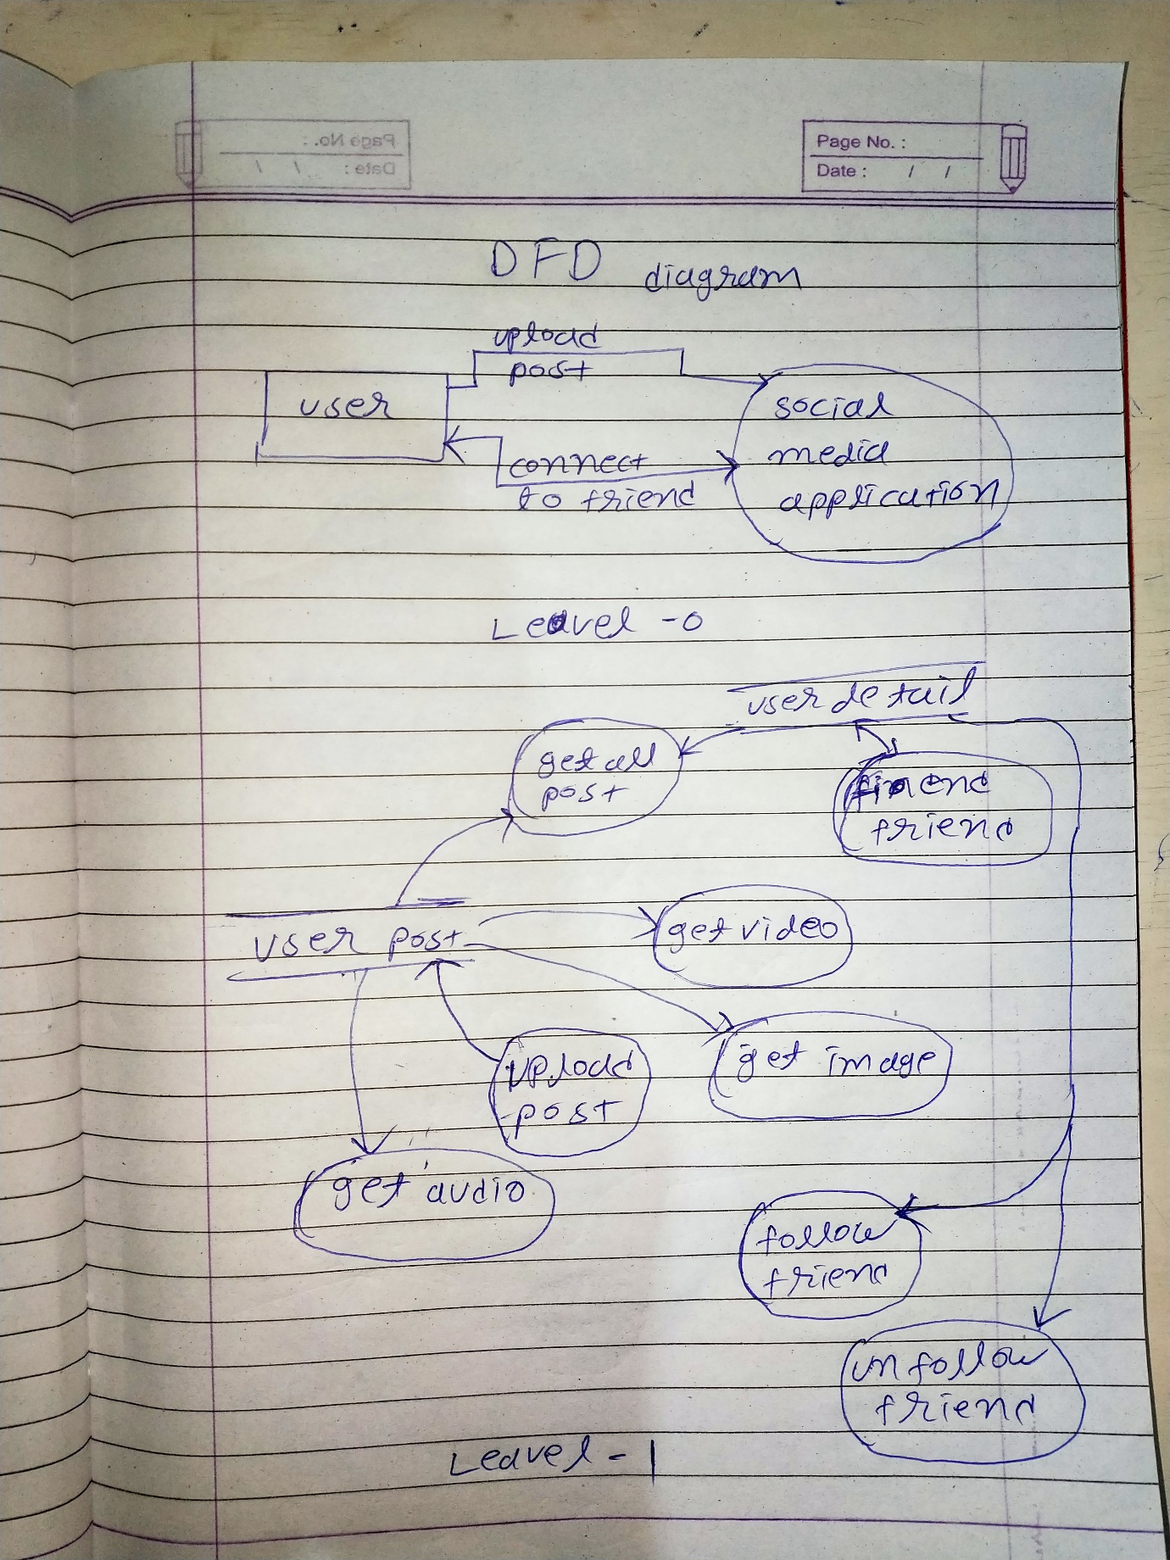

# ER diagram

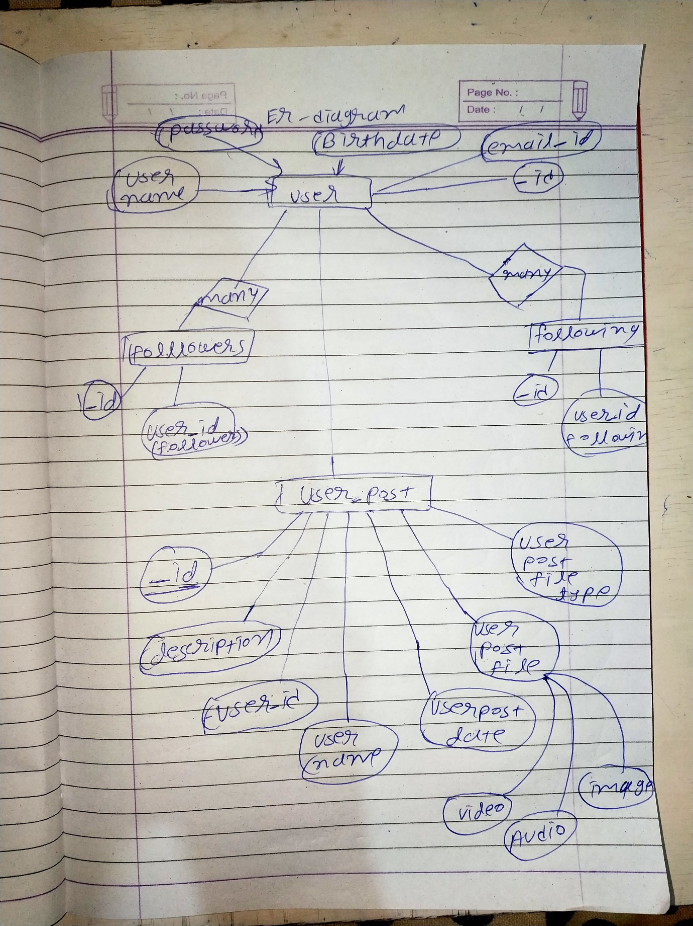

# Data dictionary:-

**User_detail** databse

|  |  |
| --- | --- |
| _id | Unique auto generated |
| Name | String |
| Email | String |
| Password | String |
| Birthdate | Date |
| Followers | Array |
| Following | Array |
| User_profile_photo | String |

**User_post** databse

|  |  |
| --- | --- |
| _id | Unique auto generated |
| description | String |
| User_id | String |
| User_Name | String |
| User_post_date | Date |
| Like | Array |
| User_post_file_name | String |
| User_post_file_type | String |
| Comment | Array |

# Implementation Detail:-

**Login-register:-**

In this module i implement login and register form.register form is add data to data base and login data for validate and ser appropriate name and user id cookies

**Navigation-bar :-**

In this model navigation bar and logout button.

**Home-page:-**

In home page page divide into 3 phase 2 is side bar and 1 is output of side bar as per routing ling is changed.

**First-page:-**

In this all user post are display.

**Add-newpost:-**

This modeul 2 filed 1 is description 2 is file upload filed. User can post a new post using this filed.

**My-profile:-**

In this user can edit own profile and user can show no of follows and no of following.

**Fiend-friend:-**

User can follow other people. Display all people that user not follow.

**Post-video:-**

User show all video available in tha application ans all video are auto paly

**Post-photos:-**

This module is display all photos.

**Post-audio:-**

Display only audio.

**Myfriend:-**

Display all fiends that user follow in this module.and user wand to unfollow some user than user can unfollow other people.

**About-us:-**

This modus is show basic detail abour me.

**Contect us :-**

In this one text box for email.and test area for description.

**Logout:-**

User using this user can logout.

# Major functionality: -

Getfriend(id):-

Return a specific user detail pass by id

Add_unfollowe(data):

Unfollow specific user and update follow and following array in user detail.

User_authen(data):

User authentication for login purpose.

Creatuserdetail(data):

Creat new user.

Get_user_detail()

Get all user detail.

Add_follow(data):

Update followers arrary.

Update_user_detail(id,data):

Update specific user detail. For edit your profile.

Create_post(data):

Create new user post. For add new user post.

Getuser_posts()

Get all post. For display all post.

Getuser_post(id):

Get specific post.

# Screen shots

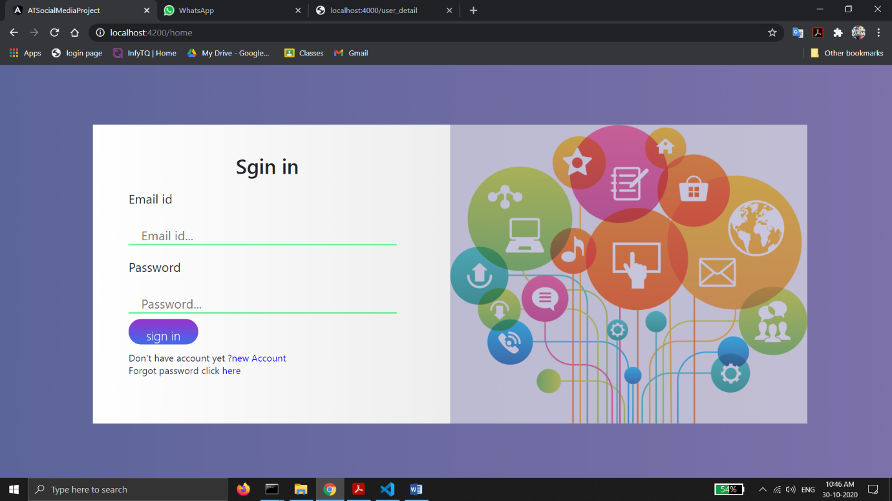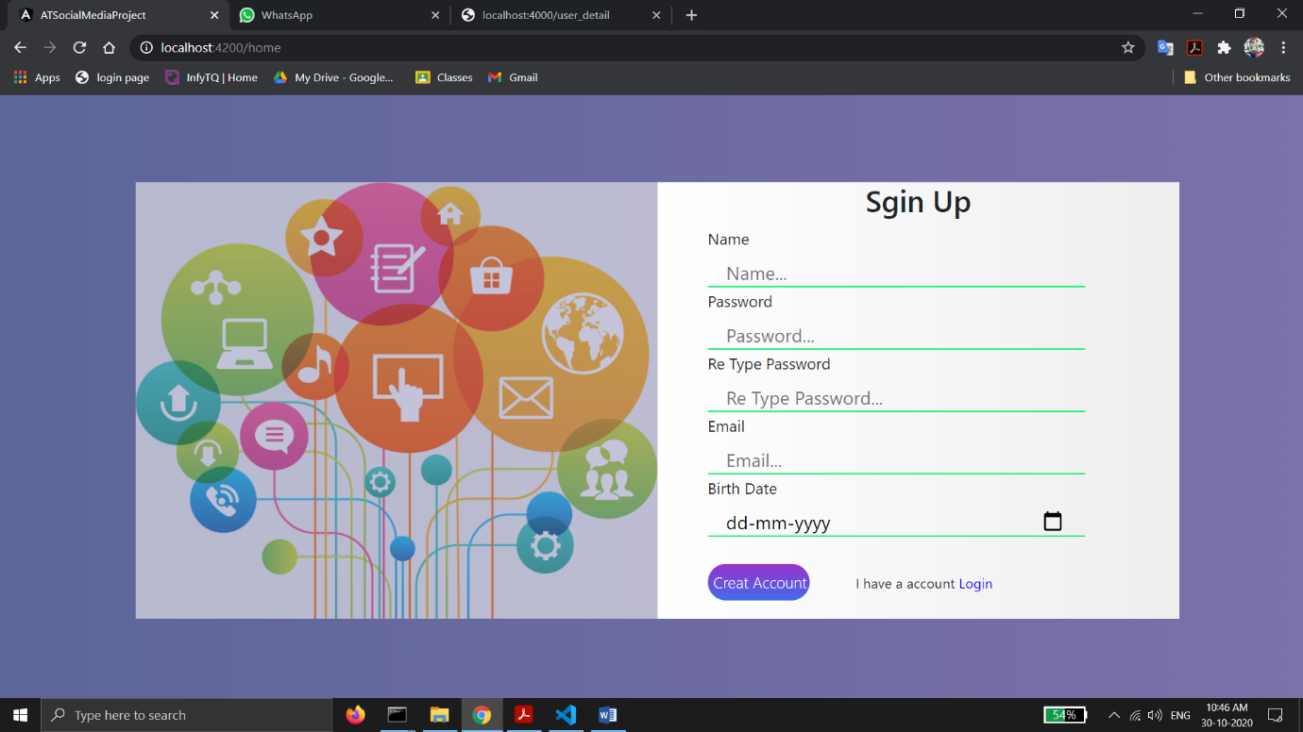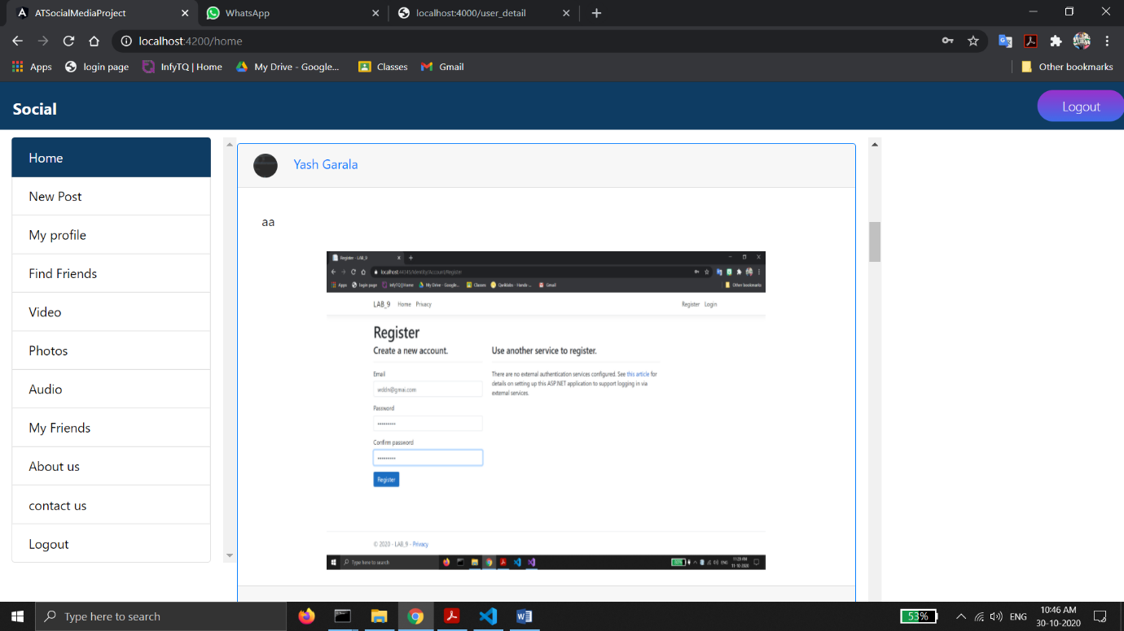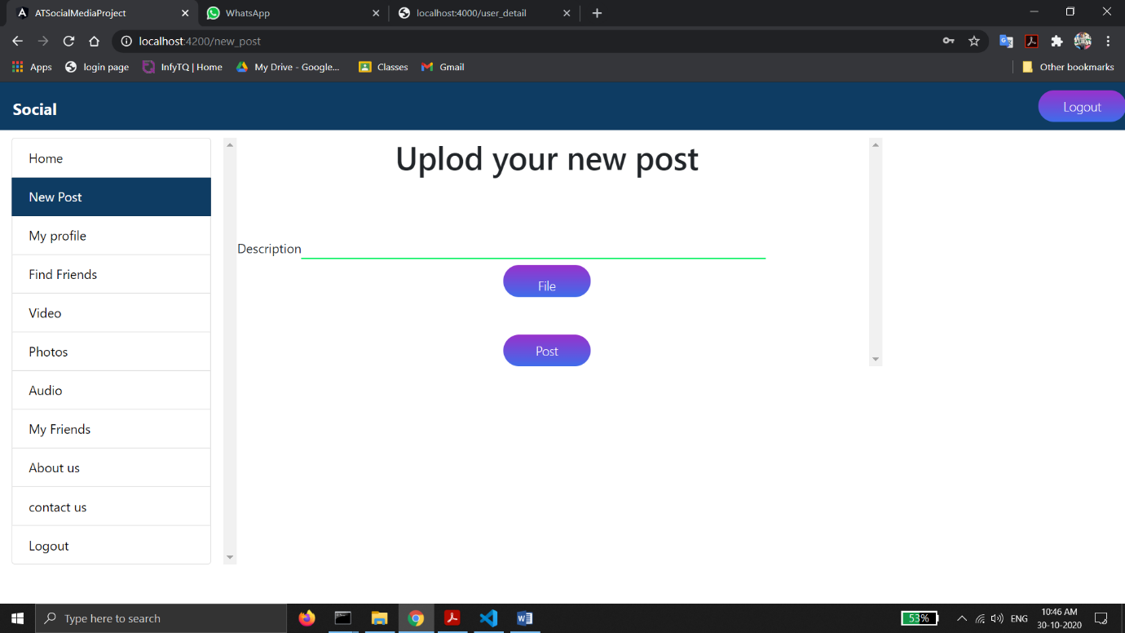

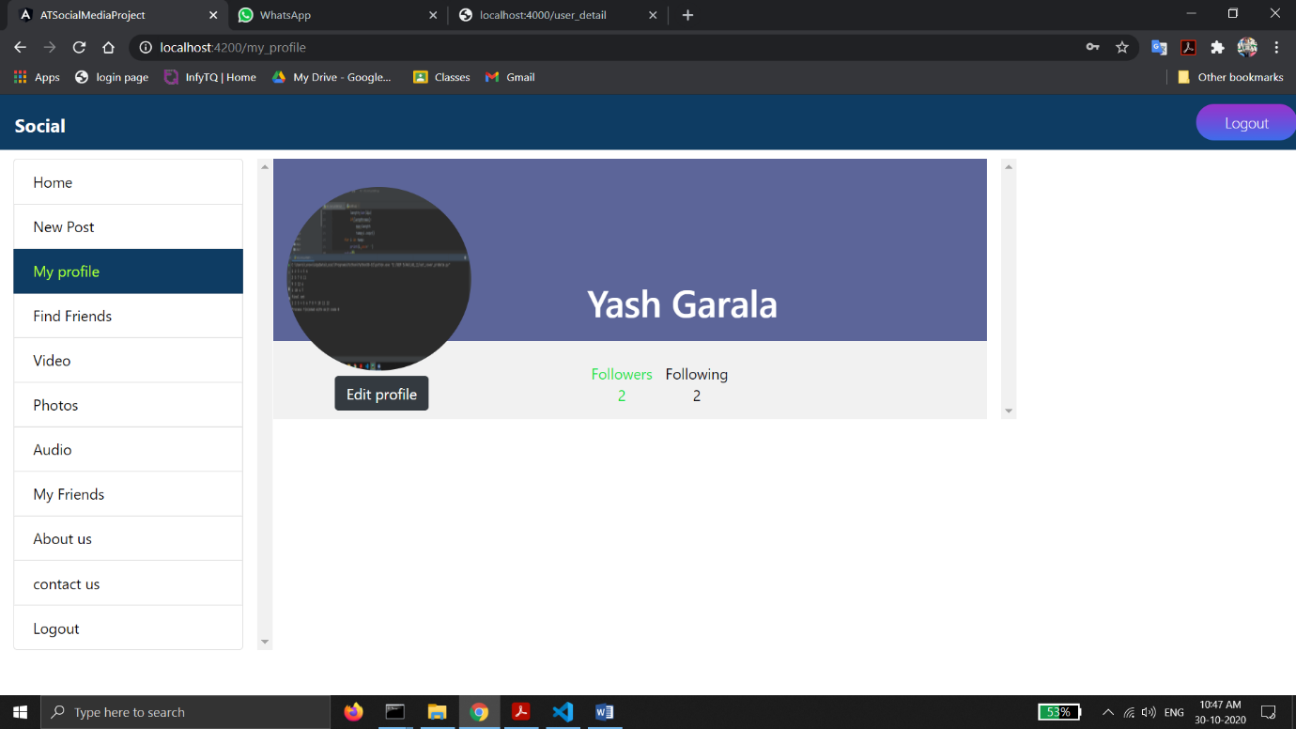

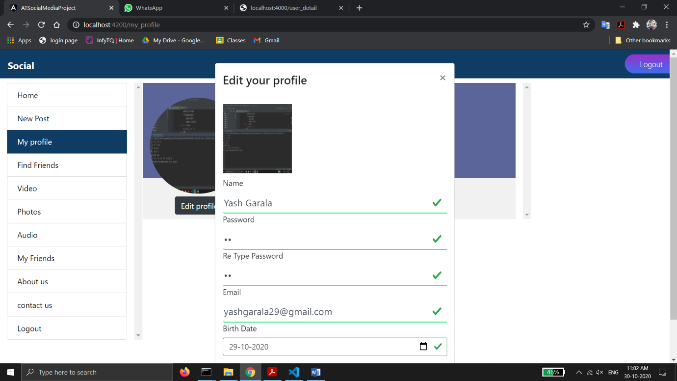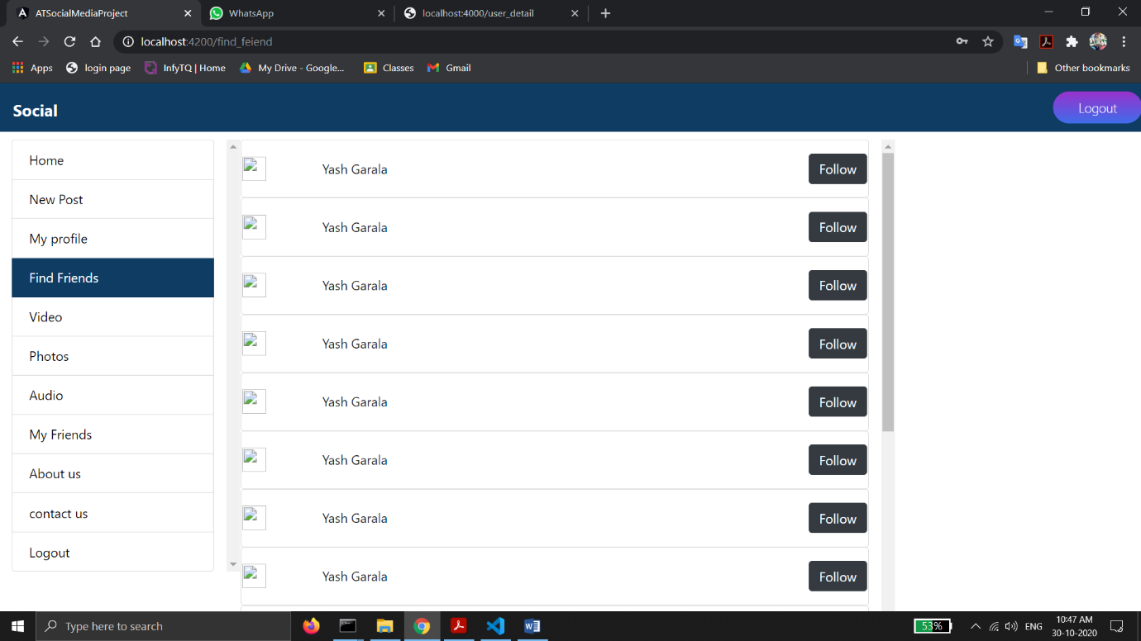

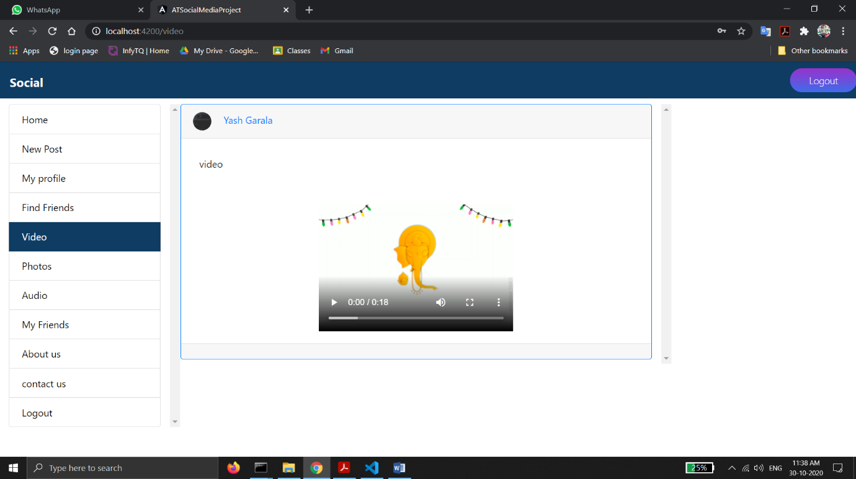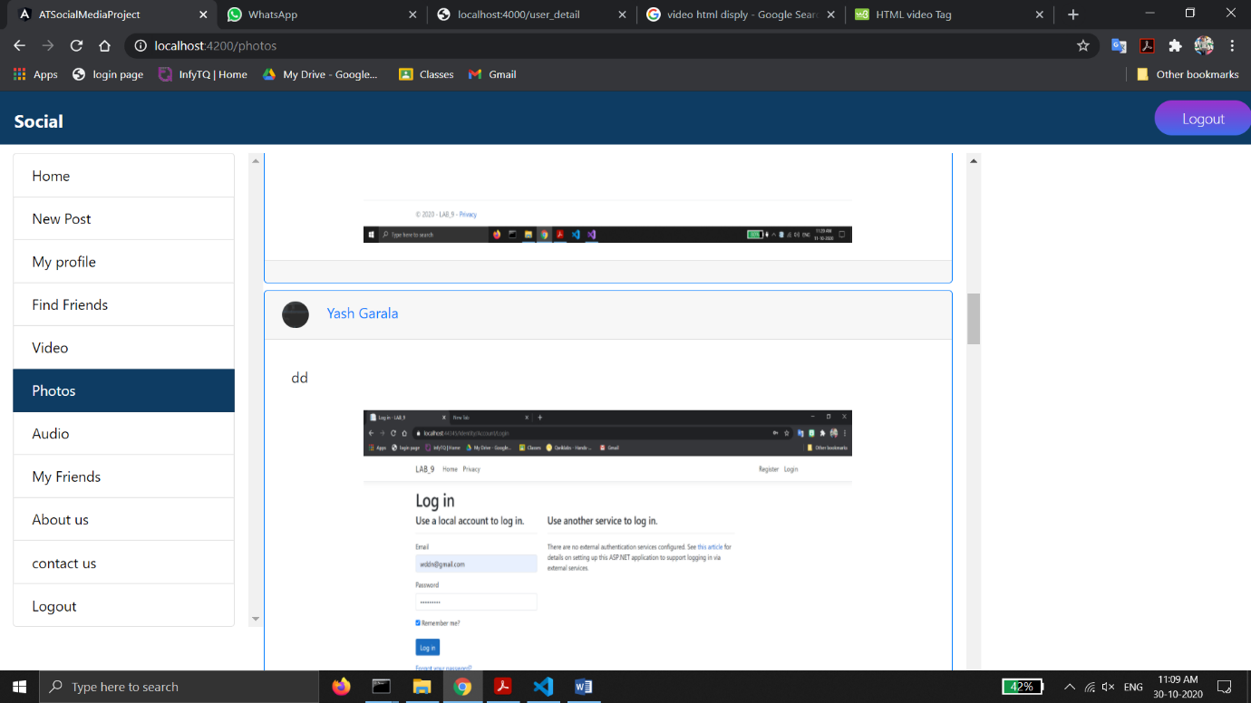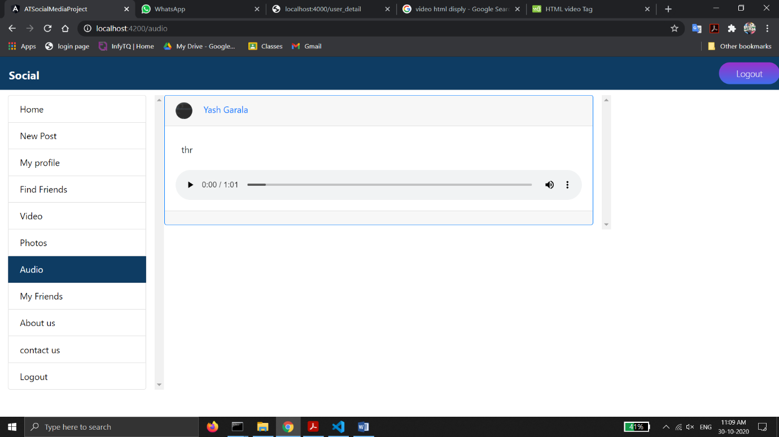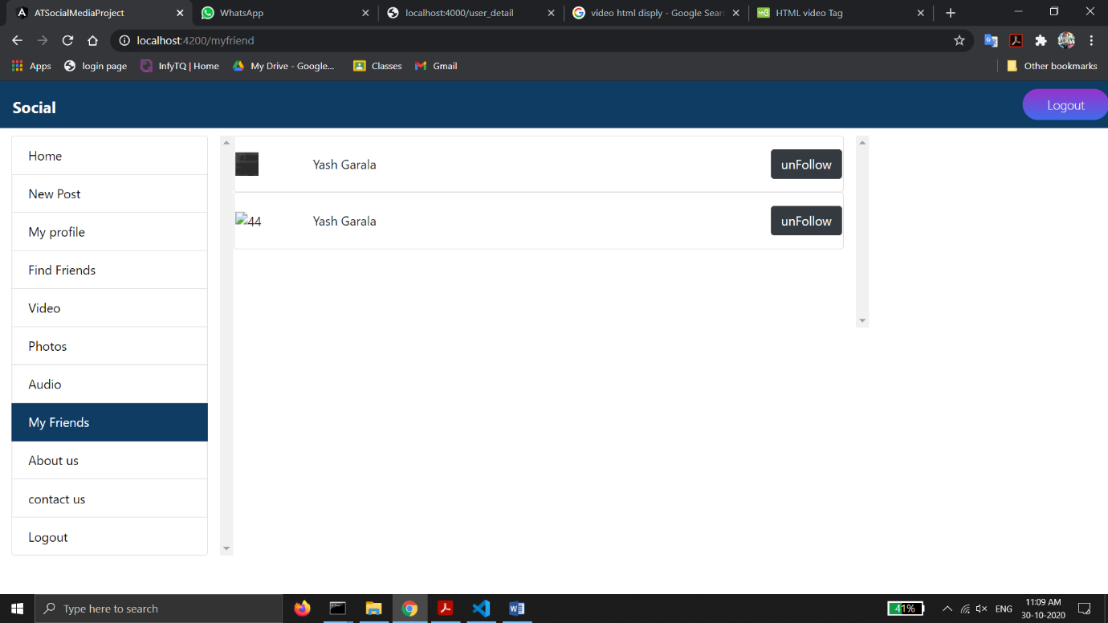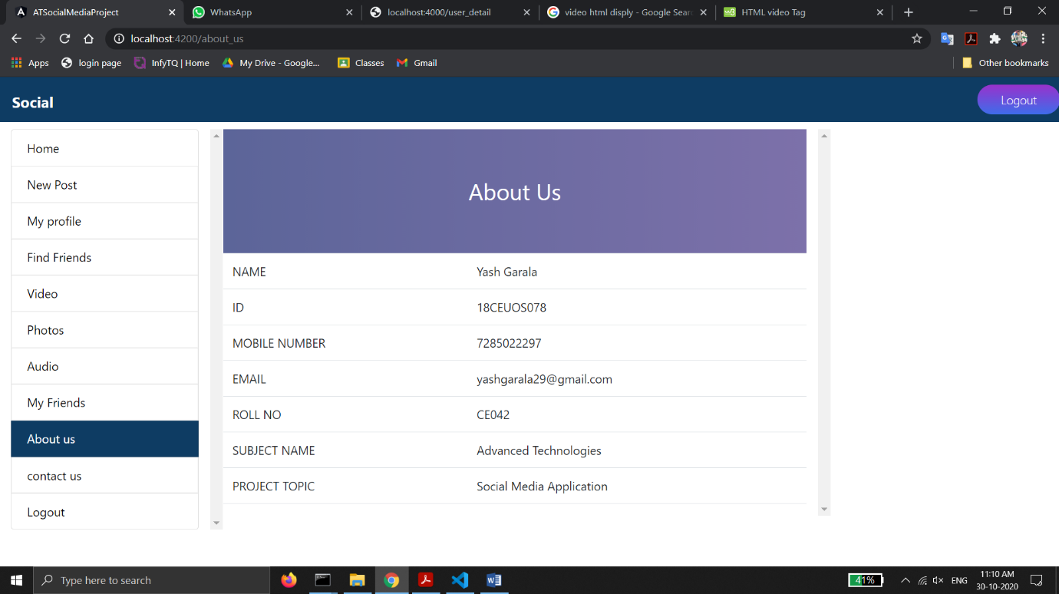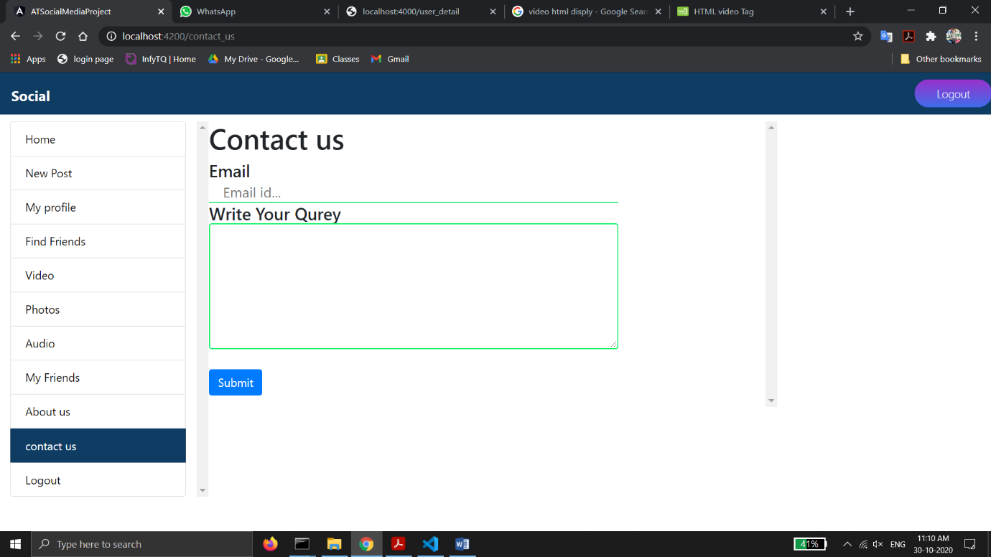

# Conclusion:-

I am implemented login and logout functionality , add new post, follow and unfollow user. user can edit your profile. Show no of followers and following. We can show all post separately like 3 section 1). Only video 2). Only photo 3). Only audio.

# Limitation and Future Extension:-

In this project I will extend add more functionality for example like, comment, user can show only friend post user an not show other user project.

**Limitation :-**

In new post user must upload image, audio and video .and must insert description in description field.

# Bibliography:-

* Google
* PMJ sir ppt
* W3 schools
* stackoverflow