**Name and Roll No :** Yash Ginoya (20BCE075)

**Course and Course code :** Compiler Construction (2CS701)

**Practical 5 :**

**To implement a calculator in YACC , Syntax Directed Transitions.**

----------------------------------------------------------------------------------------------------------------------------

**Code: For file : calc.l**

**%{**

**#include<stdio.h>**

**#include "y.tab.h"**

**extern int yylval;**

**%}**

**%%**

**[0-9]+ {**

**yylval=atoi(yytext);**

**return NUMBER;**

**}**

**[\t] ;**

**[\n] return 0;**

**. return yytext[0];**

**%%**

**int yywrap()**

**{**

**return 1;**

**}**

**Code: For file calc.y**

**%{**

**/* Definition section */**

**#include<stdio.h>**

**int flag=0;**

**%}**

**%token NUMBER**

**%left '+' '-'**

**%left '*' '/' '%'**

**%left '(' ')'**

**/* Rule Section */**

**%%**

**ArithmeticExpression: E{**

**printf("\nResult=%d\n", $$);**

**return 0;**

**};**

**E:E'+'E {$$=$1+$3;}**

**|E'-'E {$$=$1-$3;}**

**|E'*'E {$$=$1*$3;}**

**|E'/'E {$$=$1/$3;}**

**|E'%'E {$$=$1%$3;}**

**|'('E')' {$$=$2;}**

**| NUMBER {$$=$1;}**

**;**

**%%**

**//driver code**

**void main()**

**{**

**printf("\nEnter Any Arithmetic Expression which can have operations Addition, Subtraction, Multiplication, Division, Modulus and Round brackets:\n");**

**yyparse();**

**if(flag==0)**

**printf("\nEntered arithmetic expression is Valid\n\n");**

**}**

**void yyerror()**

**{**

**printf("\nEntered arithmetic expression is Invalid\n\n");**

**flag=1;**

**}**

**Output :**

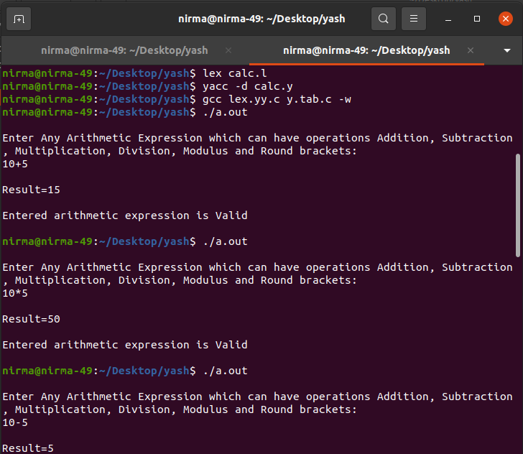

**s**