# Modeling of Peaker Plant Application Profile

The following section puts forth a basic approach to assess the size of Second use electric vehicle batteries to mimic the behavior of Peaker plants throughout the year. As per Clean Energy Group’s report (Clean Energy Group, n.d.), New York’s peakers generate one of the most polluted and expensive electricity during peak load. Thus, the use case under consideration was that of NYC (New York City). As per the data obtained from NYISO (Energy Online, 2020), electricity load data for January 2020 to July 2020 (Current date as of analysis) was extracted and used for modeling. The data was averaged for the entire duration of the month, amounting to a single value every hour for every month for New York City.

The trend of load over 2020 is as follows:

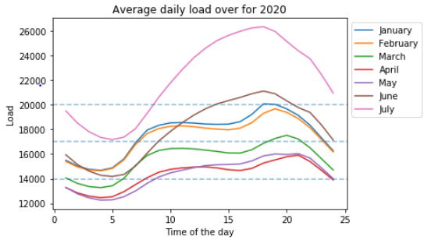

Certain underlying assumptions follow the modeling methodology:

1. Units of Load are in MWh
2. Fluctuations in the load data over days is negligible
3. Excess load has been manually set for base loads of 14000 MWh,17000 MWh and 20000 MWh

Battery capacity for second use batteries have been evaluated taking into account the following values:

|  |  |
| --- | --- |
| First use battery capacity | 85 kWh |
| Working capacity of 2nd use battery | 70% (Ambrose, n.d.) |
| Maximum charge | 80% |

Based on this, for a ‘x’ MWh of excess load, number of second use batteries are estimated as:

$n_{s}=\frac{x*1000}{85*0.7*0.8}$

The value is then rounded off to the next integer.

i. Base load: 14000 MWh

|  |  |  |  |  |  |  |  |
| --- | --- | --- | --- | --- | --- | --- | --- |
|  | January | February | March | April | May | June | July |
| 1 | 9698 | 9266 | 3138 | 2658 | 2661 | 11756 | 28145 |
| 2 | 7534 | 7220 | 2726 | 2572 | 2558 | 8121 | 23600 |
| 3 | 6329 | 6083 | 2674 | 2520 | 2491 | 5641 | 20333 |
| 4 | 5960 | 5754 | 2658 | 2496 | 2455 | 4098 | 18239 |
| 5 | 6876 | 6643 | 2688 | 2510 | 2460 | 3679 | 17452 |
| 6 | 10227 | 9834 | 2960 | 2593 | 2512 | 4416 | 18339 |
| 7 | 16285 | 15604 | 7844 | 2709 | 2606 | 7581 | 21546 |
| 8 | 20996 | 19710 | 11492 | 3216 | 2729 | 12383 | 27265 |
| 9 | 22782 | 21547 | 13379 | 5251 | 3486 | 16932 | 33275 |
| 10 | 23666 | 22386 | 14060 | 6314 | 4997 | 20498 | 38620 |
| 11 | 23801 | 22554 | 14151 | 6864 | 6022 | 23719 | 43516 |
| 12 | 23601 | 22242 | 13958 | 7163 | 6929 | 26536 | 47944 |
| 13 | 23237 | 21710 | 13506 | 7239 | 7704 | 28901 | 51526 |
| 14 | 23129 | 21338 | 13011 | 6842 | 8039 | 30758 | 54376 |
| 15 | 23205 | 21084 | 12417 | 6173 | 8108 | 31999 | 56340 |
| 16 | 24133 | 21701 | 12380 | 5882 | 8347 | 33185 | 57888 |
| 17 | 26849 | 23738 | 13650 | 6679 | 9468 | 34549 | 59106 |
| 18 | 30770 | 27208 | 16036 | 8657 | 11336 | 35549 | 59570 |
| 19 | 30603 | 28957 | 17852 | 9840 | 12046 | 34534 | 57809 |
| 20 | 28909 | 27585 | 19041 | 11031 | 11865 | 31895 | 54096 |
| 21 | 26450 | 25261 | 17630 | 11604 | 12179 | 29392 | 50585 |
| 22 | 22826 | 21858 | 14380 | 9252 | 10524 | 27583 | 47665 |
| 23 | 18006 | 17367 | 10223 | 5917 | 6819 | 22825 | 41618 |
| 24 | 13250 | 12799 | 6081 | 2787 | 2851 | 17260 | 34783 |

ii. Base load: 17000 MWh

|  |  |  |  |  |  |  |  |
| --- | --- | --- | --- | --- | --- | --- | --- |
|  | January | February | March | April | May | June | July |
| 1 | 3101 | 3082 | 2816 | 2658 | 2661 | 3191 | 14940 |
| 2 | 3007 | 2993 | 2726 | 2572 | 2558 | 3033 | 10395 |
| 3 | 2955 | 2944 | 2674 | 2520 | 2491 | 2926 | 7128 |
| 4 | 2939 | 2930 | 2658 | 2496 | 2455 | 2859 | 5034 |
| 5 | 2979 | 2969 | 2688 | 2510 | 2460 | 2841 | 4247 |
| 6 | 3125 | 3108 | 2809 | 2593 | 2512 | 2873 | 5134 |
| 7 | 3388 | 3359 | 3022 | 2709 | 2606 | 3011 | 8341 |
| 8 | 7791 | 6505 | 3180 | 2821 | 2729 | 3220 | 14060 |
| 9 | 9577 | 8342 | 3263 | 2909 | 2833 | 3727 | 20070 |
| 10 | 10461 | 9181 | 3292 | 2956 | 2899 | 7293 | 25415 |
| 11 | 10596 | 9348 | 3296 | 2980 | 2944 | 10514 | 30311 |
| 12 | 10396 | 9037 | 3288 | 2993 | 2983 | 13331 | 34739 |
| 13 | 10032 | 8505 | 3269 | 2997 | 3017 | 15696 | 38321 |
| 14 | 9924 | 8132 | 3248 | 2980 | 3032 | 17553 | 41171 |
| 15 | 10000 | 7879 | 3222 | 2951 | 3035 | 18794 | 43135 |
| 16 | 10928 | 8496 | 3220 | 2938 | 3046 | 19980 | 44683 |
| 17 | 13644 | 10533 | 3276 | 2973 | 3094 | 21343 | 45901 |
| 18 | 17565 | 14003 | 3380 | 3059 | 3176 | 22344 | 46364 |
| 19 | 17398 | 15751 | 4647 | 3111 | 3207 | 21329 | 44604 |
| 20 | 15704 | 14380 | 5836 | 3163 | 3199 | 18690 | 40891 |
| 21 | 13245 | 12056 | 4425 | 3188 | 3213 | 16187 | 37379 |
| 22 | 9621 | 8653 | 3309 | 3086 | 3141 | 14378 | 34460 |
| 23 | 4801 | 4162 | 3128 | 2941 | 2981 | 9620 | 28413 |
| 24 | 3259 | 3240 | 2948 | 2787 | 2808 | 4055 | 21578 |

iii. Base load: 20000 MWh

|  |  |  |  |  |  |  |  |
| --- | --- | --- | --- | --- | --- | --- | --- |
|  | January | February | March | April | May | June | July |
| 1 | 3101 | 3082 | 2816 | 2658 | 2661 | 3191 | 3904 |
| 2 | 3007 | 2993 | 2726 | 2572 | 2558 | 3033 | 3706 |
| 3 | 2955 | 2944 | 2674 | 2520 | 2491 | 2926 | 3564 |
| 4 | 2939 | 2930 | 2658 | 2496 | 2455 | 2859 | 3474 |
| 5 | 2979 | 2969 | 2688 | 2510 | 2460 | 2841 | 3440 |
| 6 | 3125 | 3108 | 2809 | 2593 | 2512 | 2873 | 3478 |
| 7 | 3388 | 3359 | 3022 | 2709 | 2606 | 3011 | 3618 |
| 8 | 3593 | 3537 | 3180 | 2821 | 2729 | 3220 | 3867 |
| 9 | 3671 | 3617 | 3263 | 2909 | 2833 | 3418 | 6865 |
| 10 | 3709 | 3654 | 3292 | 2956 | 2899 | 3573 | 12210 |
| 11 | 3716 | 3661 | 3296 | 2980 | 2944 | 3713 | 17106 |
| 12 | 3707 | 3648 | 3288 | 2993 | 2983 | 3836 | 21534 |
| 13 | 3691 | 3625 | 3269 | 2997 | 3017 | 3939 | 25115 |
| 14 | 3687 | 3609 | 3248 | 2980 | 3032 | 4348 | 27966 |
| 15 | 3690 | 3598 | 3222 | 2951 | 3035 | 5589 | 29930 |
| 16 | 3731 | 3625 | 3220 | 2938 | 3046 | 6775 | 31478 |
| 17 | 3849 | 3714 | 3276 | 2973 | 3094 | 8138 | 32696 |
| 18 | 4360 | 3865 | 3380 | 3059 | 3176 | 9139 | 33159 |
| 19 | 4193 | 3941 | 3459 | 3111 | 3207 | 8124 | 31399 |
| 20 | 3939 | 3882 | 3511 | 3163 | 3199 | 5485 | 27686 |
| 21 | 3833 | 3781 | 3450 | 3188 | 3213 | 3961 | 24174 |
| 22 | 3675 | 3633 | 3309 | 3086 | 3141 | 3883 | 21255 |
| 23 | 3466 | 3438 | 3128 | 2941 | 2981 | 3676 | 15208 |
| 24 | 3259 | 3240 | 2948 | 2787 | 2808 | 3435 | 8373 |

There can be some trends seen in the data. Firstly, as the base load is increased, peak demand is only needed for a lower amount of time, and thus, the second use EV battery equivalent is lower. It can also be seen that the equivalent reached its lower value in April and then rose steeply until July.

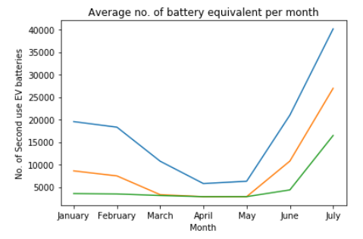

In addition to it, certain trends could also be observed for the entire day. For all peak loads, the demand increases from around 8 am and reaches its maximum around 4 pm, thereby declining further. 