**EXPERIMENT 5**

**Aim:** Design a login form using Bootstrap

**Lab Objective:** Students will be able to:

 Learn how to implement login form using Bootstrap **Theory:**

Designing a login form using Bootstrap involves creating a user-friendly, responsive, and visually appealing interface for users to access your website or application securely. Below is a theoretical approach to designing a login form using Bootstrap, taking into account best practices for usability and aesthetics:

1. Choose a Layout:

- Start by deciding whether you want a cantered or full-width login form. Bootstrap provides grid system classes to help you achieve the desired layout.

2. HTML Structure:

- Create the HTML structure for your login form. Use Bootstrap's form components and classes to style the form elements.

3. Form Elements:

* Add form elements like input fields for the username and password, and a submit button.
* Utilize Bootstrap classes for styling and responsiveness, such as `form-control`, `btn`, and `btn-primary`.

4. Validation and Feedback:

- Implement client-side validation to ensure users enter valid data. Use Bootstrap's validation classes like `is-invalid` and `is-valid` for feedback.

5. Responsiveness:

- Bootstrap provides responsive classes to adapt the form layout to various screen sizes.

Test your form on different devices to ensure it looks good and functions well on all of them.

6. Styling and Theming:

- Customize the form's appearance by overriding Bootstrap's default styles. You can create your custom CSS or use Bootstrap's theming options to match your site's branding.

7. Accessibility:

- Ensure that the login form is accessible to all users, including those with disabilities. Use appropriate HTML attributes and ARIA roles for accessibility.

8. Security:

- Implement proper security measures on the server-side to handle user authentication securely. Never store passwords in plain text; use salted and hashed passwords.

9. Error Handling:

- Provide clear error messages and feedback to users when they enter incorrect credentials or encounter other issues during login.

1. Remember Me and Forgot Password:

Consider adding options for "Remember Me" and "Forgot Password" links to enhance user convenience.

1. Testing:

Thoroughly test the login form for functionality, usability, and compatibility with different browsers.

1. Mobile-Friendly Design:

Pay special attention to the mobile design of the login form, as many users access websites from their smartphones. Bootstrap's responsive classes will help with this.

1. User Experience (UX):

Focus on creating a seamless and intuitive user experience. Use appropriate field placeholders, labels, and tooltips to guide users.

1. Feedback and Notifications:

Consider adding success messages upon successful login and error messages for unsuccessful attempts.

1. Logging and Monitoring:

Implement logging and monitoring systems to track login attempts and identify potential security issues.

**Source Code:**

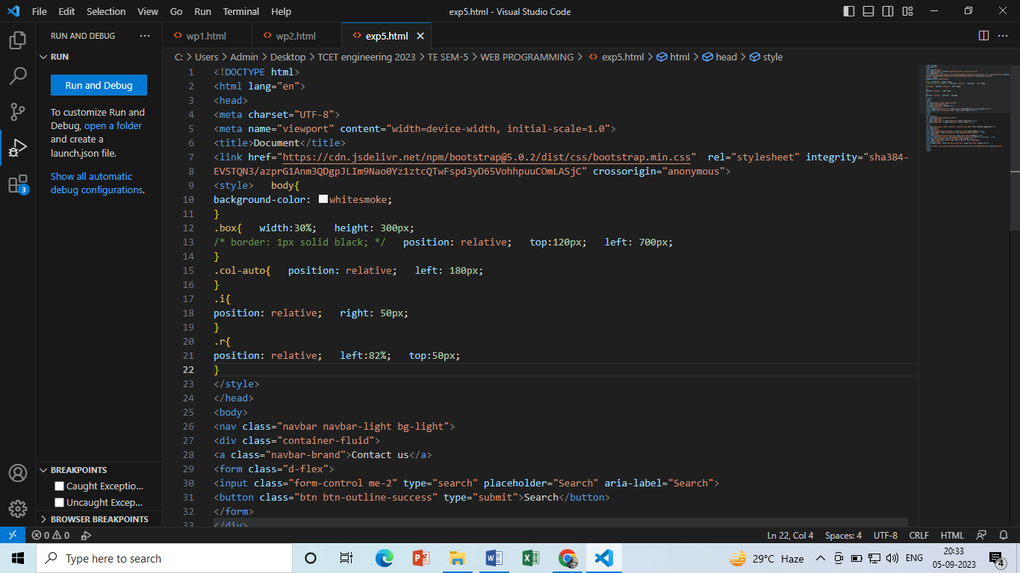

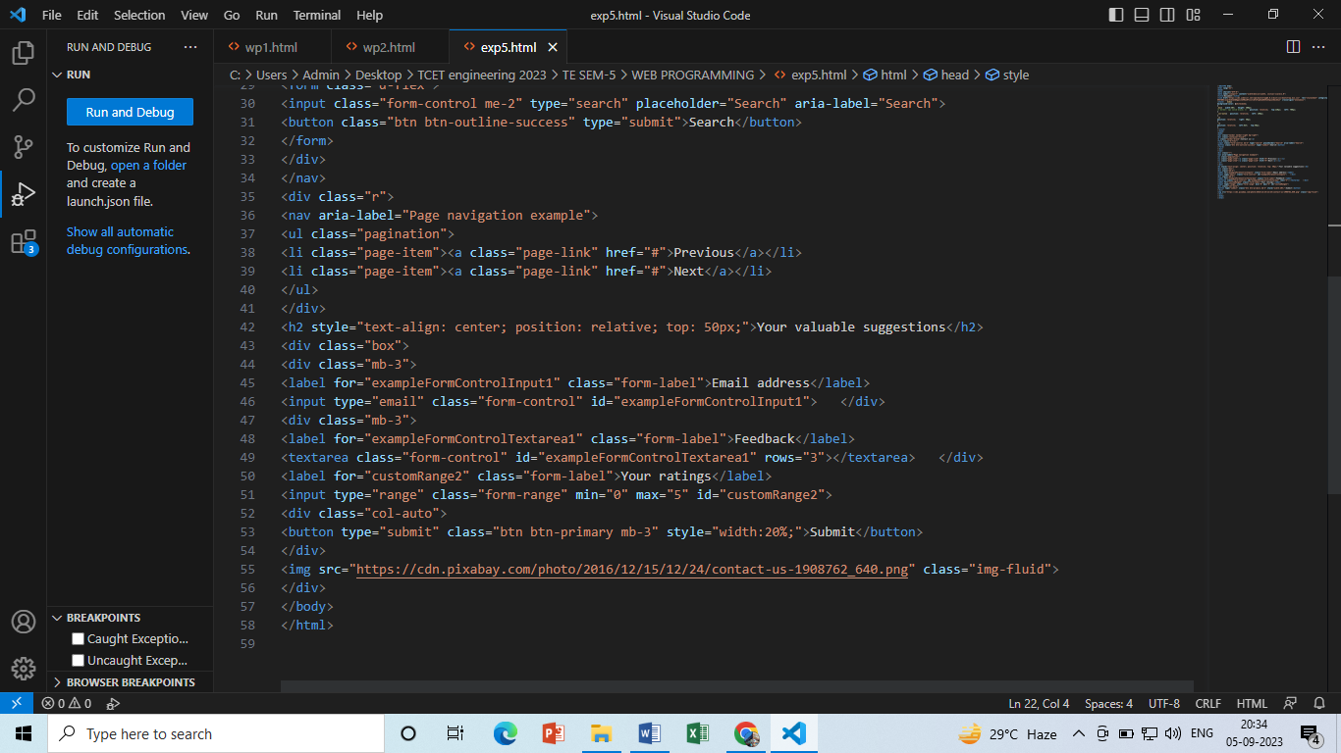

**Output:**

We have used the **pagination, navbar, range responsiveness property of an image** from bootstrap.

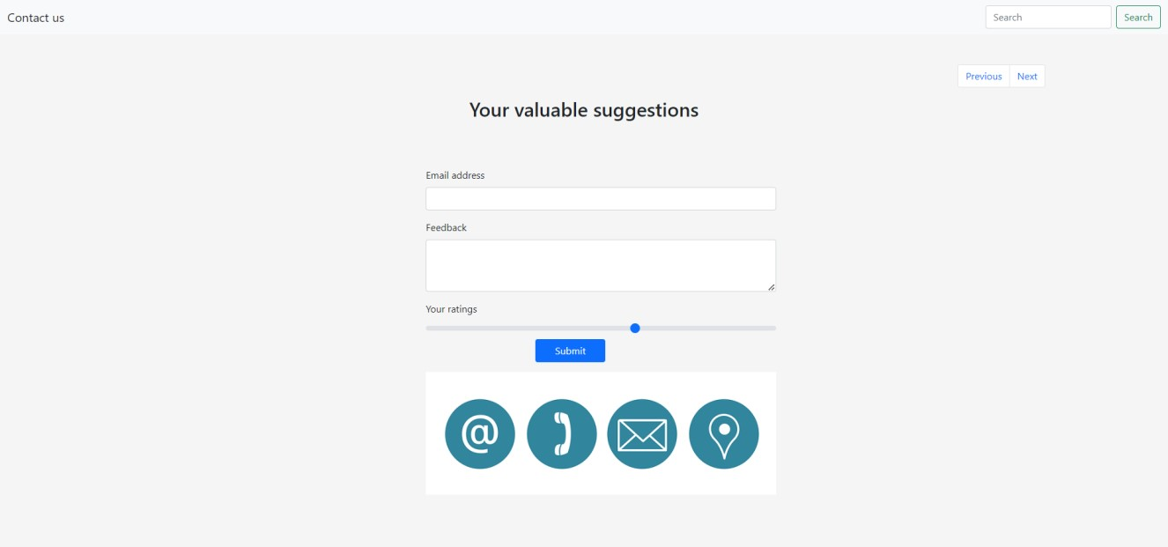

**Learning Outcomes:**

 Learn a new way for implementing login form.

**Conclusion:** Designing a login form using Bootstrap involves a thoughtful blend of aesthetics, usability, security, and responsiveness. By following best practices in HTML structure, form elements, validation, and accessibility, you can create a login interface that not only looks appealing but also functions smoothly across various devices. Remember to prioritize security measures, user experience, and error handling to ensure a secure and user-friendly login process. Regular testing, customization, and attention to detail will result in a polished and effective login form that enhances the overall user journey on your website or application.

**COs attained:** CO1, CO2

**POs attained:** PO1, PO2, PO3 and PO5

**PEOs achieved:**  PEO1, PEO2